
APPENDIX GA36a

LEVEL 4 ASSESSMENT SPECIFICATION

Student name: | Gruff Williams | Student ID number: | 143348 /
Programme: | HNC Mechanical Engineering
Module: | Mechanics 1
Module code: | PSDM 4002 | Contribution to Overall Module Assessment (%): | 20%
Lecturer: | P R Taylor | Internal Verifier: | L Rutherford
Assignment Title: | Bending Moments | Word count (or equivalent): | 1500
Submission deadline: | March 25th | Return date of provisional marks & written feedback: | April 15th 2021
Submission method: | All written assessments, where practical and possible, must be submitted via Turnitin unless otherwise instructed by the Lecturer. (Please DO NOT put this assessment specification into Turnitin or it will match many similarities with other students’ submissions.)  Alternative submission method (if applicable):  Late submission of the assessment will result in a late penalty mark. Penalties for late submission: Up to one week late, maximum mark of 40%. Over one week late, 0%. Only the Extenuating Circumstances Panel may approve a change to submission dates.
Academic honesty / referencing: | Academic honesty is required. In the main body of your submission you must give credit to authors on whose research and ideas your work is based. Append to your submission a reference list that indicates the books, articles, etc. that you have used, cited or quoted in order to complete this assessment.

Module Learning Outcomes
(from module syllabus)
2. Demonstrate the ability to solve problems in simple static and dynamic systems through the application of suitable experimental and analytical techniques.

TASK DESCRIPTION

Objective:

a. To determine the Bending moment in a simply supported beam under the action of a series of concentrated loads.
b. To compare the Bending Moment obtained with that calculated from the bending moment diagram for the beam.

Apparatus:
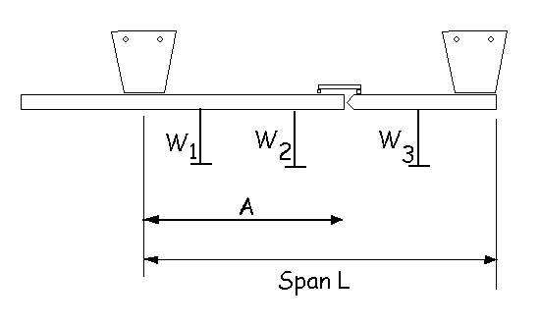
Method:

1. Measure the span of the beam.
2. Switch on the force display meter and zero.
3. Apply three 100g load hangers on the beam and note their position relative to the left-hand support.
4. Record the force meter reading.
5. Repeat for three different load conditions.
Note : Maximum total loading on beam is 500g

Beam dimensions and load data

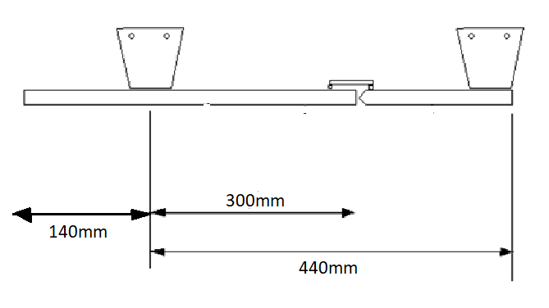

Case 1

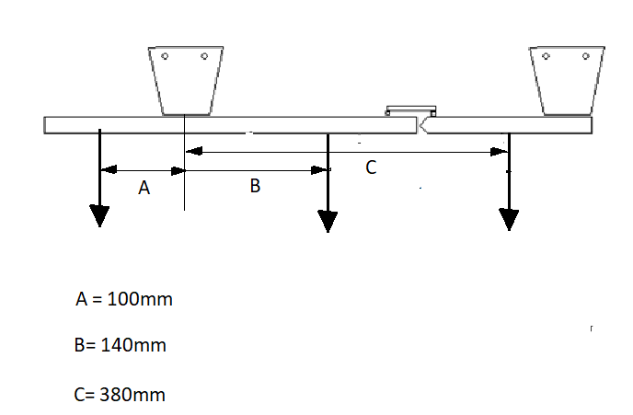

Force metre reading 0.5 N

Case 2
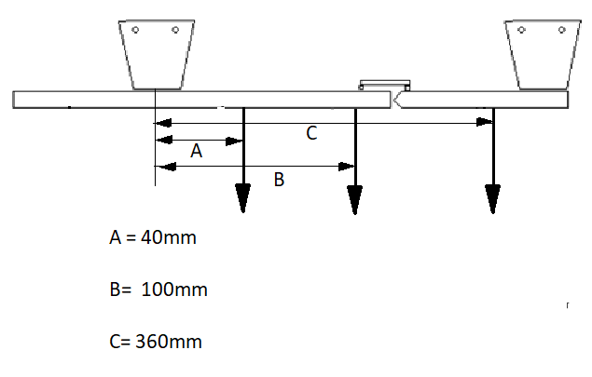
Force metre reading 0.8 N

Case 3

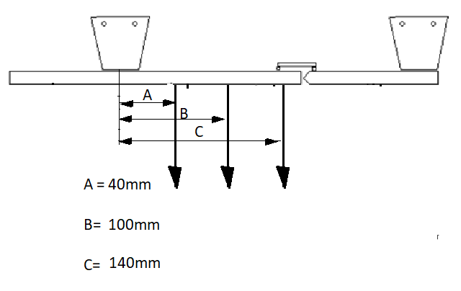

Force metre reading 0.8 N

GUIDANCE FOR Students IN THE COMPLETION OF TASKS

Calculations

- For each load case, the reading obtained from the Pembrokeshire College equipment must be multiplied by 0.125.
- For each load case determine the bending moment equations and draw the corresponding bending moment diagram.
- For each load case, compare the experimental results with the calculated bending moment at the critical section.
- Express the difference in percentage terms and comment on the degree of accuracy and suggest any possible source of errors.
- Compare and contrast the shear force diagrams with the bending moment diagrams for each of the three load cases for both the longer and shorter spans scenarios. What conclusions can you come to when the span is shortened?

GUIDANCE FOR Students IN THE COMPLETION OF TASKS

NOTE: The guidance offered below is linked to the five generic assessment criteria overleaf.

- Engagement with Literature Skills
Your work must be informed and supported by scholarly material that is relevant to and focused on the task(s) set. You should provide evidence that you have accessed an appropriate range of sources, which may be academic, governmental and industrial; these sources may include academic journal articles, textbooks, current news articles, organisational documents, and websites. You should consider the credibility of your sources; academic journals are normally highly credible sources while websites require careful consideration/selection and should be used sparingly. Any sources you use should be current and up-to-date, mostly published within the last five years or so, though seminal/important works in the field may be older. You must provide evidence of your research/own reading throughout your work, using a suitable referencing system, including in-text citations in the main body of your work and a reference list at the end of your work.

Guidance specific to this assessment: This will be assessed via the quality of your literature review and referencing.

- Knowledge and Understanding Skills
At level 4, you should be able to demonstrate knowledge of the underlying concepts and principles associated with your area(s) of study. Knowledge relates to the facts, information and skills you have acquired through your learning. You demonstrate your understanding by interpreting the meaning of the facts and information (knowledge). This means that you need to select and include in your work the concepts, techniques, models, theories, etc. appropriate to the task(s) set. You should be able to explain the theories, concepts, etc. to show your understanding. Your mark/grade will also depend upon the extent to which you demonstrate your knowledge and understanding.

Guidance specific to this assessment: This will be assessed by your discussion of results.

- Cognitive and Intellectual Skills
You should be able to present, evaluate and interpret qualitative and quantitative data, in order to develop lines of argument and make sound judgements in accordance with basic theories and concepts of your subject(s) of study. You should be able to evaluate the appropriateness of different approaches to solving problems related to your area(s) of study and/or work. Your work must contain evidence of logical, analytical thinking. For example, to examine and break information down into parts, make inferences, compile, compare and contrast information. This means not just describing what! But also justifying: Why? How? When? Who? Where? At what cost? You should provide justification for your arguments and judgements using evidence that you have reflected upon the ideas of others within the subject area and that you are able to make sound judgements and arguments using data and concepts. Where relevant, alternative solutions and recommendations may be proposed.

Guidance specific to this assessment: This will be assessed by the quality of your comments and conclusions, throughout the report.

- Practical Skills
At level 4, you should be able to apply the basic underlying concepts and principles to evaluate and interpret these within the context of your area of study. You should be able to demonstrate how the subject-related concepts and ideas relate to real world situations and/or a particular context. How do they work in practice? You will deploy models, methods, techniques, and/or theories, in that context, to assess current situations, perhaps to formulate plans or solutions to solve problems, or to create artefacts. This is likely to involve, for instance, the use of real-world artefacts, examples and cases, the application of a model within an organisation and/or benchmarking one theory or organisation against others based on stated criteria.

Guidance specific to this assessment: This will be assessed via the quality of your discussion relating to the practical relevance of the results.

- Transferable Skills for Life and Professional Practice
Your work must provide evidence of the qualities and transferable skills necessary for employment requiring the exercise of some personal responsibility. This includes demonstrating: that you can communicate the results of your study/work accurately and reliably, and with structured and coherent arguments; that you can initiate and complete tasks and procedures, whether individually and/or collaboratively; fluency of expression; clarity and effectiveness in presentation and organisation. Work should be coherent and well-structured in presentation and organisation.

Guidance specific to this assessment: This will be assessed via the written and presentational quality of your report.

Programme – HND/C Mechanical engineering

MODULE – Mechanics

MODULE CODE – PSDM4002

LECTURER – Peter Taylor

STUDENT – Gruff Williams

Introduction

Mechanical science assignment detailing a method of calculating the bending moments and shear stresses along a beam with multiple loads applied at different distances. Three cases have been given to the student to calculate each bending moment and shear stress and tasked with comparing the cases to one another.

Contents Page.

Introduction page - 10

Case 1 pages 12 – 18

Case 2 pages 19 – 25

Case 3 pages 26 – 32

Reference Page – 33

Case 1

Force metre reading 0.5 N

Part 1

$$0.5N x 0.125=Force metre BM$$

$$0.0625N/m=Force metre BM$$

Part 2

As stated in the assignment’s notes, each arrow has a mass of 100grams. To do the calculations these masses need to be converted to forces.

The grams need to be converted to kilograms.

$$1kg=1000g$$

$$100/1000= 0.1kg$$

Now that the mass is in kilograms the force can be calculated

$$Force=mass x acceleration due to gravity$$

$$F=0.1 x 9.81$$

$$F=0.981N$$

The force exerted on each arrow in the image above is 0.981N.

The distances across the beam are in mm these need to be converted to metres.

$$1metre=1000mm$$

$$A=100/1000$$
$$A=0.1Metre$$

$$B=140/1000$$

$$B=0.14Metre$$

$$C=380 /1000$$

$$C=0.38Metre$$

Now that all distances are known in meters, the reactions can be calculated.

$$EMA=0$$

$$Moment=Force x Distance$$

Right hand reaction

$$0.44Rr-\left(0.1 x 0.981\right)-\left(0.14 x 0.981\right)-\left(0.38 x 0.981\right)=0$$

$$0.44Rr-\left(0.0981\right)-\left(0.13734\right)-\left(0.37278\right)=0$$

$$0.44Rr=0.0981+0.13734+0.37278$$

$$0.44Rr=0.60822$$

$$Rr=\frac{0.60822}{0.44}$$

$$Rr=1.382318N$$

Now that the right-side moment is known the left-side moment can be calculated.

$$Emy=0$$

Left hand reaction

$$Rl+Rr-A-B-C=0$$

$$Rl+1.382318-0.981-0.981-0.981=0$$

$$Rl=\left(0.981 x 3\right)-1.382318$$

$Rl=1.560691$N

With both moments calculated now the bending moment can be calculated.

$$(0 <x <0.1)$$

$$Bm=1.56069x$$

$$(0.1 <x <0.14)$$

$$Bm=1.56069x-0.981(x-0.1)$$

$$Bm= 1.56069x-0.981x+0.0981$$

$$Bm=0.57969+0.0981$$

$$(0.14 <x <0.38)$$

$$Bm=1.56069x-0.981 \left(x-0.1\right)-0.981 \left(x-0.14\right)$$

$$Bm=1.56069x-0.981x+0.0981-0.981x+0.13734$$

$$Bm= -0.40131x+0.23544$$

$$\left(0.38 <x <0.44\right)$$

$$Bm=1.56069x-0.981 \left(x-0.1\right)-0.981\left(x-0.14\right)-0.981(x-0.38)$$

$$Bm=1.56069x-0.981x+0.0981-0.981x+0.13734-0.981x+0.37278$$

$$Bm= -1.38231x+0.60822$$

$$x=0.44$$

$$Bm= -(1.38231 x 0.44)+0.60822$$

$$Bm=3.6 x 10^-6$$

$$Bm=-0.0000036$$

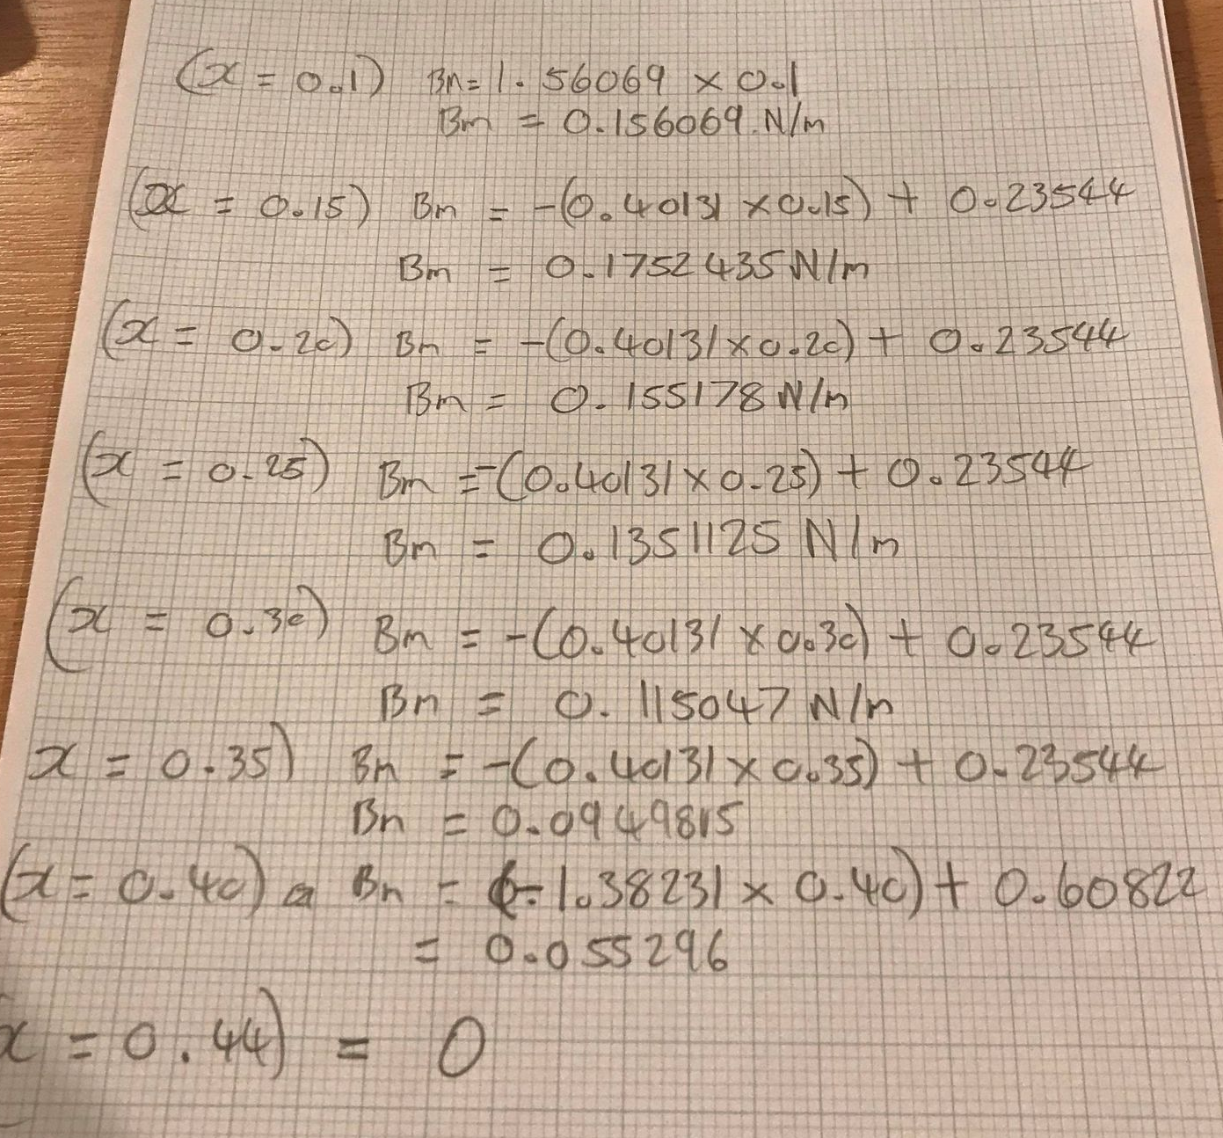

Bending moment graph x values.

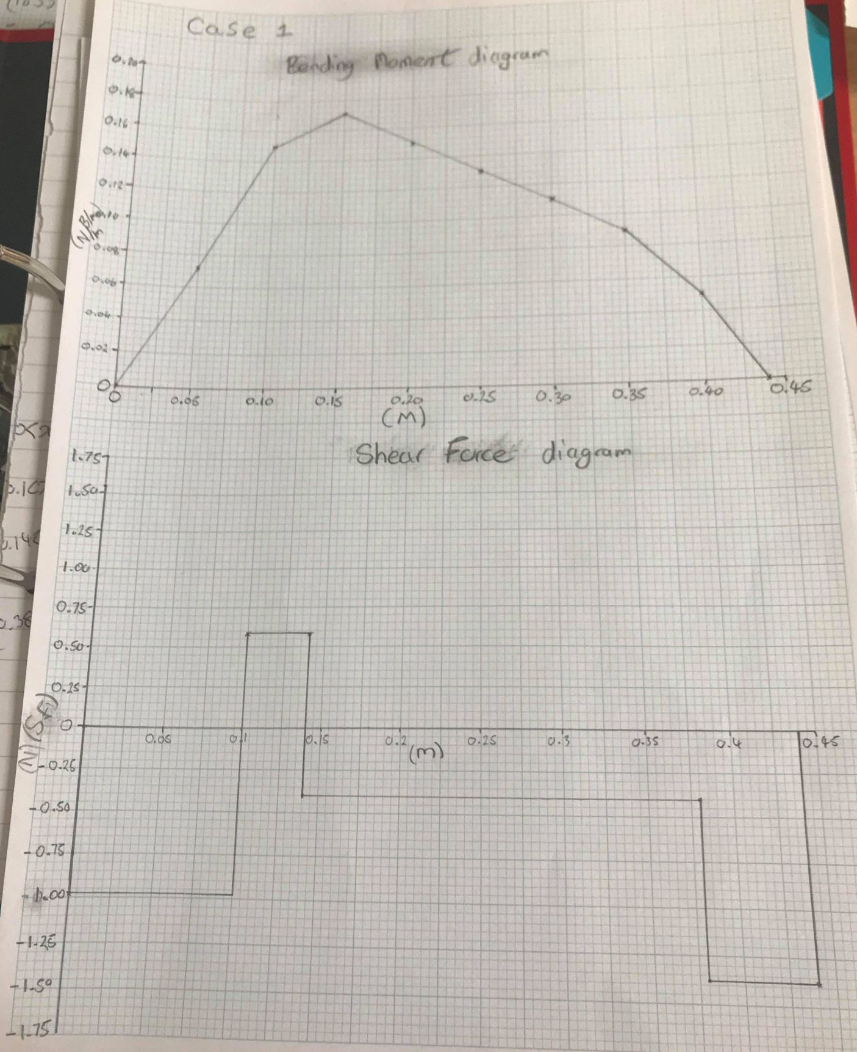
Bending moment and shear force Diagrams.

Part 3

With the calculations that have been above, it is known that the critical point on the beam at the 0.3 metres. By using the relevant bending moment equation, the force applied at the critical point can be calculated.

$$x=0.3$$

0.3 metres is between these two points so this equation can be used.
$$(0.14 <x <0.38)$$

$$Bm=1.56069x-0.981 \left(x-0.1\right)-0.981 \left(x-0.14\right)$$

$$Bm=1.56069x-0.981x+0.0981-0.981x+0.13734$$

$$Bm= -0.40131x+0.23544$$

$$Bm= -\left(0.40131 x 0.3\right)+0.23544$$

$$Bm=0.115047N/m$$

It is stated in part 1 of the calculation brief. The meter reading must be multiplied by 0.125

The force meter reading for case 1 is 0.5N

$$0.5 x 0.125=0.0625N/m$$
0.0625N/m is the force applied from the test rig. From the calculations the bending moment and 0.3 metres across the beam is 0.115047N/m. The calculated bending moment is close to double of the force meter reading obtained from the test rig.

Part 4

$$Percentage Difference=$$

$$\frac{Calculated Bm-Original metre reading }{Original metre reading }x 100$$

$$\%=\frac{0.115047-0.0625}{\begin{aligned}0.0625 \\ \end{aligned}} x 100$$

$$\%=84$$

The percentage difference shown for case 1 is large. it shows that the bending moment from the test rig and the calculated bending moment are no where near each other this could be seen in part 3 with there being a 0.052547N/m of difference between the two readings. The calculated bending moments are correct. This can be justified from the bending moment and shear force diagrams. Both diagrams finish at 0.44 metres at 0 N/m. Other factors that could result in different readings are that the equipment wasn’t calibrated properly, if the equipment isn’t calibrated the readings wouldn’t be accurate. Human error, a mistake could have been made when measuring the metre readings when the experiment took place.

Part 5

Comparing the bending moment diagram to the shear force diagram, on both graphs the maximum bending moment and shear stress occur at the same distance of 0.14metres along the beam. At 0.14metres the shear force diagram changes sign from positive to negative. Once the line is in the negative region of the graph the bending moment begins to decrease at an indirectly proportional line until the next force is reached at 0.38metres. Then the slope increases to reach 0 N/m at 0.44metres.

On the shear force diagram, there are two points of contraflexure meaning that there is a force bending the beam in one direction and another force is attempting to move the beam in the opposite direction. The beam begins with a force on the overhang. This starts the shear force in the negative region of the graph until it reaches the left resultant force at 0.1metres. This force increases the shear stress into the positive region of the graph moves along until it reaches another force 0.14mertes and flips the sign once more into the negative region. This is where the double contraflexure occurs. The shear force stays constant at -0.4N until it reaches the last force at 0.38metres decreasing the shear force, the right-hand resultant force equals the final shear stress bringing the graph to close at 0.

Case 2

Force metre reading 0.8 N

Part 1

$$0.8 x 0.125=0.8N/m$$

Part 2

As previous all forces acting on the beam are 0.981N

The distance need to be in metres

$$A=0.04Metre$$

$$B=0.1Metre$$

$$C=0.36Metre$$

$$EmA=0$$

$$Moment=Force x Distance$$

Right hand reaction.

$$0.44Rr-\left(0.04 x 0.981\right)-\left(0.1 x 0.981\right)-\left(0.36 x 0.981\right)=0$$

$$0.44Rr-0.03924-0.0981-0.35316=0$$

$$0.44Rr=0.03924+0.0981+0.35316$$

$$Rr=\frac{0.4905}{0.44}$$

$$Rr=1.114772727N$$

$$Emy=0$$

Left hand reaction

$$Rl+Rr-A-B-C=0$$

$$Rl+1.114772727-0.981-0.981-0.981=0$$

$$Rl=\left(0.981 x 3\right)-1.114772727$$

$$Rl=1.8282N$$

Calculations for bending moments.

$$(0 <x <0.04)$$

$$Bm=1.8282x$$

$$(0.04 <x <0.1)$$

$$Bm=1.8282x-0.981\left(x-0.04\right)$$

$$Bm=1.8282x-0.981x+0.03924$$

$$Bm=0.8472x+0.03924$$

$$(0.1<x<0.36)$$

$$Bm=1.8282x-0.981\left(x-0.04\right)-0.981(x-0.1)$$

$$Bm=1.8282x-0.981x+0.03924-0.981x+0.0981$$

$$Bm= -0.1338x+0.13734$$

$$(0.36 <x <0.44)$$

$$Bm=1.8282x-0.981\left(x-0.04\right)-0.981\left(x-0.1\right)-0.981(x-0.36)$$

$$Bm=1.8282x-0.981x+0.03924-0.981x+0.0981-0.981x+0.35316$$

$$Bm= -1.1148x+0.4905$$

$$x=0.44$$

$$Bm= -\left(1.1148 x 0.44\right)+0.4905$$

$$Bm= -1.2 x 10^-5$$

$$Bm=-0.000012$$

Bending moment x values for diagram.

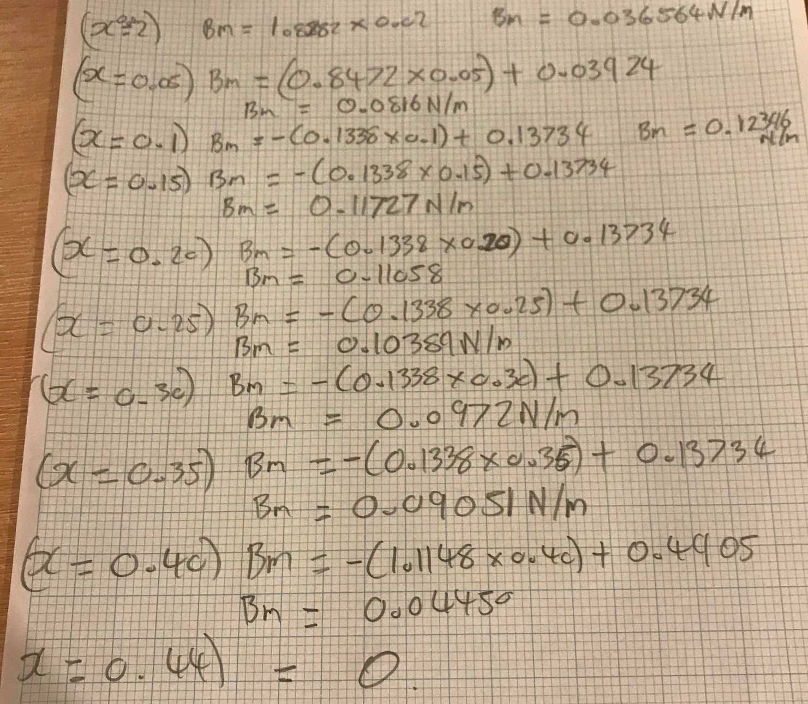

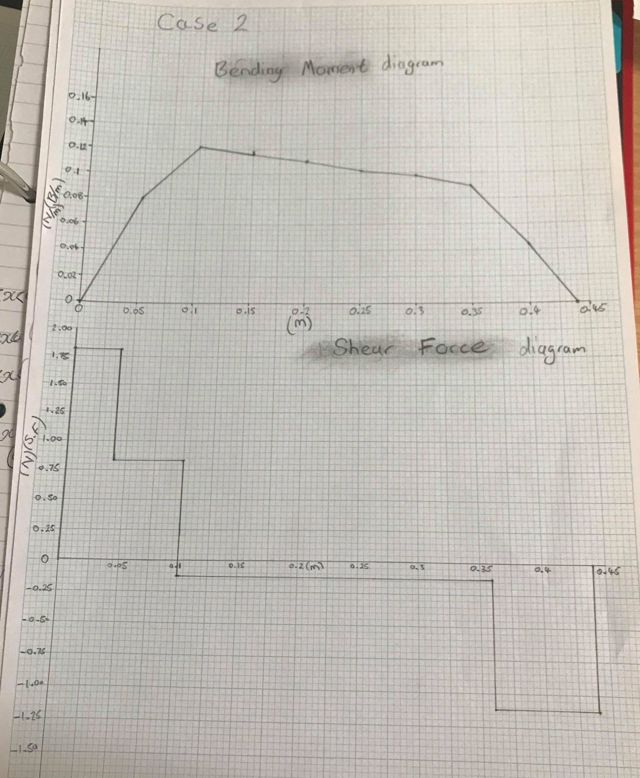
Shear force & Bending moment diagrams.

Part 3

With the calculations that have been above, it is known that the critical point on the beam at the 0.3 metres. By using the relevant bending moment equation, the force applied at the critical point can be calculated.

$$x=0.3$$

0.3 metres is between these two points so this equation can be used.

$$(0.1<x<0.36)$$

$$Bm=1.8282x-0.981\left(x-0.04\right)-0.981(x-0.1)$$

$$Bm=1.8282x-0.981x+0.03924-0.981x+0.0981$$

$$Bm= -0.1338x+0.13734$$

$$Bm= -\left(0.1338 x 0.3\right)+0.13734$$

$$Bm=0.0972N/M$$

The force meter reading for case 2 is 0.8N

$$0.8 x 0.125=0.1N/m$$

0.1 N/m is the force applied from the test rig. From the calculations the bending moment and 0.3metres across the beam is 0.0972N/m. The bending moment from the calculations is close to the meter reading from the test rig with only a 0.0028N/m difference between the two bending moments.

Part 4

$$Percentage Difference=$$

$$\frac{Calculated Bm-Original metre reading }{Original metre reading }x 100$$

$$\%=\frac{0.0972-0.1}{\begin{aligned}0.1 \\ \end{aligned}} x 100$$

$$\%=-2.8$$

The percentage difference for case 2 is significantly smaller than case 1. it shows that the bending moment from the test rig and the calculated bending moment are similar, with the calculated bending moment being 2.8% smaller than the reading from the test rig. Again, the bending moment equations are correct as the moment at the end of the beam equals to 0 N/m. This time the accuracy between the test rig is excellent. In case two the metre reading has been red correctly.

Part 5

Comparing the shear force diagram with the bending moment diagram for case 2. The bending moment increases across the beam, the left-hand resultant force on the shear stress diagram starts the line at 1.8282N as the distances is spread across the beam the loads begin to adjust the courses of the shear and bending moment diagrams. the first load is reached at 0.05metres where the shear force decreases to 0.8472N and the bending moment increases to 0.0816N/m. The next load is reached at 0.1metres sending the shear force down to -0.1338N as the force has now crossed into the negative region of the graph, the point of contraflexure has been reached. The point of contraflexure is the highest point that the bending moment reaches which is 0.12396N/m. The bending moments begin to decrease gradually along the long span of the beam. Once the next load is reached at 0.36metres the shear force decreases again too -1.1148N where the bending moments begins to decrease at a higher rate at 0.36m Bm = 0.08N/m. Once the end of the beam is reached where the right-hand resultant force is equal to the shear force at 0.36metres. This Brings the shear force to 0N. The Bending moment also end at 0.44metres reading 0N/m. This beam has a long span meaning there is a greater defection along the beam. This would mean more supports would be needed to keep the forces balanced.

Case 3

Force metre reading 0.8 N

Part 1

$$0.8 x 0.125= 0.1N$$

Part 2

Once more all forces acting on the beam are 0.981N

The distances need to be in metres.

$$A=0.04Metre$$

$$B=0.1Metre$$

$$C=0.14Metre$$

Calculations for the reactions.

Right side reaction.

$$EmA=0$$

$$Moment=Force x Distance$$

$$0.44Rr-\left(0.04 x 0.981\right)-\left(0.1 x 0.981\right)-\left(0.14 x 0.981\right)=0$$

$$0.44Rr-0.03924-0.0981-0.13734=0$$

$$0.44Rr= 0.03924+0.0981+0.13734$$

$$0.44Rr=0.27468$$

$$Rr=\frac{0.27468}{0.44}$$

$$Rr=0.624272N$$

Left hand Reaction.

$$Emy=0$$

$$Rl+Rr-A-B-C=0$$

$$Rl+0.6242727-0.981-0.981-0.981=0$$

$$Rl=\left(0.981 x 3\right)-0.6242727$$

$$Rl=2.3187273N$$

Calculations for the bending moments.

$$(0 <x <0.04)$$

$$Bm= 2.31872x$$

$$\left(0.04 <x <0.1\right)$$

$$Bm=2.31872x-0.981(x-0.04)$$

$$Bm=2.31872x-0.981x+0.03924$$

$$Bm=1.33772x+0.03924$$

$$(0.1 <x <0.14)$$

$$Bm=2.31872x-0.981\left(x-0.04\right)-0.981\left(x-0.1\right)$$

$$Bm=2.31872x-0.981x+0.03924-0.981x+0.0981$$

$$Bm=0.35672x+0.13734$$

$$(0.14 <x <0.44)$$

$$Bm=2.31872x-0.981\left(x-0.04\right)-0.981\left(x-0.1\right)-0.981(x-0.14)$$

$$Bm=2.31872x-0.981x+0.03924-0.981x+0.0981-0.981x+0.13734$$

$$Bm=-0.62428x+0.27468$$

$$x=0.44$$

$$Bm= -\left(0.62428 x 0.44\right)+0.27468$$

$$Bm= -3.2 x {10}^{-6}$$

$$Bm= -0.0000032$$

Bending moment x values for diagram.

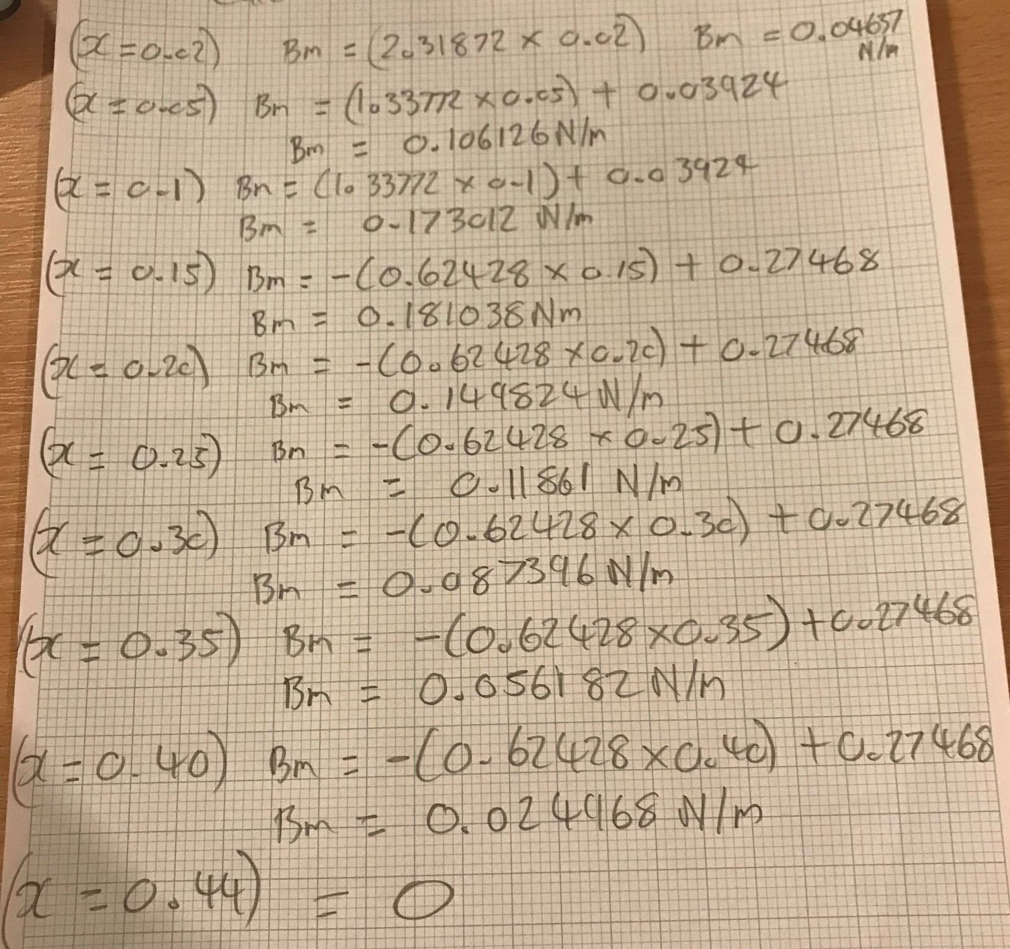

Shear force & Bending moments diagrams.

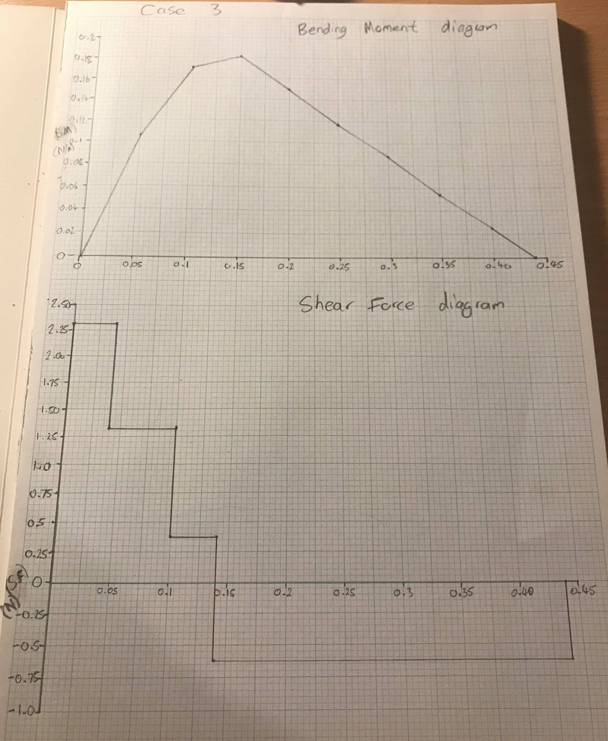

Part 3

With the calculations that have been above, it is known that the critical point on the beam at the 0.3 metres. By using the relevant bending moment equation, the force applied at the critical point can be calculated.

$$x=0.3$$

0.3 metres is between these two points so this equation can be used.

$$(0.14 <x <0.44)$$

$$Bm=2.31872x-0.981\left(x-0.04\right)-0.981\left(x-0.1\right)-0.981(x-0.14)$$

$$Bm=2.31872x-0.981x+0.03924-0.981x+0.0981-0.981x+0.13734$$

$$Bm=-0.62428x+0.27468$$

$$Bm= -\left(0.62428 x 0.3\right)+0.27468$$

$$Bm=0.087396$$

The force meter reading for case 3 is 0.8N

$$0.8 x 0.125=0.1N/m$$

0.1 N/m is the force applied from the test rig. From the calculations the bending moment and 0.3metres across the beam is 0.087396N/m. The bending moment from the calculations is close to the meter reading from the test rig with 0.012604N/m difference between the two bending moments.

Part 4
$$Percentage Difference=$$

$$\frac{Calculated Bm-Original metre reading }{Original metre reading }x 100$$

$$\%=\frac{0.087396-0.1}{\begin{aligned}0.1 \\ \end{aligned}} x 100$$

$$\%=-12.6$$

The percentage difference for case 3 is significantly smaller than case 2. it shows that the bending moment from the test rig and the calculated bending moment are similar however not as accurate as case 2, with the calculated bending moment being 12.6% smaller than the reading from the test rig. Once more, the bending moment equations are correct as the moment at the end of the beam at 0.44metres equals to 0 N/m. This time the accuracy between the test rig is not to the accuracy of case 2 however it is far better than case 1. This could be the case of human error, not reading the metre reading accurately. Or the test rig was not calibrated correctly. Another possibility is that the test rig hasn’t been reset to zero before changing the distances of the loads resulting in inaccuracies.

Part 5

Comparing the bending moment to the shear force diagrams for case 3. The shear force diagram begins with the left side resultant force starting at 2.31872N. The first load is exerted on the beam at 0.04 metres this decreases the shear force to 1.33772N. As the shear force decreases the bending moment on the beam increase to 0.08N/m. it is clear that the loads for case 3 have been applied at shorter distances to one another compared with case 1 and 2. The next load on the beam is applied at 0.1metres, this decreases the load on the shear force to 0.35672N and increases the bending moment to 0.173012N/m. Another short distance away at 0.14metres is where the final load is exerted on the beam. At this distance, the shear force diagram changes sign from positive to negative the force is -0.62428N at this point the maximum bending moment has been found and the point contraflexure has been reached, a bending moment of 0.181038N/m. From this point the shear force remans at -0.62428 until the right-side resultant force is applied at 0.44metres. The resultant force equals the final shear force making the graph end at 0N. For the bending moment diagram the bending moment begin to decrease at an indirectly proportional rate until it reaches 0.44 metres where the bending moment equation equals 0N/m. As the loads are closer together along the beam on case 3, this indicates a shorter span of force along the 0.44 metres of beam present. This means that there is less stress exerted on the beam compared with the longer spanned cases. Less stress means there wouldn’t be need for as many support to keep the beam at equal forces.
Reference page

Books

Natalya Pertaya-Braun, Kai-Felix Braun (2019). Another Book on Engineering Mechanics: Statics Part 2 Shear Forces and Bending Moments.

Mark Huber (2013 ). The Beginner's Guide to Engineering: Mechanical Engineering: . .: CreateSpace Independent Publishing.

Fiona Cobb (2014 ). Structural Engineer's Pocket Book. .: Routledge

Ali Sadegh, William Worek (2017 ). Marks' Standard Handbook for Mechanical Engineers. 13th ed. .: McGraw-Hill Education

Student FEEDBACK FORM

This section details the extent to which the assessment criteria are demonstrated by you, which in turn determines your mark. The marks available for each category of skill are shown. Lecturers will use the space provided to comment on the achievement of the task(s), including those areas in which you have performed well and areas that would benefit from development/improvement.

Generic Assessment Criteria | Marks available | Marks  awarded
1. Engagement with Literature Skills
.
A bibliography is provided but there is no evidence of referencing within the text, |  | 4
 | 20 | 4
2. Knowledge and Understanding Skills

The calculations and derivation of bending moment equations show a comprehensive understanding of the principles involved. There are some errors of understanding in the conversion of calculated bending moment to force meter reading. |  | 22
 | 30 | 22
3. Cognitive and Intellectual Skills

Excellent understanding of the concepts involved. Candidate has shown excellent ability to discuss and analyse results. |  | 14
 | 20 | 14
4. Practical Application Skills

A very good application of skills and techniques. |  | 13
A very good application of skills and techniques. | 20 | 13
5. Transferable Skills for Life and Professional Practice

Mostly coherent, organised and accurate work, in a suitable structure and is for the most part clearly expressed. Could have made more use of graphical presentation packages. |  | 6
 | 10 | 6

Assessment Mark (Assessment marks are subject to ratification at the Exam Board. These comments and marks are to give feedback on module work and are for guidance only until they are confirmed. ) | Late Submission Penalties (tick if appropriate) |  | 59%
 | Up to 1 week late (40% Max) |  | 59%
 | Over 1 week late (0%) |  | 59%

GENERIC ASSESSMENT CRITERIA

Level 4
In accordance with the Framework for Higher Education Qualifications, at the end of Level 4 students will be expected to have demonstrated knowledge of the basic underlying concepts and principles of a subject, and an ability to evaluate and interpret these within the context of that area of study. They should be able to present, evaluate and interpret qualitative and quantitative data in order to develop lines of argument and make sound judgements in accordance with basic theories and concepts of their subject(s) of study. They will have learned how to evaluate different approaches to solving problems, and will be able to communicate the results of their study/work accurately and reliably, and with structured and coherent arguments. They will be able to undertake further training and develop new skills within a structured and managed environment and will have the qualities and transferable skills necessary for employment requiring the exercise of some personal responsibility.

Level 4 | FAIL | MARGINAL FAIL | SATISFACTORY  (3rd / Pass) | GOOD  (2.2 / Pass) | VERY GOOD  (2.1 / Merit) | EXCELLENT  (1st / Distinction) | EXCEPTIONAL  (1st / Distinction)
Category | 0-29% | 30-39% | 40-49% | 50-59% | 60-69% | 70-84% | 85-100%
Engagement with literature (including reading, referencing,  academic conventions and  academic honesty) | Little or no evidence of reading and/or reliance on inappropriate sources.  Views and findings mostly unsupported and non-authoritative.  Referencing conventions used incoherently or largely absent. | Poor engagement with essential reading. No evidence of wider reading. Reliance on inappropriate sources, and/or indiscriminate use of sources. Heavily reliant on information gained through class contact. Inconsistent and weak use of referencing. | Engagement with a limited range of mostly relevant and credible sources but with some reliance on information gained through class contact. Some omissions and minor errors.  Referencing conventions evident though not always applied accurately or consistently. | Engagement with an appropriate range of literature, including sources retrieved independently. Some over-reliance on texts rather than other sources. Referencing may show minor inaccuracies or inconsistencies. | Engagement with a wide range of literature, including sources retrieved independently.  Selection of relevant and credible sources. Generally sound referencing, with no/very few inaccuracies or inconsistencies. | Engagement with an extensive range of relevant and credible literature. Consistently accurate application of referencing. | Exceptional engagement with an extensive range of relevant and credible literature. High-level referencing skills consistently applied.
Knowledge and understanding (Knowledge of the basic underlying concepts and principles of a subject.) | Major gaps in knowledge and understanding of the basic underlying concepts and principles of the subject matter. Inclusion of irrelevant material. Substantial inaccuracies. | Gaps in knowledge of the basic underlying concepts and principles, with flawed or superficial understanding. Some significant inaccuracies and/or irrelevant material. | Limited knowledge and understanding of the basic underlying concepts and principles within the subject area. Some elements may be missing. | Knowledge of the basic underlying concepts and principles is accurate with a good understanding of the field of study but lacks depth and/or breadth. | Competent knowledge of the basic underlying concepts and principles. Exhibits very good understanding. | Excellent knowledge and understanding of the basic underlying concepts and principles of the subject. | Exceptional, detailed knowledge and understanding of the basic underlying concepts and principles
Cognitive and intellectual skills  (Evaluate underlying concepts and principles of a subject and interpret qualitative and quantitative data in order to develop lines of argument and make sound judgements.) | Wholly or almost wholly descriptive work. Little or no evaluation of the underlying concepts and principles.  Failure to develop arguments, leading to illogical or invalid judgements. Minimal or no use of  evidence to back up views. | Largely descriptive work, with superficial evaluation of the underlying concepts and principles. Weak interpretation of data, flawed development of arguments and judgements. Information accepted uncritically, uses generalised statements made with scant evidence and unsubstantiated opinions. Ideas sometimes illogical and contradictory. | Limited attempt at evaluation of the underlying concepts and principles, tending towards description.  Can interpret qualitative and quantitative data but with some errors. Some evidence to support emerging arguments and judgements but these may be underdeveloped or with a little inconsistency / mis-interpretation. | Good evaluation of the underlying concepts and principles. Can interpret qualitative and quantitative data, with minor errors.  An emerging ability to use evidence to support the argument.  Mostly valid arguments and logical judgements. | Sound evaluation of the underlying concepts and principles. Can interpret qualitative and quantitative data accurately. Ability to devise arguments using evidence to make mostly appropriate and valid judgements. | Excellent evaluation of the underlying concepts and principles. Can interpret qualitative and quantitative data accurately and with some insight. Excellent ability to devise arguments using evidence and make appropriate and valid judgements. | Exceptional evaluation of the underlying concepts and principles based evidence. Outstanding interpretation of qualitative and quantitative data.  Exceptional ability to devise arguments using evidence and make wholly appropriate and valid judgements.
Practical skills  (Different approaches to solving problems in particular contexts.) | Limited or no use of taught, basic methods, materials, tools and/or techniques.  Little or no appreciation of the context of the application.  Very weak evidence of different approaches to problem-solving in particular contexts. | Rudimentary application of taught, basic methods, materials, tools and/or techniques but without consideration and competence. Flawed appreciation of the context of the application.  Weak evidence of different approaches to problem-solving in particular contexts. | An adequate awareness and mostly appropriate application of basic methods, materials, tools and/or techniques.  Basic appreciation of the context of the application.  Can identify problems in particular contexts and propose basic alternative approaches or solutions though there may be errors. | A good and appropriate application of basic methods, materials, tools and/or techniques.  Clear appreciation of the context of the application.  Good evidence of different approaches to problem-solving in particular contexts and proposes mostly appropriate solutions. | A very good application of a range of basic methods, materials, tools and/or techniques.  Very good consideration of the context of the application. Very good evidence of different approaches to problem-solving in particular contexts and proposes appropriate solutions. | An advanced application of a range of taught, basic methods, materials, tools and/or techniques.  The context of the application is well considered, and insightful.  Excellent evidence of different approaches to problem-solving in particular contexts and proposes appropriate solutions. | Exceptional levels of application and deployment skills in particular practical contexts. Outstanding identification of problems in particular contexts and formulation of wholly appropriate, thoughtful solutions / different approaches.
Transferable skills for life and professional practice  (Communicate the results of their study/work accurately and reliably, and with structured and coherent arguments; the qualities needed for employment requiring the exercise of some personal responsibility within a structured and managed environment.) | Work is poorly structured, disorganised, inaccurate and/or confusingly expressed. Very weak use of language and/or very inappropriate style. Failure to work effectively individual or as part of a group. Little or no evidence of the skills for employment requiring the exercise of some personal responsibility. | Work is poorly presented in a disjointed manner. It is loosely, and at times incoherently, structured, with information and ideas often poorly expressed. Weak use of language and/or inappropriate style. Flawed approach to individual or group work, meeting only partial obligations to others. Limited evidence of the skills for employment requiring the exercise of some personal responsibility. | Mostly ordered presentation and structure in which relevant ideas / concepts are reasonably expressed. Work may lack coherence and/or accuracy in places. Can work as part of a group, meeting most obligations to others but perhaps with limited involvement in group activities.  Demonstrates the basic skills for employment requiring the exercise of some personal responsibility, with some areas of minor weakness. | Mostly coherent, organised and accurate work, in a suitable structure and is for the most part clearly expressed. Can work effectively independently and/or as part of a team, with clear contribution to group activities.  Demonstrates the skills for employment requiring the exercise of some personal responsibility, with some areas of strength and some of minor weakness. | Work is accurate, coherent, fluent, well-structured and organised.  Can work effectively independently and/or as part of a team, with very good contribution to group activities. Demonstrates very good skills for employment requiring the exercise of some personal responsibility, with just occasional minor weakness. | Work is coherent, very fluent and is presented professionally. Can work effectively independently and/or as part of a team, with an excellent contribution to group activities. Demonstrates excellent skills for employment requiring the exercise of some personal responsibility with an appetite for further development. | Work is accurate, exceptionally coherent, very fluent and presented well. Can work effectively independently and/or as part of a team, with an exceptional contribution to group activities. Demonstrates exceptional skills for employment requiring the exercise of some personal responsibility with an appetite for further development.

THIS DOCUMENT IS ALSO AVAILABLE IN WELSH

