Programme: | BA Business Management
Module: | The Global Business Environment
Module code: | LCCB4005 | Contribution to Overall Module Assessment (%): | 50%
Module Coordinator/ Lecturer: | Dr Rexon Nting | Internal Verifier: | Dr Molly Jack
Assignment Title: | Assessment 2 Environmental Analysis of an industry | Word count (or equivalent): | 2000 words (+) 10%
Submission deadline:  Student Name | To be announced by the Assessment team-  Please refer to the assessments schedule published on Students’ Hall in Moodle  Andreea David ( 2120246) | Return date of marks & written feedback: | 20 Working days after submission deadline

Executive Summary
This report has mainly analysed and evaluated the impact of COVID-19 on the automobile industry. COVID-19 has affected both the growth and development of the industry which has put a negative impact on the economy of the country and the world. The number of purchases and registrations has declined due to the financial instability of the customers which has collectively affected the output of the automobile industry. In order to overcome the adverse effects of the pandemic, the industry has implemented certain policies such as selling 'used' vehicles, using online platforms for the dealership and many others for improving their condition.

Table of Contents
Introduction 4
Main Body 5
Conclusion 12
Reference List 13

Introduction
COVID-19 has widely affected the people all over the not world not only physically but also led to social, economic, cultural, and political crises (Ghazanfari, 2020). Europe had the highest mortality rate of COVID-19 after the United States. The pandemic has adversely affected the business and economic growth of the country and the people all over the world. This report will analyse the impact of a pandemic on the automobile industry. It will also discuss the various factors of survival and success that will be implemented by this particular industry after the pandemic in order to sustain the market for a long period.

Main Body
Impact of COVID-19 pandemic on the automobile industry
The automobile industry is regarded and considered as one of the important sectors in the UK to contribute to the growth and economy of the country. The industry contributes over £60.2 billion in turnovers along with around £11.9 billion in value to the economy of the country (Smmt, 2020). Around 156, 400 individuals are hired and recruited in the manufacturing industries and around 797,300 individuals are working widely in the automobile sector. The automobile sector mainly deals and accounts for about 11% of the overall export of products or goods in the UK which is worth around £42.4 billion and an investment of £2.9 billion is made every year under the section of automobile R&D. According to a survey, it has been recorded that in the year 2021, more than 859.000 cars, 1.6 million engines, and around 72,913 commercial cars or vehicles were manufactured or built in the UK (Smmt, 2020).
During the pandemic and the lockdown situation, the entrepreneurs were mainly trying to protect and save their business, retain their employees or staff, and keep moving their supply chain. In the year 2020, along with the pandemic, there were the various tariffs and terms of BREXIT that were hampering the proper and positive relationship among international traders (Mckinsey & Company, 2020). The automobile sector was mainly getting disturbed and disrupted by the implication of new and advanced technologies, including electrification, automation, artificial intelligence or AI, and connectivity. According to a report, it has been observed that in the year 2020, during lockdown the rate of registration of various new vehicles or cars has drastically dropped down to the rate of 97% in a year (Pwc, 2022). There has been a sharp decline in the intention of the customers to purchase cars on and after the pandemic situation.
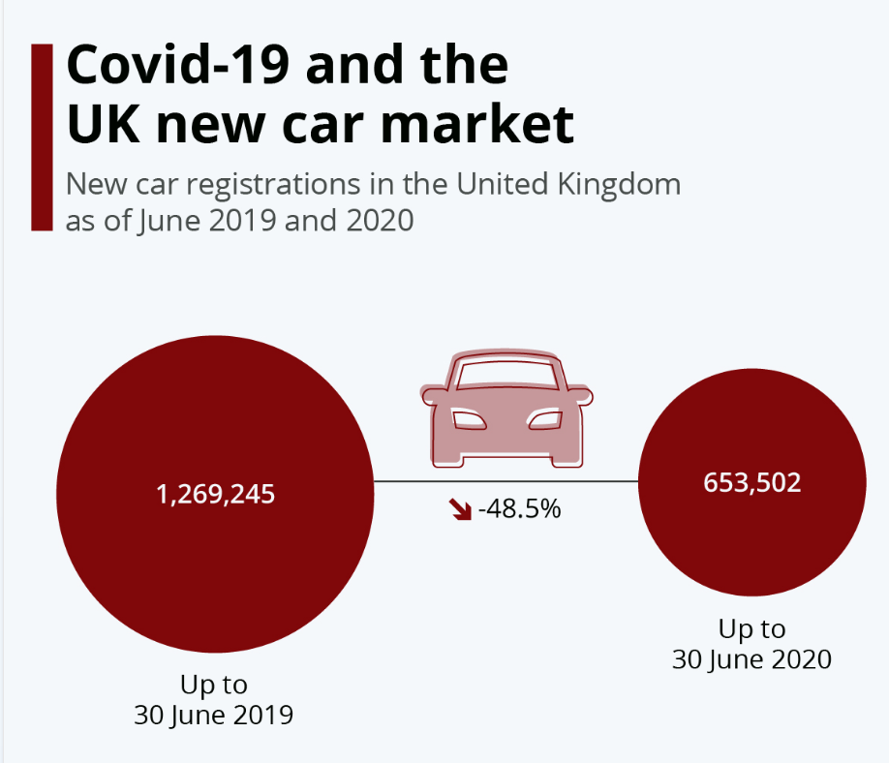
Figure 1: Impact of COVID-19 on the new market of the cars in the UK
(Source: Armstrong, 2020)
It can be seen from the above figure that in the year 2019, the number of cars or vehicles that were registered for selling was around 1,269,245 units which have drastically decreased in 2020 by 48.5% accounting for approximately 653,502 units (Armstrong, 2020). This showed that COVID-19 has adversely affected the purchasing power and intention of the consumers which in turn has affected the growth and development of the automobile industry in the UK.
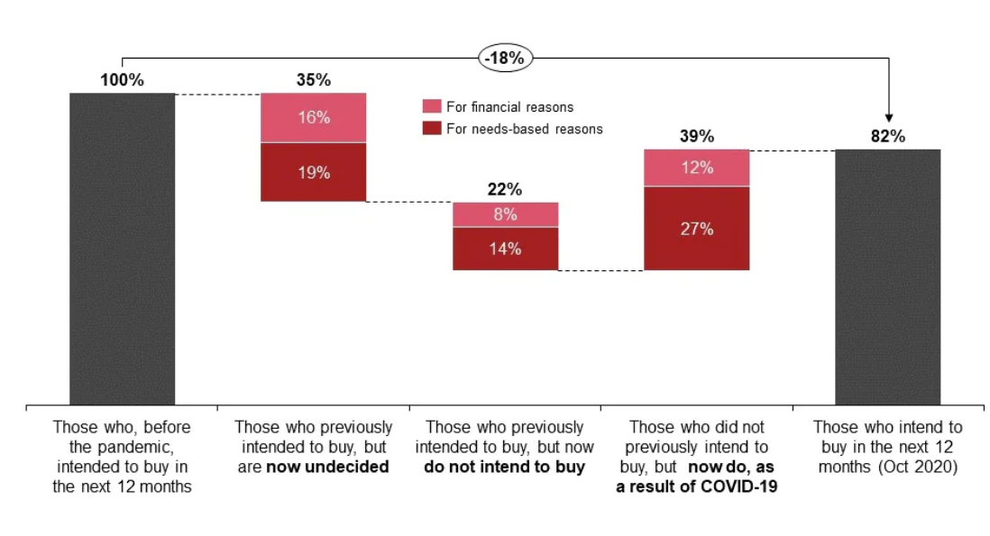
Figure 2: Percentage of customers who intended to purchase cars before the pandemic
(Source: Pwc, 2022)
It can be seen from the above diagram that around 100% of customers were willing to purchase vehicles in the upcoming twelve months before the hit of the pandemic. Later, around 35% of the customers have undecided about their preference of buying cars either due to economic or financial reasons or other needs-related reasons. Around 22% of the customers have denied their intention of investing any amount in purchasing vehicles after the onset of COVID-19. 39% of consumers had newly decided to purchase vehicles due to the pandemic. Overall, there has been a decline in the rate of customers who were willing to purchase cars in the upcoming year before the pandemic has reduced by 18% after the pandemic.
According to a survey, it has been observed that due to the pandemic, the auto production of the vehicles will decline by 200,000 to 1.1 million in the UK due to the closing and shutting down of the various plants resulting in the fall in the rate of 18% in the yearly output (Bailey, 2022). In this regard, automobile companies like Jaguar Land Rover had completely stopped their production of vehicles due to the pandemic for a period of one month in order to save the company from undergoing any kind of extra losses. In the second half of 2020 when the pandemic had already begun, the automobile industry faced the problem of ‘chip shortage’ (Wu et al., 2021). In manufacturing a car, a large number of chips are required. Due to the COVID-19 pandemic and friction or misbalance in the international trade, the supply and demand relationship between the downstream manufacturers of cars and upstream suppliers of the chip has been disrupted and disturbed. As a result, many manufacturing companies of cars have stopped their production due to this particular issue of chip supply. In this regard, automobile companies like Daimler have cut down their level of production in Europe.
Due to the onset of the pandemic in the year 2020, Britain’s automobile industry witnessed the closing of various dealerships and factories since the mid of March with very few companies being sure about their reopening dates in the month of May (Auto.com, 2020). The automobile industry from all over the world was facing continuous challenges from strict emission rules and regulations, the price of crude oil, and the onset of new technology.
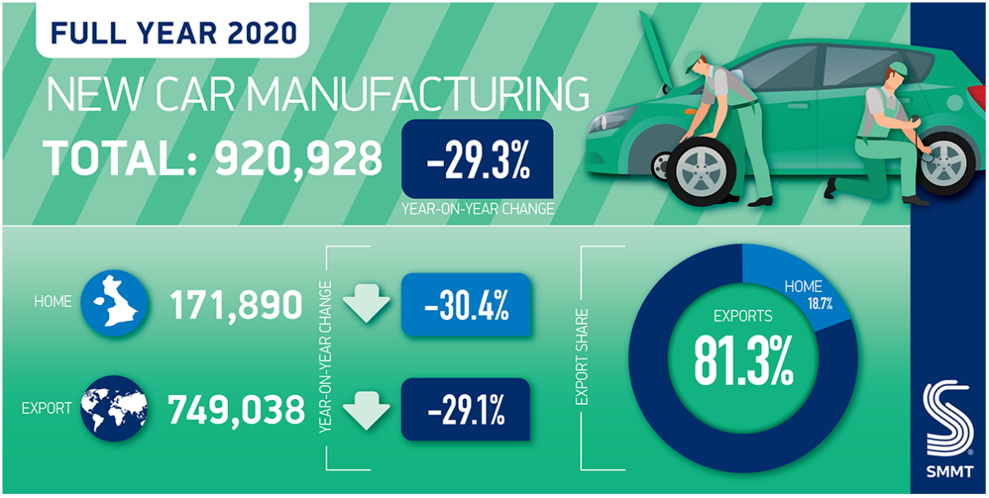
Figure 3: Production of vehicles in the UK in 2020
(Source: Smmt, 2021)
It can be seen from the above diagram that in the year 2020, the overall output or production of cars in the UK fell by the rate of 29.3% which implies a downfall of approximately 920,928 units which is the lowest recorded since the year 1984 (Smmt, 2021). Production or manufacturing of vehicles for the UK and also for the overseas market has seen a sharp decline by the rate of 30.4% and 29.1% respectively. It has also been reported that over eight vehicles out of the cars were held in the abroad market. Presently, it is believed that the production of cars will gradually increase and the automobile industry will recover from its losses depending upon the confidence and preference of the customers and new rules and regulations of the cross-channels.
In the year 2020, the production and manufacturing of British vehicles or cars have sharply declined yearly by the rate of 18.2% in the month of October because of the demand being affected by the various phases of lockdown and COVOID-19 pandemic (Businesstoday, 2020). According to the Society of Motor Manufacturers and Traders or SMMT, these numerical figures are considered bad for the automobile industry of the UK due to the impact of BREXIT, COVID-19, and the urge of shifting to the electrified cars or vehicles.
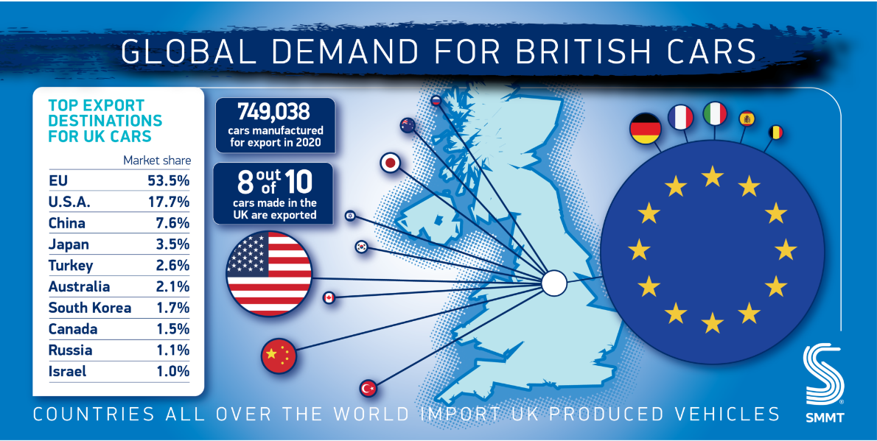
Figure 4: Demands of British Cars all over the world
(Source: Smmt, 2021)
The above diagram shows the demand for the various models of British cars all over the world. The COVID-19 pandemic has adversely affected this trading relationship which has adversely affected the outcome or revenue of the automobile industry. The UK’s trade has sharply declined with its key and primary export partners because of the tough and difficult conditions of the market during the pandemic situation. Shipment or export to the US, Australia, and Japan fell at the rate of 33.7%, 21.8%, and 21.6% respectively. This has caused an adverse effect on the growth and development of the automobile industry in the UK during the pandemic situation.
Survival and success factors of the automobile industry
The COVID-19 pandemic along with BREXIT has adversely affected the growth and economic condition of the automobile industry in the UK in the past years. The automobile industry is trying to implement and undertake certain strategies that would help them to overcome this miserable state. They are as follows:
- ‘Used’ will become the present ‘new’: The purchasing power of the customers has been badly affected due to the pandemic because around 7.6 million jobs which account for approximately 24% of the total workforce of the UK are facing risks due to the onset of pandemic and lockdowns (Mckinsey & Company, 2020). As a result, ‘used’ products or goods can be termed as the present ‘new’. Due to concerns regarding the security of jobs, financial instability, and limited purchasing power, the customers will opt more for the used vehicles than the newer ones (Dcadvisory, 2020). The automobile industry is sure to cut down or minimize its level of production due to shutting or closing down of factories and industries, logistics and import operations, and various facilities of production. The consumers chose to keep their existing vehicles and look for used vehicles for replacement.
- Shift to the online dealership: Many consumers have denied entering the physical market during the COVID-19 situation and even after the pandemic. Therefore, the automobile industry can implement and undertake the online dealership technique to improve and increase its sales. According to a survey, it has been observed that in the year 2019 around 81% of individuals research their products on various online platforms before purchasing (Saleslion, 2019). Presently, it is estimated that a car shopper approximately spends/nine hours researching their vehicle online before making their purchase (Dcadvisory, 2020). It has also been observed that around 63% millennials try avoiding the bulky traditional paperwork during making their purchase. Therefore, the automobile industry is trying to develop and enhance many e-commerce offerings. This will help the consumers to get better insights about their cars or vehicles sitting at their homes before making the purchase which will help the company to have a competitive advantage in this modern competitive business market.
- Shifting to recurring streams of revenue: Between the months of February and March in the year 2020, The majority of the stock index has fallen down by the rate of 40% thereby, affecting all the businesses and industries in the market (Mckinsey & Company, 2020). During the COVID-19 pandemic situation, many customers are hesitating to make a large investment and demand some sort of flexibility in the changing world. In this regard, various automobile companies are trying to offer short-term leases as one the alternatives to purchasing cars. This has helped the automobile industry to improve and enhance the flexibility of their customers thereby increasing their sales and profit.
- Focusing on higher margins and premium models: The automobile industry all over the world is trying to channel its energy into producing premium models of cars and earning higher margins of profit or turning towards whistles and bells of the mainstream models to cut down the demand for chip requirement (RSM, 2022). Problems like inflation in the price, blockage in the supply chain, and shipping problems have collectively contributed to the reason for a longer waiting period for many models. Due to these issues, many customers have changed their minds over the course of time and decided to cancel their purchases. This has also put a negative impact on the industry.

Conclusion
It can be seen from the above discussion that the COVID-19 pandemic situation has adversely affected the working of the automobile industry in the UK and all over the world. The pandemic has not only tended to cut down the purchasing intention of the customers but also the number of registrations of vehicles. Many factories have shut down and stopped their production in order to save the companies from facing extra losses. COVID-19 has affected the supply of chips, which are used in the manufacturing of cars and has also disrupted the internal trade relationship. The automobile industry is trying to implement certain policies in order to survive this situation of COVID-19. Policies like providing short-term leases, selling 'used' vehicles, implementing online dealership techniques or methods, and channelizing the energy in manufacturing premium models of cars to generate higher margins have helped the automobile industry to recover after the adverse effect of the pandemic.

Reference List
Armstrong, M., 2020. Covid-19 and the UK new car market [Online] Available at: https://www.statista.com/chart/21903/uk-new-car-registrations-yoy-comparison/ [Accessed on: 16th June 2022]
Auto.com, 2020. Coronavirus slashes UK car output as industry warns of big hit [Online] Available at: https://auto.economictimes.indiatimes.com/news/passenger-vehicle/cars/coronavirus-slashes-uk-car-output-as-industry-warns-of-big-hit/75462870 [Accessed on: 16th June 2022]
Bailey, D., 2022. Auto industry hit from Coronavirus could be even bigger than latest forecast [Online] Available at: https://www.birmingham.ac.uk/research/perspective/auto-industry-hit-from-coronavirus.aspx [Accessed on: 16th June 2022]
Businesstoday, 2020. COVID-19 impact: UK's car output slumps 18% in October [Online] Available at: https://www.businesstoday.in/auto/story/covid-19-impact-uk-car-output-slumps-18-in-october-279783-2020-11-26 [Accessed on: 16th June 2022]
Dcadvisory, 2020. Engine stalling? The impact of COVID-19 on the UK Automotive sector [Online] Available at: https://www.dcadvisory.com/news-deals-insights/insights/engine-stalling-the-impact-of-covid-19-on-the-uk-automotive-sector/#gref [Accessed on: 16th June 2022]
Ghazanfari, A., 2020. The impact of the Covid-19 pandemic and crude oil price crisis on the price of automobile fuels in European countries. Diverse Journal of Multidisciplinary Research, 2(6), pp.10-19.
Mckinsey & Company, 2020. COVID-19 in the United Kingdom: Assessing jobs at risk and the impact on people and places [Online] Available at: https://www.mckinsey.com/industries/public-and-social-sector/our-insights/covid-19-in-the-united-kingdom-assessing-jobs-at-risk-and-the-impact-on-people-and-places [Accessed on: 16th June 2022]
Mckinsey & Company, 2020. Moving forward: How COVID-19 will affect mobility in the United Kingdom [Online] Available at: https://www.mckinsey.com/industries/automotive-and-assembly/our-insights/moving-forward-how-covid-19-will-affect-mobility-in-the-united-kingdom [Accessed on: 16th June 2022]
Mckinsey & Company, 2020. Reimagining the auto industry’s future: It’s now or never [Online] Available at: https://www.mckinsey.com/industries/automotive-and-assembly/our-insights/reimagining-the-auto-industrys-future-its-now-or-never [Accessed on: 16th June 2022]
Pwc, 2022. UK automotive demand in the wake of COVID-19 [Online] Available at: https://www.pwc.co.uk/industries/automotive/insights/uk-automotive-demand-in-the-wake-of-covid-19.html [Accessed on: 16th June 2022]
RSM, 2022. The Road to Recovery: How the automotive industry can come back from COVID-19 [Online] Available at: https://www.rsm.global/insights/finding-opportunity-change/road-recovery-how-automotive-industry-can-come-back-covid-19 [Accessed on: 16th June 2022]
Saleslion, 2019. How Much Research Do You Do Online Before Buying? [Online] Available at: https://saleslion.io/ecommerce-statistics/81-of-shoppers-research-their-product-online-before-purchasing/ [Accessed on: 16th June 2022]
Smmt, 2020. UK Automotive [Online] Available at: https://www.smmt.co.uk/industry-topics/uk-automotive/#:~:text=More%20than%2030%20manufacturers%20build,in%20the%20UK%20in%202021. [Accessed on: 16th June 2022]
Smmt, 2021. UK car production down -29.3% as coronavirus slams brakes on sector [Online] Available at: https://www.smmt.co.uk/2021/01/uk-car-production-down-29-3-as-coronavirus-slams-brakes-on-sector/ [Accessed on: 16th June 2022]
Wu, X., Zhang, C. and Du, W., 2021, July. An analysis on the crisis of “chips shortage” in automobile industry——Based on the double influence of COVID-19 and trade friction. In Journal of Physics: Conference Series (Vol. 1971, No. 1, p. 012100). IOP Publishing.

