Effective Team Work and Communication



Name: Costel-Alexandru Crap
Student ID: 2132995
Lecturer: Saqib Shamim
Date Submission: 03.01.2023

Contents
Introduction 1
Models of Communication 2
1. The communication model of Shannon and Weaver 2
2. Communications Model of Wilbur Schramm 3
3. Communication model of Berlo 3
Communication skills 4
Verbal communication skill 5
Nonverbal Communication skill 5
Active Listening skill 6
Advantages and Disadvantages of Communication Technology 6
Advantage 6
Disadvantage 7
Conclusion 7
Reference 8

Figures
Figure 1: The communication model of Shannon and Weaver 2
Figure 2: Communications Model of Wilbur Schramm 3
Figure 3: Communication model of Berlo 4

Introduction
In every sphere of life communication skills comes into play and one who possesses excellent communication skill finds himself ahead of others. Communication skill is also necessary for learning other skill. Effective communication requires every element of communication to work properly. In this writing, three models of communication are discussed with examples. Types of communication skills such as verbal communication skills, non-verbal communication skills, and active listening skills are also discussed here. At last, the advantage and disadvantage of communication technology in students learning experience is provided along with a brief explanation.

Models of Communication

1. The communication model of Shannon and Weaver
The model of Shannon and Weaver regarding communication explains how effective communication takes place. They came up with a factor namely noise which significantly affects the effectiveness of communication (Al-Fedaghi, 2012). This model has numerous communication elements such as sender, encoder, channel, decoder, and receiver. The model explains that successful communication depends on the proper working of each of these elements along with the proper selection of communication channels.
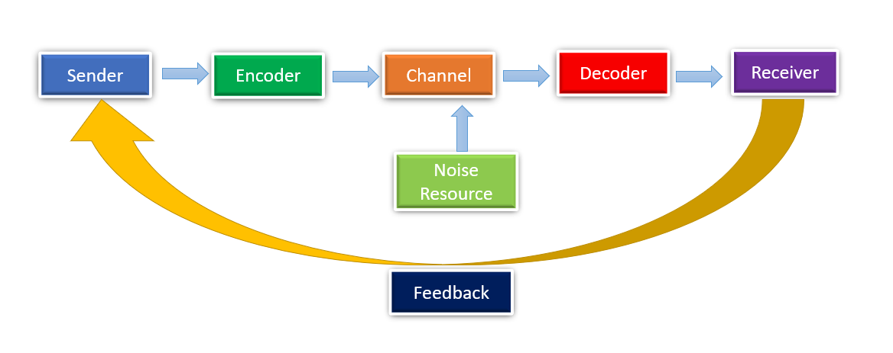
Figure 1: The communication model of Shannon and Weaver (Al-Fedaghi, 2012)
This model can be better understood with the help of an example. For example, in a workplace, a guest lecturer on blockchain technology was invited to explain his valuable insights. When he started to deliver his speech employees got confused because of his strong accent. Failing to understand his lecture employees lost motivation to concentrate and the lecturer started to talk in English. But, the situation got worsened and nobody could understand his actual message.
Here, the lecturer is the sender from whom the message was being delivered. The Channel of communication was air, the receivers were the staff and the decoder was their brain while noise was the lecturer's accent which interrupt the whole communication. The feedback was the staff’s reaction that they understand the speaker has great knowledge but they were unable to understand (Al-Fedaghi, 2012). This whole communication situation could have been improved through the use of an interpreter and the aim of communication could have been achieved then.

2. Communications Model of Wilbur Schramm
Wilbur Schramm, the famous communication theorist suggests in his model that effective communication needs three elements. These elements are the source of the message, the message, and the destination. He claimed that communication always takes a two-way process where two-way sharing and receiving of messages takes place (Schramm, 2015). Both the sender and receiver get there to receive and send messages. The importance of coding of words is given vital exposure as information can get distorted and misunderstood if proper wording is not ensured (McAnany, 2014). Above all, this model explains the classical approach of communication that takes place when two people get involved in communication to share their opinion, ideas, and thoughts.
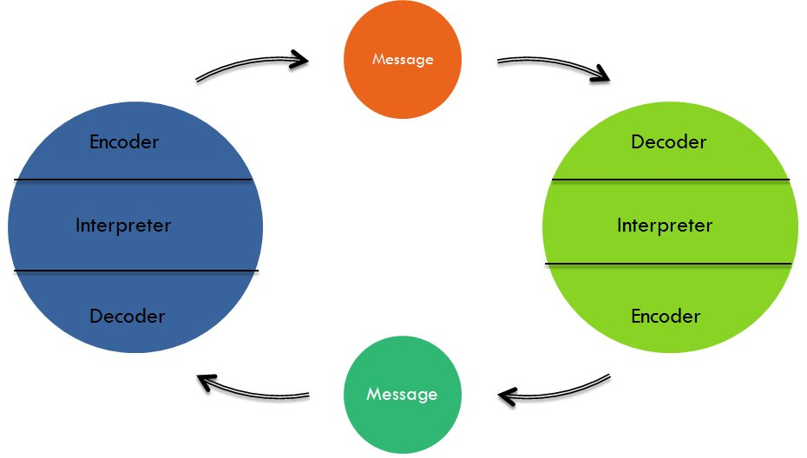
Figure 2: Communications Model of Wilbur Schramm (Schramm, 2015)
For example, when in the workplace a manager asks his subordinate to complete a task within a certain deadline. In reply, the employee asked to increase the deadline of work to ensure quality work and the manager grant it.
In this scenario, in the first place manager was the sender and encoder of the message while the employee was working as the receiver and decoder. But when an employee asked to increase the deadline he became the source of the message who encoded his words for the receiver and decoder manager (Schramm, 2015). Here, two-way communication has happened where both the parties became sender and receiver by turns in the whole communication scenario.

3. Communication model of Berlo
David Berlo came up with this model of communication in the 60s which is also known as the SMCR model. The key component of this model is the sender, message, channel, and receiver. This model became popular as various surrounding factors rated to communication are also considered under this mode (van Dalen, 2013). The emotional aspect is given vital weight as an important part of the whole communication case. According to this model David Berlo, communication gets influenced by both the sender's and receiver’s communication skills, attitudes, culture, knowledge, and also by social structure. The message’s effectiveness depends on the message's structure, content, elements, treatment, and by code used in the message (Bambaeeroo, 2017). Berlo also states that along with media communication channels get affected by several non-verbal acts such as hearing, seeing, touching, smelling, and testing.

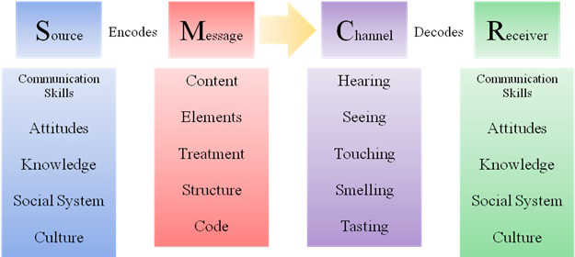
Figure 3: Communication model of Berlo (van Dalen, 2013)
For example, when an employee is asked to prepare a feedback report on his subordinates’ work performance, his recent experience with those subordinates will influence his wording and figures on that report. His attitude towards fellow workers will actively shape his feedback report towards a positive or negative end.

Communication skills
communication means sharing of information to express one's opinions, thoughts, and messages to others. Communication skill is a must as an everyday human being has to communicate with a diverse group of people through different channels. If one fails to make others understand own messages situation can get complicated and frustration may result. In everyday life human being encounters various events and engage in different forms of communication. When thinking about communication a common notion comes into mind which is verbal communication (van Dalen, 2013). But, non-verbal communication is equally important for affecting communication success. In the following section, various aspects of verbal communication, non-verbal communication along with active listening are discussed.

Verbal communication skill
Verbal communication comprises both oral and written formats of communication. A common mistake by many people happens when they think of verbal communication only as oral communication excluding the written part. However, verbal communication is all about how people select words and use those to communicate and how those words are being listened to or interpreted. In the case of verbal activity depending on the aim of communication words are chosen and used in speech. While speaking choosing of correct words matters a lot. The way of talking and reinforcing non-verbal communication signs also matter equally.
Selecting the right word is important because not every word has the same meaning that goes with every situation. For example, the words people use with colleagues are far different from words that one uses in a formal conference. Choosing words is crucial for written communication. As there may be no in-person contact to explain further any understanding can lead to a greater crisis. Clear, brief, simple words using on-point writing can decrease the possibility of miscommunication here.

Nonverbal Communication skill
Nonverbal communication depends on human body language. What signs people give with their gestures, posture, and touch are the common factors here. Facial expression and gesture is the core element upon which most nonverbal communication gets interpreted (Wahyuni, 2018). Improper body language can provide a negative message if one cannot control own transition and movement of body parts. Controlling and knowing how to act is crucial here as the wrong message can be noted by the receiver if misunderstood. Some important non-verbal ways of communication are:
- Gesture: some of the common gesture that is included every day is pointing, waving, and showing thumbs up. Gestures differ according to culture to the culture which is why giving them greater consideration is required. For example, showing an ‘ok’ sign is acceptable for English-speaking countries but it is taken the offensive in Russia and Germany.
- Facial expression: Facial expression tells a lot in a small amount of time which people see first even before hearing actual words. Facial expression is universal as the facial expression of fear, anger, happiness, and sadness looks alike around the world.
- Eye contact: the way of looking and maintaining eye contact usually express interest, affection, boredom, and many other messages that are vital for complete understanding and communication.
- Voice: the tone of one's voice express a lot about the importance of the message and other aspects as well. Timing, pace, loudness all these things are read by listeners along with words to comprehend exact messages.

Active Listening skill
To excel in academic and professional life active listening is essential. Through practicing active listening one can develop own productivity, and a feeling of trust and can create strong networking (Robertson, 2015). Active listening can be difficult in today’s digital setting as interruption of devices and distraction has become a common phenomenon. To become successful active listening is required as it makes other people feel valued and help in avoiding negative impression which can hamper one's career. Ways of active listening and creating better engagement include,
Developing connection
To develop a conversation finding common interest is necessary and to find common interest at the start of a conversation listening for a few minutes with the highest concentration is a must.
Mirroring
It involves repeating words in the head to ensure accurate understanding (Robertson, 2015). One can ask questions and make things clear if found gaps of understanding while repeating.
Asking question
By asking questions one can clear all confusion and may come to know more details if the speaker feels it necessary. Moreover, to ask a question one has to try to understand first by actively listening.

Advantages and Disadvantages of Communication Technology
Communications technology has its blessing for students in many ways such as in terms of cost, effectiveness, convenience, and easy access. But the downsides are also there. Some prominent advantages and disadvantages of these techniques on students’ learning are demonstrated here.

Advantage

- Cost effective: Technology devices such as smartphones, tabs, computers, and VR devices are a cost-effective solution for students learning (Weger et. al., 2014). The facilities and services that are provided by these technologies are huge compared to the cost incurred.
- Easy access: Students can access the collection of different online libraries with an internet connection easily (Mikre, 2011). Time and geographic restrictions are no more hindering learning opportunities now.
- Remote learning: In the Covid-19 pandemic, the advantage of remote learning through communication technologies has proved how helpful these technologies are.
- Better engagement: Technologies in the classroom create better engagement and collaboration as learning procedures can be made interesting with the help of technologies.

Disadvantage
- Distraction: The most prominent disadvantage of communication technologies for students learning journey is a distraction. Social media and gaming create most of the distractions when a student tries to concentrate on studying (Weger et. al., 2014). Interesting and attractive deals and notifications drive students towards mobile phone scrolling and losing track of time.
- Health hazard: prolonged staring at a screen for learning purposes can cause irritation and problem in the eyes. Improper settings can rise the problem of ergonomics also.
- Privacy issue: With technology threat of privacy evolves for every involved party.
- Misguiding source: Not every piece of information on the internet can be trusted (Weger et. al., 2014). Some students face hardship in differentiating between authentic and fake sources of information.

Conclusion
Communication is affected by various factors which can be realized after analyzing discussed three theories of communication. Mostly, the sender's wording, channel, and receiver’s decoding ability decide the effectiveness of communication. The communication skills of both sender and receiver are prominent factors for successful communication. To get improved communication one should concentrate on non-verbal language carefully as it is a tricky aspect of communication. Students can improve their learning abilities by choosing communications technologies and planning the usage of technologies according to the concept of studies and requirements.

Reference

Al-Fedaghi, S., 2012. A conceptual foundation for the Shannon-Weaver model of communication. International journal of soft computing, 7(1), pp.12-19.
Bambaeeroo, F. and Shokrpour, N., 2017. The impact of the teachers’ non-verbal communication on success in teaching. Journal of advances in medical education & professionalism, 5(2), p.51.
McAnany, E.G., 2014. Wilbur Schramm: Beginnings of the" communication" field. Communication Research Trends, 33(4), pp.3-16.
Mikre, F., 2011. The roles of information communication technologies in education: Review article with emphasis to the computer and internet. Ethiopian Journal of Education and Sciences, 6(2), pp.109-126.
Robertson, K., 2015. Active listening: more than just paying attention. Australian family physician, 34(12).
Schramm, W., 2015. 2. Communication Development and the Development Process. In Communications and Political Development.(SPD-1) (pp. 30-57). Princeton University Press.
van Dalen, J., 2013. Communication skills in context: trends and perspectives. Patient education and counseling, 92(3), pp.292-295.
Wahyuni, A., 2018, January. The power of verbal and nonverbal communication in learning. In 1st International Conference on Intellectuals' Global Responsibility (ICIGR 2017) (pp. 80-83). Atlantis Press.
Weger Jr, H., Castle Bell, G., Minei, E.M. and Robinson, M.C., 2014. The relative effectiveness of active listening in initial interactions. International Journal of Listening, 28(1), pp.13-31.

