Material Science and Building Services

Lighting Layout and Sound Index calculation

Steffan Dancey
2014079

Task A
A production area in a factory measures 60 metres x 24 metres x 8 metres in height.
The factory’s work benches are set at a height of 1m above the floor level. 3
The area’s reflectance’s are 0.3 for the ceiling and 0.5 for the walls.
The Lighting design specifies Fluorescent lamps in recessed louvre with DLOR of 50%.
(The actual size for the luminaires is 1200mm (1.2m) in length and 200mm (0.2m) wide.)
A Lighting Design Lumen (LDL) output of 18,000 lumens is required.
The illumination required for the factory area is 200 lux at the working plane.
Light Loss Factor = 0.75
1. Calculate:
1) The Room Index
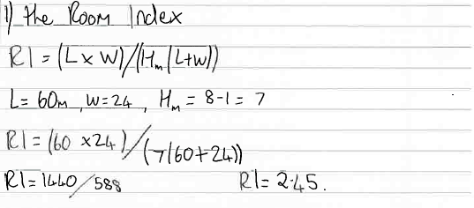

2) The Utilisation Factor (from tables), explaining exactly how this value was arrived at.
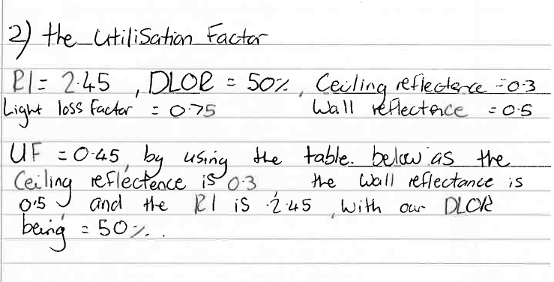
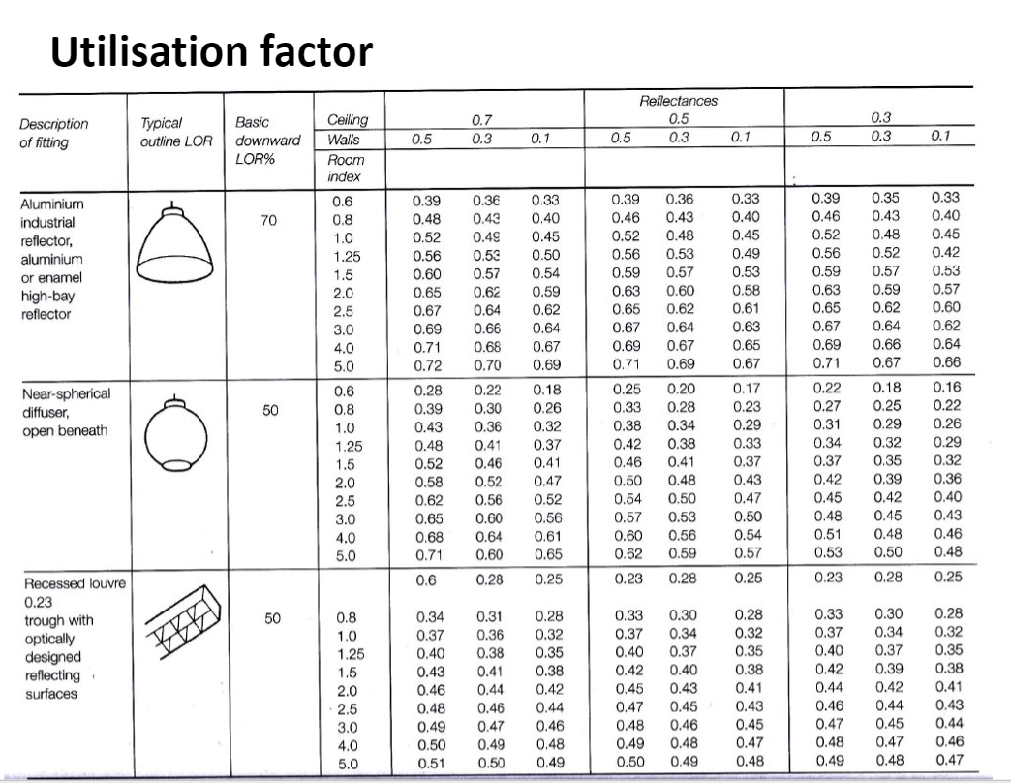

3) The Number of lamps required
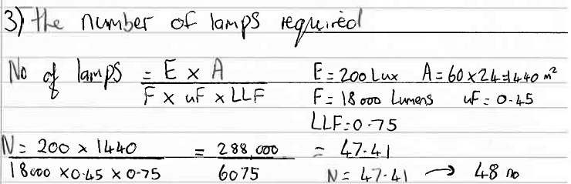

4) A suitable layout (value of S) for the lamp fittings
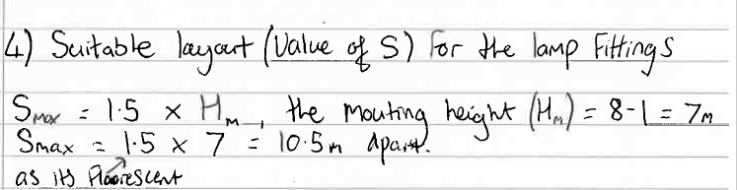
Therefore Smax = 10.5

2. Draw the plan layout on a scale drawing of the factory floor indicating
Your ‘best fit’ design for the luminaire installation.
Points on the row layout should indicate the position of the lamp centres.

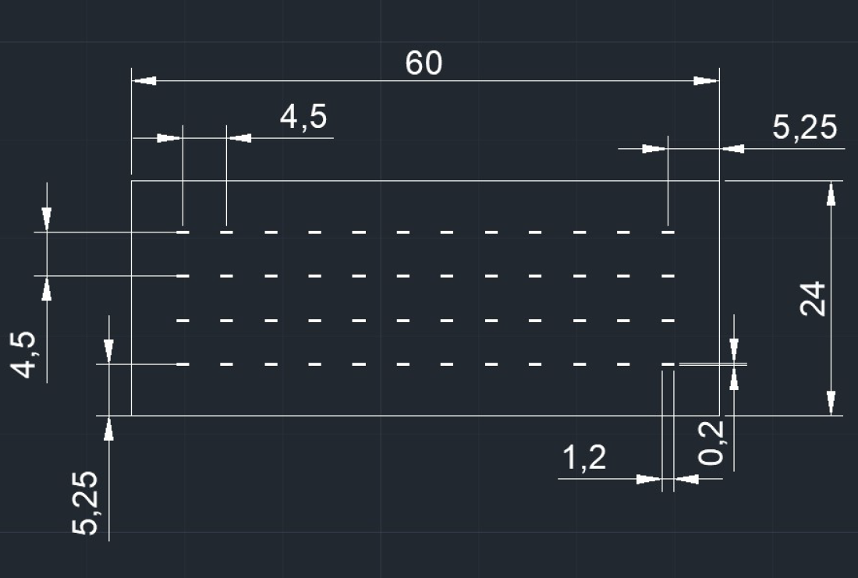

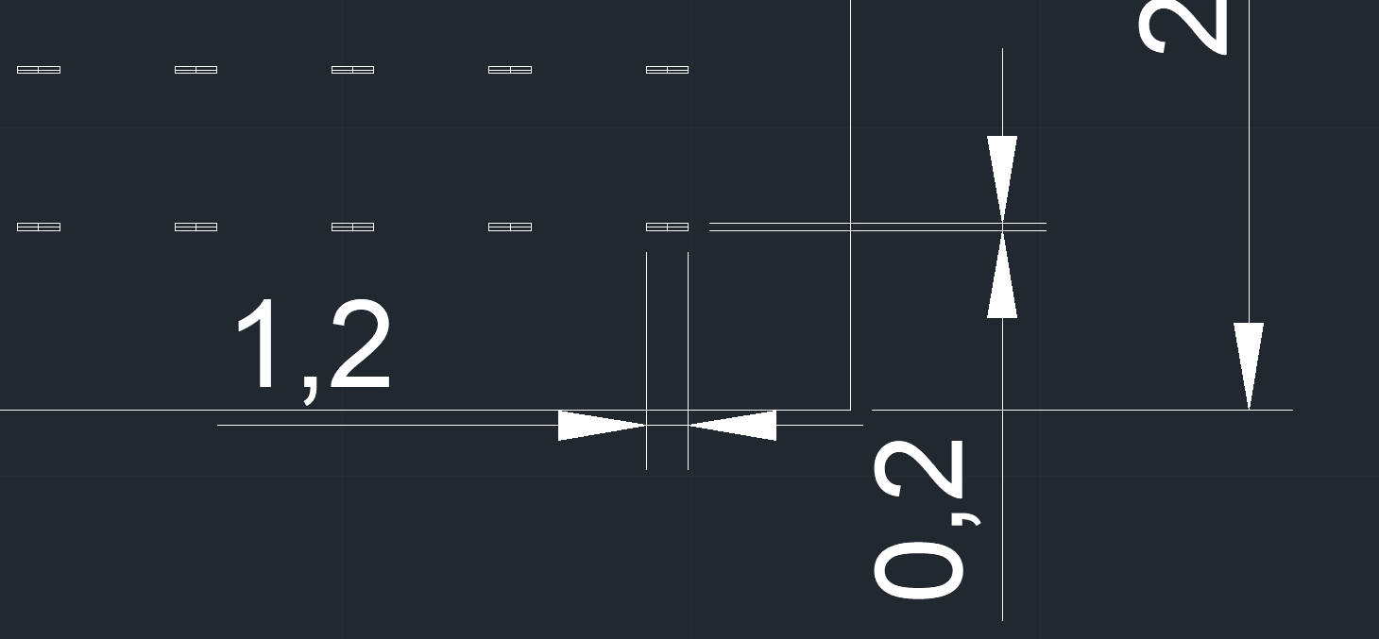

Unit of measure in Meters
Task B
- A brick wall of area 20m2 contains a window of area 4m2.
The values of sound reduction indexes are:
50dB for the brickwork and 10dB for the window.
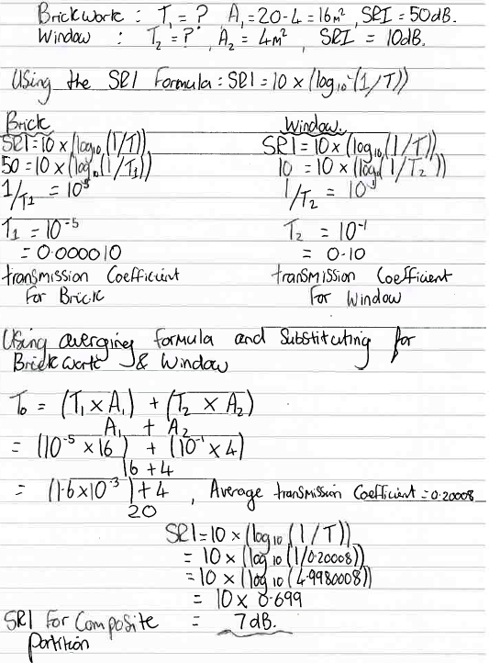
Calculate the overall sound reduction index for the entire wall.
Include the full arithmetic development of your answer.

- Discuss the implications of the factors of frequency and wavelength in:
1). Internal sound management
To successfully manage sound internally, attention should be made to the factors of frequencies and wavelengths as lower frequencies are well transmitted but poorly absorbed, where higher frequencies are well absorbed and poorly transmitted.
To maintain acoustic quality internally, ceiling heights and suspending ceiling reflectors can be installed, these measures help eliminate echoes. An echo is defined as a reflection that arrives 0.3 seconds after the direct sound, it can also be defined as a wave reflected with a path length that is at least 17meters longer than of the direct wave.
Type of reflectors are subjective and are down to the intended use. Concave shaped reflectors tend to focus on quality of sound where a convex shaped reflector tends to focus on spreading the sound. There are also plane reflectors, these are often adjustable and suspended over stages to produce an early reflection of sound into the area of audience. The reflected sound must not be delayed and reflected equally across the whole area of audience.
Sound absorption is also required for the acoustic quality, sound absorption is the reduction in the sound energy after reflecting from a surface. At a given point in a room it’s understood the effect of absorption by measuring the sound pressure level caused by steady sound power source. Instead of rising as increasing number of reflections arriving at the measuring position, the sound level then quickly stabilises. At that point, the rate of sound energy input is exactly compensated by the rate where the energy is absorbed by the surfaces in the room.
In sound absorption there are 3 main types of absorbers, the first being cavity absorber. This is for specific frequencies and are enclosures of air with one small opening, this small opening acts as an absorber of air when the opening is made to vibrate, and the drag of the air gets rid of energy from the sound waves. The second type of absorber is the panel absorber, these absorbers are used for lower frequencies approximately 40Hz to 400Hz. They’re constructed as continual sheets with air space behind, the panel absorbs the sound energy by converting them to mechanical vibrations in the panel. These then loose energy as friction in the panel. The final method of absorption is the porous absorber, this method is most effective for frequencies over 1KHz. Porous absorbers are made from materials with cellular network of interlocking pores, these pores transfer sound energy into heat.
In areas where high structure borne energy is present structural materials such as wood, steel, concrete, and masonry are susceptible. To convert the sound energy into heat and create mechanical resistance, damping materials are required. An example of this would be cork, mainly due to its cellular structure and higher loss factor than a rubber alternative, this is crucial for dampening.

2). Partition wall construction technique
A partition walls construction technique will vary according to its requirements. Different mediums provide absorption, for example insulation. Insulation is a solid material with air pockets, this is the reason insulation performs so well in heat and sound absorption.
Please see below Noise Reduction Coefficient table:
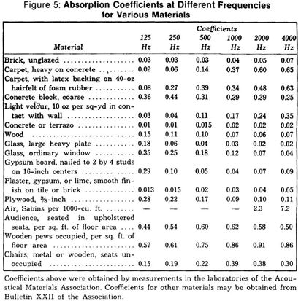
Sound absorption, Sound proofing, Chart, Website title: Pinterest, URL:https://www.pinterest.co.uk/pin/526991593889880799/, accessed 10/04/2021.
The table above is used to calculate abilities of sound absorption of commonly used materials. In the table it will be evident that smooth, hard, heavy, and dense materials will have strong reflective power but do not absorb sounds well. Materials that are soft and porous with pores are better sound absorbers, but do not reflect sounds well, foam and wood wool boards would be an example of good sound absorbers.
As sound waves hit a surface of a material, some of the energy is absorbed through the material, part of the material is reflected, and the remainder of the energy is shifted into the material.
As lower frequencies are poorly absorbed, partition wall construction techniques are amended to suit. A suitable partition wall in this instance is likely to include soft and porous materials, these can then absorb the frequencies and reduce the reflection of sound.
Please see above an image of a partition wall constructed of porous materials.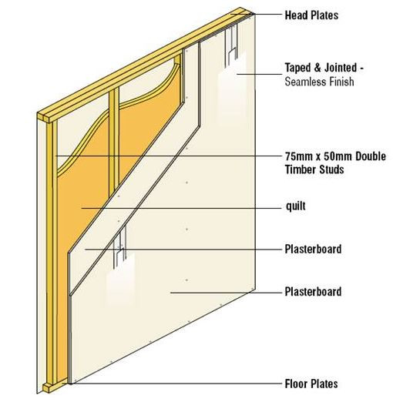
Azukotech.com, URL: https://www.azukotech.com/post/2020/02/12/sound-insulation-of-buildings, accessed 15/04/2021

3). The Insulation material choice.
When addressing the issues associated with lower frequencies, Lower frequency noises will be most noticeable of the two as it needs to move a large amount of air which causes large wave forms. This produces an increased amount of sound energy leading to penetration through many different materials.
The table below shows the different insulation types and noise treatment:

Acoustix, URL: https://www.akoustix.co.uk/blogs/noisy-neighbours/what-is-the-best-soundproofing-material, accessed 19/04/2021.
The choice of insulation material is very important to consider with frequency and wavelength. A good choice of insulation will have to be dense; as it then offers better insulation, as sound waves are effectively vibrations a heavier insulation will be less likely to be vibrated. It is also very important that structures are airtight and there is not any air gap that allows air to pass, air gaps will compromise insulation and allow sound vibrations to pass. Materials such as Rock fibre slab, Plasterboard, and Mineral wool are suitable for airborne noise applications, as they have the density required. In structure borne noise, the noise energy is transferred through the building rather than the air. The energy travels through solid materials such as concrete and steel but can be greatly reduces through using materials such as chip foam and PUR Foam, these materials are softer and absorb more energy.

