Coexistent Perspectives (ADAA7000)

The Politic of Desire
How designers make an approach to cope with nihilism

MA Visual Communication: Yuxi Chen
Submission Date: 14th December 2023

Abstract
This essay explores the role of design in addressing the increasingly serious issues of nihilistic society, particularly in consumer driven culture. It emphasizes the impact of capitalism and digital information overload, discussing how these factors lead to uncertainty in survival and hinder the formation of individual values. It also shows the integration of mindfulness and therapeutic techniques in design, the concept of "slow design" for sustainable consumption, and the role of graphic design in narrating the journey from nihilism to mindfulness. At the same time, this essay provides examples and explores the unique methods of designers such as Alexander McQueen and the creators of the game Sword Zen in combating nihilism. McQueen's fashion "nihilism" series challenges traditional clothing roles, promotes profound reflection on the meaning of life, and resonates with emotional construction and mutual inductance theory. In contrast, Sword Zen provides a meditation gaming experience that focuses on mindfulness and controlling breathing, in line with the principles of managing attention and time. Finally, it emphasizes the important role of designers, which not only enhances people's understanding of complex problem like nihilism, but also provides solutions beyond aesthetic boundaries for social commentary and personal growth.

Introduction
In a world increasingly influenced by desire politics and capitalism, the role of design in addressing social challenges, especially nihilism, has never been so crucial. With the unremitting efforts of capitalism to increase people's desires and attract them into an endless cycle of consumption, this has had a profound impact on collective psychology. (Barnet & Bossio, 2020) The constantly emerging fragmented information aims to capture and sell people's attention, spreading the idea that happiness is linked to material wealth, leading to persistent dissatisfaction and ultimately leading to the abyss of nihilism (Lembke, 2021, p.93). This shift towards consumerism in society and the resulting nihilism are being studied by experts in various fields such as psychology, sociology, biology, and philosophy. Each discipline provides unique insights into how material pursuit affects human psychology and its impact on society. However, in the field of design, a particularly transformative approach is being implemented. Designers are playing an increasingly important role in people's daily lives, not only influencing trends and aesthetics, but also solving urgent social problems like nihilism. Designers possess unique abilities to integrate and bridge discoveries from different fields, utilizing their craftsmanship to make complex concepts easier to understand and relate to. Through their work, they can uncover and address the concept of nihilism. By visually presenting the essence of this philosophical stance, designers have created avenues for awakening and understanding, enabling individuals to face and deal with nihilistic ideas.

Alexander McQueen's "Nihilism" series clothe design and game "Sword Zen" are exemplary examples of designing solutions to this serious problem. McQueen's collection, as part of his 1994 spring/summer collection, strongly embodies the concept of nihilism in fashion. His works challenge the traditional function of clothing and thus prompt the audience to engage in in-depth, personal reflection, contemplation of the meaning and purpose of life, echoing Lisa Feldman Barrett's theory in How Emotions Are Made that coping with interoception needs to concretize the concept first to help comprehension (Barrett, 2018, p.92). McQueen's design not only stimulates the audience's instinctive reactions, but also resonates with existentialist philosophy, which believes that action defines the essence of the individual. By transforming clothing into a medium for expressing nihilism, McQueen demonstrated that even in a world deemed meaningless, creative action can give new meaning and value. Meanwhile, "Sword Zen" represents a unique method in the gaming world. Unlike traditional number games that often lead to addiction and accompanying mental health issues, Sword Zen is designed as a meditative Zen experience. It directly addresses the challenges of the modern digital environment, which is characterized by immediate satisfaction and sustained stimulus flow. The game mechanism revolves around controlling breathing and mindfulness, providing a way to escape from external interference. This method is consistent with the principles discussed by Nir Eyal (2019) in Indistractable , emphasizing the importance of managing time and attention to overcome distractions. Sword Zen has promoted the development of mental health and mindfulness, building a bridge between the digital world and the real world, and helping players transfer the skills and mentality cultivated in the game to their daily lives.

McQueen's fashion design and Sword Zen's approach to dealing with nihilism highlight the diversity and influence of design in solving social problems. McQueen uses shock strategies and challenges social norms to stimulate thinking and discussion, while Sword Zen provides practical tools for personal development and mental health. Although these two media have different methods, they both aim to promote individuals to have a deeper understanding of themselves and the world. McQueen's works transcend the boundaries of traditional fashion design and enter the realm of conceptual art. He invites individuals to reflect on their existence and the structure around them, encouraging them to break free from conventions and seek personal meaning and authenticity. In contrast, Sword Zen extends the concept of mindfulness from gaming to real-world applications, helping players build resistance against distractions and stress in their daily lives. This approach of combining gaming with therapeutic practice marks the arrival of a new era of digital entertainment, with mental health becoming a core concern.

Lee McQueen's "Nihilism" series and game "Sword Zen" showcase the important role of designers in addressing the social issue of nihilism. They not only increased their understanding of the problem through their respective media, but also provided solutions. McQueen's fashion challenges the audience's sense of unease and lack of meaning in communication, while Sword Zen provides a way to practice mindfulness and psychological balance. These creative efforts demonstrate that design can transcend aesthetic boundaries and become a powerful tool for social commentary and personal growth. As society continues to cope with the complexity of modern life and the general sense of nothingness, the contributions of designers like McQueen and the creator of Sword Zen have become increasingly important, providing new perspectives and solutions for a more serious and fulfilling life.

Theoretical perspective
As a growing social issue, nihilism reflects people's struggle to find meaning in the tide of desire politics and digital information. This state of uncertainty, fueled by constantly conflicting data and opinions, challenges individuals' ability to form personal values and leads them towards nihilistic despair (Postman, 2010, p.98). In the modern digital age, the constant proliferation of information is often contradictory or overwhelming, leading to uncertainty in survival. In the Netflix documentary Social Dilemma (2020), individuals face a bombardment of news, opinions, and data from countless sources. This influx is driven by the demand for eye-catching and stimulating content in advertising, which leads to an increase in user engagement with advertising. Application developers have utilized advances in neuroscience and social sciences to design mechanisms that promote addiction to these applications. Therefore, people's attention is attracted, making it difficult for them to distinguish truly useful information. This leads to an information cocoon, where individuals can only see what they want, limiting their ability to form a broad and objective view of reality (Clear, 2018, p.121). The rise of artificial intelligence tools has further exacerbated this trend. In such an environment, personal efforts to establish personal values may lead to nihilistic despair and the inability to find a meaningful direction in life.

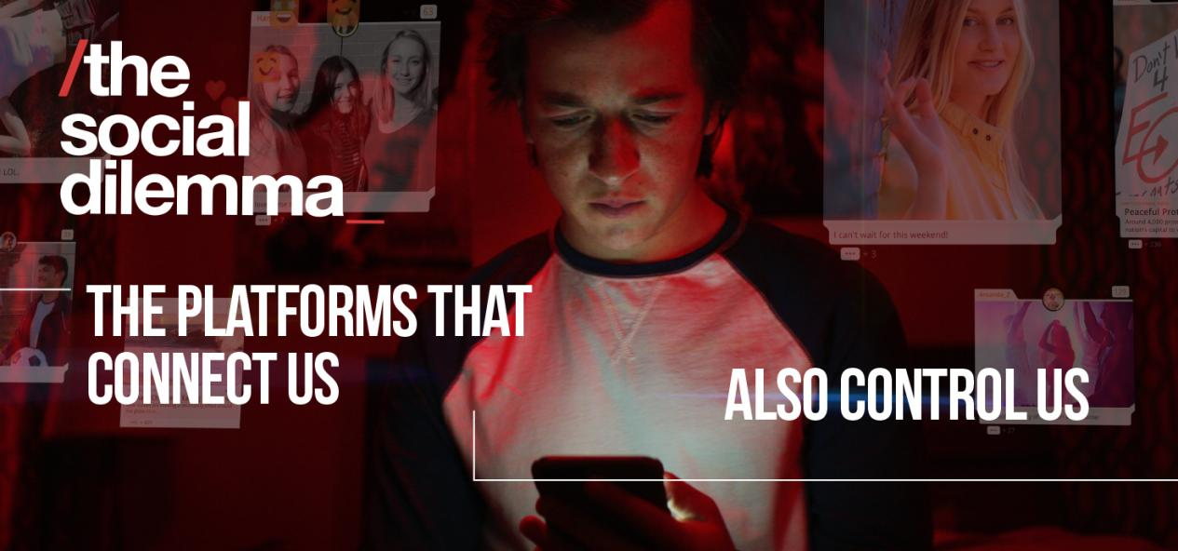1. User gets addicted to social media from Social Dilemma

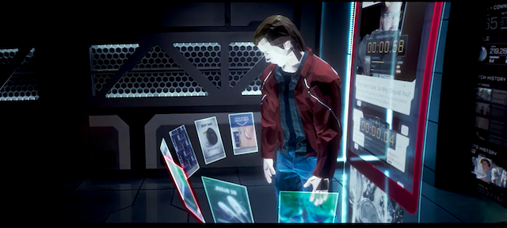
2. Scene of user trapped with digital flow from Social Media

In Dalai Lama’s book The Art of Happiness (1999), he points out that happiness is basically funding on the contentment of current situation, and people confuse the happiness with pleasure, always looking for something new to satisfy their desire instead of coexist and balance for it. The focus on individualism and personal achievement further exacerbates this issue, as modern society increasingly measures success through material wealth and reputation. As a result, people lose their perspective on real needs and confuse happiness with fleeting pleasure. When these pursuits prove unsatisfying, they fall into the trap of nihilism. Nihilism, as a manifestation of the mismatch between the mind and body, thoughts and actions, significantly leads to mental health problems such as depression and anxiety. Designers recognize their influence and use visual metaphors to enhance people's understanding of consumer driven nihilism and the political influence of desire. By helping people recognize their current situation, designers provide individuals with ways to solve and solve potential problems. The concept of "time management as pain management" (Eyal, 2019, p.38) is consistent with this method, indicating that understanding and managing discomfort is the key to overcoming distractions and instant gratification temptations.

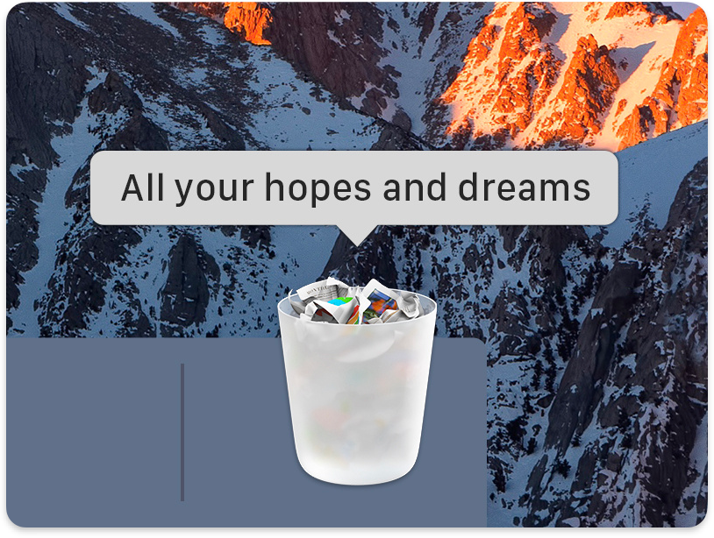
3. A meme repersents nihilism

The designer is currently collaborating with meditation experts to use graphic design to express mindfulness, making it easier to understand. The mindful meditation app design, Headspace, emphasizes mindfulness, integrating therapeutic and meditation techniques, shifting attention from external stimuli to internal psychological states (Jones, 2021). This method encourages users to engage in self reflection and awareness, and to understand their psychological state through a more subjective perspective. A mindfulness application designed to promote regular practice, with reminders, rewards, and interactive features, promotes mindfulness habits as an antidote to nihilism, guiding users towards a more positive and meaningful lifestyle. As designers continue to explore and express the social issues of nihilism, the trend of mindfulness design is growing day by day. This not only enhances the understanding of the problem, but also provides practical solutions for individuals to integrate mindfulness into their daily lives, guiding them away from nihilistic mentality and towards a more positive and fulfilling existence. In this regard, the role of design is not only to create beautiful products, but also to create experiences that resonate with individuals at a deeper psychological level, providing them with tools to cope with the complexity of modern life and find true satisfaction and purpose (Hermann, 2023). This shift in design philosophy is not just a trend, but a necessary response to the intensifying mental health crisis in the digital age. Designers are increasingly aware of their responsibility to make positive contributions to social welfare. By creating experiences that encourage mindfulness and existence, they provide narratives that are contrary to the consumerist culture that dominates the modern world. This approach goes beyond traditional design paradigms, integrating insights from psychology, neuroscience, and even philosophy to create solutions while also focusing on the mind and spirit.

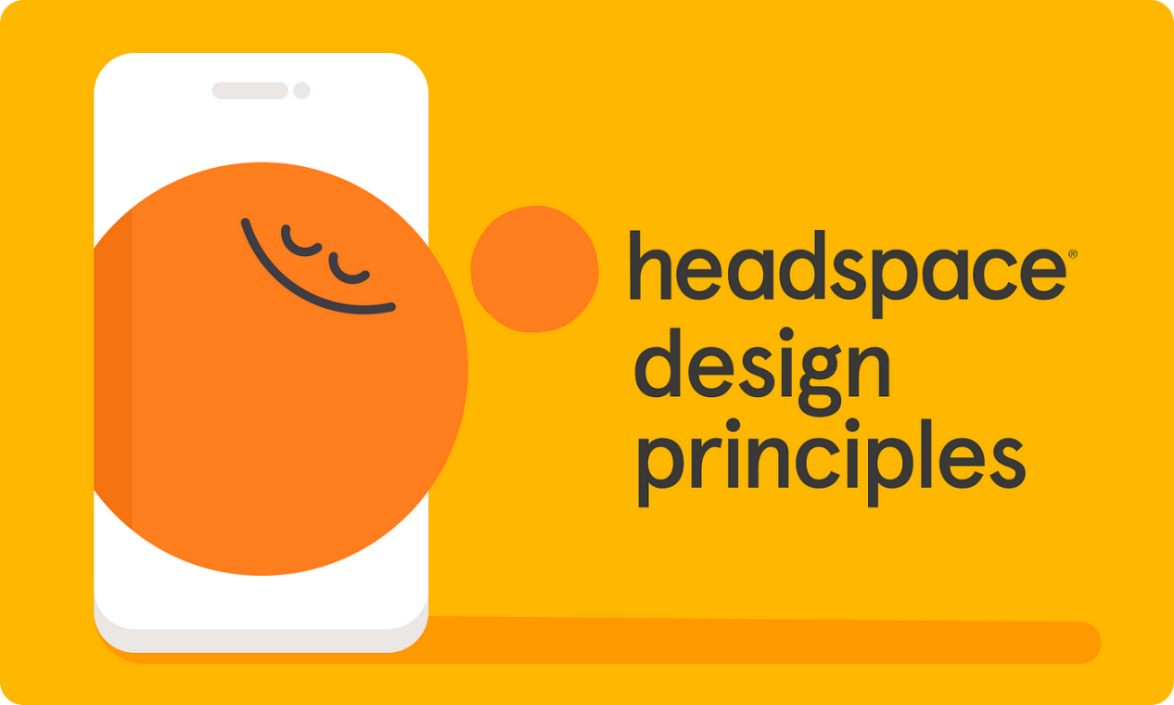

4. APP user interface of Headspace

The intersection of design with mindfulness and mental health has led to innovative methods in various fields. For example, in architecture and interior design, spaces are being created that promote calmness and reflection, with natural elements and a serene aesthetic. In the field of digital design, the applications and platforms being developed are not only for entertainment or productivity, but also to promote mental health, providing guidance for meditation, mindfulness exercises, and emotional regulation tools. In addition, designers are embracing the concept of "slow design" and encouraging more thoughtful and sustainable consumption methods. This philosophy is consistent with the struggle against nihilism, emphasizing long-term, sustainable, and meaningful value rather than the temporary satisfaction brought by quick purchases (Tolle, 2001, p.164). Slow design encourages consumers to invest in products with lasting value, both functionally and emotionally, promoting deeper connections between users and items. In the field of graphic design, the complexity of mental health and well-being is being conveyed through visual narrative. These narratives typically use metaphors and symbols to depict the journey from nihilism to mindfulness, making abstract concepts more concrete and relevant. Through these visual stories, designers can stimulate dialogue about mental health, reduce stigma, and encourage individuals to seek support and participate in self-care practices.

In short, the role of design in combating nihilism and cultivating mindfulness is becoming increasingly important in our fast-paced, digital driven world. Designers stand at the forefront of creating not only pleasing sensory experiences, but also nourishing soul experiences. By focusing on mindfulness, sustainability, and emotional health, designers not only shape the physical world around us; They are still shaping our life experiences, helping us find meaning and happiness in a world that often feels overwhelming and lacks purpose. As we move forward, the integration of design with psychology, technology, and philosophy will continue to provide individuals with new paths to cope with the complexity of modern life, find balance and satisfaction.

Nihilism, Alexander McQueen S/S 1994
Nihilism: "Life is without objective meaning, purpose, or intrinsic value."

Alexander McQueen (1969-2010), known as Lee by his family and friends, was born and educated in London. He is one of the most acclaimed fashion designers of his generation, known for his highly creative designs that blend artistry and exceptional technical abilities. In his debut stage show, Lee McQueen showcased models who appeared to have experienced car accidents or suffered abuse in the eyes of some critics. They walked on the runway, seemingly covered in blood or dirt, wearing pants cut very low to expose the top of the model's buttocks. The Independent's review of the show was titled "McQueen's Cruel Theater," and wrote: "24-year-old McQueen from the East End of London has a view that talks about abused women, violent life, and daily hardships, which are offset by the wildness of clubs at night and drug enhanced semi nude attire." The most unforgettable part of this series is the 'bumster' pants, from which the trend of low rise pants is believed to have originated. ". In 1996, McQueen told The Guardian Weekend that "the bottom of the spine - that's the most pornographic part of anyone's body." Although McQueen's debut was almost unanimously considered a horror show, people believed he was still defining British fashion. Marion Hume of The Independent wrote that although she hoped he could break free from his "abnormal views... he has a confident view of fashion."

Lee used the shocking strategy in his early shows to attract attention, even if it was negative. Nihilism indicates that although the audience is shocked by the exposed clothing and styling of the model, they respect other well cut and sharp shaped works on the runway. Alexander McQueen's 1994 Spring/Summer series "Nihilism" presents a vivid visual interpretation of the philosophical viewpoint of nihilism through fashion, that is, life lacks objective meaning, purpose, or intrinsic value (David. 2018. p.121). Known for his pioneering and often provocative designs, McQueen explores and expresses this concept through his "nihilistic" series.


5. Nihilism, Alexander McQueen S/S 1994

In this series, McQueen challenged the traditional purpose of clothing - to provide protection and adhere to cultural norms with prudence. By subverting these expectations, he stripped away the traditional meaning of clothing and allowed the audience to confront the primitive and naked essence of human form. This approach reflects Lisa Feldman Barrett's theory in How Emotions Are Made (2018), emphasizing the understanding of concepts and their emotional resonance through internal sensations (sensations within the body). McQueen's works, by stripping away the traditional meaning of clothing, force the audience to confront the inner reactions caused by what they see, thereby communicating with the concept of nihilism at the inner level. McQueen's "nihilistic" series of designs also resonate with existentialist philosophy, which holds that action defines the essence of the individual. By transforming clothing into a medium for expressing nihilism, McQueen claims that even in states that are considered meaningless, creative action can give new meaning and value. This viewpoint challenges the audience to reconsider their preconceptions about fashion, beauty, and clothing purposes (Borecka, 2016). The most iconic item in the series, the 'bumster' pants, embodies this concept. McQueen lowered her waistline to an unprecedented low, drawing attention to the usually concealed parts of the body and redefining the realm of fashion or desire (Auctions, K. T. 2020). His purpose is not just to shock, but to encourage people to reassess social norms and personal comfort zones.

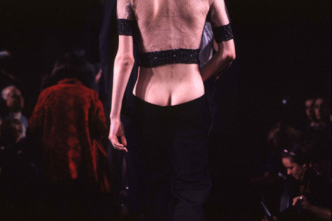
6. Alexander McQueen, the 'bumster' pants,

The philosophical depth in McQueen's works also resonates with the viewpoints presented by Lisa Feldman Barrett in How Emotions Are Made (2018). Barrett's theory suggests that emotions are constructed by our brain and influenced by our past experiences, culture, and environment. In this context, McQueen's design serves as a stimulus that triggers each audience's unique emotional responses, which are influenced by their personal experiences and cultural background. The interaction between observers, clothing, environment, and context reflects Barrett's concept of emotional construction, making McQueen's series a profound exploration of human psychology through fashion exploration. The materials and contours chosen by McQueen in the "Nihilism" series can be seen as a direct challenge to the traditional fashion industry, which values aesthetics and commercial appeal. His designs are often primitive and unadorned, challenging the concepts of beauty and luxury typically associated with high-end fashion. This rebellious attitude not only solidified McQueen's position as a avant-garde designer, but also reflected his deeper dissatisfaction with the superficial aspects of the fashion industry and the entire consumer culture.

Overall, Alexander McQueen's "Nihilism" series is a multifaceted art piece that delves into complex philosophical and psychological themes. It proves the power of fashion as a medium for expressing and exploring profound and problematic aspects. Through his pioneering design, McQueen not only redefined the boundaries of fashion, but also provided a new perspective to see the world, which challenged conventions and encouraged us to have a deeper understanding of human experience. His works still have influence and relevance, continuously inspiring designers and artists who seek to use their craftsmanship as a means of philosophical and emotional exploration.

Sword Zen, A 2021 Global Game Jam Game
Sword Zen is a voice Zen action game. In the game, you are a swordsman who has suffered from the torment and loss of past experiences. You need to face your chaotic inner world again, restore your perception of things and the present by adjusting the rhythm of your search for breath, face threats, break through obstacles, and relearn how to strike the perfect blow when your breath is calm, defeat the huge shadow, find your own peace, and face the ultimate (Zitao. Y, 2021).

Sword Zen represents a unique approach in the gaming industry that differs from the traditional path of digital gaming that typically leads to addiction and accompanying mental health issues such as anxiety, depression, and nihilism. This innovative game is designed as a meditative Zen experience in response to the challenges posed by the modern digital environment, where immediate satisfaction and constant flow of stimulation disrupt the natural balance of human psychology. As Robert Wright explained in Why Buddhism is True (2017), humans have evolved traits of adaptation and seeking improvement, which are crucial for survival in the natural environment. However, in today's technology driven world, this adaptability has become a double-edged sword. The richness of entertainment and the endless pursuit of happiness lead to a state of dissatisfaction and pain, as described by Anna Lembke in Dopamine Nation. The reward system of the brain, aimed at maintaining a balance between pleasure and pain, is constantly exposed to high levels of stimulation and becomes overwhelmed, increasing the threshold for dopamine release and leading to a series of negative emotions (Lembke, 2021, p.41).

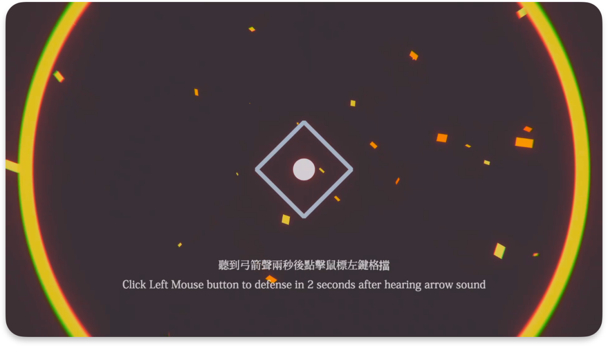
7. The game scene of Sword Zen

Sword Zen provides a strategy to resist this cycle of addiction and dissatisfaction. The mechanism of the game revolves around controlling breathing and mindfulness, providing an outlet to escape from sustained external stimuli. Players engage in simple and profound interactions through synchronized breathing with the game rhythm: inhaling and exhaling. This breathing technique goes beyond normal mode, encouraging deep and conscious breathing, and connecting players to a relaxed and mindful state. The game is designed with only a square and a circle contrasting a dark background, reducing visual clutter and allowing players to focus inward and establish connections with their breathing and inner self. The process of the game is cleverly designed to maintain player engagement without feeling overwhelmed (Csikszentmihaly, 1990, p.143). As the difficulty increases, the design slightly exceeds the player's current abilities, maintaining their engagement and focus. Unlike other addictive number games, Sword Zen balances the increasing difficulty with its mindfulness methods (Clear, 2018, p.169). The more players engage in the game, the more they practice mindfulness, thereby achieving higher levels of awareness and existence. This mindfulness based gameplay method provides players with a clear sense of self-awareness and self-awareness, overcoming the numbness effects commonly found in traditional number games. Sword Zen empowers players with the ability to make conscious choices, cultivating a sense of presence and mindfulness that extends beyond gaming to daily life. This shift in focus from the outside in allows players to experience true happiness and satisfaction, as they embrace every moment and establish connections with their true selves (落日间xpaidia, 2021). Therefore, Sword Zen is not only a form of entertainment, but also a tool for practicing mindfulness, providing a potential way to achieve happiness and a more balanced life. Its innovative design showcases the power of mindfulness games in addressing the challenges of the modern digital age, providing an alternative to the ongoing pursuit of happiness and its associated dissatisfaction and nihilism. With the development of the gaming industry, Sword and Zen has become a proof of the potential of games to not only entertain, but also heal, inspire, and transform.

The design philosophy of Sword Zen is consistent with the principles discussed by Nir Eyal (2019) in Indistractable, emphasizing the importance of managing personal time and attention to overcome the traps of distraction. By integrating mindfulness into its core gameplay, Sword Zen provides players with a practical application of these principles, providing a way to cultivate focus and presence in a world increasingly dominated by superficial distractions. This approach represents a paradigm shift in game design, with the goal not only of entertainment or skill development, but also of promoting mental health and mindfulness. Games become a bridge connecting numbers and the real world, helping players transfer the skills and mindset cultivated in the game to their daily lives. As players progress in Sword Zen, they embark on a journey that aligns with their personal growth. The increase in game difficulty reflects the challenges in life, teaching players to remain calm and focused in adversity. The act of synchronizing breathing and action in games has become a metaphor for aligning thoughts and actions in the real world, cultivating a sense of harmony and balance.

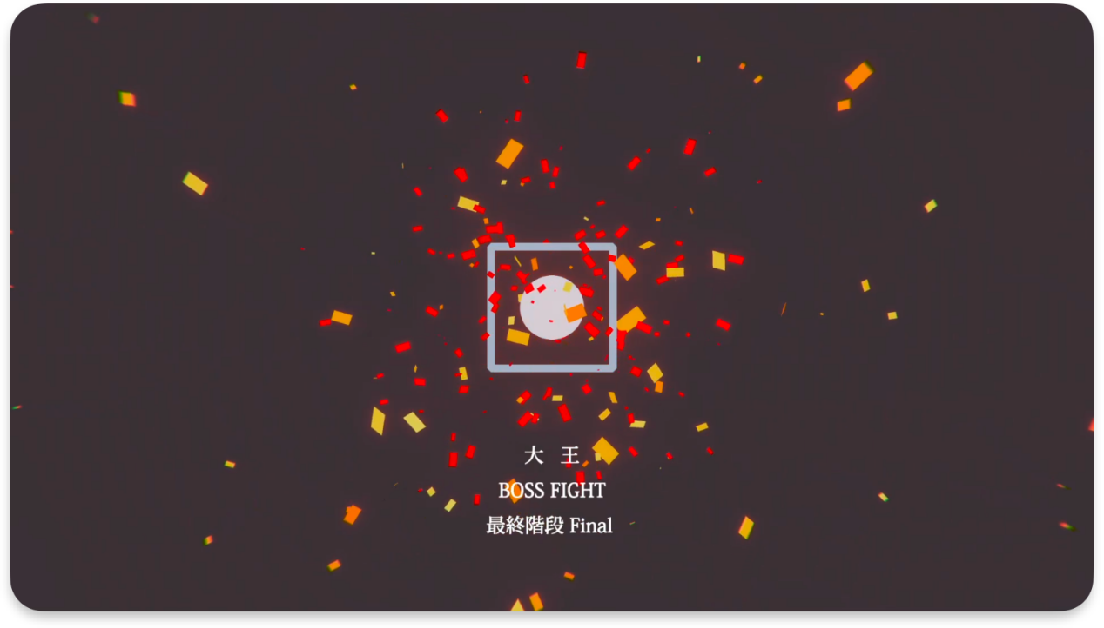
8. The interactive visual effects of Sword Zen

In summary, Sword Zen is not just a game; It is a tool for personal development and a response to the challenges of modern life. It serves as an example of how games are designed not only for entertainment and enjoyment, but also for personal growth, mindfulness, and mental health. As we continue to navigate through a world full of digital distractions, Sword Zen provides a fresh and necessary way to rest, guiding players towards a more focused and balanced existence. Its innovative design extends the concept of mindfulness from gaming to real-world applications, helping players build resistance against distractions and stress in their daily lives. This approach of combining gaming with therapeutic practice marks a new era of digital entertainment, with mental health being the core focus. Games are not just a way to escape reality, but a tool for better understanding and navigating the real world. The contribution of Sword Zen to the gaming industry is multifaceted - it is not only a source of enjoyment, but also a tool for personal growth and mindfulness, setting a precedent for future game design that prioritizes mental health and well-being.

conclusion
Lee McQueen's "Nihilism" series and the game "Sword Zen" have profound enlightening significance in their comparative approach to dealing with nihilism through design. These two creative efforts, although different in media and execution, both address the social problem of nihilism, providing unique perspectives and solutions.

Lee McQueen's "Nihilism" series, as part of his 1994 Spring/Summer collection, is a powerful expression of the concept of nihilism in the fashion industry. McQueen challenged the traditional purpose of clothing - protection and dignity - and thus stripped away the traditional meaning of clothing (Victoria and Albert Museum, 2023). This radical approach is consistent with Lisa Feldman Barrett's theory in How Emotions Are Made, which emphasizes the construction of emotions through inner sensations (Barrett, 2018, p.113). McQueen's design stimulates the audience's instinctive response, forcing them to face their inner reactions and engage in deeper communication with nihilism. His works resonate with existentialist philosophy, which believes that action defines the essence of the individual. By transforming clothing into a medium for expressing nihilism, McQueen demonstrated that even in a state that is considered meaningless, creative action can give new meaning and value (Tumblur, 2020). On the other hand, "Sword Zen" represents a unique approach in the gaming industry. Unlike number games that often lead to addiction and accompanying mental health issues, Sword Zen is designed as a meditative Zen experience. It addresses the challenges of the modern digital environment, which is characterized by immediate satisfaction and sustained stimulus flow. The game mechanism revolves around controlling breathing and mindfulness, providing a way to escape from external bombing. This method is consistent with the principles discussed by Neil Ayar in "Undistributable", emphasizing the management of one's own time and attention to overcome distractions (Eyal, 2019, p.38). Sword Zen promotes mental health and mindfulness, connecting the digital world with the real world, and helping players transfer the skills and mindset developed in the game to their daily lives (Csikszentmihaly, 1990, p.144).

McQueen's fashion design and Sword Zen's approach to dealing with nihilism highlight the diversity and influence of design in solving social problems. McQueen stimulates thinking and discussion through shocking strategies and challenging social norms, while Sword Zen provides a practical tool for personal development and mental health. Although these two media have different methods, their goal is to promote a deeper understanding of oneself and the world for individuals.

McQueen's works have transcended traditional fashion design and entered the field of conceptual art. It invites individuals to reflect on their existence and the structure around them, urging them to break free from conventions and seek personal meaning and authenticity. In contrast, "Sword Zen" extends the concept of mindfulness from gaming to real-world applications, helping players build resistance against distractions and stress in their daily lives. This approach of combining gaming with therapeutic practice marks a new era of digital entertainment, with mental health being the core focus.

From this, it can be seen that Lee McQueen's "Nihilism" series and game Sword Zen demonstrate the important role of designers in addressing the social issue of nihilism. They not only increased their understanding of the problem through their respective media, but also provided solutions. McQueen's fashion challenges the audience's uneasy communication of concepts lacking meaning, while Sword Zen provides a method for practicing mindfulness and psychological balance. These creative efforts demonstrate that design transcends aesthetic boundaries and becomes a powerful tool for social commentary and personal growth. As society continues to cope with the complexity and universal nihilism of modern life, the contributions of designers like McQueen and the creators of Sword Zen have become increasingly important, providing new perspectives and solutions for a more serious and fulfilling life.

References & Bibliography
Lembke, A. (2021). Dopamine nation: finding balance in the age of indulgence. [New York, New York], Dutton, an imprint of Penguin Random House LLC.

Barrett, L. F. (2018). How emotions are made. Pan Books.

Eyal, N., & Li, J. (. t. I. (2019). Indistractable: how to control your attention and choose your life. Dallas, TX, BenBella Books, Inc.

Clear, J. (2018). Atomic habits: tiny changes, remarkable results : an easy & proven way to build good habits & break bad ones. New York, New York, Avery, an imprint of Penguin Random House.

Postman, N. (2010). Amusing ourselves to death. Penguin.

David, G. (2018). Can't hurt me : master your mind and defy the odds. Cork : BookBaby.

Csikszentmihaly, M. (1990). Flow: the psychology of optimal experience. 1st Ed. New York , Harper Perennial.

Xiv, D. L., & Cutler, H. C. (1999). The art of happiness. Hodder Paperback.

Wright, R. (2017). Why Buddhism is true: the science and philosophy of meditation and enlightenment. First Simon & Schuster hardcover edition. New York, NY, Simon & Schuster.

Tolle, E. (2001). The power of now. Hodder Paperback.

Barnet, B., & Bossio, D. (2020). Netflix’s The Social Dilemma highlights the problem with social media, but what’s the solution?. Avilable at: https://theconversation.com/netflixs-the-social-dilemma-highlights-the-problem-with-social-media-but-whats-the-solution-147351 (Accessed 12 December 2023)

Jones, C. (2021). Why it works – Headspace’s Tone of Voice. Avilabel at: https://matchstickcreative.co.uk/why-it-works-headspaces-tone-of-voice/ (Accessed at: 25 November 2023)

Hermann, J. (2023). How Headspace Grows: The Monk Who Built a $3B Meditation App. Avilable at: https://www.howtheygrow.co/p/how-headspace-grows-the-monk-who (Accessed at: 12 December 2023)

Borecka, N. (2016). Fashion Nihilism: What’s Trending? Who Cares. Avilable at: https://lonewolfmag.com/fashion-nihilism-whats-trending-cares/ (Accessed: 14 November 2023)

Auctions, K. T. (2020). First-ever ‘Bumsters’ by Alexander McQueen. Avilable at : https://www.kerrytaylorauctions.com/story/first-ever-bumsters-by-alexander-mcqueen/ (Accessed: 12 December 2023)

Victoria and Albert Museum. (2023). Alexander McQueen – an introduction. Avilable at: https://www.vam.ac.uk/articles/alexander-mcqueen-an-introduction#:~:text=Alexander%20McQueen%20was%20one%20of,born%20and%20educated%20in%20London. (Accessed: 25 November 2023)

Tumblur. (2020). Long Live McQueen. Avilable at: https://the-widows-of-culloden.tumblr.com/post/57631402062/alexander-mcqueen-ss-1994-nihilism-nihilism#:~:text=For%20his%20first%20staged%20runway,top%20of%20the%20models'%20bottoms. (Accessed: 27 November 2023)

Zitao, Y. (2021). Sword Zen. Avilable at: https://yezi.itch.io/sz (Accessed: 5 December 2023)

落日间xpaidia. (2021). E18 四十八小时做个游戏？《剑入禅境》GGJ 2021 Post-Mortem. Avilable at: https://docs.xpaidia.com/update/podcast/e18 (Accessed at: 11 December 2023)

