Analysis and Critical Evaluation of Hyatt Hotels Corporation
Student name: Alexandru Badea.
Student ID: 2208275.
Module name: Management and Organisational Behaviour
Module code: BMIH5004.
Lecturer: Daniel Payne.
Words: 2126

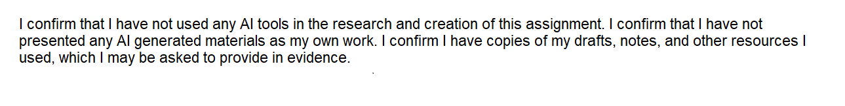

Executive Summary
The main purpose of the report is to analyse the structure and culture of Hyatt, the leading hospitality organisation in the world. They follow a collaborative and transparent workplace culture, under the control of the senior management of Hyatt. This is helping the brand to make employees feel happy and healthy, which is contributing a lot to the company's workplace productivity. Changes in the sustainability efforts are allowing them to act as a responsible corporate citizen, which is resulting in a great brand identity for them. The main factor that skyrocketed Hyatt’s immense growth was its international expansion strategy. However, as the intensity of competition in the global hospitality industry is rapidly increasing, some suggestions have been given for the brand to retain their position in the market.

Table of Contents
1. Introduction 4
1.1 Overview of Hyatt Hotels Corporation 4
1.2 Aim and Context of the Report 4
2. Organisation Structure, Culture, and Goals 4
2.1 Structure of Hyatt Hotels Corporation 4
2.2 Corporate Culture of Hyatt Hotels Corporation and Its Impact on the Internal Operation of the Hotel 5
2.3 Corporate and Individual Unit-Level Goals of Hyatt Hotels Corporation 5
3. Recent Change Initiatives 7
3.1 Recent Change Initiatives Undertaken by Hyatt Hotels Corporation 7
3.2 Impact of These Initiatives on the Hotel 8
3.3 Management of Change on Hyatt Hotels Corporation 8
4. Strategic Direction 9
4.1 Strategic Direction of Hyatt Hotels Corporation 9
4.2 Strategies Implemented by Hyatt Hotels Corporation to Accomplish Long-Term Objectives 10
5. Conclusion and Recommendations 10
5.1 Conclusion 10
5.2 Recommendations 11
Reference List 12

1. Introduction

1.1 Overview of Hyatt Hotels Corporation
This report intends to discuss about internal structure and culture of Hyatt Hotels Corporation. This is one of the leading US-based hospitality companies with a strong presence across the globe. This organisation was built by a family and is continuing to grow in the highly crowded marketplace. Care is the heart of the business of Hyatt and with this vision, they have made the workplace friendly and collaborative. In addition to that, Hyatt constantly puts stress on the distinct guest experience, due to which they are considered the leading hospitality brand across the globe (Hyatt, 2024a). The current portfolio of the company includes 1,350 hotels, which are being operated successfully in more than 75 countries (Hospitalitynet, 2024).

1.2 Aim and Context of the Report
The main aim of the report is to make a critical analysis of the internal functionality of Hyatt. The structure and corporate culture of the brand and their impact on its internal function will be discussed in the report. Furthermore, this report will also shed light on recent change initiatives undertaken by Hyatt Hotels Corporation, the impact of the change on their performance and the tactics, followed by the organisation to manage the change. This will be followed by the strategic direction of Hyatt Hotels Corporation and the strategies, followed by the hotel to accomplish the business objectives. Finally, recommendations will be provided to Hyatt to take the right action to sustain their position in the global hospitality industry.

2. Organisation Structure, Culture, and Goals

2.1 Structure of Hyatt Hotels Corporation
A well-defined organisational structure is highly important to have immense success in business as allows the companies to explore how they are operated. According to Joseph and Gaba (2020), the proper organisational structure allows companies to move towards the right direction, which is the key to attaining the desired outcome from business. Being the leading hospitality brand around the globe, the hierarchical organisational structure is followed at Hyatt. The senior management holds the responsibility to make the ultimate decision and manage the day-to-day operation of the company. This is led by the CEO and president, who support the C-level executives in managing the regular functionality in different areas like HRM, finance and operations (Organimi, 2024). The company follows a functional organisational structure at the corporate level and a divisional organisational structure to manage the hotels and resorts. Effective corporate structure plays a major role in Hyatt to carry out internal functionality efficiently by organising different departments like finance, marketing, human resources, legal, and operations properly. The organisation runs under the kind control of the President and Chief Executive Officer, who hold the responsibility to strengthen the long-term value for the stakeholders (Investors.hyatt, 2024).

2.2 Corporate Culture of Hyatt Hotels Corporation and Its Impact on the Internal Operation of the Hotel
Good organisational culture is the main essence of having long-term business success. As discussed by Halim, Ahmad and Ramayah (2019) effective organisational culture leads to greater employee engagement, which is the key to strengthening organisational productivity. This leads to greater organisational performance. The culture of Hyatt is based on different values like integrity, respect, creativity, empathy, humility and fun. The senior management of the company is extremely committed to attracting and retaining the best talent and they are continuing to cultivate the workplace culture in such a manner, that the staff can discover their potential and feel healthy and happy (Hyatt, 2024c). Such a collaborative workplace culture plays a major role in strengthening the operational efficiency of Hyatt by aligning all the human resources in a single platform. Diversity, equity and inclusion are the core aspects of the organisational culture of Hyatt. The organisation continues to work to uphold its vision to work closely with those people, who are subjected to discrimination (Hyatt, 2024d).

2.3 Corporate and Individual Unit-Level Goals of Hyatt Hotels Corporation
Being the leading global hospitality organisation, the main corporate-level goal of Hyatt is to create a world of care. This goal of the organisation is supported by their actionable commitment to care for the planet, people and business every single day. According to the triple bottom line (TBL) framework, the sustainability initiatives of the companies revolve around three important aspects people, planet and profit. As opined by Nogueira, Gomes and Lopes (2023) by protecting these aspects, the companies can have a positive impact on the world, while strengthening their financial performance.
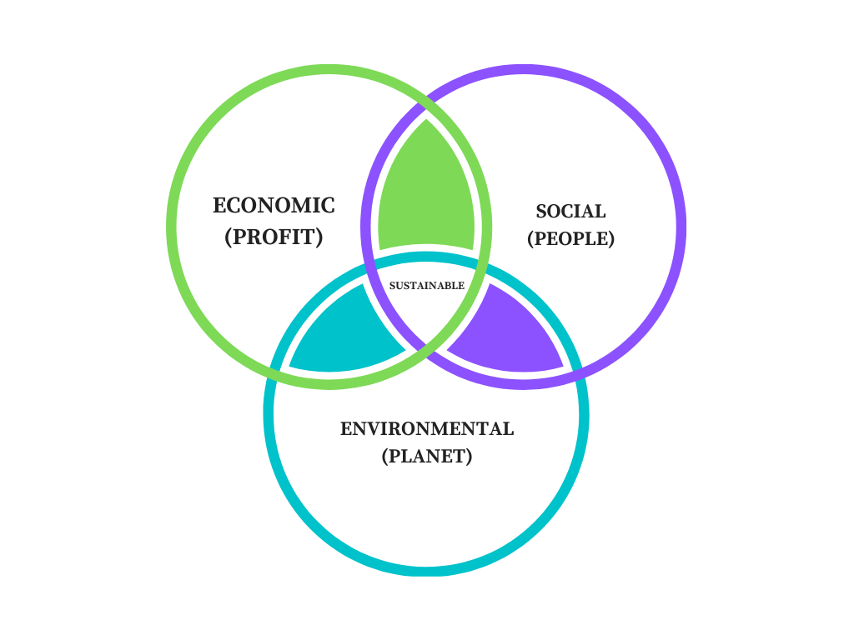
Figure 1: Tripple Bottom Line Framework
(Source: Nogueira, Gomes and Lopes, 2023)
For Hyatt, World of Care is the global approach to improve their care for the planet and people and thereby act as a responsible corporate citizen. Hyatt also intends to make themselves accountable, which is the key to enhancing the engagement of stakeholders in a meaningful way (Hyatt, 2024e). Diversity, equity, inclusion, responsible sourcing, attracting and retaining skilled and competent human resources are the individual unit-level goals of Hyatt. They are highly committed to sustainably running a business and developing an inclusive organisational culture, where the staff can feel happy and welcomed (Hyatt, 2024b). The current diversity and inclusion scenario at Hyatt is presented below:
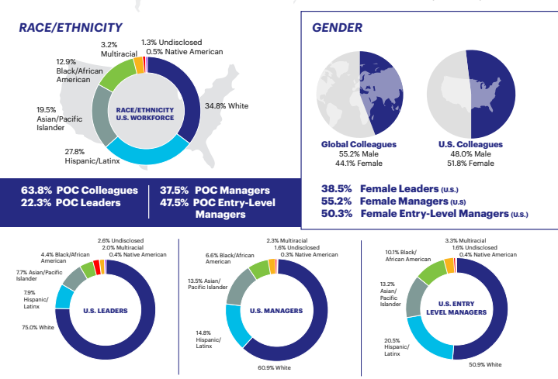
Figure 2: Diversity and Inclusion at Hyatt
(Source: Hyatt, 2024b, p.4)

3. Recent Change Initiatives

3.1 Recent Change Initiatives Undertaken by Hyatt Hotels Corporation
In the highly volatile business environment, change is the inevitable factor for organisational existence. In the view of Wijethilake, Upadhaya and Lama (2023) initiating change allows the companies to respond to the ongoing trends in the market, which is the key to strengthening brand identity. That is why, companies irrespective of the nature and size of the business are initiating change. This is so with the case of Hyatt. Recently, the company has made changes in their internal operation. They have installed electric vehicle charging stations at over 170 properties across the globe (Hyatt, 2024f). The main aim of Hyatt behind taking this initiative is to exhibit their responsiveness towards the environment. This is the biggest change in the CSR strategy of Hyatt. In addition to that, in their properties, they are also offering straws as per the request of guests. At the same time, the company is also looking for preferable substitutes like paper bags and using digital key entry solutions. On top of that, the company has also modified their CSR policy by installing unique features of water management to minimise the flow of stormwater. A transparent decision-making process is being followed at Hyatt to involve both guests and colleagues in the change initiatives. They are continuing to grow the native plants to support the local ecosystem and establish both feeding and hydration zones for the wildlife. These are some major changes, made by Hyatt to strengthen their effort to protect the environment from the harmful impact of business (Hyatt, 2024g).

3.2 Impact of These Initiatives on the Hotel
Sustainable initiatives play a major role in the companies improve their bottom line. Cader, Koneczna and Smol (2022) showed that this acts as a great source of competitive advantage, which is the key to accomplishing organisational goals and objectives. Similarly, the changes in CSR policies are helping Hyatt to boost their public image. Nowadays, customers are also looking for eco-friendly services due to the growing concern among them to promote environmental well-being. That is why, the installation of electric vehicle charging stations at their hotels is playing a pivotal role for the company to gather a unique image among the minds of guests, which is key to increasing customer engagement and leading to a greater organisational public image.
The introduction of more paper-based solutions is also allowing Hyatt to promote their contribution to recycling, which is extremely important to increasing the rate of renewable energy resources. Furthermore, improvement of water management infrastructure is necessary for Hyatt to upgrade the guest experience by protecting the environment. This results in improved brand identity of Hyatt by boosting their public image. They are also allowing their colleagues in the process of changing existing sustainability initiatives (Hyatt, 2024g). This is critical for Hyatt to generate a feeling of belongingness among the employees, which leads to greater productivity of this hospitality organisation.

3.3 Management of Change on Hyatt Hotels Corporation
The success of change can only be acquired if it is managed properly. Li et al., (2021) stated that this allows companies to adapt to changes quickly, which is extremely critical to ensure the growth and sustainability of business. According Lewin's Change Management Model, change management comprises three important steps such as unfreezing, changing and refreezing, which support the companies to initiate change successfully by aligning all the resources (Bezjian et al., 2023). To manage the change properly, Hyatt continuing to focus on skill development of the staffs. This helps in enabling the staffs to be aligned with the change process by improving their skills and competencies.
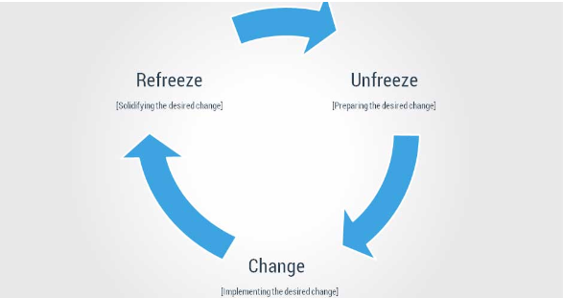
Figure 3: Lewin's Change Management Model
(Source: Bezjian et al., 2023)

4. Strategic Direction

4.1 Strategic Direction of Hyatt Hotels Corporation
In this highly competitive hospitality industry, international expansion is the main strategic direction of Hyatt. With their commitment to be the most preferred brand among customers, the company has recorded a pipeline of 127,000 rooms across the globe by the end of 2023. Organic growth, conversions, and strategic acquisitions are the main growth strategies, followed by Hyatt, which is resulting in a premium portfolio of the organisation. In the first half of 2024, Hyatt entered the main global market by, launching Park Hyatt London River Thames, Park Hyatt Johannesburg, Park Hyatt Cancun and Park Hyatt Los Cabos. They are also planning to enter Mexico City by 2027 by launching Thompson Puerto Vallarta (Hyatt, 2024h).

4.2 Strategies Implemented by Hyatt Hotels Corporation to Accomplish Long-Term Objectives
Employee engagement, diversity, equity, and inclusion, responsible sourcing, inclusive collection, lifestyle brands and operational improvements are the main strategies, followed by Hyatt to accomplish its business objectives. The organisation is highly committed to innovating its services and thereby offering unique experiences to the guests. That is why, Hyatt has developed a unique talent management strategy. They have developed an innovative and supportive working environment, where the employees can strive to put in their best effort to work as per the requirement of management (Hyatt, 2024i). This is playing a major role in Hyatt's long-term goal of improving organisational productivity by keeping the staff skilled and competent. In addition to that, with their aim of being the most sustainable brand, Hyatt is working closely with the suppliers to maximising the responsible sourcing of products and services and address severe environmental issues like climate change, deforestation, human rights, waste, public health, resource scarcity, biodiversity and animal welfare. The science-based target of carbon reduction was also established by Hyatt to lower the emission rate, which is the key to protecting the environment from the negative impact of business and promoting environmental well-being.

5. Conclusion and Recommendations

5.1 Conclusion
In sum, it can be said that being the giant in the global hospitality industry, the main essence of grand success lies in its implementation of unique policies. A collaborative and transparent workplace culture is acting as a main source of motivation for the staff of Hyatt, which is contributing a lot to the organisation to maximise their operational efficiency. Change in the existing CSR strategy is helping the company to offer a unique experience to the guests while protecting the local ecosystem. This results in a greater brand identity for Hyatt across the globe. To stay ahead of its rivals, the company has designed a comprehensive growth strategy. This is the main source of competitive advantage of Hyatt.

5.2 Recommendations
As the competition in the global hospitality industry is skyrocketing, Hyatt needs to take strong action to strengthen their position in the market. Here are some recommendations for Hyatt:
- Development of high-performing workplace culture: The brand has to make the workplace better so that the employees can exceed at their job. This is key to enhance operational efficiency. It can be done by investing into training sessions and checking how well the employees are doing by using well designed performance tests or charts. Directly addressing their skill gap will help them improve further.
- Strengthening CSR initiative: It is recommended that Hyatt should do more for the community by keeping their energy usage in check to reduce pollution. This will make the brand to explore the emission rate and take action accordingly. As a part of their CSR program, Hyatt needs to review their recruitment and selection program to make sure that it’s free from any kind of discrimination like race, age, sex and socio-economic background.
- Third-party relationships: The Company should maintain strong relationships with its partners. Listening to their needs will keep them happy and in return they will help Hyatt grow.

Reference List
Bezjian, J., Godinez, J., Dean, B.P. and Wright, S.L., (2023). “Teaching Lewin's Model on Change Management: Lessons from the" Cool Runnings" Film. Journal of Instructional Pedagogies,” 29.
Cader, J., Koneczna, R. and Smol, M., (2022). “Corporate social responsibility as a significant factor of competitive advantage-a case study of energy companies in Poland. Energy Reports,” 8, pp.7989-8001.
Halim, H.A., Ahmad, N.H. and Ramayah, T., (2019). “Sustaining the innovation culture in SMEs: The importance of organisational culture, organisational learning and market orientation. Asian Journal of Business Research,” 9(2), pp.14-33.
Hospitalitynet (2024). “Hyatt Hotels Corporation.” [Online]. Available at: https://www.hospitalitynet.org/organization/17001488.html (Accessed on: October 26, 2024)
Hyatt, (2024a). “ABOUT HYATT.” [Online]. Available at: https://about.hyatt.com/en.html (Accessed on: November 8, 2024).
Hyatt, (2024b). “ADVANCING OUR PURPOSE OF CARE: Diversity, Equity and Inclusion at Hyatt.” [Online]. Available at: https://about.hyatt.com/content/dam/hyatt/woc/DEIReport.pdf (Accessed on: November 8, 2024).
Hyatt, (2024c). “CULTURE.” [Online]. Available at: https://about.hyatt.com/en/world-of-care/caring-for-people/culture.html (Accessed on: October 26, 2024).
Hyatt, (2024d). “Caring for People.” [Online]. Available at: https://www.hyatt.com/world-of-care/en-US/caring-for-people#diversity-equity-inclusion (Accessed on: November 8, 2024).
Hyatt, (2024e). “World of Care.” [Online]. Available at: https://www.hyatt.com/world-of-care/en-US (Accessed on: November 8, 2024).
Hyatt, (2024f). “Caring for the Planet.” [Online]. Available at: https://www.hyatt.com/world-of-care/en-US/caring-for-the-planet (Accessed on: November 8, 2024).
Hyatt, (2024g). “World of Care Highlights.” [Online]. Available at: https://about.hyatt.com/content/dam/hyatt/woc/2023WOCHighlights.pdf (Accessed on: November 8, 2024).
Hyatt, (2024h). “Hyatt Announces Record Signings and Pipeline of 127,000 Rooms at Year-End, Fueling Growth Strategy in 2024 and Beyond.” [Online]. Available at: https://newsroom.hyatt.com/2024-01-19-Hyatt-Announces-Record-Signings-and-Pipeline-of-127,000-Rooms-at-Year-End,-Fueling-Growth-Strategy-in-2024-and-Beyond (Accessed on: November 8, 2024).
Hyatt (2024i). COLLEAGUE DEVELOPMENT. [Online]. Available at: https://world.hyatt.com/content/hyatt-about/en/world-of-care/caring-for-people/colleague-development.html (Accessed on: November 8, 2024)
Investors.hyatt, (2024). “Governance Documents.” [Online]. Available at: https://investors.hyatt.com/governance/governance-documents/default.aspx (Accessed on: November 8, 2024)
Joseph, J. and Gaba, V., (2020). “Organizational structure, information processing, and decision-making: A retrospective and road map for research. Academy of Management Annals,” 14 (1), pp.267-302.
Li, J.Y., Sun, R., Tao, W. and Lee, Y., (2021). “Employee coping with organisational change in the face of a pandemic: The role of transparent internal communication. Public relations review,” 47(1), p.101984.
Nogueira, E., Gomes, S. and Lopes, J.M., (2023). “Triple bottom line, sustainability, and economic development: What binds them together? A bibliometric approach. Sustainability,” 15(8), p.6706.
Organimi, (2024). “Hyatt Hotels’ Organizational Structure.” [Online]. Available at: https://www.organimi.com/organizational-structures/hyatt-hotels/ (Accessed on: November 8, 2024)
Pwc, (2024). “Hyatt’s talent strategy transformation.” [Online]. Available at: https://www.pwc.com/us/en/library/case-studies/hyatt-talent-strategy-transformation.html (Accessed on: November 8, 2024)
Wijethilake, C., Upadhaya, B. and Lama, T., (2023). “The role of organisational culture in organisational change towards sustainability: evidence from the garment manufacturing industry. Production Planning & Control, 34(3),” pp.275-294.

