Managing Enterprise in the 21st century

Module code: BMSW 4006
Student ID: 2020323
Student Name: Mihayl Panchev

Executive Summary
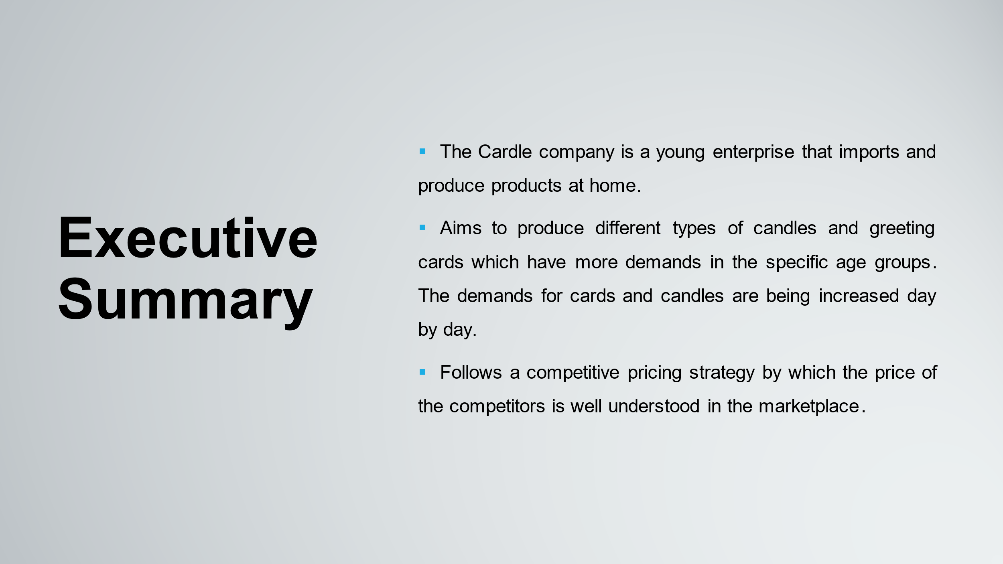
In the competitive environment, the Cardle company is a young enterprise that imports and produce products at home. The company aims to produce different types of candles and greeting cards. The variety of cards and candles have more demands in the specific age groups. The demands for cards and candles are being increased day by day. The Cardle company follows a competitive pricing strategy by which the price of the competitors is well understood in the marketplace.
Table of Contents
Executive Summary ii
Introduction 1
Business Overview 2
Product and services 3
Market audit 4
Competitor Analysis 4
SWOT analysis 6
Target market 8
The factors influencing the market 10
Main competitors (Industry’s Participants) 11
Marketing Plan 12
Pricing Strategy 14
Sales Strategy 15
Management Team 16
Financial forecasts 17
Business Justification 18
Conclusion 19
References 20

Introduction
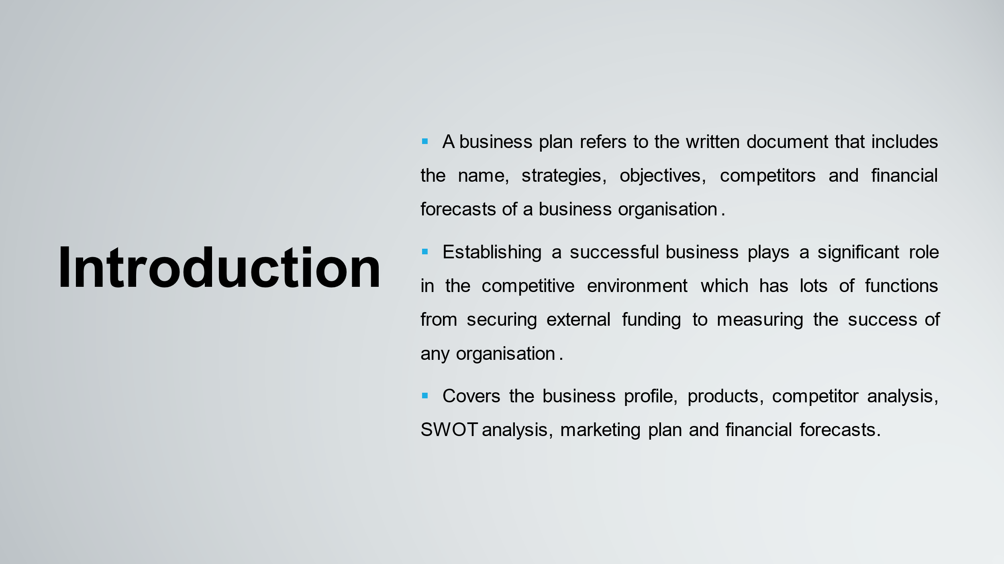
A business plan refers to a written document that includes the name, strategies, objectives, competitors and financial forecasts of a business organisation (Ryans et al., 2017). Establishing a successful business plays a significant role in the competitive environment. It has lots of functions from securing external funding to measuring the success of any organisation. Having a realistic and working business plan is also essential when starting a new business. It covers the business profile, products, competitor analysis, SWOT analysis, marketing plan and financial forecasts.

Business Overview
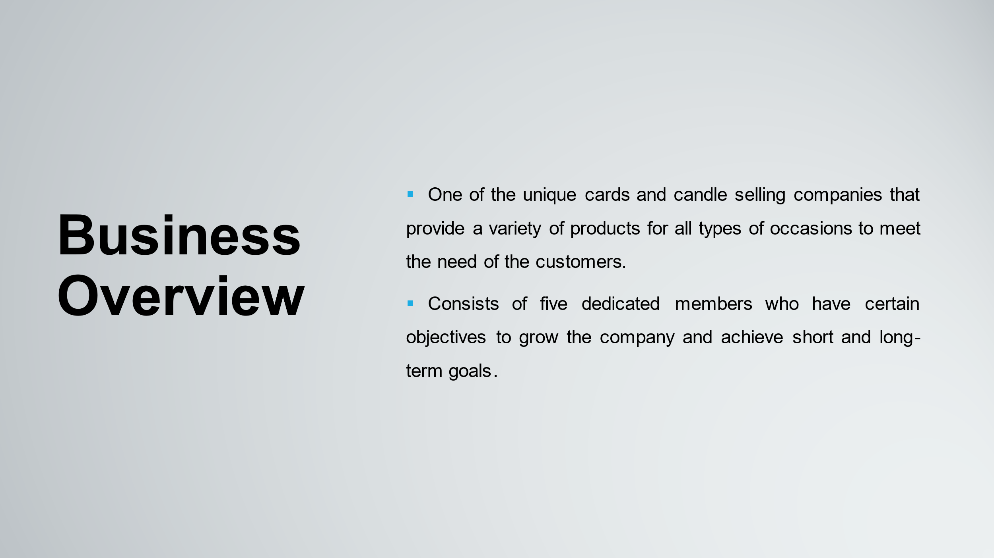
Cardle is one of the unique cards and candle selling companies that provide a variety of products for all types of occasions to meet the need of the customers in the context of the United Kingdom (Fuchs and Gutmann, 2022). The cards and candle selling company consists of five dedicated members who have certain objectives to grow the company and achieve short and long-term goals.

Product and services
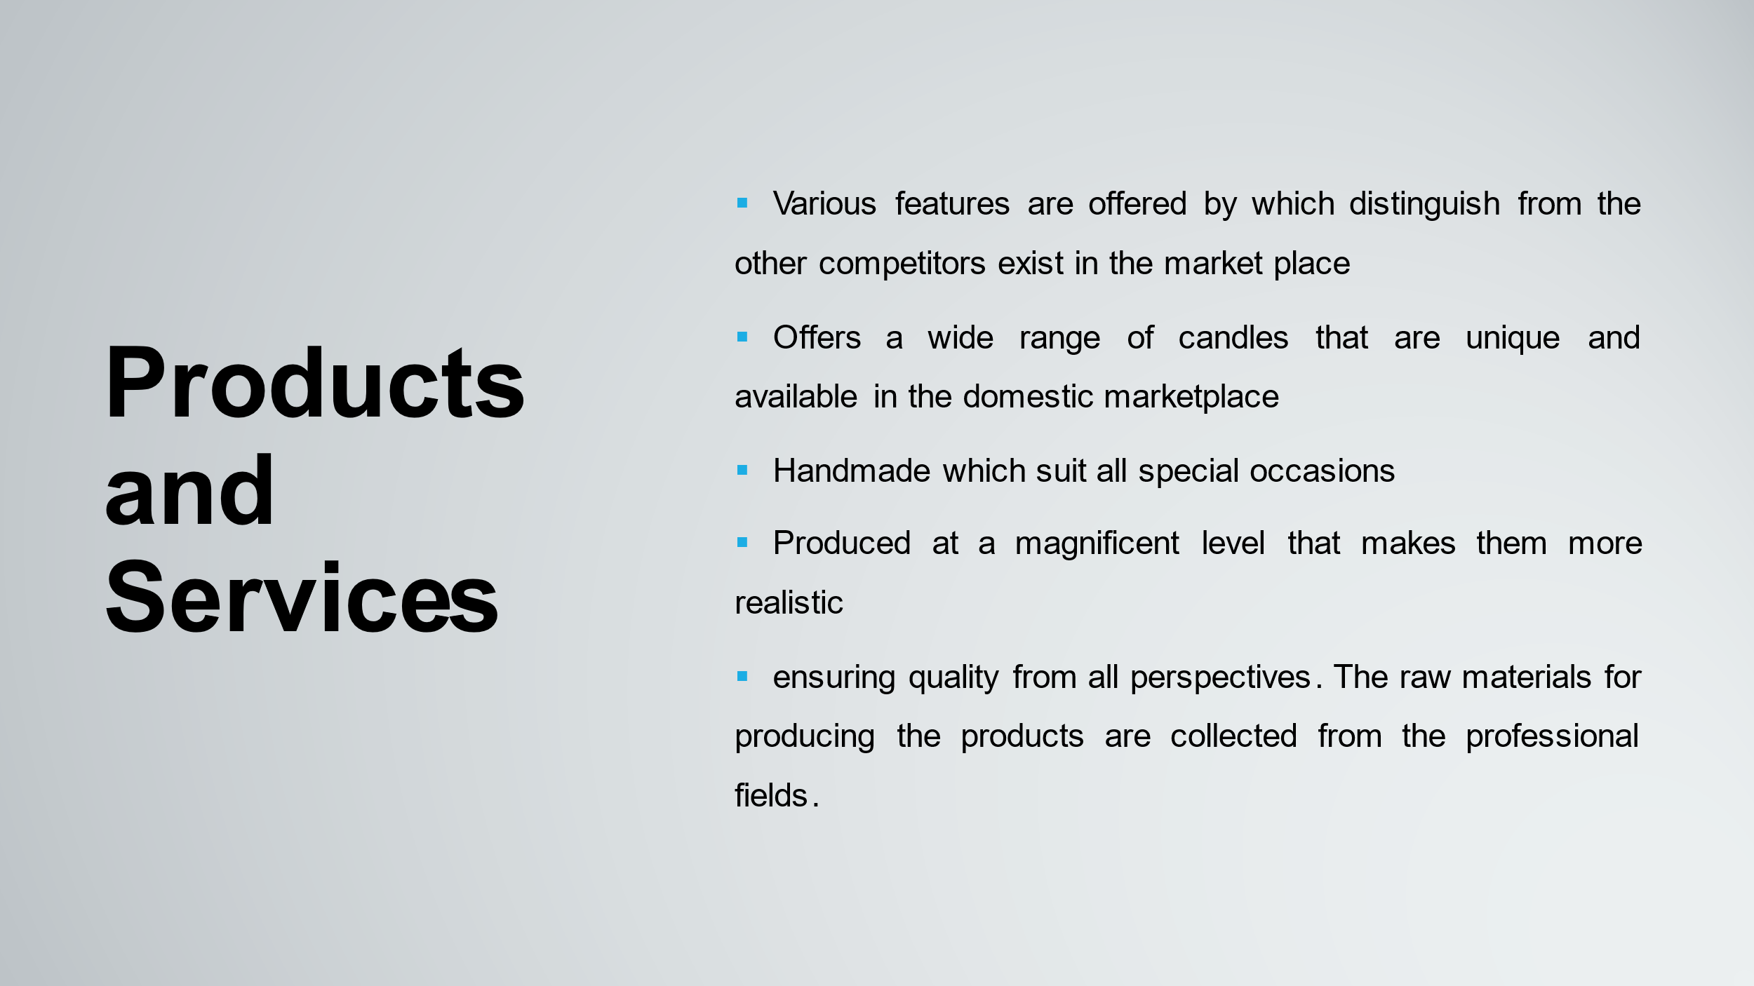
To suit various needs and for all special occasions including valentine's day, anniversary, birthdays and exams, different types of cards are provided. Best wishes for courses and exam congratulations cards have a huge market needs which also have good selling point in the universities of Wales.
Various features are offered by the products of Cardle company which distinguish them from the other competitors exist in the market place,
- It offers a wide range of candles that are unique and available in the domestic marketplace
- The products of Cardle are handmade which suit all special occasions
- The cards and candles are produced at a magnificent level that makes them more realistic
Whereas, Cardle’s products are handmade, ensuring quality from all perspectives. The raw materials for producing the products are collected from the professional fields (Panov et al., 2018). A wide range of benefits is provided by the products of Cardle company to its customer’s base. The people of the competitive marketplace would like to purchase our products because of the quality and variety of features provided.

Market audit

Competitor Analysis

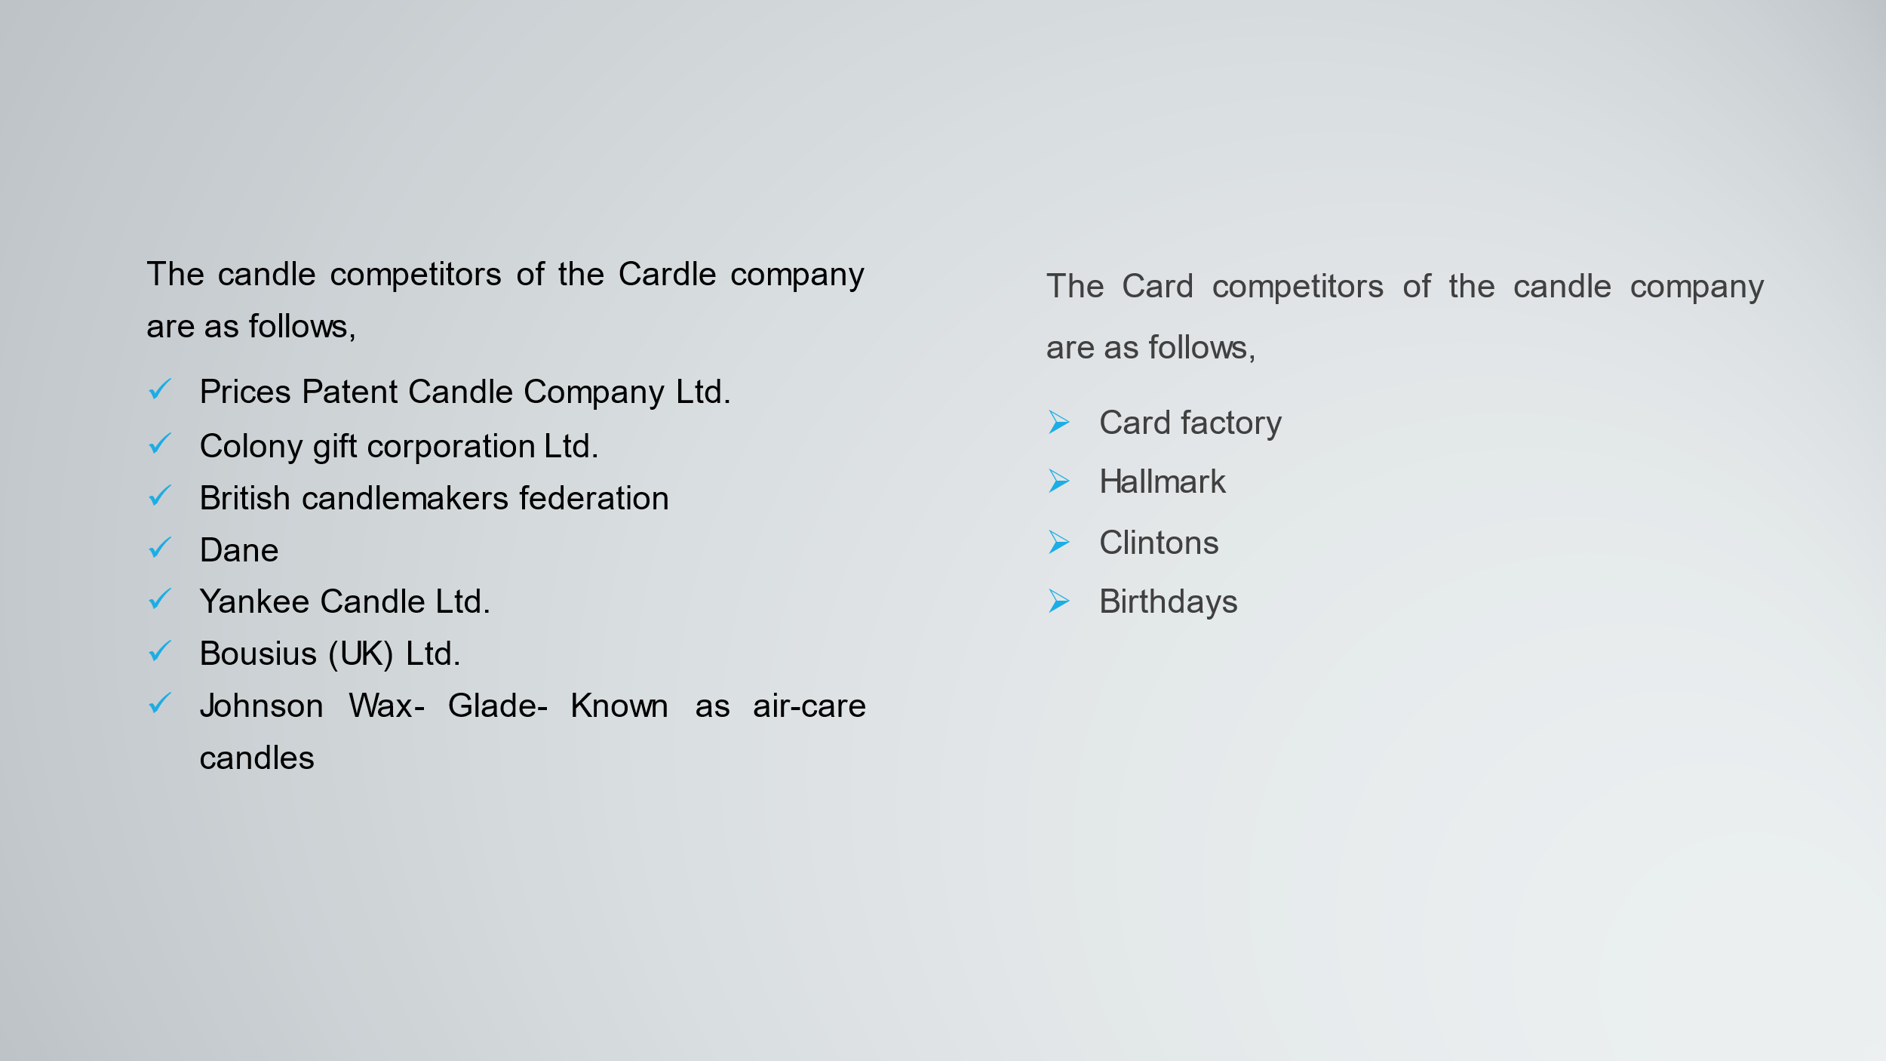
To gain insight into products, sell and marketing tactics, Competitor analysis refers to a strategy that analyzes the major competitors within a marketplace. The benefits of conducting competitor analysis include capturing market share, implementing stronger business. The analysis helps to learn how the business environment runs in the competitive environment and identify the potential opportunities to achieve the organisational objectives. the Cardle company must have to know about the competitors that sell relevant products in the marketplace. The candle competitors of the Cardle company are as follows,
- Prices Patent Candle Company Ltd.
- Colony gift corporation Ltd.
- British candlemakers federation
- Dane
- Yankee Candle Ltd.
- Bousius (UK) Ltd.
- Johnson Wax- Glade- Known as air-care candles
The Card competitors of the candle company are as follows,
- Card factory
- Hallmark
- Clintons
- Birthdays

SWOT analysis
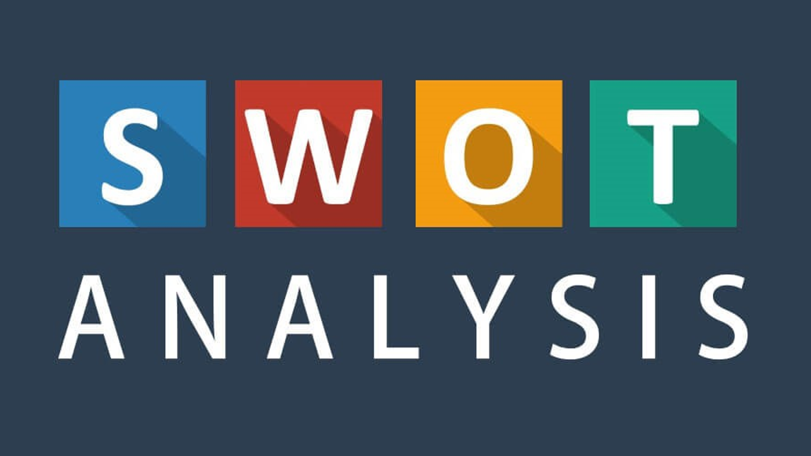
SWOT analysis refers to the strategic management and strategic planning technique which is used to assist the Cardle company to identify the strengths, weaknesses, opportunities and threats in the context of the competitive environment which is sometimes known as situational analysis or assessment (El Sawy, 2016). the SWOT analysis is provided below,
Strengths:  - Limited startup-risk  - Highly visible websites  - Very high gross margins  - Limited competition  - Highly-experienced owner-operator  - High barriers to entry | Weaknesses:  - Limited start-up costs  - Limited flexibility in pricing  - High transportation costs  - Similar products can be offered by the competitors of the Cardle company
Opportunities:  - Development of wholesale distribution relationships  - Sale of the business for a significant P/E  - Development of Proprietary products  - Affiliate relations with related vendors  - Acquisition of additional rounds of capital  - Ability to develop additional stores  - Continued expansion of online sales | Threats:  - Enhances in price inputs cause the upward pricing  - Major competitors sell products already in the markets.  - Changes in regulations impact the organisation (Panov et al., 2018).  - Insurance costs are increasing continuously.

Target market

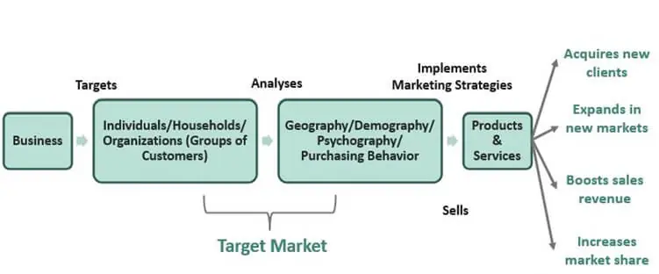
Figure 1: Target Marketing of Cardle company
Sources: (Pauwels, 2020)
Increasing sales target market plays a significant role in the competitive environment. Target marketing refers to the segmenting of the market into different groups in the context of age, sex, gender, religion, country etc. making the organisation to the success and increasing sales, target marketing is the key to the activities of the Cardle company (El Sawy, 2016). To target users based on market segments, the Cardle company utilises social media platforms such as LinkedIn, Facebook, Instagram, etc. For example, the Cardle company target students on Facebook with an ad for Exam congratulations cards.
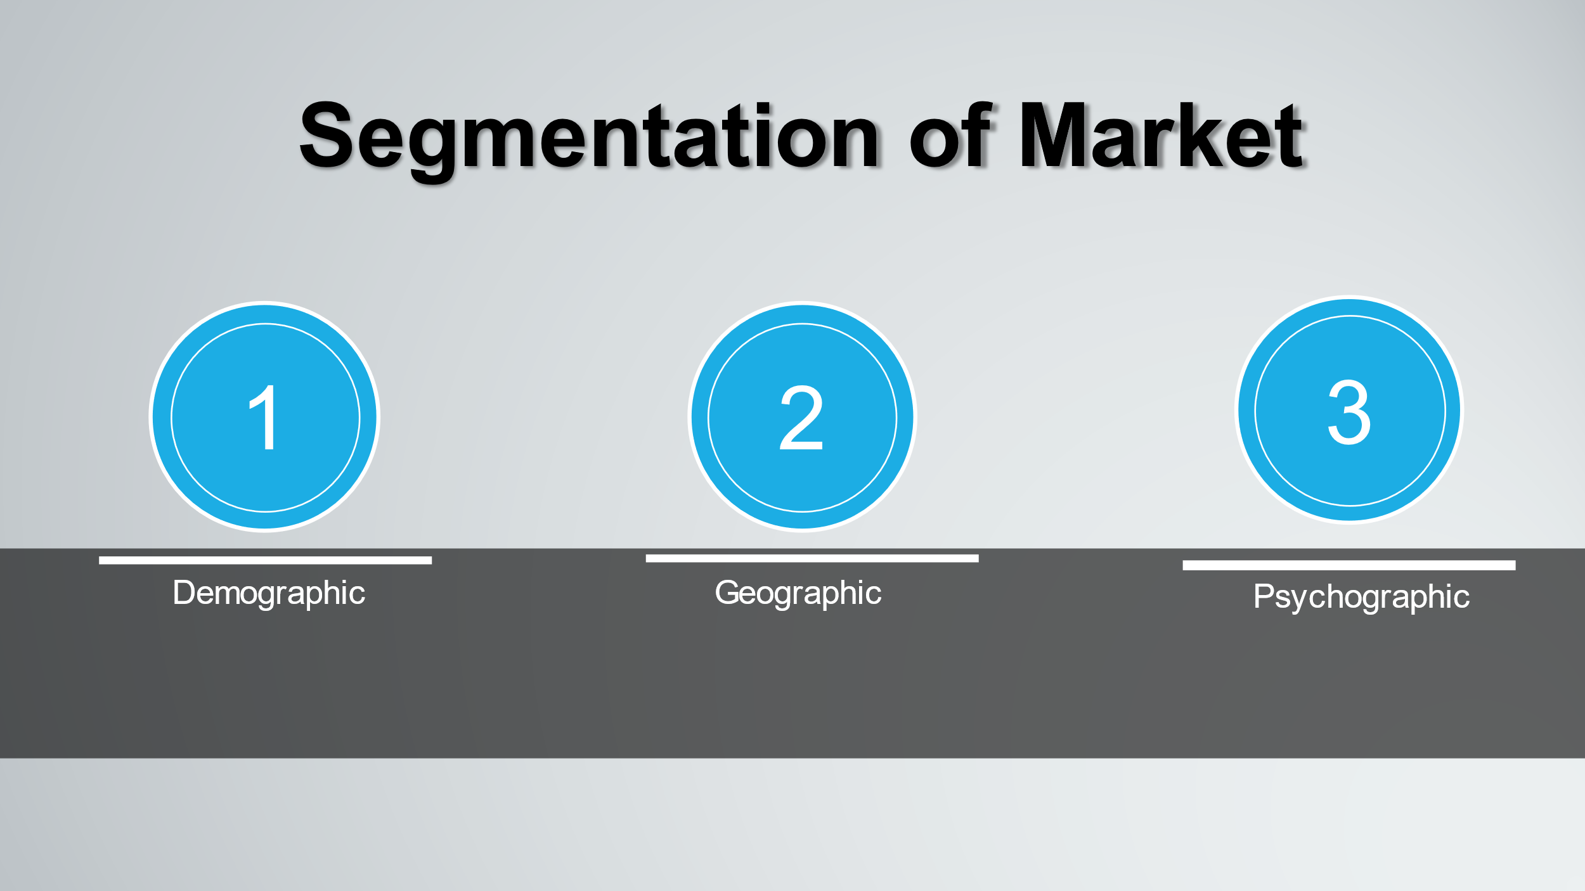
Demographic Segmentation: For identifying target markets, Demographic segmentation is the most important criteria by which the people can be targeted in the context of age, race, religion, material status, Gender, Income level. The age level of selected customers is from 18 to 50. According to a study, 63% of housewives purchase scented candles and have a huge market demand in the marketplace. Besides, the company also focuses on the students of many universities in the United Kingdom who purchases cards for different uses.
Geographic segmentation: Segmenting a market based on location is referred to as Geographic segmentation including city, region, province or state, Area code, etc. It depends on the notion of which specific group of people requires specific products or services (Januario, 2015). The company initially focuses on the cities of Wales including Bangor, Cardiff, Newport, St Asaph, St Davids, Swansea. Whereas the company runs its activities in the cities, lots of market demand can be created by following the effective strategy.
Psychographic segmentation: Based on lifestyle preferences and socio-economic class, the company segments the market into different areas. From the affluent and highly educated to the uneducated as well as unskilled at the bottom, the socio-economic scale ranges. The Cardle company produce Cards and Candles according to the demands and requirements of people by which customer beliefs and brand value can be created in the competitive market.

The factors influencing the market
Several factors influence the cards and candle markets of the Cardle company. Basically, the vast number of Women and students create a positive influence on the sales of candles and cards in the marketplace, because of an increase in discretionary financial independence and income (Long, 2014). Changes in the age structure also boost the sales of cards and candles of the Cardle company that have a high purchase rate according to a recent study on the current market.

Main competitors (Industry’s Participants)
Colony Gift corporation Ltd
The UK’s leading quality candle manufacturer, named the Colony gift corporation, provides different types of gift cards and candles across Europe. The activities of the colony are over 70 counties and more than 560 people are working in the organisation now.
Price’s Patent candles company Ltd
The candles and related accessories are produced by the Price patent candles company which offers a variety of candles including Scented, aromatherapy, Christmas and easter, decorative candles for different occasions.
Yankee Candle Ltd
For home fragrance, Yankee candles are recognised as the premium and gift-worthy candle provider across the United Kingdom. Various types of fragrance candles are provided by the company including spiced apple, honeysuckle, French vanilla, sage as well as citrus, spiced pear (Januario, 2015).
Johnson Wax
The US company SC Johnson and son Inc owns the Johnson wax which is a major player in several households’ goods, polishes and cleaning agents. Behind the glade brand, the company leads the air freshener sector with an effective marketing effort.

Marketing Plan

An effective marketing plan help to achieve the short and long-term business objectives in the competitive environment. The Cardle company’s marketing plan is divided into two parts such Online marketing and offline marketing. Now, the whole discussion is as follows,
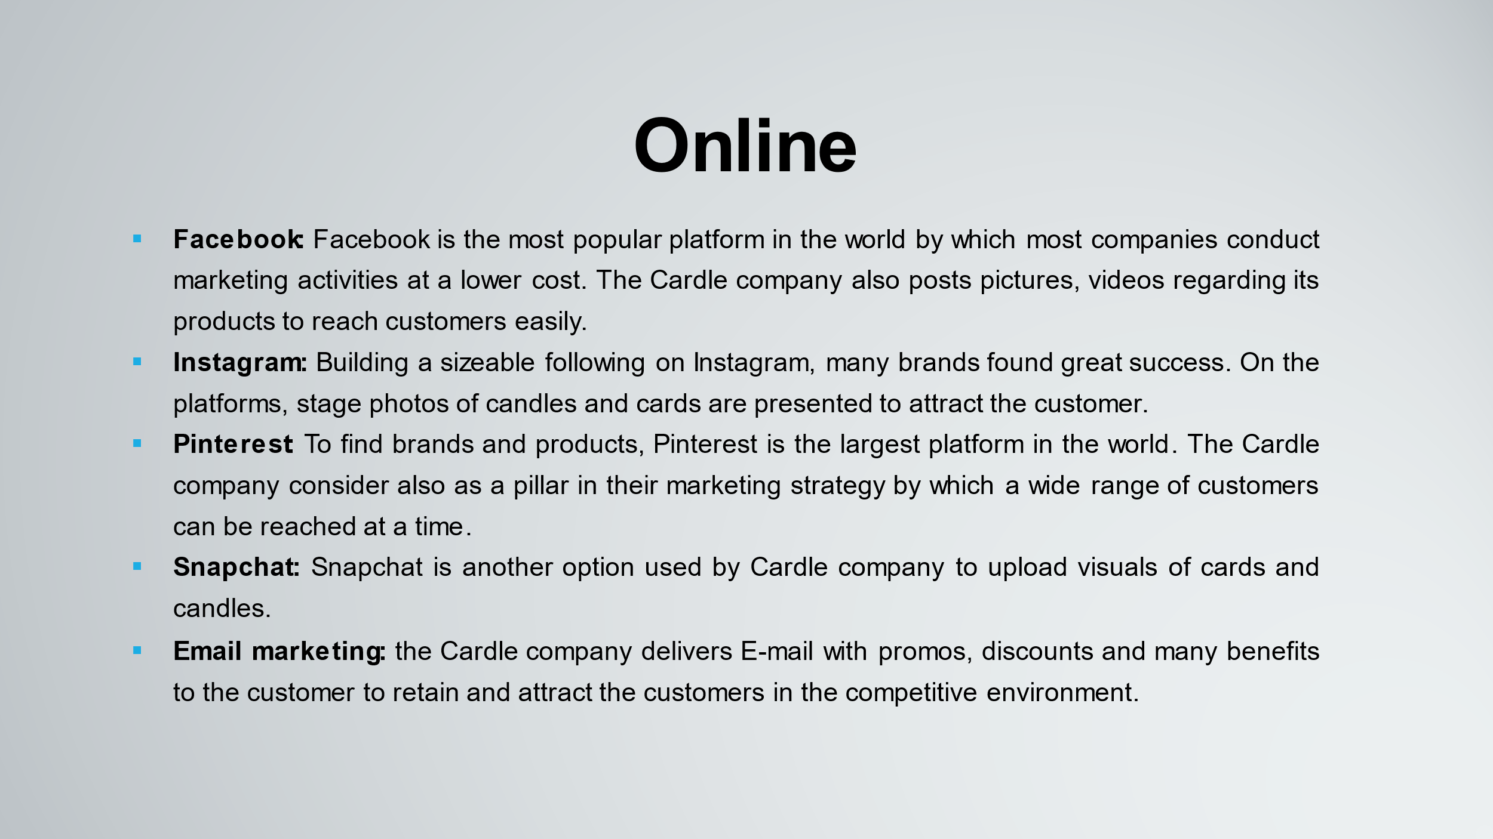
Online: One of the most lucrative mediums to sell cards and candles is to conduct marketing online. By using multiple digital platforms, the Cardle company reach its potential customers across the world (Choi, 2022). Sometimes, the online platforms are not the positive influencer for all the merchants. To be successful in those platforms requires constructive research that provides proper knowledge and guidance. The Cardle company uses the following platforms for marketing its products,
- Facebook: Facebook is the most popular platform in the world by which most companies conduct marketing activities at a lower cost. The Cardle company also posts pictures, videos regarding its products to reach customers easily.
- Instagram: Building a sizeable following on Instagram, many brands found great success. On the platforms, stage photos of candles and cards are presented to attract the customer. To reach out to brand evangelists and provide a behind the scenes peek, Instagram is used.
- Pinterest: To find brands and products, Pinterest is the largest platform in the world. The Cardle company consider also as a pillar in their marketing strategy by which a wide range of customers can be reached at a time.
- Snapchat: Snapchat is another option used by Cardle company to upload visuals of cards and candles (Long, 2014).
- Email marketing: the Cardle company delivers E-mail with promos, discounts and many benefits to the customer to retain and attract the customers in the competitive environment.
Offline marketing
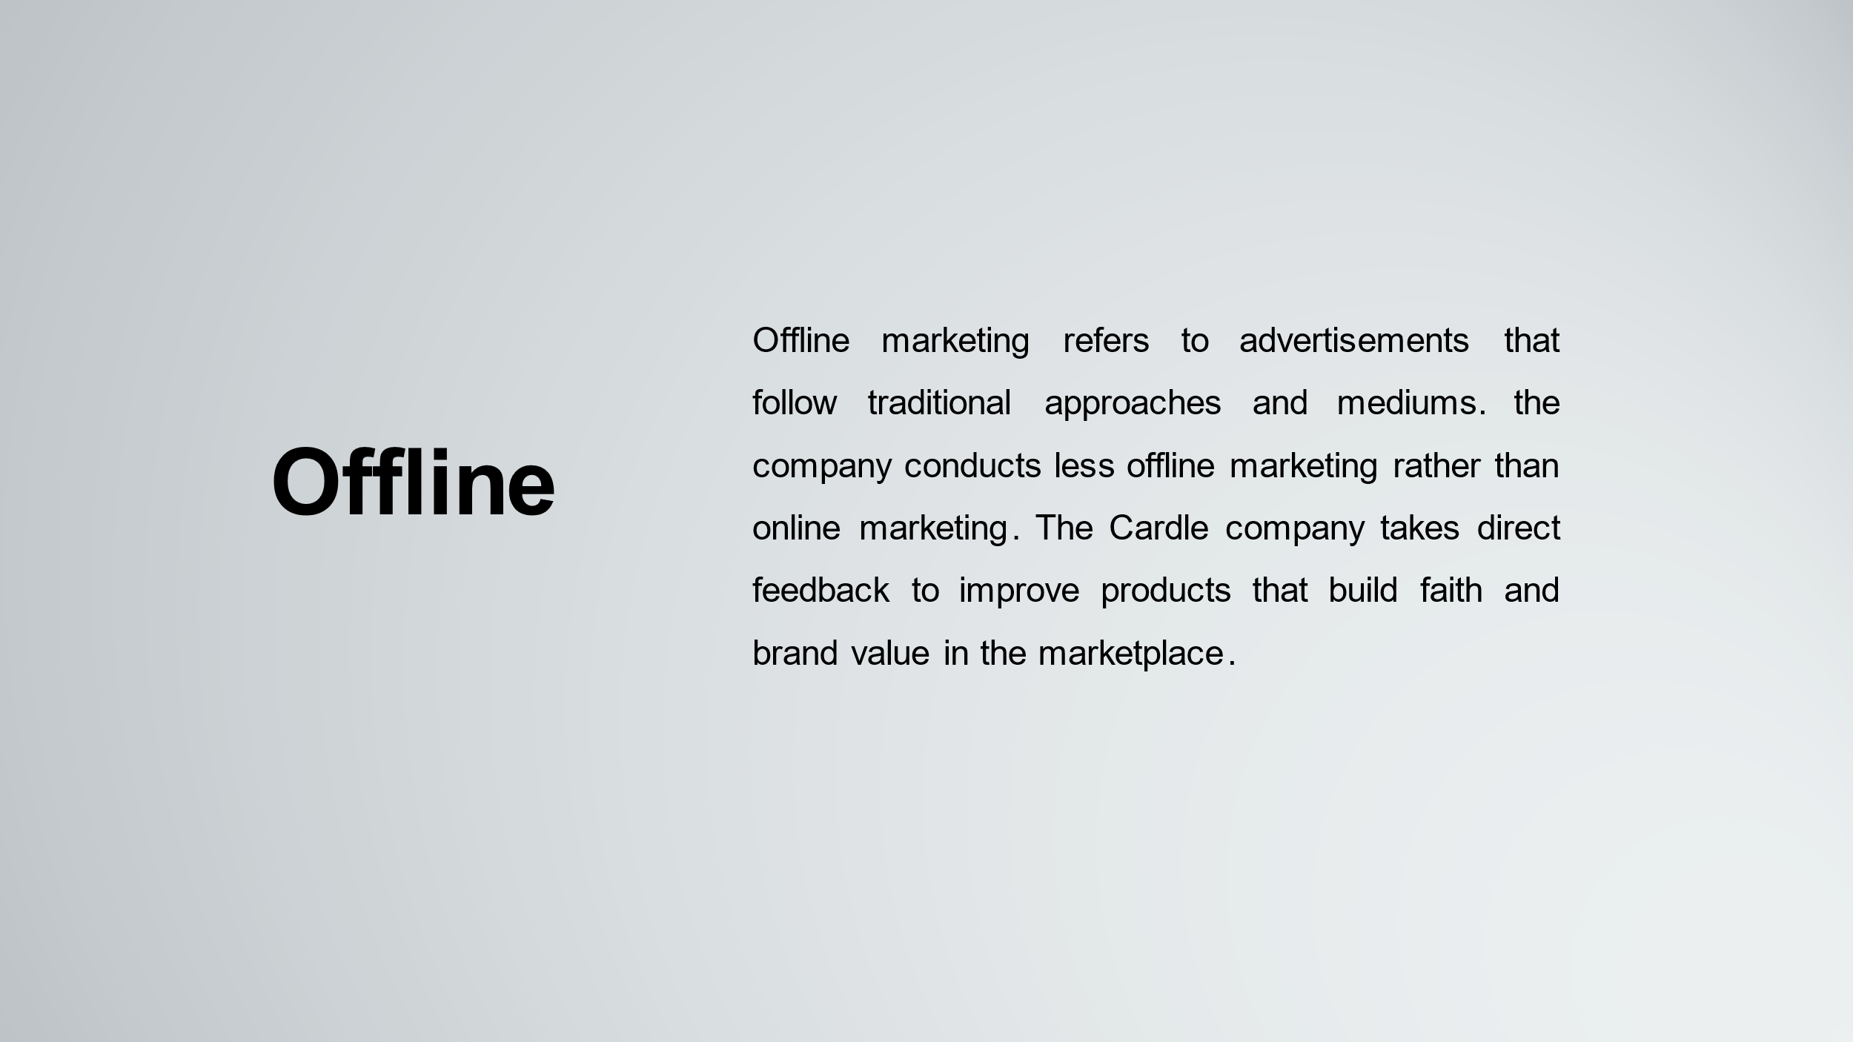
Offline marketing refers to advertisements that follow traditional approaches and mediums. the company conducts less offline marketing rather than online marketing. The Cardle company takes direct feedback to improve products that build faith and brand value in the marketplace.

Pricing Strategy
In selling a product, a business organisation can use a variety of pricing strategies. To determine the most effective pricing strategy for the Cardle company, the Cardle company analyses the pricing segment, pricing position, pricing capability. Based on the competitive analysis, it is clear that the Cardle company follow competition-based pricing strategies in which the product’s price is set when the competition is charging (Sandelands, 2015).

Sales Strategy
Effectively reaching out into the market, the Cardle company makes the strategy to advertise its range of products,
- Advertising on local broadcast and print channels such as radio, TV, Newspapers
- To boost the online presence of the card and candle making business, creating a simple research engine optimised websites for gaining higher online ranking
- Advertising the products on local directory listing (El Sawy, 2016).
- Marketing the business on social media platforms such as Twitter, Facebook, Instagram, etc.
- For advertising cards and candle producing company, attending trade shows and exhibitions.
- To create awareness regarding cards and candle companies, Sending introductory letters to stakeholders and businesses.
- Inviting guests from target markets and organising an opening party to advertise the company.

Management Team
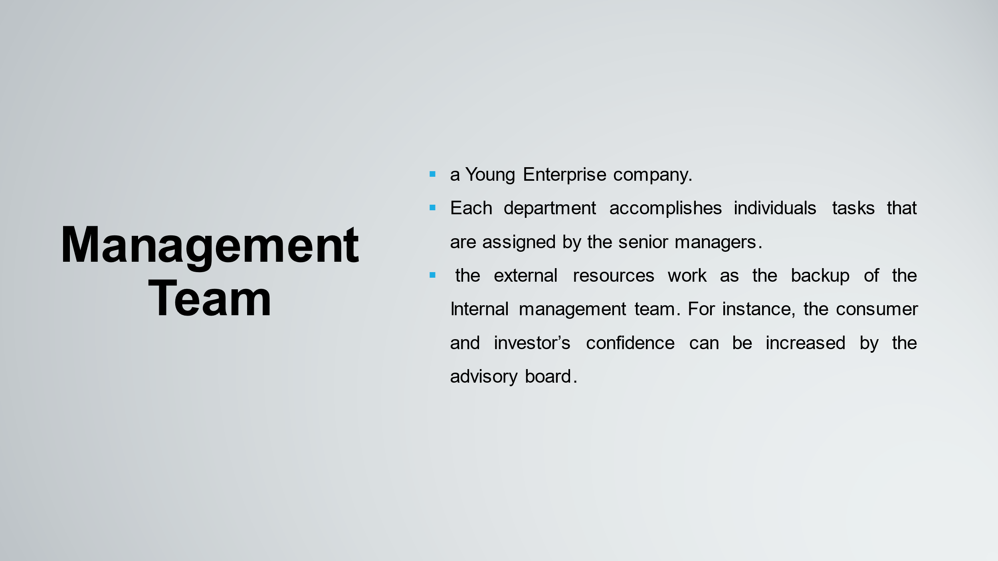
The Cardle company’s management team includes ownership structure, Internal management team, external management resources and Human resources. First of all, Cardle is a Young Enterprise company. Secondly, the internal management team is divided into Sales, marketing, operation, distribution, etc. Each department accomplishes individual’s tasks that are assigned by the senior managers. Thirdly, the external resources work as the backup of the Internal management team. For instance, the consumer and investor’s confidence can be increased by the advisory board.

Financial forecasts
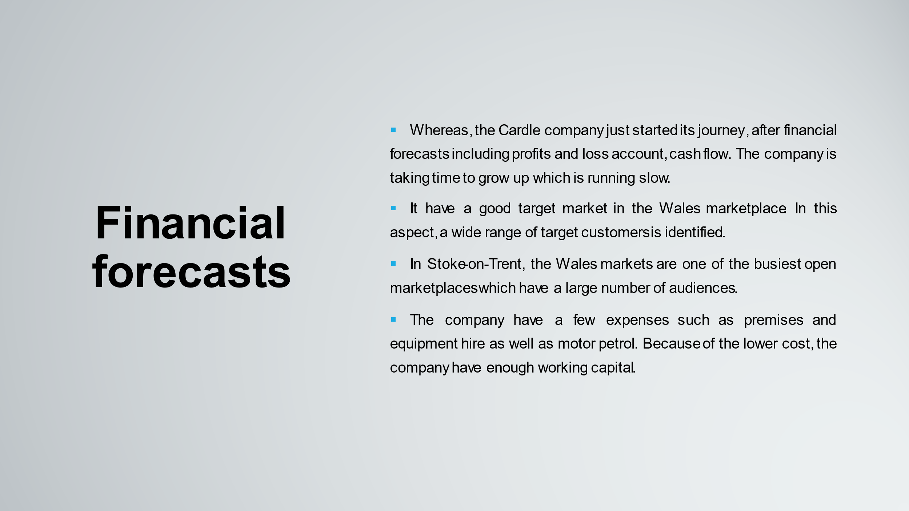
Whereas, the Cardle company just started its journey, after financial forecasts including profits and loss account, cash flow. The company is taking time to grow up which is running slow. Besides, the company have a good target market in the Wales marketplace. In this aspect, a wide range of target customers is identified (Guerard, 2020). In Stoke-on-Trent, the Wales markets are one of the busiest open marketplaces which have a large number of audiences. The company have a few expenses such as premises and equipment hire as well as motor petrol. Because of the lower cost, the company have enough working capital. Besides, a wide range of target audiences is attracted by the products of Cardle company so the company intended to raise a huge amount of money.

Business Justification
To convince the Lottery company UK, the business plan is produced. Purchasing pre-produced products is the main concept of Cardle company such as Candle, cards and in some cases producing products. For the various age groups, the products will be sold. It is important in the competitive environment that cost is kept to a minimum and reasonable, to succeed and make a profit. The company focuses on selling different types of hand-made cards and candles including unscented, scented, floating, etc. Product, as well as market research, is important by which the company is able to forecast its success. Besides, choosing the correct location is more important for marketing a product. Because the products can be sold on various platforms such as market stalls. Compared to high street stores, the Cardle company will see fewer overhead costs.
According to current research proves that trends change over time. For instance, an Un-scented candle is not popular as a scented candle in the marketplace. Creating the desired atmosphere, the products are used for the show (Guerard, 2020). The sale of the total amount of products is increasing means the demand for the products is increasing also. Basically, there are no overhead expenses for accomplishing the project. The main expense is renting the stall which costs approximately £16 per week. In that case, the other major elements are required including electronics, water. The customer gets many opportunities to transfer bargains to our customers. The product’s cost will be minimal and reasonable. For getting success with a project, analysing the business plan is a big deal in the competitive environment. In the dynamic environment, the public is looking for new products to buy and the company’s sales every year is increasing a rate. The market analysis proved that the demand for Candle and Cards are created and purchased by women. After families have been created an environment for candles and cards, with stressful and busy lifestyles combined with working.

Conclusion
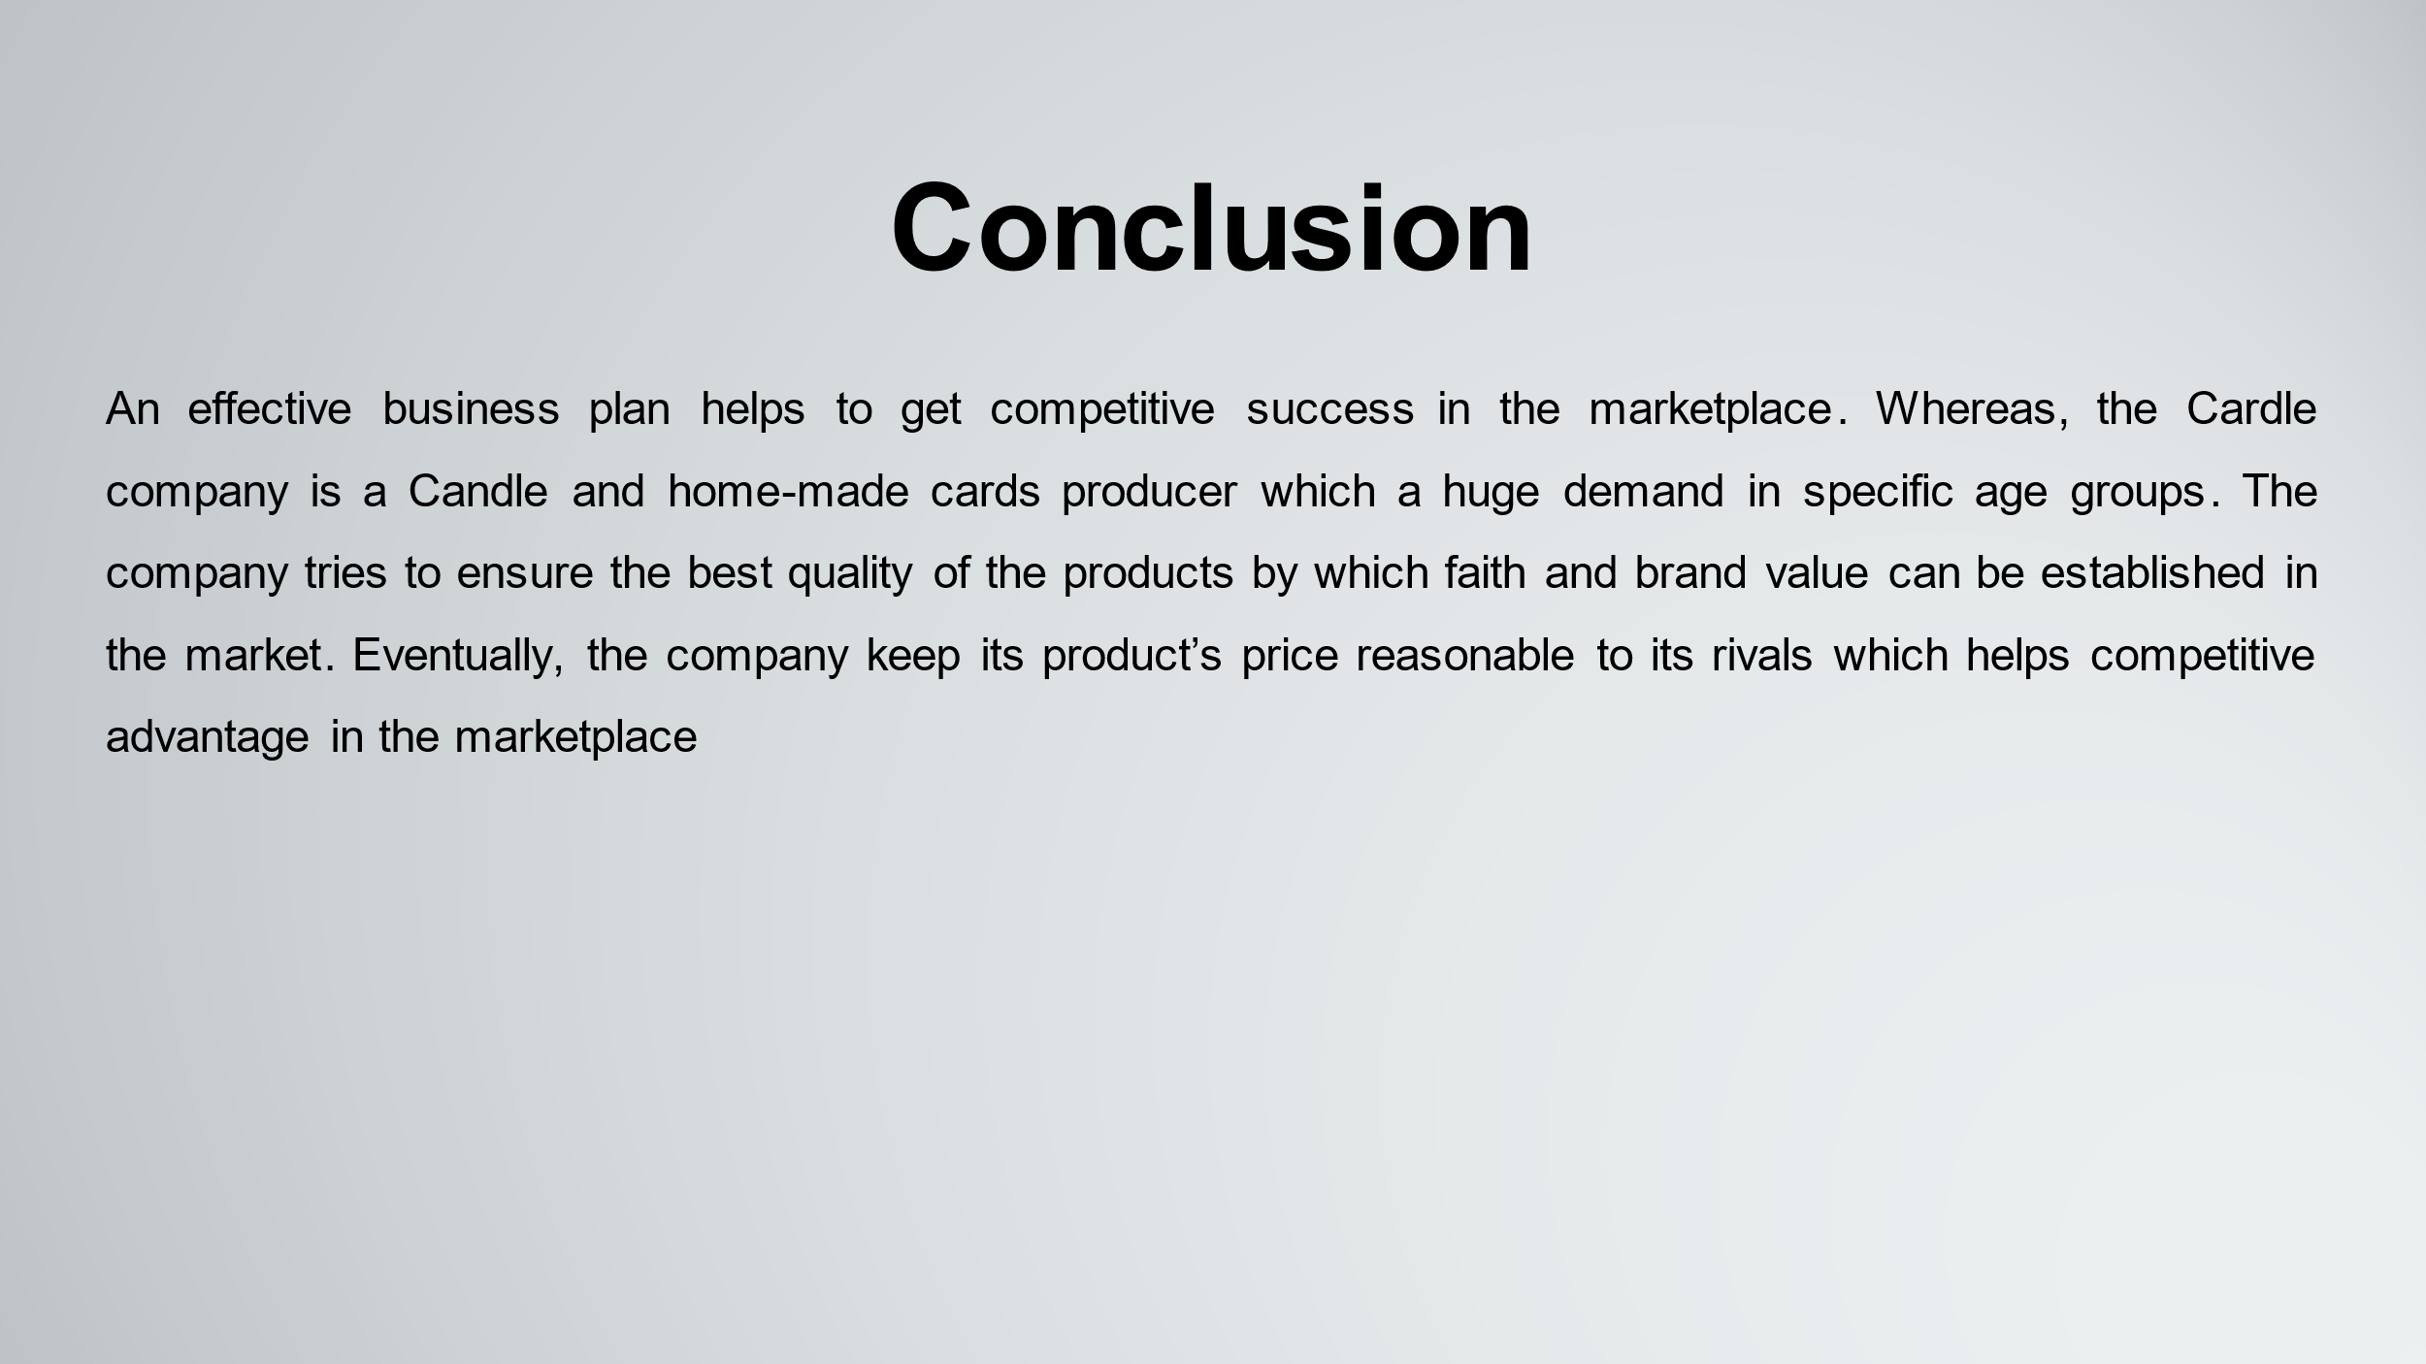
It can be concluded that an effective business plan helps to get competitive success in the marketplace. Whereas, the Cardle company is a Candle and home-made cards producer which a huge demand in specific age groups. The company tries to ensure the best quality of the products by which faith and brand value can be established in the market. Eventually, the company keep its product’s price reasonable to its rivals which helps competitive advantage in the marketplace.

References
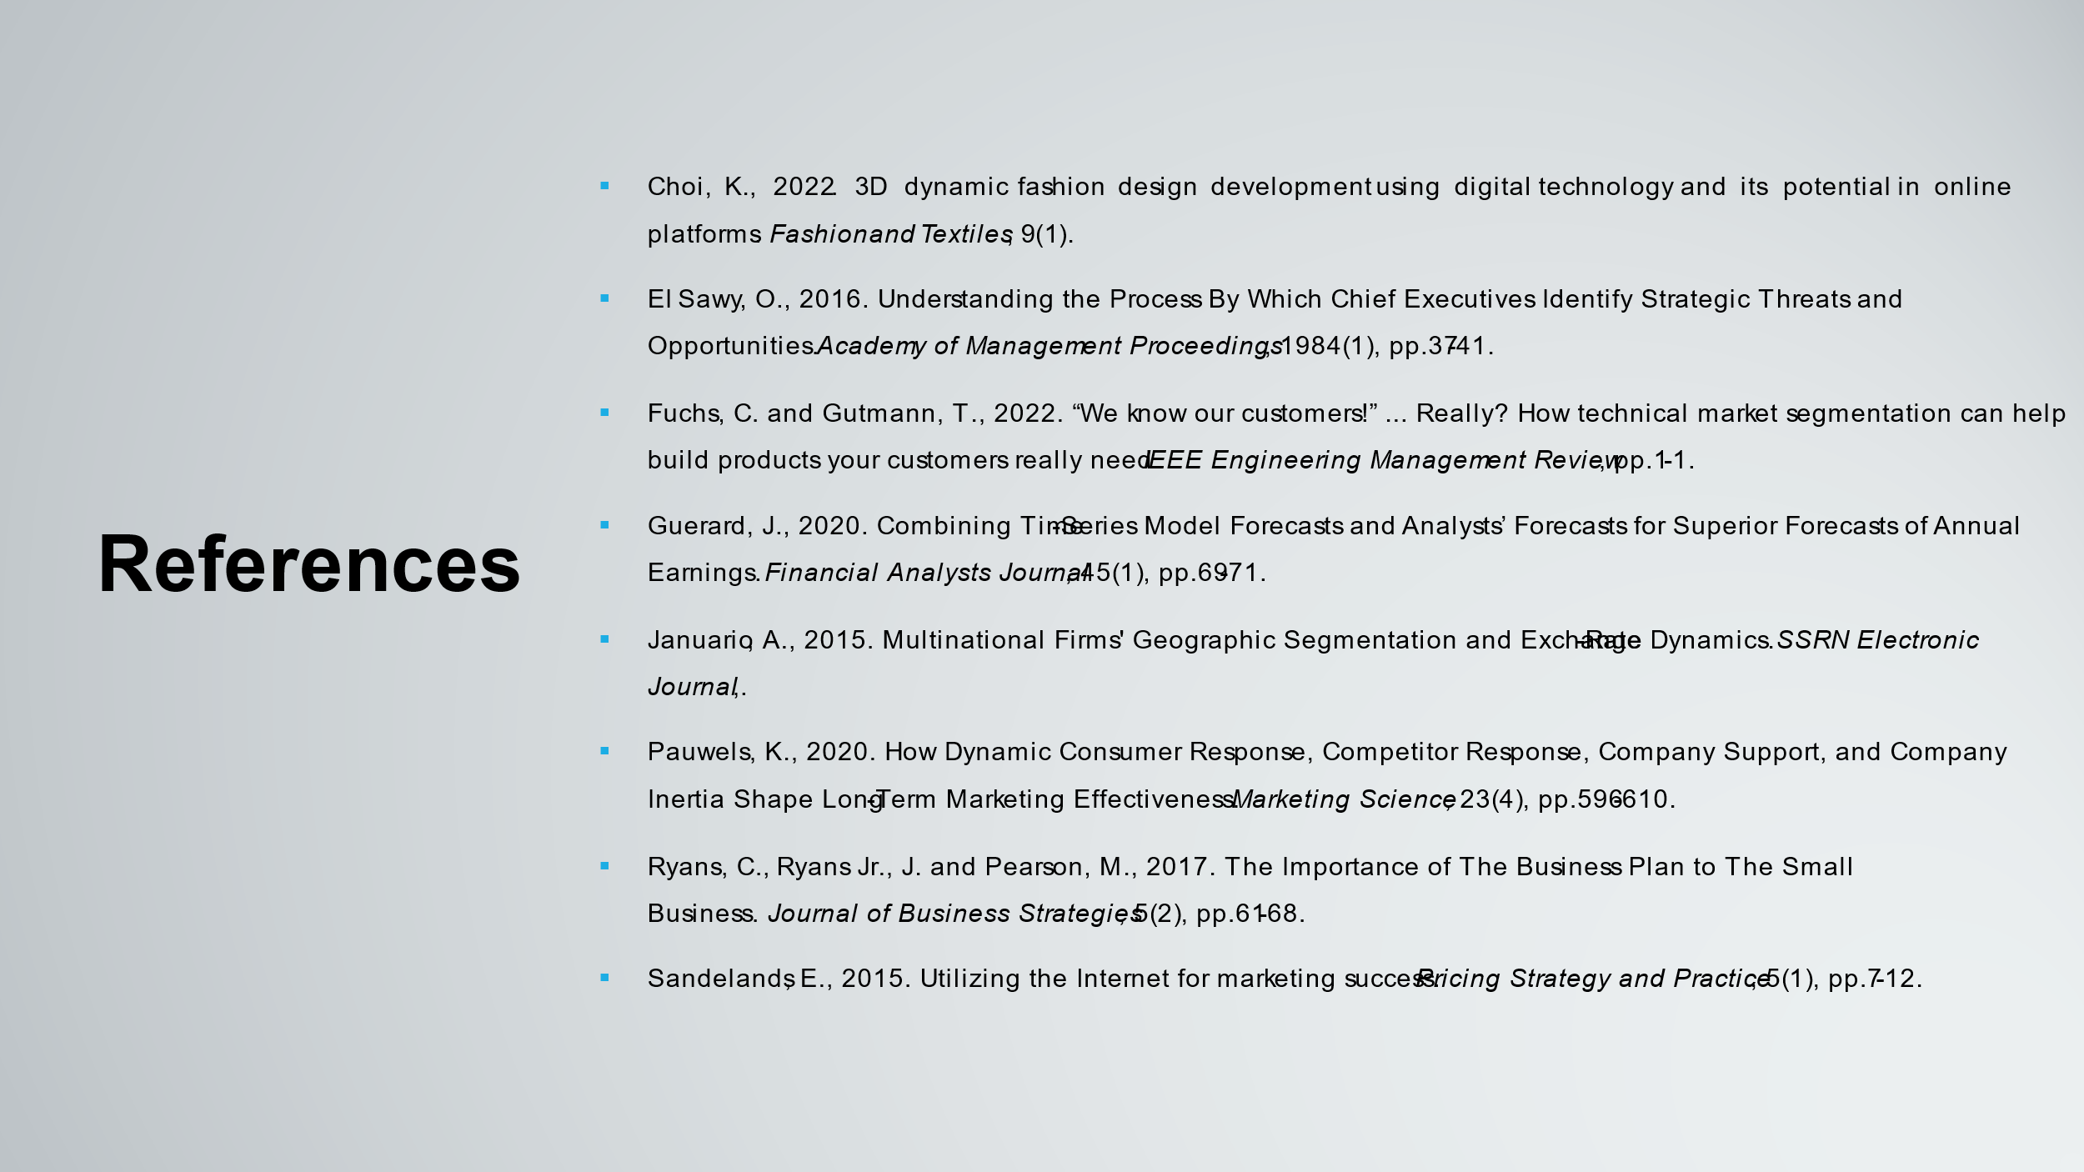
Choi, K., 2022. 3D dynamic fashion design development using digital technology and its potential in online platforms. Fashion and Textiles, 9(1).
El Sawy, O., 2016. Understanding the Process By Which Chief Executives Identify Strategic Threats and Opportunities. Academy of Management Proceedings, 1984(1), pp.37-41.
Fuchs, C. and Gutmann, T., 2022. “We know our customers!” ... Really? How technical market segmentation can help build products your customers need. IEEE Engineering Management Review, pp.1-1.
Guerard, J., 2020. Combining Time-Series Model Forecasts and Analysts’ Forecasts for Superior Forecasts of Annual Earnings. Financial Analysts Journal, 45(1), pp.69-71.
January, A., 2015. Multinational Firms' Geographic Segmentation and Exchange-Rate Dynamics. SSRN Electronic Journal.
Long, H., 2014. Exploring the Principal Factors Influencing IPOs in the Emerging Growth Enterprise Market of China. International Journal of Trade, Economics and Finance, pp.77-81.
Panov, V., Koverda, M., Gavrilov, B. and Kucherenkov, S., 2018. Theoretical substantiation of the cryoscopic method for determination of the degree of lactose hydrolysis in milk whey. Dairy Industry, (6), pp.19-20.
Pauwels, K., 2020. How Dynamic Consumer Response, Competitor Response, Company Support, and Company Inertia Shape Long-Term Marketing Effectiveness. Marketing Science, 23(4), pp.596-610.
Ryans, C., Ryans Jr., J. and Pearson, M., 2017. The Importance of The Business Plan to The Small Business. Journal of Business Strategies, 5(2), pp.61-68.
Sandelands, E., 2015. Utilizing the Internet for marketing success. Pricing Strategy and Practice, 5(1), pp.7-12.

