Shaun Farthing
Student number: 1708439
Abstract
Evaluation of current available weather stations, compare and contrast sensors, connectors and components required to produce a bespoke marine weather station. Produce full circuit schematic drawings and PCB design. Finishing with costings and evaluation.
Marine weather monitor/ logger
Module code: ACDA6002
Dr Gary Jones

Table of Contents
Tables and figures 2
Introduction 4
Literature review 5
Background research 5
Existing Systems 6
Sensor selection 8
Combined Temperature and Humidity 8
Wave height 10
Wind speed & direction 12
Sunlight brightness 14
GPS position 16
Connector selection 17
LED’s 19
Battery sizing & selection 20
Enclosure selection 21
Microcontroller selection 22
Non-volatile memory 24
Structure Diagram 25
Data acquisition cycle 26
Schematic design 27
Power circuit 27
Temperature & humidity 28
Wave height 28
Wind speed & direction 29
Sunlight brightness 29
GPS sensor 30
USB 30
Non-volatile memory 30
LED’s 31
PIC layout 32
PCB Design 33
Prototype build cost 37
Future Improvements 38
References 39

Tables and figures
Figure 1 - Weatherpak marine 6
Figure 2 - RWS - 07 6
Figure 3 - Vantage Pro2 6
Figure 4 - HydroMet MAWS201 6
Figure 6 - Omega HX94BV1 9
Figure 7 - ATO - LEVS - ZP 11
Figure 8 – Gill Windsonic 13
Figure 9 - Apogee SP-215 15
Figure 10 - Standard horizon SCU-31 16
Figure 11 - 4 pin panel connector 18
Figure 12 - 4 pin cable connector 18
Figure 13 - 3 pin panel connector 18
Figure 14 - 3 pin cable connector 18
Figure 15 - 12v present LED 19
Figure 16 - Flashing indication 19
Figure 17 – Yuasa L35-90 battery 20
Figure 18 - Challenger TR5013 enclosure 21
Figure 19 - PIC18F25K50 23
Figure 20 - SanDisk SD Card 24
Figure 21 - Structure diagram 25
Figure 22 - Data acquisition cycle 26
Figure 23 - Proteus overall schematic design 27
Figure 24 - Power supply circuit 27
Figure 25 - Temperature & humidity 28
Figure 26 - Wave height 28
Figure 27 - Wind speed & direction 29
Figure 28 - Sunlight brightness 29
Figure 29 - GPS sensor circuit 30
Figure 30 - USB circuit 30
Figure 31 - Non-volatile memory circuit 30
Figure 32 - LED circuits 31
Figure 33 - PIC layout 32
Figure 34 - Easy-PC schematic 33
Figure 35 - Top copper layer of PCB 33
Figure 36 - Bottom copper layer 34
Figure 37 - PCB all layers 34
Figure 38 - Top layer 3D view 35
Figure 39 - Bottom layer 3D view 35
Figure 40 - Design rule check 36
Figure 41 - Prototype build cost 37

Table 1 - Existing systems 7
Table 2 - RH and temperature technology types 8
Table 3 - Manufacturer's RH & Temp 9
Table 4 - Wave height measurement technologies 10
Table 5 - Manufacturer's ultrasonic transducer 10
Table 6 - Wind speed & direction technology types 12
Table 7 – Manufacturer’s wind speed & direction sensors 13
Table 8 - Sunlight brightness technology types 14
Table 9 - Manufacturer's pyranometers 15
Table 10 - Manufacturers GPS antennas 16
Table 11 - 4 pin connectors 17
Table 12 - 3 pin connectors 18
Table 13 - Resolution requirements 22
Table 14 - PIC specification 23
Table 15 - Non-volatile memory requirement 24

Introduction

This report details the tasks required to design a microcontroller based marine weather monitor/ logger. Firstly, current market systems are analysed, compared and evaluated. The report then looks at the different sensor types available to measure temperature, humidity, wave height, wind speed, wind direction, sunlight brightness and GPS position. Connector types and suitability for each sensor is then researched and documented. A microcontroller will be selected based on the chosen sensor requirements and calculations. Data storage, data transfer, power supply and a transportation system will be designed and documented in this report. The circuit design will be carried out using Proteus software, this will then transfer to the Easy-PC software for PCB design. The report concludes with a cost table for the prototype build and a full project review.

Literature review

Background research
Weather data acquisition is the process of sampling signals that measure real world physical conditions and converting the resulting samples into values that can be manipulated by a computer. [1] A marine weather monitor/ logger is a device that collects data related to the weather and environment using many different sensors. Weather station sensors may include air temperature, wind speed and direction, humidity and barometric pressure. [2] Data acquisition systems serve a very important part of many systems, they tie together a range of sensors measuring lots of different processes. Many have the ability to visually relay live data and/ or store data to be transferred elsewhere later. [3]

Existing Systems
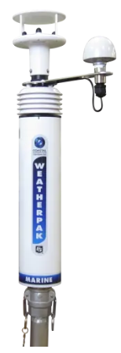
Campbell scientific Weatherpak marine is a professional - level meteorological weather monitoring system in a compact, rugged, and easy-to-install package. It can be used in a wide range of industries and has the ability to be able to add additional instruments. [4]
Figure 1 - Weatherpak marine

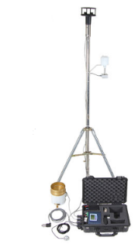
Omni instruments RWS-07 is a portable, solid-state weather station. The RWS-07 can monitor pressure, temperature, rainfall and many other weather conditions. It has a 6-month battery capability and all data can be transferred in Excel or CSV format. [5]
Figure 2 - RWS - 07
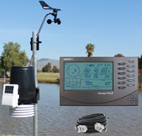
The vantage pro 2 is a compact, robust and accurate weather station. It has multiple sensor options and offers output alarm contacts. Power can be provided by mains or battery. There is a hand-held visual console with the option of a weather link to a PC. [6]
Figure 3 - Vantage Pro2

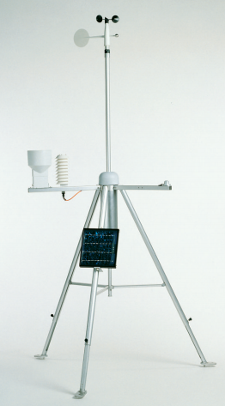
The Vaisala HydroMet MAWS201 portable automatic weather station is designed for temporary installation. It’s lightweight, robust and suitable for demanding meteorological applications. The HydroMet is fully adjustable to suit uneven terrains. [7]
Figure 4 - HydroMet MAWS201

Manufacturer | Campbell Scientific | Omni Instruments | Davis Instruments | Vaisala
Model | Weatherpak Marine | RWS - 07 | Vantage Pro2 | HydroMet MAWS201
Picture |  | 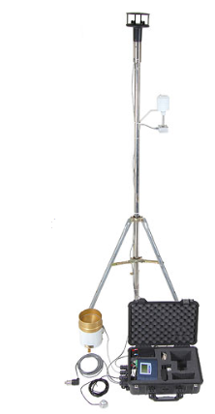 | 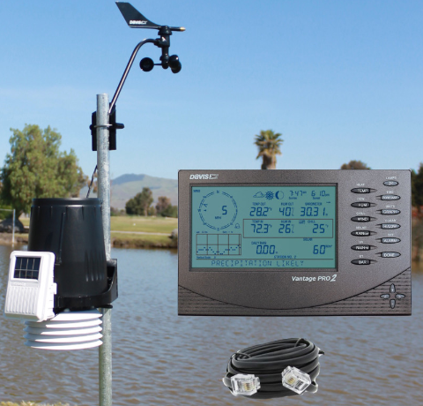
Instrument types | Air temp, relative humidity, barometric pressure, wind speed/ direction, compass. | Wind Speed, direction, Temperature, Humidity, Rainfall  Solar Radiation, Barometric Pressure | Wind speed, direction, rain collector, temperature, relative humidity, | Wind, pressure, air temperature, relative humidity, solar radiation, precipitation, soil/ water temperature, soil moisture
Input voltage | 9.6 – 16 vdc Optional power cable (AC/DC) | 12vdc | 5VDC adaptor with battery back up | 12VDC with solar panel and 7Ah battery back up
Inputs/ outputs | 6 integrated instruments plus additional through junction box | 4-8 x 4-20mA, 0-10v  T/C, mV, 8 x Digital  2 x Counter | Integrated sensor suite (ISS) contains rain collector, anemometer, passive radiation shield. | 10 analogue inputs, 2 counter/ frequency inputs, internal channel for pressure sensor
Data transfer/ storage | NMEA 0183, RS-232, RS-485, TCP/IP, UHF, satellite | Direct RS232, USB | USB | RS-232, 2 wire RS-485, SDI-12
Sample rate | 100Hz | 1 second to 12 hours | Dependant on sensor | Dependant on sensor
Logging duration/ battery life | Power supply | Up to 6 months | 1 month on battery | 12 months
Storage/ memory | 4MB | 1.8 million readings | Weatherlink option to upload straight to computer/ database. | 3.3MB internal, 2GB on Compact Flash card
Durability | Military-Standard 6061-T6 anti-corrosive aluminium; coated with a baked-on thermoplastic resin | IP67 weatherproof case | UV resistant ABS plastic | Anodized aluminium, NEMA 4X, IP66.
Cost | £2,740.70 | £2,414.80 | £909.90 | £2,987.00
Web  address | https://www.campbellsci.co.uk/weatherpak-marine  [4] | https://www.omniinstruments.co.uk/rws-07-portable-weather-station-1082.html  [5] | https://www.weather-station-products.co.uk/cabled-vantage-pro2-bundle  [6] | https://www.vaisala.com/en/products/instruments-sensors-and-other-measurement-devices/weather-stations-and-sensors/maws201  [7]
Table 1 - Existing systems

Sensor selection

Combined Temperature and Humidity

Sensor type | Humidity and Temperature integrated circuit sensor | Relative humidity (capacitive/ resistive) and temperature sensor ( Thermistor/ RTD/ TC temperature sensor) | Thermometer hygrometer
Cost | Low | Medium | High
Accuracy | High | High | High
Environmental suitability | Low | High | Low
Operating range suitability | High | Medium | Medium
Installation suitability | Low | Medium | High
Table 2 - RH and temperature technology types
The sensor technology chosen is a RH and temperature transducer.
Manufacturer’s options;
Manufacturer | Omega | Measurement Systems LTD | Omni instruments | Dwyer instruments
Model | HX94BV1 | RHT-02 | Hygroclip 2. Mini probes | WHT-333
Image | 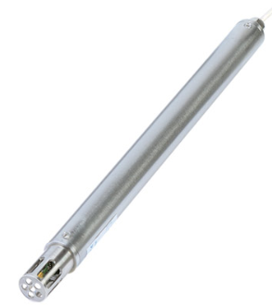 | 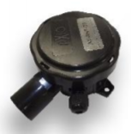 | 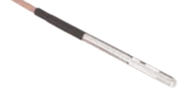 | 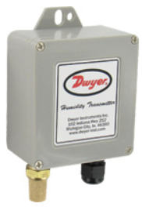
Power supply | 9–30 Vdc | 24V ac/dc | 3.2-5VDC | 10-35VDC
Power consumption | 100mA | 10mA | 4.5mA | 5mA
Output | 0–5vdc | 0-5Vdc | 0-1 V | 0-5V
Environmental protection | IP66 stainless steel NEMA4 | IP65 plastic | Nickel plated brass | IP54, NEMA3S, ABS.
Connections | 4 pin | 5 pin | 7 pins | 4 pins
Operating range | Temp = 0-100 degC. RH = 0-100%. | Temp= -20+50degC. RH=0-95%. | Temp= -40+60degC. RH=0-100%. | Temp=-40+60degC. RH=0-100%.
Cost | £243.00 | £75.00 | £477.00 | £300.00
Web | https://www.omega.co.uk/pptst/HX94B.html | https://www.measurementsystems.co.uk/rht-3-o_outside_temperature__relative_humidity_transmitter | https://www.omniinstruments.co.uk/temperature-and-humidity/temperature-relative-humidity-probes/hygroclip-2-mini-probes.html#upsell-product-div | https://www.dwyer-inst.co.uk/Product/AirQuality/Humidity-TemperatureTransmitters/SeriesWHT#specs
Table 3 - Manufacturer's RH & Temp
On evaluation, the HX94BV1 from Omega was chosen because it offers the best environmental protection. Due to the harsh marine conditions it will be operating in, it was the most desirable. [8]
Figure 6 - Omega HX94BV1

Wave height

Sensor type | Pressure based sensor | Ultrasonic | Capacitive level probes
Cost | Low | Medium | High
Accuracy | Medium | High | Medium
Environmental suitability | High | High | High
Operating range suitability | High | High | Low
Installation suitability | Medium | High | Medium
Table 4 - Wave height measurement technologies
The technology type chosen to measure wave height is ultrasonic.
Manufacturer’s options;
Manufacturer | Siemens | ATO | APG | Gems sensors
Model | LU240 | ATO-LEVS-ZP | IRU-9429-C6 | UCL-520
Image | 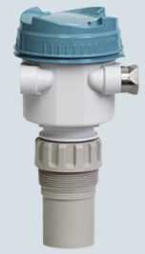 | 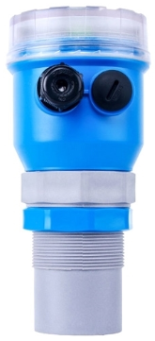 | 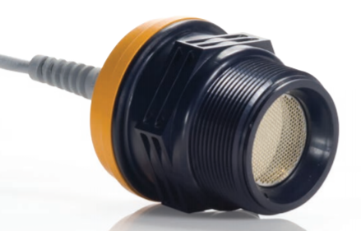 | 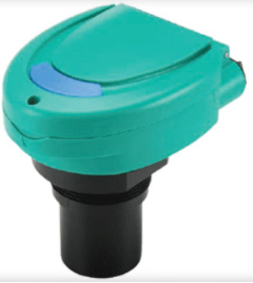
Power supply | 10.5-30 V DC | 12-24VDC | 12-28VDC | 12-28 VDC
Power consumption | 20mA | 125mA | 75mA | 22mA
Output | 4-20mA | 0-5V | 0-5V | 4-20mA
Environmental protection | Type 4X, Type 6, IP66 | IP68 | NEMA12 | NEMA4X, IP65
Connections | 2 pin | 3 pin | 5 pin | 2 pin
Operating range | 0.2-12m | 0-40m | 0.15-10.67m | 1.8-8m
Cost | £984.20 | £536.50 | £499.40 | £1,006.87
Web | https://www.finecontrols.co.uk/level-control/level-transmitters/ultrasonic-level-transmitters/ultrasonic-level-transmitter-lu240 | https://www.ato.com/ultrasonic-level-sensor-40m | https://www.bellflowsystems.co.uk/iru-9400-general-purpose-ultrasonic-level-transmitter.html?category_id=1210 | https://www.gemssensors.co.uk/level/continuous-transmitters/ultrasonic/ucl-520
Table 5 - Manufacturer's ultrasonic transducer

Following evaluation, the ATO – LEVS – ZP has been chosen, because it has a suitable IP rating, a favourable voltage output and is mid-range priced. [9]
Figure 7 - ATO - LEVS - ZP
Please note, when using the ultrasonic transducers to measure wave height, two transducers need to be used. One needs to be connected to an open ended pipe, this will allow the pipe to fill quickly, the second needs to be connected to a pipe with a small opening, and this will allow a damped signal and slow changing level. The difference between the two readings is the wave height.

Wind speed & direction

Sensor type | Ultrasonic | Vane anemometer | Cup anemometer | Thermal anemometer
Cost | High | Medium | Low | High
Accuracy | High | High | High | High
Environmental suitability | High | Medium | Low | Medium
Operating range suitability | High | High | Low | High
Installation suitability | High | High | Medium | Medium
Table 6 - Wind speed & direction technology types
The technology type chosen is ultrasonic as there are no moving parts. All other options have physical, mechanical moving parts. The less moving parts, the less susceptible to damage the instrument will be.
Manufacturer’s options;
Manufacturer | Nova Lynx | Richard Paul Russell | FT Technologies | Gill
Model | 200-8100 | WS3 | FT742 | Windsonic
Image | 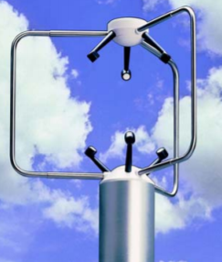 | 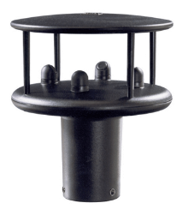 | 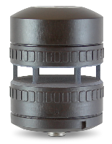 | 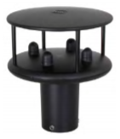
Power supply | 12-30 Vdc | 7-30 V dc | 6-30V DC | 5-30 V DC
Power consumption | 333mA | 5.5mA | 29mA | 44mA
Output | 0-5V | 0-5V | RS422, RS485 | 0-5V
Environmental protection | UV stabilized thermoplastic, Stainless steel and anodised aluminium. | IP65 | IP66 | IP66
Connections | 5 pin | 5 pin | 8 pin | 5 pin
Operating range | Wind speed = 0-40m/s. Wind direction = 0-360° | Wind speed = 0-60m/s. Wind direction = 0-359° | Wind speed = 0-75m/s. Wind direction = 0-360° | Wind speed = 0-60m/s. Wind direction = 0-359°
Cost | £1950.00 | £1272.00 | £1250.00 | £640.00
Web | https://novalynx.com/store/pc/200-81000-Ultrasonic-Anemometer-19p335.htm | https://www.r-p-r.co.uk/windsystems/windsonic.php | https://fttechnologies.com/wind-sensors/ft7-series/surface-mount/ | https://www.omniinstruments.co.uk/weather-stations-and-instruments/wind-speed-and-direction-sensors/windsonic-solid-state-wind-speed-and-direct [10]ion-sensor.html#upsell-product-div
Table 7 – Manufacturer’s wind speed & direction sensors
Following comparison, the chosen instrument is the Windsonic by Gill as it’s most cost effective. All instruments were suitable. [10]
Figure 8 – Gill Windsonic

Sunlight brightness

Sensor type | Pyranometer | Pyrheliometers | Light dependant resistor | Spectrometer
Cost | Medium | High | Low | High
Accuracy | High | High | Medium | Medium
Environmental suitability | High | High | Medium | Low
Operating range suitability | High | High | Medium | High
Installation suitability | High | High | Low | Low
Table 8 - Sunlight brightness technology types
The sensor type selected is a pyranometer. The pyranometer offered the most suitable all round option with a mid-range price.
Manufacturer’s options;
Manufacturer | Kipp & Zonen | Hukesflux | Apogee Instruments | Li-cor
Model | SP Lite2 | SR05-D1A3 | SP-215 | LI-200R
Image | 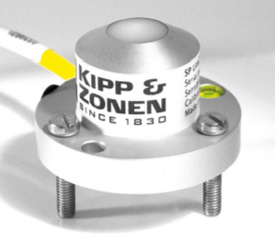 | 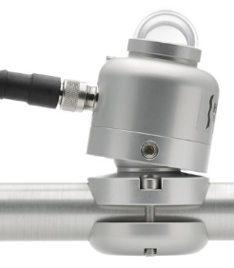 | 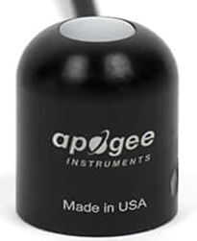 | 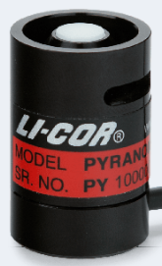
Power supply |  | 5-30VDC | 5.5-24 V DC | 3.8-28 V
Power consumption |  | 6mA | 0.3mA | 1mA
Output |  | 0-1V | 0-5V | -2.5-5V
Environmental protection | IP67 | IP67 | IP68 marine grade stainless steel | Weatherproof anodised aluminium
Connections | 3 pin | 4 pin | 4 pin | 3 pin
Operating range | 400-100nm | 285-3000nm | 360-1120nm | 400-1100nm
Cost | £330.00 |  | £197.00 | £325.00
Web | https://www.omniinstruments.co.uk/weather-stations-and-instruments/pyranometers-solar-irradiance/sp-lite2-silicon-pyranometer.html#upsell-product-div | https://www.hukseflux.com/products/solar-radiation-sensors/pyranometers/sr05-d1a3-pyranometer | https://www.apogeeinstruments.com/sp-215-ss-amplified-0-5-volt-pyranometer/#product-tab-description | https://www.licor.com/env/products/light/pyranometer.html?gclid=EAIaIQobChMI8cjgpqmP5wIVFODtCh3klgvDEAMYAiAAEgJ3ePD_BwE
Table 9 - Manufacturer's pyranometers
After comparing, the Apogee SP-215 is chosen. It offers the best environmental protection, a desired output and is most reasonably priced. [11]

Figure 9 - Apogee SP-215

GPS position

Manufacturer | Garmin | B&G | SparkFun | Standard Horizon
Model | GPS16X-HVS | ZG100 | GPS-12751 | SCU-31
Image | 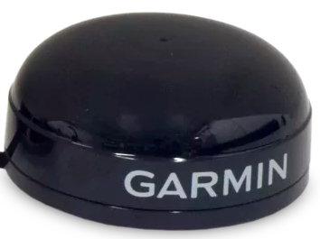 | 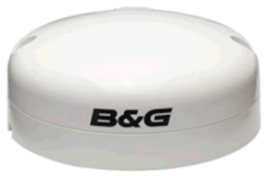 | 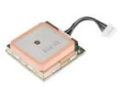 | 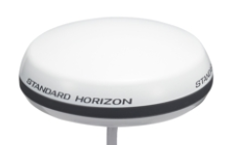
Power supply | 8-40 Vdc | 9-18v | 4.5-6.5Vdc | 10-35 VDC
Power consumption | 65mA | 100mA | 55mA | 25mA
Output | Position <15m | Position 3m | Position <2.5m | Position 2.5m
Environmental protection | IPX7, immersed in 1m of water for 30m | IPX-7 | Requires suitable enclosure | IPX7
Connections | 8 pins |  | 6 | 4 pin
Cost | £87.00 | £268.00 | £32.00 | £109.00
Web | https://www.campbellsci.com/gps16x-hvs | https://www.bandg.com/bg/type/instrument-sensors-and-transducers/gps-sensors/gps-antenna-bg-zg100-module-pack/#prl_product_details | https://www.mouser.co.uk/ProductDetail/SparkFun/GPS-12751?qs=sGAEpiMZZMsjLMBIknjmkr7UcSbxhsyWkbeQM%2FV612RTadYIA5zSIw%3D%3D | https://www.cactusnav.com/standard-horizon-external-antenna-with-cable-p-27129.html?gclid=EAIaIQobChMIg-m95sWP5wIVArTtCh2OMQ-tEAQYASABEgIRUPD_BwE
Table 10 - Manufacturers GPS antennas
After comparing, the Standard horizon SCU-31 was chosen. It boasts a high accuracy position, suitable IP rating and minimal current draw. [12]
Figure 10 - Standard horizon SCU-31

Connector selection
All connectors are to have a high IP rating (IP67/68) to protect against water ingress, gold plated contacts to prevent corrosion and possible bad connections and a weather resistant body material.
Temperature & humidity – 4 contacts
Pin 1 - + power supply, pin 2 – 0v, pin 3 – temperature output, and pin 4 – humidity output.
Wave height – 3 contacts
Pin 1 - + power supply, pin 2 – 0v, pin 3 – signal.
Wind speed & direction – 4 contacts
Pin 1 – signal ground, pin 2 - + power supply, pin 3 – wind direction, pin 4 – wind speed.
Sunlight brightness – 4 contacts
Pin 1 - + power supply, pin 2 – ground, pin 3 – signal, and pin 4 – shield/ ground.
GPS position – 4 contacts
Pin 1 - + power supply, pin 2 – ground, pin 3 – R/X signal, and pin 4 – T/X signal.
All connectors require 3 or 4 pins. Research has been completed to determine the most suitable connector, the selected connector has been highlighted in yellow on the tables below. Both the connector types selected meet the IP rating required, have gold plated, non-corrosive contacts and also a weather resistant body. The same connectors are going to be used on all sensors requiring 4 pins. The sensor and associated connector will both be identified using a coloured marker to avoid plugging the wrong connector into the wrong sensor.
Manufacturer | Amphenol | Amphenol | Souriau-sunbank | Souriau-sunbank | Lumberg | Lumberg
Model No. | C09131H0041002 | C091-31N004-1002 | UTS7104S | UTS6JC124P | 030404 | 033204
Supplier | RS Components – 157 - 2461 | RS Components – 157-2534 | Digi-key SOU1280-ND | Digi-key SOU1300-ND | RS Components – 533-7795 | RS Components – 170-5486
Image | 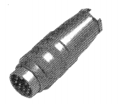 | 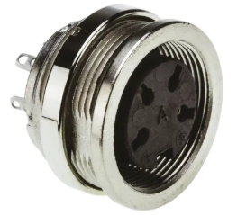 | 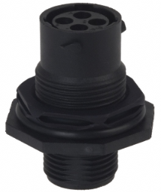 | 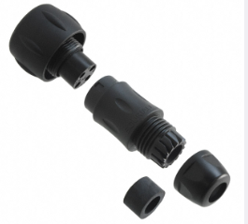 | 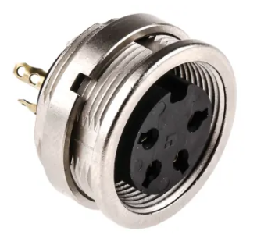 | 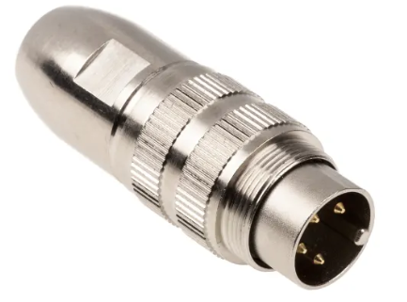
Contacts | 4 | 4 | 4 | 4 | 4 | 4
IP rating | IP67 | IP67 | IP69K | IP69K | IP68 | IP68
Contact material | Silver plated | Silver plated | Gold plated | Gold plated | Gold plated | Gold plated
Body material | Die cast nickel plated | Die cast aluminium, nickel plated | Thermoplastic | Thermoplastic | Glass filled polyamide (PA GF) | Glass filled polyamide (PA GF)
Cost | £9.82 | £6.41 | £8.88 | £13.55 | £4.52 | £5.34
Table 11 - 4 pin connectors
Manufacturer | TE Connectivity | TE Connectivity | MBS Connect | MBS Connect | Bulgin | Bulgin
Model No. | HD10-3-96P | HD14-3-96P | SP1312/S3C | SP1310/S3IIC | PX0731/P | PX0730/S
Supplier | Digi-key 1734-1308-ND | Digi-key 1734-1300-ND | Farnell – CN21343 | Farnell – CN21315 | Farnell – CN08568 | Farnell – CN08589
Image | 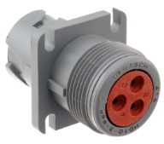 | 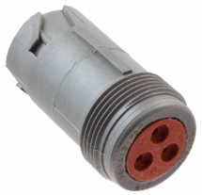 | 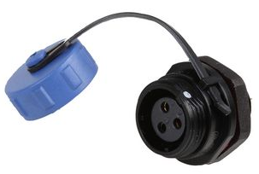 | 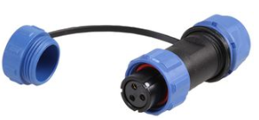 | 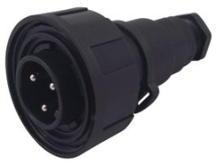 | 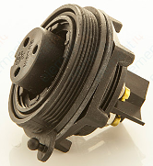
Contacts | 3 | 3 | 3 | 3 | 3 | 3
IP rating | IP68 | IP68 | IP68 | IP68 | IP68 | IP68
Contact material | Gold plated | Gold plated | Gold plated | Gold plated | Nickel | Nickel
Body material | Glass filled polyamide (PA GF), nylon | Glass filled polyamide (PA GF), nylon | Nylon polyamide | Nylon polyamide | Nylon polyamide | Nylon polyamide
Cost | £4.38 | £4.74 | £2.43 | £2.43 | £8.12 | £6.39
Table 12 - 3 pin connectors
[13] [14] [15]

Figure 11 - 4 pin panel connector

Figure 12 - 4 pin cable connector

Figure 13 - 3 pin panel connector
Figure 14 - 3 pin cable connector

LED’s

LED 1 indicates that 12v is present. LED 2 flashes once every 10 seconds, the timing for the flashing LED will be built into the software.
12v supply red LED: 5mm, forward voltage = 1.8v, forward current = 20mA.
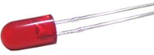
Figure 15 - 12v present LED

Flashing once every 10 seconds green LED: 5mm, forward voltage = 2.1v, forward current = 20mA.
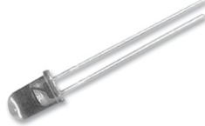
Figure 16 - Flashing indication

Battery sizing & selection

Component | Quantity | Power consumption | Total power consumption
Temperature & Humidity sensor | 1 | 100mA | 100mA
Wave height ultrasonic sensor | 2 | 125mA | 250mA
Wind speed & direction sensor | 1 | 44mA | 44mA
Sunlight brightness pyranometer | 1 | 0.3mA | 0.3mA
GPS position | 1 | 25mA | 25mA
LED’s | 2 | 20mA | 40mA
Total |  |  | 459.3mA

Total power consumption is 459.3mA. The specification states that data should be acquired for a 7 day cycle (168 hours).
Total power consumption is multiplied by 168 to give the total power consumption over the monitoring period, 77,162.4mA (77.16A).
The battery chosen is a 12v, 90Ah, sealed, lead acid battery. Dimensions = 350mm x 174mm x 224mm. Weight = 23.6kg. [16]
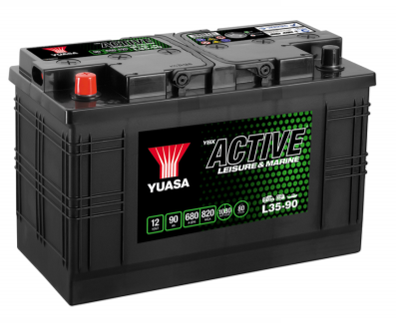
Figure 17 – Yuasa L35-90 battery

Enclosure selection

The enclosure selected is the Challenger TR5013, waterproof, wheeled travel case. IP67 rated and made from high strength moulded plastic. Measures 626mm x 492mm x 318mm which is sufficient to house all components and battery. The case has foam inserts which can be altered to the required shape to ensure there are no loose components. [17]
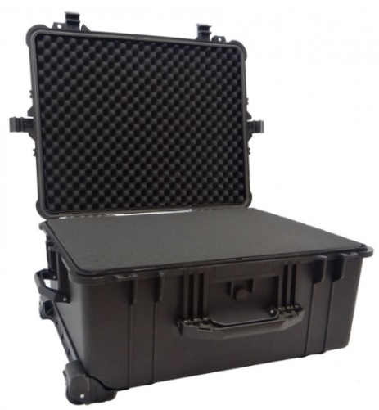
Figure 18 - Challenger TR5013 enclosure

Microcontroller selection
To select a suitable microcontroller, we must consider, analogue and digital pin requirement, resolution, program memory requirement, RAM requirement, clock speed, and other connections such as USB and SD card.
Resolution calculations;
Temperature, logged every 0.5 degC change. Instrument range, 0-100 degC. 100÷0.5 = 200. 8 bits required.
Humidity, logged every 0.5% change. Instrument range, 0-100 degC. 100÷0.5 = 200. 8 bits required.
Wave height, logged every 50mm change. Instrument range, 0-40m. 40000÷50=800. 10 bits required.
Wind speed, logged every 0.5mph change. Instrument range, 0-135mph. 135÷0.5=270. 10 bits required.
Wind direction, logged every 0.5°. Instrument range, 0-359°. 359÷0.5=718. 10 bits required.
Sunlight brightness, logged every 5W/m2. Instrument range, 0-2000w/m. 2000÷5=400. 10 bits required.
Signal | Pins | Analogue/ Digital | Log frequency | Resolution
Temperature | 1 | Analogue | 1 s | 8 bit
Humidity | 1 | Analogue | 1 s | 8 bit
Wave height open | 1 | Analogue | 0.5 s | 10 bit
Wave height damp | 1 | Analogue | 0.5 s | 10 bit
Wind speed | 1 | Analogue | 0.5 s | 10 bit
Wind direction | 1 | Analogue | 0.5 s | 10 bit
Sunlight brightness | 1 | Analogue | 1 s | 10 bit
GPS position | 2 | Digital | 1 s | 8 bit
SD card | 4 | Digital
Start button | 1 | Digital
Tell | 1 | Digital
USB | 2 | D+/D-
Power | 3
Total | 20
Table 13 - Resolution requirements

Microcontroller criteria.
Voltage | 5v device
Digital signals | 8 bits
Analogue signals | 8 @ 10 bit resolution
USB | 2 bits
UART | Yes (1)
SPI | Yes (1)
Program memory | 16KB
RAM | 0.5KB
Clock speed | 16MHz
Table 14 - PIC specification
Requirements were entered into microchip.com ‘parameter chart search’ function. The search narrowed down to a choice of 2 microcontrollers. PIC18F25K50 and PIC18F25K40. PIC18F25K50 was chosen over PIC18F25K40 as it has everything that is required and was most cost effective. [18]
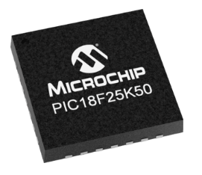
Figure 19 - PIC18F25K50

Non-volatile memory

Signal | Signal type | Log frequency | Bytes | Total bytes
Temperature | Analogue | 1 s | 1 | 1
Humidity | Analogue | 1 s | 1 | 1
Wave height open | Analogue | 0.5 s | 2 | 4
Wave height damp | Analogue | 0.5 s | 2 | 4
Wind speed | Analogue | 0.5 s | 2 | 4
Wind direction | Analogue | 0.5 s | 2 | 4
Sunlight brightness | Analogue | 1 s | 2 | 2
GPS position | Digital | 1 s | 1 | 1
Table 15 - Non-volatile memory requirement
Total number of bytes is 21/ s.
21 x 60 secs = 1260 bytes/ min
1260 x 60 mins = 75.6KB/ hour
75.6 x 24 hours = 1814.4 KB (1.81MB)/ day
1.81 x 7 days = 12.67MB / 7 days
Total storage required for the 7-day monitoring is 12. 67MB.

The SD card chosen is 1GB by SanDisk, this will provide ample storage space for the application. [19]
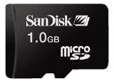

Figure 20 - SanDisk SD Card

Structure Diagram

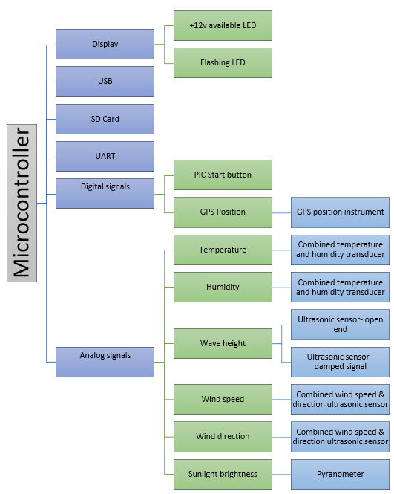

Figure 21 - Structure diagram

Data acquisition cycle

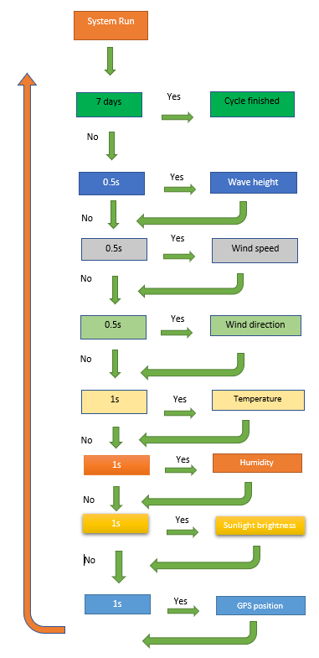

Figure 22 - Data acquisition cycle

Schematic design
Proteus schematic.
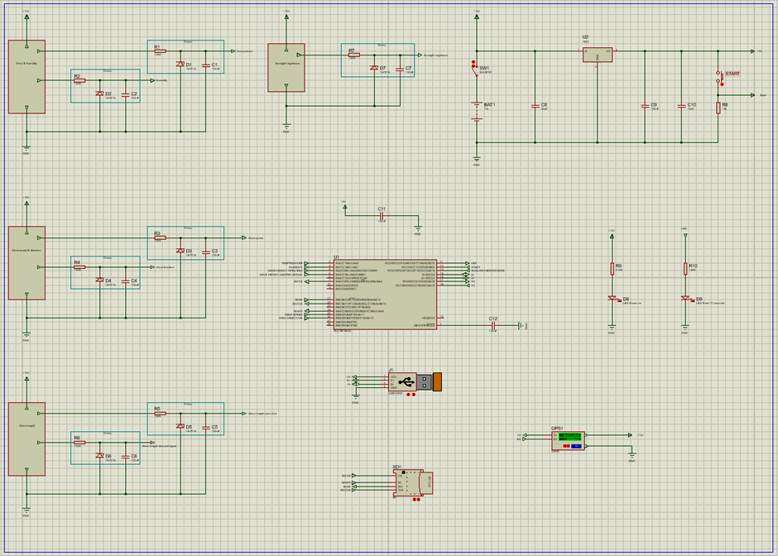
Figure 23 - Proteus overall schematic design

Power circuit
There is a 12v battery in the circuit. Immediately after the battery is a switch, when operated, puts 12v onto all sensors requiring a 12v supply, voltage regulator and to an LED to indicate that there is 12v present. The voltage regulator has a 5v output. From the voltage regulator, all components requiring a 5v supply and fed. Capacitor C9 acts as a filter and capacitor C10 acts as a tank. R8 is a de-coupler. There is also a button that sends a signal to the PIC and brings on a green LED that flashes every 10 seconds.
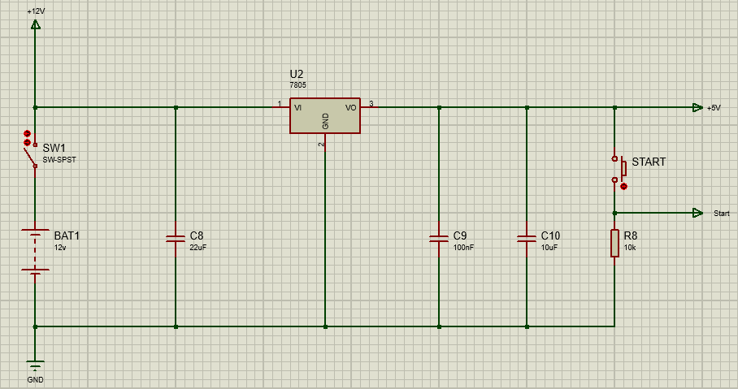
Figure 24 - Power supply circuit
Sensors used for temperature, humidity, wave height, wind speed/ direction and sunlight brightness all require a 12v supply. They also all provide a 0-5v output. All these circuits have a clamp, the clamp consists of a capacitor and resistor that form a filter and a Zener diode to protect against overvoltage.

Temperature & humidity
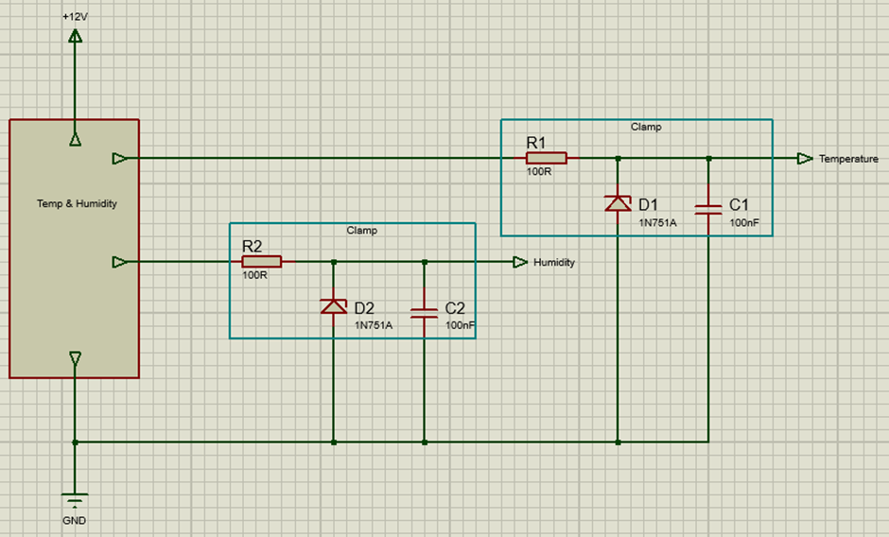
Figure 25 - Temperature & humidity

Wave height
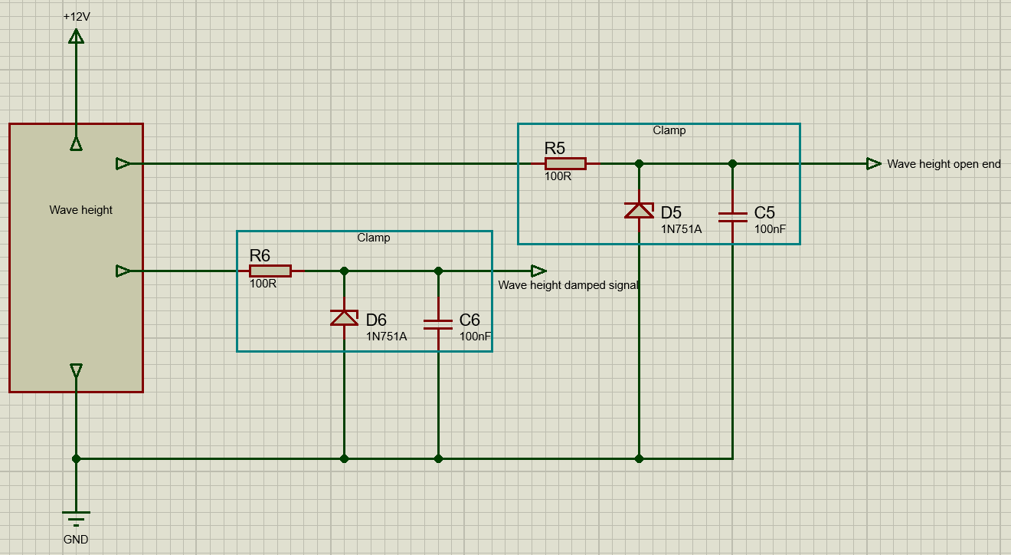
Figure 26 - Wave height

Wind speed & direction

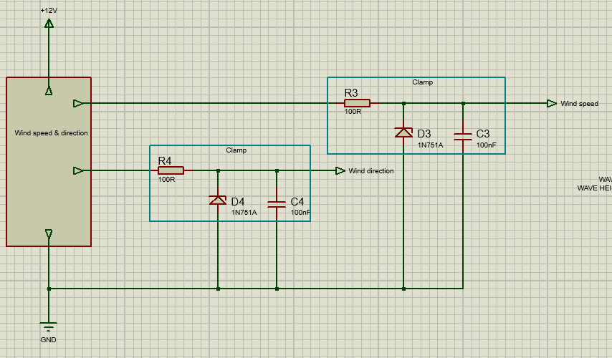
Figure 27 - Wind speed & direction

Sunlight brightness
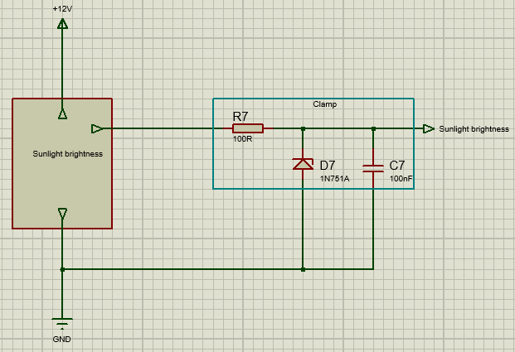
Figure 28 - Sunlight brightness

GPS sensor
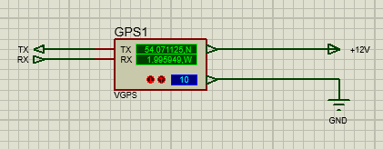
Figure 29 - GPS sensor circuit

USB
The USB is required to enable the device to connect to a computer. The VCC will be supplied from the computer. The D+/- are bi-directional pins for data transfer.
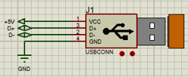
Figure 30 - USB circuit

Non-volatile memory
The SD card has a digital input from the PIC, a digital output to the PIC, a clock rate signal to allow the PIC to synchronise and a chip select signal so that the PIC can identify the device to write to as it’s a BUS system, although, it is the only device on the BUS, the CS is connected.
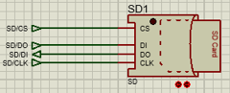
Figure 31 - Non-volatile memory circuit

LED’s
Resistor sizing calculations;
12v on red LED.
$$Vres=12v-1.8v=10.2 v$$
$$R=\frac{10.2 v}{0.020 A}=510Ω$$

5v flashing green LED.
$$Vres=5v-2.1v=2.9 v$$
$$R=\frac{2.9 v}{0.020 A}=145Ω$$

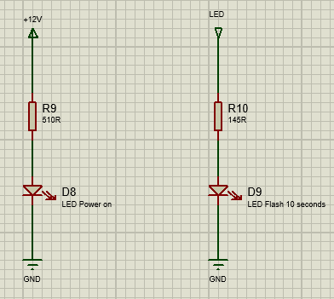
Figure 32 - LED circuits

PIC layout

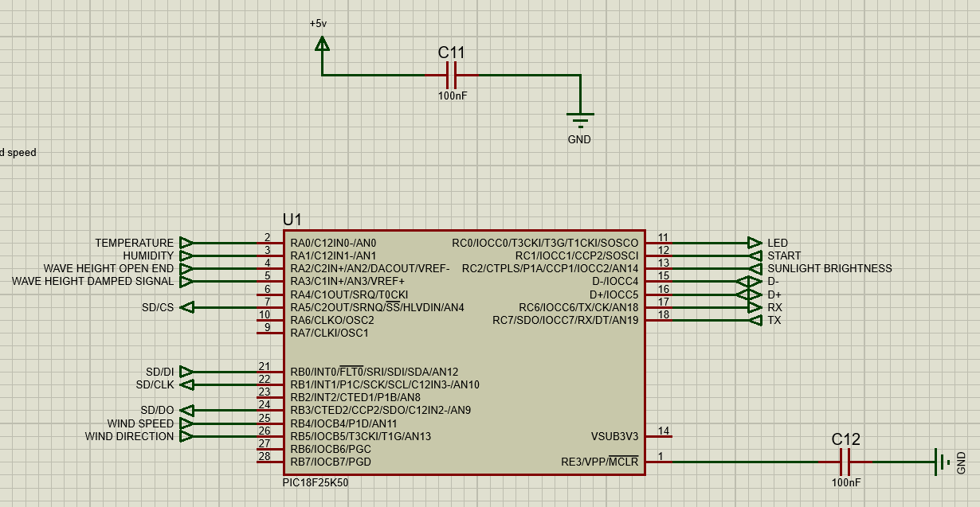
Figure 33 - PIC layout

PCB Design
Easy-PC schematic.
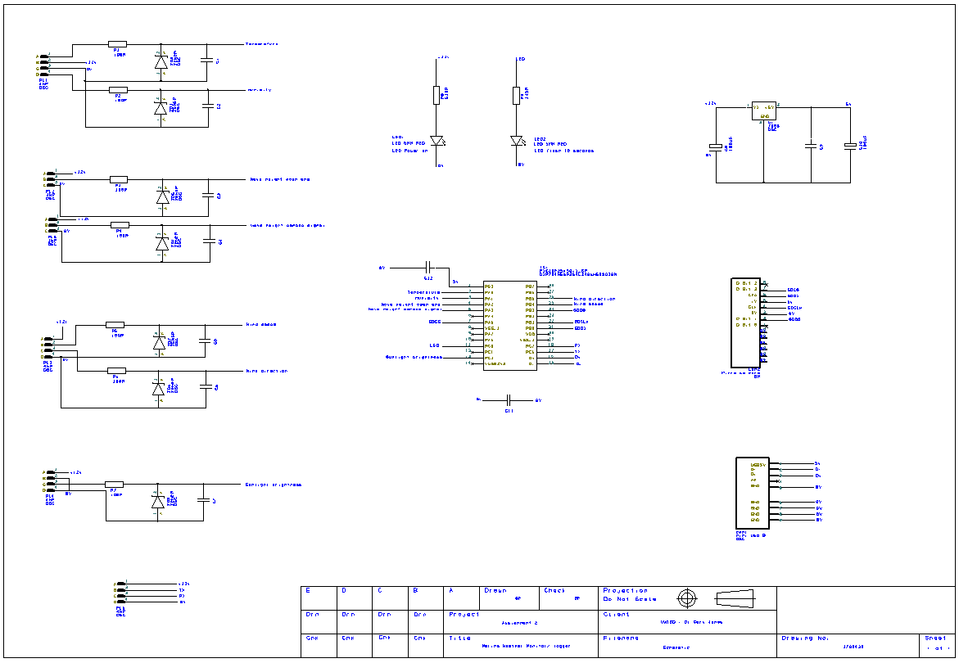
Figure 34 - Easy-PC schematic
Top layer translated to PCB. Using the optimise nets function, the PCB tracks were drawn onto the board.
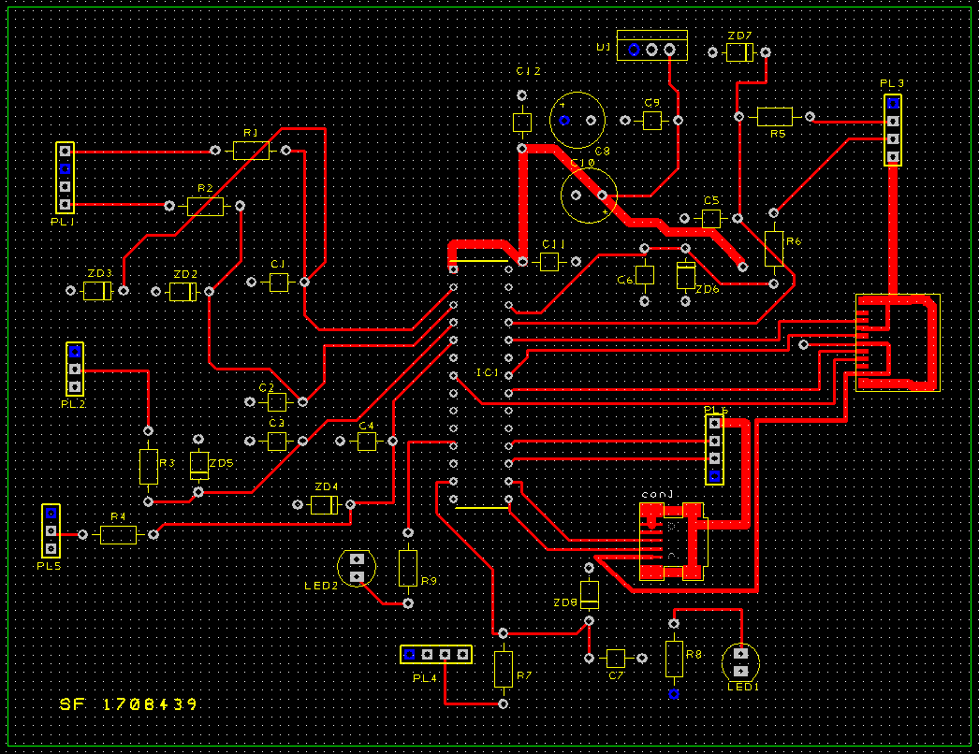
Figure 35 - Top copper layer of PCB
Dark blue, 12v copper. Light blue, 0v copper.
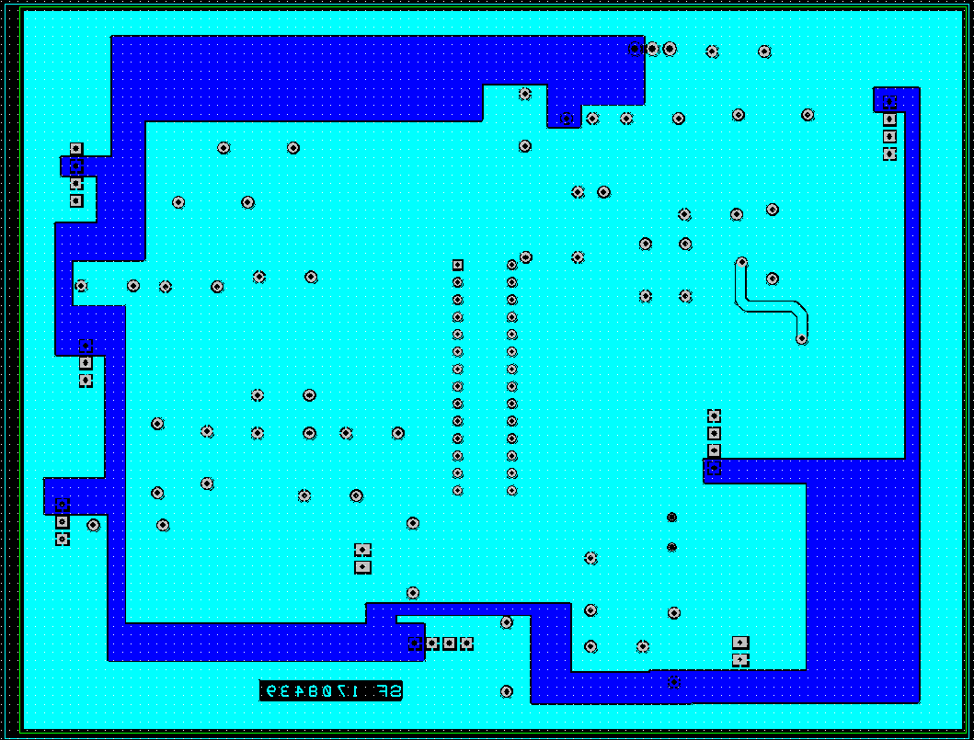
Figure 36 - Bottom copper layer
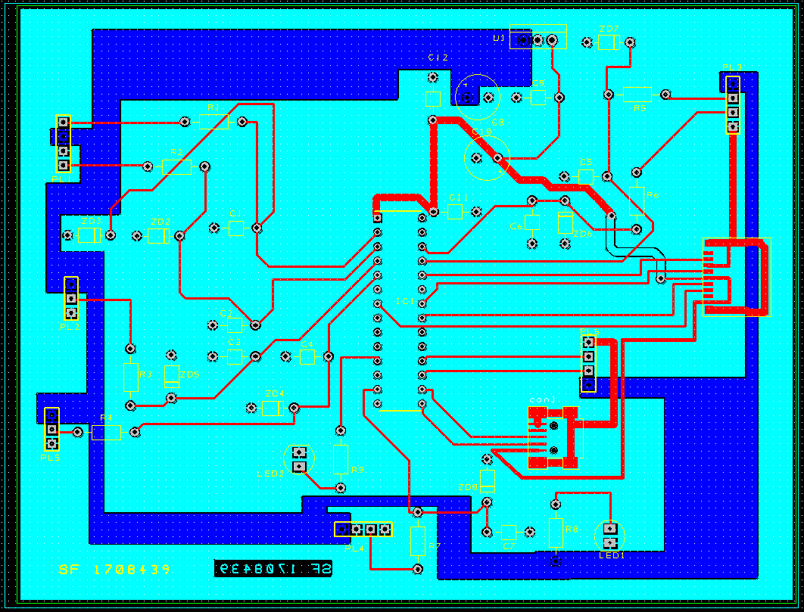
Figure 37 - PCB all layers

3D views.
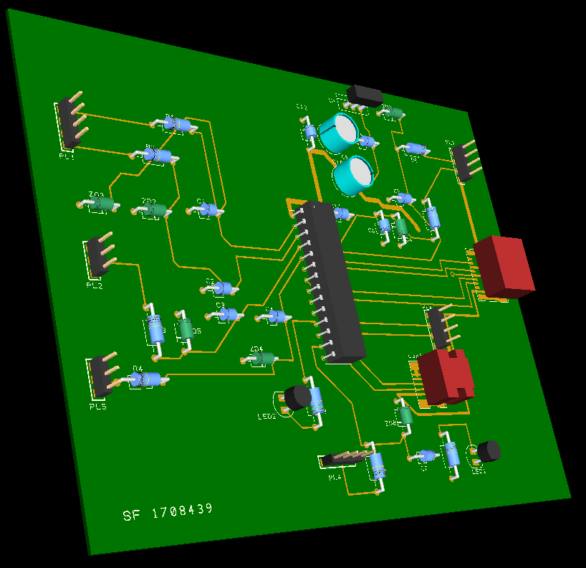
Figure 38 - Top layer 3D view

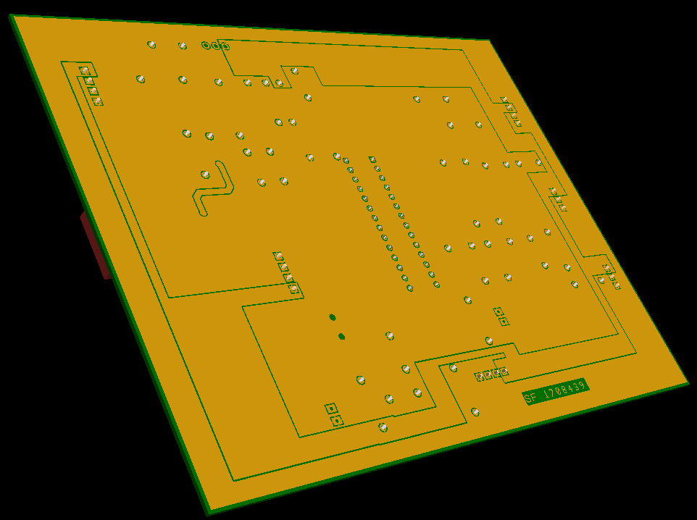
Figure 39 - Bottom layer 3D view
Design rule check.
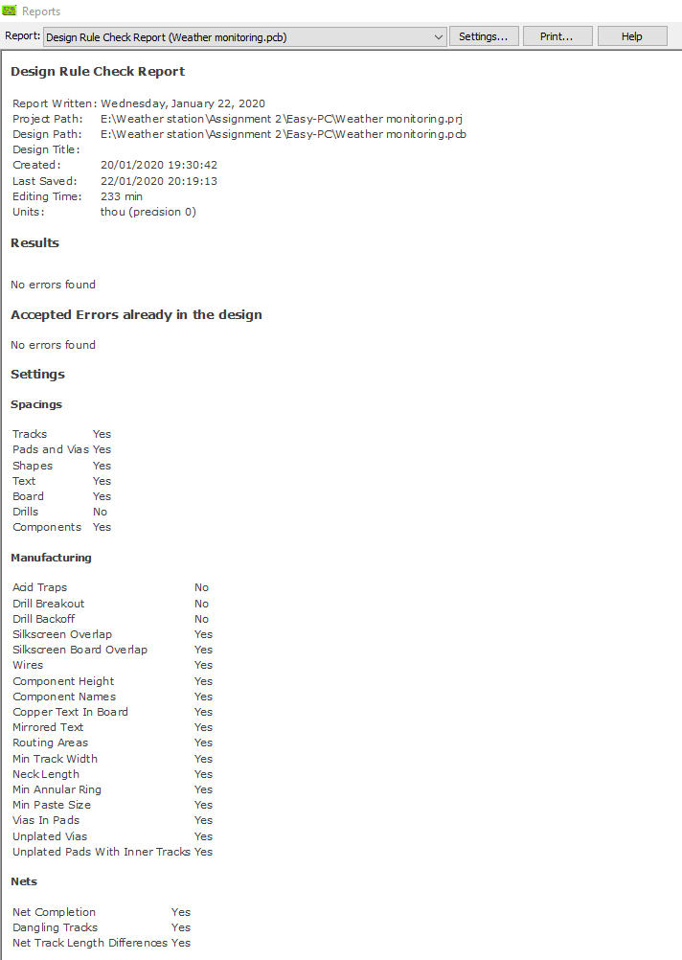
Figure 40 - Design rule check

Prototype build cost

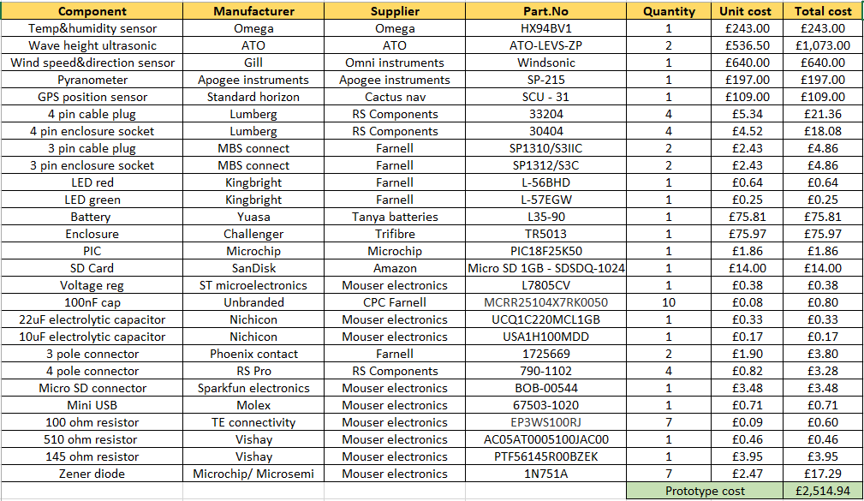
Figure 41 - Prototype build cost

Future Improvements

- Additional weather monitoring e.g. air pressure, rain gauges, dew point.

- Bluetooth & Wi-Fi connectivity.

- Decrease system physical size e.g. use PCB mounted GPS sensor.

- Select sensors with smaller energy usage to minimise size and weight of battery requirement.

- Reduce cost by using more cost-effective sensors and connectors.

References

[1] | A. P. P. M. Suvarna K. Gosav, “Weather Data Acquisition System,” June 2015. [Online]. Available: https://www.ijraset.com/fileserve.php?FID=2702. [Accessed 13 January 2020].
[2] | “What is a weather station?,” 13 January 2020. [Online]. Available: https://www.acurite.com/.
[3] | “Data Aquisition,” Omega, [Online]. Available: https://www.omega.co.uk/prodinfo/dataacquisition.html. [Accessed 13 January 2020].
[4] | “Campbell Scientific,” [Online]. Available: https://www.campbellsci.com/weatherpak-marine. [Accessed 25 01 2020].
[5] | “Omni Instruments,” [Online]. Available: https://www.omniinstruments.co.uk/rws-07-portable-weather-station-1082.html. [Accessed 15 01 2020].
[6] | “Weather station products,” [Online]. Available: https://www.weather-station-products.co.uk/cabled-vantage-pro2-bundle. [Accessed 10 01 2020].
[7] | “Vaisala,” [Online]. Available: https://www.vaisala.com/en/products/instruments-sensors-and-other-measurement-devices/weather-stations-and-sensors/maws201. [Accessed 07 01 2020].
[8] | “Omega,” [Online]. Available: https://www.omega.co.uk/pptst/HX94B.html. [Accessed 12 01 2020].
[9] | “ATO,” [Online]. Available: https://www.ato.com/ultrasonic-level-sensor-40m. [Accessed 05 01 2020].
[10] | “Omni instruments,” [Online]. Available: https://www.omniinstruments.co.uk/weather-stations-and-instruments/wind-speed-and-direction-sensors/windsonic-solid-state-wind-speed-and-direction-sensor.html#upsell-product-div. [Accessed 23 12 2019].
[11] | “Apogee,” [Online]. Available: https://www.apogeeinstruments.com/sp-215-ss-amplified-0-5-volt-pyranometer/#product-tab-description. [Accessed 22 01 2020].
[12] | “Cactus nav,” [Online]. Available: https://www.cactusnav.com/standard-horizon-external-antenna-with-cable-p-27129.html?gclid=EAIaIQobChMIg-m95sWP5wIVArTtCh2OMQ-tEAQYASABEgIRUPD_BwE. [Accessed 22 12 2019].
[13] | “RS Components,” [Online]. Available: https://uk.rs-online.com/web/. [Accessed 24 01 2020].
[14] | “Digi Key,” [Online]. Available: https://www.digikey.com/. [Accessed 25 01 2020].
[15] | “Farnell,” [Online]. Available: https://uk.farnell.com/. [Accessed 25 01 2020].
[16] | [Online]. Available: https://www.tayna.co.uk/leisure-batteries/yuasa/l35-90/. [Accessed 21 01 2020].
[17] | [Online]. Available: https://www.trifibre.co.uk/product/waterproof-tr5013-equipment-hard-carry-photography-drone-wheeled-travel-flight-case/. [Accessed 21 01 2020].
[18] | “Microchip,” [Online]. Available: https://www.microchip.com/. [Accessed 25 01 2020].
[19] | “Amazon,” [Online]. Available: https://www.amazon.co.uk/dp/B000EYAEK8/ref=psdc_296791011_t3_B00065KA7C. [Accessed 25 01 2020].

