Student Name: Vasile Robert Gore
Student ID: 1915927
Module Name: Marketing Fundamentals
Teacher Name: Tushara Balendran
Work Title: Burberry
Communication Blogging

Burberry World



The History
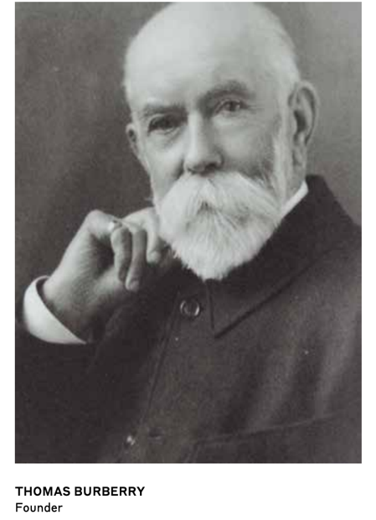
The story of Burberry starts in 1856, nearly 164 years ago when Thomas Burberry, the founder established the company in Basingstoke. The main idea was to design products that will help people to protect themselves from rainy weather. The founder invented gabardine an innovative weatherproof material which made the clothes easier. Burberry products were popular because of its features. For example, its trench, invented during the first World War has a functional design, using pockets for gloves, epaulettes and a non-wetting material has been used. Later on, in 1995 Her Majesty Queen Elizabeth II Grants Burberry a royal warrant a weather proofer. Burberry increased its popularity and has been exported worldwide in Europe, America, Russia, Japan etc. The first Burberry store it is opened in 2000 on Bond Street and only 14 years later it appears in over 500 stores all over the world. Burberry establishes itself in a luxury market and works on improving its products by inventing sustainable materials. Nowadays, in the period of pandemic Burberry focuses on helping NHS by donating pieces of PPE and funding coronavirus vaccine and produces masks.
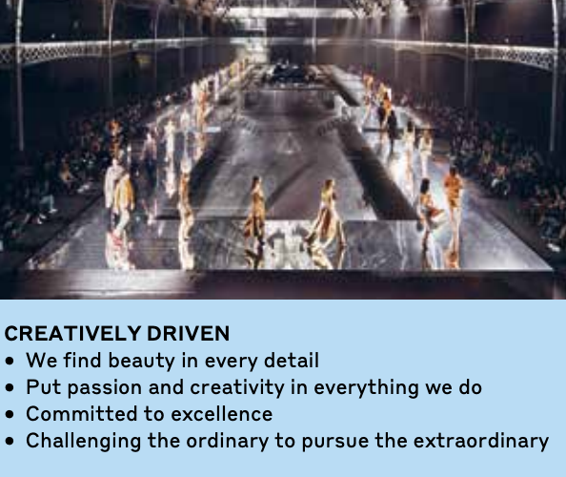
Mission Statement and Values

The company mission is to maintain its integrity and to encourage the power of creativity in order to open to possibilities and growth. The core values include creativity, openness and caring; proud of our heritage; innovation driven and proud of our heritage. The team find inspiration in history but at the same time is driven to meet the needs of the consumers.

Burberry Products
Variety of products

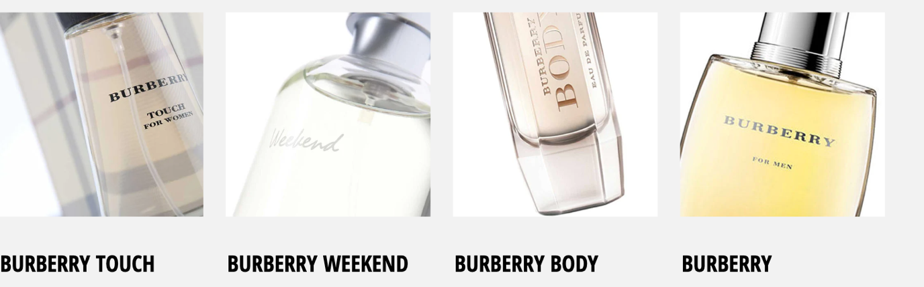
Burberry display a wide range of products for men, women and kids. The clothing section for men include coats and jackets, casual shirts, knitwear, suits, blazers, swimwear, jeans etc. It also, sell accessories such as bags, belts, scarves, hats, eyewear etc. It is mainly known for its raincoats. Burberry has a wide range of shoes including sneakers, boots and sandals. And last but not least it sells fantastic refreshing woody perfumes for men. Similar categories are for women and kids.
Discover More

The quality of products
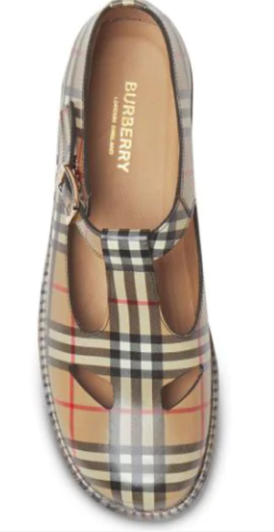
Burberry is a British high quality and practical brand. Most of its items are designed by Christopher Bailey. The products are manufactured not only in Britain but also in other countries such as China and European countries. Burberry is considered one of the top international clothing brands. The Burberry products such as coats are stylish, classy and made of a good material such as cotton-gabardine. Another product such as T-bar shoes is made using leather from a tannery certified to environmental traceability and social standards. The lining is made of sheepskin, the outer of calf leather and sole of calf leather and polyurethane.

Features and benefits

The fabric
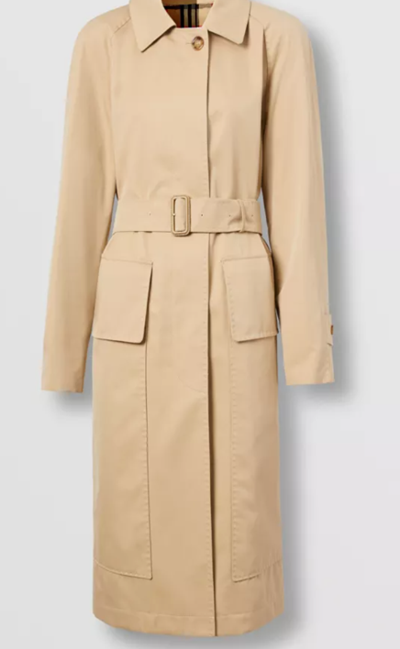
The most popular product is trench coat which is cut from gabardine material which keeps you dry in rainy weather. The outer and lining is 100% cotton. Also, it is lightweight and packable it is excellent for travel. The khaki shade flatters every skin tone and pair well with neutrals and bright alike.

The details
It has a belted design featured with pockets and a vintage check lining. The buckles are made of leather and the signature details include button-tab- cuffs and check undercollar. The mid-length style provides rear coverage, and it is perfect to wear at work and in weekends as well. The style is timeless, and you can wear it forever.

Packaging design

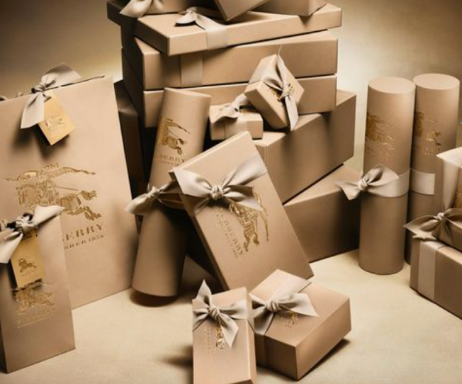
Burberry packaging reflect sustainability objectives. Oak paper is used which is made from upcycled coffee cups. The company focuses on using recyclable package along with recyclable hangers. The sustainable packaging materials have a luxurious and beautiful look, but the most important thing is that is plastic free and are 100% recyclable which is a huge advantage for organisation and for environment as well. The main aim is to minimize the amount of packaging used and maximize the use of recycled materials.

Commitments
Burberry’s commitments include usage of materials is low risk of human health. Also, ensure the packaging is traceable and ensure the process of recycling is made easy for consumers.
Allocate finances to develop more sustainable packaging options.

EXPLORE THE COLLECTION

Price
Prestige Pricing
Burberry is a well-established brand it is why the pricing is considered to be exclusive, high, prestigious. Its high price is causing high desirability and limited accessibility. It is known for high quality materials, sustainable packaging, durability and good customer service which explains the high price for its products. Not only that but also, it displays a feeling of high social status and sophistication due to classic British heritage.

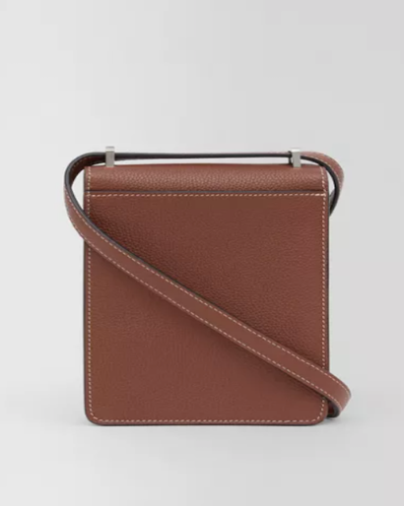
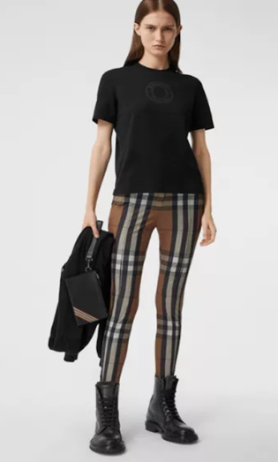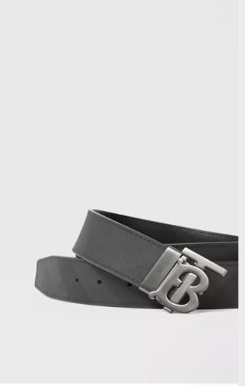

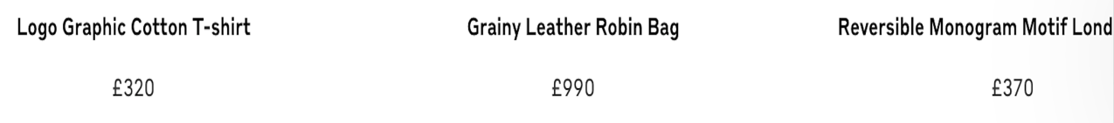

Limited discounting

Burberry discount schemes are limited. Burberry sales can be spontaneous and a sign up for email strategy is used to keep costumers up do date with new items and sales. When the organisation holds sales, the maximum discount is 50%. The discounts are usually on some items however, other sales may offer frequent price drop on its products. Burberry are using coupons for NHS Staff and employee discounts as a part of promotion plan.

Place

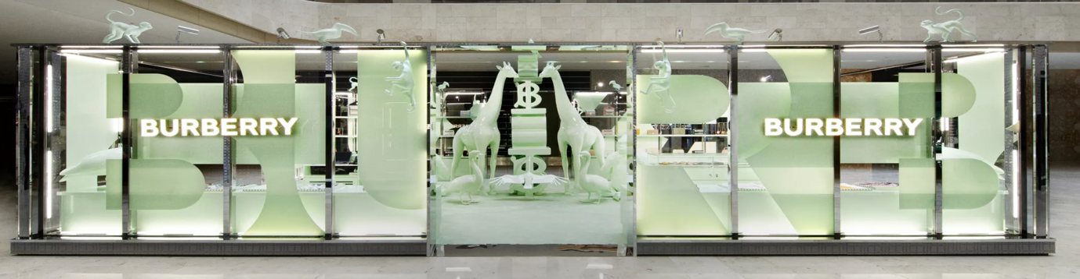
The company makes products available to consumers via physical stores worldwide, online stores and other sellers. Burberry distributes its products via channels such fancy stores, e-commerce and supermarkets. It is registered a total of 421 stores worldwide. You can find Burberry stores in London, Paris, Madrid, Rome, Moscow, Cairo, New Delhi etc. Also, the products may be ordered via Burberry website, and it can be shipped and delivered to your home address. However, based on trading restrictions some products such as make up, nail polish, jewellery is restricted in some locations such as Australia, Japan, Slovakia etc.

Online Store and Digitalisation

Burberry as many other companies is faced with challenging times because of external factors such as politics, environmental risks such as the pandemic. Many physical stores were closed because of new regulations. Which encouraged the management to direct its focus on online stores and authorised retailer in order to ensure the product accessibility to its clients. Besides accessing on mentioned above methods, Burberry it is considered to be the first fashion brand to livestream on social media. It has millions of fans across different platforms which can easily access the products order and pick up in store or vice versa. In addition to that, one of the innovative techniques implemented by Burberry is livestreaming and simultaneously interacting with brand and ordering as well. The organisation not only plead to sell its products but also create a unique luxury fashion experience for its clients.



Promotion

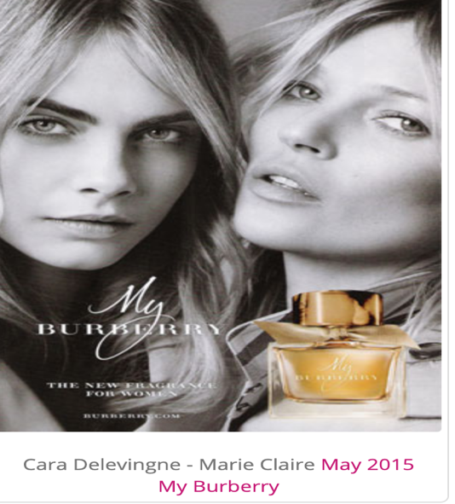
Burberry uses various promotion schemes to communicate with their target market such as advertising, sales promotion, public relations, direct marketing, personal selling, social media marketing and integrated marketing communication etc.

Burberry Advertising is circulated via social media platforms such as Facebook, Twitter, WeChat, Instagram etc. Also, the company uses google ads, hashtags to increase brand awareness to attract potential consumers. Digital advertising is one of the main promotion strategies used.

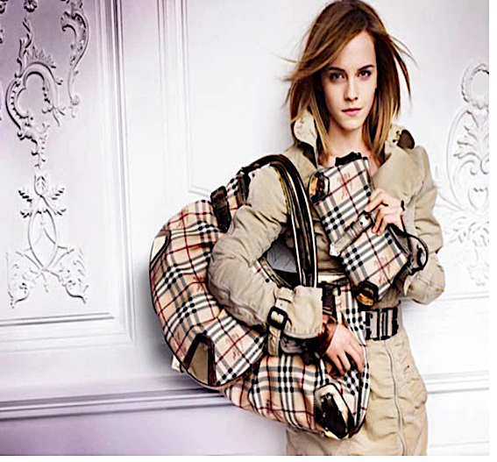
Burberry is recognised a British heritage brand and its promotion campaign are British actresses and other famous individuals such as Emma Watson, Cara Delavigne, Marie Claire, Naomi Campbell, Romeo Beckham and other. Celebrities attracts attention and potential clients. It also, builds trust and balance information with entertainment. Also, it generalates site traffic and social engagement.

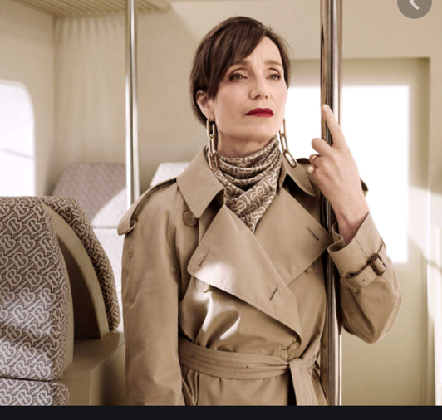
Burberry Shows are a part of integrated marketing communication plan. The shows are a harmony between great music art and fashion. The organisation creates special collaborations with British artists and connects a large audience not only interested in fashion luxury but in fresh talents and established icons as well.

Watch Benjamin Clementine live at the Burberry Menswear January 2016 show

Bibliography
- Armstrong, G. K. P., 2017. Principles of Marketing,. Student Value Edition ed. United States:Pearson Education..
- Bowman, ., 2010. Market Response and Marketing Mix Models: Trends and Research Opportunities.. In: Netherlands:: Now .
- Burberry , 2020. Sustainable Packaging Materials Commitment. [Online]
Available at: https://www.burberryplc.com/content/dam/burberry/corporate/Responsibility/Responsibility_docs/
[Accessed 26 December 2020].
- Burberry Annual Report 2019/20, 2020. Creativity opens spaces, United Kingdom : burberryplc.com .
- Chanday, ., 2020. Burberry. Independently Published .
- Handbook on Place Branding and Marketing , 2017. In: United Kingdom:: Edward Elgar Publishing Limited..
- Kitson, ., 2016. Burberry Days. United Kingdom: Austin Macauley Publishers Limited.
- McGruer, ., 2020. Dynamic Digital Marketing: Master the World of Online and Social Media Marketing to Grow Your Business.. United Kingdom: Wiley.
- Scott, ., 2011. Real-Time Marketing and PR. In: How to Instantly Engage Your Market, Connect with Customers, and Create Products that Grow Your Business Now.. Germany: Wiley, pp. 79-85.
- Strangmueller, ., 2018. Economic Strategies. Potential Improvements of Burberry. Germany: GRIN Verlag.
- Taylor, ., 2004. Marketing Communications: An Integrated Approach. United Kingdom: Kogan Page.
- Tungate, ., 2008. Controlling the plot. In: Fashion Brands: Branding Style from Armani to Zara. India: Kogan Page, pp. 29-32.
- Weinman, ., 2015. Digital Disciplines: Attaining Market Leadership Via the Cloud, Big Data, Social, Mobile, and the Internet of Things. Germany: Wiley.

