ECIE6003
Resource Pack:
Design a resource pack to support an element of effective classroom management.

Emily Evans - 2215303

Visual timetable / task board resource pack.
The resource.
A visual timetable is a set of pictures/symbols that are typically used across most schools for continuity usually using the ‘widgit’ software, the symbols are usually simple and clear to represent the word used for example ‘lunch’ or ‘dinner’ are symbolised with a plate with food on it and ‘home’ is a house. The timetable is structured and tailored to a class or to an individual pupil and it’s the structure of their day or week, depending on the pupil some students find it easier to have just a day by day timetable and others like to know what their week looks like ahead of time so work better with a week timetable. The timetables are designed to be clear and simple and easy to follow. The visual timetables can be adapted and used in different ways, if you use Velcro you can move around the symbols and use ‘now,next,then’ or just ‘now and next’ boards to help with transitioning from one task to another. “A visual timetable, timeline or visual activity schedule is a way of supporting a child to predict what will happen next. It enables a child to know the things that must happen first, before they can do the activity that they are often focused on. It also helps them to understand where they are in the day, by knowing what has gone before and what will come after the present moment.” (Council for Disabled Children, 2024) This resource can be used across all age groups and even something that can be used and brought into life outside of school , like at home or into adult years.
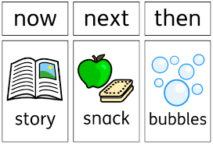
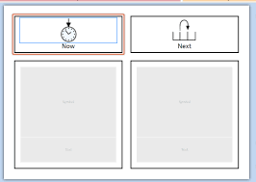

(Creating a Now and Next Board Creating a Now and Next Board, n.d.) City of Bradford MDC

The rationale.
Albert Bandura is a theorist who believed that children learn through modelling, and that visual learning is highly important in the development of children and students in school, he believed that adults should model what they want to teach their children or students as this is the best way for children to pick up skills and traits, whether that is positive behaviour or negative children will pick things up through modelling from adults and their peers in school, this is a tactic used in schools daily , without even intentionally doing so, its something children do naturally and something even adults do in new situations if they are in a new setting, Albert is a Canadian theorist and did most of his theorising in the 1960’s, although this is many years ago, the way the human brain works and functions would not be that much different now, so his theories still stand and are still widely used to this day. Albert conducted a study in 1961 called ‘the Bobo doll experiment’ “Each child was individually exposed to their respective scenario. Afterward, they were placed in a room with toys, including a Bobo doll, and their behaviors were observed.”
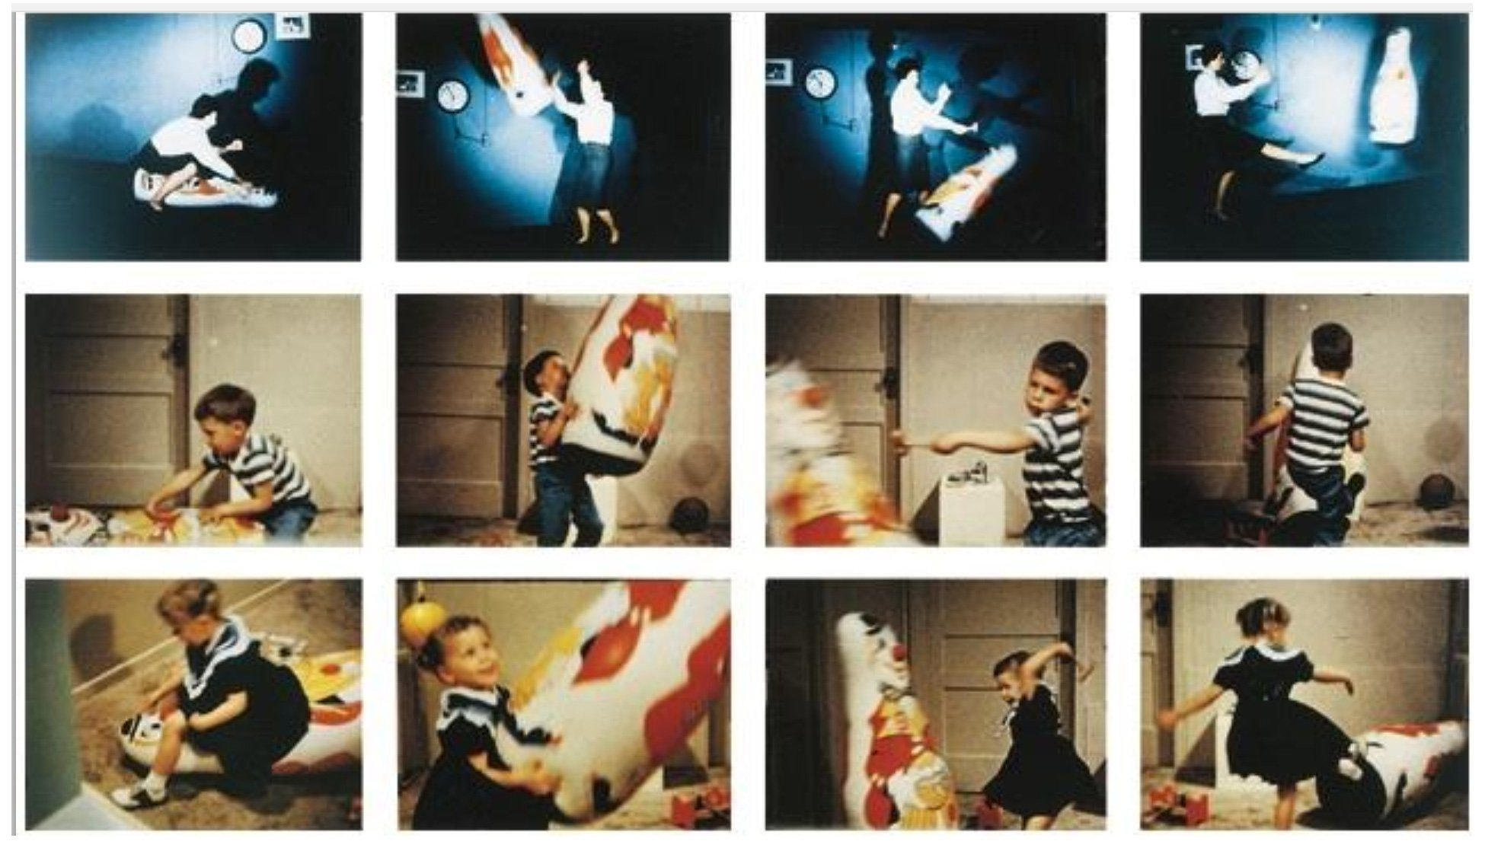
(McLeod, 2025)
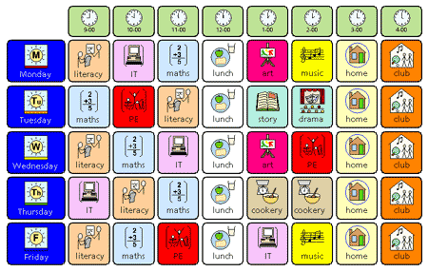
The study showed Albert that the children who where exposed to a violent model showed signs of violence towards the doll, and the children who’s model was to ignore the bobo doll showed a drastically lower violent behaviour towards the doll, although the study proved Alberts point, it was not looked upon greatly as people believed that he did not get the proper consent from parents and guardians of the children and that people worried children that have now been exposed to unnecessary violence may start to show signs of violence outside of the experiment. “The social learning theory proposes that individuals learn through observation, imitation, and reinforcement. According to the theory, there are four stages of social learning: Attention: In this stage, individuals must first pay attention to the behaviour they are observing. This requires focus and concentration on the model’s behaviour. 1. Retention: In this stage, individuals must remember the behaviour they observed. This involves cognitive processing and memory storage. 2. Reproduction: In this stage, individuals attempt to reproduce the behaviour they observe. This may involve practicing and refining the behaviour until it can be performed accurately. 3. Motivation: In this stage, individuals must have a reason or motivation to perform the behaviour. This may involve reinforcement, punishment, social approval, disapproval, or other incentives.” (McLeod, 2025). Alberts theory supports the use of visual timetables in class rooms as they use symbols which are easy to read and are eye catching in order to grab the users attention and keep it, the symbols encourage the children to look at it, and as its visual this will hopefully help children to retain it in their minds, and it is in place to encourage reproduction as they will see what is next on their timetable and will help them to know what is going to happen next in their day, this helps support the children with having a clear structure to their day and as a result its aim is to reduce anxiety and uncertainty the children may have about their day, as a result it will help them have a successful day in school. Visual aids are a key factor in learning in every school but they are absolutely essential in a SEN setting, for children who are under speech and language, visually impaired, cognitive difficulties, hearing loss, deprived areas, children who can’t read, special needs, physically disabled, and ADHD these symbols and visual aids are a core tool used in their everyday life, in school and sometimes outside of school, along side visual timetables, you can have core boards that use the same symbols and they are used to express wants and needs, like ‘More’ ‘I want’ ‘like’ ‘dislike’ , and ‘stop’ or ‘finished’, these visual aids and timetables help children with special needs have a voice and have a sense of choice and a tool for them to be able to have independence in the class room, schools provide these for the children, often the teaching staff will produce individualised time tables for the learners , and theres also generic ones for the whole class to use but if a learner has a motivator in class for example ‘now literacy work, next trampoline’ this is a tactic used to help children know that if they do the task that is asked of them, they can then get a reward afterwards within reason for doing so, other motivators include, music , a story, an amount of time on a computer or ipad, colouring in or a game, this wont be used in every instance but motivators are frequently used especially in a SEN setting. Visual timetables are an essential tool to use when children are transitioning from one task to another especially if the task Is in another part of the classroom or the school. These timetables can be adapted in many ways to be the right fit for the pupil, different background colours can be used, white, black and sometimes yellow being most common, font and symbol size can be adjusted to be easier to see, different symbols can be used in some circumstances especially if the student has come from a school that has used different symbols, some children prefer to see real pictures on their timetable as it is easier for them to relate to the pictures and visualise what they are expected to do next or where they are expected to go to, for example if they are going to the school hall or the school field a picture of the actual school hall or field should be used so they can visualise what is expected of them. A negative aspect to visual timetables can be that some learners become heavily reliant on them and sometimes this can become a trigger to them and if something has to change last minute or a staff member accidently puts a symbol at the wrong time, this can cause behaviours in children or cause anxiety, its also not something that is a quick fix as children will need to learn the symbols and know what they represent before they will understand the timetable or the now and next boards or core boards, this is why in class it is encouraged for teachers and support staff to teach the pupils what they mean and what they are used for, this is where modelling comes into practice.
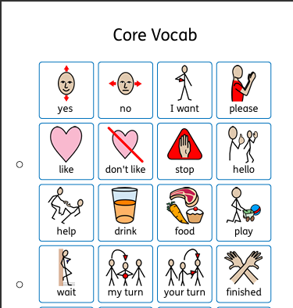

(symbolsinclusionproject.org, n.d.) (widgitonline.com, n.d.)

Instructions for use –

- Teacher or support staff to print off all necessary resources eg: blank timetable, blank now and next board, core boards, symbols for the timetable that are relevant to the class and pupils ensure that the wording matches the symbol. Ensure the symbols are consistent and familiar.
- Find a designated place for class timetable and individual timetables, on the wall or on each individual student’s table if they are tailored to the pupil. Make sure its at a good eye level for the pupils and easy to access.
- Laminate and cut out the symbols and apply Velcro where necessary.
- Keep all symbols in an easy to access area for staff to be able to change the symbols depending on the schedule for the day.
- Introduce it to the pupils, explain what it’s for and why it’s used.
- Model to the children the use of the class timetable and teach them what the symbols mean and represent on the day and time they are being used.
- Each morning goes through the timetable so the pupils know what to expect from the day.
- Regularly refer back to it throughout the day.
- Encourage the children to update their own timetables with help from staff.
- Encourage children to express how they are feeling or their wants and needs using the provided visual aids e.g. core board, now and next.
- Keep the symbols up to date and always monitor if symbols need to be added into the already existing symbol collection or if any need to be taken away as if the symbol is still available but the task is no longer a task that is done this could cause confusion or be a trigger.
- Monitor students to ensure they understand and can read the symbols properly and adjust accordingly or report to teacher if adjustments need to be made like actual pictures being used or a different colour background.
- Encourage students to model to their peers using the timetable and core board.
- Encourage staff to bring them with them to all activities even outside of the classroom to reduce anxiety and for all pupils to be included and have a voice.
- Use positive reinforcement when pupils use the visual aids.
- Encourage children to remove symbols once the task is complete to reinforce that the day is moving forward.
- At the end of every day or first thing in the morning update the visual timetable to be relevant for that day, its good practise to have the day of the week on the timetable each day this will need to be changed to be the correct day.

Creating a Now and Next Board Creating a Now and Next Board. (n.d.). Available at: https://www.widgit.com/support-docs/uk/widgit-online/helpsheets/content/now-and-next-boards.pdf [Accessed 30 Oct. 2025].

Council for Disabled Children (2024). What is a visual timetable? [online] Available at: https://councilfordisabledchildren.org.uk/sites/default/files/uploads/attachments/Visual%20Timetables%20Resource.I%20CAN.FIN

https://bso.bradford.gov.uk/userfiles/file/4_%20Now%20and%20a%20Motivating%20Next.pdf
McLeod, S. (2025). Albert Bandura’s Social Learning Theory. [online] Simply Psychology. Available at: https://www.simplypsychology.org/bandura.html.

McLeod, S. (2025). Albert Bandura’s Social Learning Theory. [online] Simply Psychology. Available at: https://www.simplypsychology.org/bandura.html.
symbolsinclusionproject.org. (n.d.). SIP Project - Resources and Tips - Classroom Management - Visual Timetables. (online)https://symbolsinclusionproject.org/resources/classroom/timetables/making.htm.

widgitonline.com. (n.d.). Widgit Online. [online] Available at: https://widgitonline.com/en/home.

