

PROGRAMME: MARKETING PRACTICE
MODULE: SITUATION ANALYSIS
MODULE CODE: BMBM5024
STUDENT NAME: HARSHINI A/P JANASINGGAM
STUDENT ID NUMBER: 2426418
SUBMISSION DEADLINE: 23:59 ON FRIDAY 28/3/25

Table of contents
Introduction 2
Background of the Amazon 2
Mission and vision of Amazon 2
Market performance of Amazon 3
Current external market condition of Amazon 3
PESTLE analysis 3
Industry trends, marketing strengths and growth scope of e-commerce, technology and e-streaming industry 4
Competitive environmental analysis 5
Porter’s five forces 5
Strengths, weakness, market share, business strategies of the competitors 6
Internal analysis 6
Resource-based view 6
VRIO Analysis 7
SWOT Analysis 8
Summary of the environmental analysis of Amazon 9
New strategic market direction of Amazon 9
Recommendation to improve market position of Amazon 11
References 12

Introduction

Background of the Amazon
Amazon is one of the most successful technology companies, online video streaming, and e-commerce companies, and it has achieved immense success and growth in recent days in a competitive environment worldwide. As Waters (2025) mentioned, Amazon.com is a Seattle, Washington–based e-commerce and cloud computing company that has started selling books. A consumer-centric approach and innovative business activities help the company achieve superior business growth in the current international domain. Jeff Bezos founded the company Amazon in 1994 out of his Seattle garage, in recent days Jeff Bezos stepped down from the position of CEO to executive chairman in 2021 and the company achieved worth $194 billion in 2024 (Forbes, 2025). The study describes the internal, external, and competitive environment of Amazon to identify suitable marketing plans for the company in recent days' global environment.
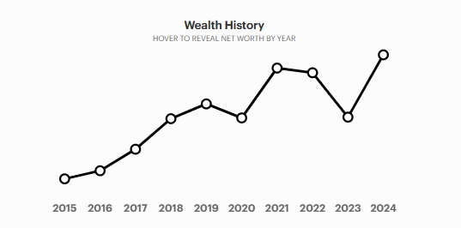
Figure 1: Wealth of Amazon
(Source: Forbes, 2025)

Mission and vision of Amazon
Amazon is highly focused on becoming the most customer-centric company in the worldwide domain. The four business principles of Amazon are to meet customer obsession, passion for invention, committed operational excellence, and long-term thinking (Amazon, 2025). The vision of Amazon is to become the world’s most customer-centric firm, the best employer on earth, and to become the safest place to work for employees. The mission of Amazon is to raise the bar of the customer experience through implementing the internet and technology to find, discover, and buy, empowering businesses and content creators to maximising their success internationally (Amazon, 2022). This customer-centric approach and innovative strategy provide key assistance to foster the success and growth of Amazon in the recent days global market.

Market performance of Amazon
In the last few years, Amazon has been able to achieve superior business success and effective marketing performance in the worldwide market. In the fiscal year of 2024, Amazon has earned 438 billion U.S. dollars in the US, 41 billion U.S. dollars in Germany, 37.9 billion U.S. dollars in the UK, 27.4 billion U.S. dollars in Japan, and 93.83 billion U.S. dollars in the rest of the world (Coppola, 2025). It represents the increasing success of Amazon all around the globe.
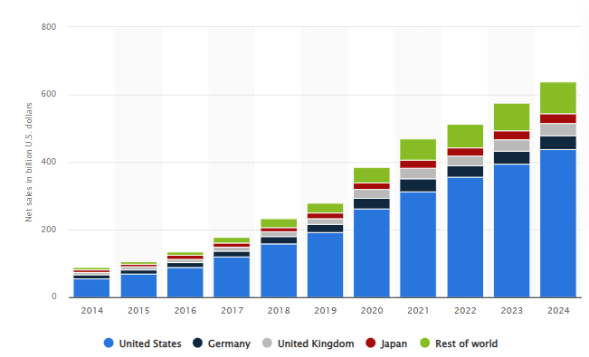
Figure 2: Net sales of Amazon
(Source: Coppola, 2025)

Current external market condition of Amazon

PESTLE analysis

Factors | Influence | Impact
Political | Political influences play a pivotal role in global business elections, and cross-boundary conflicts bring high uncertainty in world business (Forbes, 2024). | Moderate
Economic | In 2025, the projected revenue of the e-commerce market worldwide is US$4.32tn (Statista Market Insights, 2024). | Positive
Social | In 2023, total sales of the e-commerce market were approximately 5.8 trillion U.S. dollars (Chevalier, 2024). E-commerce firms can foster business growth by meeting the needs of customers belonging to different social, cultural, and ethnic backgrounds. | Positive
Technological | The arrival of modern technologies supports the marketing, communication, networking, and distribution support of the e-commerce industry worldwide. | Positive
Legal | The risk of marketing and distributing fake goods in the e-commerce market can cause violence against intellectual property and lead to legal repercussions for online marketplaces (Blease, 2024). However, an optimistic approach to maintaining transparency, effective CSR, sustainability, and other legal aspects can help to gain a superior position for an e-commerce company worldwide. | Moderate
Environment | The environmental crisis globally has been escalating at a rapid rate. For this purpose, e-commerce companies are focused on implementing Eco-Conscious E-Commerce to bridge the demand of the customer and need for sustainability efforts (Forbes, 2023). | Moderate
Table 1: PESTLE analysis of the e-commerce market worldwide
(Source: Self-Developed)

Industry trends, marketing strengths and growth scope of e-commerce, technology and e-streaming industry
As shown in PESTLE analysis the market trend of the e-commerce industry is significantly influenced by the political, economic, social, and technological factors. The PESTLE analysis shows that the increasing trend of the customer towards purchasing online e-commerce products is the key strength of the industry. In addition, the adoption of modern technologies helps to implement data-driven strategies in the demand and supply process to foster value for the consumers as well as foster success of the enterprise (Li, 2022). The technological adoption steps mostly increase success for the e-commerce industry worldwide and meet the needs of the customers towards e-streaming. Therefore, the adoption of modern technology can be considered as the emerging trend in the e-commerce industry. However, the PESTLE analysis showcases that legal complications and environmental risk factors can affect the growth of e-commerce companies internationally. E-commerce companies need to improve CSR and sustainability steps to improve business success and avoid interruption in global business.

Competitive environmental analysis

Porter’s five forces

Forces | Influence
The threat of new entrants | Low
Threat of substitute | Moderate
Bargaining power of the buyers | High
Bargaining power of the suppliers | High
Competitive rivalry | High
Table 2: Porter’s five forces analysis of the e-commerce market worldwide
(Source: Self-Developed)

Strengths, weakness, market share, business strategies of the competitors
As shown in Porter's five forces analysis the competition within the e-commerce industry is significantly high due to the presence of Flipkart, Walmart, eBay, Alibaba with Amazon. These companies focus on improving marketing, customer relationships, and association with suppliers to ensure a positive business position in the industry. According to Chevalier (2024), Amazon had the leading market share during 2024 over two trillion U.S. dollars following companies such as Alibaba, Shopify, and others. Its showcase, and high market cap provides high business strength for Amazon in the ecommerce industry. In contrast, in terms of market share Alibaba received the highest market share of approximately 23% of the e-commerce industry whereas Amazon has a market share of 12% (Coppola, 2024). It portrays as per the amount of market share Alibaba achieved higher success compared to Amazon which can be considered as a key weakness of Amazon in the e-commerce market. As mentioned by Rahman (2024), the business strategy of Alibaba focuses on early market entry, the use of different business platforms, advanced logistics, technological innovation, strategic investment, secure payment, and marketing to enhance business growth. Similarly, Amazon also needs to improve the use of business platforms, suitable market entry policies, marketing efforts, payment security, and enhanced logistics to foster business success.

Internal analysis

Resource-based view
The resource-based view can help to identify the tangible and intangible resources of Amazon to evaluate its performance in recent days' business environment.
Tangible resources of Amazon
Human resources
Amazon has strong and highly skillful human resources. In 2023, Amazon was the top-ranked employee base worldwide with an employee strength of over 1.52 million employees (Clement, 2025). It portrays the effective human resource base of the company.
Innovation and technology
Amazon emphasis on innovation and technological improvement to improve operational success. Amazon has also initiated trialing humanoid robots in the US-based warehouse (McCallum and Vallance, 2023).
Financial resources
In the fourth quarter of 2024, the total net sales revenue of Amazon was 188 billion U.S. dollars (Coppola, 2025). It portrays the positive financial resources of Amazon in the international domain.
Intangible resources of Amazon
Product differentiation
Amazon makes effective product differentiation efforts that help the company gain positive notice from customers in the e-commerce, technology, and video-streaming industries.
Brand value
In 2024, the brand value of Amazon was 577 billion U.S. dollars (Faria, 2024). It helps to foster the market success of the company in a competitive environment.

VRIO Analysis

Resources | Valuable | Rare | Immitable | Organised | Competitive position
Innovation and technology | Yes | Yes | Yes | No | Unused competitive advantage
Human resources | Yes | Yes | No |  | Temporary competitive advantage
Brand value | Yes | Yes | Yes | Yes | Long-term competitive advantage
Product differentiation | Yes | Yes | No |  | Temporary competitive advantage
Sustainability and CSR | Yes | Yes | Yes | No | Unused competitive advantage
Financial resources | Yes | Yes | Yes | No | Unused competitive advantage
Table 3: VRIO analysis of e-commerce market worldwide
(Source: Self-Developed)
As per the VRIO analysis, the high brand value of Amazon helps to achieve a long-term competitive advantage for Amazon worldwide. The availability of financial resources, sustainability efforts and innovation offers an unused competitive advantage for Amazon. The company needs to improve product differentiation efforts and skills of the employees to achieve a superior business edge in the competitive market.

SWOT Analysis

Strength | Weakness
- Market leadership in the ecommerce sector with the annual sale of 5.8 trillion US dollars approximately provides a strong position in the global market (Statista, 2024).  - Amazon Prime currently has 200 million global members as of 2023 (Statista, 2024b). This increased growth of membership, especially in the international markets such as India helps Amazon to enhance customer retention and improve the average spend by customer. | - Rising logistics costs have put pressure on Amazon's core retail business, with shipping costs jumping from $83.5 billion to 89.5$B just in 2023 (Statista, 2024c).  - This above said rising cost of shipping is negatively affecting the profit margin of the retail sectors of amazon.
Opportunities | Threat
- Amazon expands Amazon Fresh to all customers for grocery delivery and pickup and debuts reimagined Amazon Fresh stores in Los Angeles (Amazon, 2023).  - Amazon says it has begun deliveries and free pickup of grocery items to all customers throughout all U.S. cities and towns served by Amazon Fresh to Prime members. | - Shipping costs in Amazon’s 2023 increased, meanwhile there were inflationary pressures, container shortages, and the rise in fuel costs. Hence, it has the threat of experiencing delivery issues in the supply chain .
Table 4: SWOT analysis
(Source: Self made)

Summary of the environmental analysis of Amazon
The operating environment in which Amazon operates is a dynamic one, subject to technology, competitive, and regulatory pressure (Medium, 2024). There are ideas that involve a global e-commerce boom, strong cloud services (AWS), constant improvements in AI and logistics. Regulators, particularly on antitrust issues, and labor, however, have begun to scrutinise it as a result of rising prices. There are other challenges such as supply chain disruptions, cyber security risks and the need for sustainable practices. Despite these, Amazon’s diverse business model and its global reach are in a good position for future growth.

New strategic market direction of Amazon
Amazon utilises a mixture of Pull and Push strategies, i.e. demand generation and supply chain operations (Luther, 2024). Amazon uses push marketing by promoting products to customers through personal recommendations, marketing ads, and collaboration with consumers.
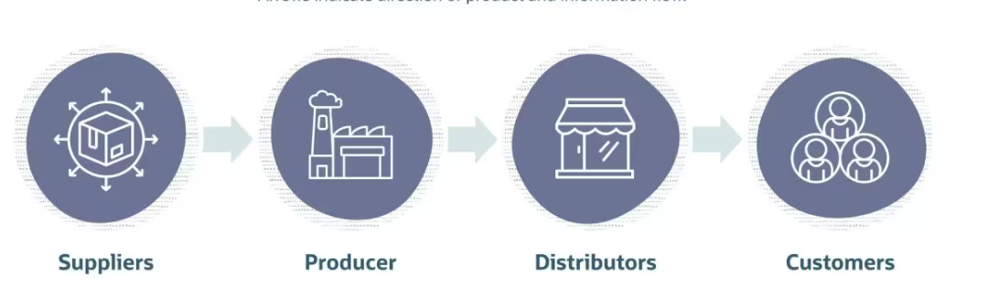
Figure 3: Push marketing
(Source: Luther, 2024)
Since Amazon has vast customer data available, it can then push products suggesting to the customers via emails, app notification as well as recommending these products on-site through its page based on customer behavior as well as his purchase history. Push marketing tactics such as Amazon’s “Deal of the Day” and Flash Sales encourage immediate purchases through an incentive (Chandrasekhar et al. 2024). In addition, Amazon also does co branded marketing through the prime day. In addition, Amazon is still enhancing its advertising platform by which third party sellers can advertise their products to customers through Amazon ad tools, to generate more sales through Amazon’s huge network.
Creating Demand Through Awareness (Pull Marketing): One of Amazon's pull strategies is through building brand equity through customer satisfaction and an unparalleled shopping experience and innovative products.
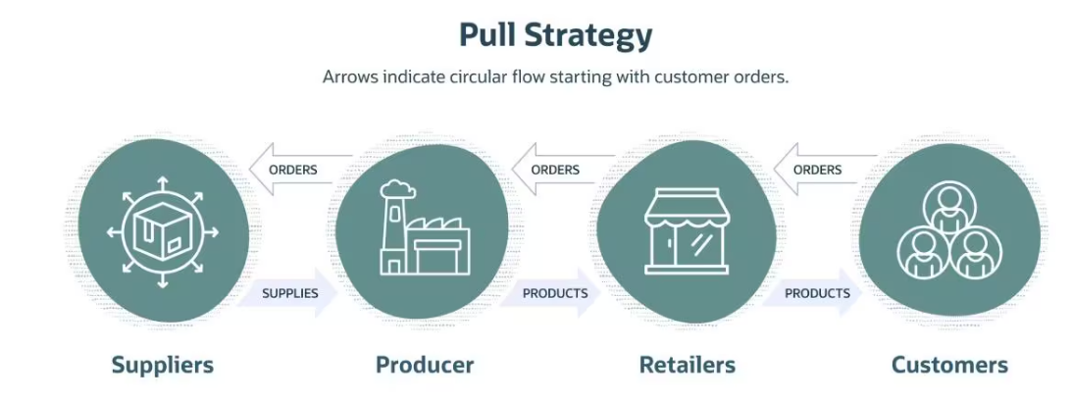
Figure 4: Pull marketing
(Source: Luther, 2024)
The pull marketing that Amazon utilizes to acquire customers is one of retention with an ecosystem that customers cannot leave easily, having over 200 million Prime members globally (Statista, 2024b). The aim is for people to buy something as something, without organic demand, word of mouth, positive reviews or trust in the Amazon brand. For example, Amazon Prime Day is a globally deployed shopping event that uses massive demand by offering exclusive discounts to Prime members (Amazon, 2022). The digital content (video, music etc.) in the catalog is also extensive and sets into a pull effect of making customers come back frequently and buy more products.
Amazon uses influencer partnerships on social media platforms like Instagram and TikTok to have influencers promote Amazon exclusive products and consequently drive traffic to Amazon’s website. Amazon Influencer Program is a program that encourages influencers to create contents that attract shoppers to Amazon’s marketplace directly (Watanabe et al. 2021). In 2023, Amazon’s strategy involved its characteristic market penetration strategy in existing markets, deep product innovation especially in cloud computing and healthcare, and calculated diversification in new sectors like autonomous vehicles and health services. The Push-Pull marketing strategies enable Amazon to maintain the demand whilst promoting customer loyalty so that it can keep pace with the fast changing global market and edge out the competition.

Recommendation to improve market position of Amazon
Amazon has to focus on expanding its sustainable practices like eco-friendly delivery options and renewable energy investments to improve its position in the market by attracting environmentally conscious customers. Moreover, Amazon could further leverage AI to predict and serve the customer better with personalised shopping experience. With localised offerings, it will help to capture new customers and strengthen its presence in emerging markets like Southeast Asia and Africa (Mari, 2023). Overall, addressing reputational concerns and solidifying leadership in e-commerce, cloud, tech innovation can be accomplished through enhancements of its customer service and employee relations.

References
Amazon (2022), Our mission Available at: https://www.aboutamazon.eu/news/how-amazon-works/our-mission [Accessed on: 20th February, 2025]
Amazon (2022). How peak events like Prime Day helped Amazon navigate the pandemic. Available at:https://www.amazon.science/latest-news/how-peak-events-like-prime-day-helped-amazon-navigate-the-pandemic. [Accessed on: 20th February, 2025]
Amazon (2023). Customers Can Now Get Amazon's Fast, Affordable Grocery Delivery Without a Prime Membership. Available at: https://press.aboutamazon.com/2023/11/customers-can-now-get-amazons-fast-affordable-grocery-delivery-without-a-prime-membership.
Amazon (2025), About Us Available at: https://www.forbes.com/profile/jeff-bezos/ [Accessed on: 20th February, 2025]
Blease, R. (2024), E-Commerce Marketplaces: Four Risks Impacting Consumer Trust Available at: https://www.forbes.com/councils/forbestechcouncil/2024/09/30/e-commerce-marketplaces-four-risks-impacting-consumer-trust/ [Accessed on: 20th February, 2025]
Chandrasekhar, K., Das, S., Gupta, N. and Jena, S.K., 2024. Comparative analysis of impulse buying behaviour across retail channels: a study of physical stores, e-commerce websites and mobile shopping apps. Economic Affairs, 69(2), pp.1109-1120.
Chevalier, S. (2024), Leading large cap e-commerce companies worldwide 2024, by market cap Available at: https://www.statista.com/statistics/245340/leading-large-cap-e-commerce-companies-market-cap/ [Accessed on: 20th February, 2025]
Chevalier, S., (2024), Global retail e-commerce sales 2014-2027 Available at: https://www.statista.com/statistics/379046/worldwide-retail-e-commerce-sales/ [Accessed on: 20th February, 2025]
Clement, J. (2025), Workforce of leading global online companies 2014-2024 Available at: https://www.statista.com/statistics/271575/number-of-employees-in-web-companies/ [Accessed on: 20th February, 2025]
Coppola, D. (2024), Global e-commerce market share of leading e-retailers 2022 Available at: https://www.statista.com/statistics/664814/global-e-commerce-market-share/ [Accessed on: 20th February, 2025]
Coppola, D. (2025) Net sales of Amazon in leading markets 2014-2024 Available at: https://www.statista.com/statistics/672782/net-sales-of-amazon-leading-markets/ [Accessed on: 20th February, 2025]
Coppola, D. (2025), Amazon quarterly net sales revenue 2007-2024 Available at:https://www.statista.com/statistics/273963/quarterly-revenue-of-amazoncom/ [Accessed on: 20th February, 2025]
Faria, J. (2024), Amazon: brand value 2006-2024 Available at:https://www.statista.com/statistics/273963/quarterly-revenue-of-amazoncom/ [Accessed on: 20th February, 2025]
Forbes (2023), Advancing Towards Eco-Conscious E-Commerce: Bridging Consumer Demand And Sustainable Operations Available at: https://www.forbes.com/sites/shoplazza/2023/10/18/advancing-towards-eco-conscious-e-commerce-bridging-consumer-demand-and-sustainable-operations/ [Accessed on: 20th February, 2025]
Forbes (2024), How politics affects global business Available at: https://www.forbesindia.com/article/thunderbird/how-politics-affects-global-business/94657/1 [Accessed on: 20th February, 2025]
Forbes (2025), Jeff Bezos Available at: https://www.forbes.com/profile/jeff-bezos/ [Accessed on: 20th February, 2025]
Li, K., (2022). SWOT analysis of e‐commerce development of rural tourism farmers' professional cooperatives in the era of big data. IET communications, 16(5), pp.592-603.
Luther. D (2024). Push vs. Pull: Finding the Right Balance in Supply Chain Strategy. Available at: https://www.netsuite.com/portal/resource/articles/erp/push-pull-strategy-supply-chain.shtml. [Accessed on: 20th February, 2025]
Mari, M., (2023). When Customer-centricity is Not Enough: Lessons From Amazon’s Ventures in Emerging Markets. Available at SSRN 4629289.
McCallum,S., and Vallance, C. (2023), Amazon trials humanoid robots to 'free up' staff Available at:https://www.bbc.com/news/technology-67163680 [Accessed on: 20th February, 2025]
Medium (2024). External Environment Analysis of Amazon. Available at: https://medium.com/@nareshnavinash/external-environment-analysis-of-amazon-6eeb634b1b6e#:~:text=Amazon%2C%20a%20global%20e-commerce,dynamic%20and%20complex%20external%20environment. [Accessed on: 20th February, 2025]
Rahman, M.S., (2024), E-commerce Evolution: A Strategic Analysis of Alibaba's Business Ecosystem.
Statista (2024). Retail e-commerce sales worldwide from 2014 to 2027. Available at: https://www.statista.com/statistics/379046/worldwide-retail-e-commerce-sales/. [Accessed on: 20th February, 2025]
Statista (2024b). Amazon Prime - statistics & facts. Available at: https://www.statista.com/topics/4076/amazon-prime/#topicOverview. [Accessed on: 20th February, 2025]
Statista (2024c). Amazon's shipping costs from 2011 to 2023. Available at: https://www.statista.com/statistics/806498/amazon-shipping-costs/. [Accessed on: 20th February, 2025]
Statista Market Insights (2024), eCommerce - Worldwide Available at: https://www.statista.com/outlook/emo/ecommerce/worldwide [Accessed on: 20th February, 2025]
Watanabe, C., Akhtar, W., Tou, Y. and Neittaanmäki, P., (2021). Amazon's initiative transforming a non-contact society-Digital disruptionleads the way to stakeholder capitalization. Technology in Society, 65, p.101596.
Waters, J. (2025), Amazon.com Available at: https://www.britannica.com/money/Amazoncom [Accessed on: 20th February, 2025]

