April 26

Student ID : 2426374
Name: Elena Magher
Lecturer: Fahad Ahmed

LinkUp CIC
Innovation. Enterprise & Computing Project
Assessment 2 ACCA5033 -Level 5 BSC computing Portfolio
Table of Contents
Task 1: Project Management 3
Q1: Project Management and Planning 3
1.1 Project Scope 3
1.2 Required Technologies and Resources 3
1.3 Project Constrains 4
1.4 Grant Chart – Project Schedule 4
1.5 Development Methodology 4
Q2 Project Design 6
Design Piece1: User Journey Flowchart 6
Design Piece 2 : UML Use Case Diagram 8
Task 2: Enterprise and Innovation (T2 Innovation) : 9
Q1. PEST and SWOT Analysis 9
Figure 4: PEST Analysis LinkUp 9
Legal and Ethical Considerations: 10
SWOT Analysis 10
Q2- Development, Development, Maintenance, and Evolution 10
Development Approach in a Large Organisation 10
Deployment strategy 11
Maintenance and Evolution 11
Justification of Technical Choices 11
Task 3 project Reflection 12
Gibb’s Reflective Cycle – LinkUp CIC 12
Skills Developments 13
Societal Impact 13
Risks, Challenges, and Mitigation Strategies 14
Progress Diary 14
Conclusion: 14
References: 16

Introduction
This report advances LinkUp CIC from a conceptual social innovation, established in Assessment 1 , into a structured enterprise and computing project. LinkUp is a location-bases community coordination platform designed to reduce the organisational barriers to in-person social interaction to urban environments.
The project is grounded in the principle that Innovation =Creativity + Commercialisation. [1]Whilst creativity generates the idea, commercialisation provides the mechanism for sustainable delivery.
LinkUp applies this principle through the 3Ps framework:
- Person = identify urban loneliness as the core problem
- Process = applying structured software development and project management
- Product = developing a minimum viable platform
Poisoned as a Community Interest Company (CIC), the platform priorities social value er profit maximisation. [1]
This report addresses the tasks:
- Task 1 covers project management , system design , and methodology.
- Task 2 examines the enterprise environment through Pest and SWOT analysis and considers the platform’s technical deployment and evolution.
- Task 3 reflects on the project using Gibb’s Reflective Cycle and identifies risks, skills development, and societal impact.

Task 1: Project Management

Q1: Project Management and Planning

1.1 Project Scope
LinkUp CIC aims to develop a Minimum Viable Product (MVP) – a location-based mobile application that enables urban communities to discover and participate in recurring local social events. The proposed solution directly addresses increasing social isolation in UK cities, a problem formally recognised by the UK government in its Loneliness Strategy .[2]
The MVP scope is deliberately constrained to six core functions:
- User registration and profile creation.
- Location based event discovery.
- Event creation
- RSVP confirmation
- Basic in-app messaging
- Moderation and reporting tools
Advanced features such as AI-based matching algorithms or large-scale infrastructure are explicitly excluded from the pilot phase to maintain focus and manage complexity.

1.2 Required Technologies and Resources
- Front-end: React Native ( for cross-platform iOS/Android)
- Backend: Node.js with Express.js REST API
- Database: PostgreSQL ( relational. For user and event data)
- Geolocation: Google Maps API / Map-box SDK
- Messaging: Firebase Realtime Database
- Hosting: AWS EC2 (pilot) with scalability to AWS lamb
- Security: HTTPS , JWT authentication , UK GDPR – complaint data handling[3]

1.3 Project Constrains
- Time: 12 weeks pilot development cycle ( see Grantt Chart below )
- Financial: Limited seed capital consistent with CIC model , no venture funding
- Legal : Full compliance with UK GDPR and Data Protection Act 2018 required from outset
- Technical: No proprietary algorithms ; open-source stack only in pilot
- Social: Low initial user density in pilot geography requires careful location selection

1.4 Grant Chart – Project Schedule
The following Grantt chart documents the six development phases across a 12-week schedule, applying the hybrid SDLC methodology described in Section 1.5
Project Phase | W1 | W2 | W3 | W4 | W5 | W6 | W7 | W8 | W9 | W10 | W11 | W12
Phase: 1 Requirements & Scope
Phase 2 : System Design & Prototyping
Phase 3: Core Development (MVP)
Phase 4: Testing &QA
Phase 5: Pilot Development
Phase 6: Review &Documentation
Figure1 LinkUp CIC – 12 Week Gantt Chart

1.5 Development Methodology
A hybrid SDLC approach was selected following a comparative analysis of available methodologies. A strict Waterfall model was rejected because social platform development requires iterative feedback to validate user behaviour assumptions. Fully open Agile was also rejected as it risks uncontrolled scope and fixed review milestones with documented deliverables. This approach aligns with hybrid lifecycle model, which combining the structure of plan-driven development with adaptability of agile practices. [4]

Q2 Project Design

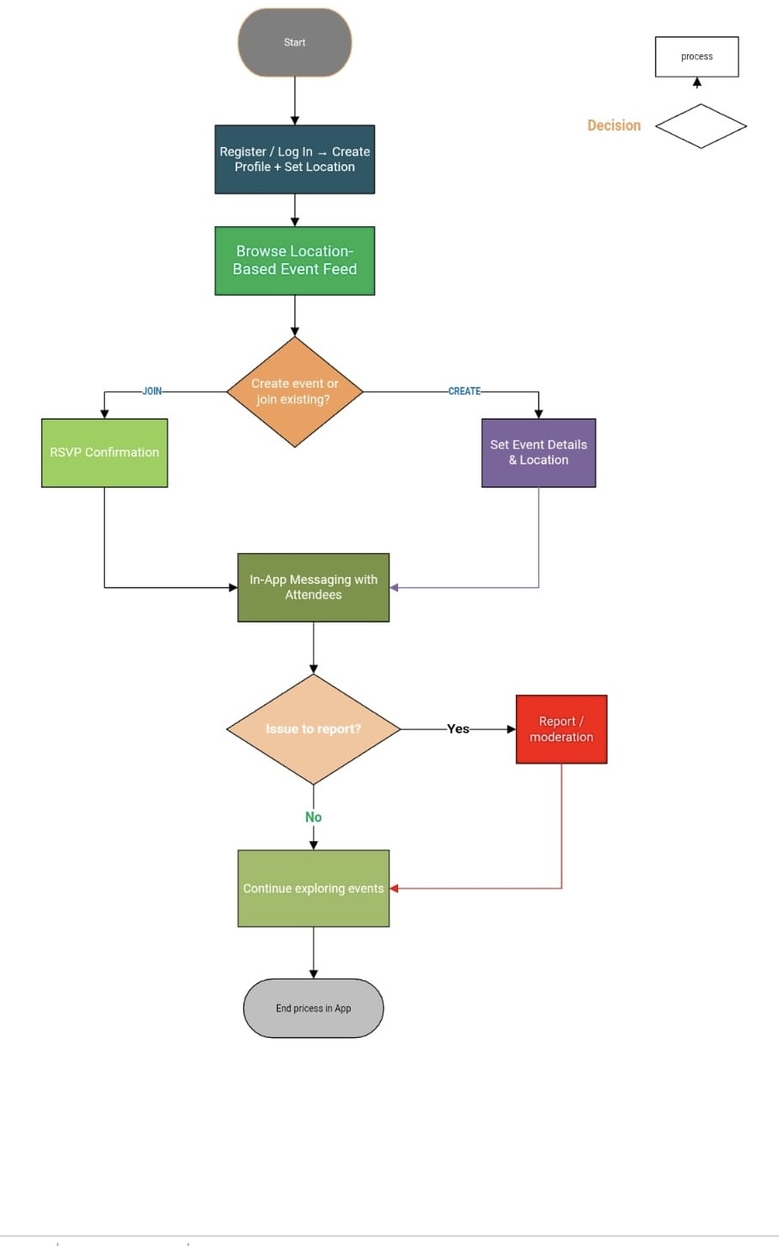
Design Piece1: User Journey Flowchart
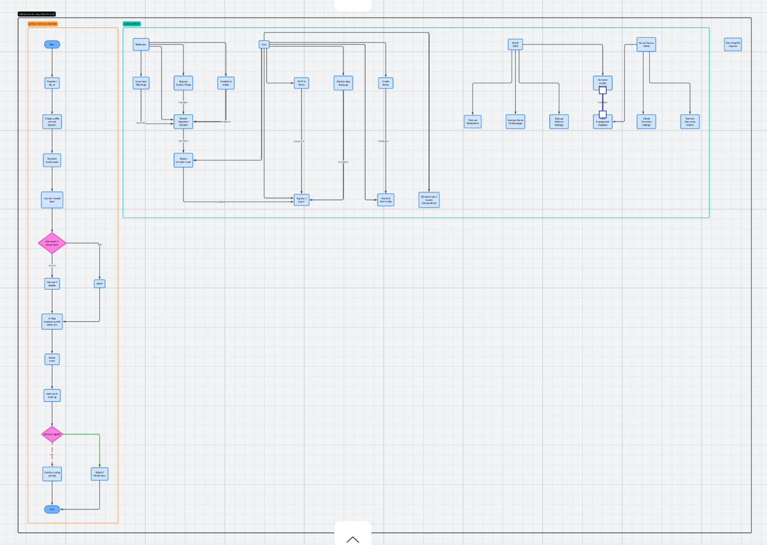

Figure 2: Journey Flowchart

The flow chart presented below models the end-to-end user journey within the LinkUp platform, beginning with user registration and profile creation, progress through event and profile creation, progressing through event discovery and participation, also extending to post-event reporting and moderation. The inclusion of decision nodes demonstrates that safeguarding considerations are structurally integrated into the system design from the outset, rather than treated as a secondary feature.

Design Piece 2 : UML Use Case Diagram
The UML Use Case Diagram below defines the for primary system factors:
- User
- Moderator
- Admin (CIC)
- Venue Partner (SME) and maps their respective system interactions.
This structured approach to actor-system relationships follow standard UML 2.0 notation [5]and ensures that safeguarding and venue partnership roles are architecturally rather than added retrospectively
Actor | Use Cases (System Interactions)
User | • Register / Log In  • Create & Edit Profile  • Discover Local Events (Geolocation)  • Create Event  • RSVP to Event  • Send In-App Message  • Report Content / User
Moderator | • Review Reported Content  • Remove Harmful Posts  • Issue User Warnings  • Escalate to Admin
Admin (CIC) | • Manage Platform Settings  • Oversee Moderation  • Manage Venue Partnerships  • Generate Impact Reports
Venue Partner (SME) | • Create Promoted Listings  • Sponsor Recurring Events  • View Engagement Analytics
Figure 3: LinkUp CIC -UML Use case Diagram system interaction

Task 2: Enterprise and Innovation (T2 Innovation) :

Q1. PEST and SWOT Analysis
The Following analysis applies PEST and SWOT frameworks to LinkUp CIC drawing on the UK technology and social enterprise environment.
Whilst both tools provide useful structural scanning, their epistemological limitations must be acknowledged: PEST categorises macro-environmental factors but cannot measure behavioural adoption responses, and SWOT simplifies dynamic environments into static quadrans without probability weighing .[6]

Figure 4: PEST Analysis LinkUp

Legal and Ethical Considerations:
Uk GDPR and Data Protection Act 2018 impose strict obligations on geolocation data collection, requiring explicit user consent, data minimisation, and clear retention policies [7]. Ethically, location-based platforms create inherent power asymmetries between the operator and user.
LinkUp addresses this by explicitly excluding targeted advertising and behavioural data monetisation from its revenue model. This reduces revenue potential but preserves ethical credibility a deliberate strategic choice aligned with CIC’s social mission .[1]

SWOT Analysis
Strengths
- Clear social mission
- CIC legal mission lock
- Hyper-local focus
- Low infrastructure cost

Weaknesses:
- Network-effect dependency
- Safeguarding demands
- Limited capital reserves
- Adoption uncertainty
Opportunities
- Local council partnerships
- University wellbeing ties
- Community grants
Threats
- Limitation by lager firms
- Regulatory tightening
- Safety incident risk
- Novelty fade-out

Figure 5: SWOT Analysis of LinkUp CIC Strategic Evaluation

Q2- Development, Development, Maintenance, and Evolution

Development Approach in a Large Organisation
If LinkUp were implemented with large organization such as a local authority or national housing association; the development lifecycle would follow enterprise-grade SDLC practices. The requirements Phase would involve structured stakeholder workshops with residents, council officers, and community groups, producing a formal Software Requirements (SRS) aligned with the organisation’s digital strategy.[4]
The design phase would produce detailed UML artefacts including Class Diagrams, Sequence Diagrams Specification (SRS) ,and Entity-Relationships Diagrams (ERD) for the database layer . Development would adopt an Agie -within-Waterfall (Agil Waterfall) framework; quarterly milestone gates with two-week sprint cycles within each phase , enabling iterative delivery whilst maintaining corporate gouvernante accountability.[4]

Deployment strategy
Deployment would follow a Phased Rollout strategy, beginning with a single borough pilot before city-wide expansion [8][8]. This consistent with Innovation model, which identifies the need to establish early adopter on private Cloud (Azure Government or AWS GovCloud ) to satisfy public sector data residency requirements.

Maintenance and Evolution
- Post-deployment maintenance would be classified into four types following established software engineering taxonomy ( corrective =bugs fixes.)
- Adaptive (GDPR regulatory updates)
- Perfective (feature enhancements based on usage analytics
- Preventive (security hardening and codebase refactoring) [4]
- A dedicated DevOp’s pipeline with automated testing and continuous to past-release maintenance is managed efficiently.

Justification of Technical Choices
React Native was selected for it cross-platform capability, reducing development cost without sacrificing user experience quality. SQL provides relational integrity essential for privacy-complaint user data management. The deliberate avoidance of proprietary AI or machine learning components ensures transparency, auditability , and reduced vendor lock-in values consistent with both public sector and CIC governance expectation.[1]

Task 3 project Reflection

Gibb’s Reflective Cycle – LinkUp CIC
This reflection applies Gibb’s six-stage Reflective Cycle to critically evaluate the development of LinkUp CIC [9], identify skills development Opportunities, asses societal impact potential , and document risks with mitigation strategies.

3.1 Description | This project required designing LinkUp CIC, a location-based community coordination platform. Tasks spanned project management , enterprise , analysis, system design , and ethical governance . The project was developed independently applying frameworks from coursework including SDLC, PEST, SWOT and the 3PS’s.
3.2 Feelings | Initially, the breath of the project felt overwhelming – balancing technical system design with enterprise strategy and ethical consideration simultaneously. However, as the work progressed, confidence grew as connections between the frameworks became clearer. The process of choosing the CIC legal structure felt particularly meaningful.
3.3 Evaluation | The application of PEST and SWOT provided structured insight into the operating environment. The hybrid SDLC methodology proved well-suited to the project scope. However, producing fully details UML diagrams and Grantt Chart required additional time, highlighting the gaps in prior planning experience.
3.4 Analysis | The core learning here was that innovation frameworks provide structure but cannot resolve the fundamental tension between commercial viability and social mission[10]. Rogers’s Diffusion of Innovation theory suggest that adoption barriers(not technical ones) are the primary risk for LinkUp . Computing can reduce coordination friction but cannot replace trust building.
3.5 Conclusion | Going forward, stronger time management during the design phase would improve deliverable quality. A more structured research log would help manage citations. Developing skills in diagramming tools such as Lucid Charts pr Draw.io would strengthen future project design outputs significantly.
3.6 Action Plan | To develop new skills: complete an online course in mobile app development (React Native) within three months. Begin personal progress diary from week one to track design decisions. Enhance with the UK Government’s Loneliness Strategy documentation to inform safeguarding and parentship strategy [2]for the phase
Figure 6 of Gibb’s six-stage Reflective Cycle

Skills Developments
This project identified several concrete skills developments priorities. Technically, prophecy in React Native mobile development will be developed through structured self-study using official React Native documentation and freeCodeCamp curriculum. Diagrams and system design skills will be strengthened through practice with Lucid Chart and Draw.io . Academically, IEEE citation management will be practised consistently across future assignments to reinforce scholarly rigour.[10]
Professionally, this project developed competences in enterprise strategy, legal structure analysis, and ethical technology governance – skills directly transferable to technology management roles with public sector or social enterprise contexts.

Societal Impact
LinkUp CIC directly addresses urban loneliness, which the UK Government classifies as public health issue affecting over nine million people .By reducing the organisational barriers to in-person community participation, the platform has the potential to improve mental wellbeing, strengthen neighbourhood identity, and support local small business through increased footfall at partner venues .
The CIC legal structure ensures that social impact remains the primary organisational objective regardless of commercial success, providing long-term mission protection . [4]If the pilot demonstrates measurable reduction in social isolation metrics, the platform would be positioned for partnership with NHS social prescribing schemes and local authority community resilience programmes.

Risks, Challenges, and Mitigation Strategies
Risk/ Challenge | Likelihood/  Impact | Migration
Low user density in pilot area | High/high | Select dense urban pilot area; partner with university wellbeing programmes for initial user base
Safeguarding incident  (user safety) | Medium/Critical | Manual moderation from day one:  -clear reporting tools.  -zero-tolerance policy with admin escalation path.
GDPR non-compliance | Low / Critical | Legal review of data architecture before launch; privacy-by-design approach emblemed in system design
Venue partner disengagement | Medium/ Medium | Diversify revenue streams; offer free pilot listing to establish value before fees
Scope creep / over-engineering | High/ Medium | Strict MVP boundary enforced; All new features require documented justification before sprint inclusion
Figure 7 : Risk Register -LinkUp CIC

Progress Diary
Period | Activity & Milestones
Week 1-2 | Requirements gathering, scope definition, literature review, identified urban loneliness as the core problem. Reviewed ~Uk loneliness Strategy and GDPR obligations.
Week 3-4 | System design phase: produced flowchart and UML use case diagram. Identified MVP features. Selected hybrid SDLC methodology and documents constrains.
Week 5-8 | System design phase (MVP) build: user registration, event discovery, RSPV, and basic messaging modules. Documented technical decisions
Week 9-10 | Testing and quality assurance. Manual moderation controls piloted. Privacy permission validated against UK GDPR.
Week 11-12 | Pilot deployment in limited geographic area. Review of enterprise strategy documentation of PEST/ SWOT, and final writing.
Figure 8: Project Progress Diary – 12Week development Cycle

Conclusion:
This project has advanced LinkUp CIC from conceptual innovation into a structured evidenced enterprise and methodology, supported by a Grantt Chart and clear MVP constrains, provides a realistic framework for delivering a socially impact impactful platform within academic and resource constrains. The flowchart and UML use case diagram established are architecturally central rather than peripheral concerns.
Task 2 demonstrated, through PEST and SWOT analysis, that LinkUp operates in a contextually supportive but operationally complex environment. The decision to pursue the CIC legal structure rather than a private limited company reflects a deliberate governance choice prioritising mission integrity over capital seed a trade-off that shapes every subsequent strategic decision. The T2- Innovation response showed that LinkUp’s deployment in a large organisational context would require enterprise SDLC rigour , phased rollout , and long-term maintenance planning.
Task 3 structured through Gibb’s Reflective Cycle, revealed that the primary learning outcome of this project is not technical – it is the recognition that responsible innovation in social computing contexts requires the continuous alignment of purpose, process, and practice. Computing enables coordination; it does not create community. Long-term impact depends on trust, sustained engagement and measured growth.

References:
[1] G. Gibbs, Learning by Doing: A Guide to Teaching and Learning Methods, Oxford: Further Education Unit, Oxford Polytechnic, 1988.
[2] K. Andrews, "Strategic Analysis Tools: SWOT and PEST Revisited," vol. 34, no. 1, pp.12–19, 2023,
[3] G. Booch, J. Rumbaugh and I. Jacobson,The Unified Modeling Language User Guide, 2nd Ed. Reading, MA: Addison-Wesley, 2005.
[4] I. Sommerville, Software Engineering, 10th Ed. Harlow: Pearson, 2016.
[5] H. M. Government, "Tackling Loneliness: The Second Annual Report," London. 2020.
[6] E. M. Rogers, Diffusion of Innovations, 5th Ed. New York: Free Press, 2003.
[7] P. Kotler and G. Armstrong,Principles of Marketing, 17th Ed. Harlow: Pearson, 2021.
[8] M. C. Addis and M. Kutar, "The General Data Protection Regulation (GDPR), Emerging Technologies and UK Organisations: Awareness, Implementation and Readiness", Proceedings of the BCS Annual Conference on, Computing.
[9] U. K. Government, "A Connected Society: A Strategy for Tackling Loneliness," London. 2018.
[10] C. Doering, "SME Resilience in Economic Downturns: Evidence from the UK," J.Small Bus.Manage. vol. 61, no. 2, pp.445–462, 2023,
[11] Office of the Regulator of Community, Interest Companies. "Community Interest Companies: Guidance." [Online]. Available: https://www.gov.uk/government/collections/community-interest-companies
[12] Information Commissioner's Office. "Guide to the UK General Data Protection Regulation (UK GDPR)." [Online]. Available: https://ico.org.uk/for-organisations/guide-to-data-protection/guide-to-the-general-data-protection-regulation-gdpr/
[13] J. Tidd and J. R. Bessant,Managing Innovation: Integrating Technological, Market and Organisational Change, 5th Ed. Chichester: Wiley, 2013.

References
[1] Office of the Regulator of Community, Interest Companies. "Community Interest Companies: Guidance." [Online]. Available: https://www.gov.uk/government/collections/community-interest-companies
[2] U. K. Government, "A Connected Society: A Strategy for Tackling Loneliness," London. 2018.
[3] Information Commissioner's Office. "Guide to the UK General Data Protection Regulation (UK GDPR)." [Online]. Available: https://ico.org.uk/for-organisations/guide-to-data-protection/guide-to-the-general-data-protection-regulation-gdpr/
[4] I. Sommerville, Software Engineering, 10th Ed. Harlow: Pearson, 2016.
[5] G. Booch, J. Rumbaugh and I. Jacobson,The Unified Modeling Language User Guide, 2nd Ed. Reading, MA: Addison-Wesley, 2005.
[6] K. Andrews, "Strategic Analysis Tools: SWOT and PEST Revisited," vol. 34, no. 1, pp.12–19, 2023,
[7] M. C. Addis and M. Kutar, "The General Data Protection Regulation (GDPR), Emerging Technologies and UK Organisations: Awareness, Implementation and Readiness", Proceedings of the BCS Annual Conference on, Computing.
[8] E. M. Rogers, Diffusion of Innovations, 5th Ed. New York: Free Press, 2003.
[9] G. Gibbs, Learning by Doing: A Guide to Teaching and Learning Methods, Oxford: Further Education Unit, Oxford Polytechnic, 1988.
[10] J. Tidd and J. R. Bessant,Managing Innovation: Integrating Technological, Market and Organisational Change, 5th Ed. Chichester: Wiley, 2013.

