CONTEMPORARY CHALLENGE: MAKING A DIFFERENCE(BMSW4007/C_CARD)
ASSIGNMENT ON AIR POLLUTION (DEFINE)
GEMECHU ALIYI
STUDENT NUMBER:2117285

UNIVERSITY OF WALES TRINITY SAINT DAVID
LECTURERS: JAMES S. COUNT WORRDS 1000
Table of Contents
INTRODUCTION 2
AIR POLLUTION CAUSES 2
EFFECTS OF AIR POLLUTION 3
MONITORING OF AIR POLLUTION’S GOALS 4
Air POLLUTION CONTROL 5
CONCLUTION 6
REFERENCES 7

INTRODUCTION
Any molecular, biologic, or physical agents that change the natural characteristics of the atmosphere are referred to as air pollutants. Both natural processes (volcanic activity, ocean currents, woodlands, etc.) and human actions (burning fossil fuels, driving a car, emitting pollution from power plants or other industrial processes) produce air pollutants. Air pollutants come in two different categories: primary and secondary. (“How many types of air pollutants are there?”) Primary pollutants are substances that are produced directly by a process. Examples of these substances are gaseous carbon monoxide from auto emissions or volcanism. Ozone (O3) as well as other photo - chemical pollutants, which are secondary contaminants, can be created with in lower atmosphere because of sun energy and heat. (Pénard-Morand, 2004)

AIR POLLUTION CAUSES
Significant factors that contribute to air pollution include:
- Using Fossil fuel
Sulphur dioxide is widely emitted to the environment during the burning of fossil fuels. Carbon monoxide, that is produced whenever fossil fuels are utilized inefficiently, also contributes to air pollution.
- Automobiles
The ecology is harmed by motor vehicle exhaust, which include those from lorries, buses, and jeeps. They are the primary emitters of greenhouse gases and cause illness in humans.
- Actions of Farmers
Ammonia is one of the substances that is generated during agriculture activities that is the most hazardous. By releasing harmful gases into the atmosphere, insecticide, herbicides, and fertilisers cause environmental harm.
- Factories and Industries
Industries and manufacture are the main producers of chemicals, hydrocarbon, organic molecules, and carbon monoxide.

EFFECTS OF AIR POLLUTION
1.Effect of air pollution on human Atmospheric pollutants may lead to both short- and long-term illnesses, such as strokes, chronic obstructive pulmonary disease, trachea, bronchioles, and lung cancer, aggravated asthma, and fewer infections of the respiratory tract. (EEA, 2022)

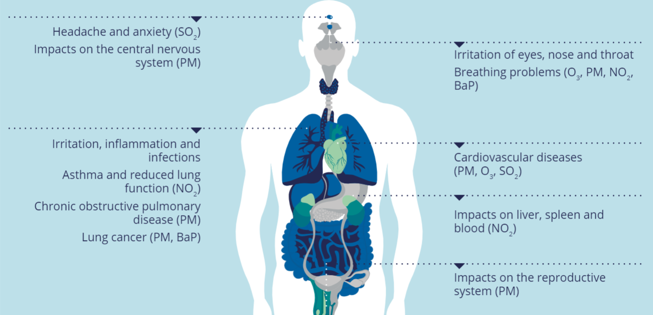
Figure 1: Effect of air pollution on Human being
2. How air pollution affects the environment
Regarding endangering people's life, air pollution can harm the environment in several ways:
Acid rain is defined as precipitation that contains harmful concentrations of nitric and sulfuric acids. N2o and Sulphur compounds are generated during the burning of fossil fuels and play a significant part in the production of these acids in the atmosphere. These acids either fall to the Earth as dry precipitation or moist precipitation (rain, ice, or fog) (gas and particulates). Some are carried by the wind dozens of miles. Plants are harmed by acid rain, which also encourages soil and water body acidification, making the water unsafe for just some aquatic creatures.
(Waters-Ekanem, 2013)
3. Effect of Environment on wildlife
Animals and wildlife are susceptible to the negative effects of air pollution. ' Acid rain, toxic metals, organic pollutants that persist (OPP), and other harmful chemicals are among the pollution-related issues of concern. There are two basic ways that air pollution can impact wildlife. It has an impact on the area or environment in which they reside as well as the supply and quality of food. (Eccc, 2012)
4. Global Warming
Component of air pollution are 'greenhouse gases', such as atmospheric co2. Greenhouse gases increase global warming by trapping solar heat inside the Earth's atmosphere. Despite being a naturally existing element of the Earth's crust, greenhouse gases have increased in quantity since the beginning of the twentieth century, warming the planet. Farm pollutants, smoke emissions from industries and power stations, and vehicle exhaust are some of the sources that are contributing to the rise. Scientists predict that compared to the previous century, global warming will be more pronounced in this one. (Ristvey, 2023)
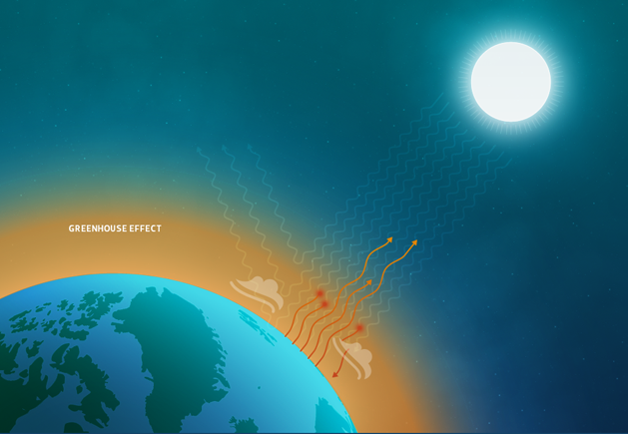
Figure 2: Greenhouse effect

MONITORING OF AIR POLLUTION’S GOALS
Every air quality monitoring programme typically aims to accomplish the following broad goals.
a) To offer a solid scientific foundation for the creation of affordable control strategies and methods to reduce air pollution.
b) To analyse the degree to which regulations on air quality, limit values, and targets are indeed being fulfilled.
c) to evaluate the extent in which the community is provided with reliable and higher knowledge on polluted air; and to achieve regulatory environmental quality disclosure rules. (molina, 2010)

Air POLLUTION CONTROL
The following activities must be performed to lessen air pollution:
1. Avoid driving.
For shorter trips, it is best to avoid using a car. To travel from one place to another, individuals should prefer taking public transit. This also saves energy while lowering emissions.
2.Energy effectiveness
Most of the fossil energy are needed to generate electricity. Hence, keep in mind to switch off all the electrical appliances that is not in service. Thus, you might take individual actions to safeguard the planet. Using thermal, renewable power, and energy from the wind facilitates more significant air pollution reduction. The use of these resources has been permitted by several countries as a step towards a healthier environment.
The extra actions taken to lower air pollution.
a) Making less common use of fire and items related to fire can be one of lowering air pollution. Even though industrial wastewaters are among the major causes of air pollution, it is possible to decrease the toxins at the supplier by managing or trying to treat them. For illustration, a raw material could be swapped out with one that generates less emissions when a specific raw - materials reacts in a manner that generates a pollutants.
b) Fuel replacement is another technique for minimising air pollution. Compressed natural gas vehicles are overtaking petrol and diesel-powered cars in some regions of the world.
c) Another way to lessen air pollution caused by organizations is to upgrade and maintain existing technology to decrease the discharge of pollutants.
c) The best and last option for reducing the effects of air pollution is to grow trees. The presence of trees and plants help minimise many air pollutants. (Byju, 2011)
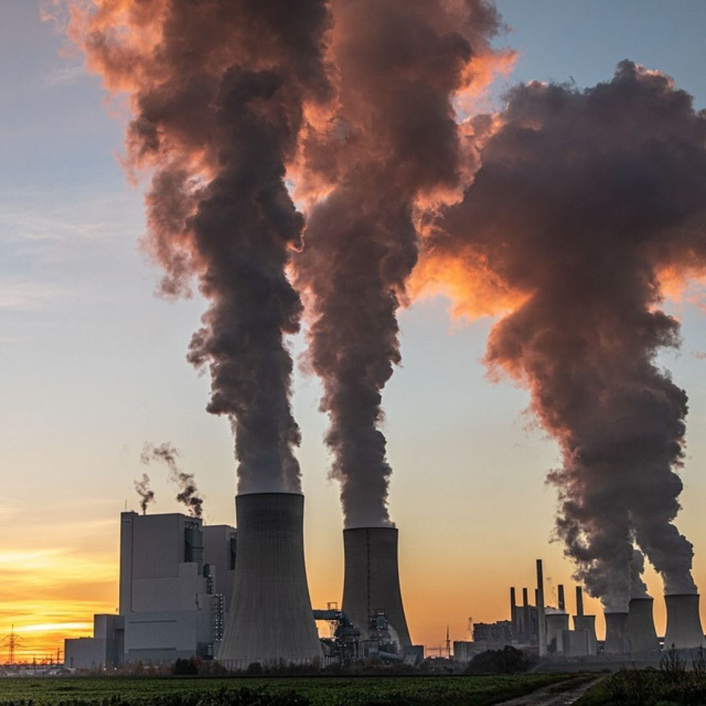

CONCLUTION
Complaints about air pollution, particularly in cities, continue to be serious. Air pollution exposure can, in fact, enhance both sickness and mortality. The very first source of pollution in metropolitan areas is now vehicle traffic, resulting in a rise in photochemical oxidant polluted air, despite significant success being achieved in minimizing emissions from manufacturing sources, reflected in a significant drop in SO2 levels. In order to reduce air pollution emissions, fuel switching and engine designs must be developed. Public transportation and other different modes of transportation, including bicycle, must also be used. Also, significant political decisions must be made in order to lessen air pollution and also its harmful impacts on the well-being of humans and the environment. (C. Pénard-Morand, 2004)

REFERENCES
Byju, 2011. BYJU'S.
Available at: https://byjus.com/biology/air-pollution-control/
C. Pénard-Morand, I. A.-M., 2004. Air pollution: from sources of emissions. In: Air pollution: from sources of emissions. Villejuif: s.n., p. 12.
Eccc, 2012. canada. ca.
Available at: https://www.canada.ca/en/environment-climate-change/services/air-pollution/quality-environment-economy/ecosystem/wild-animals.html
[Accessed 29 MAY 2012].
EEA, 2022. europa.eu.
Available at: https://www.eea.europa.eu/themes/air/health-impacts-of-air-pollution#:~:text=Both%20short%2D%20and%20long%2Dterm,asthma%20and%20lower%20respiratory%20infections.
[Accessed 5 october 2022].
molina, M. J., 2010. Air pollution; health and Environmental impacts. In: Air pollution; health and Environmewnt. Newyork: Taylor & Francis Group, pp. 46-47.
Pénard-Morand, 2004. Air pollution: from sources of emissions to health effects. In: Air pollution: from sources of emissions to health effects. Villejuif, France: s.n., p. 2.
Ristvey, J., 2023. UCAR.
Available at: https://scied.ucar.edu/learning-zone/air-quality/air-quality-and-climate-change#:~:text=The%20recent%20increase%20in%20greenhouse,causing%20the%20climate%20to%20warm.&text=Air%20pollution%20includes%20greenhouse%20gases,Sun%20in%20the%20Earth's%20atmosphe
[Accessed 2023].
Waters-Ekanem, M., 2013. massdep.
Available at: https://www.mass.gov/doc/health-environmental-effects-of-air-pollution/

