What is tendering?
Tender is an offer which incorporates the sum of money, time and other conditions required to carry out the contract obligations in order to complete a project or a part of it consisting of specified works.
Tendering is a formal process which involves and results in a offer that will typically be made by a contractor or even a consultant which will come from after a response to a invitation to the tender. Contractors that are tendering in the construction industry are most likely going to be competing with more than one which means they will need to submit the their most competitive tender that they can. This is done because they wont know who else will be quoting on this and this will mean that the client will be able to receive quotes at the highest value possible.
What are the advantages of tendering?
With a established and well trained quantity surveyor that will prepare and monitor the tender they will ensure that the client will get the best value they possibly can for it. Also the client is well aware of the programme duration and also knows the number of errors and omissions that will be made in the pricing.
Part of the Quantity Surveyors role in the tender process is to review every tender and identify any anomalies within the pricing. This ensures that the contractor is content with their tender return and are fully committed to carrying out the work for the price quoted. Low items especially can cause issues down the line, so rather than letting the contractor find this out during the project (and start claiming every extra they can to make it up) it is often better to work collaboratively at the beginning of the project.
The pros are:
- Ensures that the client receives the best value tender for every project.
- It gives the client a set of competitive unit rates for use in variation negotiations.
- Ensures that the client is comparing “like for like” quotations.
- Contractors take part in formal process with clear selection criteria.
- Demonstrates to the client the commitment of the potential contractor.
The disadvantages of tendering
Tendering can have its downfalls. The pricing of tenders are much more expensive than just basically sending someone a email explaining that you have drawings and can you get a quote on the price for this. However this can be counteracted by the argument that this is a long term decision to have a tender process because the money that it can save in the long run of a project but the initial cost of this a lot higher than it can be made to be.
Smaller construction companies or your local standard builder may decide they do not want to take part in a project that involves a tender because of the initial cost is much more expensive than a simple quote for the price of the work. Also premium contractors will choose not to competitively tender because the demand that is there for their services without having to compete with other companies.
Competitive tenders are often only cost-effective on projects over £200,000, unless the smaller project is particularly complicated or of a high specification.
The cons of tendering
- More expensive (initially) than sending out drawings to builders and asking for a quote.
- Take longer than the above scenario.
- Can exclude small builders who do not have time to price.
- Can exclude builders in high demand who do not need to compete for work.
- Only suitable for mid-high value residential projects.
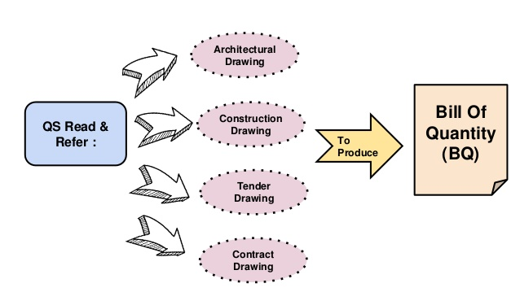
How can you ensure effective tendering?
One crucial error that a quantity surveyor sometimes make is the issue of a tender pack which would typically be used in a commercial project but would be way to complicated for a smaller domestic project. A residential contractor would likely to be seen very different to their counterparts in a commercial sector.
A quantity surveyor should be understanding to the tenderers and make sure that all the information is seen to be clear and obviously understandable. This needs to be done as it is not the tenderer to have to do, this is up to the Quantity surveyor at hand.
A local residential contractor will obviously have far less staff but will look at completing a higher sum of projects than say a larger commercial contractor. This means that when sending over information to the contractor that it doesn’t need to be made to complicated so information that is important should only be sent to the contractor and not sent a lot of un needed information that they will then have to work through which will take up too much time.
A tender is a submission made by a prospective supplier in response to an invitation to tender issued by an employer. It makes an offer for the supply of goods or services.
The two purposes of tendering are:
- Being able to select a suitable contractor at the right time of the project
- The price that is required from the contractor at the right time. This offer will be on the basis of the contract at hand. Also this includes the conditions, the contracts drawings and also the bill quantities, in all this makes up the bill of quantities
There is no direct relationship that exists between the type of tendering process and the form of the contractual agreement. The tendering process will show that the start of the contract has began and the relationship has formed between both parties.
The Main methods that are used for tendering:
- Open Tendering
- Negotiated tendering
- Selective tendering in single or two stage
- Serial tendering
- Joint ventures

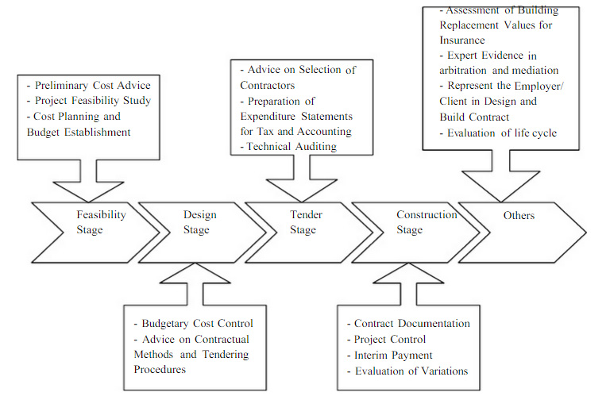

Legal obligations
Like everything along comes the legal side of the process. The parties have obligations to each other so they are protected.
- The employer’s request for tenders is an invitation to treat and therefore the employer is under no legal obligation to accept any tender.
- The cost of tendering is generally borne by the contractor.
- Where the preliminary work goes beyond what is normally expected, an employer may agree to make payment.
- A person who invites another to tender with no intention whatsoever of accepting that tender can be liable for any expenses that the latter incurs.
- An employer who expressly promises to accept the lowest tender will be bound by that promise, if that tender complies with any conditions.
- An employer may be under an implied obligation to give proper consideration to any tender submitted in accordance with published conditions.
- Local authorities are required by the Local Government Act 1972 to publicise formal contracting procedures, normally involving competitive tendering.
- Local authorities are required to give reasons for their procurement decisions and are generally prohibited from taking into account non-commercial considerations in reaching those decisions.

Types of tendering strategies
Open Tendering

With open tendering the employer will advertise the project that gets proposed and will permit as many contractors that show interest in applying for the tender documents. This csn even be cemented by a paid deposit from the applicant on a bona fide tender.
This method has been known to be described as a bit wasteful of contractors and their resources as they will be spending their time preparing the tenders with no effect. This also may be the case as the chances of them getting the contract is likely to be small and they may not study this contract in the greatest detail to work out the overall minimum price but only to come up with a price quote that will clearly make them profit if the contract is rewarded.
The employer among all of this maybe only offered a number of prices and therefore not the lowest price which his project can be constructed at. If the employer chooses the lowest priced tender then they run the big risk that the tenderer does not have the technical and financial resources to complete the job properly and therefore runs big risks in making this decision.
The employer is able to check a number of resources and then is able to find out who the lowest bidder is and move on to rejecting this tender if it proves unsatisfactory. Several bids maybe below the initial estimated cost of the job. If some tenderers appear the right fit for the contract and their bids are not far apart in price it would be very difficult for the employer to pick the right one without just going for the lowest overall bid.
The engineer advising the employer may think there is a risk that all such low bids could prove unsatisfactory, but he cannot advise the employer what other bid to accept because he has no certainty of information.

Selective Tendering
With selective tendering the employer will advertise the project and will open invitations to contractors who then will get placed onto a list which is full of contractors who will then get invited to bid for the proposed project. The contractors that are applying for this are given a list of information that they can order by themselves which will allow them to see if they are pre-qualified.
The advantage of using this method is that the employer is then able to select the contractors who qualify with the right amount experience for the job. This method is also better as only 5 or 6 contractors max get selected every contractor has a good chance so its highly competitive. This gives the contractors a big incentive to work through and study the documents properly and will the ensure they put down their best price.
A problem with both open and selective tendering is that a contractor’s circumstances can change after he has submitted his tender. He can make losses on other contracts which affect his financial stability; or may be so successful at tendering that he does not have enough skilled staff or men to deal with all the work he wins. Neither method of tendering nor any other means of procuring works can therefore guarantee avoidance of troubles.

Negotiated Tendering
Negotiated tenders are used by the employer by inviting the contractor of his particular choice to submit his decided price for the proposed project. This is normally used for specialised or extension work or even for work that is for further work from a previous contract.
These negotiated tenders can be used when there is a small time left or a tight deadline. These contractors are normally satisfactory in their abilities for the job as usually they have been used before for similar jobs.
When invited to tender the contractor submits his prices, and if there are any queries these are discussed and usually settled without difficulty. Thus mistakes in pricing can be reduced, so that both the engineer advising the employer and the contractor are confident that the job should be completed to budget if no unforeseen troubles arise.
However, negotiated tenders for public works are rare because the standing rules of public authorities do not normally permit them. But a private employer or company not subject to restraints such as those mentioned in the next section can always negotiate a contract, and many do so, particularly for small jobs.
Even when a negotiated tender is adopted it is usual to prepare full contract documents so that the contract is on a sound basis. Production of the documents also means they are available for open or selective tendering should a negotiated tender fail, or should the chosen contractor be unable to undertake the work.

