
Prepared by: Iryna Libych, group 4(flexi)
Student ID 2613531
Assessment 1 – Reading Task
PART 1: Upload your photo of your A3 in-class notes here:
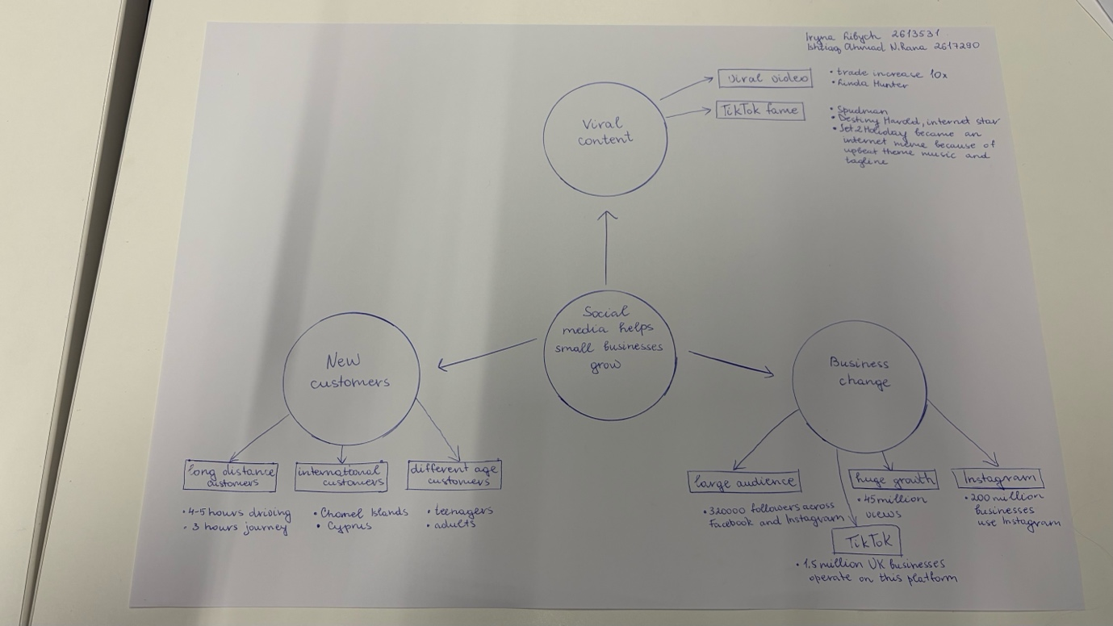

PART 2:

- What is the main idea of the whole text?

The main idea of the whole text is that social media can help small businesses grow by getting more customers and increasing sales. It shows that even a small business can become popular if it uses social media to promote its products.

- What is one key point that supports the main idea, and which specific example from the text shows this?
One key point that supports the main idea is that viral content can help businesses get more customers. For example, customers travelled for three hours to try the chicken burger they saw in a video at Honeywood Sandwich shop.

- What is a different key point that supports the main idea, and which specific example from the text shows this?

The second key point that supports the main idea is that social media helps businesses get a large audience. Little Love’s Pamper Bus racked up about 45 million views in under a year. As a result more people became interested in the business, helping it attract new customers and grow its popularity.

- Which part of the text do you think is most important, and why?
I think the most important part of the text is how social media helps businesses become more recognisable and attract more customers. This can lead to more sales and higher profits. It also allows businesses to connect with their audience and build trust.

Reflection:
- What did you find difficult in this task (including in-class components), and why was it difficult?
I found it difficult to identify key details from specific examples. I had a lot of information and it was quite difficult to decide what was most important and what would be better to include in the mind map. I think I understood how to focus on the main ideas and choose the most relevant information to make mind map easy to understand.

- What helped you with this difficulty, and how did it help you?
Making the mind map, working with my groupmate and the lecturer’s explanations helped me understand the task better. We discussed the main idea and key details together which made it easier to choose what to include in the mind map. Also I think it helps me improve my teamwork because we helped each other understand the text better.

