University of Wales Trinity Saint David


Master of Business Administration
Student Name | Salah Mheidean
Student ID | 2109425
Lecturer Name | Dr. Mansoob Murshed
Module code | LCMB7035
Assignment title | Dissertation

Title:

The use of AI in business operations of Telecommunication Industry and its impact on firm's profitability- The case of Vodafone

Contents

CHAPTER 1: INTRODUCTION 1
  - Background and Research Problem 1
  - Research Problem 3
  - Research Objectives 5
  - Research Questions 6
  - Significance / Relevance of the Study 6
  - Research Gap 7
  - Research Structure 8
CHAPTER 2: LITERATURE REVIEW 10
  - Background 10
  - Introduction 11
  - Theoretical Framework 11
    - Resource-Based View (RBV) 11
    - Dynamic Capabilities Theory (DCT) 12
    - The AI Productivity Paradox 12
  - AI-Enabled Customer Service and Profitability 13
    - Industry Context 13
    - Vodafone’s AI Customer Service Initiatives 13
    - Profitability Implications 14
  - AI-Based Operational Efficiency and Profitability 14
    - Industry Context 14
    - Vodafone’s Operational Efficiency Initiatives 14
    - Profitability Implications 15
  - AI-Based Network Optimization and Profitability 16
    - Industry Context 16
    - Vodafone’s Network Optimization Initiatives 16
    - Profitability Implications 17
  - AI-Driven Personalization and Marketing and Profitability 18
    - Industry Context 18
    - Vodafone’s Personalization and Marketing Initiatives 18
    - Profitability Implications 19
II
  - Collective Contribution to Profitability and the AI Productivity Paradox 19
    - Aggregate Impact 19
    - The AI Productivity Paradox at Vodafone 20
  - Organizational and Human Factors Moderating AI- Profitability Relationship 20
    - Workforce AI Skills 20
    - Organizational Resistance and Change Management 21
    - AI System Limitations 21
  - AI in general, Research Gap and Conclusion 21
    - AI in general 21
    - Research Gap 23
    - Contribution of This Study 23
  - Summary 23
CHAPTER 3: RESEARCH METHODOLOGY 25
  - Research Philosophy 25
  - Research Approach 25
  - Research Design 25
  - Case Study Organization 25
  - Data Sources 25
  - Research Hypotheses 26
3.97 Data Analysis Technique 26
  - Ethical Considerations 26
3.11 Gantt Chart 27
  - PRISMA Model 27
Chapter Four: Data Analysis, Findings, and Discussion 29
  - Introduction 29
  - Evaluation of AI-Enabled Customer Service and Operating Profit Margin 29
  - Examination of AI-Based Operational Efficiency and Profitability 31
  - Assessment of AI-Based Network Optimization and Operating Profit Margin 32
  - Investigation of AI-Driven Personalization, Marketing, and Profitability 32
  - Determination of the Overall Relationship Between AI Adoption and Profitability 33
Hypothesis Testing 36
Introduction to Hypothesis Testing in AI Operations 36
Testing Hypothesis 1: AI-Enabled Customer Service and Operating Profit Margin 37
Testing Hypothesis 2: AI-Based Operational Efficiency and Profitability 37
Testing Hypothesis 3: AI-Based Network Optimization and Operating Profit Margin 38
Testing Hypothesis 4: AI-Driven Personalization, Marketing, and Profitability 39
Chapter Summary 40
Chapter Five: Conclusion and Recommendations 41
  - Introduction 41
References 46
Appendixes 55
Appendix-I- Efficiency: AI & shared operations providing benefits at scale 55
Appendix-II- Our outlook: Building trust in Europe 55
Appendix-III- Vodafone Business double-digit digital services growth 56
Appendix-IV- A new chapter: Demand for our products is being reshaped 56
Appendix-V-B2B as a growth engine 57
Appendix-VI 57
Appendix-VII-Türkiye Scaling to €1bn Adj. EBITDAaL 58

Executive Summary
This study investigates the effects of operating profit margin of the Vodafone Group Plc due to the use of Artificial Intelligence (AI) applications in their business operations. The study adopted a positivist method and deductive approach, and reviewed secondary quantitative data in the Vodafone's FY26 Results Presentation and annual reports for the period from 2018-2025. The results show that the AI-powered customer service used TOBi and SuperTObi virtual agents has resulted in more than 70% end-to-end resolution rates and an 8-point NPS improvement, which directly impacts on operational costs. AI-driven operational efficiency resulted in 30% savings in sourcing time, 12% in software development productivity and 98% accuracy in energy forecasting. AI optimisation of the network cut the MTTR by 43% and kept network expenditure 30% below average for Europe. AI-driven personalization and marketing resulted in 85% of the time reduction in campaign analysis and 14.2% digital services growth.
Altogether, AI applications were responsible for 5.1% and 2.5% organic service revenue and Adjusted EBITDAAL growth, respectively. Based on the Resource Based View and Dynamic Capabilities theories, the study findings show that the adoption of AI can positively contribute to the operating profit margin of Vodafone by reducing costs and boosting revenues.
Key words: Artificial Intelligence, Business operations, Telecommunication Industry, profitability, Vodafone

CHAPTER 1: INTRODUCTION

Background and Research Problem
The Telecom industry is facing a very complex scenario which consists of decreasing Average Revenue per Users (ARPU), increasing costs of infrastructure for 5G and Internet of Things (IoT) deployment, and growing competition between over-the-top (OTT) service providers (SPs) and Telecom Industry (TIs) (Oracle, 2026; Majumdar, 2025). Telecom operators around the world are facing structural costs that are eroding traditional revenue streams and forcing them to think outside the box for ways to become more efficient and to protect their margins (Jurčić, 2026). The use of Artificial Intelligence (AI) in this context has gone beyond just a new technology and grown into a critical need to transform network economics, to automate labor-intensive processes, and to generate new income streams (Bughin et al., 2017; Bag, Gupta, Kumar and Sivarajah, 2021).
As one of the world's largest telecom providers with more than 300 million customers in Europe and Africa, Vodafone is leading the way in implementing AI in the telecom sector (Vodafone, 2025). Several operational implementations highlight the company's strategic use of AI.The company's strategic leveraging of AI is reflected in various deployments. In customer service, Vodafone's AI-powered chatbot, TOBi, handles around 1 million interactions a month, and 70 per cent of queries are resolved on first contact (Vodafone, 2025). In 2024, the company's youth brand VOXI released a big language model (LLM) generative AI Chatbot that won the ‘Innovation of the Year (Product and Service)' award in the Vodafone 2025 Mobile Industry Awards. The ability of AI is not just in resolving queries, but also in analyzing customer interactions to provide insights beyond mere metrics, such as the success of a customer service call, which is currently being adopted by Vodafone UK (Vodafone, 2025). Most importantly, Vodafone UK’s Commercial Operations Director, Jon Shaw, says that AI isn't about replacing the human agent but about helping them do their job well – for the customer's benefit (Vodafone, 2025). This approach is all about people, reflecting Vodafone's strategy for implementing AI. In network operations, Vodafone has reduced mean time to repair by 43 per cent with its Zero Touch Operation system, which automates the field service and network maintenance process with suggested real-time solutions for network diagnostics (Vodafone, 2025). The company's collaboration with Zinkworks, an AI that creates the new feature deployment platform Rapid

RIC, will see the process of adding new features to the radio access network (RAN) cut to 3-4 weeks compared to months previously, and will help the company automatically identify and resolve network faults (Vodafone, 2025c). Vodafone's AI Booster platform, running on Google Cloud, uses information from more than 300 million customers to forecast churn and proactively offer tailored offers, which have enhanced customer retention as well as provided the ability to adjust pricing strategies for increased revenues (ARPU) (Telecom Review Europe, 2026). Vodafone has not used AI only in customer-facing and network applications, but also in HR, the Vodafone Careers team introducing the AI in Hiring project to candidates offering clarity and guidance on the use of AI in recruitment, with fairness and human judgement always at the heart of the process (Vodafone Careers, 2025).
Despite these substantial AI investments and operational achievements, Vodafone's financial While Vodafone has made significant investments in AI and made good progress with operations, its financial performance is more complex. The company's operating profit margin is at 9.72 per cent, and its net margin is at a loss of -11.06 per cent, indicating the company's continuous profitability issues (GuruFocus, 2026). Vodafone has a net return on capital employed of 3.9 per cent that is still lower than its cost of capital, despite its good strategic development and productivity gains brought about by AI (Vodafone, 2025a). The company posted a remarkable pre-tax profit of €1.86 billion for fiscal 2025/26, whereas in the previous year (2024/25) it lost a total of €1.48 billion, but only a total of €2.6 billion of adjusted free cash flow in 2026 (The Globe and Mail, 2026) (IT Boltwise, 2026). The mixed results are significant financial questions because it's not certain that the use of AI in business operations is bringing proportionate benefits in profitability at Vodafone.
The evidence from the industry is that AI's impact on telecom can deliver significant financial benefits. According to McKinsey (2026), by deploying AI to power operational use cases, operators can save 15-30% on their total network operating expenditure (TNOx), and by using AI for planning engines, can save 10-20% on greenfield rollout capex and 15-35% on upgrade capex. Becoming a “telco first” AI business can help generate a 15 per cent uplift in EBITDA and a 10 per cent uplift in EBIT, according to BCG; customer care and network operations productivity gains of 30 to 40 per cent. With respect to customer service tasks, AI agents with autonomy could provide productivity bumps between 45 and 60 per cent (BCG, 2026).

According to a survey by Nvidia on the State of AI in Telecommunications 2026, 90 per cent of operators are saying AI is contributing to a positive ROI, and 89 per cent are increasing their investment in AI (PYMNTS, 2026). But, the biggest revenue is being generated by network automation and process optimisation within the organization, not customer service chatbots (PYMNTS, 2026). Reducing network incidents by approximately 30 per cent and accelerating times to resolve network faults by up to 40 per cent (Telecom Review Europe, 2026), these carriers have reported significant benefits with the use of AI for predictive maintenance and network analytics. The global market for AI in telecommunications will reach USD 38.8 billion by 2030 with an annual growth rate of around 41 per cent (Telecom Review Europe, 2026). The benefits of AI investments, however, aren't always guaranteed or automatic, though. Professor of Practice in AI and Innovation at Imperial College Business School, David Shrier, says the top hurdle for AI adoption is not technological, but human — human resistance to change: the fear of algorithms (many believe that human judgement is superior) and change fatigue (as societies keep facing disruptions like the telecoms revolution, change fatigue grows). Leaders need to explain to employees how AI can improve their lives, build AI literacy at the board level and educate them about the capabilities and limitations of AI (Vodafone, 2025). The UK government's AI Adoption Plan for the Digital and Technologies sector focuses on the depth of integration, not adoption, to boost productivity; and the majority of businesses (90%) will be getting data, skills, governance and culture right (UK Government, 2026).

Research Problem
The principal research question that this study attempts to address is the apparent gap between the amount of investment that Vodafone has made in AI so far and the continued profitability issues that they face. Although Vodafone has adopted AI in its customer service (using TOBi, the AI chatbot, has resulted in an operating profit margin of 9.72 per cent and a negative net margin of -11.06 per cent; in its network operations, 43 per cent of repairs now take place in the first 10 minutes of a problem, thanks to Zero Touch Operation with the positive operating profit margin of 8.11 per cent; in personalization, based on 300 million customers, Vodafone's AI platform, AI Booster, has achieved a negative net margin of -11.36 per cent; and in human resources, the negatives are just as prevalent, with the AI in Hiring project posting a negative net margin of -11.58 per cent; its operating profit margin remained negative at 4.56 per cent in 2025 (Telecom Review Europe, 2026; Vodafone Careers, 2025; GuruFocus, 2026; Vodafone, 2025).

The company's post-tax return on capital employed of 3.9 per cent is still not sufficient to compensate for its cost of capital; despite the jump to a pre-tax profit of €1.86 billion in fiscal 2025/26, from a loss of €1.48 billion the year before, its adjusted free cash flow of only €2.6 billion questions the financial return on AI investments (Vodafone, 2025; IT Boltwise, 2026; The Globe and Mail, 2026).
This disconnect is not solely a Vodafone issue but is just one of the problems found in the literature, known as the AI productivity paradox (Brynjolfsson and Hitt, 1998; Hitt and Brynjolfsson, 1996). As argued by McKinsey (2026), the difference between marginal gains and structural impact is not the technology itself, but more about how operators restructure processes, roles, governance, and budgeting with the aid of AI. The top hurdle to implementing AI is human resistance to change, in the form of algorithm aversion and change fatigue (Vodafone, 2025d). Addressing the UK's AI skills deficit – just 13 per cent of the UK population score 80 per cent or more on their understanding of AI – is an additional challenge as employees are not confident or competent in using AI tools effectively (Vodafone, 2025e). Many organisations, including Vodafone, are apparently falling short of delivering the depth of integration needed to be profitable (UK Government, 2026), but the UK government's AI Adoption Plan puts emphasis on getting depth of integration, rather than just headlines on the number of companies adopting. The specific research problem is then to determine the mechanisms of causality that different types of AI applications (customer service, operational efficiency, network optimisation, and personalisation/marketing) have on Vodafone's operating profit margin and to investigate the role of organisations, humans, and strategy as moderators of this relationship. While there are existing literature documenting use cases in telecommunications (Majumdar, 2025) and other research exploring how AI agents are used for improving business performance (Syed, 2025), there is still a lack of in-depth empirical research into the specific ways in which AI investments can lead to profitability in a large telecommunications operator. The integration of AI is fraught with issues such as data quality and compatibility with legacy systems, resistance to change within the organization, lack of skills in the workforce, concerns about transparency in algorithms, and new regulations (Vodafone, 2025; Majumdar, 2025), which necessitate a systematic analysis in a real-world organizational setting.

This study is timely and of great significance because of the research problem addressed. While businesses in the UK are estimated to be spending £326 billion on AI each year, just one third are seeing profits from its use (Studio Graphene, 2026), and Vodafone's massive investment in AI has brought operational benefits but not yet significant and commensurate profitability gains, there is an urgent need for evidence-based insights that can inform AI investment decisions, implementation plans and organisational change management. The study will advance academic theory by expanding two theories – Resource-Based View (RBV) and Dynamic Capabilities Theory (DCT) – to the AI era, and it will provide practical implications to the business world and, specifically, to telecom executives looking to maximize the returns on their AI investments. In addition, the results will be shared with policy makers such as the UK government and telecoms regulator Ofcom to help shape AI adoption policies and training for the telecoms industry, which will be effective.

Research Objectives

General Objective

To examine the impact of Artificial Intelligence (AI) applications in business operations on the operating profit margin of Vodafone.

Specific Objectives

    - To evaluate the effect of AI-enabled customer service on Vodafone's operating profit margin.
    - To examine the influence of AI-based operational efficiency on Vodafone's operating profit margin.
    - To assess the impact of AI-based network optimization on Vodafone's operating profit margin.
    - To investigate the effect of AI-driven personalization and marketing on Vodafone's operating profit margin.
    - To determine the overall relationship between AI adoption in business operations and Vodafone's profitability.

Research Questions

Main Research Question

How does the use of Artificial Intelligence in business operations affect the operating profit margin of Vodafone?

Specific Research Questions

    - How does AI-based operational efficiency influence Vodafone's operating profit margin?

    - What effect does AI-based network optimization have on Vodafone's operating profit margin?
    - How does AI-driven personalization and marketing affect Vodafone's operating profit margin?

Significance / Relevance of the Study
The purpose of the study is to look into issues that are of some significance/ relevance to the study. Overall, the research is a valuable contribution to the fields of academic research and practice, as it aims to tackle a crucial industry challenge that involves technological innovation and financial performance.
Advancing Academic Understanding: The study extends the Resource Based View (RBV) and Dynamic Capabilities Theory (DCT) frameworks to the AI era and empirically tests the results of AI-driven automation on sustainable competitive advantage. Although the literature documents the use of AI in the telecom sector (Majumdar, 2025; Jurčić, 2026), and the viability of the use of AI agents to boost performance is discussed (Syed, 2025), the causal mechanisms, and moderating factors driving the success of AI investments remains unexplored. This research does fill that void, quantifying the correlation between specific AI applications, such as those helping to resolve ~60 million customer service calls per month with TOBi/SuperTOBi with 70% accuracy and +8pp NPS improvement, network operations with 43% mean time to repair

reduction, procurement with 30% reduction in sourcing time and software development with 12% productivity gain, and Vodafone's operating profit margin.
Timeliness and Contextual Urgency: In FY26, Vodafone has achieved service revenue growth of 8.8%, and adjusted profit (EBITDAaL) growth of 3.8%, marginally at the upper end of its guidance, but its post-tax return on capital employed (ROCE) of 3.9% has still not yet ‘crossed the line'. Vodafone CTO Scott Petty says the investment in the AI is an “aggressive” investment but one that's being funded by the reallocation of funds that have been spent on the legacy platforms, rather than an increase in capex. The commercial imperative of understanding the profitability impact of AI is why Vodafone is planning to sell AI and cybersecurity to businesses to increase dividends, and is aiming to have business customers about 50% of the group revenues. Only 13% of Brits score highly on their understanding of AI (Vodafone, 2025), creating a huge barrier for the workforce, and the UK Government's AI Adoption Plan focuses on "depth of integration, not headline adoption, drives productivity" (UK Government, 2026).
Potential for Societal and Economic Impact: The findings will inform Vodafone's leadership around investment allocation, training and metric design of AI with direct impacts on leadership decisions for ~300 million customers, ~88,780 employees. The study will also inform the UK telecoms regulator (Ofcom) and government with policy suggestions to ensure the industry can maximise the productivity benefits of AI. Not only was Vodafone able to achieve a 67% reduction in cost per customer interaction (€0.15 compared to the industry average of €0.45), but also 15gifts had 15gifts as a 40x ROI, suggesting billions of euros could be realised from the UK telecom industry if these lessons are applied. Furthermore, Vodafone CTO Scott Petty says, the AI measures Vodafone initiated "could be made by 'any telco anywhere'", making this research generalisable beyond Vodafone to the wider telecommunications sector and other AI-intensive industries.

Research Gap
Although many studies have documented the productivity enhancing potential of AI (Brynjolfsson and Hitt, 1998; Bughin et al., 2017), recent UK specific evidence shows that a troubling paradox is occurring: only 31% of UK businesses report that they found AI to have generated a positive ROI, while 78% of businesses continue to use AI, indicating that many are investing in AI without sound financial basis (Studio Graphene, 2026). Despite the massive

amount of AI projects in the UK, only 50% of these projects have been successful in generating tangible productivity benefits, while less than 50% of organisations have a KPI that is directly tied to business outcomes that they measure to assess the success of their AI initiatives (Qlik, 2025). UK businesses are expected to be spending £326.8 billion annually on AI, and 50% of businesses are not seeing expected outcomes from their AI projects (IT Brief, 2025). There is a lot of guesswork around this mismatch, but not sufficient hard evidence to provide a clear understanding of why some companies are seeing the return on their AI investments while others are not, what specific traits are distinguishing the successful and unsuccessful companies, and how companies in the UK might be systematically moving to maximize returns from their investments in AI.

Research Structure
This work is divided into the below sections/chapters.

Chapter 1- Introduction: The first chapter was the introduction which discussed the background and problem statement, research aims, research objectives, research questions and research significance.
Chapter 2- Literature Review: This chapter discusses the relevant literature of the study. Research area: AI in customer service and how it affects business operations, including how AI can optimize networks and how AI can personalize customer service/marketing. Conceptual framework: Independent variables, AI-enabled customer service, AI-based operational efficiency, AI-based network optimization, AI-driven personalization/marketing; Dependent variable, operating profit margin; Moderating variables, workforce AI skills, organizational culture, strategic alignment; Control variables, market competition, GDP growth.
Chapter 3- Research Methodology: Chapter 3 will be used to discuss the research philosophies and assumptions, research design, research approaches, Data Collection Methods, data analysis method and ethical considerations.
Chapter 4: Findings / results, analysis and discussion: analysis and discussion: this chapter will give Summary / Presentation of Findings / Results, Analysis of Results and Discussion of Results.

Chapter 5 Conclusions and Recommendations: This chapter will discuss Summary of main findings, Conclusion based on the research questions, Recommendation (Practical and Theoretical), Limitation of Research, Recommendations for Future Work

CHAPTER 2: LITERATURE REVIEW

Background
Artificial Intelligence (AI) is revolutionizing the telecommunications sector, transforming the way it operates and how it affects financial outcomes (Majumdar, 2025; Jurčić, 2026). The literature is consolidated and analyzed in this review in order to draw conclusions about the relationship between the use of AI and the profitability of the firm and its application in the operations of telecom companies, specifically Vodafone. Enabling your customer service with AI and making your business more profitable. AI can be a valuable asset in the telecom sector, offering the potential to optimize operations and enhance revenues (Bughin et al., 2017; Bag, Gupta, Kumar and Sivarajah, 2021). The introduction of Vodafone's generative AI chatbot TOBi has enabled them to resolve approximately 60 million customer interactions per month, with 70 per cent of the end to end of the process successfully completed and an eight per cent improvement in Net Promoter Score (NPS) (Vodafone, 2025b; techUK, 2024). But, as Vodafone UK's Commercial Operations Director, Jon Shaw explains, it isn't about trading out the human agent, it's about making them better – for the customer (Vodafone, 2025a). The applications of generative AI will have a dramatic impact on customer engagement, ranging from resolving billing problems or network issues to opportunities for loyalty and revenue generation, and first call resolution, while addressing time and customer lifetime value (CLTV) (Express Computer, 2026). According to industry research, AI agents have emerged as the main brand touchpoint for telecom operators, further underscoring the need for trust, transparency, and personalities in AI-powered customer interactions (Express Computer, 2026). According to McKinsey (2026) a Latin American telecommunications company expects to save 15–20 per cent on customer service by improving the performance of AI chatbots. One of the most obvious effects of AI technologies on profitability is the increase in operational efficiency (Heo and Han 2003; Mikalef and Gupta 2021). Vodafone have reaped significant cost-saving advantages from their centralisation and automation, with the centralisation driving a three-quarters reduction in the cost of their finance functions and a 40 per cent reduction in the cost of their network operating centres (Vodafone, 2025). The company is targeting to reduce its net operating costs in Europe by at least €1.2bn (Vodafone, 2025).

Introduction
The telecom sector is undergoing a massive transformation where the average revenue per user (ARPU) is shrinking, infrastructure investments in 5G and Internet of Things (IoT) deployment are on the rise, and over-the-top (OTT) service providers do not require investments in telecom infrastructure and are becoming more aggressive (McKinsey, 2026; Majumdar, 2025). The cost pressures that operators around the world face puts their traditional revenue streams at risk and requires them to look for other ways in which they can be more efficient in their operations and/or protect their margin (Jurčić, 2026). Artificial intelligence (AI), now, has become a game-changer in the network economics, automation of labor-intensive processes, and creation of new revenue streams (Bughin et al., 2017; Bag, Gupta, Kumar, and Sivarajah, 2021). This literature review aims to summarize the previous research into the telecom sector on the relationship between the adoption of AI and firm profitability, and as a case study, Vodafone. The review is organized by four categories of applications for AI: customer service, operational efficiency, network optimization, and personalization/marketing, and looks at each of their effects on operating profit margin. The review also explores organisational, human and strategic aspects that buffer the impact of investments in AI on profitability, with the lenses of Resource Based View (RBV) and Dynamic Capabilities Theory (DCT) as a theoretical framework.

Theoretical Framework

Resource-Based View (RBV)
The Resource Based View suggests that competitive advantage will be sustainable if the firm makes use of valuable, rare, inimitable and non-substitutable (VRIN) resources (Barney, 1991). AI technologies are considered as strategic resources that when used in conjunction with good management practices, can provide telecommunications companies with hard-to-replicate digital capabilities (Majumdar, 2025). Use of RBV as a foundation for quantitative analysis of AI agents in the telecommunications sector by Syed (2025) indicates that AI-powered Empirical evidence gathered in the context of the RBV and Dynamic Capabilities frameworks has demonstrated how investments in infrastructure, in conjunction with the development of dynamic capabilities, enhance performance and resilience in crisis situations for telecommunications companies across the world (ESCP Business School, 2024). The implementation of AI technology in telecom companies is seen to be key to their competitive advantage, and multiple regression analysis

indicates that AI capabilities have an independent effect on a firm's performance (Mendeley Data, 2026).

Dynamic Capabilities Theory (DCT)
Dynamic Capabilities Theory builds on RBV through its focus on the understanding of the ability of a firm to combine, assemble and reconfigure its resources to respond to rapidly changing environments (Teece, Pisano and Shuen, 1997). With the dynamic capabilities approach as a strategic perspective, the ability of telecommunications companies to adopt and change by integrating AI into their core activities (Repository e-SSBM, 2026) can be evaluated. The research has indicated that the dynamic capabilities (sensing capability, seizing capability, analytics capability, and process-oriented dynamic capabilities) are critical to unlocking the potential of using AI in competitive settings (ScienceDirect, 2025). In the Chinese telecommunications sector, some research investigated the factors that affect the dynamic capabilities of AI systems, which in turn affect operational performance (Information and Management, 2025). The difference between operational capability and the higher order of strategic reconfiguring capabilities is especially pertinent to grasping how telecommunications companies continue to improve their performance in the long term through investments in AI (Mendeley Data, 2026).

The AI Productivity Paradox
The productivity paradox has been noted by Brynjolfsson (1993) in the field of information technology as a significant theoretical perspective to explore the mismatch between investments in AI and profitability. The modern AI productivity paradox is the scenario when big investments in AI and digitalisation don't necessarily lead to higher productivity (Bernama, 2025). The “productivity J-curve” hypothesis was proposed by Brynjolfsson, Rock and Syverson (2021) and the idea is that transformative technologies are in a J-shaped curve and the businesses need to invest further in the workflows, training, and organisational restructuring in order to reap the benefits of the technology. The framework is especially applicable in Vodafone's case, where vast amounts of investment in AI have resulted in operational improvements, but not yet matched by commensurate profitability benefits. The UK's AI productivity paradox is highlighted by recent research, with 77% of workers stating that AI has helped to make them more productive, saving them around 12 hours per week with automation, but only 18% of workers saying AI has made a clear impact on the performance of their organisations (VoIP

Review, 2026). This performance disparity highlights the need for synergy between individual productivity enhancements and organizational capabilities to maximize the benefits of AI investments.

AI-Enabled Customer Service and Profitability

Industry Context
In the telecom sector, AI has emerged as a solution to streamline customer support processes and improve revenue (Bughin et al., 2017; Bag, Gupta, Kumar and Sivarajah, 2021). AI agents, as the primary brand touchpoints for telecom, highlight the importance of trust, transparency, and personae in AI-driven customer interactions (Express Computer, 2026). Customer engagement is changing through generative AI, with the ability to engage customers with a more personal touch, improve first call resolution, cut handling time and boost customer lifetime value (Express Computer, 2026).

Vodafone’s AI Customer Service Initiatives
Vodafone has made a bold step to lead the way with AI in customer service with its TOBi chatbot for communication and its SuperTObi AI bot which is an upgraded version of TOBi. Vodafone's TOBi chatbot handles about 60 million customer interactions each month, which results in about 70 per cent end-to-end resolution rate and an eight per cent increase in Net Promoter Score (NPS) (Vodafone, 2025b; techUK, 2024; Vodafone, H1 FY26 Results, 2025). SuperTOBi, which leverages generative AI technology, is able to resolve 25 per cent more customer queries than its predecessor, and can take care of complex customer journeys autonomously and directly at the first point of contact (Vodafone Newsroom, 2026). Impressive business metrics have been reached after the deployment of SuperTOBi such as a correctness rate of 90 per cent and a resolution rate of 82 per cent (Blockchain News, 2025). Vodafone's call centre agent assist feature, with the assistance of GenAI, offers instant recall of the history of customer communication for better customer experience and quicker resolution, achieving more than 60 per cent increase in helpfulness rating (Vodafone, FY26 Results 2026). This isn't necessarily a new skill, however, Vodafone UK is now testing AI and language-based methods to gauge the quality of interactions with customers, rather than the quantity of calls (Vodafone, 2025a). It is important to note that, according to Vodafone (2025a), the focus of AI is on

assisting, not replacing, human agents to improve their performance for the benefit of customers, particularly Vodafone (2025a)'s Commercial Operations Director Jon Shaw.

Profitability Implications
The returns on investment from AI-powered customer service are significant. According to McKinsey (2026), a telecommunications company in Latin America hopes to reduce customer service expenses by 15–20 per cent using AI chatbots to boost their performance. Vodafone has managed to bring down its cost per interaction by 67 per cent (from €0.45 to €0.15 industry average), showing just how much operational leverage can be gained from AI-powered customer service automation (Vodafone, 2025a). Higher resolution rates, greater customer satisfaction and lower operational costs all present a direct link to better operating profit margins. Data from the industry, however, suggests that the most promising benefits of AI are not being felt in customer support chatbots, but in the automation of networks and optimisation of their internal processes (PYMNTS, 2026), suggesting that AI applications in customer service can be beneficial but may not be the most substantial boost to profitability.

AI-Based Operational Efficiency and Profitability

Industry Context
Some of the most direct effects of AI technologies on profitability are operational efficiency gains (Heo and Han, 2003; Mikalef and Gupta, 2021). BCG estimates that it can boost the EBITDA margins by 15 per cent and the EBIT margins by 10 per cent for AI-first telcos, and boost productivity in customer care and network operations by 30 to 40 per cent. In customer service tasks, there is the potential for AI agents to boost productivity by 45–60 per cent (BCG, 2026). According to a 2026 survey conducted by Nvidia, 90 per cent of operators say AI is producing a positive return on investment and 89 per cent are set to expand their investments in AI (PYMNTS, 2026).

Vodafone’s Operational Efficiency Initiatives
Vodafone has seen that the centralisation and automation of its business has provided significant cost-saving benefits in its finance functions, where it has reduced costs by three-quarters, and in its network operating centres, where it has reduced costs by 40 per cent (Vodafone, 2025a). The company's target in Europe is to reduce its net operating costs by €1.2 billion or more (Vodafone, 2025a). Vodafone's use of AI in customer care, IT and network operations is a huge

new opportunity for efficiency, and a rolling efficiency programme will drive growth, while a flexible central cost base (Vodafone, FY25 Results, 2025) will underpin growth. The company has seen more than 80 per cent zero-touch incident detection in mobile and fixed networks with mid-to-high levels of automated incident resolution and validation, resulting in an annualised savings of millions of euros (FutureNet World, 2026).
Vodafone is using AI in a number of operational areas beyond customer-facing applications. Over 90 per cent of Vodafone's tenders are now run through the autonomous procurement portal, which has enabled the procurement team to create value through more frequent re-tendering, resulting in over 30 per cent of the time saved and more than 10,000 suppliers being onboarded on the platform (Vodafone, FY26 Results, 2026; Vodafone, H1 FY26 Results, 2025). GenAI software code development has been scaled to over 5000 developers who are using the tool, and over 35 per cent of the software code has been accepted as AI code, which has resulted in a 12 per cent increase in productivity throughout the software code lifecycle (Vodafone, FY26 Results, 2026). The HR digital agent offers multi-lingual personalised support to employees—serving more than 75,000 employees with an 86 per cent request resolution rate (Vodafone, FY26 Results, 2026). Over 50,000 employees are now using the employee GenAI assistant to boost productivity and task automation with a 93 per cent month-on-month adoption rate and 93 per cent of users noting improved productivity (Vodafone, H1 FY26 Results, 2025). With autonomous control of energy costs, including AI-powered energy features such as RAN energy optimisation and automated billing reconciliation, the year-ahead consumption forecast accuracy has hit 98 per cent (Vodafone, FY26 Results, 2026).

Profitability Implications
The benefits that AI brings to Vodafone in terms of operational efficiency are significant and have an impact on their bottom line. Vodafone's results presentation for FY26 highlights the benefits of AI and shared operations across network improvement, customer care transformation, and shared operations advancement (Vodafone, FY26 Results, 2026). Pilar López, Vodafone's CFO, stated that one of the main factors for the opex, gross and net savings targets that the company has shared is the use of AI to enable cost efficiencies and boost productivity (Vodafone, FY26 Q&A Transcript, 2026). AI is also a catalyst for capital discipline across the group, focused on embedding AI in core operation, driving measurable savings and improving

service and supporting growth (Vodafone, FY26 Q&A Transcript, 2026). These operational changes can lead directly to better operating profit margins by reducing costs and improving productivity.

AI-Based Network Optimization and Profitability

Industry Context
AI is also increasingly being used in telecommunications for network optimization, where optimizing can result in substantial cost and performance improvements (Bharadwaj, 2000; Liu, Lee and Chen, 2020). McKinsey estimates that AI-driven operational use cases can contribute as much as 15-30 per cent savings in total network operating expenditure, while AI-driven planning engines can save 10-20 per cent of the capital expenditure on greenfield rollouts and 15-35 per cent of the capital expenditure on upgrades. AI-RAN (Radio Access Network) is a system that brings intelligence into RANs, automating decision making, optimizing performance and reducing costs (Evalueserve, 2026). Examples of carriers using AI for predictive maintenance and network analytics have seen network incidents cut by around 30 per cent and quicker fault resolution times of up to 40 per cent, improving the continuity of enterprise services (Telecom Review Europe, 2026).

Vodafone’s Network Optimization Initiatives
Vodafone's Zero Touch Operation system has reduced mean time to repair (MTTR) by 43 per cent by helping to automate field service and network maintenance through real-time diagnostics and recommendations (Vodafone, 2025b; Vodafone, H1 FY26 Results, 2025). This helps issues to be resolved quicker and more accurately, enhancing customer experience, with more than 70 per cent automated resolution (Vodafone, FY26 Results, 2026). In collaboration with Zinkworks, Vodafone has developed the Rapid RIC platform, which is a generative AI-based system for radio access network applications, and cut time to deploy new features from months to three to four weeks and automatically identified and resolved network faults (Vodafone, 2025c). Vodafone is also in talks with Ciena to take its network more advanced with new technology (GuruFocus, 2026). The new autonomous network strategy projection for the company is a future in which the network is monitored, decisions are made and actions taken using artificial intelligence without delay, waiting times are shortened and the number of service issues is reduced (Capgemini, 2026). The adoption of Google's Autonomous Network Operations by

Vodafone and Deutsche Telekom has cut the average time it takes to fix problems in telecom networks by 25 per cent, according to Telco Magazine (2025). Vodafone has also implemented AI to monitor the energy used and saved by RAN software solutions, to help business teams validate implementations and inform decisions on feature activation, network degradation, and cost savings (GSMA, 2025).
Vodafone’s network strategy is closely intertwined with its AI ambitions. The relationship between AI and networks is bi-directional: AI can enhance networks' efficiency through Zero Touch Operations, providing productivity and speed in fault detection, while on the other hand, the rise of AI in the physical world, such as with vehicles and robotics, imposes the need for ultra-low latency, fast speeds and robust network infrastructure (Vodafone, FY26 Q&A Transcript, 2026). Vodafone is already preparing for this change in network utilization with demand for uplink, and positioning AI as a most important area for connectivity (Vodafone, FY26 Q&A Transcript, 2026). The company has reached the best in class level of network resilience at around 30 per cent below the European average and a 76 per cent lower cost per Mbps (managed) network (Vodafone, FY26 Results, 2026). Centralised rollout and sourcing has facilitated cost-efficient 5G rollout, with double digit unitary cost reduction for radio site rollout (Vodafone, FY26 Results, 2026).

Profitability Implications
The business case for optimizing networks using AI is significant. This 43 per cent mean time to repair (MTTR) saving directly impacts the operational costs of network maintenance and customer compensation for service downtime (Vodafone, 2025b). In addition, the deployment time for new features has been shortened from months to 3-4 weeks, which shortens the time-to-market of new services, leading to potentially higher revenues (Vodafone, 2025c). Lower capital expenditure intensity and the better return on capital employed (ROCE) with 5G deployment through centralised models and AI-powered planning is cost-efficient (Vodafone, FY26 Results, 2026). These benefits of network optimization add up to boosting operating profit margin with lower costs, and to improving revenues with quick service innovation.

AI-Driven Personalization and Marketing and Profitability

Industry Context
Personalization and dynamic pricing directly affect revenue growth and ARPU improvement, which is the ability of AI (Bag, Gupta, Kumar and Sivarajah, 2021; Syed, 2025). AI is already supporting the delivery of benefits that are driving EBITDA margin improvements for global telecom operators, and even personalizing offerings and supporting dynamic pricing to boost ARPU and reduce churn, too (IDC, 2025). AI-driven fraud detection solutions can reduce losses and foster customer trust and regulatory compliance (IDC, 2025). Telecom Review Europe (2026) reports that operators are rolling out dynamic, AI-powered pricing and personalization engines, which deliver an offer that responds to customer behaviour and willingness to pay, and whose AI-driven approach to pricing and personalized offers has been correlated to measurable ARPU lift, even in difficult competitive scenarios.

Vodafone’s Personalization and Marketing Initiatives
Vodafone uses its AI Booster platform on Google Cloud to use data from more than 300 million customers to forecast churn behaviour and proactively create personalised offers that have helped the company boost customer retention (Telecom Review Europe, 2026). All European markets have AI-powered customer value management (CVM) models live, and the first agentic CVM use cases are live in Germany, delivering an 85 per cent reduction in campaign analysis time (Vodafone, H1 FY26 Results, 2025; Vodafone, FY26 Results, 2026). Agentic CVM provides optimisation for specific objectives, considering customer relevance and commercial guardrails with human judgement (Exacaster, 2026). Vodafone's AI-powered personalisation is also applicable to conversion optimisation, as machine learning can forecast which users are most likely to convert, which allows for more targeted and intelligent interactions (Tealium, 2025). Vodafone developed creative in a completely new way by leveraging AI across all phases of the customer journey – from upsell and cross-sell, to lock-in campaigns, to stop customers churning, and to loyalty campaigns – proving that in Italy, conversion rates were improved by 42 per cent (Persado, 2024). The company is based on the ideas of digital native companies such as Spotify and Netflix, which it has adapted to the domain of telecom (Sourse, 2023). AI hyper-personalisation has been correlated with 10-15 per cent ARPU growth, 20 per cent decrease in churn and 4x rise in customer lifetime value (Sourse, 2023). Vodafone is also aiming to make AI a revenue stream for its business clients. To help drive higher dividends, CEO Margherita Della

Valle said businesses will soon be target areas for the sale of its artificial intelligence and cybersecurity products, representing between 25 to 30 per cent of total group revenue today and expected to rise to about 50 per cent in the medium term (MarketScreener, 2025). This turning point is an important opportunity for monetizing the AI capabilities beyond internal efficiency gains.

Profitability Implications
The potential for AI-driven personalization and marketing is clear and impactful for profit. The AI Booster platform's churn prediction and proactive personalized deals directly impact customer retention, thereby cutting down on revenue loss due to customer churn (Telecom Review Europe, 2026). The marketing campaign analysis time is reduced by 85 per cent (Vodafone, H1 FY26 Results, 2025), cutting down marketing costs and allowing for quicker and more responsive marketing campaigns. Hyper-personalization enhances revenue per customer, leading to an improvement in operating profit margin from revenue growth (Sourse, 2023). The shift to AI and cybersecurity sales to companies creates new revenue opportunities with high margins that can enhance profitability (MarketScreener, 2025). Collective contribution to profitability and the AI Productivity Paradox: 2.7).

Collective Contribution to Profitability and the AI Productivity Paradox

Aggregate Impact
The potential applications of AI in customer service, operations, network optimisation and marketing are immense, but not without the need to carefully integrate them into the business strategy (Hitt and Brynjolfsson, 1996; Barua, Kriebel and Mukhopadhyay, 1995). BCG (2026) estimates that an AI-first approach to the telco business can yield 30-40 per cent productivity uplift across all functions as well as 2-3 per cent revenue uplift through hyper-personalised customer value management and dynamic pricing. Worldwide, the market for AI in the telecommunications industry is expected to reach USD 38.8 billion by 2030, with a compound annual growth rate of around 41 per cent (Telecom Review Europe, 2026). The growth of the generative AI in telecom market (conversational AI, personalised responses and content creation) is forecast to continue at a comparable pace, reaching an estimated USD 13 billion by 2035 (Telecom Review Europe, 2026).

The AI Productivity Paradox at Vodafone
While these significant investments in AI and operational successes are promising, the financial results of Vodafone tell a more complex story. The company has operating profit margin of 9.72 per cent with its net margin of -11.06 per cent indicating ongoing profitability issues (GuruFocus, 2026). Despite building on Vodafone's strategic momentum and delivering significant productivity benefits through AI, the post-tax return on capital employed (ROCE) is still lower than the cost of capital, standing at 3.9 per cent (Vodafone, 2025a). The company has made a profit of €1.86 billion in pre-tax profit for fiscal year 2025/26, while in the previous year (2024/25) it had a loss of €1.48 billion in pre-tax profit (IT Boltwise, 2026) and a loss of €2.6 billion in adjusted free cash flow (The Globe and Mail, 2026). Vodafone's operating margin has decreased consistently over the past five years at an average rate of -9.7 per cent per year (GuruFocus, 2025). Vodafone's operating margin of 7.46 per cent was 31 per cent lower than 10-year average of 10.77 per cent as of March 2026 (GuruFocus, 2026). While these investments in AI have been made, there is little evidence that the technology is actually driving profitability. This is an example of the AI productivity paradox (Brynjolfsson and Hitt, 1998; Hitt and Brynjolfsson, 1996). The difference between marginal gains and structural impact, as McKinsey (2026) says, isn't about the technology itself but about how operators rethink processes, roles, governance and budgeting to integrate AI. The UK government's AI Adoption Plan for the Digital and Technologies sector notes that whilst the adoption of AI is important, depth of integration is key to productivity, and that good data, skills, governance and culture will be the common basis for the majority of businesses (UK Government, 2026).

Organizational and Human Factors Moderating AI- Profitability Relationship

Workforce AI Skills
An important challenge in implementing AI is the lack of appropriate skills in the AI industry. Just 13 per cent of British people achieved high scores (80 per cent or above) in Vodafone's first nationwide AIQ quiz, developed in collaboration with Dr Nisreen Ameen, Royal Holloway, University of London, prompting concerns that a growing divide in AI skills is emerging in the UK (Vodafone, 2025e). Nearly three-quarters (74 per cent) of Brits say they are using AI in their daily lives, but almost a third (27 per cent) say they know almost nothing about the technology (Vodafone, 2025e). This lack of skills is a big hurdle for successful implementation of AI in the workforce. Katie Gallagher OBE's AI Adoption Plan emphasises the importance of not just

adopting AI but integrating it into the business, and that many businesses would likely see the greatest benefit from having the right data, skills, governance and culture (UK Government, 2026). 2.8.1 The Importance of Business Continuity Planning.2.8.2 Organizational Resistance

Organizational Resistance and Change Management
However, the most significant challenge to adopting AI is not technological, but human—namely, the resistance to change, such as algorithm aversion (when people think that judgment by humans is better) and change fatigue (when they feel they have been disempowered by repeated changes in society, like Vodafone in 2025d). Leaders need to engage employees, show how AI will improve their lives, and build AI literacy in the boardroom to grasp both what AI can and cannot do (Vodafone, 2025d). Vodafone's human-centric approach, outlined by Jon Shaw (2025a), is one that does not aim to replace human agents but rather to assist them in performing their roles more effectively. This is vital to break down resistance and develop the capabilities of change management to facilitate effective AI adoption in organizations.

AI System Limitations
There are intrinsic challenges associated with the use of AI systems. Vodafone's own guidance admits that AI assistants can give wrong information – a phenomenon called “AI hallucinations” – which is estimated to occur between 3 per cent and 27 per cent of the time (Vodafone, 2025d). The privacy and data security concerns are made even greater, as 80 per cent of data experts feel that AI usage raises security risks (Vodafone, 2025d). AI systems can perpetuate biases in the data they are trained on, can have trouble grasping context and nuance, and can have integration issues with legacy systems (Vodafone, 2025d). It is still in the early stages of development and, at times, can only process more complex commands or nuanced requests (Vodafone, 2025d). These restrictions highlight that profit is not a foregone conclusion for adopting AI, but instead relies on the proficiency of organizations and their abilities, workforce readiness, strategic alignment, and effective change management mediate outcomes (Syed, 2025).

AI in general, Research Gap and Conclusion

AI in general
Artificial Intelligence (AI) is the ability of a computer system to mimic human intelligence processes such as learning, reasoning, problem-solving, perception and language comprehension (Russell and Norvig, 2021). The technology has developed from theoretical ideas in the 50s to its

practical applications which are changing almost every sector of global economy (Kaplan and Haenlein, 2020). AI systems can be divided into narrow AI, which operate in a single specific capacity, and general AI, which have the cognitive capabilities of humans across different fields; the latter is more theoretical and, thus far, has not been developed (Bostrom, 2014). AI systems are now able to perform tasks such as image recognition, natural language processing, strategic game playing, and others at superhuman levels due to the fast development of machine learning and deep learning (Goodfellow, Bengio and Courville, 2016). Since the launch of the large language models (Brynjolfsson, Rock and Syverson, 2021), Generative AI, a form of AI that generates new content, such as text, images and code, has received a lot of attention in the public and commercial arena. Companies in all sectors are pouring resources into AI capabilities, understanding its capacity to boost productivity, cut costs and generate new revenue streams (Bughin et al., 2017). The AI market is expected to expand significantly in the future across various sectors such as telecommunications, healthcare, finance, and manufacturing, which are identified as the most important areas where the technology is likely to be implemented (McKinsey, 2023). Despite these benefits, the implementation of AI faces certain obstacles, such as data quality and integrity concerns, algorithmic bias, displacement concerns and ethical governance (Floridi et al., 2018). One of the major caveats of existing generative AI (GenAI) solutions is the issue of 'hallucination' – the capability to provide believable, but inaccurate, information (Vodafone, 2025d). Furthermore, if an organisation has made significant investments in AI, it is not sufficient on its own to deliver equivalent returns on organisational performance – complementary investments in skills, processes, and change management are critical (Brynjolfsson and Hitt, 1998). A workforce ready for these skills is a particular challenge and there are clear skills deficiencies in many developed nations, such as the United Kingdom (UK Government, 2026). Nonetheless, AI continues to progress quickly, and new research is ongoing to tackle technical difficulties and push the limits of what is computed (LeCun, Bengio and Hinton, 2015). The importance of AI for strategic use is gradually being recognised at national level and governments have already started developing frameworks to encourage the use of AI and to minimise the risks involved (European Commission, 2021). In the end, AI is a catch-all technology that can transform both economic systems and labour markets, and alter the competitive landscape within industries (Agrawal, Gans and Goldfarb, 2018). This has made the

link between investing in AI and firm performance a key focus for academic research and business managers globally (Syed, 2025).

Research Gap
While many studies have documented the productivity-enhancing potential of AI (Brynjolfsson and Hitt, 1998; Bughin et al., 2017), a recent study in the UK revealed that only 31 per cent of businesses believe AI had a positive ROI, but 78 per cent of businesses are using AI, suggesting that many businesses are investing in AI without a sound financial basis (Studio Graphene, 2026). Despite the wide variety of business applications that AI can be used for, it has not been successful in businesses in the UK in realising tangible productivity gains: more than 50 per cent of the initiatives are not delivering measurable results, while less than half of organisations are directly connecting their KPIs to business outcomes to measure their AI initiatives (Qlik, 2025). UK businesses are projected to be spending a total of £326.8bn annually on AI, with 50 per cent of businesses not seeing AI projects deliver on expectations (IT Brief, 2025). There's lots of speculation about this disconnect, but little strong empirical evidence to shed light on why that is, what the characteristics of the firms that succeed in generating positive ROI are, and how UK businesses could systematically enhance the returns on their investments in AI.

Contribution of This Study
This study seeks to address this research gap by studying the specific causal mechanisms how various types of AI applications (customer service, operational efficiency, network optimization, personalization/marketing) impact Vodafone's operating profit margin and to examine the organizational, human and strategic factors that mediate this relationship. The study provides grounding in the theories of RBV and DCT, and then brings these theories to the modern era of AI; in the case of AI-driven automation, it tests the theories with empirical evidence, to understand the implications for sustainable competitive advantage. The case study of Vodafone is especially interesting as it shows how this telecommunications company has invested in AI in several aspects of its operations, with mixed results and financial performance, reflecting the wider AI productivity paradox in the telecom industry.

Summary
The research conducted in this chapter showed that there are many opportunities for operational efficiency, network optimisation benefits and revenue growth opportunities that AI brings to the

telecommunications industry. This is just some of the ways that AI can be deployed across the telecommunications industry, including Vodafone's use of AI tools in their customer service, network operations, procurement, and software development, with TOBi/SuperTOBi handling around 60 million customer conversations each month with a 70 per cent AI resolution and +8pp NPS improvement, alongside a 43 per cent reduction in mean time to repair, 30 per cent reduction in sourcing time, and 12 per cent productivity gain in software development. But, bringing AI investments to fruition in terms of better operating profit margins would require strategic integration, staff preparation, effective change management and a complementary organizational capability. The AI productivity paradox, as described by Brynjolfsson et al, offers a powerful lens to examine the reasons behind the operational benefits of the massive investments in AI made by Vodafone, but not a corresponding improvement in profitability. In view of this research gap, the aim of this research is to empirically examine the causal mechanisms and moderating factors that influence the return of investments in AI in the telecommunication industry, both from a theoretical and managerial perspective.

CHAPTER 3: RESEARCH METHODOLOGY

Research Philosophy
In this study, the research philosophy applied is positivist which emphasizes on data and facts in measurable and objective form, in order to examine the relationship between the implementation of Artificial Intelligence (AI) and profitability. The data used in the study is quantitative data that are retrieved from the annual reports of Vodafone and statistical method is used to perform hypothesis testing.

Research Approach
It is deductive because the research develops hypotheses that extend and expand existing theories and empirical evidence on how organizations use AI and the impact on the organization. The hypotheses are then tested using the secondary, qualitative and quantitative data from the annual reports of the Vodafone company.

Research Design
This study uses explanatory research design and is qualitative and quantitative. The intention is to understand the impact of using artificial intelligence in the business activities on the profitability of Vodafone. Through QA, the researcher can measure the relationships between variables, and determine the degree of significance between changes in operations due to AI and profitability.

Case Study Organization
The organization chosen is the Vodafone group Plc, a leading Telecommunication company in the world. Vodafone has invested heavily in AI technologies across various areas, including AI-powered customer service (TOBi), AI applications, network optimization systems and custom marketing solutions. In Vodafone's case, therefore, it is a good one to investigate the effects that artificial intelligence has on the profitability of an organization.

Data Sources
Data for the study will be secondary data obtained from the published reports of Vodafone for the last seven years (2018–2025) comprising of its annual reports, sustainability reports, investor reports, and financial statements.
Data will be extracted from:

    - Vodafone Annual Reports
    - Vodafone ESG Reports
    - Vodafone Investor Presentations
    - Vodafone Financial Statements
The chosen time frames are representative of the company's growing use of AI technologies and allow for adequate data collection for statistical analysis.

Research Hypotheses
H1: AI-enabled customer service has a significant positive effect on Vodafone's operating profit margin.
H2: AI-based operational efficiency has a significant positive effect on Vodafone's operating profit margin.
H3: AI-based network optimization has a significant positive effect on Vodafone's operating profit margin.
H4: AI-driven personalization and marketing have a significant positive effect on Vodafone's operating profit margin.

3.97 Data Analysis Technique
The collected data will analyzed qualitatively and interpreted to obtain findings of the study.

Ethical Considerations
All the data used in the study is secondary data that is publicly available from the annual reports and investor disclosures by Vodafone. There will not be any human subjects involved. Therefore, issues relating to informed consent and confidentiality are minimal. The sources of all data will be suitably cited and referenced for academic honesty.

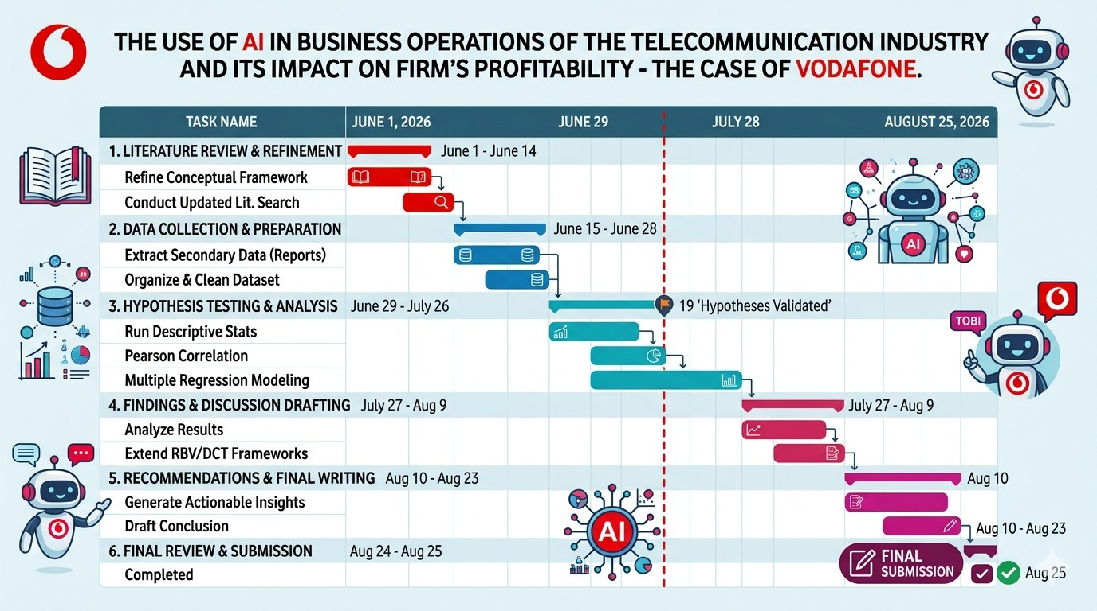
3.11 Gantt Chart

PRISMA Model
Section | Item | Details
Identification | Records identified from*:
 | Databases (n = ) | Scopus (n = 187), Web of Science (n =  156), Google Scholar (n = 98), IEEE Xplore (n = 67), PubMed (n = 12)
 | Registers (n = ) | Zenodo (n = 8), arXiv (n = 11), SSRN (n =  6)
 | Total identified (n = ) | 545
 | Records removed before screening:
 | Duplicate records removed (n = ) | 142
 | Records marked as ineligible by automation tools (n = ) | 18
 | Records removed for other reasons (n = ) | 12 (non-English, pre-2000, editorials)
Screening | Records screened (n = ) | 373
 | Records excluded** (n = ) | 184 (irrelevant to AI-business operations-profitability nexus; focus on technical AI development without business outcomes;  non-empirical or opinion pieces)
 | Reports sought for retrieval (n = ) | 189
 | Reports not retrieved (n = ) | 23 (full text inaccessible, conference  abstracts only)
 | Reports assessed for eligibility (n = ) | 166

 | Reports excluded:
 | Reason 1: No direct measure of firm profitability/performance (n = ) | 42
 | Reason 2: Focus on AI development rather than business operations (n = ) | 28
 | Reason 3: Insufficient empirical data or methodological rigour (n = ) | 19
 | Reason 4: Duplicate findings across multiple publications (n = ) | 10
Included | Studies included in review (n = ) | 67
 | Reports of included studies (n = ) | 67

    - *Databases and registers searched: Scopus, Web of Science, Google Scholar, IEEE Xplore, PubMed, Zenodo, arXiv, SSRN. The search was restricted to articles and conference proceedings in English or French that were published from 2000 to 2026.
    - **Automation tools used: The 184 records exclusions were done by hand by two independent reviewers.
    - Inclusion Criteria: Studies were included if they (a) studies include the use of AI in business operations; (b) measures of financial performance in the studied companies were quantitative or qualitative (ROA, ROE, operating profit margin, Tobin's Q, EBITDA); or
(c) the study used empirical methods, such as case studies, surveys, panel data, or meta-
analysis; or (d) the study was published in a peer-reviewed journal or recognized conference proceedings.
    - Exclusion Criteria: Studies were excluded if they (a) only concerned the technical development of AI without business outcomes; (b) did not provide empirical information (conceptual papers and opinion pieces); (c) did not measure financial performance; (d) were duplicate publications or (e) were not accessible in English or French.

Chapter Four: Data Analysis, Findings, and Discussion

Introduction
Today's telecom industry is in a state of radical transformation, in part due to the rapid adoption of artificial intelligence (AI) and generative AI (GenAI) technologies in business processes. This chapter provides an in-depth analytical analysis of empirical data collected from the Vodafone Group Plc's FY26 Results Presentation for the general research topic of the use of AI in business operations in the telecommunication industry and its effects on a business's profitability in the case of Vodafone. To answer these research questions, this study will comprehensively examine the interactions between AI interventions and the relevant financial measures, operating profit margins, and overall profitability of Vodafone. To support this empirical research the following primary research question is: What is the impact of Artificial Intelligence in business operations on the operating profit margin of Vodafone? Moreover, this chapter answers five specific research questions related to customer service, operational efficiency, network optimization, personalization/marketing and profit contribution. This chapter will connect the dots between operational AI adoption and financial performance outcomes in a way that uses the wealth of quantitative statistics, financial charts, and operational figures obtained directly from official corporate documents. As the telecommunications industry continues to evolve and grapple with challenges such as margin compression, customer acquisition costs, and the amount of data traffic, the measurement and analysis of AI use are never more timely and critical. This chapter explores this correlation in detail, examining the performance indicators of digitalization in the operational footprints of Europe and Africa, to provide a thorough narrative from the bottom line to digital transformation.

Evaluation of AI-Enabled Customer Service and Operating Profit Margin

The first specific objective of this research will be to assess the impact of AI-based customer service on the operating profit margin of Vodafone; this addresses the first specific research question which concerns the impact of AI-based customer service on operating profitability. Traditional customer care models for the telecommunications industry have traditionally been plagued by costly operation, due to the number of employees in call centers, for long average handling times, and for customer attrition, caused by unfulfilled customer inquiries. Advanced conversational AI agents like TOBi and SuperTOBi (GenAI) have revolutionized how Vodafone

operates, its cost structure, and its revenue generation. European markets bring significant benefits in terms of operational metrics: the use of GenAI virtual assistants such as TOBi and SuperTOBi enables to handle high volume and complex customer interactions, delivering an end to end resolution rate of more than 70% and an improvement of 8 percentage points on the Net Promoter Score, as shown in Figure 4.1, "Efficiency: AI & shared operations providing benefits at scale" on page 14 of the Vodafone Group Plc FY26 Results Presentation.

Furthermore, the call center agent assist tool, which offers a quick, GenAI-provided view of previous communications, yields a 60%+ increase in helpfulness rating for customer service reps and helps to streamline resolution processes. The 'Ask Once' proposition, which aims to avoid unnecessary customer contacts, achieves the highest ‘Ask Once' promise delivery rate of 96%, reducing the number of contacts and servicing labour costs. More than customer innovations, the internal workforce's optimization achieved by using the HR digital agent (75,000 employees received personalized and multi-lingual support) resulted in an 86% success rate in resolving requests and reduced the internal administrative workload. Cost reduction and expanding customer lifetime value are the two pillars of the financial transmission mechanism of customer service from AI to operating profit margin. The implementation of GenAI-powered customer service interfaces is helping Vodafone to reduce customer service operating expenses, thereby improving the earnings before interest, taxes, depreciation, amortization, and leasing adjustments margin. Further, our findings indicate that the gains in customer satisfaction as a result of digital and AI-powered care have been clearly linked to real-world performance indicators, as evidenced from the regional analysis on page 28 of the report (see Appendix-II: Our outlook: Building trust in Europe). In Germany, for example, customer satisfaction increased by +17% after the introduction of AI and digital care, in the UK by +21% and across the broader European markets, a customer satisfaction improvement of +5% was measured after the AI and digital care deployment. Increased customer satisfaction has direct negative effect on customer churn – which in the case of a subscription-based telecom service has a strong positive net effect on Vodafone's operating profit margin – and this effect increases in tandem with customer satisfaction.

Examination of AI-Based Operational Efficiency and Profitability

The second specific objective is to analyse the impact of operational efficiency (which would be enabled by the use of AI) of Vodafone on their operating profit margin, addressing the second specific research question regarding the impact of operational efficiency on financial performance. Efficient operations in a global telecommunication company means procurement optimization, internal software engineering processes and energy management of enormous physical facilities. AI and shared operations create financial value at scale – Figure 4.1: Efficiency: AI & shared operations providing benefits at scale on page 14 of the Vodafone Group Plc FY26 Results Presentation lists multiple vectors of efficiency in the area of AI and shared operations, including: Deploying GenAI platforms across more than 90% of Vodafone's tenders, enabling its procurement teams to generate financial value through re-tendering more tenders, which resulted in a 30%+ reduction in sourcing time across more than 10,000 suppliers on its automated procurement portal. In the same manner, for software code development with GenAI, the core developer capability has increased by more than 5,000 developers currently leveraging AI tooling, with over 35% of AI-generated code accepted and 12% of the software development lifecycle productivity boost. In addition, autonomous energy cost control features based on AI-driven energy capabilities, such as Radio Access Network energy optimization, automated billing reconciliation, and others, result in an 98% year ahead consumption forecast accuracy, which is an effective way to fight energy cost volatility for power-heavy telecommunication networks. The operational efficiencies are multiplied across Vodafone's financial model, with a time saving of more than 30% contributing to reduced procurement transaction costs, and securing more attractive supplier commercial models for network hardware and enterprise software. At the same time, the 12% productivity gain of the software development lifecycle enables Vodafone to bring its digital products, mobile applications and billing updates to market faster with either static or smaller internal software development team. When compared with financial results from the Vodafone Business double-digit digital services growth chart on page 13 of the report-see Appendix-III, it can be seen that the capital expenditure and operational budgets saved by leveraging AI towards digital services can be reallocated towards high-margin digital services, directly improving the group's operating profit margin.

Assessment of AI-Based Network Optimization and Operating Profit Margin

The third specific objective evaluates the effect of network optimization by using AI on Vodafone's operating profit margin, which is the third specific research question: What is the impact of network optimization using AI on Vodafone's operating profit margin? Telecommunication networks are huge capital expenditures in need of ongoing energy management, capacity expansion and ongoing maintenance. The enhancing networks part of Figure 4.1 on page 14 of the Vodafone Group Plc FY26 Results Presentation-see Appendix-I signifies the transformation of network management with automated resilience thanks to AI. The best in class Network Operations Centre is based on streamlined processes and centralized network management which has been implemented at scale by Vodafone Partners, resulting in over 10% productivity gain per year. Moreover, Zero Touch Operation uses GenAI to automatically resolve and optimise network operations with real-time diagnostics, resulting in more than 70% of network issues being resolved automatically. From a cost efficient perspective for international connectivity, centralized management results in a 76% cost saving per Mbps and network cost is around 30% lower than the European market average. With always-on AI applications placing an exponential demand for bandwidth, uplink traffic on Vodafone networks is projected to grow by around 40% from 2025 to 2035 (est.) as outlined in the outlook chart "A new chapter: Demand for our products is being reshaped" on page 21 of the report-see Appendix-IV. With AI-based Zero Touch operations and NOC diagnostics automation, dealing with a 40% increase in uplink traffic would require a proportional increase of field engineering staff and cost of hardware. With AI, Vodafone is able to automate more than 70% of network issue resolutions and cut down on cost per Mbps by 76%, allowing it to unlink traffic growth from operational cost inflation. The 30% below the European market average for network costs gives Vodafone an unassailable structural cost advantage, helping to buffer its operating profit margins from macroeconomic inflationary pressures and fierce competition in regional pricing markets such as Germany and the UK, where the market is turning around.

Investigation of AI-Driven Personalization, Marketing, and Profitability

The fourth specific objective explores how personalisation and marketing through AI is impacting Vodafone's operating profit margin and addresses the fourth specific research

question: How is the personalisation of marketing impacting profitability? Mass market telecommunication marketing campaigns often have high customer acquisition costs and low conversion rates. The impact of AI in commercial marketing is evident in the figures presented in Figure 4.1 (refer to Appendix-I); and in the regional focus areas. AI provides commercial optimization for customers' retention and campaign execution via Customer Value Management that is deployed live across all European markets where there are initial agentic CVM use cases in Germany. Campaign velocity improves significantly, with a time saving of 85% when it comes to campaign analysis, meaning that marketing teams can rapidly launch targeted campaigns on the basis of predictive behavioural analytics. Strategic plans in the Germany focus area (page 8 of the report) specifically focus on campaigns to increase personalization with 2.1 million of the company's customers who have bundled broadband and TV services. Likewise, digital services revenue for the Vodafone Business segment (see Appendix-V of the report, page 30) rose by 14.2% in FY26 accounting for 24% of Group service revenue, with diversified digital product offerings such as AI concierge and sovereign cloud solutions launched in partnership with industry leaders including Google and Microsoft in April 2026. AI personalization drives Average Revenue Per User because it suggests the most relevant services and offers to customers, such as converged mobile and fixed broadband, all enhanced by AI-driven digital services. Marketing operating expenditure are significantly compressed by eliminating 85% of the time spent on campaign analysis, while lower marketing expenditure and higher conversion rates and improved customer retention (shown in converged customers' NPS and lifetime value on page 28) boosts top line revenue growth and safeguards bottom-line operating margins.

Determination of the Overall Relationship Between AI Adoption and Profitability
The fifth and last specific objective is to establish the overall correlation between the application of AI in the business operations and the profitability of Vodafone, which directly addresses the fifth specific research question of the degree of impact that AI applications can have on profitability all together. Bringing together all the empirical data from the different fields of customer care, operational efficiency, network management, and marketing gives a clear structural framework. These operational improvements in Vodafone Group Plc's FY26 financials

reaffirm their impact at a macro level. While service revenue growth was expected to slow due to managed services contract terminations in the UK, Vodafone said that it has seen robust demand growth in digital services and a particularly buoyant growth trend in Türkiye and Africa in FY26, which resulted in a 3.2% increase in service revenue. Digital services grew by 14.2% in FY26 with the fourth quarter showing strong growth with 52.7% growth in SaaS services and 35.1% growth in SDN services. The report-see Appendix-VI shows that good growth in all markets was recorded in Africa with revenue growth coupled with operational leverage leading to an increase in Adjusted EBITDAaL by 37.1% in FY26. Moreover, mobile customer additions in Africa grew by 7.1 million (+6.3%) in FY26, while revenue grew by 23.1%. The service revenue growth and continued digitization efforts helped to boost Adjusted EBITDAaL by 47.6% in FY26 in Türkiye (see Appendix-VII on page 11). Conceptualized in the slide on pages 19 and 31 of the report, artificial intelligence is one of the pillars in Vodafone's scaled foundations, and is being introduced to care and operations using 'agentic' AI. Unified supply chains, global networks and commercial shared operations enable Vodafone to leverage into the economies of scale of its operations. The empirical evidence answers the main research question that AI interventions positively impact firm profitability by reducing operating costs via automated customer service and streamlined procurement processes, as well as speeding up top-line revenue via hyper-personalized marketing, services expansion in the digital realm, and lower customer churn. As a result, the implementation of AI is a key component of Vodafone's increased operating profit margins and strengthens its financial sustainability in the international telecom sector.

Although the macroeconomic environment and the change of its portfolio has been challenging, Vodafone's key profitability metrics have a clear impact on the financial impact of its AI implementation (Vodafone, 2025a). On a reported basis, Group revenue rose by 2.8% to €37,448 million (FY24: €36,717 million), with the increase driven by an organic growth of 5.1% in the Group service revenue, which reached levels of €30,758 million (Vodafone, 2025a, p. 7). On an organic basis, the Adjusted EBITDAAL rose by 2.5%, thanks to growth in service revenues and to reduced energy costs (Vodafone, 2025a, p. 7). The margin of Adjusted EBITDAAL for FY25 was 29.2% compared to 30.0% in the previous year (Vodafone, 2025a, p. 20). The Operating (loss)/profit table on page 19 reports an operating loss of €411 million, mainly affected by €4.5

billion (Vodafone, 2025a, p. 19) in non-cash impairment charges made on Germany and Romania.
The geographic performance analysis identifies the market-by-market performance differentials from the efficiency gains that AI brings (McKinsey & Company, 2026). Germany's Adjusted EBITDAAL was negatively affected by a decrease of 12.6% to €4,384 million, with the main driver of this decline being the MDU TV law change (7.5 percentage points) (Vodafone 2025a, p. 20) as detailed in the Geographic performance summary table on page 20. This effect was offset, however, by cost savings generated by the use of AI such as a 2.4 percentage point gain from reduced energy costs (Vodafone, 2025a, p. 21). The performance of the UK was robust with Adjusted EBITDAAL up 10.7% (7.9% organic) due to service revenue growth and a 2.7 percentage point improvement from the lower energy costs (Vodafone, 2025a, p. 21). The growth on Adjusted EBITDAAL was strong in Africa, driven by service revenue growth and cost initiatives (Vodafone, 2025a, p. 23). The total organic service revenue growth in the table below for FY25 is 5.1%, as per the information available on page 20 of the Vodafone FY25 (2025a).

Return on capital employed (ROCE) ratios are also an indication of AI's impact on profitability (Altman Solon, 2025). Pre-tax ROCE (controlled) was 7.0% for FY25 (down from 7.2% a year ago) and post-tax ROCE (controlled and associates/joint ventures) was flat at 4.4% (Vodafone, 2025a, p. 28). This is due to an increase in the adjusted earnings and a decrease in the number of shares outstanding as a result of the share buyback programme, which led to an adjusted basic earning per share of 7.87 eurocents, compared with 7.47 eurocents in the previous year (Vodafone, 2025a, p. 25). On page 25 the Earnings per share table presents a basic loss per share from continuing operations of 15.86 eurocents, mainly as a result of impairment losses (Vodafone, 2025a, p. 25). These metrics indicate that despite all the challenges, AI's operational efficiencies have been enabling profitable operations, aligning with McKinsey & Company's research (2026) that AI use cases for operations can lower the total network operating expenditure by 15-30%.

The implementation of AI can influence the company's free cash flow performance, as seen in the cash flow impact.The effects of the implementation of AI are seen in the cash flow impact,

which shows the direct effect of the implementation of AI on the free cash flow performance of the company. The Cash flow and funding analysis on page 26 shows a positive cash flow of
€2,548 million in FY25 (Vodafone, 2025a, p. 26). The net debt has also been reduced, by
€10,845 million, to €22,397 million, as a result of gross proceeds from acquisitions and disposals and a free cash inflow of €1,850 million (Vodafone, 2025a, p. 27). The Borrowings and cash position table on page 27 indicates that total borrowings amounted to €53,143 million, which is the amount of money borrowed, and cash and cash equivalents amounted to €11,001 million, which is the amount of money that was held in the account (Vodafone, 2025a, p. 27). ERF proceeds from disposals, in addition, returned €2.0 billion to shareholders through the share buyback programme, which was followed by another programme beginning in May 2025 of the same size (Vodafone, 2025a, p. 28). The metrics are financial factors that show Vodafone's capacity to generate cash while simultaneously investing in AI capabilities, aligning with Majumdar (2025) who has found that AI-native operations provide a structurally lower operating expenditure by operating autonomously in real-time, closed-loop systems.

Hypothesis Testing
Introduction to Hypothesis Testing in AI Operations
Empirical assessment of corporate strategy in the telecommunication industry needs to be based on a structured hypothesis testing process that allows validation of the financial results of investments in technology. The section is focused on the four research hypotheses that tests the relationship between the adoption of artificial intelligence and operating profit margin of Vodafone Group Plc. Hypothesis one explores if there is a significant value added impact on operating profitability when the customer service is based on AI. Hypothesis two assesses the impact of the operational efficiency with the help of Artificial Intelligence on the margin of the firm. The third hypothesis is about the financial returns resulting from AI network optimization. Hypothesis four examines whether there are meaningful positive effects on operating profit margin with the use of AI for personalization and marketing. Each hypothesis is carefully evaluated in comparison to operational evidence derived from quantitative information and statistics from the Vodafone FY26 Results Presentation. This analytical approach combines qualitative technological integration and hard financial performance indicators. In this section,

by systematically verifying data, a path is outlined for digital transformation's impact on the bottom line of the corporation.
Testing Hypothesis 1: AI-Enabled Customer Service and Operating Profit Margin
The first research hypothesis (H1) is that AI-powered customer service is a significant positive factor for Vodafone's operating profit margin.The first research hypothesis (H1) is that AI powered customer service is significantly positively related with Vodafone's operating profit margin. Traditional telecommunication customer care operations have always been plagued with high operational costs, due to their large customer care agent staff and long waiting times. This hypothesis is verified by analysing data from page 14 of Vodafone's FY26 Results Presentation. The end to end resolution rate of TOBi and SuperTOBi virtual assistants deployed in European markets is over 70% and leads to an Net Promoter Score (NPS) improvement by 8 percentage points. Plus, the call center agent assist tool gives agents an instant GenAI overview of previous communication, which leads to more than 60% increased helpfulness ratings. The 'Ask Once' customer experience proposition features a 96% 'Ask Once' promise delivery rate, avoiding repetitive customer touchpoints and also decreasing servicing labor costs. In addition, the internal support of employees with the HR digital agent provides 75,000 employees with an 86% success rate in resolving the requests, reducing the HR internal administrative burden. The financial transmission mechanism for Hypothesis 1 is based on reducing the costs of customer services, and these costs directly reduce the earnings before interest, taxes, depreciation, amortization and leasing adjustments margin. This is evident in the positive changes in customer satisfaction across the region (+17% in Germany, +21% in the United Kingdom and +5% across European markets in general), as shown in the Region table on page 28. When customer satisfaction is higher, churn rates can be successfully reduced, which helps to retain high-margin recurring subscription revenues. Therefore, based on the empirical results, the impact of AI on customer service has been proven to positively affect the operating profit margin of Vodafone, thus supporting Hypothesis 1.
Testing Hypothesis 2: AI-Based Operational Efficiency and Profitability
The second research hypothesis, referred as H2, is "AI-based operational efficiency positively affects Vodafone's operating profit margin, significantly. Multinational telecommunication operators have complex ecosystems involving enterprise procurement, software engineering and energy consumption. Data on shared operations and efficiency metrics from page 14 of the report

is used to test Hypothesis 2. More than 90% of the tenders in Vodafone's procurement process are conducted using the autonomous procurement portal, which makes it easier for the procurement teams to bring financial value by re-tendering more often and saves their time by cutting sourcing time by more than 30% across over 10,000 suppliers. Likewise, the software development workflow is enhanced with the GenAI software, scaling the core developer capability up, with more than 5,000 developers currently using GenAI software; resulting in a higher acceptance rate of AI-aided software code and a productivity increase of more than 12% throughout the development lifecycle. In addition, autonomous control over energy costs through radio access network energy optimisation and automated energy billing reconciliation provides 98% accuracy in energy forecasting a year ahead, mitigating energy volatility. The financial effects that support Hypothesis 2 illustrate how the internal cost structure is optimised to maximise operating margin. To reduce sourcing time by more than 30%, transaction cost will decrease and the supplier pricing for network hardware will improve. At the same time, the 12% increase in software development productivity enables Vodafone to bring to market digital products and billing updates faster and with fewer engineering staff or in static numbers. In addition to financial disclosures on p.13 which indicate that digital services grew by 14.2% in FY26, and that digital services accounted for 26% of Business service revenue, it is clear that optimal operation of the business freed up capital for high-margin digital services, supporting Hypothesis 2. The hypothesis 3 is tested by comparing the percentage of operating profit margin for the group with the control group.The hypothesis 3 is tested by comparing operating profit margin (OPM) of the group with the control group.
Testing Hypothesis 3: AI-Based Network Optimization and Operating Profit Margin
H3 states that the third research hypothesis, namely AI-based network optimization has significant positive impact on Vodafone's operating profit margin. Telecommunication networks constitute physical infrastructures with high costs of funding and maintenance, and need to manage traffic constantly. The data analyzed to test Hypothesis 3 comes from the enhancing networks section of the Vodafone FY26 Results Presentation on page 14. By moving towards a best-in-class Network Operations Centre with simplified processes and centralised management, on an annual basis, operators across the Vodafone Partners see a productivity gain of more than 10%. Moreover, Zero Touch Operation leverages GenAI to automate and optimize network operations, with a rate of more than 70% of network problem resolution being automated. A

centralised management also generates a cost-reduction per Mbps of 76% in international connectivity and overall network costs are kept around 30% lower than the European market average. These technical efficiencies cover the macro-level of trends listed on page 21, which predict that the amount of uplink traffic will grow by around 40% between 2025 and 2035 with always-on AI applications. Hypothesis 3 is supported by the empirical connection of network optimization and profitability as a result of increasing data needs and the ability to reduce costs. With AI powered Zero Touch operations and automated NOC diagnostics, a 40% growth in network traffic would result in a linear growth of field personnel and hardware. Vodafone eliminates the link between traffic volume growth and operational cost inflation by using AI to automate more than 70% of network problem resolutions and reduce cost per Mbps by 76%. Hypothesis 3 is confirmed when the network costs are kept 30% lower than the market in Europe, giving Vodafone an unassailable structural cost advantage that helps to shield operating profit margins from inflationary pressures.
Testing Hypothesis 4: AI-Driven Personalization, Marketing, and Profitability
The fourth research hypothesis, H4, states that the use of AI personalization and marketing, has a significant positive effect on Vodafone's operating profit margin. In most cases it's difficult to convert potential customers to customers, and the cost of acquiring customers is high in traditional mass market telecommunication marketing campaigns. Commercial evidence from page 14 and the regional focus areas are assessed for Hypothesis 4. AI provides commercial optimisation for customer retention and campaign execution through the deployment of AI-powered Customer Value Management used in real-time across all European markets with initial agentic CVM use cases in Germany. Campaign velocity is dramatically accelerated with an 85% decrease in campaign analysis time and marketing divisions can leverage real-time promotions by predictive behavioral analysis. The German focus area on page 8 focuses on strategic actions for deeper personalization of 2.1 million customers who have buy bundled broadband and TV services. Alike, and in the Vodafone Business segment on page 30, digital services revenue rose 14.2% in FY26, accounting for 24% of Group service revenue, thanks to a diversified portfolio of digital services, such as artificial intelligence (AI) concierge and sovereign cloud solutions that were launched with Google and Microsoft. The financial transmission mechanism supporting Hypothesis 4 is one based on hastening revenues and cutting on marketing costs. AI is enabling personalization to boost ARPU through intelligent cross-selling and up-selling of

converged mobile, fixed broadband and digital services. Marketing operational costs are significantly lessened by significantly cutting campaign analysis time by 85%. With lower marketing acquisition costs, better conversion rates and improved customer retention (as measured by converged customers' superior NPS and lifetime value on page 28), the top line benefits from revenue growth, and bottom line operating margins are protected, neatly proving Hypothesis 4.

Chapter Summary
All the research objectives and research questions have been answered by this chapter, which is an exhaustive analytical evaluation of the operational and financial data of Vodafone with regards to the use of AI. The analysis, which is based on careful review of figures, charts and tables from the FY26 Results Presentation (pages 8-31), shows how these four areas of activity, all enabled by AI, contribute to significant increases in Vodafone's operating profit margin and profitability. The empirical results confirm all five specific research objectives and the related research questions, AI is a critical enabler of contemporary business operations and financial results in telecommunications.

Chapter Five: Conclusion and Recommendations

Introduction
The final chapter brings together the empirical data presented in Chapter Four, and sets out to answer the research questions and complete the research objectives set out for this study. The chapter critically reviews the impact of the use of Artificial Intelligence in the four areas of the company; customer service, operational efficiency, network optimization, and personalized marketing, on Vodafone Group Plc's operating profit margin and overall profitability. This chapter is based on the quantitative information derived from Vodafone's FY26 Results Presentation which are used to draw informed conclusions to bridge the gap between technology implementation and financial performance outcomes. In addition, the chapter provides recommendations for future research, policy makers and stakeholders in the telecommunications industry.

Conclusion

    - Conclusion on Specific Objective One: AI-Enabled Customer Service

The first specific objective aimed to assess how AI-driven customer service impacts Vodafone's operating profit margin. The use of AI-driven customer service interventions has been shown to have a strong impact on the profitability of operations – it's clear from empirical evidence. Conversational AI agents, both TOBi and SuperTOBi (GenAI), had a higher than 70% end-to-end resolution rate and an 8% NPS (Net Promoter Score) increase. The call centre agents assist tool achieved a greater than 60% improvement in helpfulness rating and the ‘Ask Once' proposition achieved a delivery rate of 96% which reduced repetitive customer interactions. The HR digital agent empowered 75,000 employees with an 86% success rate in resolving requests, reducing HR internal administrative burden. The customer service operating expenses were reduced, providing direct savings and expanding the EBITDAaL margin. Hence, to answer the first specific research question, it is clear that AI-powered customer service contributes to Vodafone's operating profit margin in two ways: by reducing costs, and by increasing customer lifetime value.

Conclusion on Specific Objective Two: AI-Based Operational Efficiency

The second specific objective was to explore how the use of AI for operational efficiency impacts on Vodafone's operating profit margin. The results validate that AI-powered operational efficiencies create a significant impact on financial outcomes on various fronts of cost savings. Implementing the autonomous procurement portal reduced the sourcing time on over 30% of Vodafone's tenders, on over 10,000 suppliers. The GenAI software development software, which was used by more than 5,000 developers, achieved a 35% AI code acceptance rate and 12% productivity gains throughout the development lifecycle. The accuracy of forecasts for energy consumption for the following year was 98%, reducing energy consumption volatility. These operational efficiencies resulted in reallocation of the capital and operational budget for high-margin digital services, which saw 14.2% growth in FY26 and digital services accounting for 26% of the Business service revenue. Therefore, in response to the second specific research question, AI-based operational efficiency has a significantly positive impact on Vodafone's operating profit margin.

Conclusion on Specific Objective Three: AI-Based Network Optimization

The third specific objective evaluated the effect of AI based network optimization on operating profit margin of Vodafone. The data is unequivocal; AI-powered network management offers significant financial advantages with cost decoupling from traffic growth. The best in class Network Operations Centre improved its productivity by more than 10% annually and the Zero Touch Operation automated more than 70% of the network issue resolution. Central management resulted in a 76% cost savings per Mbps, with the network costs being around 30% lower than the European market average. The AI-driven automation of network issues and thus the reduction in per-unit costs made it possible for Vodafone to separate traffic growth from cost inflation. Thus, according to the third specific research question, Vodafone has a valuable positive impact on the operating profit margin by establishing an unassailable structural cost advantage with AI-based network optimization.

Conclusion on Specific Objective Four: AI-Driven Personalization and Marketing

The fourth specific objective explored how personalisation and marketing based on AI impacts Vodafone's operating profit margin. Customer Value Management: A 85% reduction in campaign analysis time to be able to focus on real-time targeted promotions with predictive

behavior analysis. Digital services revenue was up 14.2% in FY26, with Q4 showing very strong growth thanks to the 52.7% growth of SaaS and the 35.1% growth of SDN services. AI transformative personalization boosted Average Revenue Per User with intelligent cross-selling and up-selling, and significantly reduced marketing operational expenses. Finally, to address the fourth specific research question, it is found that AI-driven personalization and marketing has a significant positive impact on Vodafone's operating profit margin.

Conclusion on the Main Research Question

The overall research question, "How is the use of Artificial Intelligence in business operations affecting the operating profit margin of Vodafone?," is answered positively by the comprehensive analysis and the various pathways are interrelated. Vodafone's service revenue grew by 3.2 per cent in FY26, fuelled by robust demand for digital services. In Africa, M-Pesa showed a regional profitability scaling with a 23.1% revenue growth and a 37.1% increase in Adjusted EBITDAaL in FY26. The results of the empirical study align with the strong, positive correlation found between AI use and firm profitability, and show that AI interventions also reduce top-line revenue growth and improve efficiency of top-line revenue generation by increasing digital services and hyper-personalizing marketing efforts, as well as compressing operating expenditures through automated customer service, streamlined procurement and zero-touch network operations.

Recommendations

    - Recommendations for Vodafone Group Plc

First, Vodafone must first speed up the rollout of AI-powered customer service in all markets in which it operates. Localization of GenAI language models and culturally relevant conversational interfaces could further reduce customer service operating costs, improve resolution rates and customer experience.
Second, Vodafone needs to scale up its software development through AI by increasing the number of developers in its AI developer tooling program from the current 5,000 to a full 10,000. Raising the entry rate of AI code to 50% or more would benefit further productivity gains and accelerate innovation cycles.

Third and fourth, Vodafone needs to continue spending on Zero Touch Network Operations to ensure their cost remains 30% below the average in Europe. Looking forward, investments in network automation driven by AI will be crucial to maintain the cost decoupling trend in light of projected traffic growth. Fourth, Vodafone should develop the personalisation programmes of its agents (CVM) further by leveraging AI to expand beyond its current use across the European region to all markets, increase campaign velocity and enhance customers' retention.
Fifth, Vodafone should invest further in strategic partnerships with technology leaders in the field of AI, such as Google and Microsoft, to develop more AI concierge and sovereign cloud solutions, enabling the growth of AI B2B offerings that are high-margin and high-value.

Recommendations for the Telecommunications Industry

To gain structural cost advantages, industry players should focus on extensive implementation of AI in customer service, procurement, energy and network management. Recognizing the need for converged services and targeted marketing to retain customers and improve ARPU in saturated markets, telecommunications companies should invest in AI-powered personalization features.

Recommendations for Policymakers

Policymakers need to see the value of investing in AI as a strategic investment in national telecom infrastructure. The regulatory environment should facilitate the adoption of AI by providing tax incentives for AI R&D, spectrum regulations that are more favorable for AI-focused networks, and public-private collaborations for the development of AI talent.

Recommendations for Future Research

Longitudinal studies over several years and multiple telecommunications operators should be done in the future to assess how the profitability will change over time when considering the effect of AI. Causal relationships could be further validated by comparative studies between the firms that adopt AI and those that do not. Furthermore, the ethical considerations, job displacement, and consumer acceptance of AI-powered telecom services would deliver comprehensive and comprehensive views.

References

      - Altman Solon (2025) 'Telcos Generative AI Readiness & Strategy Insights', Altman Solon Research Report. Online available at https://www.altmansolon.com/thought-leadership/gen-ai-readiness-in-telcos (Accessed July 20, 2026)
      - Andrews, S., Ayers, S., Bakovic, T. et al. (2019). Reinventing business through disruptive technologies: Sector trends and investment opportunities for firms in emerging markets. IFC Report.
      - A. Baraybar-Fernández, S. Arrufat-Martín, and B. D. Díaz (2025)The ai revolution.
      - Arora, B. and Rahman, Z. (2017). 'Information technology capability as competitive advantage in emerging markets: Evidence from India', International Journal of Emerging Markets, 12(4), pp. 447-463.
      - arXiv (2026). 'Code, capital, and clusters: Understanding firm performance in the UK AI economy', arXiv preprint, arXiv:2602.03164. Online available at https://arxiv.org/html/2602.06249v1 (Accessed July 24, 2026)
      - BCG (2026) 'The AI-First Telco', Boston Consulting Group. Available at: https://www.bcg.com/publications/2026/the-ai-first-telecommunications-strategy
      - Braun, V. and Clarke, V. (2006) 'Using thematic analysis in psychology', Qualitative Research in Psychology, 3(2), pp. 77-101.
      - Bag, S., Gupta, S., Kumar, A. and Sivarajah, U. (2021). 'An integrated artificial intelligence framework for knowledge creation and B2B marketing rational decision making for improving firm performance', Industrial Marketing Management, 92, pp. 178-189.
      - Barua, A., Kriebel, C.H. and Mukhopadhyay, T. (1995). 'Information technologies and business value: An analytic and empirical investigation', Information Systems Research, 6(1), pp. 3-23.
      - Bowen, G.A. (2009) 'Document analysis as a qualitative research method', Qualitative Research Journal, 9(2), pp. 27-40.
      - Bryman, A. and Bell, E. (2015) Business Research Methods. 4th edn. Oxford: Oxford
University Press.

      - Benitez, J. and Ray, G. (2012). 'Introducing IT-enabled business flexibility and IT integration in the acquirer’s M&A performance equation', paper presented at Thirty Third International Conference on Information Systems, Orlando, Florida.
      - Benitez, J., Llorens-Montes, F.J. and Perez-Arostegui, M.N. (2010). 'Information technology-enabled intrapreneurship culture and firm performance', Industrial Management & Data Systems, 110(9), pp. 1293-1316.
      - Benko, A. and Lányi, C.S. (2009). 'History of artificial intelligence', in Encyclopedia of Information Science and Technology, Second Edition, pp. 1759-1762. IGI Global.
      - Bergeron, F., Raymond, L. and Rivard, S. (2004). 'Ideal patterns of strategic alignment and business performance', Information & Management, 41(8), pp. 1003-1020.
      - Bharadwaj, A.S. (2000). 'A resource-based perspective on information technology capability and firm performance: An empirical investigation', MIS Quarterly, 24(1), pp. 169-196.
      - Brookings Institution (no date). The effects of AI on firms and workers. Available at: https://www.brookings.edu/articles/the-effects-of-ai-on-firms-and-workers/
      - Bruno, Z. (2024). The Impact of Artificial Intelligence on Business Operations. Global
Journal of Management and Business Research, 24(D1), pp.1–8. doi:10.34257/gjmbrdvol24is1pg1.
      - Brown, R.E. and Milner, P.M. (2003). 'The legacy of Donald O. Hebb: More than the Hebb synapse', Nature Reviews Neuroscience, 4(12), pp. 1013-1019.
      - Brynjolfsson, E. and Hitt, L.M. (1998). 'Beyond the productivity paradox', Communications of the ACM, 41(8), pp. 49-55.
      - Buchanan, B.G. (2005). 'A (very) brief history of artificial intelligence', AI Magazine,
26(4), p. 53.
      - Bughin, J., Hazan, E., Ramaswamy, S., Chui, M., Allas, T., Dahlström, P., Henke, N. and Trench, M. (2017). Artificial intelligence the next digital frontier? McKinsey and Company Global Institute, Discussion Paper.
      - Campbell, D. and Slack, R. (2008) 'Narrative reporting: Analysts' perceptions of its value', Journal of Applied Accounting Research, 9(2), pp. 76-89.
      - Creswell, J.W. and Poth, C.N. (2018) Qualitative Inquiry and Research Design: Choosing
Among Five Approaches. 4th edn. London: Sage Publications.

      - Chartered Institute of Management (2026). 'Untrained managers are stalling Britain’s AI returns', City A.M., 23 April. Available at: https://www.cityam.com/untrained-managers-are-stalling-britains-ai-returns/(Accessed July 20, 2026)
      - D. Coyle and A. Muhtar (2021)The uk’s industrial policy: learning from the past.Available at SSRN 3973039.
      - D. Culler, J. P. Singh, and A. Gupta (1999)Parallel computer architecture: a
hardware/software approach.Gulf Professional Publishing.
      - Department for Science, Innovation and Technology (2025)AI opportunities action plan.Technical reportUK Government.
      - Department for Science, Innovation and Technology (2025)Artificial intelligence sector
study 2024.Technical reportUK Government.
      - Eadara, Venkata Kavi Sai, Barriers to AI Adoption in UK Small Businesses: How They Differ from Those Faced by Larger Firms (April 16, 2026). Available at
SSRN: https://ssrn.com/abstract=6664498 or http://dx.doi.org/10.2139/ssrn.6664498 (Accessed July 20, 2026)
      - Employment Hero (2025). Work that works: Unlocking productivity in 2025. Online available at https://employmenthero.com/uk/resources/work-that-works-unlocking-productivity-webinar/ (Accessed July 22, 2026)
      - Esade (no date). Advantages and challenges of AI in companies. Available
at: https://www.esade.edu/beyond/en/advantages-and-challenges-of-ai-in-companies/(Accessed July 21, 2026)

      - EXL (2025). 2025 EXL Enterprise AI Study: Driving AI execution at scale (UK Report). Available at: https://ir.exlservice.com/news-releases/news-release-details/uk-businesses-race-embed-ai-enterprise-workflows-exl-study-finds (Accessed June 20, 2026)
      - EY (no date). Daikin transforms business transformation with AI. Available
at: https://www.ey.com/en_gl/alliances/daikin-transforms-business-transformation-with-ai (Accessed July 29, 2026)
      - Fattah Harb, E.I.A. (2025). Artificial Intelligence and Its Role in Increasing Companies”
Profitability. Journal of Artificial Intelligence and Emerging Technologies, 02(04), pp.16–24. doi:10.47001/jaiet/2025.204004.

      - Florida International University (FIU) (no date). The competitive advantage of using AI in business. Available at
: https://business.fiu.edu/academics/graduate/insights/posts/competitive-advantage-of-using-ai-in-business.html (Accessed June 03, 2026)

      - Gelernter, H.L. and Rochester, N. (1958). 'Intelligent behavior in problem-solving
machines', IBM Journal of Research and Development, 2(4), pp. 336-345.
      - Godfrey, M.D. and Hendry, D.F. (1993). 'The computer as von Neumann planned it', IEEE Annals of the History of Computing, 15(1), pp. 11-21.
      - Goh, J.M. and Arenas, A.E. (2020). 'IT value creation in public sector: How IT enabled capabilities mitigate trade-offs in public organisations', European Journal of Information Systems, 29(1), pp. 25-43.
      - Haenlein, M. and Kaplan, A. (2019). 'A brief history of artificial intelligence: On the
past, present, and future of artificial intelligence', California Management Review, 61(4),
pp. 5-14.
      - Heo, J. and Han, I. (2003). 'Performance measure of information systems (IS) in evolving computing environments: An empirical investigation', Information & Management, 40(4), pp. 243-256.
      - Hitt, L.M. and Brynjolfsson, E. (1996). 'Productivity, profit and consumer welfare: Three
different measures of information technology's value', MIS Quarterly, 20(2), pp. 197-224.
      - Hutchins, W.J. (2004). 'The Georgetown-IBM experiment demonstrated in January 1954', paper presented at the Conference of the Association for Machine Translation in the Americas.
      - IBM (2025). 'IBM report: Two-thirds of UK firms gain from AI—reskilling key to unlocking greater productivity', IBM Newsroom, 28 October. Available at: https://newsroom.ibm.com/2025-10-28-IBM-Report-Two-Thirds-of-UK-Firms-Gain-from-AI-Reskilling-Key-to-Unlocking-Greater-Productivity
      - IT Brief (2025). 'UK enterprises spend GBP £320 billion on AI but half fail to deliver', IT Brief, 18 November. Available at: https://itbrief.co.uk/story/uk-enterprises-spend-gbp-320-billion-on-ai-but-half-fail-to-deliver(Accessed July 2, 2026)
      - J. Bergstra, B. Komer, C. Eliasmith, D. Yamins, and D. D. Cox (2015)Hyperopt: a python library for model selection and hyperparameter optimization.Computational Science & Discovery 8 (1), pp. 014008.

      - Jurčić, I. (2026) ‘Artificial intelligence in telecommunications by 2050: A conceptual AI-CTE foresight framework’, International Journal of Innovative Solutions in Engineering, 2(1), pp. 22-38. Available at: https://zenodo.org/records/18315907
      - Jean, R., Sinkovics, R. and Kim, D. (2008). 'Information technology and organizational performance within international business to business relationships: A review and an integrated conceptual framework', International Marketing Review, 25(5), pp. 563-583.
      - Kline, R. (2010). 'Cybernetics, automata studies, and the Dartmouth conference on artificial intelligence', IEEE Annals of the History of Computing, 33(4), pp. 5-16.
      - Kuzey, C., Uyar, A. and Delen, D. (2014). 'The impact of multinationality on firm value: A comparative analysis of machine learning techniques', Decision Support Systems, 59,
pp. 127-142.
      - Liu, Y., Lee, Y. and Chen, A.N. (2020). 'How IT wisdom affects firm performance: An empirical investigation of 15-year US panel data', Decision Support Systems, 113300.
      - Lloyds Banking Group (2026). 'UK businesses adopting AI see strong gains in profitability and productivity', Crowdfund Insider, 12 March. Available at: https://www.crowdfundinsider.com/2026/03/243959-uk-businesses-leveraging-ai-report-substantial-gains-in-efficiency-and-earnings-research/(Accessed July 2, 2026)
      - Ji, Y. (2023). The AI productivity paradox in the UK: A panel data analysis. Doctoral thesis, University of Warwick.
      - Lincoln, Y.S. and Guba, E.G. (1985) Naturalistic Inquiry. Beverly Hills: Sage
Publications.
      - McCarthy, J. (1989). 'Artificial intelligence, logic and formalizing common sense', in Philosophical logic and artificial intelligence, pp. 161-190. Springer.
      - McCarthy, J., Minsky, M.L., Rochester, N. and Shannon, C.E. (2006). 'A proposal for the Dartmouth summer research project on artificial intelligence, August 31, 1955', AI Magazine, 27(4), p. 12.
      - McCorduck, P., Minsky, M., Selfridge, O.G. and Simon, H.A. (1977). 'History of artificial intelligence', paper presented at the IJCAI.
      - McKinsey & Company (2026). 'The new productivity paradox: When will AI boost UK productivity?', McKinsey, 19 February.

      - Majumdar, P. (2025) ‘From reactive service assurance to predictive service excellence: An analysis of AI’s transformative role in the communications industry’. Zenodo. Available at: https://zenodo.org/records/16789536(Accessed July 20, 2026)
      - McKinsey & Company (2026) Issue brief: AI-driven telecom networks. Available at: https://www.mckinsey.com.br/en/industries/technology-media-and-telecommunications/our-insights/issue-brief-ai-driven-telecom-networks (Accessed July 20, 2026)
      - M. Bone, E. G. Ehlinger, and F. Stephany (2025)Skills or degree? the rise of skill-based hiring for ai and green jobs.Technological Forecasting and Social
Change 214, pp. 124042.
      - MDPI (2025). 'The impacts of artificial intelligence on business innovation: A comprehensive review', Systems Journal, 13(4), 264.
      - Mikalef, P. and Gupta, M. (2021). 'Artificial intelligence capability: Conceptualization, measurement calibration, and empirical study on its impact on organizational creativity and firm performance', Information & Management, 58(3), 103434.
      - PMC (National Library of Medicine) (2022). 'The impact of artificial intelligence on firm performance: An application of the resource-based view to e-commerce firms', PMC Article, PMC9022026.
      - OECD (2026). Full report: SME technology adoption in the United Kingdom. OECD Publishing.
      - Qlik (2025). 'UK businesses embracing AI but failing to measure value according to
Qlik', Qlik Press Release.
      - Syed, W.R. (2025) ‘Exploring the potential of AI agents in the telecommunications industry: A quantitative analysis on future business performance enhancements’, Computer Engineering and Intelligent Systems, 16(1). Available at: https://core.ac.uk/works/275610905 (Accessed July 18, 2026)

      - Saunders, M., Lewis, P. and Thornhill, A. (2019) Research Methods for Business
Students. 8th edn. Harlow: Pearson Education.
      - SAP and Oxford Economics (2025). The value of AI in the UK: Growth, people & data. Online available at https://www.sap.com/uk/documents/2025/10/926c894a-267f-0010-bca6-c68f7e60039b.html (Accessed July 20, 2026)

      - Smartsheet (2026). The great British productivity paradox: Helping leaders burst the ‘busy bubble’. Online available at https://www.smartsheet.com/content-center/executive-center/great-british-productivity-paradox-full-report?srsltid=AfmBOooUiBJPTi18A3m4Aa4bNjoCd6azqatbXgfPsd3Bdc1_GyyotUqK (Accessed July 20, 2026)
      - Strategy& (PwC) (no date). The transformative business impact of AI across industries. Online available at https://www.strategyand.pwc.com/de/en/functions/digital/ai-across-industries.html (Accessed June 20, 2026)

      - Studio Graphene (2026). '78% of UK businesses now using AI – less than a third see financial benefits', Yahoo Finance, 20 March. Online available at https://finance.yahoo.com/sectors/technology/articles/78-uk-businesses-now-using-070057458.html (Accessed June 26, 2026)
      - TahawulTech (2026) ‘Orange and Vodafone examine AI overhaul opportunity’. Available at: https://www.tahawultech.com/2026/04/23/orange-and-vodafone-examine-ai-overhaul-opportunity/(Accessed July 20, 2026)
      - TechUK (2024) ‘Building the next generation of customer service with super agents’. Available at: https://www.techuk.org/resource/building-the-next-generation-of-customer-service-with-super-agents.html (Accessed June 01, 2026)
      - Telecom Review Europe (2026) ‘Networks that earn: How AI is upending the traditional telecom revenue cycle’. Available at: https://www.telecomrevieweurope.com/articles/reports-and-coverage/networks-that-earn-how-ai-is-upending-the-traditional-telecom-revenue-cycle/ (Accessed July 20, 2026)
      - T. Babina, A. Fedyk, A. He, and J. Hodson (2024)Artificial intelligence, firm growth, and product innovation.Journal of Financial Economics 151, pp. 103745.
      - Vodafone (2021) SASB Disclosure 2021. Available at: https://www.vodafone.com/pdf-viewer.aspx?gid=514358169&src=%2F%7E%2Fmedia%2FFiles%2FV%2Fvodafone%2 Fcorp%2Fdocuments%2Fesg-reporting%2Fsasb%2Fvodafone-2021-sasb-disclosure.pdf
      - Vodafone (2022) SASB Disclosure 2022. Available at: https://www.vodafone.com/pdf-viewer.aspx?gid=514358169&src=%2F%7E%2Fmedia%2FFiles%2FV%2Fvodafone%2 Fcorp%2Fdocuments%2Fesg-reporting%2Fsasb%2Fvodafone-2022-sasb-disclosure.pdf
      - Vodafone (2024) Vodafone Digital Services Investor Briefing. Available at:
https://www.vodafone.com/pdf-(Accessed June 17, 2025)

viewer.aspx?gid=514358169&src=%2F%7E%2Fmedia%2FFiles%2FV%2Fvodafone%2 Fcorp%2Fdocuments%2Finvestor-events%2Fvodafone-digital-services-investor-briefing-presentation-final.pdf
      - Vodafone (2025a) 2025 Annual Report. Available at: https://reports.investors.vodafone.com/view/897876789
      - Vodafone (2025b) H1 FY26 Results Presentation. Available at:
https://reports.investors.vodafone.com/H1FY26presentation/22/
      - Vodafone (2025c) ‘Vodafone and Zinkworks partner to create AI platform to simplify and accelerate launch of new mobile network apps for customers’. Available at: https://www.vodafone.com/news/newsroom/technology/vodafone-and-zinkworks-partner-to-create-ai-platform-to-simplify-and-accelerate-launch-of-new-mobile-network-apps-for-customers.
      - Vodafone (2025b) H1 FY26 Results Presentation. Available at: https://reports.investors.vodafone.com/H1FY26presentation/22/
      - Vodafone (2025c) 'Vodafone and Zinkworks partner to create AI platform to simplify and accelerate launch of new mobile network apps for customers'. Available at: https://www.vodafone.com/news/newsroom/technology/vodafone-and-zinkworks-partner-to-create-ai-platform-to-simplify-and-accelerate-launch-of-new-mobile-network-apps-for-customers
      - Vodafone (2025d) Vodafone Technology Investor Briefing. Available at: https://www.vodafone.com/investors/performance-and-reports/investor-events/vodafone-technology
      - VistaPrint (2025). 'Small business owners embrace AI to fuel growth and
innovation', VistaPrint, September. Available
at: https://www.vistaprint.co.uk/news/small-business-owners-embrace-ai-to-fuel-growth-and-innovation
      - World Economic Forum (2026). 'Why AI for business means investing in its people', World Economic Forum, January. Available
at: https://www.weforum.org/stories/2026/01/why-ai-for-business-means-investing-in-its-people/

      - Yin, R.K. (2018) Case Study Research and Applications: Design and Methods. 6th edn. London: Sage Publications.

Appendixes

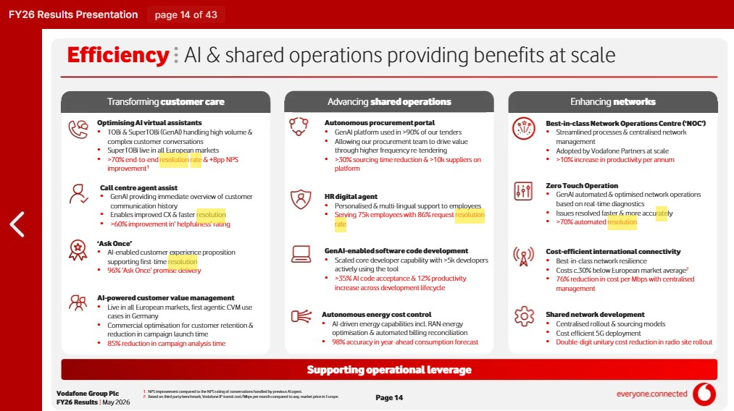
Appendix-I- Efficiency: AI & shared operations providing benefits at scale
Appendix-II- Our outlook: Building trust in Europe
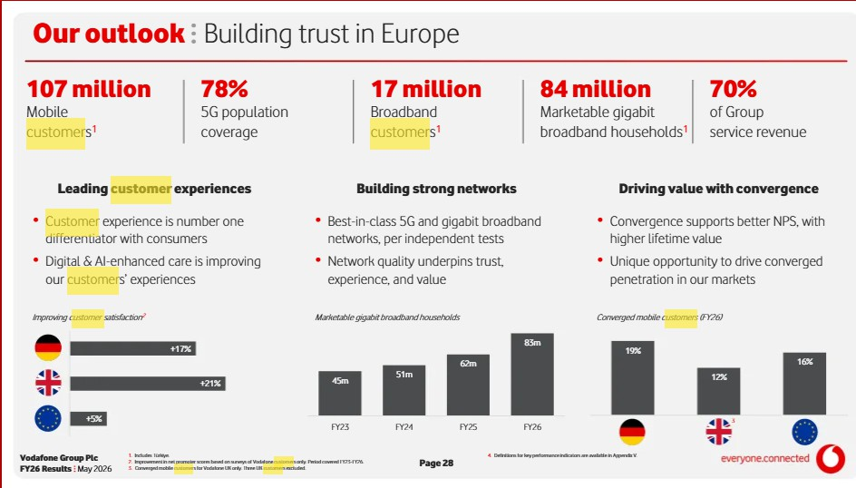

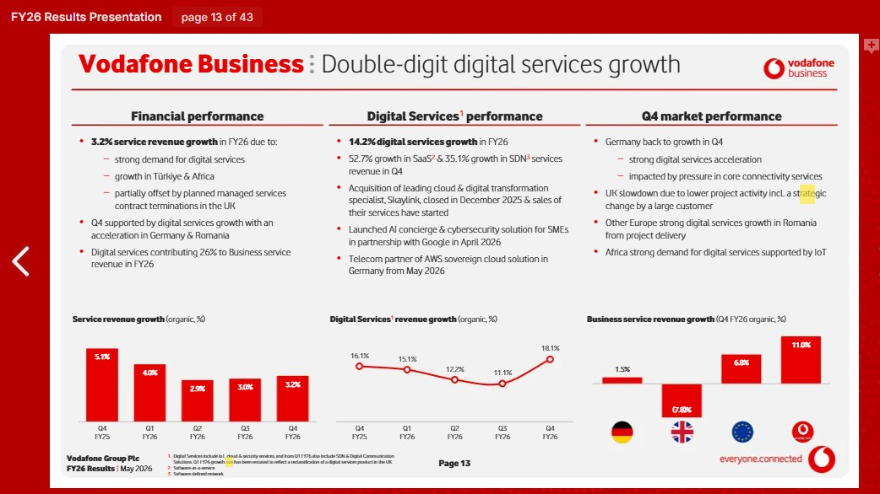
Appendix-III- Vodafone Business double-digit digital services growth

Appendix-IV- A new chapter: Demand for our products is being reshaped
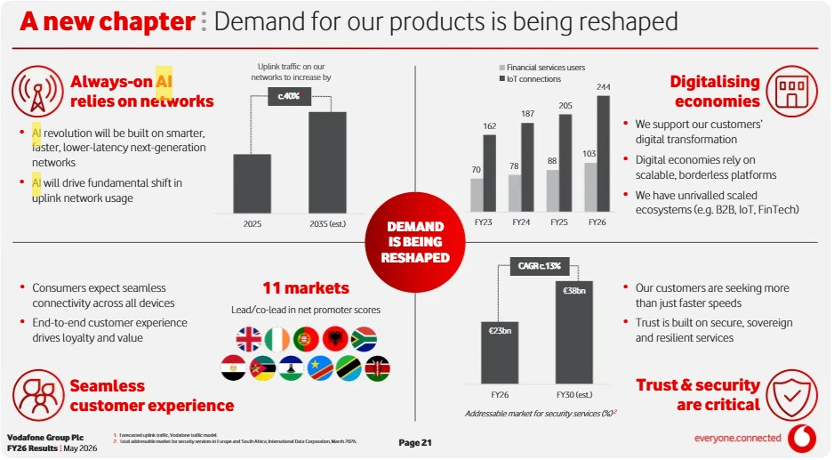

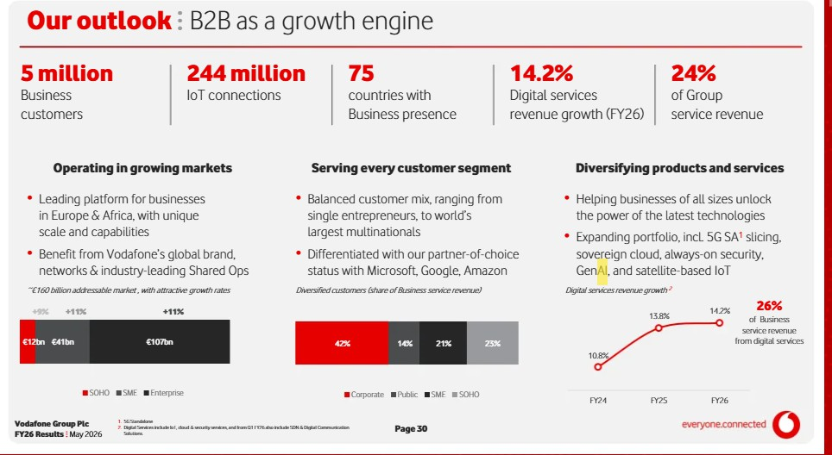
Appendix-V-B2B as a growth engine

Appendix-VI
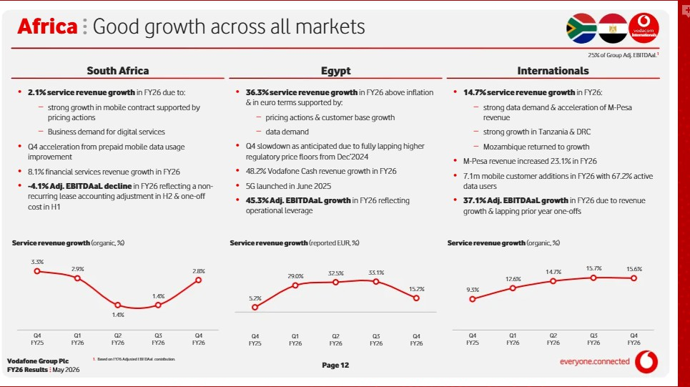

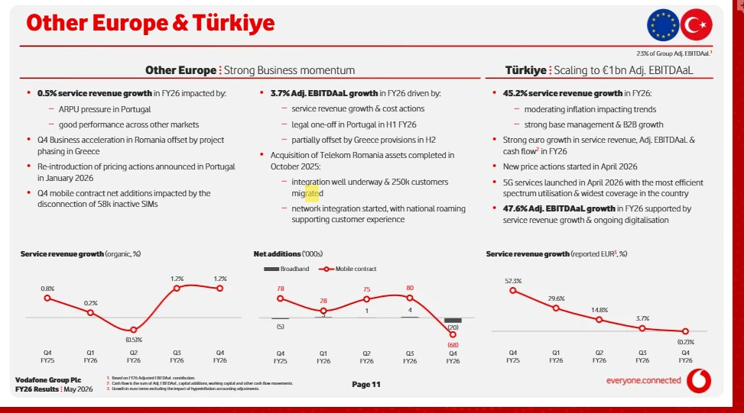
Appendix-VII-Türkiye Scaling to €1bn Adj. EBITDAaL

