INTRODUCING THE MODERN WORKPLACE

NAME: LAVINIA RUS

STUDENT NUMBER: 1814705

TABLE CONTENTS

1.Introduction………………………………………………………2
2.History ………………………………………………………………2
3.Structure……………………………………………………………2
4.Culture……………………………………………………………….4
5.Hofsted………………………………………………………………5
6.People………………………………………………………………..6
7.Conclusion…………………………………………………………8
8.Reference………………………………………………………….8

STRUCTURE AND CULTURE OF KELLOGG

- INTRODUCTION

The aim of this assessment is to analysis Kellogg’s company, is culture and it is importance, the history, structure, hofstede five dimension.

- HISTORY

Kellogg’s is an American multicultural food manufacturing association.
The company’s founders are: William Keith Kellogg and his brother Harvey Kellogg. Their vision was to create a great taste, a better breakfast products and brands that matter.
In 19 of February 1906 William Keith Kellogg together with his brother Harvey Kellog, open his first company, entitled “Battle Creek Toasted Corn Flake”, located at Battle Creek, Michigan in the United States of America.
Kellogg company has sixteen brands: All-Bran, Bran Flakes, Coco Pops, Crunchy Nut, Frosties, Kellogg’s Fruit Fibre, Happy Guts, Kellogg’s Limited Edition, Kellogg’s Corn Flakes, Kellogg’s Krave, Kellogg’s Nutri-Grain, Pop.Tarts, Kellogg’s Rice Krispies Squares, Rice Krispies, Special K and W.K Kellogg, eleven cereals: All-Bran, Bran-Flakes, Coco-Pops, Kellogg’s Fruit ‘n Fibre, Kellogg’s Limited Edition, Kellogg’s Corn Flakes, Krave, Crunchy Nut, Rice Krispies, Special K and eight snacks: Coco-pops, Crunchy Nut, Frosties, Nutri-Grain, Pop Tarts, Rice Krispies Squares, Rice Krispies and Special K.
Kellogg’s company is a foundation for the future, devoted to build relationships with varied businesses as: minority, LGBD owners businesses, Service Disabled Veteran, Disadvantage Business Enterprises. Kellogg has enforced a few non-governmental programs across the country, in order to implement a healthier breakfast with a better nutrition in the school system and at the same time growing the business.

3. STRUCTURE

The structure is to complete the design of alliance in relation to position and members in the organisation to control and coordinate the activities via the goals and the purpose of the organization.
Each organization must analysis the most convenient form structure as the structure of the organization has a huge influence in the productivity, economic, performance and the moral and job satisfaction of the personnel.
The relevance of having the good structure is the fundamental footprint in organizational changed, the structure is a plan to boost the members of the organization to bring performance to the company.
The structure of an organization is build upon the strategy, the mission and the culture of the company.
Kellogg’s use a mix of geographic, functional, product, mixed and matrix structure.(Fatehi,1996)

Kellogg’s is one of the biggest global manufacturing of cereals, manufacturing in approximately twenty countries what determinate to make is products available in more than 180 countries in the entire glob.
Kellogg’s aim is to reflect the diversity of their consumers for the duration of the company, to achieved this, they set up an office of Diversity and Inclusion in 2005, focusing on recruiting and keeping diverse personnel, creating alertness of diversification issues, encouraging a supportive and positive surroundings where inclusive behavior are the norm and be up to date because the world change came about at fast clip.
Kellogg’s area value in their human begins and nature their development whilst ensuring that all personnel are dealt with dignity and admire, they offer them a steady system for equal opportunity towards their success.

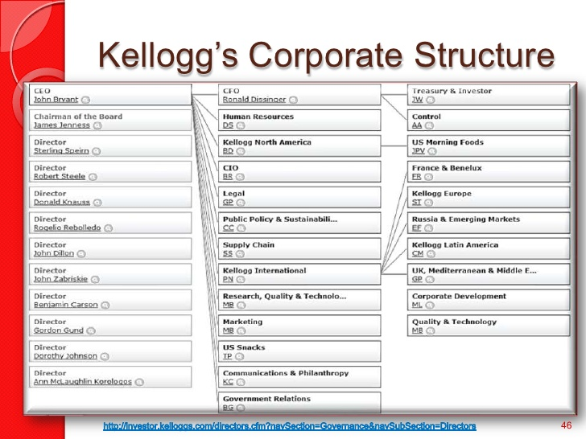

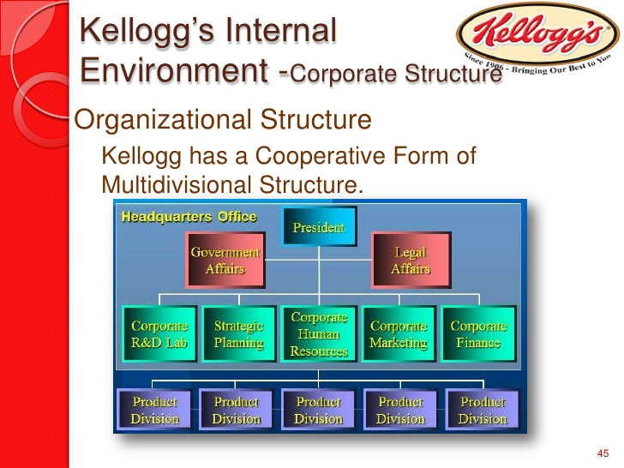

4.CULTURE

The culture is a challenging concept to describe, because there are important differences in organization crosswise the world which can be attributed to the culture as social organization behavior, rules and values founded in human society, education, beliefs, language, technology and material culture.
Every culture within the organization it is unique and different from the others, for this reason the culture is important because it can control the way employees behave amongst themselves as well as with people outside the organization, encourage the employees to stay motivated and loyal in relation to the management, employees who are trying to perform to better level than their coworkers and at the same time if it is a healthy culture organization it can extract the best of each team member.
The part of Kellogg’s company accomplishment is their commitment of honesty and worship to their tradition. This organization offer to their employees a persistent process in training, focusing their attention on the progression to help them to develop their skills and having equal opportunity for success within the organization and helping the organisation to improve performance and bring innovation and quality products.
Kellogg’s using a formal organization by premeditate and create a plan of strategy for their objectives and activities.
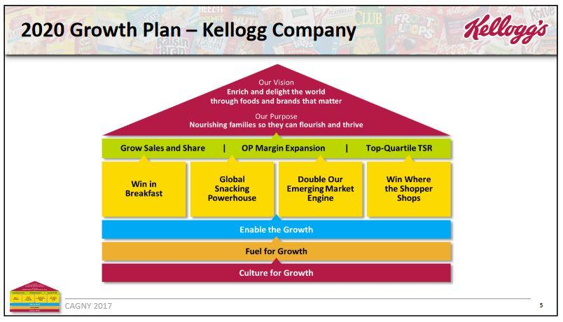

4. HOFSTED

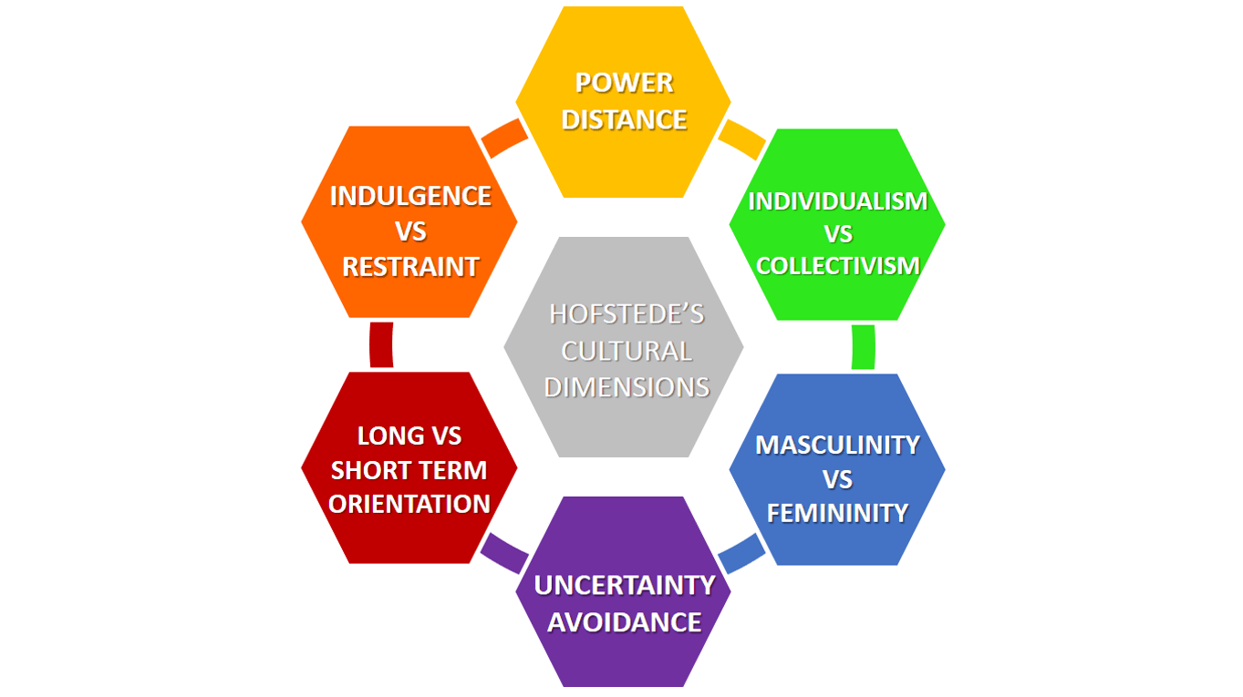

Hofstede is helping to identify five cultural dimensions which layout a particular’s country beliefs about each different dimension and how this affect the society culture and values, developed by Geert Hofstede
The first cultural dimension is the Power of Distance which one is suggesting that a society stage of inequality is encouraged by using the followers as a great deal as by way of the leaders.
Second dimension is the Individualism who refer to the scope in which individuals are unified into groups.
Third cultural dimension is Masculinity vs Feminity, a major concern for several cultures, it is attributed to the circulation of appearance between the genders. Kellogg’s has made a significant change toward the more reasonable involvement of women, people of color, people with disabilities, veterans, lesbian, guys, transgender individuals, bisexuals.
The forth one, but not the last one, is the Uncertainty Avoidance, identifying the society’s tolerance for uncertainty and ambiguity. To avoid the possibility of such a situation many culture are implementing strict laws and rules, safety and security measures.
The last one, Long Term, is associated with values and the respect for tradition.

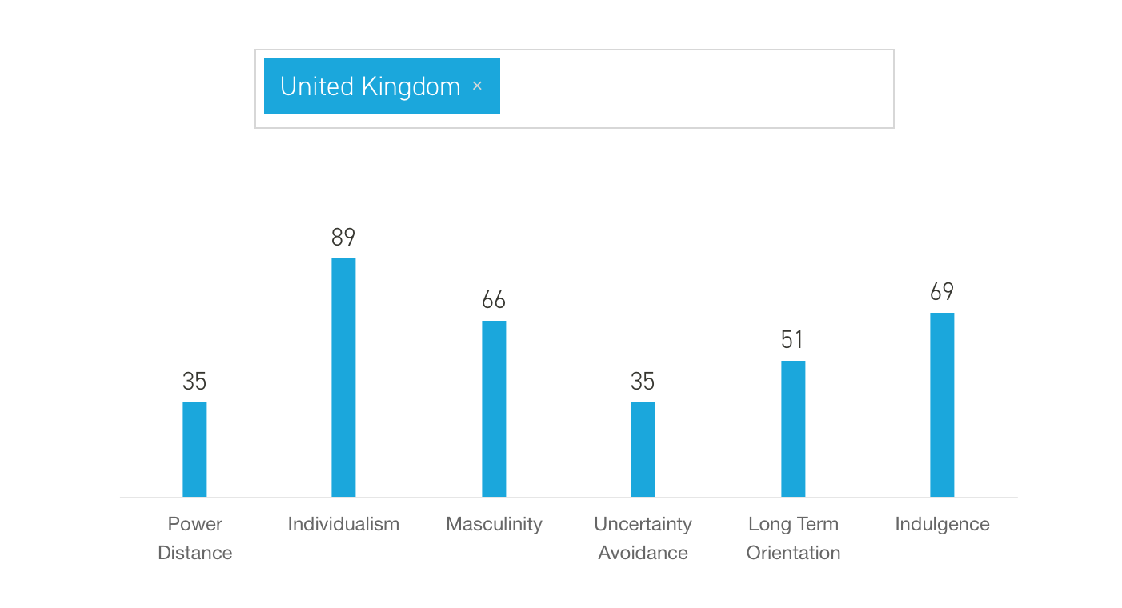
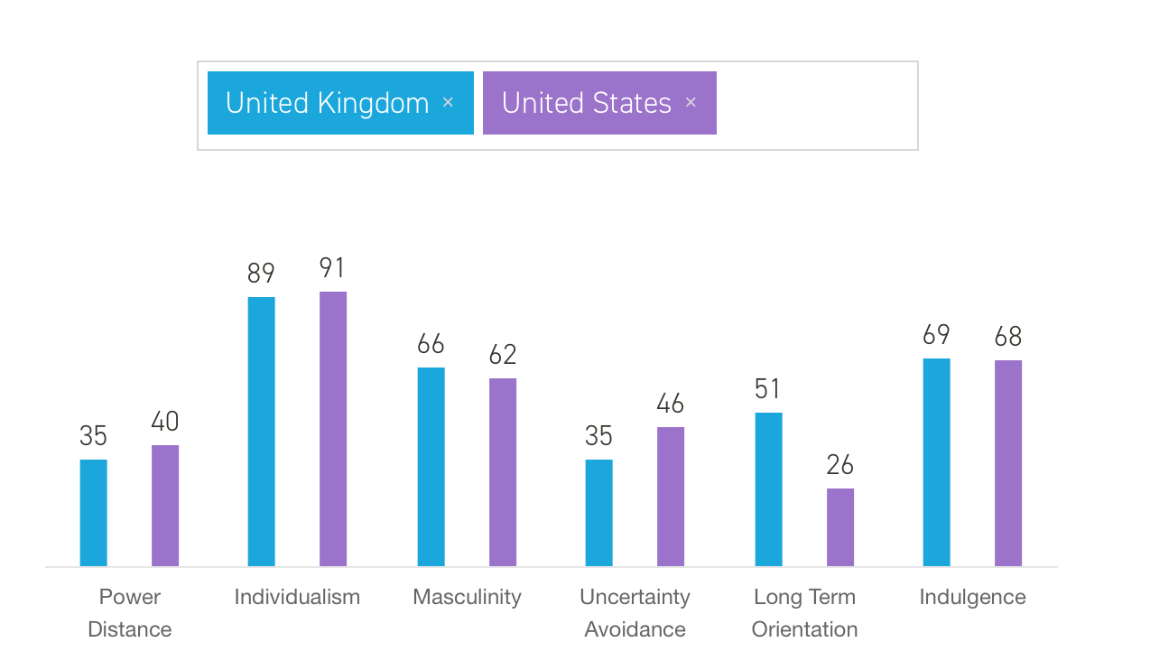

 | UNITED STATES | UNITE KINGDOM | KELLOGG’S
Power distance | 40 | 35 | 25
Individualism | 91 | 89 | 20
Masculinity | 62 | 66 | 49
Uncertain Avoidance | 46 | 35 | 29
Long Term Orientation | 26 | 51 | 75
Indulgence | 68 | 69 | 55

5. PEOPLE

It is important that an organization focus on their employees, to provide the best environment for personnel motivation and helping them to improve themselves.
Kellogg’s organisation follows the theory of motivation within the company’s members.
A theory of human motivation is Maslow’s Hierarchy proposed by Abraham Maslow. This theory focus on five main levels: physiological needs, safety needs, love needs, esteem needs and self-actualisation needs. The hierarchy does not have a fixed order among individuals, begin influenced by particular culture.
The first level of physiological needs refers to satisfaction of hunger and thirst, the need of oxygen, sleep, activity, maternal behavior and sexual appetite. Kellogg’s offer ambitious earnings for the personnel to have the essential needs for example: childcare coupon, life assurance schemes. This needs make the people from the organization to become loyal to the company.
The second level covered the assurance and freedom, protection from physical hazard and the need of equality. Kellogg’s offer them option in regards to have a work-life harmony by giving them health and safety work ambiance and preventing hazards.
The third need invoke the love: affection, social activities, friendships, the commitment to give and get love. The cereal company reward the people’s achievements and offer them information as sales and products.
Forth grade is referred to self-respect, confidence, strength, self-determination, achievement, reputation, appreciation and acceptance. Kellogg’s brings opportunities to the staff to become part of ownerships projects.
The last level, Self-actualisation needs, point out the capability to become at the best level of every human begin potential. This need is different from one person to another.

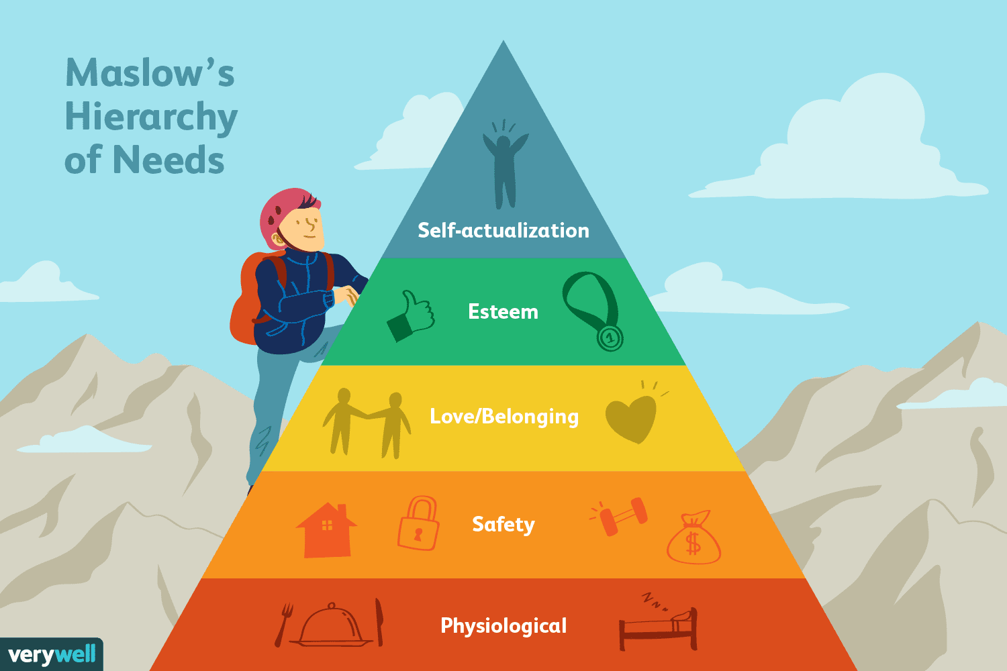

6. PERFORMANCE

Organisation performance is based on the economic performance, market performance and shareholders performance.
The performance of an organization depends on a few factors, for example the nature of management, the nature of leadership, organizational objectives, strategy and responsib ilities, the nature of work motivation, management control and power.

7. COCLUSION

In conclusion the structure and the culture of the oganisation contribute to the organisation performance.
Kellogg’s company is an old organization with over one hundred years plus of activity, multicultural food manufacturing known as the largest company of cereals interested of healthy breakfast.
8. REFERENCE

Kellogg’s Who we are?
Available at:
https://www.kelloggs.com/en_US/who-we-are/our-locations.html
(Accessed on 10 August 2019)

Hofsted’s cultural dimensions theory
Available at:
https://en.wikipedia.org/wiki/Hofstede%27s_cultural_dimensions_theory
(Accessed on 10 August 2019)

Kellogg Company (September 6, 2017)
Available at:
https://investor.kelloggs.com/Cache/1001239364.PDF?O=PDF&T=&Y=&D=&FID=1001239364&iid=4133514
(Accessed on 10 August 2019)

Marketing Strategy of Kellogg’s – Kellogg’s Marketing Strategy (June17,2018 by Hitesh Bhasin)
Available at:
https://www.marketing91.com/marketing-strategy-kelloggs/
(Accessed on 13 August 2019)

Topic page: Hofsted’s Five Dimensions of Culture from Encyclopedia of Business in Today’s World (Moskowitz,Sanford St. John’s University)
Available at:
https://search.credoreference.com/content/topic/hofstede_s_five_dimensions_of_culture
(Accessed on 15 August)

Laurie J Mullins, 2002,Sixth Edition, Management and Organisation Behavior, Eingburgh Gate, EnglandWord did not find any entries for your table of contents.( p.p 35-39,p.p 426-428, p.p 530-532, p. 646, p.807)

