Molluscs Write up
With reference to Figure 1 discuss the likely taphonomic problems in the interpretation of the molluscs from a sample taken in unit 8 on the diagram.

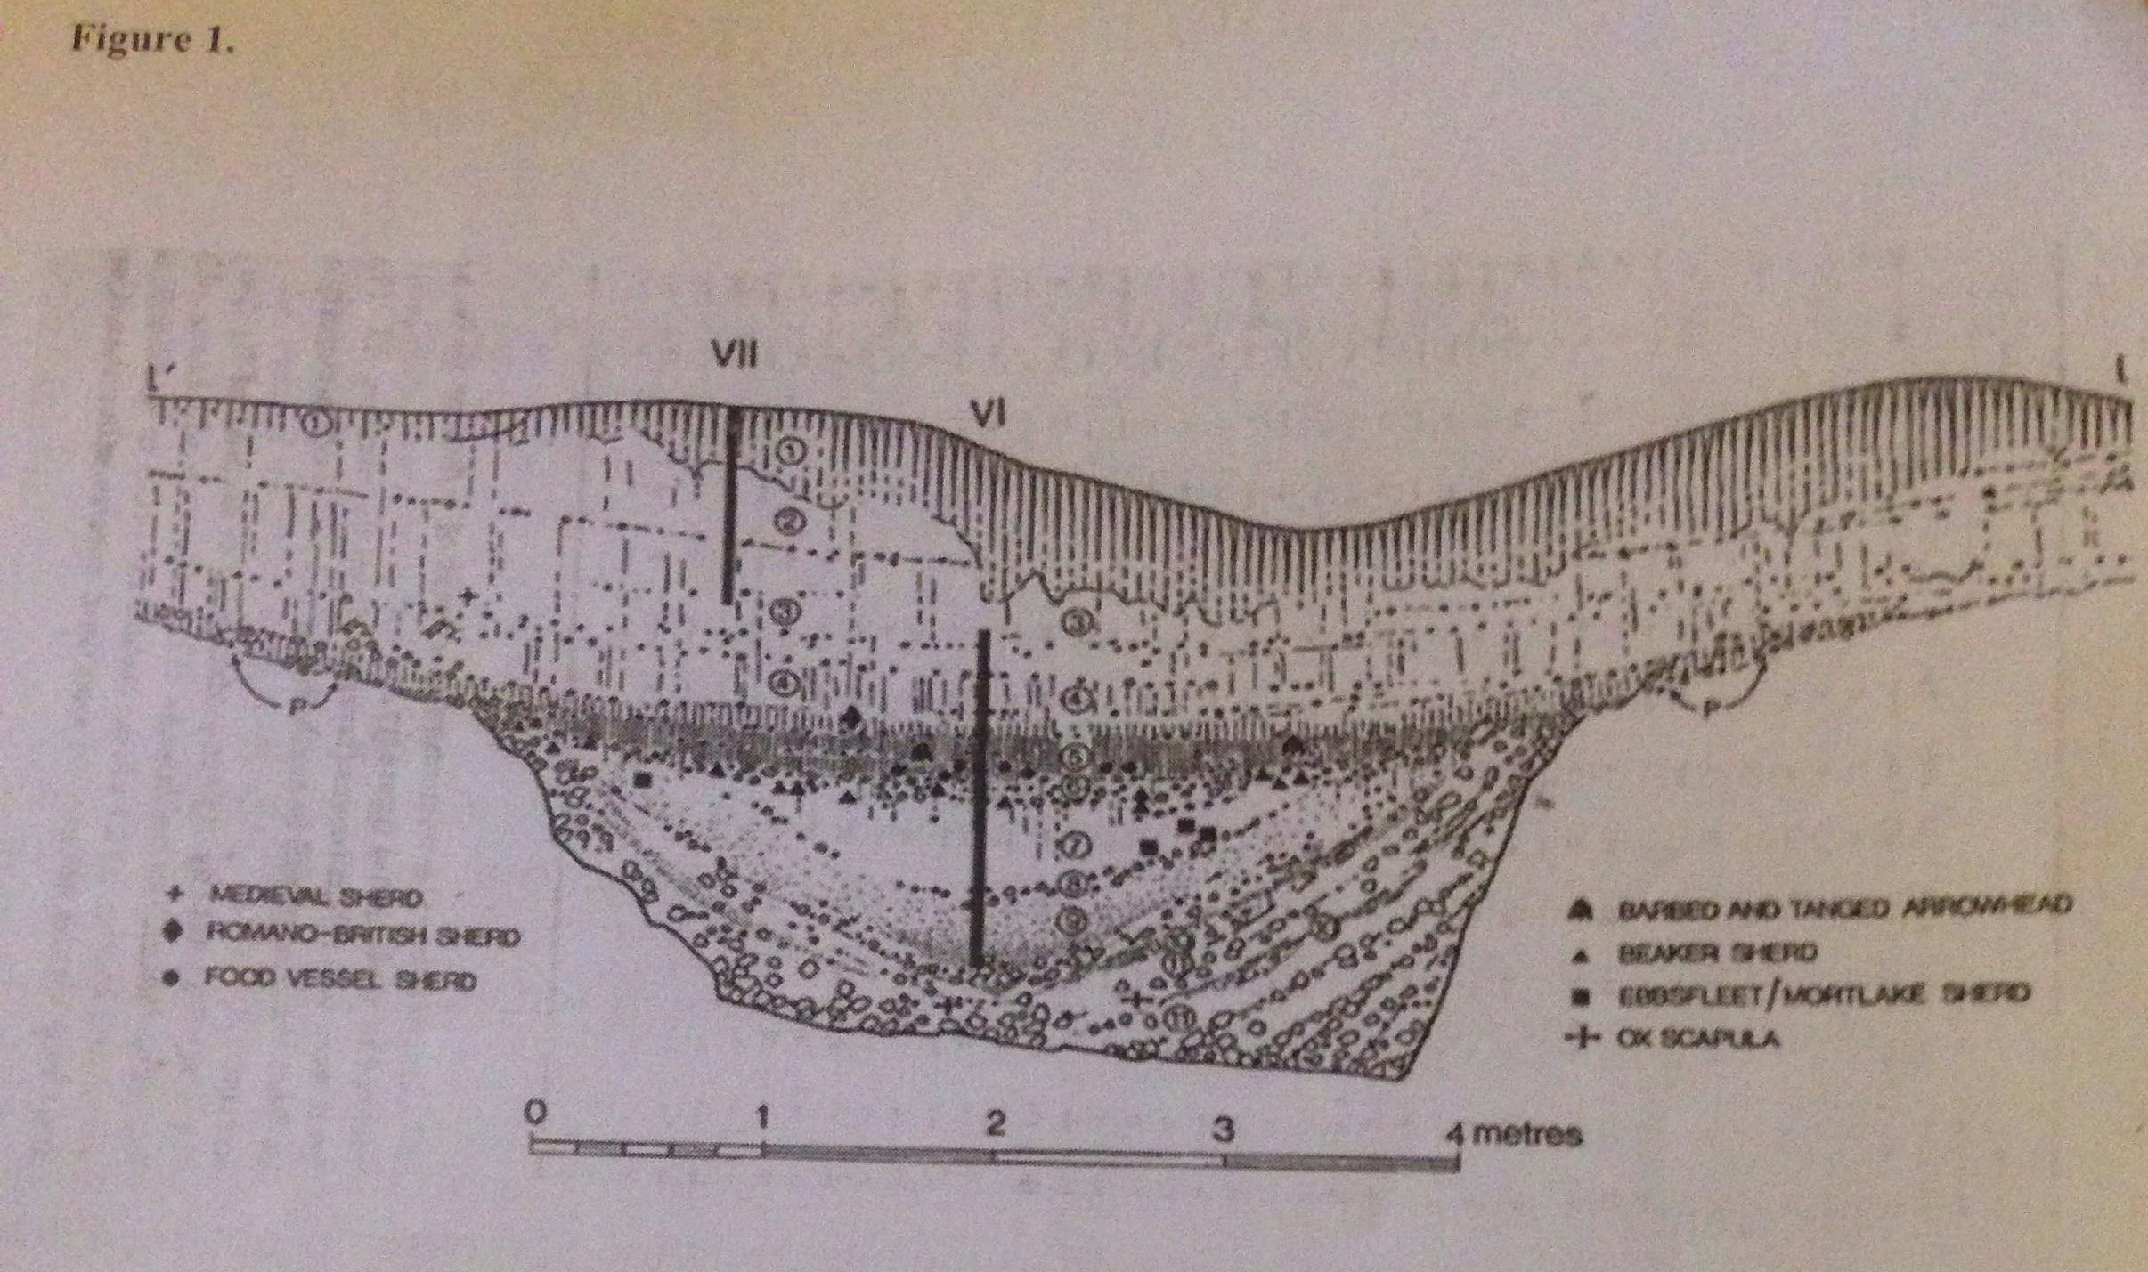
Interpreting molluscs taken from a sample in unit 8 on the diagram would have many different forms of taphonomic problems, the main one being that the surrounding soil seems to be composed of many larger rocks and pebbles. These pebbles and stones will inadvertently end up crushing many of the molluscs that were in the sample. This in turn, could lead to many problems in the identification of individual molluscs as many are very similar in appearance and indentifying molluscs from broken shells and in some cases potentially only fragments of the shells would be very difficult. A sample for molluscs should be taken specifically for molluscs, this means that a sample must be large enough to contain 100-200 examples of molluscs must not cross context in either depositional or chronological form. This means that the depth of the sample will depend heavily on the speed of which the deposition took place (Allen M.J. 2017 p30). Meaning that because unit 8 is a very thin layer in the stratigraphy that the sample taken would probably need to be larger than expected as many of the molluscs may be unidentifiable due to how badly damaged they are.
Not only would the identification of individual molluscs be very difficult if most of the shells had been crushed or eroded by the abrasive nature of the surrounding sediments, but also getting an accurate depiction of the types of molluscs that lived in and around the area when unit 8 was the top layer would be very difficult and probably not very representative of the species that actually lived there.
However, there are other taphonomic problems with interpreting molluscs from unit 8 such as the fact that unit 8 looks like it may once have been a river bed. This in turn also poses some problems as not only do you have the large stones and pebbles causing many of the mollusc shells to be crushed or fragmented but you would also have fluvial erosion and deposition acting upon them. This would add to the amount of erosion that happened to the shells potentially fragmenting even more of the molluscs in the sample gathered, making the sample even less representative of what was actually there. However, fluvial processes are not only limited to that of erosion but also of deposition.
Fluvial deposition would mean that the molluscs that were taken for the molluscs’ sample would potentially have travelled quite far before being deposited with in the area of unit 8. This would also mean that in identifying those molluscs found in unit 8 they may not be representative of an accurate picture of what was living in the area of unit 8, but rather the molluscs from an area further upstream. As molluscs are very small and light and could travel quite far before eventually being deposited when the current finally subsided. Due to this fluvial action interpreting the molluscs found in unit 8 would not be an accurate representation of what had lived in the area of unit 8 but rather of what had been deposited there before area became buried.
In conclusion, there are many taphonomic problems facing the identification and interpretation of molluscs found in unit 8 due to its composition of pebbles and stones large enough to fragment the molluscs that were buried there. But also due to the potential of fluvial action upon those molluscs and the transport and deposition of molluscs via a river would mean that any interpretation of the molluscs found in a sample taken from unit 8 would not be very representative of what had originally lived there.

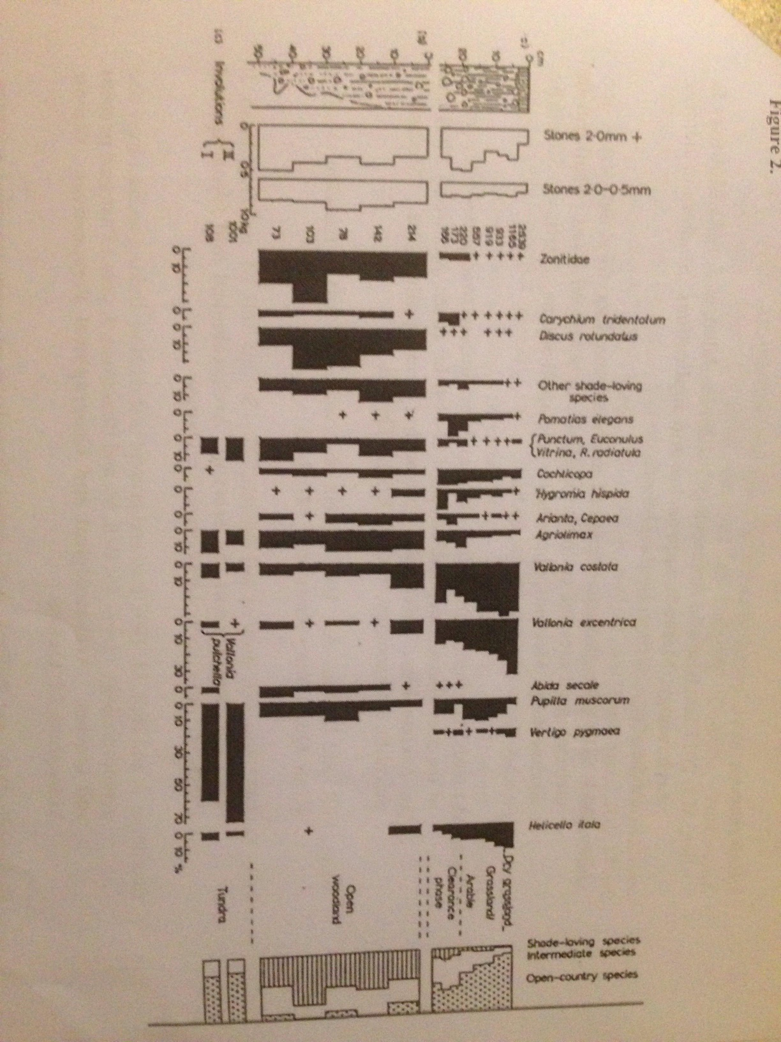
With reference to Figure 2 describe the changes you see in the diagram; explain what you think caused these changes; and suggest the likely time periods when these changes occurred.

Throughout the diagram there are three main phases that are easy to see and understand and those are of a phase of tundra followed by a phase of open woodland and following that some form of clearance which gives way to a phase of open grassland and arable lands. Starting as far back chronologically speaking as the diagram goes we can see a period of tundra which is dominated by open country species of mollusc mainly, Vertigo Pygmoea and Pupilla Muscorum. However, there are also some small pockets of intermediate species such as Agriolimax and Punctum, Euconulus there is then an incredibly sharp decrease in the amount of open country species although Pupilla Muscorum and Abida Secale are still present along with a small increase in the intermediate species heading into the open woodland phase of the diagram. However, with this change from tundra to woodland we see the emergence of some shade loving species of molluscs such as Zanitidae and Discus Rotundalus. At two points through out the woodland phase of the diagram the open country molluscs almost completely fade and the shade loving species see intermittent increases and decreases though they maintain the majority throughout this phase of woodland. The intermediate species tend to stay fairly consistent through out the woodland phase only seeing minor fluctuations in their representation. Once the woodland phase is ended by some form of clearance there is a sudden decline in the shade loving species and a slight increase in the intermediate species however, there is a massive increase in the open country mollusc species which continues to increase steadily as the intermediate and shade loving species continue to decline.
These changes could have been caused by many factors however the most likely for them is the change in environment whether that be through human intervention or natural causes. The most likely cause for the first major change in the representation of mollusc species would be the ending of the ice age around 11,700 years ago, which is when the phase of tundra is most likely to have occurred. With the temperature rising the tundra will slowly be being pushed back and there will be an influx of warmer climate trees first would be pine and eventually these would be replaced by oak forests which would offer much more shade and force the open country molluscs out into the fringes of the forest whilst allowing for shade loving molluscs to increase in numbers and establish themselves whilst the intermediate species would be largely unaffected by this change in temperature and the increase in woodlands as they have the ability to live in both open areas and shaded areas. This most likely would have taken place at some point through out the Palaeolithic. After a period of open woodland there is a much shorter period of clearance which was most likely caused by human intervention and would result in the majority of the oak forest and other trees and woodlands being removed along with the shade that they provided to the molluscs that were living with in the forests. This clearance of the woodland would create large open fields and arable land for farming and probably took place at some point throughout the mid to late Neolithic. This clearance of trees and the creation of fields for arable farming would result in an increase in the open country species being reintroduced and continuing to increase as the fertility of the soil is depleted and the reintroduction of trees becomes less likely the shade loving molluscs would be forced into decline.

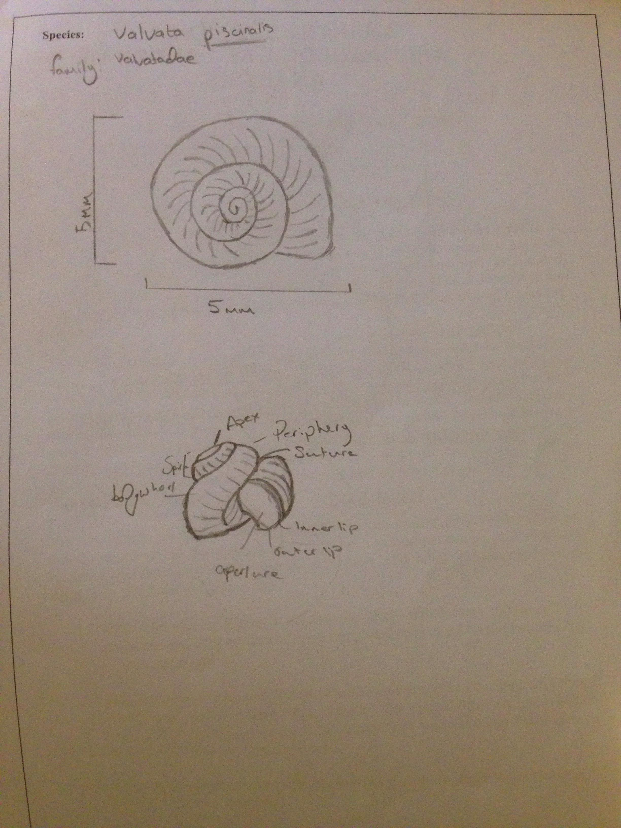

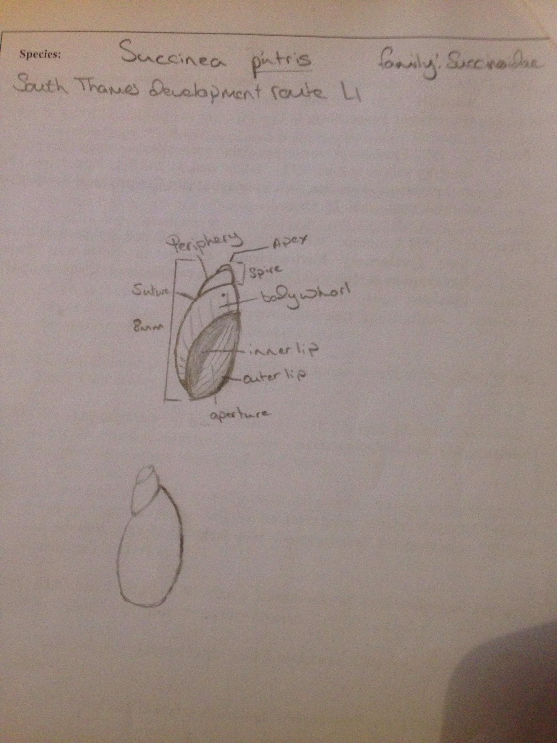

Bibliography

Allen M.J. 2017 The geoarchaeology of context: sampling for land snails (on archaeological sites and colluvium). 30-47 IN: Allen, M.J. (ed.) Molluscs in Archaeology. Methods, approaches and applications. Studies in scientific archaeology. Oxbow Books: Oxford.

