Critical analysis of Thomas Cook Group’s fall

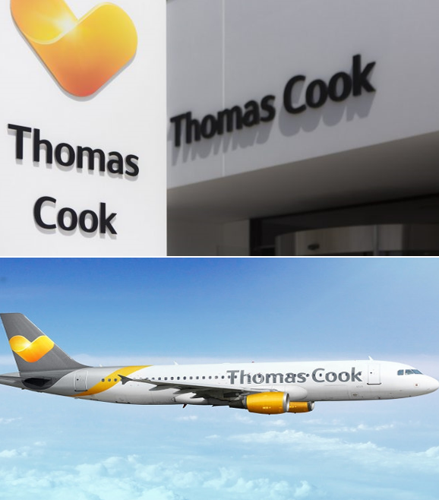
MBA Banking and Finance
University of Wales Trinity Saint David

Name | Sadia Anjum
Student number | 1708775
Module name | Corporate Finance
Module number | LCMB7005
Lecturer | Muno Zuwirai

Abstract
The aim of this report is to describe and analyse the business operations of Thomas Cook Group (TCG) and try to identify and understand the causes and effects of its demise. It has considered the macro and micro environment issues with SWOT and PESTEL analysis and has critically analysed the company’s financial performance using a five years account (www.annualreports.com). Financial ratios have been used in this report to understand the company’s investment and operating strategies. The company’s financial performance was also compared with Touristik Union International (TUI) AG to further explore the reasons for TCG’s fall. The findings of this report suggest that high debts, outdated technology, high turnover of the top management, lagging to modernise the business model and strategy are some of the reasons behind TCG’s demise and the fall has affected a lot of people, shareholders, the customers, and the employees. Taking some steps in the right direction at the right time could have saved the company from bankruptcy.

Table of Contents
List of figures 4
Introduction 5
A: The rise and fall 6
178 years of Thomas Cook 6
The rise of Thomas Cook 7
Mergers and acquisitions 7
Fall of Thomas Cook 8
Too many M&A too soon: 8
High turnover of CEOs: 9
Political instability: 10
Other issues: 10
B: Critical analysis of the company’s financial performance 11
Financial performance analysis 11
Horizontal analysis for the period 2014 to 2018 11
Comparison between Thomas Cook and TUI 15
Share price of TCG and TUI 15
Revenue, cost of sales and gross profit 16
Return on assets (ROA) 17
Profit margin 18
Gearing 19
Earnings before interest, taxes, depreciation, and amortisation (EBITDA) 20
Current ratio 21
Basic earnings per share 22
C: Factors that played a role on the demise of Thomas Cook Group 23
Capital structure and disastrous M&As 23
Limitations and barriers in airline industry 25
Failure in digital transformation of the business 26
Failure to update business model 27
Leadership shortcoming of the CEOs 28
Role of the government 29
Brexit 29
Corporate governance 30
The effects of the collapse 31
Customers 31
Employees 31
Shareholders and debt holders 31
Suppliers 31
Conclusion 32
The lessons learnt/ recommendations 33
Reference list: 34
Appendix 40

List of figures

- Figure 1: Business life cycle of Thomas Cook Group with M&A
- Figure 2a: Income statement of Thomas Cook Group
- Figure 2b: Income statement of Thomas Cook Group
- Figure 3: Graph of horizontal analysis of TCG’s balance sheet
- Figure 4: Share price charts of TCG and Tui
- Figure 5: Graphs of TCG’s and Tui’s revenue, cost of sales and gross profit
- Figure 6: TCG’s and Tui’s ROA graphs
- Figure 7: TCG’s and Tui’s profit margin%
- Figure 8: Graphs for gearings of TCG and Tui
- Figure 9: Graphs for 10 years gearings of TCG
- Figure 10: EBITDA margin graphs for TCG and Tui
- Figure 11: Current ratio graphs for TCG and Tui
- Figure 12: Basic earnings per share for TCG and Tui
- Figure 13: Thomas Cook Group’s timeline of mergers and acquisitions and major events since its formation in 2007
- Figure 14: Thomas Cook Airline’s cost of interest in 2011-2014
- Figure 15: Thomas Cook Airline’s number of tickets sold in 2011-2014
- Figure 16: the graph of profit margin of TCG from 2007 to 2018
- Figure 17: Graph of Thomas Cook’s share price from 2007 to 2019
- Figure 18: Thomas Cook’s basic earnings per share graph

Introduction
Tourism and travel industry is one of the largest service provider industries in the world and Thomas Cook was the oldest travel agency. After 178 years of service and surviving through two world wars, the company collapsed in September 2019 leading to its complete liquidation (Chris Leadbeater, 2019).
Thomas Cook Group (TCG) was unquestionably the leader of a global travel company originally started by Thomas Cook with his expedition on the 5th of June 1841, a rail trip from Loughborough to Leicester for 500 people (Calder, 2019b; Chris Leadbeater, 2019). In 178 years, the company has expanded globally and became one of the FTSE 100 companies. On its demise 21,000 people were employed by Thomas cook all over the world, of which 9,000 in the UK (Dmitracova, 2019). The business had 103 aeroplanes and 3,170 hotels in its possession (Walsh, 2019; UȚĂ, 2020). It operated in 16 countries, number of customers exceeded 19 million each year and the annual sale went up to £9bn. Then in 2019, they collapsed leaving 150,000 British holiday makers trapped abroad (Walsh, 2019).
There is therefore an interest in understanding why the pioneer of packaged holiday collapsed. Past publications suggest that Thomas Cook collapsed because of Brexit, high debt, lagging to digitise business and a number of other issues (Lavender, 2019). This report will investigate further to determine the rise and fall of this business giant, TCG and critically analyse the financial performance using the Annual Reports of TCG (www.annual reports) over the last few years of business and compare primarily with its rival company Tui AG using various financial analysing tools. This report will also produce a set of recommendations to prevent failure of the future businesses.

A: The rise and fall

178 years of Thomas Cook
In 1865, Thomas Cook opened the first office on Fleet Street with a small store to sell travel accessories like luggage, footwear, telescope, etc. He took his son John Mason Andrew Cook as a partner and named his business Thomas Cook & Son. This partnership ended in 1878 when Thomas Cook retired but the business was expanded rapidly by John Mason Cook and his three sons. Their innovative ways and expansion acquired them limited liability status in 1924 and they changed their name to Thomas Cook & Son Ltd. (Calder, 2019b; Chris Leadbeater, 2019). Thomas Cook became such an essential part of British life that when it became bankrupt after the second world war in 1948, it was made nationalised by the Labour government (Calder, 2019b; BBC news, 1972).

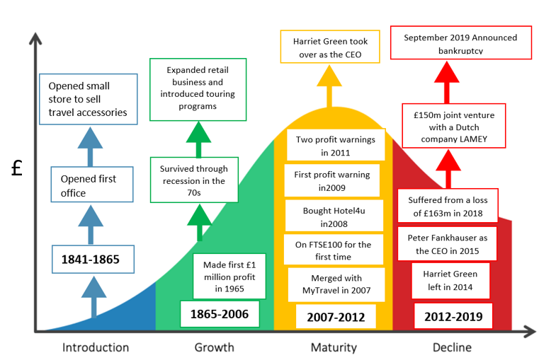
Harriet Green took over as the CEO in 2012
Announced £1.5billion loss in 2019
Figure 1: Business life cycle of Thomas Cook Group with M&A

The rise of Thomas Cook
Post the second world war, Thomas Cook’s business bloomed and in 1965, the business reported that they had made more than £1 million profit. The company became privately owned again in 1972 and was renamed Thomas Cook Group Ltd in 1974 (Lavender, 2019). The business survived through the recession in the 70s when a lot of other travel agencies had to shut down. Throughout the 80s and the 90s, Thomas Cook grew even more by introducing long touring programs and expanded their retail business (Keeley, 2019). The company was sold to the third largest German bank in 1992, then again in 2001 by another German tourist company who rebranded their whole business as Thomas Cook. By this time, they also started an airline business (Stevenson, 2012).

Mergers and acquisitions
The business was named Thomas Cook Group in February 2007 when it merged with My Travel Group plc which put the business on the FTSE100 list (Pa, 2007; Collinson, 2019). On the 14th of February 2008, in an attempt to digitise the business Thomas Cook bought online booking website Hotel4u.com and then again in April bought luxury holiday firm Elegant Resorts to attract the niche market. In order to expand more the company took over Gold Medal International, the owner of NetFlights in December 2008. In 2009, they made a deal with Octopus Media Technology to host, produce and upload videos for Thomas Cook TV (Collinson, 2019). In the same year, they made a deal with the International Entertainment Supplier, The E3 Group to supply entertainment to the group exclusively. To gain competitive edge in the market Thomas Cook acquired a German tourism firm called Oger Tours (Impey, 2010) and also made a deal with the Co-operative Group to merge with their branch, Co-operative travel which made them the largest travel company in the UK in 2010 (Collinson, 2019).

Fall of Thomas Cook
Thomas Cook Group declared bankruptcy in September 2019. The collapse of this business giant was sudden but not unexpected, and it left more than 600,000 travellers stranded all over the world (Garcia, 2019). There were a number of reasons behind this; a series of mergers and acquisitions, poor management from the CEOs, political situation, climate change and change of trends, all of these had a significant impact on this collapse (Segal, 2019). From 2006, the business was on the brink of collapse a few times then eventually in the early hours on Monday the 23rd of September 2019, the CEO Peter Fankhauser announced the demise of the company and said that it was "deeply distressing" that it could not be saved.

Too many M&A too soon:
“Mergers and acquisitions are designed and executed to create growth, competitive advantages, technological acquisition, eliminate competition and more in order to create value. But many companies badly estimate the complications that can arise during an acquisition, resulting in a “2+2=3” rather than a “2+2=5” effect” (Appelbaum, 2000; Cartwright and Cooper, 1993; Hovers, 1971)
The primary TCG went for the M&A deals in order to grow the business. When internal growth initiatives do not materialise, or there are no other organic growth options, M&A transactions prove to be the only way to create growth (Kummer and Steger, 2007).
Thomas Cook merged with MyTravel in 2007 (Pa, 2007). In September 2008, in order to fully capitalise on the organisation's four-pronged strategy of: maximising the value of the mainstream business; be a leading travel-related financial services provider; become a leading independent travel provider; and grow the company's value through mergers and acquisitions e a restructure saw a separation of the UK division into “Independent Businesses” and “Mainstream” with the promotion of a CEO figurehead for each (Dennis, 2008). In line with the above strategy Thomas Cook had, since 2008, made a number of strategic acquisitions to complement their existing portfolio. All these partnerships and acquisitions could not stop their failure.

High turnover of CEOs:
The world is still shifting from an analogue to a digital one with new information technologies, in which consumers increasingly search for travel related issues online (Tjostheim, Tussyadiah, & Oterholm Hoem, 2007). Manny Fontenla-Novoa, the CEO who was in charge of Thomas Cook from 2003 to 2011, seems to have failed to adapt to the new online trend. He was unable to provide services online as well as the traditional way, from High Street shops. He also led the merging with My Travel in 2007 which cost them £1bn (Quinn and Walker, 2019). This made them into a group with a retail estate, tour operator and airline, and enabled them to compete with online rivals and low-cost airlines. They were able to get into the FTSE 100 for the first time. The number of retail shops of Thomas Cook Group increased to 1,200 in 2010, when Mr Fontenla-Novoa bought Co-operative Travel. This purchase was highly criticised for being overpriced. There were three profit warnings in 2011, afterward Mr Fontenla-Novoa left the company. That year the business net debt was £891m and the annual interest was £122m (Hancock, 2019).
When Harriet Green took over in 2012 as the CEO, she was credited for turning around the tour operator which suffered a loss of £398m in 2011. She concentrated on cutting costs and strengthening the balance sheet. Her focus was to increase online business. She was very enthusiastic about the business and convinced the shareholders to be on board. Michael Healy, the finance chief of Thomas Cook was also said to have a part as he did the difficult negotiating with the banks. With joint effort the business turned around from the brink of collapse and the share price rose more than 680%. She was highly criticised for her controversial expenses and actions regarding the deaths of two children in Corfu during Thomas Cook holiday. Ms Green depended a lot on advisers, she spent £180m on consultancy fees in 2013 and 2014. She left the business in November 2014 (Hancock, 2019).
When Peter Fankhauser took over Thomas Cook Group as the CEO in 2015, the company made a profit of £23m which could be the after effect of Harriet Green’s cost cutting strategies but within a couple of years in 2018 it fell to £163m loss. The company was paying £150m debt cost each year which left only a small amount of capital to Peter Fankhauser to turn it around with. Mr Fankhauser set up a £150m hotel joint venture between Thomas Cook and Dutch real estate investment company LMEY and built a partnership with a Chinese company Fosun as the largest shareholder. This partnership enabled them to get over £200m into the business before it collapsed. In February 2019, they announced that they will sell their airline but none of the bids were high enough to cover the £1.2bn debt they declared in May (Hancock, 2019).

Political instability:
Political instability due to the military coup of 2013 in Egypt and coup attempt of 2016 in Turkey had a significant effect on travel companies. Thomas Cook provided most of the Turkish holiday packages from the UK and Germany and they had to cut down 40% of their capacity in Turkey which caused a £100m reduction in revenue between April and June 2016. Europe has seen a few terrorist attacks in 2015 to year 2017, such as Paris attack in 2015, France truck attack in 2016, Berlin market attack in 2016, etc. People were scared to go on holidays due to these terrorist attacks, as a result, travel industry suffered a lot of loss.
The instability due to Brexit affected the UK population and their holiday plans. People started to cut down their spending due to the uncertainty of Brexit.

Other issues:
The internet enables the holiday makers to choose different elements of their holidays for competitive prices so the demand for package holidays decreased drastically. People also prefer city breaks now rather than beach holidays. From 2010 onwards, the European countries suffered from extreme weather like heat waves, floods and heavy snow which prevented holiday makers from travelling. Especially during hot summers, people have a good time even in their own gardens and parks.

B: Critical analysis of the company’s financial performance

Financial performance analysis
To understand how a company is performing, a financial performance analysis is conducted for which four statements are studied and analysed extensively: balance sheet, income statement, cash flow statement and the annual report. The most common and popular tools that are used to measure the financial performance are horizontal analysis, vertical analysis, and ratio analysis such as: gross profit margin, current ratio, return on capital employed (ROCE), return on assets (ROA), return on equity (ROE), etc. (Bose, 2011).

Horizontal analysis for the period 2014 to 2018
The income statement of Thomas Cook (Appendix 1) and the horizontal analysis of the income statement (Appendix 2) of the year 2014 to 2018 shows that the revenue, cost of sales and gross profit went up and down throughout these years. What’s noticeable is that from 2014 the revenue went down by 8.78% in 2015 and then again it went down by 0.28% in 2016. However, from 2016 it had a whooping increase of 15.30% in 2017, and from 2017 to 2018 it was 6.41%. Similarly, the cost of sales went down by 9.79% and 1.19% in 2015 and 2016. It went significantly up in 2017 by 17.10% and 9.08% in 2018. From figure gross profit, it can be seen that the gross profit decreased from 2014 to 2015 by just over 5%, then in 2016 it increased by 2.82%.

From 2016 to 2017 the gross profit went up by 9.39% and in 2018 it went down by 3.01%. The net profit also reflects a similar trend. Thomas Cook suffered from a £115 million loss in 2014 but in 2015 they made a profit of £19 million which is a huge increase of 116.52% from the previous year. The horizontal analysis shows that the net operating cost went down by almost 25% in 2015, personnel expenses went down by 5.6% and financial cost went down by 0.56%. The reduction of all these expenses had a significant impact on the growth of net profit. The change of the company CEO in 2015 brought some confidence back in the company which also helped with this matter. In the following year 2016, the net profit went down by 52.63%. In 2015, the jury of the case of two siblings’ death in 2006 proclaimed that Thomas Cook had “breached its duty of care”. After the verdict they were highly criticised for the controversial method they used to deal with the case. This incident had an impact on the reduction of profit in 2016. At that time, Thomas Cook Group plc's three major shareholders were Invesco (19%), Standard Life Investments (10%), and the business magnate and investor Guo Guangchang (7.03%).

The Co-operative Group decided to move away from their joint venture with Thomas cook in 2016. In March 2017 they sold their Belgian airline operations to Lufthansa which was stut down by November. A British couple died on a Thomas Cook holiday in 2018 who were staying at the Steigenberger Aqua Magic in the Red Sea resort of Hurghada. The couple’s daughter who was also on holiday with her parents blamed faulty air-conditioning for the deaths. When other guests in the same hotel started to fall ill as well, Thomas Cook had to evacuate 300 guests from the hotel. These incidents affected their reputation and resulted in them to suffer from a huge loss of £163 million which was a 1,458% decrease from the previous year.

Figure 2a: Income statement of Thomas Cook Group

Figure 3: Graph of horizontal analysis of TCG’s balance sheet

Comparison between Thomas Cook and TUI
TUI is a rival travel agency to Thomas Cook Group. Four German tour operators started a new enterprise called Touristik union International (TUI) in 1968 which was based in Hannover, Germany. In 1970, the biggest German tour operator at that time, Airtours International joined TUI. German Preussag Group took over TUI in 1998 and made it their tourism brand in 2000. They also acquired 49.9% of another travel agency called Thomson Travel in the same year. In 2002, the business was renamed as TUI AG instead of Preussag AG.
Tui went through some mergers which aided their growth such as: in 2007 with First Choice and especially in 2014 with Britain’s TUI travel. This merger enabled them to start trading on London Stock Exchange in December 2014. This part of the report will compare the financial performance of TUI AG and TCG for the period 2014 to 2018.

Share price of TCG and TUI
The share price of TCG and TUI throughout the years 2014 to 2018 is displayed in Figure 4 below. It is noticeable that the share price of Thomas Cook was higher during 2014 to 2015 compared to TUI share price. After that, it has declined gradually. On the other hand, TUI share price was lower compared to TCG at the beginning of their stock market journey but slowly and steadily it has gone up. During the political instability in Turkey during 2016, share price dropped drastically for both companies in July (Collinson, 2019). After that the share price kept going up for Tui and going down for Thomas Cook. In 2018 when TCG collapsed, Tui’s share price went up significantly; share prices went up to £7.62.

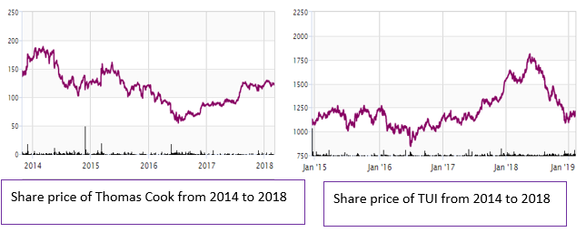
Figure 4: Share price charts of TCG and Tui

Revenue, cost of sales and gross profit
Below are the side-by-side graphs representing the revenue, cost of sales and gross profit of TCG and Tui from 2014 to 2018. From the graphs it can be seen that both companies had similar trends throughout the years, and both had steady gross income. The terrorist attacks in 2015 and 2016 in France and Berlin and 2016’s military coup in Turkey had a significant affect in the travel industry. Both companies suffered from a decrease in revenue and cost of sales in 2016. However, in 2017 and 2018 they had steady growth in these aspects.

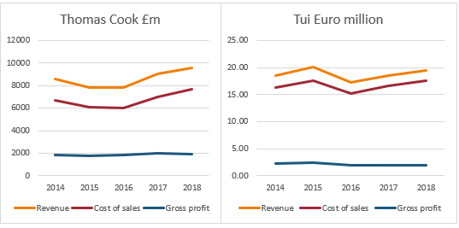
Figure 5: Graphs of TCG’s and Tui’s revenue, cost of sales and gross profit

In 2018 TCG declared bankruptcy and was liquidated in 2019 while Tui is still a strong participant in the travel industry. The collapse of Thomas Cook created business opportunities for Tui and other travel agencies.

Return on assets (ROA)
Return on assets (ROA) is a ratio used to measure how efficiently a company uses its assets. This ratio indicates the percentage of profit that a company earns in relation to its total assets. The higher the ROA the better the company performance is, and it will attract more investors. This is a very effective tool to compare companies in the same industry. Figure 6 shows graphs of ROA for TCG and Tui. By observing the graphs, it is evident that Tui earned more profit using their assets than TCG. In 2014 and 2018 TCG over-invested assets that have failed to make profit. Tui on the other hand was efficient in using their assets which enabled a steady ROA growth throughout the years.

Figure 6: TCG’s and Tui’s ROA graphs

Profit margin
Profit margin is worked out to understand the amount the company is able to retain from every pound of the earning. This calculation involves net profit and revenue, if the net profit of the company is high then the profit margin is high. Negative or zero profit margin indicates that the business is struggling to achieve good sales, or its expenses are too high. Banks, lenders, and investors use this to compare with other businesses when making decisions regarding the business.
Figure 7: TCG’s and Tui’s profit margin%

Throughout the years Tui’s profit margin was higher than Thomas Cook and it increased consistently. On the other hand, Thomas Cook suffered from huge losses in 2014 and 2018 which is reflected in its profit margin. Its profit margin was negative or near zero throughout 2014 to 2018.

Gearing
Gearing is a ratio which is a comparison between company debt and company equity. Higher gearing means the company has got high debt. Whether the company makes profit or loss, it will have to pay its debts back, so it indicates that this business is riskier to invest in. Lower gearing means the company is financially sound and is less risky for the investors. The graph below in figure 7 shows the gearings for TCG and Tui. Interpreting the graph, it can be seen that TCG had a high gearing which means the capital structure of TCG was heavily dependent on debt. Tui had a relatively lower gearing which makes it less risky for the investors. Figure is the graph of gearing of Thomas Cook from 2007 to 2018, it shows that the gearing was lower till 2011 and from 2012, it increased drastically and almost each year it went up.

Figure 8: Graphs for gearings of TCG and Tui

Figure 9: Graphs for 10 years gearings of TCG

Earnings before interest, taxes, depreciation, and amortisation (EBITDA)
EBITDA is the measurement of a company’s operating profit as a percentage of its revenue. This helps to compare the financial performance of a company to other companies in the industry. When compared to the amount of revenue generated, the EBITDA margin can be used to determine the operational efficiency of a company and its capacity to produce sustainable profits. The higher the EBITDA margin the better it is for the company and less risky for the investors. The lower EBITDA margin can indicate weakness in the business model. The figure below is the graphs for TCG and Tui EBITDA margin side by side for 2014 to 2018. It can instantly be seen that Tui had a higher EBITDA margin than TCG throughout the years. This means Tui was more reliable for the investors.

Figure 10: EBITDA margin graphs for TCG and Tui

Current ratio
Current ratio is a popular tool used to assess a company’s short-term liquidity. This ratio is between current assets and current liabilities. The current ratio helps investors and creditors understand the liquidity of a company and how easily that company will be able to pay off its current liabilities. If the ratio is 1 then it means that the company has got the exact amount of assets that can pay off the company’s current liabilities. A ratio between 1.5 to 3 indicates healthy finance of a company. If it is less than 1 that means the company might struggle with liquidity. More than 3 ratio means that the company is not using their current assets efficiently or not managing working capital properly.

Figure 11: Current ratio graphs for TCG and Tui

The graph in Figure 9 indicates that TCG’s current ratio has been lower than Tui’s which means compared to their own current liabilities/debts, Tui had more ability to pay off its current liabilities than TCG.

Basic earnings per share
The graph in figure 10 represents the basic Earnings per share for Thomas Cook and Tui in pounds. The price of Tui’s share was in Euro which was converted into pounds using the exchange rate by the Bank of England on the 30th of March 2022. In 2014, Thomas Cook made a loss of £115 million and it reflects on the basic share price which was -8.2p. Again in 2018, when the loss was £163m the share price went down to -1.6p from 0.8p in 2017. In 2015 to 2017 the share price went up due to the after effect of Harriet Green’s cost-cutting strategy.

Figure 12: Basic earnings per share for TCG and Tui

C: Factors that played a role on the demise of Thomas Cook Group

Capital structure and disastrous M&As
Thomas Cook depended on debt to grow their business. In 2007, they merged with MyTravel and that was the start of a disaster. The idea was to reduce the number of competitors and to make the company indestructible and into a business giant. However, the combination of these two companies proved to be a hugely expensive mistake. Stakeholders were concerned at the idea of this merger with a loss-making company especially when MyTravel announced that they have made profit for the first time in 6 years 2007 (Martinez and Bunyan, 2019). They were hoping to cut annual costs by £75 million. Thomas Cook went through more mergers and acquisitions throughout the years (Figure 12) in an attempt to expand business and make more profit which had a consequential effect on their debt and finance cost (Figure 13). In 2008 TCG acquired Hotels4U.com for £22 million which put them in touch with 500,000 online customers and gave them access to 30 properties for accommodation (Willman, 2008).
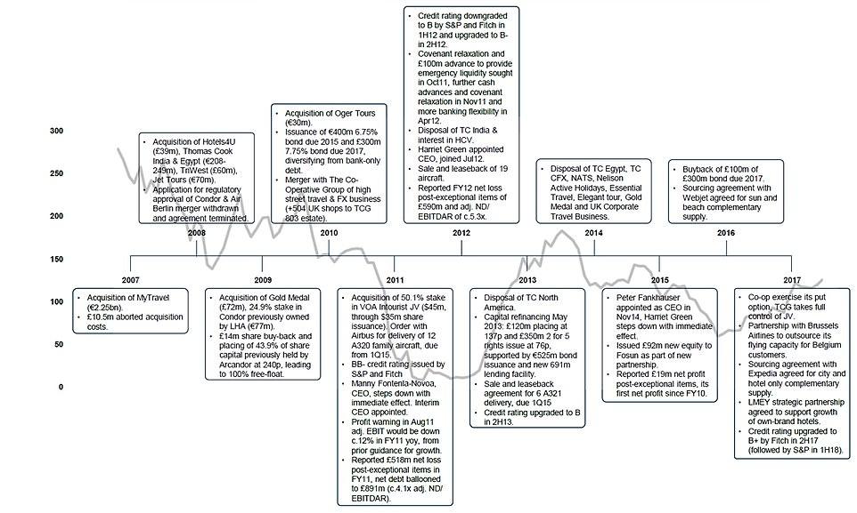
Figure 13: Thomas Cook Group’s timeline of mergers and acquisitions and major events since its formation in 2007

The company had its first profit warning in 2009. The net debt of the company raised to £804 million in 3 years from £249 million in 2007. Yet in 2010 when the company should have looked for ways to improve their online platform, they merged with the Co-operative Travel which increased the number of their retail outlets to 1,200. They expected to achieve £35 million synergies from this merger (Jacobs, 2010). Even though both companies had a wide and loyal customer base, the deterioration of retail travel industry did little to increase profit margin or reduce their debt. In 2016 Thomas Cook bought out the Co-operative for £55.8 million despite their growing debt (Collinson, 2019). Their debt reached £1.1 billion in 2011 and the company was on the verge of collapse. It only survived by borrowing more money which caused the debt to go even higher. In 2018 they received two more profit warnings within two months just before their audited results for the year was about to get published. The CEO Peter Fankhauser admitted that they experienced a larger decline in gross profit than anticipated. He called 2018 a “disappointing year” for them and blamed the heatwave for their failure for making the expected profit. The debt of the company was also a lot higher at £389 million than the prediction by City analysts which was £267 million. May 2019, the company announced that they have secured a £300 million loan from banks. Then again, they announced that in the first half of 2019 the company suffered from £1.5 billion loss, and their debt reached up to £1.7 billion (Martinez and Bunyan, 2019). Since the merger in 2007, each year Thomas Cook used a substantial amount from their income to pay for their debt (Figure 13). The total interest they paid from 2007 to 2018 is a whooping £2.06 billion.

Figure 14: Thomas Cook Airline’s cost of interest in 2011-2014

Limitations and barriers in airline industry
Thomas Cook started their airline business in early the 2000s as JMC Air. They rebranded in 2003 as Thomas Cook Airline. When MyTravel merged with Thomas Cook in 2007, their airline businesses Thomas cook airline and MyTravel Airline also merged in March 2008. They had 93 aircraft in their possession to travel to 82 destinations. Running an airline is undoubtedly costly. Cost of buying or leasing an aeroplane, hiring qualified people to fly the plane and fuel costs are the three major costs but not the only ones. There are so many other expenses like airport fees, maintenance costs, travel agent’s fees add to operational expenses. TCG had to maintain this high cost of running their airline. Even if the majority of the plane seats are empty and have not been bought, the flights still had to be operated for the passengers who had tickets. They had to suffer loss for empty seats in their trips especially during the off-peak holiday seasons (Grabianowski, 2009).

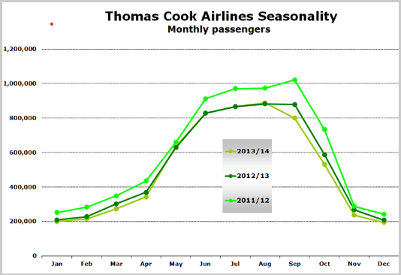
Source: UK CAA. Each year runs from September-August.
Figure 15: Thomas Cook Airline’s number of tickets sold in 2011-2014

Failure in digital transformation of the business
Online holiday booking was introduced in the late 90s and it turned into the most popular way to book holidays in the next 10 years (May, 2014). A study in 2012 shows that 80% of people use online comparison sites and holiday sites to book their holidays (Travel Weekly, 2012). When only one in seven people in the UK went to the high street travel agencies to buy a holiday, Thomas Cook was operating their business from their 560 high street outlets (The Consumer Holiday Trends Report ABTA Consumer Survey 2014). Thomas Cook’s competitors like TripAdvisor, Airbnb, easyJet, Ryanair adapted to the online system and let their customers book holidays online. This enabled them to gain cost leadership in the market. Thomas Cook on the other hand failed to take the demand and the buying power of the customers into account and did not follow the trend of their competitors.
Online business opportunities enabled the competitors to cut down costs in some areas like lower rent and lower energy bills. They also had the advantage of being flexible, people could book holidays to any destination from anywhere in the world. Holiday makers also had the flexibility to create their own itinerary via online booking. Thomas Cook missed out on these advantages of going online and also lost their popularity. Their customer group was mainly over 65 who are in lower socio-economic groups and are likely to spend less money. Their competitors were popular with the younger age groups who would go on holiday more frequently and have more money to spend.

Failure to update business model
Thomas Cook bought bulk holiday packages in advance which was highly risky as unexpected situations like terrorist attacks, changes of travel rules and regulations, changes in insurance policies, natural disasters, political instabilities etc. made selling these packages uncertain. Another trouble with their business model was that the product and service they provided was seasonal, peak-time during summer months and off-peak in the winter. They struggled to generate profit during the winter months. When traditional travel agencies started to lose business because of the internet, net profit margin started to decline (Figure 15). It went from 3.01% to 0.61% from 2007 to 2008. Tui Group, which was Thomas Cook’s chief rival in the travel industry, also ran an airline. Tui started to look for alternative ways to keep up their revenue. Tui acquired and started operating cruise ships and hotels in 2007 which provided 70% of their earnings where the tour operator and the airline only earned 30%. (www.cruise industry news.com, 2008; Sims, 2019). Thomas Cook took some steps to modernise their business model by merging with Hotels4u.com, an online business in 2008. However, in the following few years they committed to more mergers and acquisitions and failed to maintain their strategic change.
Figure 16: the graph of profit margin of TCG from 2007 to 2018

Leadership shortcoming of the CEOs
The last three CEOs of Thomas Cook before collapse may have made some leadership decisions which had huge impact on the company’s failure. Manny Fontenla-Novoa was the CEO of the company from 2003 to 2011. He like making deals (Hancock, 2019). When internet was taking over businesses in various industries, he was making deals to expand the business. Modernising the company and going online would have been a better step for the company but instead 2007 Mr Fontenla-Novoa agreed to a merger between Thomas Cook and MyTravel (Goldstein, 2019). This merger put the company on FTSE100 for the first time and was predicted to cut cost by £75m per year. Under his wings Thomas Cook merged again with Co-operative Travel in 2010. The company’s net debt was £891m and interest charges was £122m for the year Mr Fontenla-Novoa retired in 2011 (Makortoff and Davies, 2019; Drewett, 2019). In the last four years of his service as the CEO of Thomas Cook Group, he took over £17m as his pay including bonuses for cutting 2,800 jobs after the merger with MyTravel (Farmbrough, 2019a). The share price was on the decline from 2008, after 2010 merger the share price went down even more just over 1p in February 2012 (Makortoff and Davies, 2019; Drewett, 2019; Calder, 2019).
Harriet Green took over as the CEO of the company in July 2012 and resigned in November 2014. She turned the company around, and the share price went up by 680%. However, she was highly criticised for the controversial way she dealt with the case of two children’s death in Corfu (Calder, 2019). She got paid over £4.7m for just over two years and also a share bonus worth £5.6m. she also claimed £80,000 a year for her hotel bills where she used to live during the weeks in London (Farmbrough, 2019a).
The last CEO who was in charge of the company when it crumpled Peter Fankhauser was paid £8.3m including bonus £4.3m (Farmbrough, 2019a). in the last 10 years the directors gave themselves £47m. Critics thought it was unethical of the CEOs to take such big amounts of pay-outs while the company was going through struggles. Shadow chancellor of the Labour Party John McDonnell called for Thomas Cook’s CEOs to “examine their consciences” and asked them to return their bonuses (bbc.co.uk, 2019).
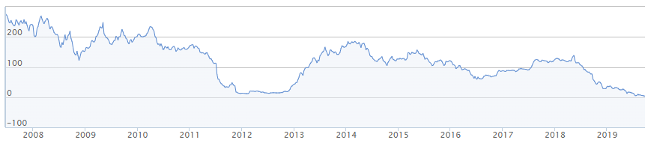
Figure 17: Graph of Thomas Cook’s share price from 2007 to 2019

Role of the government
Thomas Cook wanted £200m from the government so that the company could be saved from bankruptcy (Cook, 2019). But the British government refused to provide any financial support (Coppola, 2019). The PM said that the government does not want to spend tax-payers money to save the business. He was also concerned that the directors of the company were not motivated to sort matters out by themselves (Quinn and Walker, 2019).
After the fall of the company the government called for an investigation as the PM questioned whether it was ethical for the bosses to pay themselves large bonuses while the business was going “down the tubes” (Makortoff and Davies, 2019). Manny Fontenla-Novoa and Harriet Green were called in the parliament to be questioned by the MPs. Fontenla-Novoa refused to take responsibility got the failure of the company, he said that when he left the company the debt was not unmanageable. He also said that the mergers during his time made the company’s finance strong for future growth. Ms Green told in the hearing that she “inherited a huge wall of debt”. The last CEO also blamed the company’s debt for its collapse. He said his “hands were tied” and the debt made his job “impossible”. The three of them avoided taking any responsibility, rather they blamed each other for the failure of the company (bbc.co.uk, 2019).
The government arranged for the 150,000 British holiday makers to come home; it was part of a rescue effort called Operation Matterhorn (Goldstein, 2019). 45 jets were chartered for the operation and according to CAA (Civil Aviation Authority) the cost was £100m.

Brexit
Due to the uncertainty of Brexit, a large number of holiday makers restrained from booking holidays in 2018 and 2019. Thomas Cook announced a huge loss of £1.5 billion and blamed Brexit for this loss (Martinez and Bunyan, 2019). However, other travel agencies including Tui was affected by Brexit, still managed to survive through that struggling period.

Corporate governance
When the collapse was investigated, fingers were pointing towards the corporate governance of Thomas Cook (Calder, 2019a). It was proved how incompetent corporate governance system can be in the UK. Questions were asked whether the board members had the company’s best interest at heart. Labour MP Rachel Reeves were the chairperson of the inquiry committee. She called the fall of Thomas Cook “a sorry tale of corporate greed”.
The CEO of the company admitted in the high court witness statement that the balance sheet of the company had a deficit of £3.1 billion. The company debt to the banks was £1.7 billion and £1.3 billion to the suppliers (Calder, 2019). When the financial structure of the company was weak and in the verge of collapsing, the corporate governance did not try to strengthen it, instead in 2017 shareholders cast 78% votes to approve the company’s remuneration policy which deliver high pay-outs.
In 2016, Thomas Cook announced that it would give dividend for the first time in 5 years (Monaghan, 2016). It was surprising as the company was making loss at that time so the dividend pay would be another cost which will add on to the debt (Walsh, 2016). In 2017 the company paid £8m and £9m in 2018 as dividend payment. These payment amounts are set by the board of directors usually to distribute corporate profit among the eligible shareholders. In this case it was done to portray a positive image of the company’s financial situation so that the share price would not decline further (Figure 17).

Figure 18: Thomas Cook’s basic earnings per share graph

The effects of the collapse
When a business collapses a lot of lives get affected, the bigger the company is more people’s livelihood are at stake. People who get affected first when Thomas Cook collapse are employees and customers, then shareholders and debt holders and also stakeholder and supplier.

Customers
Thomas Cook’s demise left over 600,000 people stranded in their holiday destination including 150,000 from the UK.

Employees
Over 21,000 people were jobless among them 9,000 people in the UK. The pilots, the cabin crews, the employees of the travel agencies, all these people and their families’ livelihoods were at risk (McCahill, 2019). They were not even sure whether they will get paid on the last month of their employment (Olesya Dmitracova, 2019). TCG’s rival companies like Virgin Atlantic and TUI offered jobs to the staff who were left unemployed by the collapse (Andrews, 2019).

Shareholders and debt holders
Debt was paid with assets, but shareholders did not have a share in the assets, so the share holders lost their investment when Thomas Cook collapsed.

Suppliers
The suppliers who supplied to the hotels, food suppliers to hotels and airline, other service providers like travel agencies, travel insurance companies, car hire agencies they all lost a part of their income due to the collapse of Thomas Cook. All stakeholders were financially in loss due to TCG’s bankruptcy.

Conclusion
Thomas Cook has been providing services in the world of travel and tourism for over 100 years. The company changed the way people were travelling and introduced a whole new concept of holiday packages which could include flights to destinations, accommodations at hotels, and other transportations. The irrational mergers, unethical leadership and flaws in the business model and strategy are some of the reasons why the business was drowning in debt which was growing even more every year. So, when this 178 years old tourism and hospitality company went bankrupt which led to liquidation in 2019 spectators were not surprised. Even though it was end of an era for the travel industry, it was inevitable. The competitor travel agencies had a lot to learn from the demise of Thomas Cook especially in context with managing financial resources effectively and understand shifts in the market. Before deciding to merge with a company it is essential for businesses to do extensive research to determine if the merging will be beneficial for the business or not. The study of customer behaviour is also effective to adopt and adapt to new trends in the market.

The lessons learnt/ recommendations
The liquidation of Thomas Cook placed 22,000 jobs at risk including the 9,000 in the UK and over 600,000 people stranded on their holidays overseas. UK government brought 150,000 Britons back to the UK by launching a major repatriation program. Other businesses can learn some valuable lessons from analysing the fall of this business giant Thomas Cook Group.
- CEOs need to practice ethical leadership in their businesses.
- Evaluate the business environment before investing in a new project to determine if the new project will be profitable.
- Profit warning allows a company to declare to the investors that the profit for the current quarter of the company will be significantly less than the previous year. Thomas Cook received three profit warnings, still failed to act on them.
- Business models should be updated regularly to keep up with the rivals in the industry.
- Effective financial planning is vital to ensure success for any business.
- Businesses should be cautious about piling up their debt even though debt is normally considered to be a source of cashflow. Thomas Cook had accumulated debts of over £1.7billions which ultimately led to the company’s demise despite the partnership with Fosun.
- Use WACC (weighted average cost of capital) to evaluate investments to utilise capital and identify all the loss-making sectors and close them.
- Strategies need to be evaluated regularly to make sure they do not become outdated and irrelevant for the business.
- Thomas Cook’s collapse was mainly the result of their high and growing debt for a number of years. Businesses should be cautious when it comes to increasing debt.
- Perform business environment scanning to be able to forecast challenges.

Reference list:

- "Corfu deaths firm 'breached duty'". BBC News. 13 May 2015. Retrieved 17 May 2015.
- Andrews, J. (2019). Thomas Cook rivals place job adverts only for staff left unemployed by collapse. [online] mirror. Available at: https://www.mirror.co.uk/money/thomas-cook-rivals-place-job-20163031 [Accessed 3 Apr. 2022].
- Appelbaum, S., Gandell, J., Yortis, H., Proper, S., Jobin, F., (2000). Anatomy of a merger: Behavior of organizational factors and processes throughout the pre-during – poststages (part1). Management Decision, 38(9), 645-662.
- BBC news (1972). 1972: Thomas Cook packaged and sold. news.bbc.co.uk. [online] 26 May. Available at: http://news.bbc.co.uk/onthisday/hi/dates/stories/may/26/newsid_3003000/3003665.stm [Accessed 7 Mar. 2022].
- Bose, D.C., 2011. Fundamentals of Financial management. PHI Learning Pvt. Ltd. Pp260-262
- Bowers, S. (2007). Job cuts likely as MyTravel and Thomas Cook merge. [online] the Guardian. Available at: https://www.theguardian.com/business/2007/feb/13/travel.travelnews [Accessed 26 Nov. 2020].
- Calder, S. (2019a). Thomas Cook collapse was ‘a failure of corporate finance, not travel’. The Independent. [online] 8 Oct. Available at: https://www.independent.co.uk/travel/news-and-advice/thomas-cook-collapse-travel-abta-corporate-finance-failure-mark-tanzer-a9146851.html [Accessed 9 Oct. 2019].
- Calder, S. (2019b). Thomas Cook: A timeline of the world’s oldest tour operator. The Independent. [online] 23 Sep. Available at: https://www.independent.co.uk/travel/news-and-advice/thomas-cook-bankrupt-timeline-tour-operator-travel-package-holiday-a9116836.html [Accessed 3 Apr. 2022].
- Cartwright, S., & Cooper, C.L., (1993). The psychological impact of merger and acquisition on the individual: A study of building society managers. Human Relations, 46, 327-47
- Chris Leadbeater (2019). The history of Thomas Cook, from tours for teetotallers to boozy packages in Spain. [online] The Telegraph. Available at: https://www.telegraph.co.uk/travel/tours/history-of-thomas-cook/ [Accessed 7 Mar. 2022].
- Cook, T. (2019). Thomas Cook was brought down by incompetence, not boardroom greed. [online] the Guardian. Available at: https://www.theguardian.com/business/2019/sep/29/thomas-cook-failure-incompetence-not-corporate-greed [Accessed 3 Apr. 2022].
- Coppola, F. (2019). Why The U.K. Government Was Right Not To Bail Out Thomas Cook. [online] Forbes. Available at: https://www.forbes.com/sites/francescoppola/2019/09/29/why-the-u-k-government-was-right-not-to-bail-out-thomas-cook/?sh=495764c417b9 [Accessed 3 Apr. 2022].
- Dmitracova, O. (2019). Thomas Cook is no more – what now for its 21,000 staff? Independent. [online] 23 Sep. Available at: https://www-independent-co-uk.cdn.ampproject.org/v/s/www.independent.co.uk/news/business/news/thomas-cook-news-collapse-employees-jobs-staff-latest-a9116816.html?amp_js_v=a2&_gsa=1&&usqp=mq331AQCKAE%3D#aoh=15692599232694&referrer=https%3A%2F%2Fwww.google.com&_tf=From%20%251%24s&share=https%3A%2F%2Fwww.independent.co.uk%2Fnews%2Fbusiness%2Fnews%2Fthomas-cook-news-collapse-employees-jobs-staff-latest-a9116816.html [Accessed 8 Mar. 2022].
- Drewett, Z. (2019). Thomas Cook bosses gave themselves £50,000,000 before company collapse. [online] Metro. Available at: https://metro.co.uk/2019/09/24/thomas-cook-bosses-gave-50000000-company-collapse-10796972/ [Accessed 3 Apr. 2022].
- Duffy, C. (2019). Thomas Cook collapses leaving some travelers stranded. [online] CNN. Available at: https://edition.cnn.com/2019/09/22/business/thomas-cook-collapse/index.html [Accessed 28 Mar. 2022].
- Farmbrough, H. (2019). Thomas Cook Pay Row Highlights Bigger Issue. [online] Forbes. Available at: https://www.forbes.com/sites/heatherfarmbrough/2019/09/26/thomas-cook-pay-row-highlights-bigger-issue/?sh=5cf05834968a [Accessed 2 Apr. 2022].
- Farmbrough, H. (2019). Why Debt Brought Down Thomas Cook, Not The Internet. [online] Forbes. Available at: https://www.forbes.com/sites/heatherfarmbrough/2019/09/23/why-debt-brought-down-thomas-cook-not-the-internet/?sh=39a2f2643873 [Accessed 28 Mar. 2022].
- Farmbrough, H. (2019a). Thomas Cook Pay Row Highlights Bigger Issue. [online] Forbes. Available at: https://www.forbes.com/sites/heatherfarmbrough/2019/09/26/thomas-cook-pay-row-highlights-bigger-issue/?sh=5cf05834968a [Accessed 2 Apr. 2022].
- Garcia, M. (2019). What Killed Thomas Cook? Brexit And Decline Of Package Holidays Undercut Venerable Travel Brand. [online] Forbes. Available at: https://www.forbes.com/sites/marisagarcia/2019/09/23/virgin-atlantic-steps-in-to-offer-jobs-to-displaced-thomas-cook-employees/?sh=2576d294391c [Accessed 2 Apr. 2022].
- Goldstein, M. (2019). Failure To Adapt To The Internet Cooked Thomas Cook. [online] Forbes. Available at: https://www.forbes.com/sites/michaelgoldstein/2019/09/24/did-the-internet-kill-thomas-cook-/?sh=68dfd7d154ae [Accessed 2 Apr. 2022].
- Grabianowski, E. (2009). How Budget Airlines Work. [online] HowStuffWorks. Available at: https://money.howstuffworks.com/personal-finance/budgeting/budget-airline1.htm#:~:text=Running%20an%20airline%20is%20unavoidably [Accessed 27 Mar. 2022].
- Hancock, A. (2019). Subscribe to read | Financial Times. [online] www.ft.com. Available at: https://www.ft.com/content/1b1abb78-e089-11e9-9743-db5a370481bc [Accessed 12 Feb. 2020].
- Hovers, J., (1971). Expansion through Acquisition. London, England: Business Books.
- Jacobs, R. (2010). Thomas Cook and Co-op merge travel businesses. [online] Financial Times. Available at: https://www.ft.com/content/5bd4403e-d2a7-11df-9166-00144feabdc0 [Accessed 26 Mar. 2022].
- Jillian Ambrose (6 December 2016). "Thomas Cook to take over Co-op travel stores". The Telegraph.
- Keeley, A. (2019). Thomas Cook: A 178-year history. [online] Travel Weekly. Available at: https://travelweekly.co.uk/articles/343501/thomas-cook-a-178-year-history [Accessed 28 Sep. 2021].
- Lavender, J. (2019). Thomas Cook’s timeline to disaster - how Brexit and heatwave caused collapse. [online] mirror. Available at: https://www.mirror.co.uk/news/uk-news/thomas-cooks-timeline-triumph-tragedy-20149097 [Accessed 23 Jan. 2021].
- Martinez, G. and Bunyan, R. (2019). This American Said He Had to Pay $2,400 to Get Home After Travel Company Thomas Cook Collapsed. [online] Time. Available at: https://time.com/5683934/thomas-cook-travel-collapse/ [Accessed 9 Mar. 2022].
- Martinez, G. and Bunyan, R. (2019). This American Said He Had to Pay $2,400 to Get Home After Travel Company Thomas Cook Collapsed. [online] Time. Available at: https://time.com/5683934/thomas-cook-travel-collapse/ [Accessed 2 Apr. 2022].
- May, K. (2014). How 25 years of the web inspired the travel revolution. [online] the Guardian. Available at: https://www.theguardian.com/travel/2014/mar/12/how-25-years-of-the-web-inspired-travel-revolution [Accessed 26 Mar. 2022].
- McCahill, E. (2019). Sobbing Thomas Cook staff leave HQ in tears as 9,000 UK workers lose their jobs. [online] mirror. Available at: https://www.mirror.co.uk/news/uk-news/sobbing-thomas-cook-staff-leave-20155852 [Accessed 3 Apr. 2022].
- Monaghan, A. (2016). Thomas Cook resumes dividend despite fall in profits. [online] the Guardian. Available at: https://www.theguardian.com/business/2016/nov/23/thomas-cook-dividend-profits-pound-brexit [Accessed 3 Apr. 2022].
- Monaghan, A. (2018). Thomas Cook in new profits warning after “disappointing” year. [online] the Guardian. Available at: https://www.theguardian.com/business/2018/nov/27/thomas-cook-profits-warning-shares#:~:text=Shares%20in%20Thomas%20Cook%20plunged [Accessed 26 Nov. 2021].
- Olesya Dmitracova (2019). Thomas Cook is no more – what now for its 21,000 staff? The Independent. [online] 23 Sep. Available at: https://www.independent.co.uk/news/business/news/thomas-cook-news-collapse-employees-jobs-staff-latest-a9116816.html [Accessed 3 Apr. 2022].
- Quinn, B. and Walker, P. (2019). Row breaks out over government’s refusal to rescue Thomas Cook. [online] the Guardian. Available at: https://www.theguardian.com/business/2019/sep/23/row-breaks-out-government-refusal-rescue-thomas-cook [Accessed 3 Apr. 2022].
- Segal, D. (2019). What Killed Thomas Cook, One of the Oldest Names in Travel? The New York Times. [online] 24 Sep. Available at: https://www.nytimes.com/2019/09/24/business/thomas-cook-airlines-bankruptcy.html [Accessed 28 Mar. 2022].
- Simon Gwynn (6 December 2016). "Co-operative Travel to disappear from high street as Thomas Cook confirms full takeover". Campaign. Retrieved 13 November 2017.
- Sims, S. (2019). How Could Travel Giant Thomas Cook Fail? The New York Times. [online] 23 Sep. Available at: https://www.nytimes.com/2019/09/23/travel/why-thomas-cook-travel-collapsed.html [Accessed 27 Mar. 2022].
- Steger, U. and Kummer, C., (2007). Why merger and acquisition (M & A) waves reoccur: The vicious circle from pressure to failure. Lausanne, Switzerland: IMD.
- Stevenson, T. (2012). Lessons to be learnt from rampant inflation of the 70s. [online] www.telegraph.co.uk. Available at: https://www.telegraph.co.uk/finance/comment/tom-stevenson/9076261/Lessons-to-be-learnt-from-rampant-inflation-of-the-70s.html [Accessed 8 Mar. 2022].
- The Consumer Holiday Trends Report ABTA Consumer Survey 2014. (2014). [online] p.7. Available at: https://www.abta.com/sites/default/files/media/document/uploads/The%20Consumer%20Holiday%20Trends%20Report%202014.pdf [Accessed 26 Mar. 2022].
- Travel Weekly. (2012). 80% booking holidays online, finds study. [online] Available at: https://travelweekly.co.uk/articles/41280/80-booking-holidays-online-finds-study [Accessed 26 Mar. 2022].
- Trend, Nick (4 February 2016). "Corfu carbon monoxide tragedy: Can we trust tour operators with our safety?". The Daily Telegraph. Retrieved 17 May 2015.
- UȚĂ, I.-C. (2020). 5 reasons for the failure of Thomas Cook, the world’s first travel agency. [online] Brand Minds. Available at: https://brandminds.live/5-reasons-for-the-failure-of-thomas-cook-the-worlds-first-travel-agency/ [Accessed 3 Apr. 2022].
- Walsh, D. (2016). Thomas Cook to pay first dividend in five years. www.thetimes.co.uk. [online] 23 Nov. Available at: https://www.thetimes.co.uk/article/thomas-cook-to-pay-first-dividend-in-five-years-zghrj88v5 [Accessed 3 Apr. 2022].
- Walsh, D. (2019). Aircraft owner takes back its jets from Thomas Cook. www.thetimes.co.uk. [online] 5 Oct. Available at: https://www.thetimes.co.uk/article/aircraft-owner-takes-back-its-jets-from-thomas-cook-3mhzt6bpc [Accessed 3 Apr. 2022].
- Willman, J. (2008). Thomas Cook buys Hotels4U for £22m. [online] Financial Times. Available at: https://www.ft.com/content/67ad52c4-dacf-11dc-9fdd-0000779fd2ac [Accessed 26 Mar. 2022].
- www.annualreports.com. Thomas Cook Group plc - AnnualReports.com. [online] Available at: https://www.annualreports.com/Company/thomas-cook-group-plc.

Appendix
Appendix 1 horizontal analysis Income statement of TCG
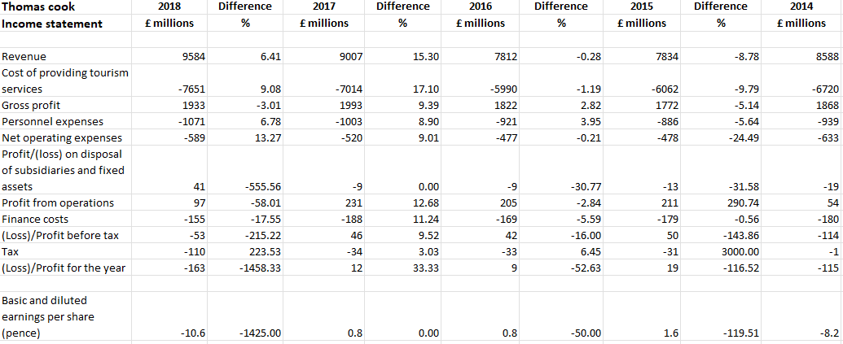

Appendix 2 balance sheet of TCG

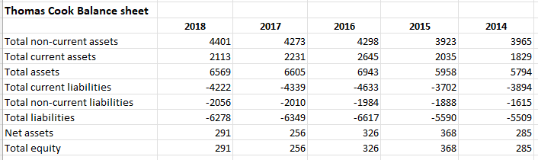
Appendix 3 horizontal analysis of balance sheet of TCG

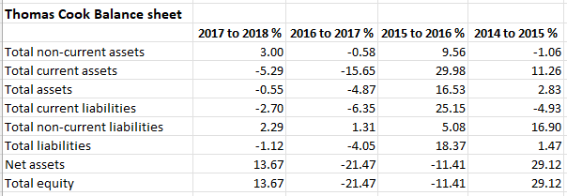

Appendix 4 Horizontal analysis Income statement of TCG

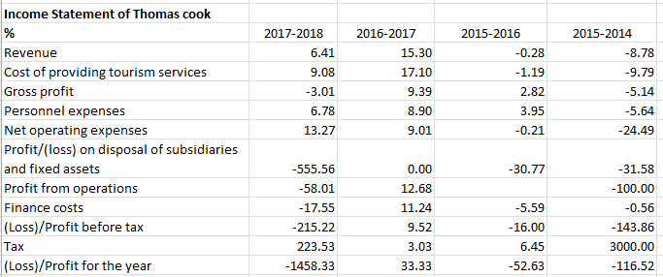
Appendix 5 Income statement of TCG

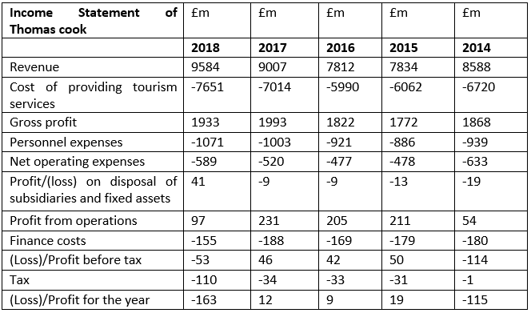

Appendix 6 Income statement of TCG

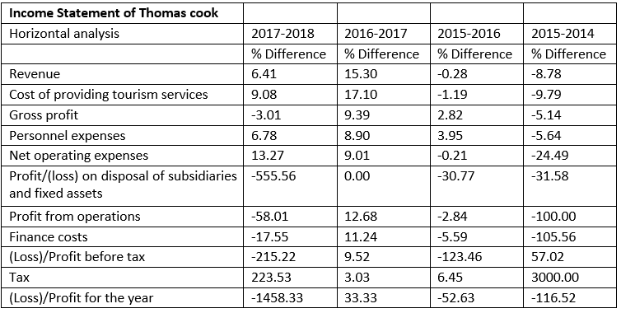
Appendix 7 Balance sheet of TCG

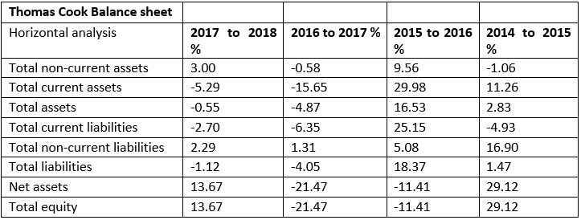

Appendix 1 Balance sheet of TUI



