

CERTHE BUSINESS SKILLS
FOR THE WORKPLACE

ENTERPRISE AND ENTREPRENEURSHIP

LECTURER: Mrs Taonga Kaonga Sobre-Smithers

MODULE CODE: LCLM 4006

TASK 1:
BUSINESS PROPOSAL FOR THE DEVELOPMENT OF AN INNOVATIVE SPECIALIST ALTERNATIVE PROVISION BASED IN BIRMINGHAM

By Tesenai Bertram
24070997

Table of Contents

- Overview of the Business Idea
- Executive Summary
- Product & Services Offered
- Legal Format & Management Structure
- Environmental Analysis
- PESTEL
- SWOT
- Academic & Business Strategy
- Marketing Strategies
- Target Market
- End User Profile
- Positioning & Branding
- Preparation, Transition, and Follow-Up
- Marketing Approach: Value-Centric Digital Strategy
- Technology and Platforms to Attract Customers
- Funding Requirements and Sources
- Pricing & Growth Strategy
- Startup Expenses
- Cash Flow
- References
- Abbreviation/Acronym Full Term / Definition

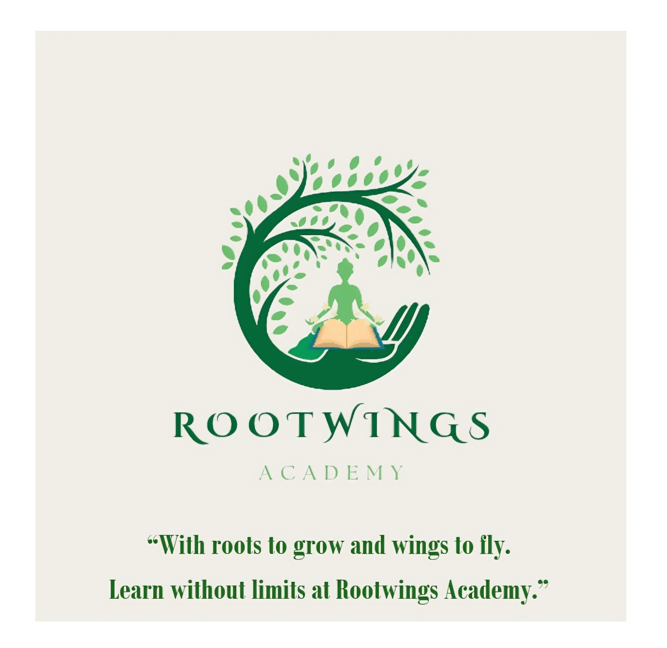

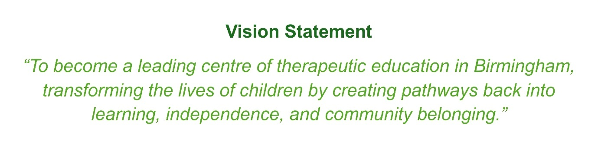

Executive Summary
Rootwings Academy is a proposed alternative provision for children aged 5–11 in Birmingham who face challenges in mainstream education due to special educational needs, sensory issues, or trauma. Our mission is to create a nurturing, therapeutic, and academically focused environment that promotes emotional regulation and positive self-identity while encouraging an "I Can Too" mindset. We aim to reintegrate children into mainstream education through a unique multi-therapy approach. This business plan outlines our strategy to address a growing need in Birmingham's educational landscape with an innovative, evidence-based solution.

1. Overview of the Business Idea
Product and Service Offered
Rootwings Academy will offer a full-time, commissioned day-school placement for up to 35 primary-aged pupils. Our service is a departure from traditional AP models, which often replicate the negative cycles of mainstream schooling. Instead, our curriculum is a fusion of the national curriculum and five core therapeutic modalities:
1. Music Therapy: Used to enhance emotional expression, improve communication, and aid in behaviour regulation, particularly for children with high sensory needs.
2. Art Therapy: Provides a safe, non-verbal outlet for children to process trauma and complex emotions, fostering creativity and reducing anxiety.
3. Animal-Assisted Interventions: Our on-site program will use trained therapy animals to encourage empathy, nurture responsibility, and promote calmness in children with high levels of anxiety.
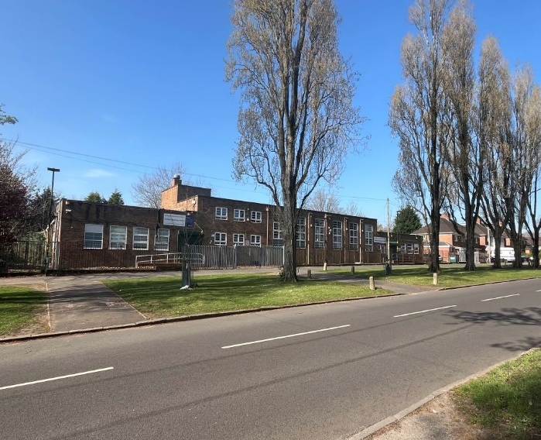
4. Movement Therapy: Through structured dance, yoga, and sensory integration exercises, we will help children develop body awareness, improve physical regulation, and release physiological stress.
5. Outdoor Learning: We will use forest school methods and gardening to foster resilience, teamwork, and independence.
The Academy’s primary objective is to reintegrate children into mainstream education where possible or otherwise prepare them for lifelong learning and independence. We will work in close partnership with local schools, Birmingham City Council, health services, and parents/carers.
Rootwings Academy will be based at the former Trittiford Learning Centre in Moseley (109–111 Trittiford Road, Birmingham), a facility currently available for purchase (guide price £500,000+). This site provides ready-made education spaces, secure grounds, and scope for outdoor/animal-based learning. Acquisition ensures long-term stability and a strong community presence (Bond Wolfe, 2024).

Legal Format and Management Structure
Rootwings Academy will be registered as a Community Interest Company (CIC) limited by guarantee. This structure balances business sustainability with a social mission. The asset lock means all profits are reinvested to benefit students, helping attract ethical investment and public funding (Community Interest Company Regulator, 2025)

As a Special Educational Needs (SEN) academy with integrated therapy services, Rootwings Academy operates in a monopolistic competition market. It offers a unique service but competes with other schools for students.

Our management structure is designed to be lean and expert-led from the outset:
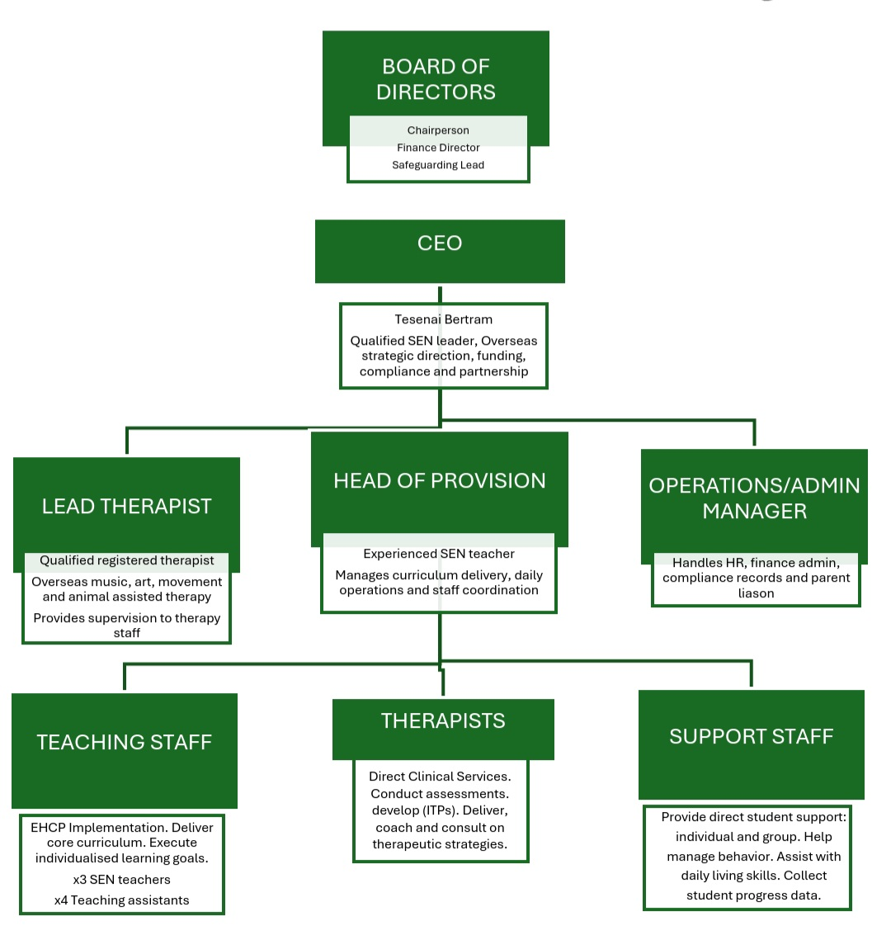

3. Environmental Analysis
PESTEL Analysis

Political: The Birmingham City Council SEND Strategy 2023-2028 explicitly prioritises high-quality local provision to reduce its reliance on costly out-of-city placements. The DfE's SEND Review (2022) and the Education Act (1996) focus on improving outcomes for children with SEND, providing a clear legal and political mandate for the commissioning of our service.

Economic: Despite public sector funding pressures, the High Needs Block, Pupil Premium, and Education, Health, and Care Plan (EHCP) budgets remain key funding streams. Funding sources may need to be blended to cover initial costs. Investing in early, effective AP represents a long-term cost-saving measure for LAs, as the cost of permanent exclusion and long-term disengagement is significantly higher.

Social: Demand for trauma-informed education is at an all-time high. The DfE (2024) reports that over 1.7 million pupils in England have been identified as having SEN. Furthermore, the rate of permanent exclusions in Birmingham primary schools is higher than the national average (Birmingham City Council 2024), highlighting a critical social need for our intervention. Families increasingly expect personalised, holistic, child-centred provision rather than traditional classroom-based models. Focus on reintegration into mainstream settings aligns with societal goals of inclusion and equal opportunity.

Technological: We will leverage technology for digital safeguarding, administrative efficiency (e.g., progress tracking systems) and as an assistive tool for learning. This includes speech-to-text apps and remote hybrid models such as online platforms for art and music, which will also enable us to create comprehensive digital portfolios for pupils. Technological motoring tools will widen our reach and strengthen evidence for investors and commissioners.

Environmental: Outdoor learning is a core part of our curriculum. Birmingham’s designation as a ‘Nature City’ (Birmingham City Council, 2025), with its extensive green spaces and recent focus on sustainability, aligns perfectly with our ethos. We will promote animal care, eco-projects, and transportation solutions for those with mobility or sensory needs and use our proximity to Trittiford Park as a Unique Selling Point. Local councils support eco-education and may provide partnerships or funding for outdoor and nature projects to improve wellbeing and mental health.

Legal: We must comply with rigorous legal and regulatory frameworks, most notably Ofsted's Education Inspection Framework, the Children and Families Act (2014), and the SEND Code of Practice (2015). The Education Act (1996) mandates LAs to arrange suitable alternative education for excluded children, guaranteeing a market for commissioned places. We will also need to meet strict safeguarding and health and safety protocols for our children, especially for our animal-assisted and outdoor programs. The CIC structure aligns with ethical investment and social mission funding criteria.
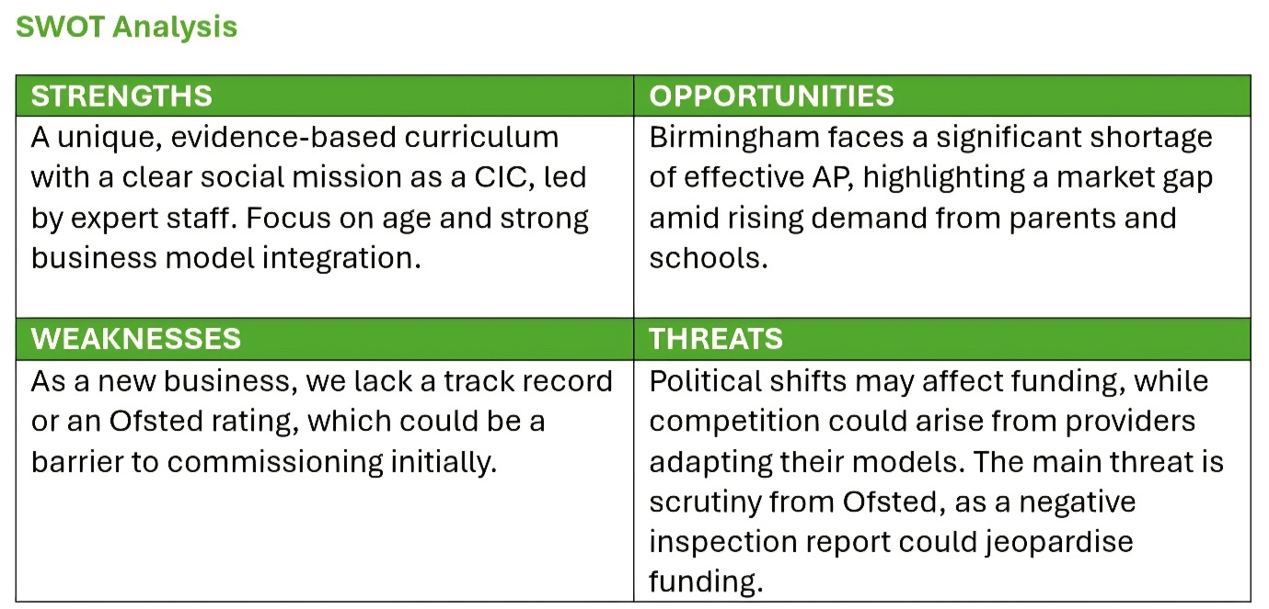
(Ofstead, 2025)

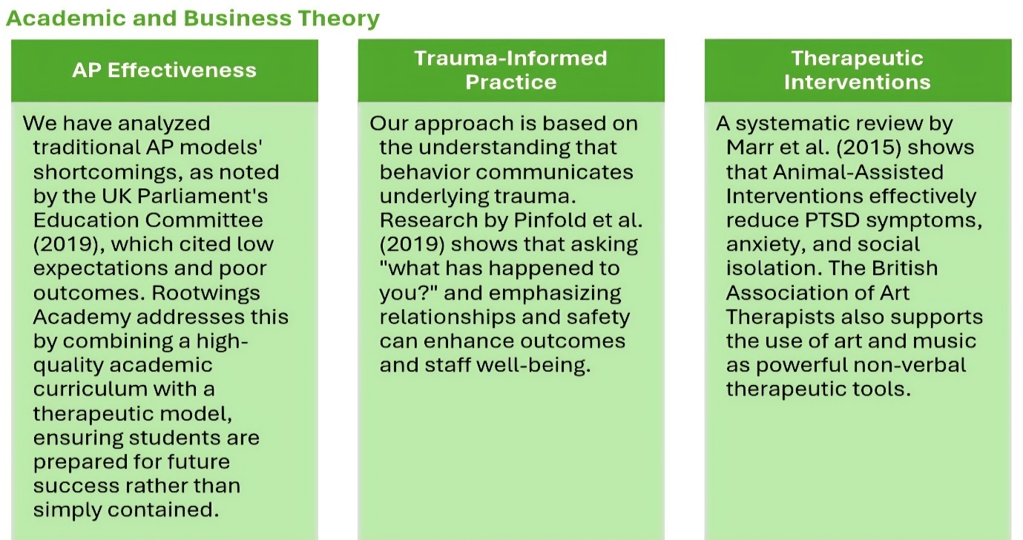
Business Theory
We have used Porter's Five Forces to analyse Rootwings Academy's market position, as a social enterprise, balancing commercial sustainability with a core social purpose (Porter,1985). This will assess the competitive intensity and attractiveness of the AP market in Birmingham and help determine our long-term profitability and strategic positioning:
Threat of New Entrants: LOW. The high startup costs and rigorous regulatory requirements create significant barriers.
Bargaining Power of Buyers: HIGH. Birmingham City Council, as our primary buyer, has strong bargaining power. Our mitigation is to provide a uniquely effective and difficult-to-replicate service, creating strong loyalty through proven results which generalist PRUs cannot.
Bargaining Power of Suppliers: LOW. Most equipment is commoditised. The key "supplier" is our highly skilled staff, but we will mitigate this risk by offering a compelling mission-led work environment. This attracts and retains staff based on purpose, not just salary. Premises suitability gives landowners moderate power over lease terms.
Threat of Substitutes: MEDIUM. Mainstream schools typically handle behaviour internally, but our specialised therapeutic model provides a superior service for vulnerable children. While cheaper alternatives like non-registered provisions or online AP exist, Rootwings offers in-class support in a PRU provision.
Competitive Rivalry: LOW. Our competition is one local PRU, City of Birmingham Schools, which currently only has one premises for children aged 5-11. Our niche—a primary, therapeutic focus—differentiates us.

3. Marketing Strategies
Target Market
Primary: Local Authorities (Birmingham City Council) commissioning places for children with EHCPs or those who have been excluded.
Secondary: Local mainstream primary schools requiring part-time therapeutic placements for at-risk pupils.
Tertiary: Parents/ carers seeking private SEN support or therapy-led alternative education.
End User Profile
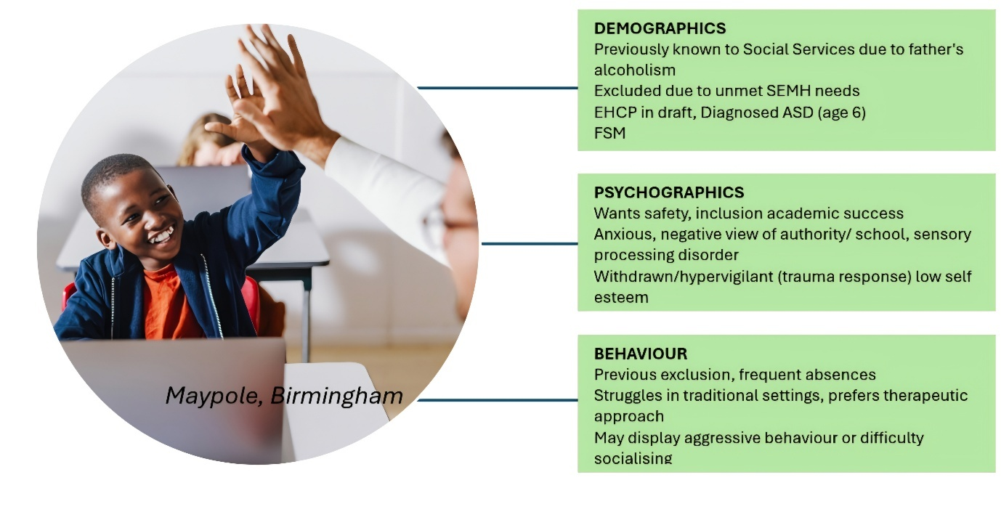
MALACHI BROWN, 7
Maypole, Birmingham

(Microsoft Word Photo, 2025)
Positioning and Branding

Rootwings Academy will brand itself as a therapeutic reintegration pathway, distinct from other APs by its emphasis on multi-therapy approaches. Our logo features roots (for stability and nurturing) and wings (for growth and independence).
Our slogan: “Roots to grow and wings to fly. Learn without limits at Rootwings Academy.”
Roots to Grow — building strong foundations in knowledge, values, and skills.
Wings to Fly — empowering learners to explore, achieve, and reach their full potential.
Learn Without Limits — emphasising freedom, curiosity, and lifelong learning.

The Reintegration Pathway: From Therapeutic Care to Mainstream Success
Rootwings Academy views reintegration not as an endpoint, but as a carefully managed transition supported by evidence-based steps. Our process begins once a student demonstrates consistent emotional regulation and academic readiness. The pathway involves three phases over a nine-month period.

Preparation, Transition, and Follow-Up
Preparation (Rootwings Academy): The student's academic timetable is gradually modified to increase focus on core subjects, while a bespoke Reintegration Portfolio detailing their unique sensory needs, triggers, and therapeutic coping strategies is created.
Transition (Partner School): We facilitate a staged transition, starting with half-day placements or attending non-core classes (e.g., PE, Art) at the receiving mainstream school. This is supported by a Rootwings Mentor Handover—a dedicated academy staff member who conducts on-site check-ins for the first month and trains the receiving school’s SENCO and key staff on the student’s specific portfolio.
Follow-Up (6-Month Support): To ensure sustained success and prevent relapse, we provide a 6-month post-placement follow-up service, including quarterly reviews with the student, parents/carers, and the receiving school. This guarantee of sustained support provides maximum confidence to commissioners and ensures the LA achieves long-term cost savings by reducing the risk of a second exclusion.
Marketing Approach: Value-Centric Digital Strategy
The marketing approach for Rootwings Academy will be a digitally driven, strategy focused on showcasing our unique educational proposition, exploiting our Business to Government direct market. Our core marketing message will focus on the transformation and results our students achieve, positioning Rootwings Academy as the key to unlocking their potential. The strategy will include:
Local Authority Engagement: Make direct presentations to SEN panels, Birmingham Education Partnership, and local Headteacher associations. Build strong links with Birmingham City Council, SEN coordinators (SENCOs), and local healthcare providers.
Schools and SENCO Networks: Direct outreach, CPD presentations, workshops and taster sessions for teachers on trauma and sensory needs. Develop referral pipelines from schools and pupil referral units (PRUs).
Content Marketing & SEO: Create and distribute high-value educational content (e.g., “5 Study Habits of Top-Scoring Students,” “Guide to Choosing the Right Career Path”) to attract our target audience (students and their parents) through search engines. We will focus on keywords related to the courses and outcomes we offer.
Social Proof and Testimonials: Feature success stories, student and parent video testimonials, and measurable academic improvements across all platforms to build trust and credibility.
Targeted Digital Advertising: Use platforms like Google Ads and social media advertising (Facebook, Instagram, YouTube) to precisely target parents and students based on demographics, interests (education, test prep, specific subjects), and location.
We will also create professional brochures containing key information and a GDBR-compliant website with sections for Commissioners, Referrers, and Parents.
To reduce parental costs and promote our academy, each student will receive promotional packs, a full uniform, stationery, a bag, and a water bottle.
Technology and Platforms to Attract Customers
The internet and mobile devices are critical, as they allow for continuous, personalised engagement with both students and parents.
Mobile-Optimised Website & Landing Pages: This is the primary hub for all information (curriculum, results, enrolment). It must be fast, secure, and fully responsive on all mobile devices. A professional, easy-to-navigate site ensures a seamless experience for busy parents and tech-savvy students. Social Media (Instagram, TikTok, YouTube) with engaging videos showcasing “day in the life,” classroom energy, and quick educational tips.
YouTube: Longer-form content like recorded webinars, faculty interviews, and successful alumni spotlights. Meets the audience where they spend their time. Engaging video content goes viral easily, builds a community, and humanises the brand, making it relatable to students.
Google My Business (GMB) & Local SEO: Optimising our GMB profile with accurate hours, photos, and actively responding to parent reviews. Ensure Rootwings Academy appears prominently on Google Maps and local search results when parents search for “academy near me.” High ratings and responsive management build instant trust.
Email Marketing & Mobile Messaging: Collect contact information via website sign-ups (e.g., “Download a Free E-book”) and send targeted, mobile-friendly newsletters with course updates and study tips. Email and messaging (e.g., WhatsApp Business for quick queries) keep the academy top-of-mind and provide consistent value.
Virtual Open Houses & Webinars (e.g., Zoom/Google Meet): Host live online sessions for parents to meet the teachers, review the curriculum, and ask questions without having to physically visit the premises. Lowers the barrier for initial engagement. Parents can attend from anywhere on their mobile device, experiencing the quality of the teaching and addressing their concerns in real-time

4. Funding Requirements and Sources
Our initial startup capital is £150,000, to be sourced from a combination of:
- Grants
- Impact Investment
- Corporate Social Responsibility (CSR)
- Local Authority Commissioning (ongoing)
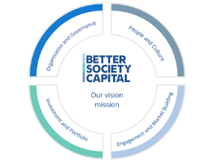




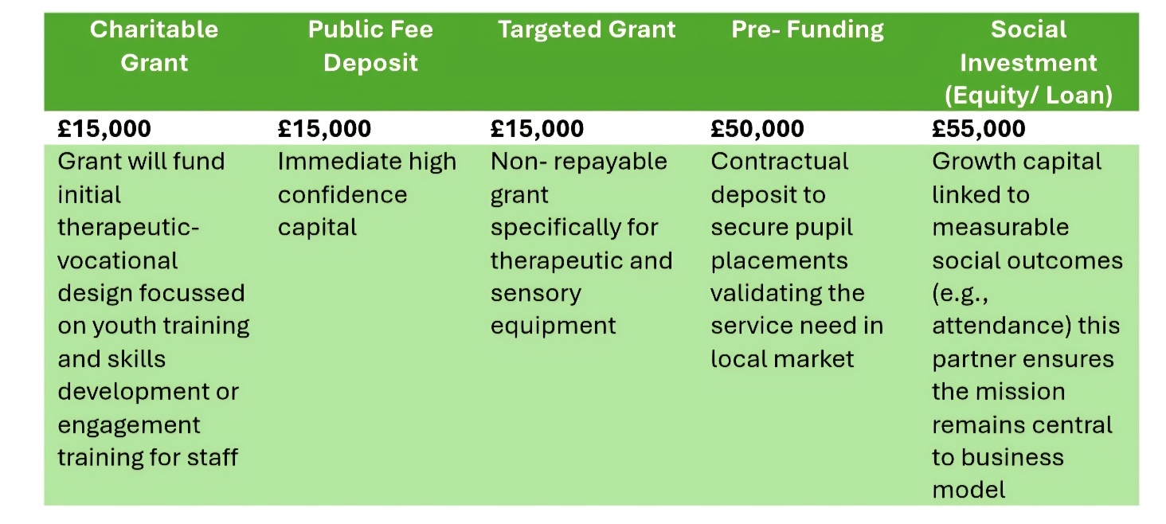

Pricing and Growth Strategy
We will price our council-funded placements at approximately £350–£450 per pupil per week, in line with local benchmarks. We will aim for a Breakeven Point of 15 pupils to cover all fixed costs.
- Year 1: Establish the provision at Trittiford Learning Centre with an intake of 15 pupils.
- Year 2: Expand to 25- 30 pupils with extended therapy services.
- Year 3: Replicate the model in another Birmingham site to meet growing demand.

5. Startup Expenses
The £102,000 in Month 1 expenses identified in the cash flow represent immediate funding requirements, with the remaining £48,00 serving as a working capital reserve. This will cover operating costs in subsequent months before the flow of pupil fees stabilises.
The initial funding is dedicated to securing the premises, acquiring essential equipment, and assembling the core senior team. The expenses are structured to rapidly prepare the academy for operation and LA inspection.
The 3 main strategic areas where the startup expenses will be used are:
- Fixed Asset & Premises Set up (44% of Total)- £48,000
- Equipment Purchase/ Leasing £30,000
- Rent Costs £15,000
- Utilities/ Insurance £3000
- Human Resources & Professional Fees (41% of Total)- £47,500
- Staff Wages £25,000
- Legal Fees £10,000
- Recruitment Fees £7500
- CEO Wages £5000
- Operational & Administration (15% of Total)- £6500
- Marketing & Advertising £2500
- Licensing/ Permits £2000
- Postage, Printing, Stationery £1500
- Telephone & Internet £500

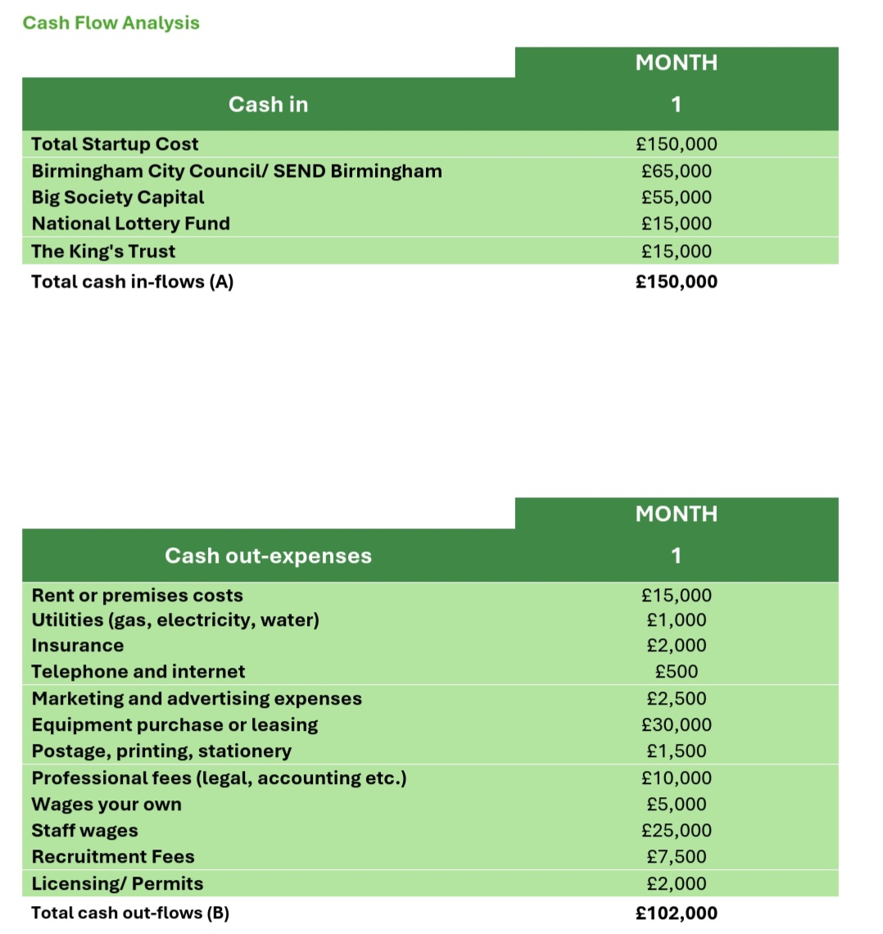

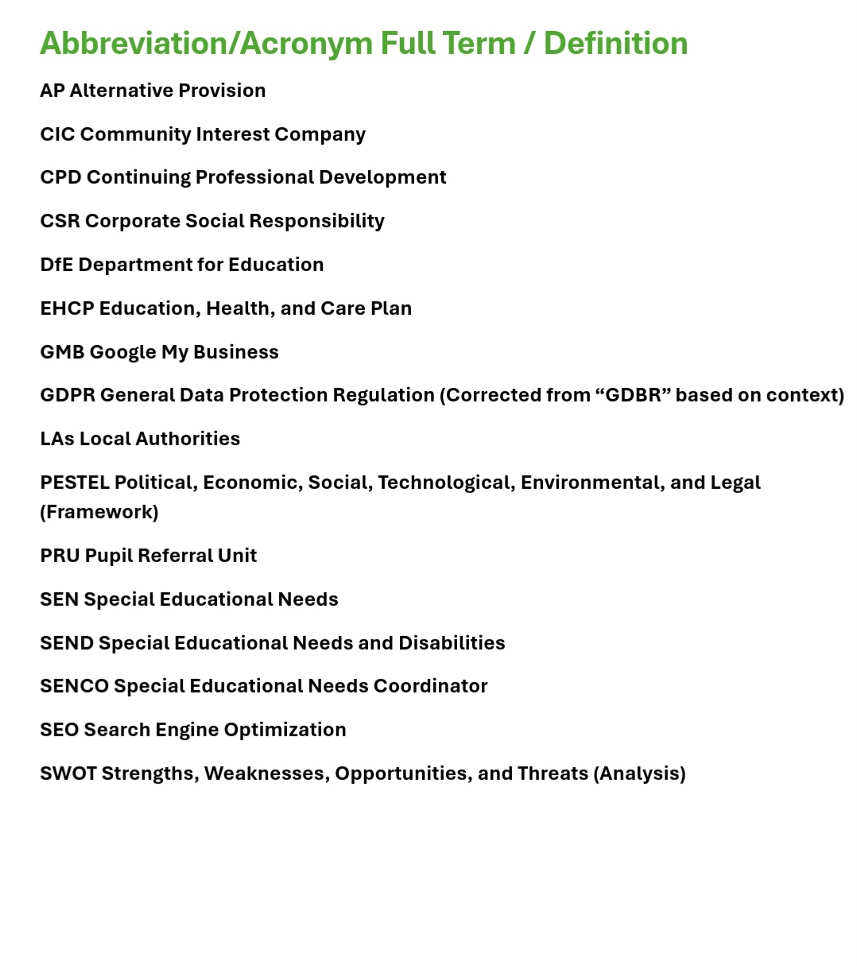

6. References

Adobe Stock (2025) Example Organisational Chart [Online image]. Available at: https://stock.adobe.com/image/12345 (Accessed: 10 October 2025).

Birmingham City Council (2023) Birmingham SEND Strategy 2023–2028. Available at:https://www.birmingham.gov.uk/download/downloads/id/14179/send_strategy_2023_to_2028.pdf (Accessed: 12 October 2025).

Birmingham City Council (2024) Report to Education, Children and Young People Overview and Scrutiny Committee (2024). Available at: [Birmingham CMIS.uk.com] (Accessed: 10 October 2025).
Birmingham City Council (2023) Local Offer for Special Educational Needs and Disabilities. Birmingham City Council.
Children and Families Act 2014. London: The Stationery Office. Available at: https://www.legislation.gov.uk/ukpga/2014/6/contents (Accessed: 10 October 2025).

Community Interest Company Regulator (2025) Community Interest Companies Guidance. Available at: https://www.gov.uk/government/publications/community-interest-companies-how-to-form-a-cic/community-interest-companies-guidance-chapters (Accessed: 26 October 2025).
Case, C. (2025) Birmingham Has Been Named The UK's Very First 'Nature City'. Secret Birmingham. Available at: https://secretbirmingham.com/birmingham-first-nature-city-25-year/ (Accessed: 20 October 2025).

Department for Education (DfE) (2025a) Special educational needs in England, Academic year 2024/25. Available at: https://explore-education-statistics.service.gov.uk/find-statistics/special-educational-needs-in-england/2024-25 (Accessed: 13 October 2025).

Department for Education (DfE) (2025b) Suspensions and permanent exclusions in England, Academic year 2023/24. Available at: https://explore-education-statistics.service.gov.uk/find-statistics/suspensions-and-permanent-exclusions-in-england/2023-24 (Accessed: 12 October 2025).

Department for Education and Department of Health and Social Care (DfE and DHSC) (2024) SEND code of practice: 0 to 25 years. Available at: https://www.gov.uk/government/publications/send-code-of-practice-0-to-25 (Accessed: 26 October 2025).

Education Act 1996. London: The Stationery Office. (Specifically Section 19 duty). Available at: https://www.legislation.gov.uk/ukpga/1996/56/section/19 (Accessed: 26 October 2025).
Marr, C. A. (2015) Animal-Assisted Intervention for Trauma: A Systematic Literature Review. Journal of Clinical Psychology.
Ofsted (2025) Education inspection framework. Available at: https://www.gov.uk/government/publications/education-inspection-framework/education-inspection-framework-for-september-2023 (Accessed: 26 October 2025).
Ofsted (2023) Alternative Provision: Effective Practice and Challenges. Ofsted.
Pinfold, J. (2019) An Evaluation of a Whole-School Trauma-Informed Training Intervention Among Post-Primary School Personnel. Children and Youth Services Review.
Porter, M. E. (1980) Competitive Strategy: Techniques for Analysing Industries and Competitors. Free Press.
Shutterstock (2025) Diverse group of primary school children smiling [Online image]. Available at: https://www.shutterstock.com/image/67890 (Accessed: 17 October 2025).
UK Parliament (2019) Alternative Provision. House of Commons Report.

