ECEY5005 Portfolio

Awe and Wonder: Science, Mathematics, and the Outdoors
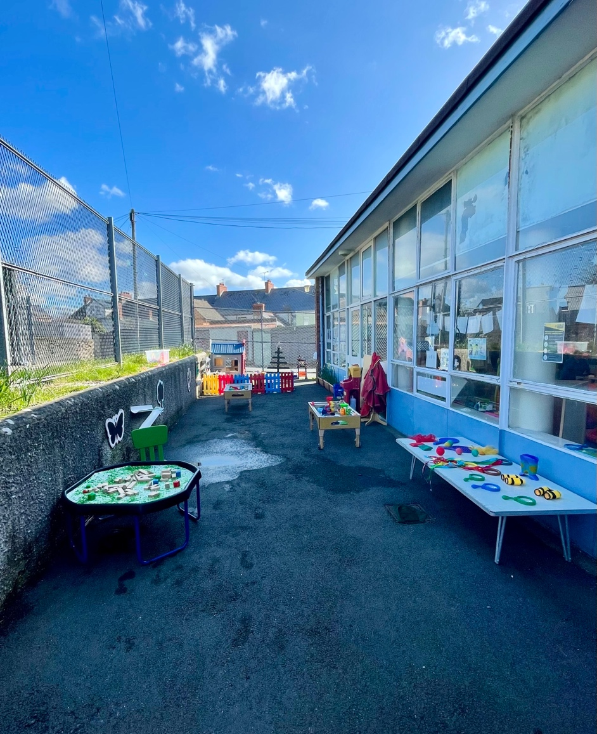

Part 1 [source: personal image]

Part 2
- Water and Sand Tray
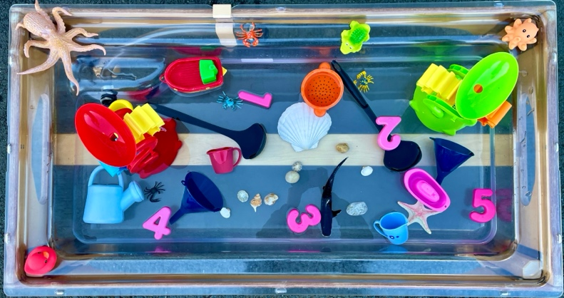
[source: Personal Image]
Water tray activities in the setting can enhance science and maths in the outdoor environment as Drake (2009: 30) asserts natural materials such as sponges, pebbles, pinecones, driftwood, and twigs can also be incorporated as Moorhouse (2020: 1) acknowledges authentic experiences allow children to ask questions about the world creating opportunities to support curiosity, exploration, investigation and make connections to the wonder of nature in their play. Sand tray activities in the setting can deliver opportunities for investigating the properties of sand, as Smith et al. (2012: PAGE) points out, sand can teach children how wet sand sticks together and can be moulded, whereas dry sand does not stick and can be poured.

To aid children’s learning, Drake (2009:31) suggests adults should support children to count the objects and talk about sizes of pebbles, sticks, sponges and jugs, and discuss cause and effect, which is defined as spontaneous play where a child discovers that actions they initiate can have certain effects (Witty, 2018), for example, children can be asked “what will happen if we put a pebble into this jug of water?” or “what will happen if we pour water over the sand?’ (To promote communication and mathematical concepts) and once the child acknowledges pebbles don’t float, they can compare objects that do float which can help children understand float and sink concepts (Drake, 2009).

Scientifically, water can help children use their senses to investigate water, such as hot/cold and observe how objects behave in water. Water can help children make predictions and ask questions about how things work in the water and why (water wheels, floating and sinking). Mathematically, children can compare the quantity of water in different containers by pouring from one to another and incorporate mathematical language in their play, such as full/empty, more/less, heavy/light talk about the size and shape of containers (Early Years Interboard, 2019).

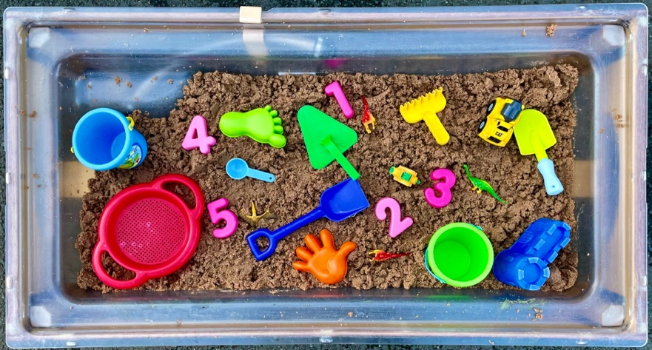
Scientifically, sand can help children use their senses to explore the properties of dry and wet sand and observe changes in sand and look at differences and similarities in dry/wet sand. Mathematically, sand can encourage children to explore various mathematical concepts such as capacity, size and weight and understand or use mathematical language in play, such as full/empty, more/less, heavy/light and name common shapes (Early Years Interboard, 2019).
[source: Personal Image]

- Gardening (Flowerpots)

Gardening can help to develop children’s learning about growth and living things, and by growing a range of flowers children can observe and measure their growth (Drake, 2009). Through gardening activities outdoors, children have real and direct experience of the natural world where they can learn within nature not just about nature as stated by (Brown, 2012) cited by Tovey (2016) and throughout activities such as planting flowers, they experience the changing seasons, the cycles of life and death, and growth and decay.

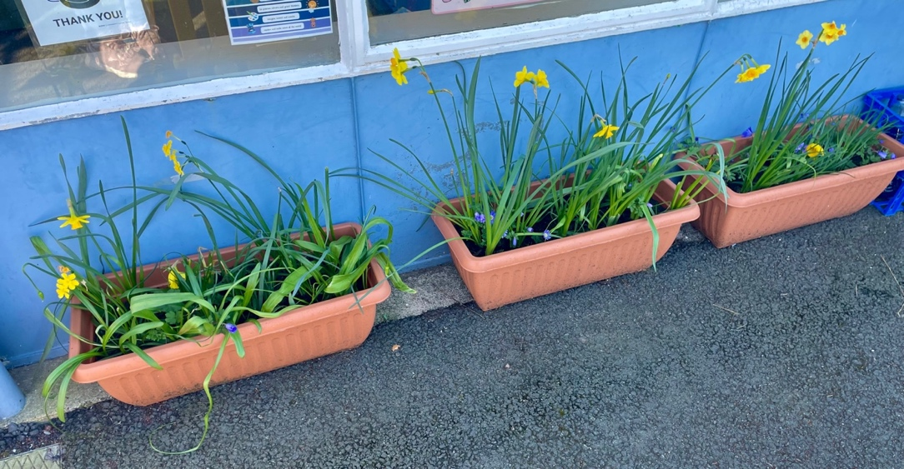
Science can be interwoven throughout gardening experiences as Munn (2012) believes it creates opportunities to discuss soil with all the nutrients it offers and explain that plants get nutrients they need from soil to grow, just like our bodies get nutrients from the food we eat. Examples of scientific concepts that can be taught in the garden Montessori Nature (2022) proclaims, botany can be experienced through the interaction with plants and dissection of seeds, chemistry can be taught through composting and meteorology through monitoring the weather and its effects on the garden
[source: Personal Image]

Furthermore, Grant (2022) and Montessori Nature (2022) asserts using gardens to teach math allows children to immerse themselves and peruse the development and growth of the garden, therefore maths can be indorsed through measuring and collecting data regarding the growth (height) of flowers and an exercise to teach
numeracy through gardening is to have children count the number of seeds planted and how many holes do they need to dig and through exploration of textures, children can gain insight on density, weight, permeability, and malleability.

- Building Blocks

When children play with blocks, Phelps and Stannard (2012) state children are practicing mathematical skills when selecting blocks of different sizes and shapes, and when tidying up, this helps children to sort and organise blocks into their correct homes by their size and their shapes.

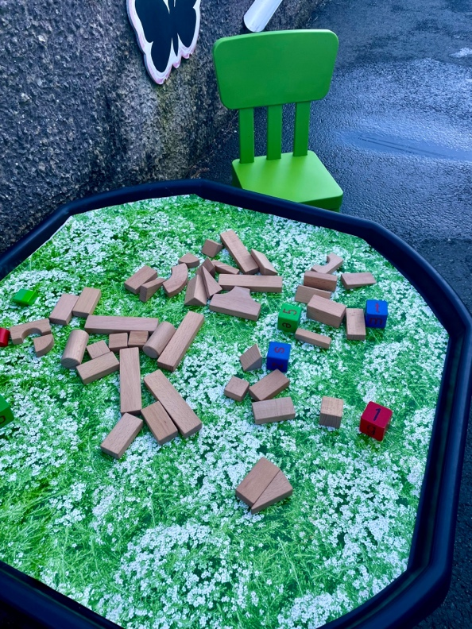
In accordance with Linsay et al. (2018) wooden unit blocks (much like the example picture) can aid intellectual thinking as they can be held, measured, compared, and counted, creating a ‘perfect hands-on medium’ for children to profoundly experience these relationships between objects. In addition, Linsay et al. (2018) continued to discuss children need to master basic neuro-developmental skills to successfully build a steady tower, which consist of eye-hand motor coordination and spatial ordering, aside from sequencing actions such as: following directions, maintaining focus, self-monitoring of one’s behaviour, controlling mental energy, and holding a clear memory of shapes.
[source: Personal Image]

Block play is an educational and exciting form of open-ended play (Hug, 2020) and in accordance with Tina Bruce cited by the Early Years Interboard (2019) once children are involved in block play, they are getting involved in engineering and are beginning to look at things such as the centre of gravity and how children can connect pieces. Furthermore, Moorhouse (2020: 6) states the hands-on experiences benefit children’s scientific thinking as they engross in balance, spatial awareness and encourages problem solving skills due to the scale of work and allows children to construct their own learning, more so in child-led play.

Block play can also lead to increased understanding of scientific concepts, aiding gravity, weight, and balance perceptions. As adults engage in blocks to play with children, it is fundamental to be attentive of some important and fun questions you can ask children to support their learning and scientific skills as suggested by Zoromski (2019). For example, questions for learning about gravity with blocks adults can ask children “what makes the blocks fall?” and “what can you do to make the tower fall?”. Questions for learning about balance with blocks, adults can ask children “can you hold this block and stand on one foot?” and “how many blocks can you stack before it tips over?”. Questions for learning about weight with blocks adults can ask “can you show me the block you think is the heaviest? Lightest?” and “what would happen if you put the heaviest block on top of the tower?”

Risk Benefit Assessment
Location/Activity: | Outdoor Play Area | Date: | 27/03/2022
Assessor: |  | Review Date: | 27/03/2023

Part 3
Activity | How will children BENEFIT from this space? | Possible hazards and risks | Who is at risk? | PRECAUTIONS in place to reduce the risk of injury | Overall risk rating:  L/M/H
Sand Tray | Children can explore properties of dry/wet sand, use building skills, make shapes and patterns in the sand, explore various mathematical concepts (capacity/size/weight), and understand and use mathematical language (full/empty, heavy/light, more/less) and name common shapes. (Early Years Interboard, 2019) | Children can get sand flicked into their eyes and insects and litter can get into the sand unnoticed causing cross-contamination.  Adults can also be injured when moving the large tray (if moveable).  (The Grange, 2018) | Children,  Adults | Adults should model good play and keep a close eye on this area to ensure children are playing appropriately. Adults must also make sure that the sand tray lid is put on at the end of the day to avoid anything getting in the sand and to promote good health and safety, staff should work together when lifting the lid on/off and when moving the tray to prevent staff injury. | M
Water Tray | Children can explore properties of water, observe how objects behave in water, make predictions, compare the size of containers, use mathematical language (full/empty, heavy/light, more/less). (Early Years Interboard, 2019) | Spills might cause slips and falls and broken or damaged resources are likely to cause cuts. Babies, toddlers, and disabled children are likely to drown in water if they are unsupervised while investigating the water, especially if they do not understand the risks.  (Childcare, 2022) | Children | Adults are clear about safety rules and remind children regularly and fully supervised, resources added to water are safety checked before and during play, children with eczema or sores on their skin are provided with waterproof gloves, aprons are provided for each child and fresh water is used and changed daily to avoid cross-contamination and all adults are trained in first aid and check daily the water tray is safe to use. (Childcare, 2022) | M
Gardening | Gardening can promote healthy eating for all and helps teach children patience and creates a sense of responsibility as plants require care and commitment to thrive. Gardening encourages and stimulates all senses and develops fine motor skills by picking up tiny seeds and putting them in the soil (BBC: date unknown) | Some plants can cause allergic reactions for some individuals and other plants have poisonous parts if eaten such as fungi, and many common bulbs can be toxic if eaten such as daffodils. Throughout the year, there will be a profusion of different insects mainly bees and wasps in spring and summer which children can heave allergic reactions to. (Royal Horticultural Society, 2015). | Children | Be sure to educated children on the importance of staying safe and washing hands before carrying out an activity and help children to identify the difference between necessary and dangerous insects as many insects are helpful in the garden. (Royal Horticultural Society, 2015). | M
Weather (heat) | Playing in all weathers helps children to stimulate a child’s immune system whilst provoking the senses with new sights, smells, textures and sounds which stimulate brain development and boosts creative thinking and gross motor movement skills (Only About Children: date unknown) | Children can become ill during outdoor play in very hot weather which can cause dehydration, heat exhaustion/heat stroke and sunburn (NHS: 2021) |  | Keep young children out of direct sunlight, by planning to play in more shaded areas or attach a parasol. Apply sunscreen regularly, including when children are in and out of the water tray and ensure there is clean water on premises to keep children hydrated (NHS: 2021) | M
Bikes | Children seek challenge through practicing their bike riding skills, build confidence trying new skills on bikes, concentrate on maintaining balance, listen and make judgements and build their gross motor skills and foot-eye coordination when peddling.  (Davies, 2020) | Broken parts, flat tyres, rusting or flaking metal and children falling off causing bumps, bruises, cuts, and broken bones. | Children | Ensure the equipment is suitable for the age of the child. Staff to supervise especially new or young children until they are able and more confident. Bikes checked before use and cleaned regularly. Verbal reminders and warnings of care. First aid box easily accessible. | M
Toolkits (toys) | Tools (real or fake) can encourage children to actively learn while thinking critically, risk assessing themselves and give children responsibility and independence. Tools are great fir fine motor skills and can encourage children to learn self-control and hand-eye coordination. (Kimberley, 2017) | Children can get hit by a tool and cut themselves on sharp equipment.  (The Grange, 2018) | Children | Adults should model good play and supervise this area ensuring tools are used appropriately. Items checked before use and cleaned regularly. Verbal reminders and warnings of care. First aid box easily accessible. | M
Home Corner  (Tea set, pots, pans, utensils, play food, dolls, push chairs, dressing up clothes) | The home corner supports both individual and cooperative play. Many children spend considerable time in the home corner stirring, filling, emptying, pouring, shaking, and mixing, as they may imitate cooking sequences they have seen at home or pretend to feed a doll. Children also re-enact events they have experienced or heard cleaning up after a flood, having a birthday party and picnics as the home corner allows children to make sense of their immediate world.  (Hohmann and Weikart, 2012) |  | Children | Daily checks conducted by adults and check all equipment and resources and anything broken or damaged should be removed / replaced. Resources are put away and secured at the end of each day to protect equipment and resources from changing weather conditions and should wash equipment regularly. Clothes kept in good condition with no rips or trailing pieces. (Maltby Lilly Hall Academy, 2016) | M

Part 4
There is overwhelming evidence that the outdoor environment is where children grow and learn best, as Moorhouse (2020:1) asserts children are having fewer outdoor experiences and are disengaged from the natural world, therefore it is more important now than ever children are given opportunities to play and learn outdoors. Children are much more immersed in experiences when children can make more sense of the world around us, the outdoor environment has the capacity to stimulate children’s senses significantly more than an indoor learning environment and when senses are amplified learning is extended and learning experiences are retained for longer (Thomas and Boulton, 2021:26-30).

Within the new curriculum, Welsh Government, (2022b) progression in the ‘Mathematics and Numeracy Area of Learning and Experience’ involves the development of five connected and interdependent proficiencies, known as conceptual understanding, communication using symbols, fluency, logical reasoning, and strategic competence and numeracy contains applying and linking these proficiencies in a variety of real-life contexts, across the curriculum. These proficiencies have been used in developing the descriptions of learning and are central to progression at each stage of mathematics learning.

Furthermore, Welsh Government (2022c) further upholds, development in science areas have always been drivers of change, underpinning innovation and impacting on everyone’s lives culturally and environmentally. As such, the ‘Science and Technology Area of Learning and Experience’ will be progressively relevant in the opportunities young people face and the life choices that they make whilst drawing on the regulations of biology, chemistry, computer science, design and technology, and physics to boost learners’ knowledge and understanding of the world.

As children are naturally curious and explore the world around them through play experiences, open-ended allows children the time and space to develop their own ideas and is defined by Hug (2020) as the type of with no pre-determined limitations or “right” or “wrong” set outcomes where children follow the pull of their own creativity and process experiences. As Bland (2016) expresses, an open-ended resource is any item that can be used in a range of ways, whereas a made-for-purpose toy are often single-purpose and have a predetermined conclusion, for example, a puzzle is completed thus the game has a winner. In contrast, a child may hold a stick and it can be anything they want it to be.

Compliant with Welsh Government (2022a: 22) and Moorhouse et al. (2019:2) children’s scientific and mathematical thinking can be provoked by resources that support investigation and discovery, such as magnifying glasses, scales, binoculars, different sized containers, and measurers. Open-ended, natural resources provide endless possibilities as loose parts create richer environments for children to extend their play providing children with many possibilities to construct their own learning (Play Wales, 2017; and Moorhouse, 2020:3). Providing open ended play materials allows children the opportunity to be curious, creative, and direct their own play. It encourages dramatic play, exploratory play, role play, constructive play and builds on children’s language skills, problem solving, teamwork, games, experimenting with cause and effect, trial and error and builds creative thinking and innovation that will encourage more symbolic play a higher level of play (The Empowered Educator, 2017; Neill, P, 2013).

In accordance with research gathered by The Empowered Educator (2017) and Dancer (date unknown) when provisions incorporate open ended materials or loose parts in the outdoor environment it allows children to take risks and challenge themselves through play and feel as though they have some control of their environment, which broadens their own play. In the outdoor area it is the role of the adult to identify opportunities for maths learning and enhancing provision, by celebrating the unique qualities of the outdoor environment by collecting and sorting natural objects, measuring huge areas using non-standard measures such as strides, exploring, carrying, taking materials apart and put them back together, rearranging to suit their needs and work out how to move heavy materials and decide on how the materials will be used.

In Thomas and Boulton’s (2021) view, affordances are predicted on what practitioners provide within an enabling environment through materials, resources, and loose parts in the setting. These types of play can ‘afford’ children amazing opportunities to develop their brains, their thinking patterns, and actions/schemas as well as their self-efficiency, which helps them to construct patterns of thinking and understanding how the world works.
Affordances are functional properties of the environment that propose specific behavioural options to individuals (Zamani and Moore, 2013). The affordance theory, a teaching strategy used in Reggio Emilia, proposed by Gibson, suggests that the environments and objects within, have values and meanings that are unique to the child using them. These affordances and variables increase with open-ended materials integral in loose parts that invite children to discover on their own, leading to decision-making and problem solving (Kashin, 2018; and Jackson, 2019).
Affordance is crucial for outdoor learning as according to Gibson (2014) cited by Sandro and Sandseter (2020) affordance is defined by as what the environment offers the individual and what it provides or furnishes, either good or ill, as a well thought out layout of play spaces can encourage children’s engagement in play, where physical activity constructs a positive result in children’s movement to aid development. However, as Martin (2017) affirms if the environment does not provide, or meet the necessary requirements then individuals are less likely to interact with the environment, hence it is principal when planning the outdoor area, adults must consider a variety of affordances so the environment can appeal to a variety of optimal levels of affordances.
According to MacKintyre and McVitty (2004) ‘physical development is the key that unlocks all learning’ as it underpins an outward attitude to the world which enables positive dispositions to interaction and exploration, and is at the root of effective brain functioning, memory, and learning (White, 2018). Movement is beneficial to children’s vestibular sense, also known as balance, which aids scientific thinking, which Humber Sensory Processing Hub (2020) affirms the vestibular system is stimulated by movements linked to up or down, around, and over, and forwards and backwards, which is also responsible for controlling children’s muscles and many reflexes.
Playing outdoors bolsters children’s senses and scientific thinking as Moorhouse et al (2019) and Hug (2020) affirms, the outdoors is constantly changing with seasons and weathers, providing element of unpredictability and surprise, and stimulation of sunlight and shadow, damp and dry, mud, plants, and fresh air, and is ultimately the best environment for open-ended play, in contrast to more controlled and static indoor environments. Children’s senses are engaged as they feel the wind, smell a flower, hear a bird’s distant cry, notice ripples while splashing in water, additionally as Playground Centre (2022) affirms, sunlight is an excellent source of vitamin D, which is important for their health to build strong bones.

Conversely, a research study conducted by Kalpogianni (2019) to clarify whether children’s outdoor play needs are adequately met, examined educators’ views and practice aiming to gain better understanding on factors that affect play and learning. Kalpogianni (2019) found the physical environment, attitudes and policies, limited time and lack of suitable space with health and safety concerns were a main factor suggested to hinder children play.

Outdoor play offers young children plentiful, sensory first-hand experience which is essential for growing minds as Tovey (2016), cited by Welsh Government (2022a), conveys, outdoor play inspires children to engage with the wonder and mystery of the natural world through space and freedom to explore, experiment and investigate how the world works whilst also providing opportunities for challenge and risky adventurous play providing meaningful opportunities for learning in all areas of the curriculum. Nevertheless, as cited by Moorhouse (2020:11) the Government Equality Act states “an education provider has a duty to make ‘reasonable adjustments’ to make sure disabled student are not discriminated against” as these children often miss out on play opportunities central to learning, therefore, adaptions or additions are necessary to provide suitable challenges and experiences allowing equal access and inclusion.

The outdoor play environments should provide a blend of natural areas and environmental features which interest children in learning about nature and its elements. Therefore, is the role of the adults to have accountability to bring curriculum to life through realistic experiences using the outdoor environment to its full potential, recognising that it is a place that can provoke awe and wonder, creativity, joy, and peace (Welsh Government, 2022; and Education Standards Boards, 2019). However, to achieve their outcomes, Drake (2009:45) suggests practitioners should anticipate such learning experiences and plan an effective outside area that will offer children an abundance of opportunities to find out about the natural environment and a variety of stimuli that will motivate children to ask questions about the world around them and seek answers, enhancing their knowledge and understanding of the world.

A stated by Moorhouse et al. (2019) the pedagogy of many early education pioneers emphasised the importance of outdoor play for young children as they highlight their practice has had positive influence on the evolution of early years outdoor provision. According to Tovey (2016) and Moorhouse et al. (2019:7) Frobel named the school ‘kindergarten’ which means ‘garden for children’ as he believed the garden offered young children an ideal environment to explore, develop an understanding of the world and learn to take care of it and a key idea of Froebel’s work was the key role of the adult in observing, supporting, and extending play and learning. Rachel and Margaret McMillan’s work were influenced by Froebel, as MacBlain (2018:260) states they placed great emphasis on the importance of children being healthy and having access to the outdoors as Welsh Government (2022) affirms Margaret McMillan once said, "the best kept classrooms and the richest cupboard are roofed only by the sky”. Consistent with Robinson (2019), Piaget believed that children learn primarily from their environment, and he bought into the idea that children learn best when they’re doing the work (child-led) rather than being given explanations by adults (adult-led) and Piaget also believed that children should be given every possible opportunity to do it by themselves, as Piaget once said “Parents and teachers should be sparking curiosity in children rather than giving direct instruction. Our job is to support our children in their search for answers”.

As implemented by Sargent (2009) and Dourish (2021), fostering sustained shared thinking within early years settings encourages autonomous thought and helps to produce creative life-long learners as it positively impacts their overall learning and development as children engage in deeper thinking in all areas of learning by developing their thinking skills as they are encouraged to be curious, critical thinkers and problem solvers. Parenta (2020) suggests, adults can support children sustained shared thinking by supporting them in the zone of proximal development and engaging with children and responding sensitively and practitioners need to be positively interested in what the children are exploring or engaging with and notice how they are interacting. An appropriate way to do this is to get down to their level and adults becoming engrossed themselves, not just to play alongside, but instead be a co-player, someone who can offer ideas in leading the play, but also someone who can be led by the children.
To conclude, maths is an important part of learning in the early years within the curriculum as it provides vital life skills helping children to problem solve, measure, develop their own spatial awareness, and teach them how to use and understand shapes. Whereas science supports and teaches children how to discover and wonder about everything in the world around them, embedding a desire to explore and investigate. Mathematics is a deep-rooted element of science, part of its framework, its universal language and indispensable source of intellectual tools. Equally, science inspires and stimulates mathematics, posing new questions, stimulating new ways of thinking, and ultimately conditioning the value system of mathematics.

