
Task 1: Individual Written Business Plan

Figure 1: (University of Wales Trinity Saint David logo, n.d.)

LCLM4006 Enterprise and Entrepreneurship

Certificate in Higher Education Business Skills for the Workplace
  - TACTICAL
MARKETING PLAN
Lecturer: Fouziya Farheeen
Student: Dean Kiran
Student ID: 2520250

Executive Summary

Global Bites is a food truck serving real, home-style meals from all over the world. It’s made mainly for international students who want familiar, comforting food from home, but everyone is welcome, including other students, university staff and local people, to enjoy and celebrate different cultures together.
I will start as a sole trader, then become a limited company once the business is running well and eventually offer franchises so Global Bites can operate at lots of university campuses. The business is built on three main ideas:
1. Kind to the environment: all packaging can be recycled or composted
2. Bringing people together: with a rewards app and cultural events
3. Helping students grow: Providing paid jobs that include official training in health, safety and food hygiene, and may even invest in a franchise themselves.
Global Bites needs £60,000 of start-up funding: a £40,000 government-backed Start Up Loan and £20,000 of personal savings.




Figure 2: GlobalBites Logo Created using AI (ChatGPT)

Contents

1. Overview of the Business Idea 4
1.1 Products and Services 4
1.2 Sustainability and Community Support 5
1.3 Legal Format 5
1.4 Management Structure 7
2 Market Research 8
Environmental Analysis (PESTEL) 8
Political 8
Economic 8
Social 8
Technological 8
Environmental 8
Legal 8
2.1 Market Research – Competition 9
2.2 Marketing Communications 9
Financials 10
Reference List 12
Image Sources 13

1. Overview of the Business Idea

1.1 Products and Services
The food truck will offer a variety of freshly prepared meals using 100% halal meat. The menu could include different international dishes, street-food meals, wraps, rice dishes, burgers, loaded fries and vegetarian options.
To accommodate students with different dietary requirements, the truck will have separate cooking equipment for meat and vegetarian food. A dedicated cooker will be used for meat products, while another cooker will be used exclusively for vegetarian products. Food will also be prepared by separate staff members where possible to reduce the risk of cross-contamination. The business will place a strong emphasis on food hygiene, cleanliness and safe food preparation, including a click-and-collect service for students on the go. There were 685,565 international students at UK universities in 2024/25, that’s nearly 1 in 4 students overall Bolton, P., Lewis, J. and Gower, M. (2025). Many of them find it hard to get tasty, authentic food from home at a fair price and this is the gap Global Bites aims to fill for students across the UK. Major source countries include India, China, Pakistan and Nigeria (Walsh, 2024). We aim to cater for these groups and will provide a suggestions box for future dishes as we are about inclusion. Our short-term goal is to run one profitable truck on a single campus within 12 months; our long-term goal is to become a limited company and franchise to other universities providing students nation-wide work experience, additional certifications and tasty food which makes us stand from the standard food truck business.
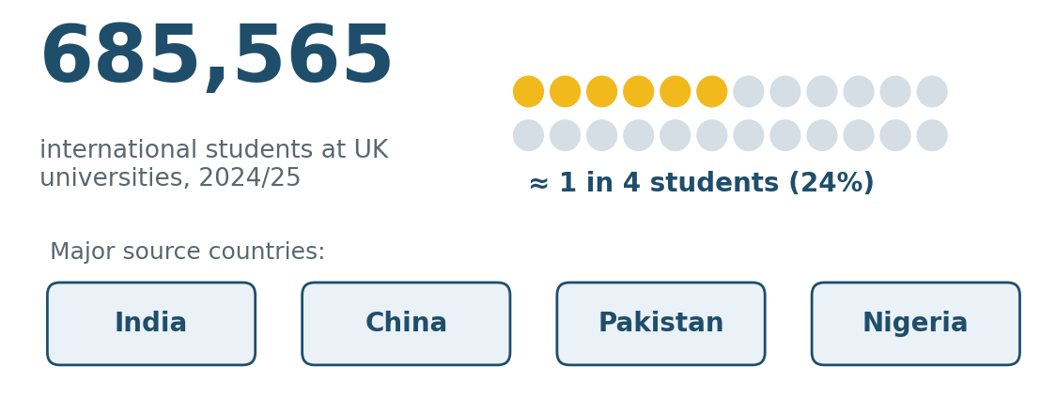
Figure 3: International students in UK higher education, 2024/25. Source: created in PowerPoint using data from Bolton, Lewis and Gower (2025) and Walsh (2024).

1.2 Sustainability and Community Support
Global Bites is built on three pillars: cultural inclusion, environmental responsibility, and student development all centred around supporting our community. We can reduce residual waste and make our economy truly circular and sustainable (DEFRA, 2023). All packaging used is fully recyclable or compostable. We go further than just serving food: we offer paid work placements to university students, giving them real work experience. Every placement includes official training and certification in food safety and hygiene. This builds valuable skills and confidence directly supporting the community we serve and helping students improve their future job prospects.
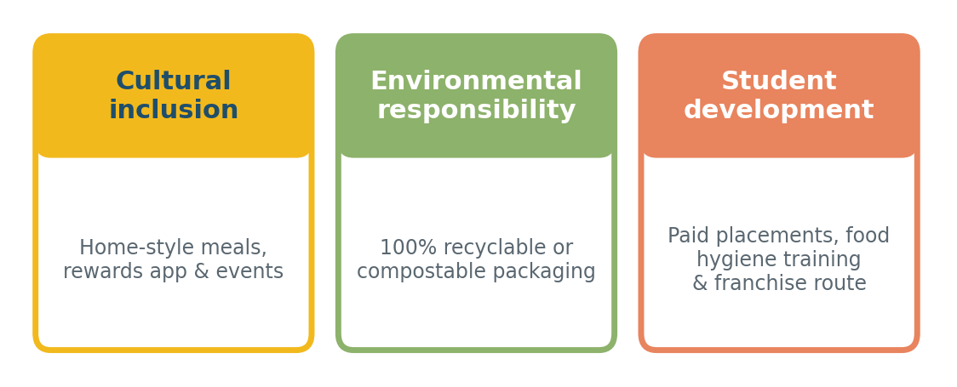
Figure 4: The three pillars of Global Bites. Source: created by the author from the business plan.

1.3 Legal Format

The business type I have chosen is a sole trader. This would be suitable because the food truck is a new, small business being started and managed by one owner.
As a sole trader, I would be responsible for making the main business decisions and would keep the profits after paying business costs and applicable taxes. The owner would also be personally responsible for the business's debts and liabilities.
The business would need to comply with relevant food safety, hygiene, health and safety and trading requirements. It would also need appropriate insurance and any licences or permissions required to operate a food truck in the areas where it trades.
If the business becomes successful and expands to multiple food trucks or employs a larger number of staff, I will then consider changing the legal structure to a limited company. This could provide limited liability and make it easier to expand the business (Osome, 2026).
I chose this structure because “As a sole trader, you’re in full control of your business, in the ultimate sense ‘your own boss’. You don’t need to consult other directors or shareholders, take account of their views or compromise your own vision for the business” (Korchak, 2016).

1.4 Management Structure
The business will initially have a simple management structure because it will be a small food truck. The owner will act as the business manager, responsible for the overall running of the company.

The owner/manager will be responsible for:
Managing finances, budgets and business expenses.
Ordering food, ingredients and packaging.
Planning the menu and setting prices.
Managing relationships with universities and suppliers.
Organising staff rotas and working hours.
Promoting the business through social media.
Ensuring food hygiene and health and safety requirements are followed.
Monitoring customer feedback and improving the service.

The business will also employ food preparation and serving staff. One member of staff will primarily prepare meat products, while another will be responsible for vegetarian food. Separate cooking equipment will be used for meat and vegetarian products to reduce the risk of cross-contamination.
As the business grows, additional staff could be employed to help with cooking, serving customers, deliveries, social media and administration.
This structure will allow the owner to maintain control of the business while ensuring that day-to-day operations run efficiently.

2 Market Research

Environmental Analysis (PESTEL)

Factor | Analysis
Political | - The UK Start Up Loans scheme provides accessible funding and mentoring for new enterprises (UK Government, 2026)  - The single-use plastic ban makes eco-friendly packaging a legal requirement and market advantage (DEFRA, 2023)
Economic | - There are 685,565 international students in the UK: a large, stable customer base representing 24% of all students (Bolton, Lewis and Gower, 2025)  - Low overheads as a food truck enable affordable pricing, critical amid ongoing cost-of-living pressures
Social | - 73% of consumers choose cardboard over plastic for the same product and 82% considering climate impact when making a purchase (Corbin, 2026)  - International students frequently report difficulty finding familiar, affordable home cuisine (Walsh, 2024)
Technological | - QR-code ordering and click-and-collect suit smartphone-first student lifestyles and reduce waiting times  - Instagram, TikTok and X deliver free, real-time marketing and location updates across the campus
Environmental | - Fully recyclable/compostable packaging eliminates single-use plastic waste and meets legal standards (DEFRA, 2023)  - Sourcing ingredients locally cuts food miles and supports regional producers while strengthening supply chains
Legal | - Launching as a Sole Trader offers simple, low-cost setup; converting to a Forming a limited company can provide personal asset protection and a tax-efficient business structure (Donnelly, 2025)  Food business registration is a legal requirement (GOV.UK, 2026); paid student placements must comply with National Minimum Wage and tax rules

2.1 Market Research – Competition

Global Bites faces direct competition from campus cafés and other street-food traders, and indirect competition from delivery apps such as Uber Eats and Deliveroo, supermarket meal deals and nearby takeaways. Most campus outlets offer standardised menus, and few serve authentic home-style dishes, 100% halal food prepared on separate equipment, or plastic-free packaging. Delivery apps are convenient but their fees strain student budgets.
Global Bites’ advantage is therefore authenticity, affordable pricing, a strong cultural community and click-and-collect convenience. The main threat is that established caterers could copy the concept, so the rewards scheme and cultural events will build loyalty that is harder to replicate.

2.2 Marketing Communications

Global Bites targets international students first, then all students, university staff and local residents, reaching them mainly through digital and campus channels:
- Digital Ordering & Click-and-Collect: A fast website with scheduled pick-up times reduces peak-hour queues, and QR codes on the truck link straight to the menu with no app download.
- Social media: Instagram and TikTok will showcase daily specials and student spotlights, while X will post the truck's campus location each morning. Young adults spend more time online than any other age group (Online nations report 2025, 2025).
- Digital Rewards Scheme: Customers earn 1 point per £1 spent, and 100 points give £5 off. Birthday bonuses and double-points days encourage repeat visits.
- Campus Partnerships: Freshers' Week stalls, international societies and student union events will launch the brand, while tasting sessions build word of mouth, the most trusted form of advertising (Nielsen, 2015).
- Location Strategy: Pitches at university entrances and library plazas in term time, and at local markets and festivals in holidays, prioritising footfall over low rent.
- Franchise Readiness: Branding, recipes, systems and training materials will be documented from Month 6, creating a franchise pack for university partners in Year 2 (UK Franchise Opportunities, 2026).
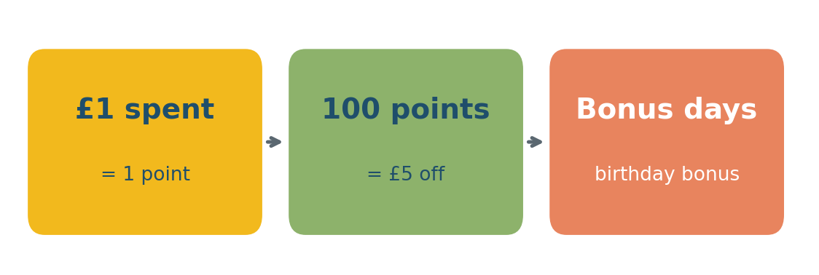
Figure 5: How the digital rewards scheme works. Source: created by the author from the scheme terms in Section 2.2.
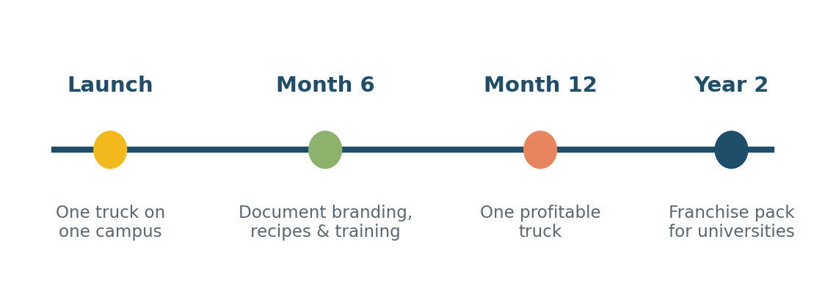
Figure 6: Growth roadmap from launch to franchise. Source: created by the author from Sections 1.1 and 2.2 (UK Franchise Opportunities, 2026).

Financials
Funding and Expenses
I have chosen a Government-Backed Start Up Loan. What it is: An unsecured personal loan used for business purposes backed by the British government, typically offering fixed interest rates and repayment terms from 1 to 5 years (Novuna, 2025).
Why it fits:
No collateral required: You do not need to risk personal property or assets.
Free mentoring: It includes 12 months of dedicated business mentoring, which helps first-time hospitality operators navigate licensing, health and safety, and cash flow.
Accessibility: It is specifically designed for new businesses that lack a long trading history (Zempler, 2026).
I need £40,000 from the Start Up Loan plus £20,000 of personal savings, a total of £60,000. Contributing my own savings shows commitment to lenders and keeps loan repayments manageable.

Main start-up expenses in the first month (estimates):
Start-up expense  (First month) | Estimated cost
Second-hand food truck and branded fit-out | £32,000
Kitchen equipment (two separate cookers, fridges, fryer) | £8,000
Licences, street-trading permits and hygiene registration | £1,500
Insurance (public liability, product, vehicle) | £2,000
Opening stock and compostable packaging | £3,000
First-month wages and food-hygiene training | £3,500
Website, QR ordering and rewards scheme set-up | £2,000
Uniforms and launch marketing | £2,500
Fuel, gas and pitch fees | £1,500
Contingency / working capital | £4,000
Total | £60,000

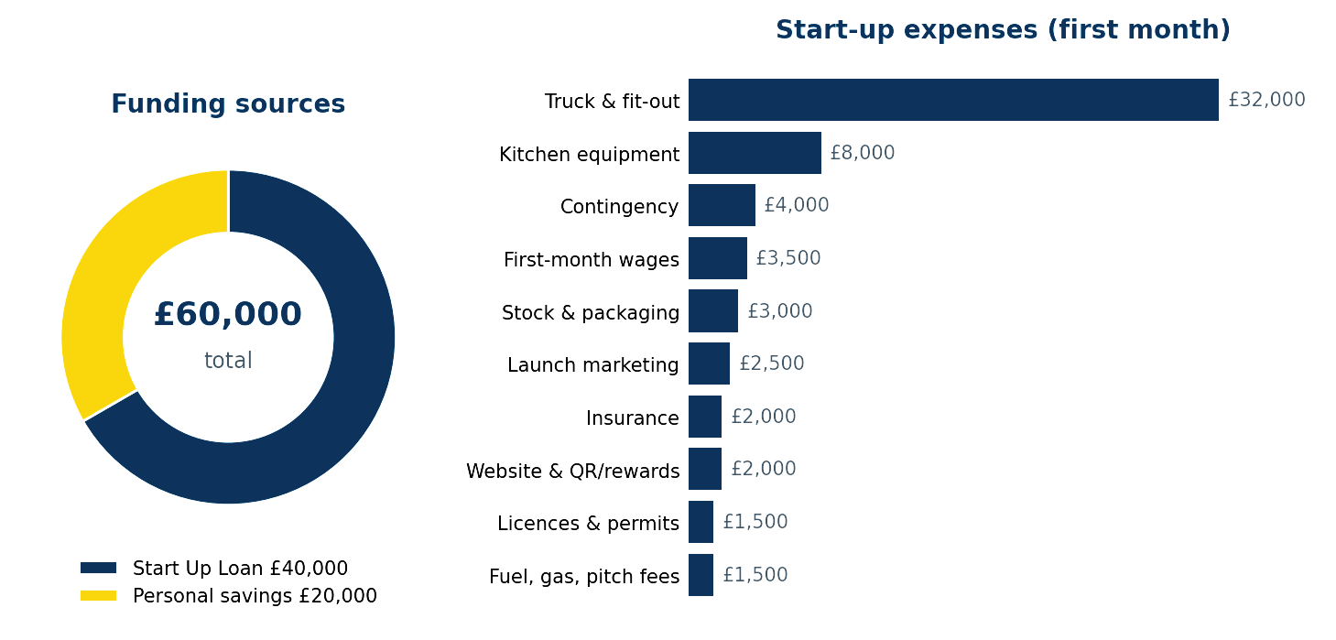
Figure 7: Funding sources and first-month start-up expenses. Source: created by the author from the funding plan and expense table above (Novuna, 2025; Zempler, 2026).

Reference List
Corbin, T. (2026). UK shoppers still favour sustainable packaging despite cost pressures, data shows. [online] Packaging News. Available at: https://www.packagingnews.co.uk/news/environment/uk-shoppers-still-favour-sustainable-packaging-despite-cost-pressures-data-shows-03-07-2026 [Accessed 13 Oct. 2026].
DEFRA (2023) The Waste Prevention Programme for England: Maximising resources, minimising waste. [online] GOV.UK. Available at: https://www.gov.uk/government/publications/waste-prevention-programme-for-england-maximising-resources-minimising-waste/the-waste-prevention-programme-for-england-maximising-resources-minimising-waste (Accessed: 9 October 2026).
Donnelly, G. (2025). Is it worth forming a limited company? The insider’s guide. [online] The 1st Blog. Available at: https://www.1stformations.co.uk/blog/forming-limited-company-guide/ [Accessed 14 Oct. 2026].
GOV.UK (2026) Starting a food business. Available at: https://www.gov.uk/guidance/starting-a-food-business (Accessed: 23 October 2026).
Bolton, P., Lewis, J. and Gower, M. (2025). International students in UK higher education. commonslibrary.parliament.uk. [online] Available at: https://commonslibrary.parliament.uk/research-briefings/cbp-7976/ [Accessed 23 Oct. 2026].
Korchak, J. (2016) Sole trader advantages: Benefits of operating as a sole trader. [online] Inform Direct. Available at: https://www.informdirect.co.uk/business-management/sole-trader-advantages-for-business/ [Accessed 2 Oct. 2026].
Novuna (2025) Business loans for food truck businesses. Available at: https://www.novuna.co.uk/news-and-insights/business-cash-flow/business-loans-for-food-truck-businesses/ (Accessed: 17 Oct. 2026).
Online nations report 2025. (2025). [Government or public sector report] Available at: https://www.ofcom.org.uk/siteassets/resources/documents/research-and-data/online-research/online-nation/2025/online-nations-report-2025.pdf?v=409837 (Accessed: 23 October 2026).
Osome (2026) Sole trader vs limited company: which structure is best? Available at: https://osome.com/uk/guides/sole-trader-vs-limited-company (Accessed: 2 Oct. 2026).
UK Franchise Opportunities (2026) Franchise your mobile food business UK. Available at: https://uk-franchise-opportunities.org/franchise-your-business/franchise-mobile-food-catering-business-uk (Accessed: 2 October 2026).
UK Government (2026) Start up loans scheme. Available at: https://www.gov.uk/apply-start-up-loan (Accessed: 2 October 2026).
Universities UK (2026) Graduate employability and student experience. Available at: https://www.universitiesuk.ac.uk
(Accessed: 9 October 2026).
Walsh, P.W. (2024) Student migration to the UK. Oxford: Migration Observatory. Available at: https://migrationobservatory.ox.ac.uk/resources/briefings/student-migration-to-the-uk/
(Accessed: 9 October 2026).
Zempler (2026) How to start a food truck business in the UK. Available at: https://www.zemplerbank.com/resources/food-and-drink/how-to-start-food-truck-business-uk/ (Accessed: 17 October 2026).

Image Sources
Figure 1- University of Wales Trinity Saint David logo. (n.d.). [Logo] Education Vibes. Available at: https://educationvibes.in/uploads/university_logo/study_abroad/university-of-wales-trinity-saint-david.png [Accessed 24 Oct. 2026].
Figure 2 - Global Bite Logo Created in AI (ChatGPT 2026)
Figure 3 - Bolton, P., Lewis, J. and Gower, M. (2025). International students in UK higher education. House of Commons Library. Available at: https://commonslibrary.parliament.uk/research-briefings/cbp-7976/ [Accessed 23 Oct. 2026]; Walsh, P.W. (2024). Student migration to the UK. Migration Observatory. Available at: https://migrationobservatory.ox.ac.uk/resources/briefings/student-migration-to-the-uk/ [Accessed 9 Oct. 2026]. Graphic created by the author using Python (Matplotlib), 2026.
Figure 4 - Original graphic created by the author using Python (Matplotlib), 2026, based on the business pillars in Sections 1.1 and 1.2.
Figure 5 - Original graphic created by the author using Python (Matplotlib), 2026, based on the rewards scheme terms in Section 2.2.
Figure 6 - Original graphic created by the author using Python (Matplotlib), 2026. Timeline based on Sections 1.1 and 2.2; UK Franchise Opportunities (2026). Available at: https://uk-franchise-opportunities.org/franchise-your-business/franchise-mobile-food-catering-business-uk [Accessed 2 Oct. 2026].
Figure 7 - Original graphic created by the author using Python (Matplotlib), 2026. Figures taken from the funding plan and start-up expense table in the Financials section; Novuna (2025); Zempler (2026).

