

Intergenerational aspects of crime
Is there a greater possibility that the children of offenders will themselves become offender?

Name: Emily Bowden
Student ID: 1900526
University: UWTSD Swansea
Degree: Policing and criminology
Due date: 6th May 2022
Word count: 9985

Abstract
Report represents an analysis and evaluation of whether children of offenders will themselves become offenders, analysis shows that there is a higher chance of children with a troubling childhood can lead them down a criminal path. The report finds that ACEs has a lot to do with a child’s upbringing, evidence suggests that even when a child can have a traumatic upbringing there is still a way and support out there for them in order to prevent children from following the same path as their parents. The major issues are, abuse, neglect having prison imprisonment as it causes mental health issues alongside behavioural issues.

Acknowledgment
I would like to thank my supervisor Mike Durke for the support and guidance throughout this dissertation.
I would also like to thank my friends and family for providing me with support and encouragement to get through this dissertation. With the support I’ve got of my friends and family it has encouraged me to focus on the degree and work to my best ability.
I would also like to thank the participants who took part in my questionnaire, it allowed me to gather all the information I needed and was very crucial to my findings.

Declaration
This work is not previously been accepted in substance for any degree and is not being concurrently submitted in candidature for any degree.
Statement 1
This dissertation is being submitted in partial fulfilment of the requirements for the degree of BA/BSC.
Statement 2
This dissertation is the result of my own independent investigation/work, except when otherwise stated. Other sources of information acknowledge in the reference section.
Statement 3
I heard by give consent to my dissertation, if accepted, to be available for photo copying and for interlibrary loan, and the title and summary to be made available to outside organisations.
Statement 4
I heard by give consent to my dissertation, if accepted, to be available on the university IT system to those who have consent to use the system.
Student Name: Emily Bowden
Student signed: E. Bowden
Date: 6/05/22

Contents
Abstract 1
Acknowledgment 2
Declaration 3
Chapter 1- Introduction 6
Background and rationale 6
Objectives 6
Research structure 8
Chapter 2: Literature review 10
Defining childhood 10
Nature Vs Nurture 10
Different childhoods 12
Traumatic events 12
Adverse Childhood Experiences 13
Parents imprisonment 14
Observational theory 15
Statistics 15
Real life events 16
Chapter 3-Methodology 17
Research onion 17
Philosophy 18
Approach and Strategy 18
Choices 19
Time Horizon 19
Techniques, Data, and analysis 20
Data collection 20
Reliability and Validity 21
Ethical consideration 21
Limitations 22
Chapter 4- Findings 23
Data Analysis 23
Analysis 24
Conclusion chapter 5 31
Main findings 31
Implications 32
Recommendation 32
Limitations 33
References 34
Appendices 39

Chapter 1- Introduction
Throughout this dissertation it will examine whether there is a greater possibility that children of offenders will themselves become offenders. This dissertation will seek out if there is a key link within offenders and if their children will be influenced by their behaviour resulting in them repeating it. It will determine if the influence of a child’s background can affect their behaviour and lead them down the route of becoming a young offender (SCCJR, 2019).

Background and rationale
It may be suggested that children are influenced the way they are parented, they have a strong influence on how their children can be raised, a child will learn things they are shown and what they see when growing up. Therefore, if a parent was to act in an aggressive behavior the likelihood of the child replicating is high, similarly, when they show caring and emotions towards a child. However, throughout this dissertation it will explore if there are connections between a parent’s behavior and a child’s along with if they are more likely to imitate their behavior themselves (Shewark, 2021). It will argue that there is indication of children being involved in crime at a young age due to the influence of their childhood, however it will also reason that there may be cases that a child’s upbringing can be altered displaying that not all children will follow the path like their parent or guardian. Due to having the support of organisations and early interventions which can provide the support and knowledge they need to live a normal life (Early Intervention Foundation, 2020).

Objectives
The objective of this dissertation is to acknowledge a child’s upbringing whether they have had a traumatic childhood which then influenced them to committing crimes, seek out if a child’s upbringing can play a role in their behavior and if they are set up for life due to what they have been through in the past. For instance, to uncover if there is a link connecting their parents or guardians’ behaviour and how they act, is it true then their child will follow due to them only seeing how they manage things, could influencing a child cause them to act out in a negative way. In order to provide reliable sources, I will be using multiple case study one main one being the Bobo doll as it has relations to adults influencing children. I will also explore the meaning behind the definition of traumatic, due to it being such a wide topic and to get to the route of the meaning allow me to evaluate the different subjects and terms used under the word traumatic (Macnow, 2020).

To get a clearer understanding of how relationship work between parent and child, it will dive into it in more detail and examine the qualities of the nature vs nurture debate. Therefore, for my next objective it will highlight one of the best-known ways to seeking out if a child can be influenced by their surroundings as a child for example influenced by their parents or if they can be influenced by their environment and pick up on behaviors from other individuals. It will illustrate the difference between the two qualities, showing if there is one more dominant side where a child’s development can be influenced. On the contrary exploring this debt will provide a clearer understanding on how easy or hard it can be to encourage and alter how a young individuals can present themselves (Experts, 2020).
Following on the next discussion will express the thoughts of Adverse childhood experience (ACE’S) which will determine whether it plays a role in how a young individuals will later go on to live their life. Essentially it will evaluate if a child who has suffered trauma as a young child will that put them in the category of ACE’S, which can potentially put them at more risk of getting into serious crime and impacting their live. Inevitably children who suffer some sort of trauma usually impacts on their behavior due to the stress and form of neglect they have suffered. This dissertation will aim to identify why ACE’S is a huge part of society and if there is a solution to over coming so many young individuals experiencing unimaginable trauma. (Asmundson, Afifi, 2019).

Lastly to discuss will be is there support out there in order to prevent children from committing crimes, being influenced by bad behavior and helping them achieve their goals in life. By having the correct support at an early stage, it can prevent as many young individual’s entering the justice system. It can provide support not only to the children but to the adults as a way of helping them cope with their children and bring them up in a happy environment (Morin,2022). Factors such as children who are influenced by their parent’s action need the support in order for them not to go down the same path to keep them out of jail and not follow the same ways their parents or guardians have recently done. Simply put if a young individual is influenced by their parent who is in and out of jail could be prone to committing a crime themselves, in order to prevent this from occurring having the correct support and organisation in place can prevent them from entering the criminal justice system and show them there is alternative solutions (Bolton, 2021).

Research structure

In order to collect the relevant data, needed for the dissertation it will be conducting a questionnaire with eight questions to answer and looking for around 80+ responses, which will lead to a wide range of a mixture of opinions which will allow the analysis of the findings and uncover what the participants thoughts are. In addition to the analysis, qualitative data will be used during the findings as it will be collecting data from a questionnaire, qualitative data is a form of descriptive and conceptual findings, it allows you to explore ideas and to further explain the results. Qualitative data collects numerical data which presents as a narrative. It illustrates the importance of my findings and allows me to have a clear understanding of how to explore the questionnaire and reach the intended goal (Ivan, 2021).

The key literature that will be utilizing as part of the research will be mainly articles as there will be wider understanding of individuals experiences and what they have experienced themselves which will allow me to have a clear path to analysing the data and learning about the subject. Furthermore, it will also take advantage of books as part as my research due to the amount of information that will be provided and the fact that they will be a reliable source of material to incorporate in my writing.
Lastly, journals will be applied to my research as there can be used in comparison to real life events which can show me how situation are dealt with in true cases. Not only does it provided me with real life cases it can allow me to compare them to the facts which have been allocated from my other sources which would have been previously used. Overall, by having theses literature research methods it will allow me to explore different aspects of the topic, such as the actual case how an individual has experienced the matter and to have the knowledge to understand the topic to answer the question, resulting in having a clear understanding of if children will end up following their parents/ guardian’s behavior (Hilton, 2020).

Chapter 2: Literature review

Defining childhood
Child development is referred to as the physical, language, thoughts and emotional changed that occurs in a child from birth to the beginning of adulthood. During this development a child’s progress comes from the dependency on their parents. Child development is strongly influenced by genetic factors and events that occurs during prenatal life. They can also be influenced by environmental factors and the child’s earning capacity (Neaum, Envy 2019).
Many life-influencing factors in the life of the developing child can be influenced from birth as each child has their own unique characteristics. This can influence them to choose their own behavior and how they portray themselves (Maccoby, 2000). However, from birth children will always have the role model of their parents, they will learn they’re from their behavior and pick up some factors from their characteristics. Environmental factors can also play a role in their learning such as being shaped by individuals at their school or coping the behavior of other people. In order to gain a deeper understanding of how a child can be influenced there is one longstanding question to display biological or environmental factors, this being the nature Vs nurture debate (Henig, 2020).

Nature Vs Nurture
The term Nature stands for, “we are influenced by our genetics and other biological factors”, for instants how we are brought up and the environment our parents or guardians raises them to be in. As opposed to nurture where, individuals are influenced by the environment and external factors such as life experiences and learning of different individuals (McLeod, 2018).
This discussion has a lot of history behind it, as throughout the years there are culture changes also alongside individual’s opinions. From birth each child’s brain is wired differently this is what makes everyone distinctive and allowing them to have their own characteristics, this further leads them onto being more curious to new experiences as when they go through life they learn and develop new skills (Felson, 2020).
Everyone will have similar traits to their family members this is purely due to being brought up around them and constantly learning and developing their behaviour. Not only do they learn from their behaviour, but they will also have similar characteristics as their parents, such as same eye colour and hair but can also inherit diseases such as sickle cell and Huntington’s, which is all passed on through their genetic inheritance. Furthermore, teratogen is something that can be caused pre-birth this is due to the birth defects or abnormalities in the development of the embryos or fetus upon exposure. Teratogens include some medicine, alcohol, drugs certain infections and health problems (Mauldin, 2022).
However, when entering adulthood there are new experiences resulting in the brain changing itself to suit the environment it is in. Consequently, when growing they learn from experiences which essentially alters their behaviour. Depending on what experiences an individual goes through it can be altered if it is a positive experience or negative (Mitchell, 2018). Despite all the opinions around the debate it demonstrates that they can’t work together, nevertheless, in the early years of a child’s development it is crucial for nature and nurture to play work alongside each other in order for it to play a crucial role in a child’s development, due to the growth of their brain being at the highest level of development. It is crucial that at this stage the development of the child is positive for the child as it can have an impact on their long-term health and can improve future opportunities (Barbarin, Wasik, 2011).
It needs both sections as the brain’s plasticity and the child’s ability to learn their biological uniqueness which are shaped by the environmental influences such as physical, emotional, social, and cognitive which is creating a new pathway to their learning and development skills. Developmental plasticity is referred as the change in neural connections during development as a result of environmental interactions as was as neural changed introduced by learning. Essentially, it is a crucial time for the child’s brain to be evolving and learning through different experiences (Novak, 2019).
Biological factors play a crucial role within early child development, from birth all the children will know is their parents this is a crucial time as they will be learning and developing, this is where biological factors can influence a child’s behavior, leading it down a positive or negative pathway. This can contribute to their cognitive development and their gross motor development which is widely considers to be a result of innate and biological factors (Haddad, 2020).

Different childhoods
A study of twins can help to gain a better understanding of certain aspects of child development. This study becomes important when explaining nature vs nurture, due to getting a better understanding of what it’s like for two individuals to share the same genetic and to compare their health and characteristics, but also experience what it was like for them to live into different environments but think and look like the same person even though they were separated at birth (Chen, 2019). The study shows that there were identical twins which were separated at birth, which later lead to them uncovering that they had similar behaviour and preferences, all coming from their genetic background, however due to the different types of environments they had been brought up in they have different behaviour and different ways to how they would approach things. This study clearly shows that there is the same amount of nature vs nurture traits in both twins. It appears that you will always have your genes and they will play a role in how an individual performs, alternatively nurture also plays a huge role as they are influenced by the environment, they are brough up in as they learn from other people and follow the paths they can see and learn from (Hu, 2018).

Traumatic events
In addition to the nature vs nurture debate, it can also have a serious effect on children if they have experienced trauma in their life, according to Burke-Harris (2019) the repeated stress of abuse, neglect and parents struggling with mental health or substance abuse issue has a real tangible effect on the development of the brain (Demkova, 2015). There can be different expectation of what the word trauma means and how it can affect an individual differently. The word trauma or traumatic event is when an incident takes place that then causes physical, emotional, or psychological harm. Each individual can all experience trauma very differently resulting in their being different side effects from the event (Cafasso, 2021). Traumatic event is essentially another term for stress, it is marked by a sense of horror, feeling helpless or having a serious injury if that’s from someone or from a job-related incident. More disturbing is that one of the main side effects from trauma is having post-traumatic stress disorder (PTSD), where an individual can relive that trauma, they have experienced (CDC, 2020). One in four children experience some sort of trauma by the time they are eighteen, this can be a life threating and the biggest experiences a child can experience. There are numerous amounts of trauma that can involve a child, for example, sexual and physical assault, physical and emotional abuse, neglect from a parent and watching a parent get into trouble with the police (Medline Plus, 2020).

Adverse Childhood Experiences
To gather a better understanding of traumatic events, Adverse Childhood Experiences (ACEs) contributes to the early life stress and trauma that can follow into adulthood (Asmundson, Afifi, 2019). Therefore, the meaning of ACEs is when a child has been through a traumatic childhood, resulting in them with physical, emotional, and mental health throughout life. Essentially ACEs puts a huge amount of pressure on that child who can later cause an impact on their behavior into adulthood. ACEs destroys lives for young individuals due to them being very vulnerable, as their brain is still developing, which indicated that a childhood trauma be capable of disturbing normal brain development (Leonard, 2020). 47% of adults in Wales have suffered with at least one ACE as a child and 14% suffered four or more. These figures state that young individuals have been a victim of ACEs which resulted in them having a stressful event which occurred in their childhood, theses can be things from being a victim of neglect and child abuse or growing up in a household in which there are adults struggling with alcohol or drug misuse. Early life trauma within a child from ACEs exposes a child to immediate harm but not only this can lead to changes in childhood neurological, immunological, and hormonal development. Theses changed can result in short- and long-term side-effects within a child’s development making it harder for them to socialize and interact with other people (NHS Wales, 2022). ACEs affects children due to the stress and trauma they have been through, this can lead long, and short term affects and can impact every part of their body. Due to the toxic stress in their childhood adversely affects the structure and functioning of a child’s development of the brain. Therefore, if a child’s homeless is traumatic and they are not brought up in a good environment it can add stress to their development. Especially when it comes to their education they will disengage and not socializing with other people this could eventually lead them down a criminal pathway (Collingwood, 2018).
Nature Vs nurture and ACEs all have a responsibility within a child’s life, whether this is how they are brought up, if there is trauma or stress in their upbringing or if they are influenced by their genetics or the environment. Nevertheless, if a child witnesses some sort of trauma in their childhood it will have a negative effect on them. this could be them witnessing abuse or being abused, drug or alcohol misuse or even a parent who has committed a crime. By having the correct upbringing plays a crucial role in a child’s adult lives and how they will act if that will be in a positive or negative way (Daines, 2021).

Parents imprisonment
Having a negative effect on a child’s life can be a traumatic experience, when they witness their own parents doing a crime or even being arrested and sent to prison has a damaging effect on that child, this could lead them to themselves committing a crime as that’s all they know due to seeing it as a young child. Parent imprisonment has a huge effect on a child especially when it comes to their education, social, emotional and behavior development (Gampell, 2022). This is a result of them acting out from seeing a parent in prison or doing something wrong, they don’t know how to control their emotions which leaves them to act out as that’s the only thing they know how to do. The long term affect it can have on a child when they experience parent imprisonment is there is a higher chance of the child being involved with delinquent activities compared to children who haven’t experienced parent imprisonment. They are also more than twice as likely to experience mental health issues during their lives, this is due to the stress and trauma they have experiences at such a young age and not being able to process it (Morgan, Gill, 2014). Children may have a worse reaction to parent imprisonment if their mothers are imprisoned, this can be to do with how attached a child can be to their mother, having that bond between child and mother is a strong connection and when that is broken it can leave a damaging effect, which can result in a child acting out and going down the path of crime. It can also affect a child when their parents are imprisoned for a long period of time as they won’t be able to see them, and it will disrupt their daily routine (Murray & Farrington, 2008).

Observational theory
Children learn from observing factors from other individuals this can be from their parents or peers from school. According to Bandura’s social learning theory children learn through observing and interactions. His theory was for children to witness adult behavior, one being no n aggressive and the other being aggressive. The conclusion he found was that when the aggressive adult was hitting the bobo doll the child would copy what they did, compared to the non-aggressive adult the child wasn’t aggressive at all and acting how that adult did. This study showed that when a child observes an adult, they copy that behavior as they believe it is acceptable. This is to do with them not knowing anything else and they behavior they observe is what they will learn when entering adulthood (Cherry, 2020). Consequently, children observe other people’s behavior this is how they learn and develop new skills, however if a child then experiences traumatic and stressful upbringing it can influence them to have behavioral issues. Especially if their parent is in prison, they can imitate that same behavior as that is what they have witnessed when going into adulthood. Compared to a child who is in a positive environment they will learn the correct behavioral skills and social skills to use when entering later life (Shuttleworth, 2022).

Statistics
Statistics state from the government website that in 2020/2021, 15,800 children aged between 10-17 were cautioned or sentenced, theses number has fallen in the last year and an 82% decrease over the last ten years. 8,800 children entered the youth justice system, and 3,500 proven knife and offensive weapons were committed by children. Despite the number in children entering the criminal justice system this is a decrease in how children may be committing a crime. Reoffending has also decreased to its lowest level. This is a positive sign as there is not many children committing offences and are indeed getting their education and living a positive life (Ministry of Justice, 2022). Metropolitan police states that most offences for suspects under the age of 18 years are violence against the person, whilst those ages 18-25 years are most likely to commit drug offences. This displays that even though there are still crimes being committed by youth they are not as serious as they use to be and not as many crimes being committed by youths. Early intervention can help prevent youth crimes, there are many youths’ organisation around which has helped decrease the amount of crime happening and to help provide youth with a better future by providing them with the support they need (Clarke, 2021).

Real life events
From the following research it is clear that children do imitate and observe adult behaviour this can alter the way they choice to live their life, this being if they want a positive and happy childhood or whether it can lead to stress and a traumatic experience. When a parent is imprisoned is can leave a negative effect on the child which can later result in them going down the same path. However, there are many organizations in place now to prevent youth crimes and to support them to turn their life around (Sabater, 2021). A story which indicates a young child who had a traumatic upbringing was Leroy Smith, he never had the best of upbringings which resulted in him dealing drugs. This led to him to shoot two police officers, which resulted in him doing 25 years in prison. Regardless of having that negative upbringing and going to prison he turned his life around and ended up being friends with that officer he shot. This story shows that despite the bad things you do in your life there is always time to redeem yourself (Purkis, 2022). Therefore, a child who suffers with traumatic childhood or a parent who is in jail can have a powerful effect on their upbringings, it involves many challenged and difficult decision on that child as they have witnessed unbelieved pain which results in them acting out and even going down the same path as their parents. Even though, witnesses the trauma as a child can influence them to becoming an offender themselves there is always support in place for them to alter the path, they choice and for them to have a normal life even if their parent is in jail (Matin, 2017).

Chapter 3-Methodology
This chapter undertakes primary research to gather evidence about whether there is a general perception that the children of offenders will themselves offend. If this has emerged from the research undertaken or relates to the research of the literature review. In order to analysis the findings the research onion approach will be used, according to Saunders, 2009, using the research onion method is the best way to describe the different decisions you’ll make when developing research methodology (Mingers, 2014). This chapter will discuss the information which was discovered by a survey, including the publics views and relevant approaches to the research.

Research onion
The research onion is used when it comes to the methodology as it allows a breakdown in the stages which needs to be uncovered when developing a research strategy. The onion describes a more detailed stage of the research process and allows a more effective process to analyses the findings. The research onion allows the research to be properly examined and analyses the research in order to develop the approached outcome. It contains a philosophy approach which considers the nature of reality, it varies on the goals of the research (Sahay, 2016).

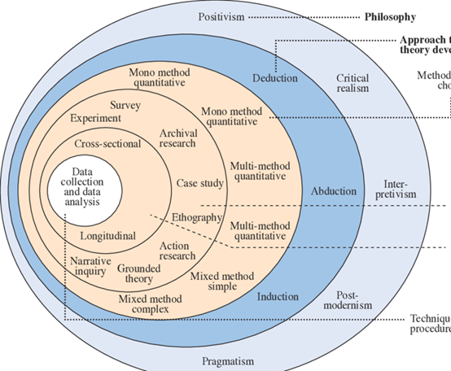

(Melnikovas, 2018)

Philosophy
To conduct the right research Philosophy was used, there are three different types of philosophy used, the one which is more useful within the research and the one that will be discussed is interpretivism, this is based on the influence of social and cultural factors. It mainly focuses on people thoughts and ideas. As part of the research a survey has been conducted, this comes under interpretivism as it has gathered individual’s thoughts and idea of the topic and expresses their opinions within the questionnaire (Crossley, 2021).

Approach and Strategy
In order to obtain the research, primary research is used as the best method to collect appropriate research, the best method which would allow more responses is an online questionnaire. This allows a wider range of feedback and the thoughts and ideas from the public. By using a questionnaire, it allows the appropriate questions to be asked in order to gather the correct research to back up the topic. The type of questioned being ask in the questionnaire allows the data to be compared and analyses in order to provide a better understanding of the research and to gather the public perspective (Thomas, 2003).
The questionnaire strategy of the research onion is linked with an Induction approach as it seeks out the understanding from people’s perspectives. It demonstrates reliable and pure data through this method. By using a questionnaire, it will be qualitative research, due to it being associated seeking for responses which helps flesh out perspectives. This strategy is mostly used to observe contributing variables among different data. This is due to the research that can be gathered from the public’s thoughts and ideas (Sahay, 2016).

Choices
The research which has been used is the mono method, this is where they choose one type of data to be collected, therefore in this research it has only collected qualitative data. The mono method would be used when creating the questionnaire as it requires there to be responses from numerous responders. This method was used as it isn’t going to be compared to any of research, I will just be taken from the data it has gathered from the questionnaire and analyses through qualitative data (Hayley, 2018).

Time Horizon
The time horizon in the research onion is the time where it takes to carry out the research and to collect and analyses the data for the topic. The cross-sectional approach was used as it was done in a short period of time, cross- sectional approach is where the time horizon means that the focus of the research is on the current situation for example as it was a questionnaire it needed to be sent out and done in a short period of time due to the deadlines and the time it needed to be managed in (Rafael 2016).

Techniques, Data, and analysis
The data will be collected by the use of a survey using a software, this is chosen as it will be easier to conduct and makes it simpler to send out, there will be eight question to answer in total all being yes or no answers, by doing this it allows the audience to answer the question in a simply way instead of getting them to write paragraphs. By using a survey, it makes it easier to analyses as it will be evaluated using qualitative data. The techniques used for the research is interpretivism, this will be used to collect the data and analyses it. This technique expresses responder opinions and ideas (Melnikovas, 2016). The data which will be collected will be from a survey, there are 44 participants the majority of them being female. The analysis of the survey will be done by using a graph to see each part of the participants opinions and what they believe to be the right response. By using a graph, it narrows It down into numerical data, making it easier to see what response is the highest (Saunders, 2009).

Data collection
In order to collect data, using a survey was the most suitable method due to the number of participants that can be involved with the survey, this is for the reason that it was an online survey as it allowed a majority of participants to accesses the questionnaire. By having a questionnaire, it shows the participants thoughts and opinions. By making it yes or no choice It will be more beneficial when analysing and collecting the data, this is due to it being easier to see what the induvial thoughts are and how they would view the topic. Data collection is crucial when it comes to analysing research, as it is ensuring that the information is rich and reliable, which is then collected for statistical analysis, in order for the data decisions can be made for research. Therefore, by choosing to do a questionnaire it makes it more reliable as it’s the thoughts and opinions of individuals, it is also easy to excess and doesn’t take up a lot of time to complete it (Driscoll, 2011).

Reliability and Validity
The key areas to making sure reliability and validity is used within my methodology is crucial in order for my findings to be analysed accurately. Reliability is about the consistency of the measures, this is ensuring that the participants are able to answer the questionnaire and that it will be a reliable source.
Validity is about the accuracy of the measures, this is being how truthful the test will be and how accurate the findings will be compared to online sources. It displays if the research from the questionnaire produces results that corresponds with further information, if the participants opinions are the same as other individuals and if they agree with the facts (Middleton, 2022).

Ethical consideration
Ethical consideration is crucial during research as there needs to be no harm or create a risk to participants. Ethics needs to be considered when conducting an online survey in order to not invade anyone’s privacy. This was delt by it being an anonymous questionnaire, making sure it was for participants over the age of 18 and ensuring to all individuals that they don’t have to take part in the questionnaire if they don’t wish to. When collecting data, it needs to be collected fairly and ensure that the research is completely reliable (Bryman, 2007).
When it comes to ethical consideration it was carefully thought out before starting research. An ethical form was provided by UWTSD and filled out before starting and was approved by supervisors that the research we were going to be conducting was approved. The online questionnaire needed to pass ethical consideration as it needed to main confidentially and to inform the participants what they will be taking part of and if they wished to not participate, they didn’t have to (Resnik, 2020).

Limitations
There have been a few limitations when it comes to the research the first one being COVID-19, this made it harder to choose other options such as an interview due to their being so many procedures in places. This led to conducting an interview where you can receive a wide range of responses instead of just one individual. It has also affected the university as it has been closed for a couple of months and limited the amount of time you can attend the university making it more challenging to communicate with students and staff.
A further limitation was the timing we have for the dissertation, it can be challenging to plan and organize the timing as there is a short period of time to getting the research done and making sure there is enough participants to take part in the questionnaire to receive a reliable and validity finding.
Additionally, by creating a questionnaire its more difficult to receive the crucial information as it’s the publics thoughts and opinions. Whereas if there was an individual who had the experience from the chosen topic it would be more reliable information as they have experience and have the knowledge of the topic. Being limited to not knowing a wide range of professional is challenging when conducting an experiment to find reliable data (McCambridge, 2014).

Chapter 4- Findings
In this chapter of the research, the primary data will be analysed and presented. There were eighty-eight responses to eight questions all aiming to identify if children can be influenced by their parent’s behaviour. This chapter will also gain information based in the gap in the literature review and will be compared with the information provided from the participants and gather the public’s opinions (Mutzler, 2010).

Data Analysis
The purpose of data analysis is to extract useful information from the findings, which allows us to take the data from the questionnaire in order to analyse the outcome to finally come to a conclusion of the results which can later be discussed (Johnson, 2022).
The data retrieved from the questionnaire will be analysed on Microsoft Excel, this is the best form to analyse the data as it shows a clear image of each question and the participants responses. By using Microsoft Excel, it shows the percentages of the participants opinions (Goldwater, 2007).
The approach that had been taken was to create a questionnaire, this was decided as it was the best possible outcome to achieve all the research. Survey monkey was the platform that was used as it was the easiest way to send out the questionnaire to as many people as possible. It was easy to share the link out via social media which worked the best to get plenty of responses (Brown, 2010).
The participants were split into two groups being females and males to gather the mixed opinions from different genders the age range went from 18-60, by having a wide age gap it allowed the research to be analysed under how each age group thinks and what their opinion of the topic is. The questionnaire allows the researcher to explore and discover individual’s opinions. Quantitative data will be used to analyse the data, due to it being an opinion-based questionnaire (Chyung,2017).
The study required 88 participants, all being over 18, 62% were female and 38% were male. There were no responders who chose “other” to describing their sex. Participants responded anonymously and voluntary and it was made clear that they can redraw from the study at any time.
The participants were all over 18, most participants who responded to the questionnaire were 18 and over. 72% of participants were age between 18-25 this is where the majority of the feedback from the questionnaire came from. 10% of the participants where aged between 26-35, another 10% were aged between 36-45 and the remaining 8% were aged 55-65. From this it is clear that there wasn’t as many participants as possible age between the ages of 55-65, resulting in the findings coming from the younger population.

Analysis
The graph below shows the opinions of what the participants thought, 54% believe that being raised in a negative environment can have an impact on a child’s behaviour. Whereas 23% of the participants believed that children are born with criminal tendencies and the final 23% were not sure.
As shown the majority of participants where aged between 18-25, from the findings for question 3 it displays that most of the participants believe that children are born into a negative environment which can result in them having a criminal tenancy. As the majority of the participants where aged between 18-25 this graph shows that the majority of the 54% where all young adults. This might indicate that young adults have experienced a negative environment which has turned their opinion to being raised in a negative environment influences how a child behaves.
As previously discussed, there are many discussions when it comes to nature vs nurture, however there isn’t truly a correct answer for it. The evidence that has been collected can back it up, as the majority of the participants have said that being brought up in a negative environment can alter a child’s behaviour, however not everyone who took part agreed with this statement, some participants believe that they are born with criminal tendencies. As stated when entering adulthood they are faced with many different experiences which will alter the way they behaviour even though having bad genes can run in the family, the environment around them has a lot to play in their growing up and their behaviour, this is supported by the evidence collected in the questionnaire as the majority of participants also believe that if a child has witnessed a negative environment or seen their parents been imprisoned that can have a negative effect on their behaviour and life style choice (Honsken, Hunt, wedell, 2019).
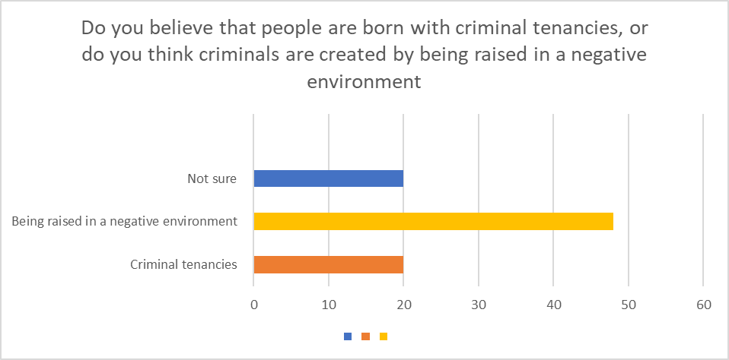
Q3

Question 4 demonstrates that 66% of the participants agree that if a child’s parent is sent to prison, they have a greater possibility that their child will also go to prison. The following 11% answered the question no and, 23% were not sure.
As previously discussed, the majority of participants are aged 18-25 therefore, a lot of young adults believe that after seeing a parent go to prison children have a greater chance of following them. The media can also have a big role with the decision the participants have made due to the media portraying more information such as saying their father or mother have gone to prison, which makes people more aware who is being sent to prison and what crimes they have committed.
Linking back to the literature review, defining a child’s upbringing has got a crucial role when it comes to their parents, they are influenced by everything they do from their behaviour to their physical characteristics. Therefore, if a child was to witness a parent going to prison there is a higher chance, they will themselves go down that pathway. The graph shows clear evidence that if a parent is sent to prison there is a higher chance their children will (Calderon, 2018).
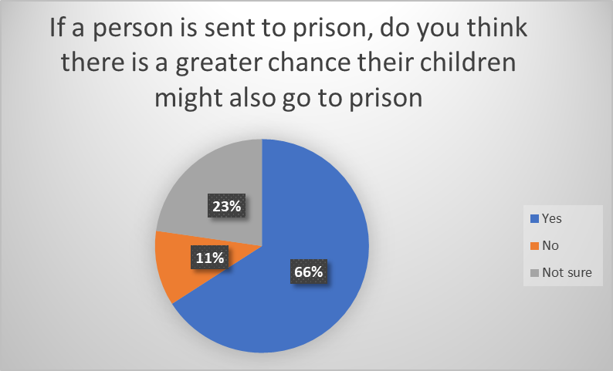
Q4

Question 5 clearly shows that the majority of the participants agree that even though a child has a traumatic childhood they can still lead a normal life. 72% of the participants said yes agreeing that children can have a normal life, whereas the following 16% said no, they don’t believe a child can have a normal life. The remaining 12% wasn’t sure.
Looking back from the first two questions there is a clear connection that as the majority of the participants are aged 18-25, they believe that there is a way to turn a child’s life around. This could be a strong belief to young adults as they could of witnessed this when growing up or seen it from a friend’s perspective. In today’s society there is more support out there for children who have experienced a traumatic up bringing. As part of the research, it is clear that ACE’s can play a huge role in a child’s life, if they have suffered trauma in their life, it can affect how they act when entering adulthood. However not every child will live a negative lifestyle there is support in place to help prevent a child from falling down the wrong path and helping them to live a long and healthy lifestyle (Feldman, 2008)
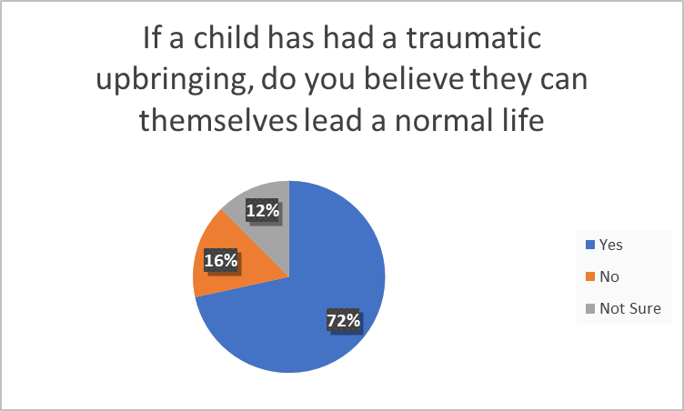
Q5
When asked if the participants agreed with the statement below, 51% of the participants agreed with the statement, 41% strongly agreed and the remaining 8% neither agreed nor disagreed. As shown, none of the participants disagreed with the statement.
The majority of the participants either strongly agree or disagree with the statement as they believe there should be support for children who have experienced a traumatic childhood. As the majority of the participants agree with the statement it is clear that the public opinions over the years have changed, from the findings it shows that people can see that even though children might have a negative upbringing there is support for them and they can change their lives around.
According to Burke-Harris (2007) the repeat stress that a child can experience when growing up can have a negative effect on the brain, this can be to do with any traumatic experience in a child’s upbringing. One main area which can result in a child having a traumatic upbring is ACE’s, which has been previously discussed (Demkova, 2015). From the evidence gathered it is a clear that the publics opinion shows that even though children may experience traumatic childhood there is still areas of support for children in order for them to have a full and healthy lives as adults.
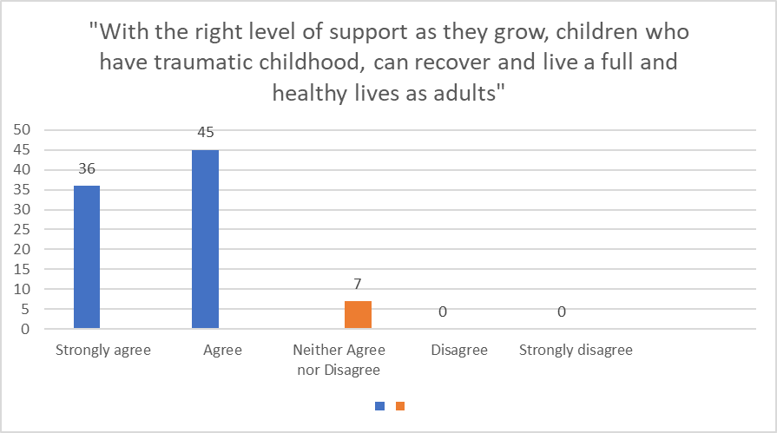
Q6

When analysing this statement, it is clear that you can see that 82% of the participants agree that childhood experiences are a powerful thing and can set up a pathway which children will follow, whereas the remaining 18% neither agreed nor disagreed.
As majority of the participants agreed with this statement it is clear that we can see that a childhood experience can be so powerful it can set their pathway when entering adulthood. It is extremely important that when a child is growing up that it is a positive experience as it will shape the way they behaviour. Witnessing a traumatic event in their life can alter the path they choose later in adulthood.
Linking back to previous research, it shows that if a child experiences ACE’s it can affect them in long and short term, the experiences a child can suffer at childhood can affect their future developmental pathway (Collingwood, 2018). From the results gathered from the questionnaire it shows strong results agreeing that a childhood experience has a lot to do with the developmental stages of a child’s future.
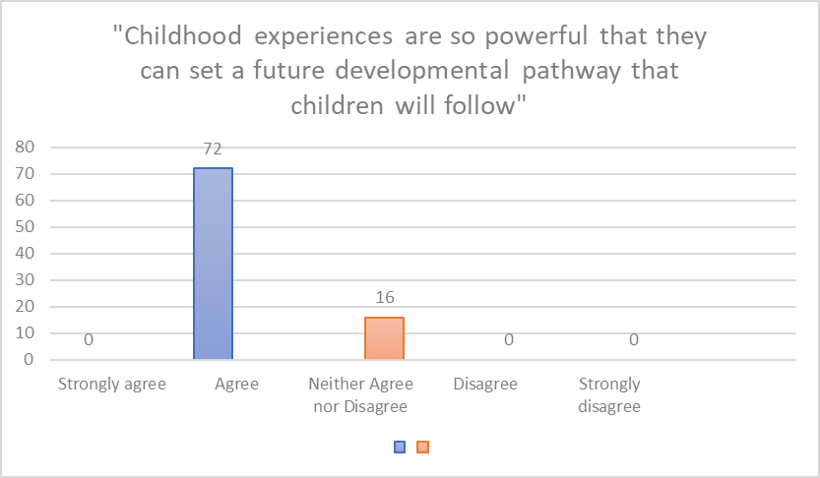
Q7

Question 8 ask if the participants believe there should be more support for vulnerable children, the results from the questionnaire where all unanimous, leaving 100% of the participants saying yes. It is clear from the result that there should be more support out there for vulnerable children. As we have established in question 6 the participants responses agree that with the right support from the correct people children with troubling upbringing can live health and long lifestyles.
Every age category has said yes to children receiving more support which shows that no matter the age group everyone is aware there should be more support for children in order for them to also have the opportunity to live a positive life. As majority of the participants are aged 18-25, which is young adults they have all said there should be more support, this may be to do with themselves witnessing vulnerable situation or even themselves as children who were vulnerable and needing that support to encourage them to a healthy life.
As mentioned prior to analysis of results, there is clear evidence to suggest that by providing the correct support for vulnerable children can themselves encourage them to have a healthy lifestyle. As supported by evidence found in the research statistic say that the amount of children offending has decreased over the ten years. This shows that by having the correct aid is working to support vulnerable children when they have had a traumatic childhood (Ministry of Justice, 2022).
Even though the result from the questionnaire suggests that there should be more support for vulnerable children. By having the correct support, we can clearly see the decrease in crime happening. From the evidence collected it is clear that there could be more support out there and to make it more known about the support around.
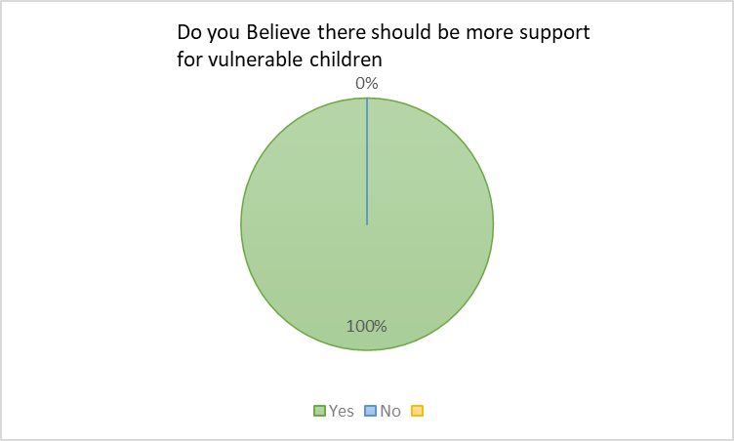

Conclusion chapter 5
This chapter of the research of the project will present the findings from the study and will summarise all the research gathered from the literature review and questionnaire.
This chapter also aims to achieve the final objectives:
To critically analyse the primary research and to gather a better understanding if children of offenders themselves turn in to offenders.

Main findings
To summarise, one of the main findings discovered in this research was, if a child is to have a negative upbring such as being neglected, abused or anything under ACE’s the likelihood of them having criminal behaviour is relevantly high due to them only knowing bad behaviour and witnessing it in their childhood (Daines, 2021). Looking back on nature vs nurture, it is clear that there isn’t a correct answer, there are both explanations for each side. Nature is the environment you are brought up in and areas to adapt and learn new skills. As previously discussed, it shows that an individual can have the best upbringings but if they hang around with the round crowded in school it can easily influence their behaviour. As for nature it’s all to do with their genes and their parents. An area which was explored was a case study involving a set of twins which were separated at birth. From the findings it was clear that they had similar characteristic and similar features. However due to them being brought up in different environment they have different behaviours and patterns they followed due to what they had learnt (Brody, 2019).
It was found from the data gathered in the questionnaire that majority of the participants believe that a child can be influenced by the environment they are around, such as if a child is brought up in a negative environment, they are more likely to have criminal tenancies. After analysing the questionnaire, it was found that majority of the participants were ages between 18-25, this may indicate that they themselves have suffered or experienced some sort of trauma when they were in their childhood or even witnessed it themselves (Honsken, Hunt, wedell, 2019).
One main point to come from the research was, the question if a parent was sent to prison would their children follow, from the research it suggested that parent imprisonment has a high impact on a child’s behaviour. Watching a parent go to prison can have damaging effect on their mental health but also social and educational. Witnessing a parent go to prison has long lasting effect on children, it may affect their future and also send them done the path of committing crimes (Morgan, Gill, 2014).

Implications
The study indicates the same response, which was discovered in the research, the data from the questionnaire shows that the participants agree that parent imprisonment has a greater chance of their children also going to prison. This data correlation with the findings due to the children witnessing and experiencing their parents going to prison. It is clear from the data collected from the questionnaire and research support each other making it clear that it can have a negative effect and cause trauma on the child.
In conclusion to the initial question, is there a greater possibly that the children of offenders will themselves become offenders, it is clear that from the research found and the data collected there is a greater possibility that if a child has witnessed some sort of trauma in their childhood or experience the trauma of their parents going to jail it can affect their own behaviour and mental health. Seeing their parents with incarcerated can have a long-term effect on their own adulthood making it harder to stay out of trouble and have a health and long lifestyle. However as discovered there is support out there for children suffering with ACE’s or trauma in their childhood which can help them get on the right path to having a healthy lifestyle.

Recommendation
Following the recent study, it is clear there are some recommendations Which can be made overall, the main point being providing enough support for young individua’s who have suffered with some sort of trauma in their life, by having the support in place it can prevent them from offending.
It also needs to be more of an awareness’s of ACE’s and the trauma children can experience. There needs to be more knowledge and a better understanding of what it’s like for children to witness and experience trauma as a child and to seek out the signs of neglect and abuse.

Limitations
A limitation that was faced during the research was the number of participants, due to it being done over a short period of time it was harder to gather responses, especially the website which was used as it limited it to how many responses, which resulted in having to make two of the same question to send out to more people in order to gather more participants.
Another limitation was the participants were mainly women, due to this the majority of the results were from women participants and lacked in the opinions from males and what their perspective was.

References

Asmundson, G, Afifi, T, (2019), Adverse Childhood Experiences Using Evidence to Advance Research, Practice, Policy, and Prevention, 1st ed, United Kingdom
Asmundson, G, Afifi, T, (2019), Adverse Childhood Experiences, Using Evidence to Advance Research, Practice, Policy, and Prevention, first ed, London, United Kingdom
Barbarin, O, &, Wasik, B, (2011), Handbook of child development and early education, research to practice, second ed, Spring street, New York
Bolton, P, (2021), Early intervention: Policy and provision, Available at: https://researchbriefings.files.parliament.uk/documents/CBP-7647/CBP-7647.pdf (Accessed: 10th January 2022)
Brown, G, (2010), Practical assessment, research and evaluation, Available at: https://scholarworks.umass.edu/cgi/viewcontent.cgi?article=1227&context=pare (Accessed: 18th April 2022)
Bryman, A (2007) Business Research Methods, 2nd edition. Oxford University Press.
Burke-harris, N, (2007), Toxic stress can harm your child, available at: http://edition.cnn.com/2014/09/26/opinion/harris-toxic-stress/index.html (Accessed: 3rd May 2022)
Cafasso, J, (2021), Traumatic events, Available at: https://www.healthline.com/health/traumatic-events#responses-to-trauma (Accessed: 8th February 2022)
Calderon, A, (2018), Interview: Changing Parental Behaviour with Behavioural Tools Can Help Children Reach their Full Potential, Available at: https://blogs.iadb.org/desarrollo-infantil/en/parental-behavior-influences-child-development/ (Accessed: 20th April 2022)
CDC, (2020), Coping with a traumatic Event, Available at: https://www.cdc.gov/masstrauma/factsheets/public/coping.pdf (Accessed: 8th February 2022)
Chen, A, (2019), Largest US twin study probes whether nature or nurture makes us sick, available at: https://www.theverge.com/2019/1/16/18185613/health-genetics-environment-nature-nurture-science (Accessed: 15th February 2022)
Cherry, K, (2020), What the bobo doll experiment reveals about kids and aggression, available at: https://www.verywellmind.com/bobo-doll-experiment-2794993 (Accessed: 20th February 2022)
Chidi, R (2016), Understanding the research onion: an illustration, available at: https://nairaproject.com/blog/understanding-the-research-onion-methodology.html (Accessed: 21st March 2022)
Chyung S, Roberts K, Swanson I, Hankinson A (2017) Evidence-Based Survey Design: The Use of a Midpoint on the Likert Scale, Available at: https://scholarworks.boisestate.edu/cgi/viewcontent.cgi?article=1086&context=ipt_facpubs (Accessed: 18th April 2022)
Clarke, N, (2021), London youth crime figures have fallen over the last five years, Available at: https://www.swlondoner.co.uk/news/17032021-london-youth-crime-figures-have-fallen-over-the-last-five-years (Accessed: 20th February 2022)
Collingwood, S, (2018), The little book of adverse childhood experiences, available at: https://www.saferbradford.co.uk/media/4sff2jsx/little-book-of-aces.pdf (Accessed: 15th February 2022)
Crossley, J, (2021), Saunders research onion: Explained simply, peeling the onion, layer by layer, Available at: https://gradcoach.com/saunders-research-onion/ (Accessed: 21st March 2022)
Daines, C, (2021), Effects of positive and negative childhood experiences on adult family health, available at: https://bmcpublichealth.biomedcentral.com/track/pdf/10.1186/s12889-021-10732-w.pdf (Accessed: 20th February 2022)
Demkova, S, (2015), Nadine Burke Harris: how childhood trauma affects health across a lifetime , available at: https://childhub.org/en/child-protection-multimedia-resources/nadine-burke-harris-how-childhood-trauma-affects-health?language=sq (Accessed: 29th March 2022)
Driscoll D L (2011) Introduction to primary research: observations, surveys, and interviews, Available at: https://wac.colostate.edu/books/writingspaces2/driscoll--introduction-to-primary-research.pdf (Accessed: 30th March 2022)
Early Intervention Foundation, (2020), Why does early intervention matter, Available at: https://www.eif.org.uk/resource/why-does-early-intervention-matter (Accessed: 24th January 2022)
Experts, A, (2020), UPTET Teacher Selection Paper-1 for Class 1 to 5, First ed, Darya Ganj, New Delhi
Feldman, M, (2008), Early intervention, the essential readings, second ed, Cornwall, United kingdom
Felson, S, (2020), Nature Vs Nurture theory: is it in our genes or our environment, available at: https://www.medicinenet.com/nature_vs_nurture_theory_genes_or_environment/article.htm (Accessed: 15th February 2022)
Gampell, L, (2022), Children Affected by Parental Imprisonment:
Goldwater, E, (2007), Using Excel for statistical data analysis, available at: https://people.umass.edu/evagold/excel.html (Accessed: 7th April 2022)
Haddad, D, (2020), Biological factors that influence child development, available at: https://www.verywellfamily.com/biological-factors-affecting-child-development-2162219 (Accessed: 15th February 2022)
Hayley, S, (2018), research onion, available at: https://tourismteacher.com/research-onion-beginners/ (Accessed: 21st March 2022)
Henig, R, (2020), Beyond Nature Vs Nurture, What makes us ourselves?, The New York Times, 29th September, available at: https://www.nytimes.com/2020/09/29/books/review/unique-david-j-linden.html (Accessed: 7th February 2022)
Hilton, A, (2020), Learning to Research and Researching to Learn, first ed, Cambridge, United Kingdom
Hosken, D, Hunt, J, Wedell, N, (2019), Genes and behaviour: beyond nature-nurture, first ed, west Sussex UK
Hu, C, (2018), A new documentary chronicles the lives of triplets separated at birth in a controversial study — here's how scientists continue to use twins in research, Available at: https://www.businessinsider.com/three-identical-strangers-twin-studies-nature-vs-nurture-2018-7?r=US&IR=T (Accessed: 7th February 2022)
Ivan, S, (2021), Qualitative Data Collection: 7 Things Researchers Need to Know to Get it Right, available at: https://www.nichq.org/insight/qualitative-data-analysis-7-things-researchers-need-know-get-it-right (Accessed:31st January 2022)
Johnson, D, (2022), What is data analysis? Research, type, methods, techniques, available at: https://www.guru99.com/what-is-data-analysis.html (Accessed: 7th April 2022)
Leonard, J, (2020),Everything you need to know about Adverse childhood experiences, Medical news todays, 16th June, Available at: https://www.medicalnewstoday.com/articles/adverse-childhood-experiences (Accessed:8th February 2022)
Maccoby, M, (2000), Parenting and its effects on children: on reading and miss reading behavior genetics, available at: https://www.annualreviews.org/doi/10.1146/annurev.psych.51.1.1 (Accessed: 8th February 2022)
Macnow, A, (2020), Behavioral science review, 2nd ed, Third Avenue, New York
Matin, E, (2017), Hidden consequences: the impact of incarceration on dependent children, available at: https://nij.ojp.gov/topics/articles/hidden-consequences-impact-incarceration-dependent-children (Accessed: 20th February 2022)
Matzler, K, (2010), Importance performance analysis revisited: the role of the factor structure of customer satisfaction, available at: https://www.tandfonline.com/doi/abs/10.1080/02642060412331300912 (Accessed:7th April 2022)
Mauldin, A, (2022), Teratogen, what is it, examples and more, available at: https://www.osmosis.org/answers/teratogen (Accessed: 29th March 2022)
McCambridge J, Kypri K, Elbourne D (2014) Research participation effects: a skeleton in the methodological cupboard. Available at: https://www.ncbi.nlm.nih.gov/pmc/articles/PMC4236591/ (Accessed:21st March 2022)
McLeod, S, (2018), Nature Vs Nurture in psychology, available at: https://www.simplypsychology.org/naturevsnurture.html#:~:text=Nature%20is%20what%20we%20think,and%20learning%20on%20an%20individual (Accessed: 7th February 2022)
Medline plus, (2020), Traumatic events and children, available at: https://medlineplus.gov/ency/patientinstructions/000588.htm (Accessed: 8th February 2022)
Melnikovas, A, (2016), Towards an explicit research methodology: adapting research onion model for future studies, available at: https://jfsdigital.org/wp-content/uploads/2019/01/03-Melnikovas-Onion-Research-Model.pdf (Accessed: 22nd March 2022)
Melnikovas, A, (2018), Towards an explicit research methodology: adapting research onion model for futures studies, Available at: https://www.researchgate.net/publication/333388233_Towards_an_explicit_research_methodology_Adapting_research_onion_model_for_futures_studies (Accessed: 30th March 2022)
Middleton, F, (2022), Reliability Vs validity in research/ differences, type and examples, available at: https://www.scribbr.com/methodology/reliability-vs-validity/ (Accessed: 22nd March 2022)
Mingers, J, (2014), Systems thinking, critical realism and philosophy, A confluence of ideas, second ed, Third Avenue, New York
Ministry of Justice, (2022), Youth justice statistics 2020/21, available at: https://assets.publishing.service.gov.uk/government/uploads/system/uploads/attachment_data/file/1054236/Youth_Justice_Statistics_2020-21.pdf (Accessed: 20th February 2022)
Mitchell, K, (2020), Innate, How the wiring of our brains shape who we are, 2nd Ed, Oxfordshire, Princeton University Press
Morgan, J, Gill, O, (2014), Children affected by the imprisonment of a family member, A handbook for schools developing good practise, available at: https://www.nicco.org.uk/userfiles/downloads/453%20-%20Welsh%20Schools%20Handbook_English.pdf (Accessed: 20th February 2022)
Morin, A, (2022), Treating the effects of childhood trauma, available at: https://www.verywellmind.com/what-are-the-effects-of-childhood-trauma-4147640 (Accessed: 30th March 2022).
Murray, J, &, Farrington, D, (2008), The effects of parental imprisonment on children, available at: https://www.nicco.org.uk/userfiles/downloads/570%20-%20Murray%20and%20Farrington%20-Effects%20of%20Parental%20Imprisonment%20on%20Children.pdf (Accessed: 20th February 2022)
Neaum, S, Envy, R, (2019), Child development for early year students and practitioners, fourth ed, City Road, London
Needs, Solutions and Rights – the Evidence from Across Europe, available at: https://www.niacro.co.uk/sites/default/files/publications/NIACRO_Occasional_Paper_Children_parental_imprisonment.pdf (Accessed: 30th January 2022)
NHS Wales, (2022), Adverse Childhood Experiences and their association with chronic disease and health service use in the Welsh adult population, available at: https://www.wales.nhs.uk/sitesplus/documents/888/ACE%20Chronic%20Disease%20report%20%289%29%20%282%29.pdf (Accessed: 15th February 2022)
Novak, I, (2019), why neuroplasticity is the secret ingredient for kids with special needs, available at: https://cerebralpalsy.org.au/sstposts/StoryId1575590115573 (Accessed: 29th March 2022)
Purkis, Z, (2022), ‘I shot a policemen in the back- 20 years later we’re friends’, available at: https://www.mylondon.news/news/south-london-news/i-shot-policeman-back-stuck-22648226 (Accessed: 20th February 2022)
Rensnik D (2020) What is ethics in research and why is it important? Available at: https://www.niehs.nih.gov/research/resources/bioethics/whatis/index.cfm (Assessed 22nd March 2022)
Sabater, V, (2021), Why do children imitate adults, Available at: https://exploringyourmind.com/why-do-children-imitate-adults/ (Accessed: 20th February 2022)
Sahay, A, (2019), Peeling Saunders’s research onion, available at: https://www.researchgate.net/publication/309488459_Peeling_Saunder's_Research_Onion (Accessed: 30th March 2022)
Saunders’s, M, (2009), Research methods for business students, fifth ed, Edinburgh
SCCJR, (2019), Impact of punishment: Families of people in prison, available at: https://www.sccjr.ac.uk/wp-content/uploads/2019/10/11-Impact-of-punishment-prisoners-families.pdf (Accessed: 24th January 2022)
Shewark, E, (2021), The impact of children’s emotions and behavior on parenting, Available at: https://ssri.psu.edu/news/impacts-childrens-emotions-and-behavior-parenting (Accessed: 30th January 2022)
Shuttleworth, M, (2022), Bobo doll experiment, available at: https://explorable.com/bobo-doll-experiment (Accessed: 20th February 2022)
Thomas R (2003) A general inductive approach for qualitative data analysis. Available at: https://citeseerx.ist.psu.edu/viewdoc/download?doi=10.1.1.462.5445&rep=rep1&type=pdf (Accessed: 30th March 2022)

Appendices

Questionnaire


