

Programme: Master of Business Administration

Module: International Marketing: Principles and Practices
Module code: LCMB7026

Assignment Title: Assessment component 1
Individual report

Topic: A Comparative Marketing Analysis of Cadbury in the United Kingdom and India
Lecturer’s Name: Tushara Balendran
Name: Tirth G Patel
Student ID: 2522415

Use of AI for proofreading: AI tools were used only to check grammar, spelling, sentence structure and clarity of expression. The ideas, analysis, research, sources and final academic arguments in this report are my own work.
Availability of original work: I have retained all original drafts, notes and supporting materials used to develop this assignment and can provide them if requested to demonstrate the development and authorship of the work.

Table of Contents
Introduction 5
Company Background 5
Comparative PESTLE 6
UK political factor — favourable and unfavourable 8
Economic 8
Social 12
A comparative cultural analysis of Hofstede's model. 13
Power distance (UK vs India) 14
Individualism vs collectivism 15
Masculinity vs femininity 15
Uncertainty avoidance 15
Long term orientation 16
Indulgence vs restraint 16
Advantages 17
Disadvantages 17
Technological factor 17
Legal 19
Environmental factor 19
The similarities and differences between PESTLE 21
Segmentation definition 21
Segmentation (UK and India) 22
Demographic segmentation (UK and India) 22
Geographic segmentation (UK and India) 23
Psychographic segmentation (UK and India) 23
VALS in the UK and India 24
Targeting definition 25
Targeting (UK and India) 25
UK concentrated marketing 25
The concentrated marketing in India 26
Positioning definition 26
Cadbury Dairy Milk Positioning Strategy: Brand, Benefits and Target Users in the UK and India 27
Marketing mix definition 30
The depth and filling of the product line – UK. 31
The depth of the product and line filling – India. 32
Product Width – India 34
Product Width – UK 34
Price definition 35
Pricing Factors and Strategies in the UK and India 35
Promotion 36
IMC definition (Integrated Marketing Communication): 36
In the UK and India, media usage is: 36
Promotion mix combination (UK vs India) 37
Sales promotion (UK and India) 37
Digital promotion (UK and India) 38
Place definition 38
Channel of distribution (UK & India) 39
Intensive distribution 40
Direct channel distribution 40
People 40
Training and motivation, people (UK and India) 40
Training and development 41
Motivation and engagement 41
Process – Customer complaint handling (UK and India) 42
Physical evidence – Websites and packaging (UK and India) 43
Packaging design (UK): 44
Packaging design (India) 45
7Ps comparison: UK vs India (Cadbury) 47
Market entry strategy – India 51
Why Cadbury chose local manufacturing and localisation in India 52
Advantages and disadvantages of the entry method – India 53
Advantages of local manufacturing (greenfield investment) 53
Disadvantages / challenges of local manufacturing (greenfield investment) 54
Ethical marketing practices – India (2 examples) 55
Unethical / ethically problematic practices – India (2 examples) 55
United Kingdom: STP evolution recommendation 56
Country B – India: STP evolution recommendation 57
Section 2: Gibbs’ Reflection 58
Gibbs’ definition 58
Feelings – before and after the task 60
Evaluation – strengths and weaknesses 61
Analysis – using Hofstede, STP and 7Ps, and what I learned 61
Conclusion – overall skills gained 62
Action plan – time management and numerical analysis 63
Final Conclusion. 64
Reference list 65

Introduction

The Cadbury (now a part of the Cadbury brand of the new group company, Mondelez International) As it has a long history with British heritage and operations that are locally adapted in India. this duality is used to explain how the macro environmental and cultural variables influence marketing decisions in the UK and India through the framework of PESTEL and Hofstede. Then the study of Cadbury can be used to conduct rigorous comparative analysis of segmentation, targeting and positioning (STP) and international adaptation of the 7Ps and analysis of market entry and ethical issues and strategy recommendations can be done in rich empirical settings and a reflective account of the report using Gibbs reflective cycle.

Company Background

It has a stable global identity, created in 1824 in Birmingham, based on quality and family ownership and the famous glass and a half milk story, which is actively moderated for different national contexts (Urde, Greyser and Balmer, 2007). Cadbury's evolution from John Cadbury's 19th century grocer to a global leader in confectionery is a continuity and a change in the context of postgraduate enquiry, acquired by Mondelez in the 21st century, with a strong UK heritage and brand equity, and an integrated multinational matrix of strategy and execution. Cadbury first introduced in India in 1948 and currently maintains a full-fledged manufacturing and distribution network, having established market leadership by innovating new products (such as local SKUs), reaching consumers in both rural and urban areas, and communicating around festivals and family events. The differences between the mature, brand saturated markets in the UK and the high growth, occasion driven markets in India offer ample opportunities to critically discuss the adaptation of the marketing mix, modes of entry, localisation of supply chains and ethical issues such as advertising to children and sourcing.

Comparative PESTLE

A comparative PESTLE analysis of Cadbury in the United Kingdom and India reveals that both countries are in a different business environment which influences Cadbury's international marketing strategy in different ways. The UK is a well-established, highly regulated and saturated confectionery market with a stable consumer base, high competition and high occasion-driven consumption, whereas India provides for faster growth, younger consumers and high occasion-driven consumption. On the political and legal side, both markets must be compliant with food standards and labelling legislation, with the Indian market being more complicated due to regional variations and less developed retail sector. Industry-wise, the UK is known for its higher purchasing power and lower category growth, while India has a high volume potential with increased income and growth in modern trade. Socially and culturally Cadbury has a great brand legacy in the UK, and in India, it has been able to tap into the local festivals, gifting culture and family-oriented consumption. There are also variations in technological and environmental factors; digital engagement and sustainability are key priorities in the UK market, whereas the Indian market requires a more comprehensive distribution efficiency and responsiveness to local supply chains. In general, Cadbury needs to find a balance between standardisation and adaptation to be competitive in both markets (Dey, 2021).
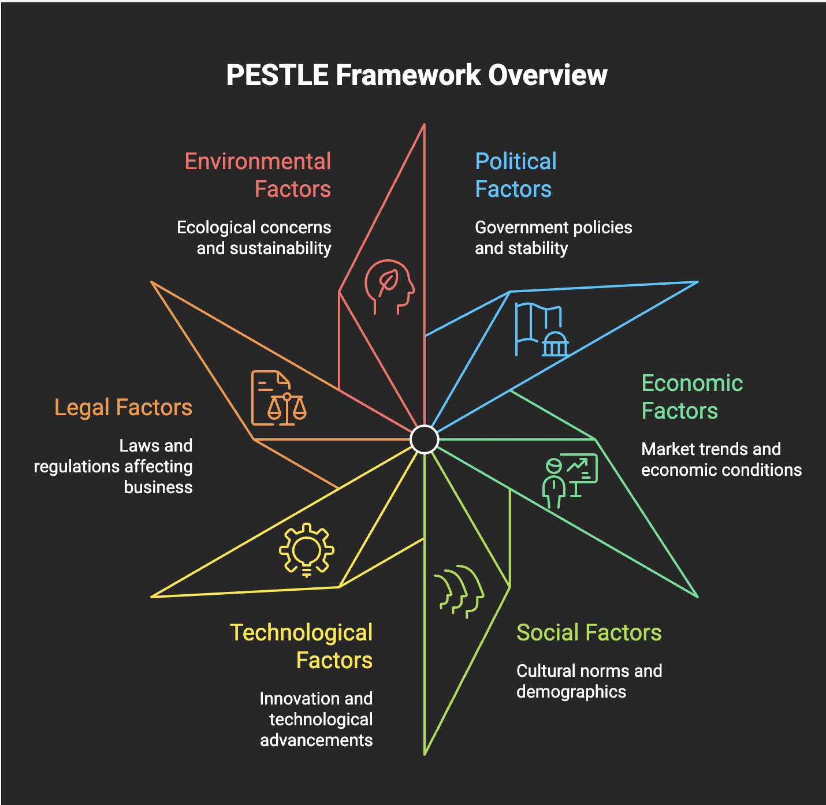
Source: Image is Created by Learner
Political

Political factor: Cadbury's presence in the UK is subject to strict regulations that have been a result of the country's departure from the European Union, public health policy and the introduction of new regulations on high sugar foods, all of which add to compliance costs and affect product and promotion decisions. In India, the political landscape is more about the complexity of the policies, tax changes and infrastructure conditions that impact distribution and market access, rather than mature market food regulation, but the size of the market and government support for domestic manufacturing also provide growth opportunities. Overall, Cadbury will need to navigate further regulation in the UK based on health concerns and a more complex and dynamic policy environment in India, which will require political adaptation as part of its international strategy (Lingham et al., 2025).

UK political factor — favourable and unfavourable
Favourable: The UK’s strong food-safety, product-composition and labelling rules are favourable for Cadbury because they create clear quality standards, build consumer confidence in trusted brands and benefit established firms such as Mondelēz that have the resources to meet complex compliance requirements (Lingham et al., 2025).
Unfavourable: Brexit-related customs requirements and stricter restrictions on advertising high-fat, salt and sugar (HFSS) products are unfavourable because they increase administrative and trading costs while limiting Cadbury’s ability to promote chocolate products, particularly to younger audiences (Lingham et al., 2025).
India—both favourable and unfavourable: India is favourable because government support for manufacturing and the country’s large consumer market create growth opportunities, but unfavourable because policy changes, GST administration and infrastructure differences across regions can complicate distribution, pricing and market access for FMCG firms such as Mondelēz India (Lingham et al., 2025).

Economic
Economic factor: Cadbury has two markets with wildly different economic contexts, and these contexts have a direct impact on the market's demand, pricing, and profitability. The confectionery market is mature and competitive in the UK and recent inflation, cost-of-living crisis and input cost pressures have dampened consumers' spending on discretionary snacks, creating a balance for Cadbury between affordability and margin pressures. In India, however, the market has greater potential for long-term growth due to increasing disposable income, large consumer base and escalating chocolate consumption, despite the fact that the market is price-sensitive and premiums need to be supported in terms of value, smaller pack sizes and occasion-based purchases. In both countries, Cadbury is also impacted by commodity price changes, particularly in cocoa and sugar, and exchange rates which affect import costs and pricing strategy (Law et al., 2019).
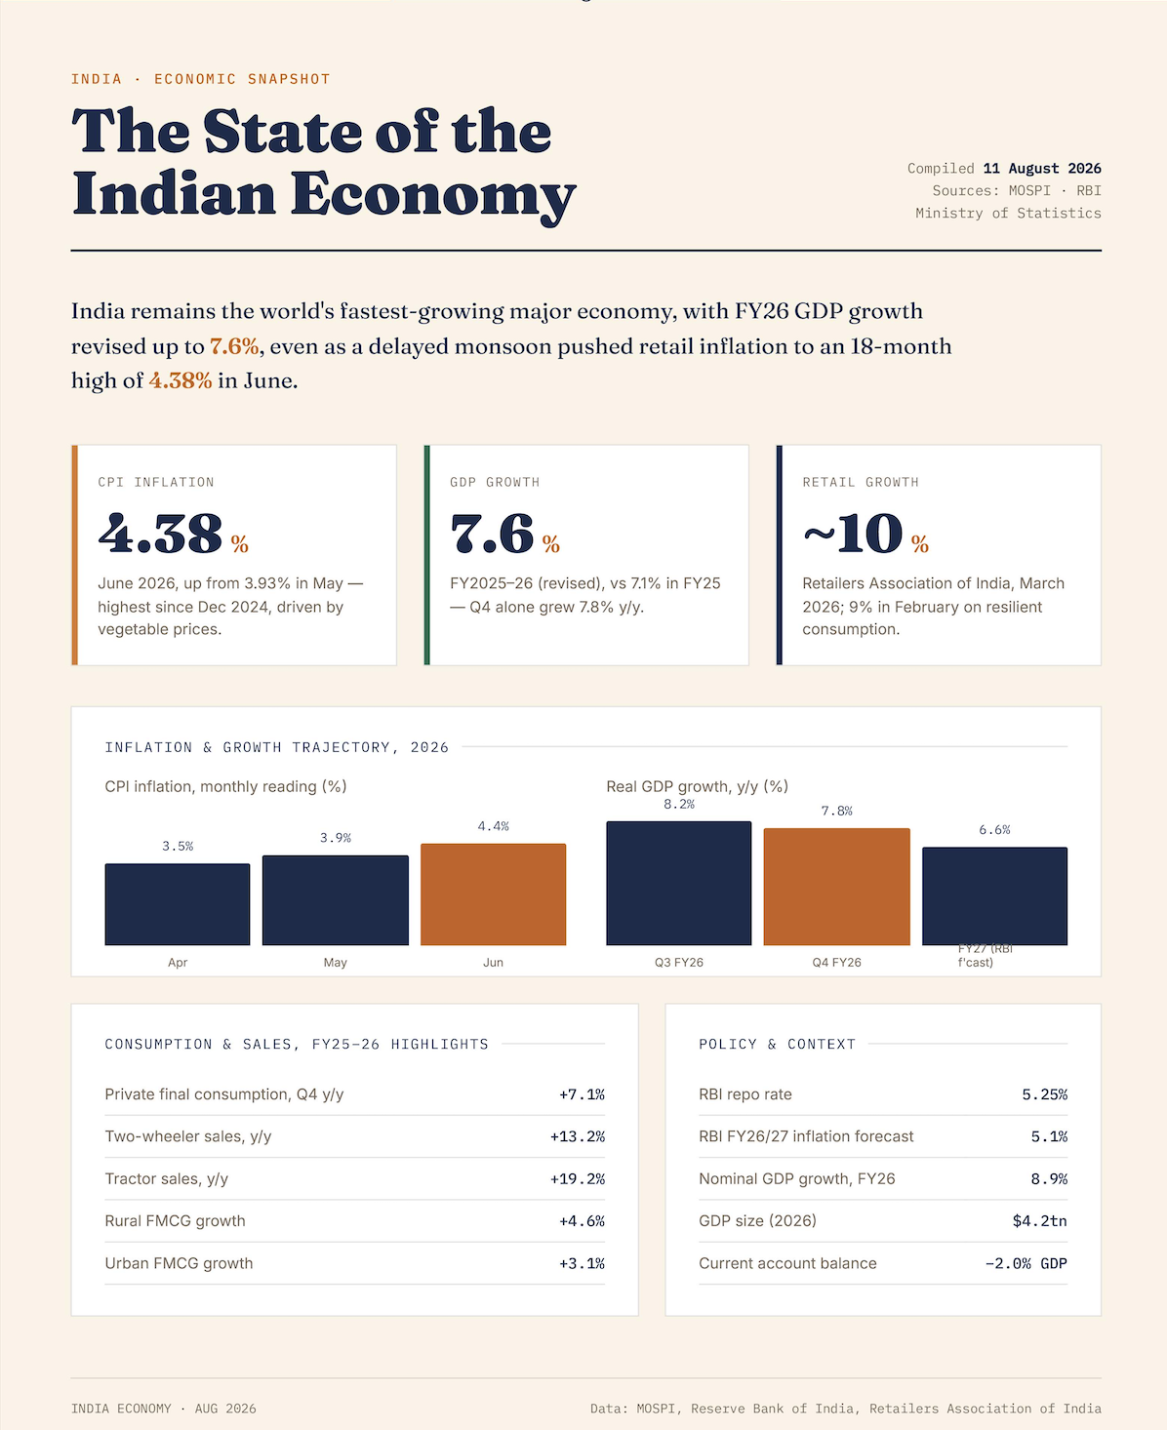
Source: site website
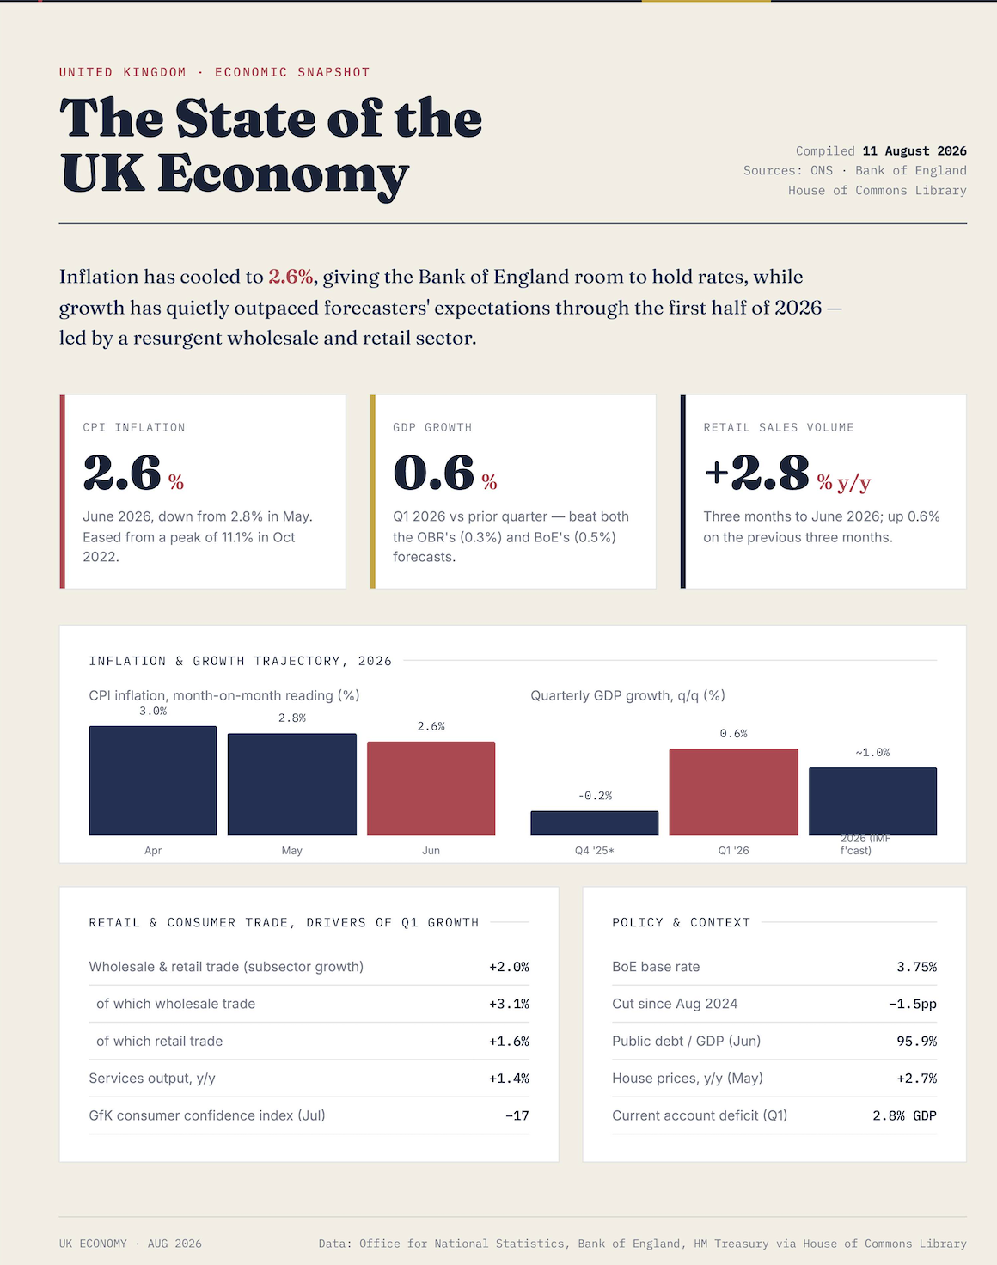
Source: site website
Favourable: India is economically favourable for Cadbury because rising disposable incomes, urbanisation and changing consumer preferences are increasing demand for chocolate, creating substantial long-term growth potential in a large consumer market (Law et al., 2019).
Unfavourable: Both the UK and India are negatively affected by rising cocoa, sugar, energy, packaging and transport costs, as these increase Cadbury’s production costs and force difficult decisions on price increases or reducing pack sizes, especially when consumers are price – sensitive (Law et al., 2019).

Social

Social factor: Social attitudes, consumption patterns and cultural significance of chocolate vary between the UK and India, influencing Cadbury's performance in these markets. Cadbury is well established in the UK as an everyday treat with brand loyalty, convenience and taste preferences being critical, but with an increasing health-conscious consumer base. But in India, Cadbury has had to deal with more fundamental cultural differences, as traditional sweets have always been linked to celebration, gift-giving and family rituals. The brand has, therefore, redefined the chocolate as a viable alternative to mithai, and tied it to collective celebrations like festivals, birthdays, exam success, etc., so that it doesn't sound out of the way or western. This cultural adaptation has been at the heart of Cadbury's success in India, with emotional marketing and family-centric messaging helping to make the brand a part of everyday social life (Dey, 2021).
For the UK, this social factor is partly unfavourable because rising health consciousness can reduce demand for high-sugar chocolate, although Cadbury benefits from strong existing loyalty and its role as an everyday treat.
For India, it is favourable because Cadbury has successfully adapted chocolate to local celebration and gifting traditions, positioning it as an acceptable alternative to mithai through family-focused and emotionally relevant marketing.

A comparative cultural analysis of Hofstede's model.

Hofstede's six dimensional model reveals significant cultural differences between the UK and India which are important in Cadbury's international marketing strategy. Power Distance is much lower in the UK, reflecting a more egalitarian society, and higher in India, reflecting higher acceptance of hierarchy and authority, which influences communication style and management expectations. The UK is also much more individualistic than India, where collectivist values are still more prevalent, allowing Cadbury to market to individual choice and self-indulgence and in India to family, sharing and social occasions. The UK is marginally more competitive and achievement-oriented in terms of masculinity, whilst India is marginally more balanced, impacting on the way status and aspiration are communicated. The two countries have moderate levels of uncertainty avoidance, with India being slightly more structured and reassuring when making a purchase. India has a higher score for long term orientation, meaning that it is more future oriented and values more in the long term, whereas the UK is more moderate. Lastly, the UK is more indulgent than India, and Cadbury can push indulgence and spontaneity more readily in the UK than in India, where indulgence must go hand-in-hand with cultural norms, celebration and social approval (de Mooij and Hofstede, 2010).
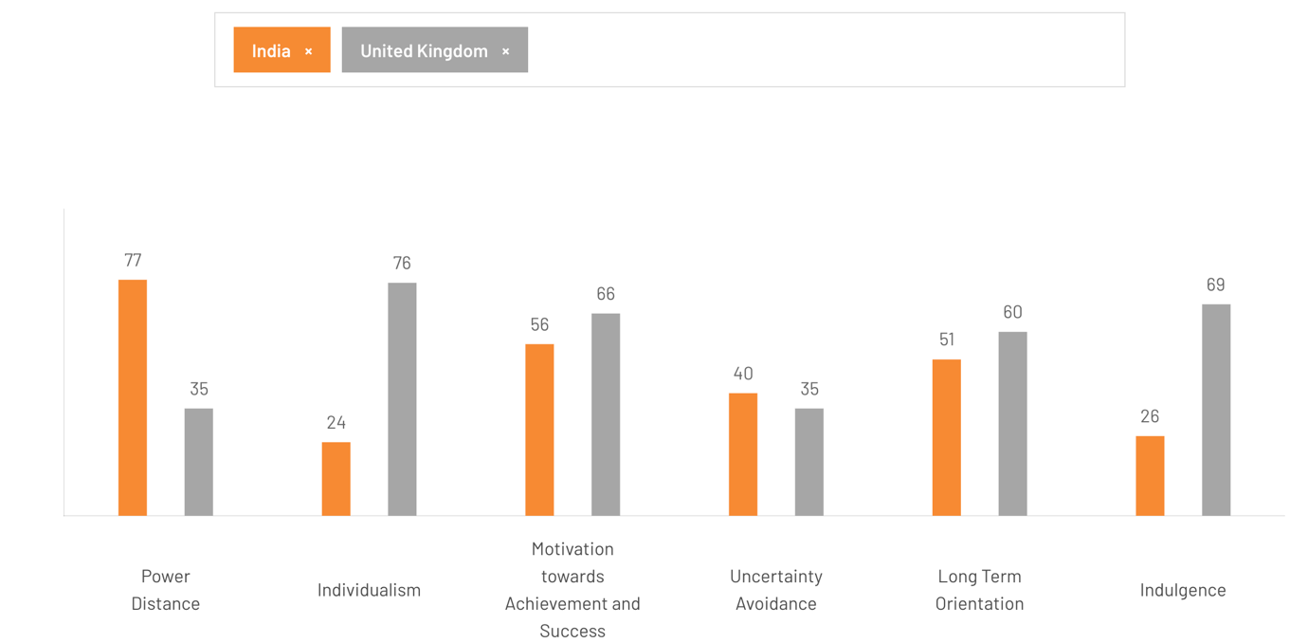
Source: https://www.theculturefactor.com/country-comparison-tool?countries=india%2Cunited+kingdom

Power distance (UK vs India)
The power distance scores are very different between the UK (around 35) and India (around 77), meaning that hierarchy and unequal power distribution is much more accepted in Indian society than in the UK. Organisations and consumer relations are relatively flat and informal in the UK and employees and customers are expected to be consulted and treated equally. In India, in contrast, the status of authority figures and senior managers is respected, decision making is more centralised, and consumers might be more swayed by status cues and endorsements by respected figures. This implies that Cadbury’s internal management and external marketing strategy in India should be more status-conscious and top down, whereas the UK should be more informal, participative and peer level (Giang, Agata and Efthymios, 2022).

Individualism vs collectivism
The UK has a very high score (around 89) on individualism, whereas India’s score is much lower (around 48), indicating that the culture of the UK is highly individualistic, while India has a collectivist culture with a growing individualism in urban settings. British consumers are consumers of choice, self-expression and individual enjoyment and Cadbury’s positioning in the UK could focus on “my treat”, self indulgence and independent decision making. However, Indian consumers are more rooted in their family and community networks, and group approval and shared experience can be a factor in purchasing decisions. Therefore Cadbury’s campaigns in India are more effective when they focus on sharing, giving, togetherness and social events, and position chocolate as an experience that brings people together, instead of just fulfilling individual desires (Shavitt and Cho, 2016).

Masculinity vs femininity
The UK (around 66) is slightly more masculine than India (around 56) indicating a greater focus in the UK on competition, achievement and material success. Themes of status, performance and “winning” might be more appealing to consumers in the British context, allowing Cadbury to appeal to consumers through aspirational messaging that suggests link between chocolate and reward, success or treating oneself after hard work. India’s score of 4.31 in the dimension of masculinity suggests that there is a balance between achievement and status, and that more subtle themes of competition and aggression may be more effective. Cadbury’s India marketing thus has an air of aspiration and emotional bonding, with chocolate being seen as a sign of success and an expression of love for family and friends (de Mooij and Hofstede, 2010).

Uncertainty avoidance
Both countries have relatively low scores on uncertainty avoidance, around 40 in India and 35 in the UK, meaning that people in both societies are able to tolerate ambiguity and are willing to consider new ideas and products, although slightly more structure and reassurance may be preferred by Indians. UK consumers are fairly tolerant of flexible rules and innovation, enabling Cadbury to try new flavours, formats and campaigns without a lot of explanation. Lower but not very low uncertainty avoidance in India means that Cadbury must create innovations that are safe, such as linking new products to the established sub brands, and reinforcing quality and reliability. This balance allows Cadbury to manage risk perceptions and continue to develop products in both markets (Ahmadi et al., 2021).

Long term orientation
On long term orientation, India has higher average scores (around 61) than the UK (around 51), indicating a more future-oriented and persevering culture in India than the UK with a more intermediate and mixed LTO in the UK. Cadbury’s India brand building can tap into the themes of continuity, tradition and long term trust and make chocolate a part of family rituals and multi-generational memories. Loyalty programmes, regular festival campaigns and ongoing investment in community initiatives all fit this long term thinking. The UK consumer is a little more interested in future possibilities, which allows Cadbury’s strategy to be a mix of long-term brand equity and short-term promotions and novelty, ensuring that the brand is relevant without being just traditional or based on heritage (Wang and Zhai, 2022).

Indulgence vs restraint
One of the most significant differences is in terms of indulgence, with the UK having a high score (around 69) and India a low score (around 26), suggesting a more restrained culture with more rigid social norms governing gratification. The UK is a place where it’s easier to enjoy life, treat yourself and enjoy spontaneous pleasure, which enables Cadbury to focus on messages of fun, everyday indulgence and emotional escape. However, there is a perception among many in India that self indulgence should be legitimised in certain acceptable scenarios, like festivals, celebrations or family gatherings. Cadbury’s marketing campaigns in India are consequently designed to make chocolate seem relevant to cultural events and moral judgments – “kuch meetha ho jaaye” at Diwali or Raksha Bandhan – so that the indulgence feels like a good thing to do, a shared pleasure, and a value that is not just myopic or over-indulgent (Shukla and Purani, 2012).

Advantages
Hofstede’s cultural dimensions model provides a simple and structured approach to comparing national cultures, transforming the many value patterns into a few easily understood and measurable dimensions of culture (e.g., power distance and individualism) that can be used in international marketing and management. The scores are available for many countries, which means that managers and students can compare markets systematically, for instance the UK and India, and can predict general differences in consumer behaviour, communication style and expectations of the workplace. It has also been applied and validated in business and cross cultural research, so there is a wealth of secondary literature, case studies and tools that can help analyse and guide organisations in their international expansion (Soares, Farhangmehr and Shoham, 2007).

Disadvantages
Although popular, Hofstede’s model is not without its limitations that need to be recognized in academic research. The original data were collected primarily from IBM employees in the 1960s-70s, a narrow, corporate, and predominantly male sample, and may not reflect the general attitudes of the entire nation, or even be relevant to the attitudes of today’s more diverse societies. The model also assumes that the countries are culturally homogeneous and that complex and dynamic cultures can be represented by numerical scores which may lead to oversimplification of differences, neglect of regional and subcultural differences and stereotyping. In addition, there are some doubts about the validity and reliability of some dimensions (particularly uncertainty avoidance and masculinity–femininity) and it is not possible to predict individual behaviour from national scores, therefore the framework is more of a macro level indicator than a precise diagnostic tool (Gerlach and Eriksson, 2021).

Technological factor
Cadbury’s operations in the UK and India are significantly affected by technological innovations, such as the use of digital technology, data analytics and media platforms, although these vary between the two markets. Cadbury has evolved sophisticated multichannel and e commerce capabilities in the UK, with integrated digital platforms, QR tagged outdoor posters, Amazon Ads and interactive campaigns like “Secret Santa” and “Worldwide Hide” all focused on personalising gifting, creating databases and stimulating online sales. By contrast, India offers challenges and opportunities as digital penetration continues to pick up pace, but many small retailers are still not formally online, Cadbury’s technological innovation is all about closing this gap with a mobile-first, hyper local and AI-first approach to campaigns like “Not Just a Cadbury Ad,” which leveraged geofencing and generative AI to market thousands of local stores alongside Cadbury products. In both markets, technology allows Cadbury to gain consumer data, personalise communication, implement user generated content campaigns and enhance its distribution and promotional effectiveness, but it’s important to match the level of infrastructure, retailer capability and consumer media consumption in the UK and India (Reporters, 2023).
For the UK, this technological factor is favourable because Cadbury can use well-developed e-commerce, digital advertising and data-led personalised campaigns to engage consumers and increase seasonal sales; for example, its digital Secret Santa activation reportedly engaged 3.4 million people and contributed to £80 million in additional revenue.
For India, it is also favourable but more challenging: rapid mobile and digital-media adoption enables Cadbury to use localised, AI-led campaigns and support smaller retailers, but uneven digital infrastructure and the large number of offline retailers can limit consistent implementation.

Legal
The legal factor has a significant influence on Cadbury’s operations in the UK and India, with food, advertising and consumer protection laws varying greatly. Cadbury in the UK are subject to a number of strict regulations on “high fat, salt and sugar” (HFSS) products (including restrictions on in store promotions, volume offers and placement, as well as a 9pm watershed for HFSS advertising on TV and a near total ban on paid online advertising targeting children, which are enforced under the CAP and BCAP Codes and overseen by the Advertising Standards Authority (ASA)). The rules have already resulted in the investigation and/or banning of several Cadbury campaigns and careful legal scrutiny of creative content and media targeting and brand level vs product level advertising. Cadbury is registered under the Food Safety and Standards Authority of India (FSSAI), which lays down standards for ingredients, labelling, health and nutrition claims, and advertising fairness, and products like Bournvita have been under a microscope for misleading or unsubstantiated health claims. In both markets, the legal environment is a significant external influence on Cadbury’s international marketing decisions, in terms of product formulation, packaging, claims, and promotion mechanics and media strategy (GOV.UK, 2023).
For the UK, the legal factor is unfavourable because HFSS rules restrict where and how Cadbury can promote chocolate, including limits on in-store placement, multibuy promotions and advertising to children; new TV watershed and paid-online advertising restrictions add further constraints from October 2025.
For India, it is also mainly unfavourable because FSSAI requirements limit product labelling and require nutrition or health claims to be scientifically substantiated, creating legal and reputational risk for products such as Bournvita; however, clear compliance can strengthen consumer trust.

Environmental factor
Cadbury, as a part of its parent company Mondelēz International, is affected by the increasing environmental regulations and stakeholder pressure in the UK and India, and this has a significant impact on its sourcing, manufacturing and packaging strategies. Cadbury also has targets for virtually 100% of its cocoa volume to be sourced sustainably in the UK, and for its cocoa sourcing to be more sustainable through initiatives like Cocoa Life and previous Fairtrade partnerships, as well as targets for reducing virgin plastic, nearly all Cadbury packaging to be recyclable and reducing greenhouse gas emissions. In India, the same ESG priorities are being achieved through plastic waste management and extended producer responsibility, with the aim of recycling up to 75% of post consumer plastics and eliminating or redesigning single use packaging for items like Cadbury Celebrations gift packs. In both markets, environmental demands from governments, NGOs and consumers are increasing, so Cadbury is constantly seeking new ways to deliver sustainable sourcing, packaging, energy and waste management, and is communicating these activities effectively and transparently to ensure the trust and long-term licence to operate (Cadbury, 2023).
For the UK, the environmental factor is mainly favourable, as Cadbury can strengthen consumer trust and meet stakeholder expectations through sustainable cocoa, recyclable packaging and lower-carbon manufacturing; for example, six Mondelēz UK production sites use 100% renewable electricity, while Cadbury has introduced packaging containing 80% certified recycled plastic.
For India, it is also favourable but operationally demanding, because actions such as recyclable packaging, removing single-use overwrap from Cadbury Celebrations packs and using renewable electricity can improve its environmental reputation, but require investment and strong waste-management systems.

The similarities and differences between PESTLE
These macro environmental trends, common to both the UK and India, are driving Cadbury to focus on compliance, transparency and innovation in both markets: politically stable democracies with clear food and advertising regulations, rising expectations in terms of health, sustainability and responsible marketing, and an increasing reliance on digital technologies and data to reach consumers and manage its supply chain. But significant differences exist in how these factors affect Cadbury’s strategy: UK confectionery market is mature, slower growth and more tightly regulated by HFSS and child-focused advertising regulations, while India’s market is faster growing, more price sensitive and is occasion driven, with evolving but less stringent regulations. Socially, UK consumers are more individualistic and indulgent, with a more personal and regular chocolate consumption, whereas Indian consumers are more collectivist and ritualistic, and need Cadbury to tie sweets to festivities and family occasions. Technology-wise, the UK has a high density of retail and e commerce platforms and offers advanced multichannel campaigns, whereas India has a combination of modern retail, kirana stores and swift mobile adoption, making Cadbury go mobile first, hyper local and AI enabled campaigns. Last but not least, environmental stresses are coming together from different starting points While UK stakeholders place greater emphasis on sustainable sourcing and recyclable packaging, Indian initiatives have a stronger emphasis on plastic waste management and extended producer responsibility, Cadbury adapts its sustainability programmes to each country context (de Mooij and Hofstede, 2010).

Segmentation definition
Market segmentation is the process of dividing a large and heterogeneous market into smaller, relatively homogeneous groups of consumers which share similar characteristics, needs or behaviours and can be approached with a different marketing mix and market positioning (SMITH, 1956).

Segmentation (UK and India)
Cadbury’s segmentation in the UK and India is multi-dimensional and varies in relative importance depending on the local market conditions. In the UK, segmentation is primarily demographic and behavioural, with products aimed at a wide age range (children, teenagers, adults and families), and variants aimed at impulse snackers, every day treat seekers and seasonal buyers, and sometimes differentiated by occasion (such as Easter, Christmas) and by price–pack architecture for different income levels. Cadbury’s segmentation strategy is more clearly defined in India, with the urban and higher income groups being the main target groups, and Cadbury is also targeting the rural market; age based segments range from children to older consumers, whereas behavioural segments are break, impulse, take home, gift and dessert, which focus on festivals and family celebrations. In both markets Cadbury markets Dairy Milk as a ‘for everyone’ chocolate, but segmentation by occasion (gifting, romance, festivals, desserts) and income (value ranges vs premium lines such as Silk and Bournville) enables Cadbury to offer the right product, price and message to UK and Indian consumers in the right way and at the right time (Dey, 2021).

Demographic segmentation (UK and India)
Cadbury’s primary segmentation in the UK and India is by age, gender and income with the proportions varying by country. Cadbury’s positioning of Dairy Milk and its brands is age-based, primarily geared towards kids, teenagers and adults (4/5 to 40/50) and the core target audiences in both markets are young people and young adults who eat a lot of chocolate and are very receptive to emotional advertising. Demographic targeting is similar in India, with children making up about half of chocolate consumption, and young adults about a third, with premium lines like Silk, Temptations and Bournville targeting millennials and higher income adults, but in the UK, the focus is even more pronounced on targeting 15-29 or 18-25 year olds in urban areas for campaigns and new variants. In both countries, gender is not a big issue except for some campaigns that touch upon romantic issues for young couples. Cadbury’s main chocolate brands are gender neutral in both countries. There is a greater level of income segmentation, with classic Dairy Milk and small pack sizes priced to be accessible to middle and lower middle income consumers and to enable rural penetration in India, while premium products (Silk, Bournville, luxury gift packs) are aimed at higher-income segments and urban professionals in both the UK and India (Georges Polti, 2006).

Geographic segmentation (UK and India)
The geographic segmentation is based on the difference in geographical structures of the UK and Indian markets. The UK is a relatively small, highly urbanised market in which the brand has national coverage, with regions (e.g. Britain and Ireland in the BIMA segment) organising distribution and marketing, while consumption is broadly similar across the major cities and towns, and geographic segmentation is more about logistics and regional promotions than about a radically different product approach. Geographic segmentation is much more pronounced in India as the population is mainly rural and the consumption of chocolate is mainly in metros and larger cities, with penetration in metros and larger towns being more than 15% as compared to 2–10% in villages and smaller towns. The Cadbury differentiates the markets as metro, urban, semi urban and rural and uses small low-priced SKUs and “rurban” distribution models to access high potential villages and also communicates to regional cultures and festivals using hyper local campaigns (Pongal in Tamil Nadu, Bihu in Assam etc.). This geographic segmentation enables Cadbury to match the high value, high density urban markets in both countries with strategic growth in under penetrated rural and regional markets – sizing packs, pricing and messaging to local infrastructure and context (Tandon, 2023).

Psychographic segmentation (UK and India)
Cadbury psychographically segments consumers based on lifestyle, values, attitudes, and personality traits, and targets those who are looking for “small moments of joy, emotional connection and affordable indulgence” rather than just “functioning nutrition.” The UK and India have core segments of family-oriented consumers who appreciate togetherness and simplicity, young consumers who are looking for a fun and expressive treat and brand-conscious consumers who prefer trusted, established brands over unbranded sweets. In India, psychographic segmentation is particularly connected to the cultural values; Cadbury’s targeting is based on people who like to celebrate life events and festivals; people who are ok with giving mithai as a gift instead of chocolate; people who associate Cadbury with warmth, tradition and trust – often through the association of celebrities like Amitabh Bachchan whom they associate with the brand, which resonates with values associated to family oriented and respect for elders. Psychographic focus in the UK is more towards convenience, everyday indulgence and modern lifestyles, which appeals to busy individuals and families, who use chocolate as a quick pick-me-up or emotional reward; and conventional middle class families who are looking to give their children and loved ones a small treat. In both markets, Cadbury’s emotional brand identity, which is focused on happiness, remembrance and togetherness, can resonate with these psychographic groups and keep them loyal to the brand beyond just their demographic (Dey, 2021; Tandon, 2023).

VALS in the UK and India
Cadbury’s core UK consumers are predominantly Experiencers and Achievers, young people who enjoy variety and fun, and adults who are goal orientated and family values driven, who are looking for emotional rewards from small treats and prestige brands that are known and affordable. Cadbury has more diversified segments in India, with Experiencers and Strivers (urban youth, trendy, status-conscious and interested in modern, brand chocolate) as well as Believers (traditional, community-oriented consumers who purchase Cadbury when it is tied to festivals, family rituals, and trusted values) and Survivors (lower income groups who purchase small, low price packs when they see clear value and reliability). In both markets, Innovators and Achievers warrant consideration for premium ranges like Silk and Bournville, while Makers and Survivors are more relevant for value SKUs and rural penetration, highlighting Cadbury’s product, price and messaging approach to different VALS segments as opposed to just demographics (Novak and MacEvoy, 1990).

Targeting definition
Targeting in marketing involves assessing the potential of various market segments after segmenting them and choosing one or more segments to target and serve through a distinct product, price, distribution and promotion mix (Sarin, 2010).

Targeting (UK and India)
Cadbury is a broad-based brand with different emphasis and messaging in both markets—UK and India. In the UK, Cadbury Dairy Milk and other brands target mass market consumers, children, teenagers, young adults and families, with a focus on 15-29 year olds and middle income who see chocolate as a ‘little treat’ and a small sign of affection, with campaigns emphasising fun, nostalgia and sharing within the household and friendship circle rather than rituals of a particular life stage. Cadbury initially aimed for the children, who were very accustomed to traditional sweets, but gradually broadened its target audience to youth, young professionals and whole families, rebranding Dairy Milk as appropriate for festivals, gifting and dessert. Cadbury’s main focus in India is on urban and semi urban middle class youth and young adults (approximately 8–25 or 10–40 years), with secondary focus on children and tertiary focus on whole families who use Cadbury chocolate for auspicious moments and celebrations; premium lines, Silk and Bournville are targeted at higher income, brand conscious consumers; low price SKUs are targeted at more price sensitive and rural consumers (Dey, 2021).

UK undifferentiated marketing.
Cadbury’s focus in the UK is predominantly a wide, differentiated mass market strategy, although there is some evidence of a more targeted approach to certain segments, e.g. families who place importance on everyday generosity and sharing. Recent campaigns, such as “Glass and a Half in Everyone”, “Fence” and “Made to Share”, focus creative activity on emotionally compelling narratives of small acts of kindness in everyday homes, and so target family-focused, socially-minded consumers as the primary audience, despite the fact that the products are still mass market . The emotional positioning and media selections are not a pure niche play, but rather are geared toward the concept of everyday giving, not attempting to speak differently to multiple audiences (Thomson, MacInnis and Whan Park, 2005).

The concentrated marketing in India
Cadbury has taken a more focused approach to niche marketing in India, particularly during specific events and occasions, such as festivals and gifting. Cadbury focused its marketing efforts on the “modern meetha” segment – urban and semi urban people who were ready to switch from sweets to branded chocolate for the festivals of Diwali, Raksha Bandhan and other festivities. Such campaigns as “Kuch Meetha Ho Jaaye” and Cadbury Celebrations gift boxes were specifically designed to appeal to this cultural class, and every aspect of the campaign was geared towards the gifting of the product during the festive season, rather than during a normal day. This consistent emphasis on the festival gifting category enabled Cadbury to become the leader in this market and gradually grow outwards to more common, everyday use in India (Dey, 2021).

Positioning definition
In marketing, positioning is the process of creating a company’s product and brand image to hold a unique and desirable spot in the minds of its target consumers in comparison to its competitor’s offerings, clarifying the value the brand provides, the benefit it offers, and why consumers should choose it over other brands (Lhotáková and Klosová, 2009).

Cadbury Dairy Milk Positioning Strategy: Brand, Benefits and Target Users in the UK and India
Cadbury Dairy Milk uses different but complementary positioning strategies in the UK and India, combining brand, benefit and user positioning. In the UK, it is positioned as an everyday, familiar chocolate brand that represents generosity, kindness and small moments of happiness, rather than simply indulgence or luxury. Its “There’s a Glass and a Half in Everyone” platform focuses on ordinary people, families and communities, presenting Cadbury as a caring and down-to-earth brand that helps people share joy in everyday life and during occasions such as Easter and Christmas. In India, Cadbury Dairy Milk is positioned as a modern form of meetha—an alternative to traditional sweets for festivals, celebrations, exam success, promotions and family occasions—supported by campaigns such as “Kuch Meetha Ho Jaaye” and “Shubh Aarambh” and by Cadbury Celebrations gift packs (Dey, 2021). In both markets, the main benefit is emotional: Cadbury enables consumers to show care, strengthen relationships and make ordinary or special moments feel happier, while functional benefits such as familiar taste, consistent quality, convenience and wide availability reinforce trust in the brand (Thomson, MacInnis and Whan Park, 2005). Its user positioning therefore targets everyday families, young people, friends and celebrators, with the consumer presented as the person who creates happiness for others and Cadbury as the simple means of making that happen (Woodside, Sood and Miller, 2008).

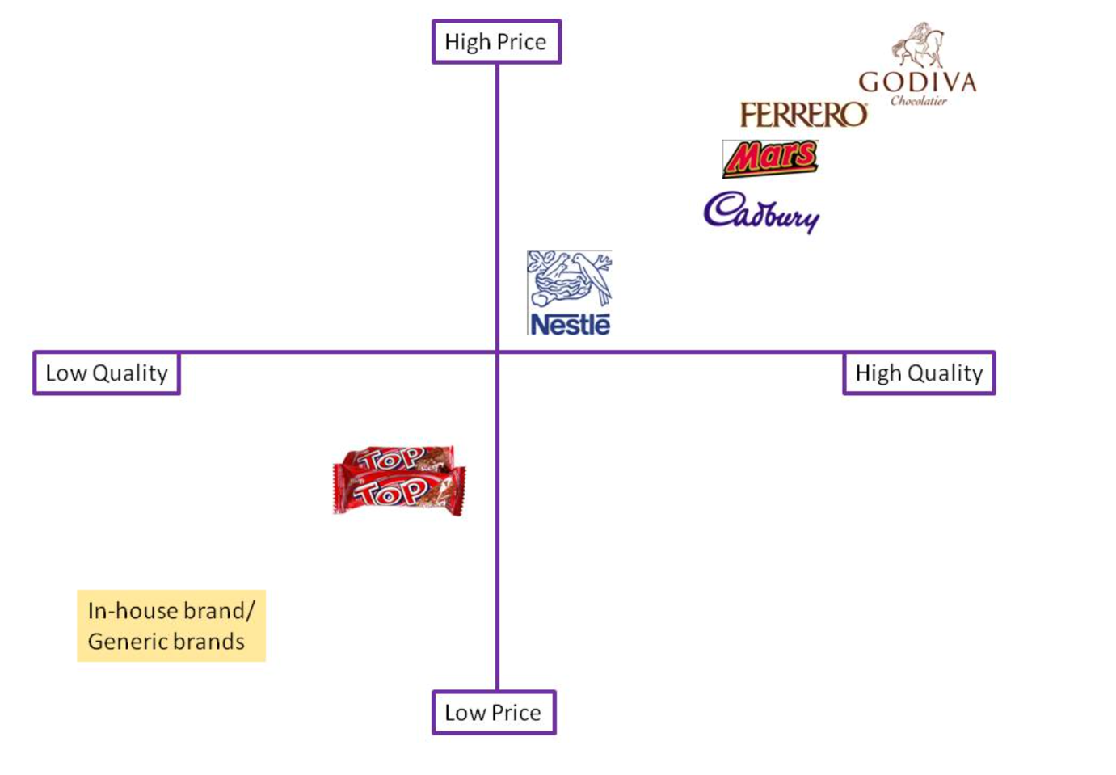
Source: Image created by Learner.
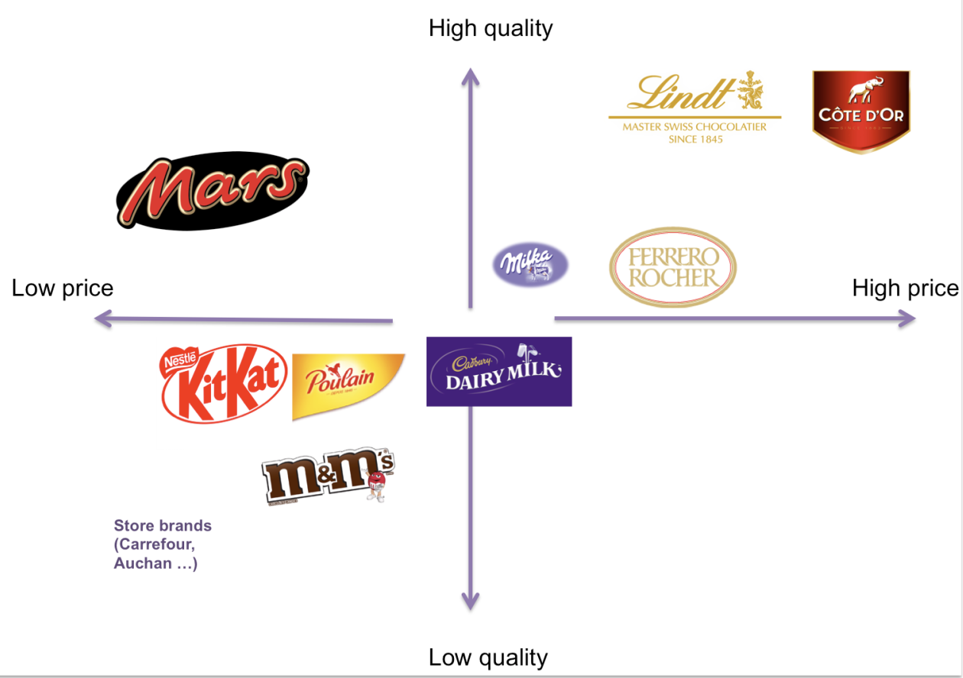
Source: Image created by Learner.
Similarities and difference of STP
STP is identical in the UK and India.The similarities and differences between the STP (UK) and the STP (India): STP is the same in the UK and India.
Cadbury's STP approach is the same in both the UK and India: it divides the confectionery market into age, income, occasion and lifestyle segments; it targets broad middle income consumers, with a focus on young people and families; and it makes Dairy Milk an emotionally-driven, warm, everyday chocolate, not just a functional snack. The brand's positioning in both countries is emotional (joy, sharing, generosity) and it has created a range of products (mass-market, Dairy Milk, Silk and Bournville for the higher income or gifting segments). In the UK, however, the positioning focus and content of the segments vary: they are less occasion specific and more about indulgence and comfort in everyday life, and positioning is about small acts of goodness and comfort, in an established, saturated chocolate culture. In India, segmentation and targeting is more about cultural events and social roles – festivals, exams, promotions, weddings – and positioning explicitly positions Dairy Milk as “modern meetha”, an emotional and symbolic replacement for the traditional meetha in auspicious moments while Cadbury Celebrations and Cadbury Silk are targeted at the gifting and premium indulgence segments. The STP framework is similar, but the segments selected, the priority targets and the positioning themes are tailored to the very different socio cultural and market environment in the UK and India (de Mooij and Hofstede, 2010).

Marketing mix definition
The marketing mix refers to the combination of controllable tactical marketing elements that a firm can mix to get the desired response in the target market – the 4Ps (product, price, place, promotion) and 7Ps (service) for services (Rafiq and Ahmed, 1995).

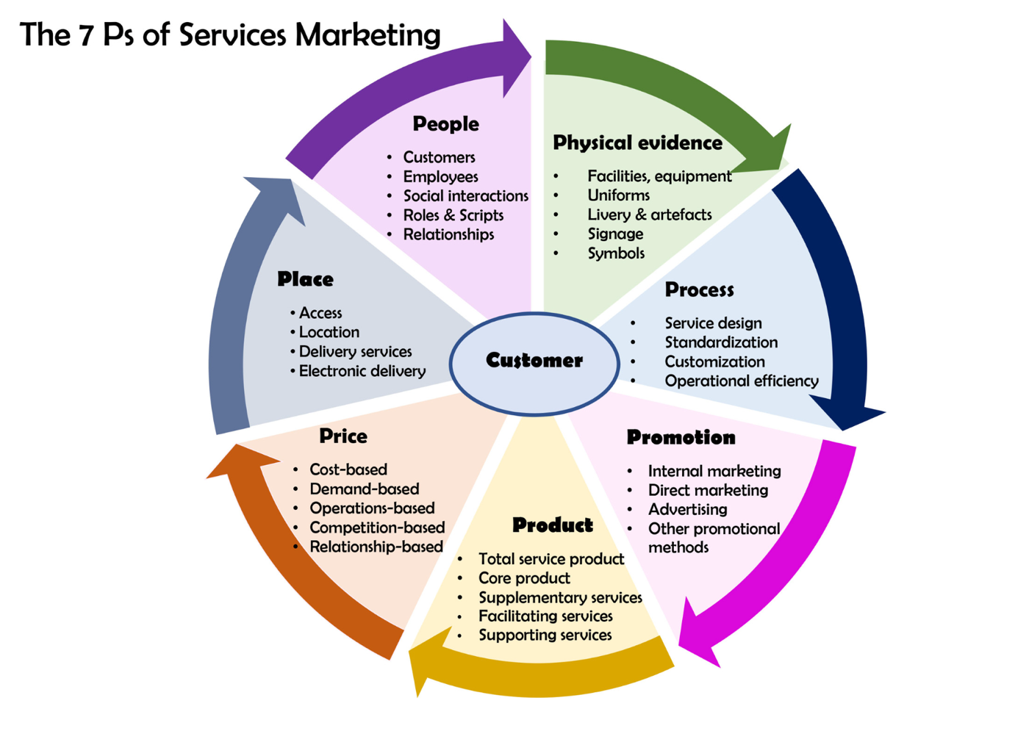
Source: Image created by Learner.

The depth and filling of the product line – UK.
Depth (UK)
The depth for Cadbury's Dairy Milk line in the UK is in many flavours, sizes & formats:
• Flavour variants: Classic Dairy Milk, Fruit & Nut, Whole Nut, Caramel, Oreo, Shortcake, Jelly Popping Candy, variants (e.g. Nutty), Plant Bar (vegan).
Pack sizes: small impulse bars (18-45g), large tablets (180-300g) and sharing bags.
Seasonal varieties: Easter eggs, Christmas selection boxes, limited edition flavours.
In the UK, this is a high depth – multiple SKUs under one brand name – the Dairy Milk line (Lucic and Radnovic, 2015).
Line filling (UK) – example
Line filling in the UK involves offering additional products or variants to fill in the gaps between the existing main products in the Dairy Milk range:
Including mid size bars (95g between the small 45g bar and 180g tablet) to complete pack/price range (Lucic and Radnovic, 2015).

The depth of the product and line filling – India.
Depth (India)
In India, the depth is even more pronounced, particularly in the case of chocolate and gifting:
Dairy Milk variants include Classic, Fruit & Nut, Roast Almond, Crackle, Shots, Lickables, Bubbly, Crispello, with pack sizes ranging from ₹5 mini bars to ₹200+ family bars.
Silk varieties: Silk Plain, Silk Fruit & Nut, Silk Oreo, Silk Caramel, Silk Heart Pop, Silk Hazelnut – all sizes and premium price bands.
Bournville: Dark chocolate in various cocoa percentages & flavours (Rich Cocoa, Cranberry, Raisin & Nut).
Assorted packs of different price points (e.g. ₹100, ₹250, ₹500, ₹1000+) – various combinations of chocolates for specific occasions – Celebrations and gift boxes.slideshare
Hence Cadbury's chocolate lines in India are very deep, particularly for festivals and gifting levels (Lucic and Radnovic, 2015).
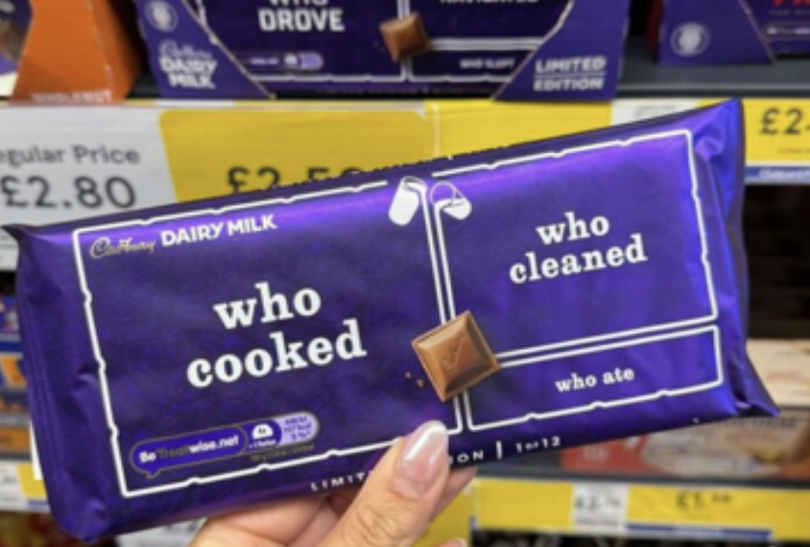
Source: (Famous Campaigns, 2026) (UK)

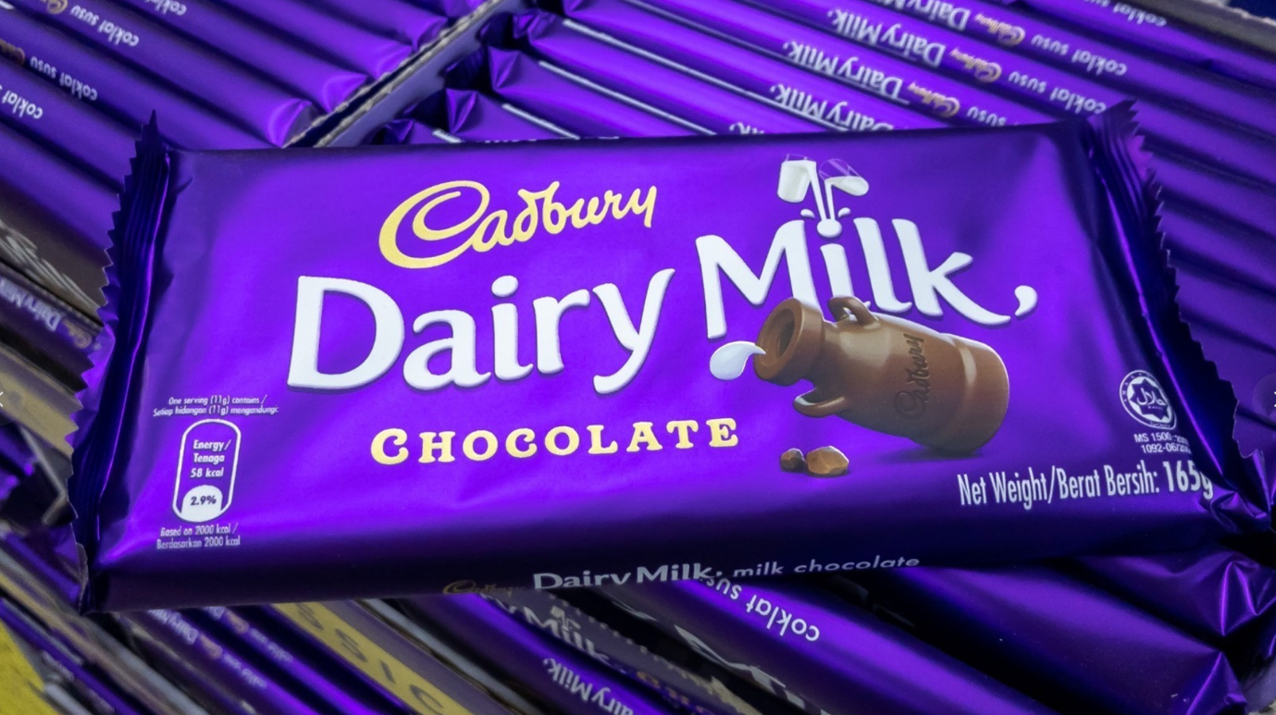
Source: Created by Learner. (India)

Product Width – India
Cadbury's product mix width includes four major product lines, in both countries:
- Any candy that contains milk (Dairy Milk, 5 Star, Perk, Temptations, Bournville, Fuse, Nutties, Shots, etc.)
- Bags and boxes / gifting (Celebrations, Gems, Eclairs/Choclairs, GLOW, Assorted gift boxes)
- Beverages and health drinks (Bournvita, hot chocolate, cocoa powder, Tang)
- Biscuits and other snacks (Oreo biscuit, Bournvita biscuit, Cadbury biscuit).
In India, the Cadbury name is not as visible as Mondelēz's, which is why the distinction may be more relevant in the latter context (Pinto, 2014).

Product Width – UK
Cadbury's product mix width includes four major product lines, in both countries:
- Any candy that contains milk (Dairy Milk, 5 Star, Perk, Temptations, Bournville, Fuse, Nutties, Shots, etc.)
- Bags and boxes / gifting (Celebrations, Gems, Eclairs/Choclairs, GLOW, Assorted gift boxes)
- Beverages and health drinks (Bournvita, hot chocolate, cocoa powder, Tang)
- Biscuits and other snacks (Oreo biscuit, Bournvita biscuit, Cadbury biscuit).
In the UK, this width is similar, but in the contemporary retail environment, Cadbury's biscuit, candy, drink and bar products are sold under a stronger umbrella in the UK (Pinto, 2014).

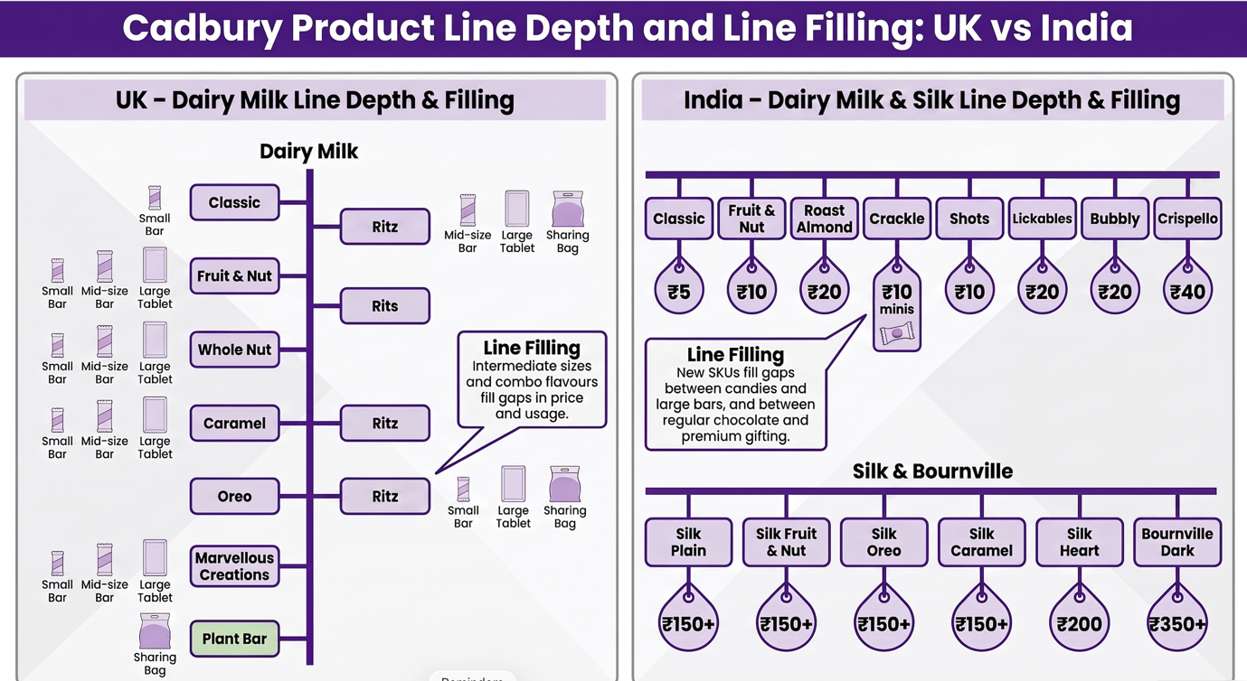
Source: Image created by Learner.
Price definition:
Price in marketing is the amount of money charged for a product or service, or the sum of all the values that customers give up – money, time and effort – in exchange for the benefits of having or using the product or service; it is the only element of the marketing mix that directly creates revenue for the firm (Susanti and Edy Yusuf Agung Gunanto, 2022).

Pricing Factors and Strategies in the UK and India
Cadbury’s pricing in the UK and India is influenced by raw-material costs, consumer demand, competition, taxes and seasonal sales. Rising cocoa, sugar, energy, packaging and transport costs can lead to cost-plus pricing, price increases or shrinkflation, where bar size is reduced while the price remains unchanged. In the UK, Cadbury uses competitive pricing and promotional pricing to remain affordable in a mature market. In India, it uses penetration pricing through low-priced mini packs, while Silk, Bournville and gift boxes use premium pricing and value-based pricing for consumers willing to pay more. Seasonal demand during Diwali, Christmas, Easter and Halloween also supports seasonal promotional pricing (Staritz et al., 2022).

Promotion

IMC definition (Integrated Marketing Communication):
Integrated Marketing Communication (IMC) is a strategic approach that guides and unifies all of a company's marketing communication tools (Advertising, Public Relations, Sales Promotion, Direct Marketing, Personal Selling, Digital/Social Media) to create a clear, consistent and compelling message to the customer at each touch point, resulting in a coherent brand experience (Kliatchko, 2005).

In the UK and India, media usage is:
Cadbury's media mix is varied in both countries, but the mix and the way it is used is different. In the UK campaigns are usually a mix of TV, video on demand, out of home (billboards, posters), digital display, YouTube and social media (Instagram, Facebook) with integrated creative platforms like “Glass & a Half in Everyone” or seasonal campaigns like Christmas and Easter – media planning is aimed at achieving high reach and emotional storytelling across TV, VOD, out of home and social, with consistent visuals and stories. In India, Cadbury also heavily uses television advertising, print and outdoor hoardings, but IMC goes deeper: TVCs are complemented by newspaper ads, shop branding (purple sheet metal dispensers, visicoolers), cinema and even ATM messages, Facebook, Instagram and YouTube campaigns, augmented reality experiences, WhatsApp sharing, microsites for customised gifting, and geotargeted dynamic video ads like #NotJustACadburyAd and #ThisAdIsMyStore. In both markets, Cadbury's IMC strategy combines TV and print to achieve mass reach, with digital and social media media to achieve participation and personalisation, and packaging, in store displays and festival activations as further media touch points which reinforce the Cadbury emotional and cultural positioning (Kliatchko, 2005).

Promotion mix combination (UK vs India)
Cadbury utilises all the elements of the promotion mix in the UK and India, albeit in different proportions and with different approaches to the mix. High profile advertising (TV, video on demand, outdoor posters, digital and social media) that tells emotional stories and uses humour (e.g. “Gorilla”, “Glass and a Half”, “Made to Share”) is the most dominant form in the UK, with sales promotions (multi buy offers, limited edition packs), PR around brand heritage and charity/sponsorship, and strong digital engagement (social media content, competitions, personalised online experiences) being the other key components. In India, Cadbury also does most of its TV advertising, but they also do more of their sales promotion work in conjunction with festivals (discounted Celebrations packs, contests, corporate gifting), point of sale and below the line work (shop hoardings, standees, sampling, rural initiatives), and culturally relevant digital/social campaigns (e.g. #KuchMeethaHoJaaye, #NotJustACadburyAd, hyperlocal WhatsApp/AI) to encourage gifting and small businesses, while managing issues (e.g. worm contamination crisis) and building trust through celebrity endorsements (e.g. Amitabh Bachchan). Overall Cadbury's promotion mix in both countries is a combination of emotional mass advertising and tactical promotions and digital IMC, but the mix is more festival centric and retail/BTL heavy in India compared to the UK where it is more iconic brand advertising and integrated national media campaigns (Kliatchko, 2005).

Sales promotion (UK and India)
Cadbury uses a variety of sales promotion tools in both markets to stimulate short term sales and reinforce brand loyalty. Common consumer promotions in the UK are price deals, multi buy promotions (e.g. ‘2 for £3’), seasonal promotions (e.g. Christmas selection boxes, Easter eggs), limited edition flavours and packaging (to encourage trial and impulse buying), and display allowances and in store fixtures (to support retailer cooperation and visibility). In India, sales promotion is more aggressive and diversified: Cadbury uses pull strategies, such as contests, sweepstakes, coupons, freebies, cross promotions, free samples and specialised giveaways, which are targeted specifically at children and youth, and also smaller, low price SKUs to boost affordability and penetration. Festival linked sales promotions (FLSPs) (Cadbury Celebrations boxes at discounts, bulk gifting offers for corporates, combo packs) are key to Diwali, Raksha Bandhan and other festivals, and are helping Cadbury to build volume and cement the chocolate gifting norm (GOV.UK, 2023).

Digital promotion (UK and India)
Cadbury is now firmly integrating digital promotion into its IMC in both countries. Cadbury leverages online video (YouTube, VOD platforms), social media campaigns (Instagram, Facebook, X), interactive websites and programmatic display to enhance the power of TV storytelling, interactive competition and personalisation in campaigns such as “Glass & a Half in Everyone” and “Made to Share” in the UK. Digital promotion is closely tied to cultural campaigns in India, with Cadbury's initiatives like KuchMeethaHoJaaye, NotJustACadburyAd, and ThisAdIsMyStore featuring social media, influencer marketing, microsites, mobile-first video, WhatsApp sharing, AR filters and AI-driven personalised ads that target local stores and promote them within the ad, thereby encouraging support for small businesses. In both markets, digital promotion is a tool that can be used in tandem with TV and in store, providing two way engagement, user generated content and data driven targeting, and consistent emotional brand narratives(Kliatchko, 2005).

Place definition
Place (also known as distribution) is the channels, location, and logistics used to move a product from the producer to the final consumer and make it conveniently available to the customer, including decisions about distribution intermediaries, market coverage, retail outlets, online platforms, inventory, transport and warehousing so that the customer can buy the product at a reasonable cost when and where they want (Lucic and Radnovic, 2015).

Channel of distribution (UK & India)
In both countries Cadbury primarily distributes its products through multi level indirect channels, though the length of the channels and the number of levels are greater in India. In the UK, the typical channel is manufacturer – central warehouses – wholesalers / large retail chains (supermarkets, convenience stores) – consumers, and an increasing number of online channels are being used to deliver to the consumer's home and for click and collect. Cadbury's national coverage and convenient access is achieved through major grocery retailers, forecourt stores, newsagents, vending machines and online platforms. Cadbury (Mondelez India) has a very layered model in India – factories, mother warehouses, depots / C&F agents, distributors / super stockists, retailers (kirana, modern trade, sweet shops, stationery, gift shops, schools / colleges) and consumers, with the help of refrigerated transport and wide coverage of routes. It has an intensive distribution system, with around 2,100 stockists and more than 450,000-550,000 retailers, and also promotes “new channels” like gift shops, cyber cafés and sweet shops to boost visibility in less traditional places (O’Shea, 2007).

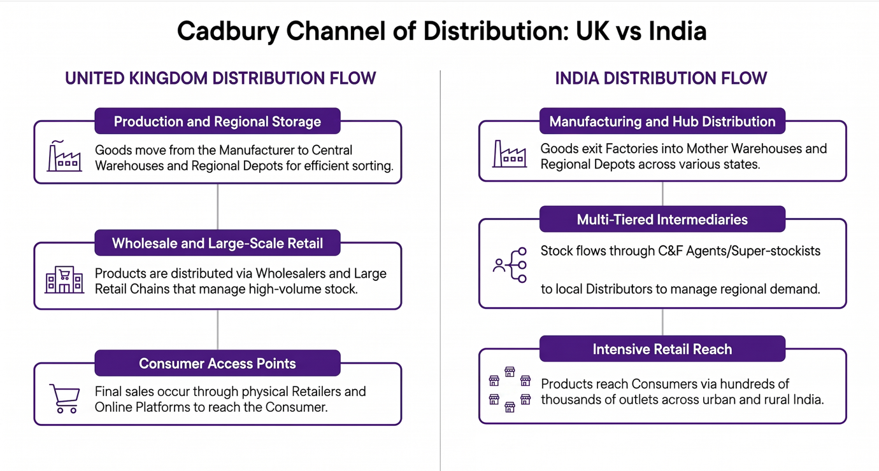
Source: Image created by Learner.

Intensive distribution
Intensive distribution is a strategy whereby the producer tries to achieve maximum coverage in the market by selling its product in as many outlets as possible: supermarket, convenience store, kiosk, small shop and online. The product is always on the shelf wherever the consumer can find it, which is common for fast-moving, low-priced convenience products such as chocolate and snacks (Lucic and Radnovic, 2015).

Direct channel distribution
A direct channel of distribution is a channel that involves no independent wholesalers, distributors or retailers, such as when a company sells directly to the final consumer through its own website, own stores, direct sales force or mail order, and the company controls the price, customer relations and delivery experience (Lucic and Radnovic, 2015).

People
In 2026, Mondelez International (Cadbury's parent company) has approximately 91,000 employees globally. Based on workforce estimates, the number of employees in India is roughly 8,000 and in the United Kingdom is approximately 5,200, making a total of approximately 13,000 employees in the two countries.
Since Mondelez is now a part of Cadbury, and the public sources do not provide an exact “Cadbury only” number of employees in each country, these figures are to be interpreted as an approximation of the number of employees at Mondelez/Cadbury in India and the UK, rather than a precise number of Cadbury employees (Kemle, 2021).

Training and motivation, people (UK and India)
Mondelez International, Cadbury's parent company, emphasises training, development and engagement of employees in the UK and India. It is a global initiative to develop in-house talent, develop future talent, develop a culture of high engagement with ongoing learning, coaching and feedback (Jung et al., 2021).

Training and development
Structured learning programmes: Both countries' employees can access formal learning through Mondelez International University, e learning modules, workshops, technical and leadership programmes, and “Growing Here” learning weeks to foster life long learning and skill development.
On the job learning and mentoring: Company has a “70 20 10” development philosophy, meaning that most development is done on the job (projects, cross functional assignments), mentoring and coaching are in place and targeted high quality training programmes are offered for emerging leaders and functional specialists.
Local talent programmes (India): Mondelez has a fast track graduate programme in India, such as iTaste, as well as other campus linked programmes, to develop young talent early through classroom training, rotations within functions and access to multi country teams.
In the UK, Cadbury is known for its commitment to ongoing skills development, even during tough economic times, and for its approach of shared responsibility for learning and development between the company and the employees, with line managers determining the need for training and ensuring that it is transferred back to the workplace (Clardy, 2018).

Motivation and engagement
Motivation and performance: Managers are encouraged to involve employees in decisions which affect their work, to hold regular briefings to the team and set up an empowering environment where employees understand goals and feel trusted to take responsibility for them.
Career growth and recognition: In both countries, clear career paths, internal promotion opportunities, performance linked development and recognition programs that reward high performance and encourage employees to “grow every day” motivate their employees.

Supportive culture: Programmes like “Being at My Best”, are based on well being, resilience and personal effectiveness, with diversity and inclusion initiatives and flexible working policies helping to build a people centric culture where staff feel valued and engaged (CIPD, 2022).

Process – Customer complaint handling (UK and India)
United Kingdom
Cadbury (through Mondelez International UK) has a centralised consumer care system for handling customer complaints in the UK. Product complaints and feedback can be raised online via a “Contact Us” web form, by phone or by email to the UK consumer services team, including information about the product name, pack size, best before date, batch code and purchase location, which will enable the product to be investigated. Complaints are logged and evaluated by the consumer care and quality teams and investigated against production and distribution records; if appropriate, the company may provide replacement, vouchers or further follow up and applies the data to enhance product quality and service. Visitors can email a dedicated address at Cadbury World and the onsite customer service team will respond to the email within approximately seven business days, and may ask for proof of visit (tickets or receipts) to fully investigate the issue (Homburg and Fürst, 2005).
India
Mondelez India (formerly Cadbury India) also has a formal consumer service cell and a complaint process in India. Customers may complain through a toll free customer service number, dedicated email (like suggestions@mdlzindia.com) or by filling the contact forms available online; they are requested to give their complete name, address, telephone number and purchase information (store, date, product, batch code, pictures if possible) for tracing the product and verifying the problem. Complaints are entered into the consumers service system and investigated by quality and regional teams, who coordinate responses and/or remedies; in extreme cases, complaints may be referred to consumer dispute forums, but the typical flow of complaints is intended to resolve most complaints in a timely fashion and to provide feedback to the manufacturing, packaging and distribution teams to prevent the occurrence of future complaints (Homburg and Fürst, 2005; Tax, Brown and Chandrashekaran, 1998).

Physical evidence – Websites and packaging (UK and India)
United Kingdom
Website (UK)

The Cadbury/Mondelez UK online presence features a modern, brand led design with good use of Cadbury purple, big product images and easy navigation with brands, sustainability and company information. Hero banners displaying ongoing campaigns are generally found on the homepage, with easy-to-navigate call to action buttons and a responsive design that looks good on any device, further cementing the brand's professional and trustworthy appearance (ELLIS and CHAFFEY, 1987).

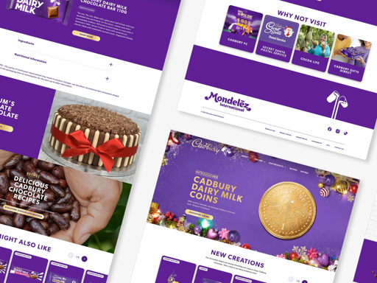
Source: Image created by Learner.

Packaging design (UK):
Cadbury Dairy Milk packaging always includes a deep Cadbury purple background with the flowing Cadbury Milk splash, Cadbury's signature script and distinctive white/yellow type for the product name, while recent designs have included ‘Made to share' messaging and for anniversary and special editions, retro designs and certified recycled plastic information. The packs are clearly branded, are extremely easy to recognise on the shelf, feature clear product variant names (e.g. Fruit & Nut, Caramel), nutritional and recycling information on the back and have bar formats that allow for sharing or single consumption (UK Press Office, 2025).
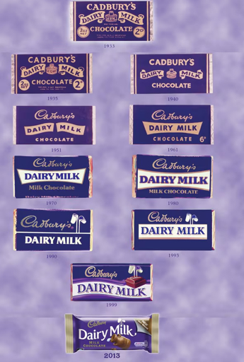
Source: Image created by Learner.
India
Website (India)
Mondelez India / Cadbury India web pages are similarly branded with Cadbury and Mondelez visuals, in a corporate style. They feature India business, product portfolio, sustainability initiatives, and careers in Cadbury, all in brand colours, product images and with simple navigation, enabling consumers and partners to easily access information on Cadbury's business and commitments in India (Cadbury, 2023).

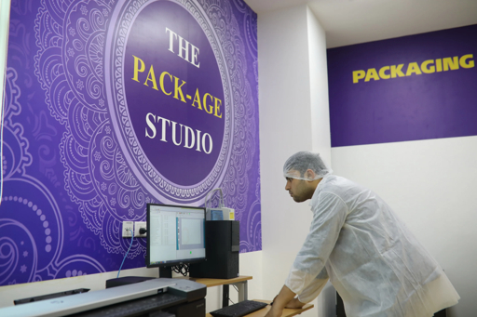
Source: Image created by Learner.

Packaging design (India)
Cadbury Dairy Milk packaging in India also features the same purple base and Dairy Milk logo, with a certain degree of localisation, for instance, the use of Indian languages, cultural elements or special campaign graphics (e.g. “Learners Pack” designs that highlight linguistic diversity). Pack formats vary from small impulse price packs to larger family packs and gift boxes, while the front of pack imagery emphasizes indulgence and celebration, back of pack information such as ingredients, vegetarian symbol, price (MRP) and customer care contact details are geared to the Indian market (Cadbury, 2023).

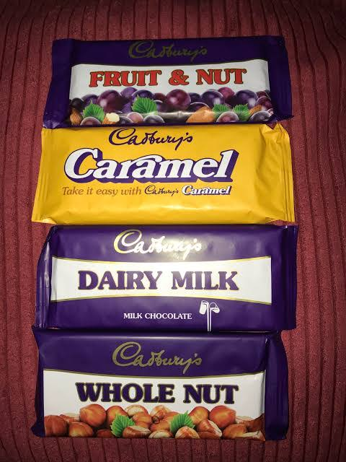

Source: Image created by Learner.

7Ps comparison: UK vs India (Cadbury)
7P element | United Kingdom (Cadbury) | India (Cadbury / Mondelez India) | Key similarity / difference summary
Product | Excellent focus on core global brands such as Dairy Milk, classic bars, sharing blocks and seasonal/limited editions for grocery and convenience channels. | Wide range of products with global brands alongside more localised products - small bars, festival/gifting packs, India specific flavours and formats like Silk, Celebrations etc. to suit local tastes and occasions. | Both markets have extensive product ranges, with Dairy Milk being common to both (similarity), and localisation and festival/gifting innovation is more prevalent in India (difference) (Rafiq and Ahmed, 1995).
Price | Tiered pricing: standard pricing at mainstream price points, multi buy/promotion pricing at supermarkets, and price marked packs at convenience and forecourts. | Tiered pricing (very low pricing, impulse and rural markets, and higher priced premium variant - Silk and gift boxes - to reach multiple income segments). | Both have tiered pricing (similarity), India's is more finely segmented with very low entry prices, and premium vs value differentiation (difference) (Rafiq and Ahmed, 1995).
Place (Distribution) | Extensive distribution via large grocery stores (Tesco, Sainsbury's etc.), convenience stores, petrol stations and online retailers with central warehouses and logistics. | Multi tier network: factories → mother warehouses → C&F agents / super stockists → distributors → retailers (kirana shops, sweet shops, gift stores, schools, modern trade) with emphasis on rural penetration and route to market reach. | Both want high availability and intensive distribution, but India's system is more multi-leveled and targets the more decentralised urban and rural retail market (difference) (Rafiq and Ahmed, 1995).
Promotion | Emotional, heritage rich campaigns focused on sharing, family moments and British cultural occasions; extensive use of TV, outdoor, in store and digital/social media in conjunction with national events and brand anniversaries. | Emotional campaigns to local culture and festivals (Diwali, Raksha Bandhan etc), Multilingual communication and region specific promotions, Extensive TV and digital usage with strong focus on younger and urban audience. | Both are emotionally driven, story based advertising and branding; India's promotion is more localized in language, festivals and cultural themes (difference) (Rafiq and Ahmed, 1995).
People | UK operations focus on continuous training, engagement and empowerment of factory and office staff, and line managers are important in communicating and developing staff. | India operations focused on grooming young talent, fast track management programmes, continuous learning and capability building for rapid market growth; the UK focused on maintaining skills and engagement in mature operations (similarity/difference). | Both invest in training and engagement (similarity); India has more explicit focus on early-career talent pipelines and growth, while the UK stresses maintaining skills and engagement in mature operations (difference) (Rafiq and Ahmed, 1995).
Process | Production is highly automated and logistics between factories, warehouses and big retailers are streamlined, optimized for efficiency, quality and service to big retailers. | Multi tier supply chain with data and AI supported planning, frequent replenishment to distributors and retailers, processes geared towards agility and coverage in a variety of markets and digitally enabled. | Both use efficient, standardised production and supply chain processes (similarity), India's processes focus on the use of digital tools and complexity management in fragmented retail (difference) (Rafiq and Ahmed, 1995).
Physical evidence | Physical identity: Cadbury purple packaging, branded experiences (Cadbury World), website and in store displays of physical heritage and sharing. | Global brand elements with localised physical elements: India specific web pages, festival themes and Indian languages on packaging, special gift packs and regional campaigns. | Both have brand cues globally that are consistent for recognition (similarity) and India has additional packaging and online cues for cultural and linguistic diversity (difference) (Rafiq and Ahmed, 1995).

Market entry strategy – India
Cadbury made its entry into India through export and greenfield investments, followed by acquisitions and localisation. Cadbury chocolates were first imported in India around 1948 and were targeted at a select affluent urban clientele. As a way to lower import expenses, overcome tariff and supply restrictions, and gain scale, the company soon set up its own production in India, with the first plant located near Mumbai and other plants, and even local cocoa farming initiatives in Kerala and other southern states. This move from pure exporting to local production is a green field type entry strategy, Cadbury established its own manufacturing plant, developed its own supply chain and slowly increased its distribution and dealer networks throughout the country.
Cadbury's presence in India has been reinforced through international restructuring and acquisition over the years (e.g., Cadbury acquired by Kraft and becoming Mondelez International), but in India the market entry and growth strategy has been local manufacturing and extensive market penetration, not franchising or licensing. The company adapted its formulations for hot climate, launched smaller packs at lower prices to reduce price barriers, and distributed extensively and promoted the product through culturally relevant channels, which helped to bring chocolates from a niche import to a mass market, every day and festival product in India (Dey, 2021).

Why Cadbury chose local manufacturing and localisation in India
Cadbury used a Greenfield foreign direct investment entry strategy in India.
1.Reduce import costs and make chocolate affordable
On the initial entry of Cadbury into India, the imported chocolates were very costly due to high import duties and shipping charges had restricted the demand to a small affluent group. Cadbury could set up local manufacturing and also later bring in locally produced cocoa and milk, thereby reducing production and logistics costs, introduce very low priced packs (e.g. ₹2-₹5 bars), and make chocolate available for all income groups (de Mooij and Hofstede, 2010; Dey, 2021).
2. Develop a sustainable local supply for the ingredients.4. Ensure consistent local supply of essential ingredients.
India started with a shortage of milk and cocoa for large scale production of chocolate. The local plants enabled Cadbury to invest in the milk supply chains (with the help of India's “White Revolution”) and also develop cocoa farming with Indian farmers (such as the farmers of Kerala) which led to lesser dependence on imports and the stabilisation of the quality and supply of cocoa over time (de Mooij and Hofstede, 2010; Dey, 2021).

3 Adapt the product to climate and local conditions
Chocolate needed special formulations and processes because of Indian temperatures and limited refrigeration to ensure that it would not be affected by heat and long storage. Local manufacturing enabled Cadbury to have direct influence over recipe and packaging to suit the Indian climate, which would be more difficult to do if they were made purely in India (de Mooij and Hofstede, 2010; Dey, 2021).

4. Develop strong distribution and category penetration
Cadbury had to expand its operations from metros to smaller towns and rural areas, which required multi layered dealer and retail networks, and frequent replenishment to millions of small outlets. Intensive distribution, from kirana shops to modern trade, was made possible by local manufacturing and warehousing, making chocolate a mass market product (de Mooij and Hofstede, 2010; Dey, 2021).
5. Promote cultural localisation and long term brand building
The locally embedded operation facilitated the development of India specific campaigns, Cadbury Celebrations (gifting during festivals), language specific advertising and pricing strategy that was culturally and habitually appropriate for Indians. This localization, which involved permanent investments and relationships with farmers, showed a commitment to the long-term and helped Cadbury transform from just a foreign luxury brand into “India's chocolate” (de Mooij and Hofstede, 2010; Dey, 2021).

Advantages and disadvantages of the entry method – India

Advantages of local manufacturing (greenfield investment)
Reducing costs and making it affordable
By setting up factories and procurement of ingredients in India, Cadbury was able to reduce import duty and transportation costs, reduce the unit cost, and introduce low priced packs (e.g. ₹5 bars) that made chocolate available to the mass and lower income segment (Cadbury, 2023; Tandon, 2023).
More control and uniformity of quality!
A 100% local manufacturing facility allows Cadbury to have complete control over technology, recipes, production standards and distribution, allowing for a consistent product quality and brand experience, as opposed to relying on external licensees or contract manufacturers (Cadbury, 2023; Tandon, 2023).
Localisation and market knowledge
Physical presence in India gives Cadbury the insight into local consumer preference, weather and culture and helps them adjust their products (heat resistant formulations, local flavours) and campaigns (festival gifting, “default meetha”) for long term competitive advantage (Cadbury, 2023; Tandon, 2023).
Ensure supply chain resilience and local sourcing
Local plants and cocoa/milk sourcing programmes with Indian farmers can cut on reliance on imports, create resilient supply chains and can enhance margins by ensuring sourcing from the local farmers and economies of scale (Cadbury, 2023; Tandon, 2023).
The credibility of the brand and social impact.
Purchasing factories and farmer programmes shows a commitment to India for the long term and creates jobs and increases farmer incomes, thereby improving corporate reputation and brand trust (Cadbury, 2023; Tandon, 2023).

Disadvantages / challenges of local manufacturing (greenfield investment)
Capital cost is high and there is financial risk.
Construction of new plants, warehouses and local sourcing networks involve significant initial capital expenditure on land, construction, equipment and compliance, which is more risky than low capital options such as exporting and licensing (Staritz et al., 2022).
Long lead times and complex set up.
Greenfield projects take time to establish and are complicated: Cadbury was required to obtain licenses, lay the groundwork, and train personnel and develop suppliers and technology to meet local conditions before the project could reach scale, which meant that it took time to return the investment compared to other strategies such as acquisitions (Staritz et al., 2022).

Local regulatory and political risk exposure.
A large physical presence puts Cadbury more at risk to the changes in Indian regulations, tax policy, agricultural and trade rules, and local controversies (e.g. the 2003 worm incident) that could potentially affect operations and tarnish the brand (Staritz et al., 2022).
The difficulty of operation and the variability of inputs.
Multiple plants, and locally sourced cocoa and milk, can be logistically complex, there are quality control and farmer support issues, and price fluctuations in inputs (cocoa, sugar, milk) can create margin pressures and necessitate constant adjustments in operations (Staritz et al., 2022).

Ethical marketing practices – India (2 examples)
1. Children are entitled to responsible marketing.Children deserve responsible marketing (India pledge).
Cadbury/Mondelez India has been added to a list of companies pledging not to target children under 12 with high fat, sugar and salt (HFSS) food and beverage advertising, by saying it won't advertise in places where more than half of the audience is under 12, and it won't advertise on children's TV channels or primary schools. This shows an ethical concern for children’s health and vulnerability, as the company limits child targeted promotion of chocolates even though doing so could boost short term sales (Wells, 2011).
2. Corporate social responsibility and community support
Cadbury India conducts wide-ranging CSR programmes, including support for cocoa cultivation and thousands of farmers, check dams and solar streetlights, education and healthcare programmes for local communities and migrant workers' children, and environmental programmes, including “Purple Goes Green” to cut emissions. These actions make for ethical marketing, connecting the brand to real social and environmental responsibility, not just profit, and working to enhance livelihoods in the areas where ingredients are being sourced (Cadbury, 2023).

Unethical / ethically problematic practices – India (2 examples)
1.Product safety and the 2003 worm controversy
In 2003, Cadbury Dairy Milk was found to be contaminated with worms in Maharashtra and the Food and Drug Administration raided the stocks, resulting in a significant drop in sales. Cadbury's initial packaging and quality control were criticised by regulators, but the company improved its packaging and introduced double wrapping under the “purity sealed” label; the initial criticism of Cadbury was because of inadequate protection for consumers from contamination, and because of the initial focus on retailer storage as the problem, this raised ethical questions regarding Cadbury's acceptance of responsibility for product safety throughout the value chain and whether consumers were adequately protected from contamination(Jung et al., 2021).

2. Brands that are available in both healthy and unhealthy forms
Cadbury's emotional advertising is a strong driver of indulgence, gifting and regular consumption of HFSS products, which may not align with the growing emphasis on obesity and non communicable diseases. Some Cadbury HFSS ads targeted at children have already been banned by regulatory bodies in other markets and similar discussions have taken place in India regarding the marketing of sweets during festivals and to children. Although it is not always prohibited, it does have ethical implications of promoting the use of unhealthy products, particularly among children and families, and of whether the brand is using the right amount of celebration messages and responsible health communication(Law et al., 2019).

United Kingdom: STP evolution recommendation
1. Improve segmentation on health and occasion
Go beyond the general “chocolate lovers” to distinct segments:
- Snack lovers who want to enjoy the treat but are still conscious of their health (reduced sugar, smaller portions).
- Everyday snackers vs special occasion givers.
- Families vs young professionals.
- Utilize this for creating differentiated product lines (e.g. “lighter treats”, “family sharing”, “premium gifting”) and customized communication(SMITH, 1956).
2. Conduct detailed analysis of the target market segments and their health status.4. Improve targeting of the premium and healthier sub segments.
- Target: Make sure that we reach out to the right target of the core Dairy Milk product and intentionally target:
- Dark and origin chocolates in the premium price range at the high end segments.
- Reduced sugar / portion controlled SKUs at health aware urban consumers.
- Use more explicit health messages and responsible consumption messaging (e.g. calories per portion, advice on occasional treats) (SMITH, 1956).
3. Move highlighted lines around to “responsible indulgence” and “heritage”
- Continue to maintain the brand positioning as happy, sharing chocolate; but adapt individual SKU's to highlight(SMITH, 1956).
- Quality, ethical sourcing, recyclable packaging, portion control – indulgence you can trust.
- British heritage and sustainability (recycled plastic packs, local community support, 200 year story) as differentiators to competitors .
- This will help to gain competitive edge in a mature market that is health and ethics conscious(SMITH, 1956).

Country B – India: STP evolution recommendation
1. Mass targeting to more targeted segment strategies
- The current practice is to view “everyone, all ages and incomes” as the target for Dairy Milk. Suggest transitioning to more transparent segments like:
- Millennials and Gen Z (gifting, sharing, digital) in the city.
- Children and families in rural and small town areas (low price impulse packs).
- Health conscious young parents (Bournvita, lower sugar options).
- This enables more targeted product, price and message design for each segment(SMITH, 1956).

2. Explicitly pursue new premium and health markets.
- Continue high level of targeting for mass segments on coinage price (₹2-₹5) but with enhanced targeting on:
- Premium dark and “indulgent” ranges (Bournville, Temptations, Silk) for richer urban consumers and gifts.
- Health and nutrition (fortified, reduced sugar, functional snacks) for parents and young professionals, as more and more people are becoming aware of health and nutrition(SMITH, 1956).
3. Evolve positioning to celebrate while remaining health and locally relevant
- With core Dairy Milk, keep positioning as “celebration and emotional connection” (“meetha” for moments) and add:
- Improved communication about size of portions and occasional treats, to address ethical/health concerns.
- More regionally specific messages (language, festivals, local stories) which account for different cultural segments (South, North, Tier 2/3 cities, rural).
- For functional brands like Bournvita, further develop positioning with claims around child development, nutrition and trust, backed by evidence and clear labelling(SMITH, 1956).

Section 2: Gibbs’ Reflection

Gibbs’ definition
Gibbs’ Reflective Cycle is a structured model that encourages systematic reflection through six stages: description, feelings, evaluation, analysis, conclusion and action plan. It is designed to help practitioners and students learn from experience by moving beyond “what happened” to “why it happened, what it means, and how I will change next time” (SMITH, 1956).
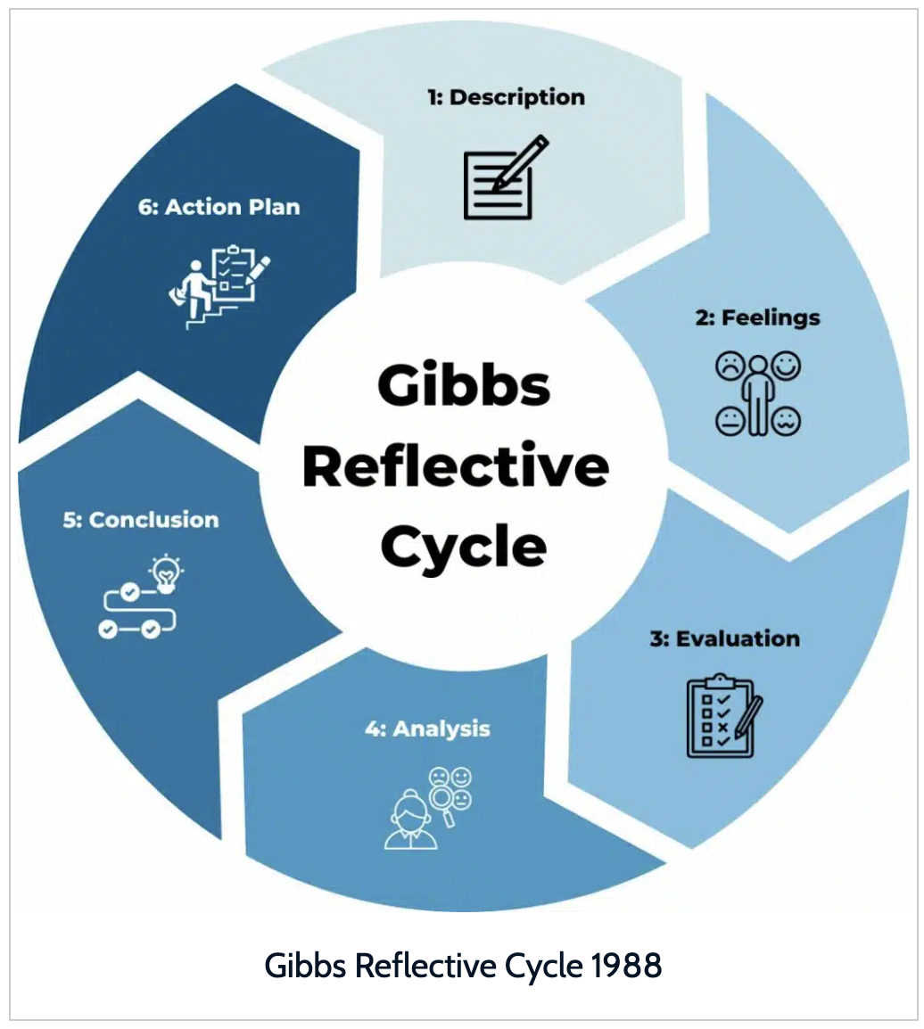

Source: Image created by Learner.
Description – the research task

In this assignment I was required to create an individual report that compares the international marketing strategy of Cadbury in two countries: United Kingdom and India. The research task consisted of several steps: PESTEL analysis of the macro environments, Hofstede's cultural dimensions to compare socio cultural differences, Segmentation, Targeting, Positioning (STP) and the 7Ps marketing mix analysis in both countries, market entry strategy and ethical issues, and finally strategic recommendations for future international marketing in both countries. I conducted secondary research through academic journals, Company reports, case studies and credible online sources to develop a critical, evidence-based comparison of Cadbury's practices in both markets.

Feelings – before and after the task
I was feeling anxious and a bit overwhelmed before beginning the report. It was quite a large word count and the learning outcomes were quite high to include critical comparison and ethical evaluation at Level 7, and I didn't feel confident in using multiple frameworks – PESTEL, Hofstede, STP and 7Ps – in a cohesive and integrated manner. I was also worried about time management because of the submission deadline for the module being the same as other module assessments.
As I progressed, my feelings gradually changed. I felt more curious and involved when I began collecting information on Cadbury's business in India and the UK. It was interesting to see how the same brand adapts its marketing mix for different cultural and economic context and using the structured models gave me a sense of control over the complexity of the task. When I was done, I felt very confident and satisfied, as I had been able to condense considerable information, compare and contrast it, and relate it to theory. I also got a bit frustrated, though, because I felt, if I had done a little more careful planning of my research schedule, I could have taken it even deeper.

Evaluation – strengths and weaknesses
In retrospect, I had a number of strengths. I had access to a variety of sources such as academic papers related to international marketing and the cultural aspects, as well as company case studies on Cadbury's market entry and ethical issues. The structure was logical and included all the elements required in the course: macro environment, culture, STP, 7Ps, market entry, ethics and recommendations. I have also used critical comparison such as comparing the intensive distribution and emotional promotion in both countries and weighing up the advantage/disadvantage of Cadbury going for a greenfield investment in India.
There were also drawbacks, however. My first research was too expansive and I had read sources that were not directly related, so this impacted my time management. In some of the sections e.g. ethical/unethical practices, I have used a lot of material from India and could have paralleled this more directly with the UK examples. Besides, while I employed numerical figures (market share, number of workers etc., and investment amounts), there was scope for a more rigorous numerical analysis, for instance through a systematic comparison of growth rates, or profitability figures etc., between the two markets. Lastly, I realised that my writing style sometimes leaned towards description and that I had to do more to go into the critical evaluation of Cadbury's strategic decisions.

Analysis – using Hofstede, STP and 7Ps, and what I learned
I applied three models in this assignment: Hofstede's cultural dimensions, STP and the 7Ps marketing mix.
With the help of Hofstede's cultural dimensions, I was able to comprehend the variation in Cadbury campaigns and product strategies across the UK and India. In the case of India, the collectivism and high power distance highlight the importance of family festivities, festivals and gifting, while in the UK, the emphasis lies on personal enjoyment and sharing amongst friends explained by their individualistic and low power distance culture. I found Hofstede very useful because it helped me understand how a consumer's expectations and communications are influenced by culture, and why a “one size fits all” marketing strategy would not work.
STP (Segmentation, Targeting, Positioning) helped me to understand and analyse Cadbury's markets and how Cadbury aims to target different market segments. I found that Cadbury seemingly tells consumers that it is for “everyone who loves chocolate” but in reality, there are five segments: Kids, Families, Urban Millennials, Premium Dark Chocolate, and Health Conscious. STP guided me to recognize areas that need attention, such as the areas of targeting health oriented segments in both countries and a clear premium positioning in urban markets in India.
The 7Ps marketing mix (Product, Price, Place, Promotion, People, Process, Physical evidence) gave us a complete picture of Cadbury's marketing where they were going and how they were going about it in both markets. It has taught me that as much as product flavours or advertising can be different, so can be the distribution networks, the training of staff, the service processes and physical evidence (websites, packaging). Through the systematic comparison of each P, across the UK and India, I became aware of the dependence of these decisions and the need for them to fit in with the culture, incomes and regulatory environment.
In general, these models were beneficial to my analytical and synthesis skills. Cultural drivers were described by Hofstede, STP by the company and how, whereas the 7Ps by the operational and service delivery implications. I discovered that action plans that are based on integrated model based analysis are more convincing than action plans based on observations alone.

Conclusion – overall skills gained
In this reflective process I have acquired a number of important skills:
Research and critical reading skills, identifying differences between descriptive and analytical material and using academic and practitioner texts.
Using theoretical frameworks to real world examples, which helps me to understand international marketing strategies by using Hofstede, STP and 7Ps.
Rather than taking company narratives at face value, critical thinking and evaluation, especially on market entry modes and ethical issues.
Numerical interpretation, basic calculations on market share, number of employees and investments to support arguments, although this could be improved.
Additionally, I became more aware of the need to be more time efficient with time spent collecting information and to also be more aware of myself when I need to work on more complex assignments.

Action plan – Time management and numerical analysis
For future modules and professional tasks, I will make the following plan:
1. Improve time management
I will make a comprehensive schedule at the beginning of an assignment in which I will assign time blocks for literature search, model selection, drafting and revision.
Apply “80/20” principle; first read the most relevant sources and frameworks that relate directly to the task, as peripheral reading may take too much time.
I will target a first draft in full a minimum of one week before the deadline in keeping with the assessment guidance.
2. Improve the ability to use numbers in analysis.
In upcoming marketing & strategy assignments I will deliberately include more quantitative data – for example a simple table and chart comparing the relative growth of the markets, positioning of the product on price, and distribution coverage.
I will practice reading and understanding financial statements and market reports for key indicators such as revenue, margins, market share, and make clear connections to my strategic assertions.
Where appropriate, I will use straightforward statistical or spreadsheet data management tools to organise and present data, to ensure my recommendations are informed by qualitative and quantitative data.
With the help of this action plan, I believe I will be able to improve my capacity to create more robust, well organized, and analytical reports as well as be more confident and professional in handling all future tasks.

Final Conclusion.
To conclude, this report illustrates how Cadbury's success in the international market is closely tied in with its balancing of the global brand with adaptation to local markets in the UK and India. The analysis of PESTEL identifies significant differences in economic, social, technological, legal and environmental contexts and Hofstede's cultural dimensions indicate the need to consider cultural aspects of each market when designing consumer behaviour and communication strategies. The STP and 7Ps analysis also reveals that Cadbury's brand emotions are consistent across the two countries, centered around happiness, sharing and quality, but that the products, pricing, distribution and promotional activities are tailored for the local consumer, with a greater focus on everyday indulgence in the UK and festivals, gifting and cultural occasions in India. Cadbury's greenfield investment and localisation efforts in India have helped with the affordability, wide distribution and long-term development of the market, while ethical concerns like responsible marketing to children, product safety and health issues are significant challenges. Overall, Cadbury must maintain its heritage and emotional brand positioning, expand on responsible marketing, provide more healthier and premium product variants, engage with digital, and enhance its sustainability and segmentation efforts. The comparison thus establishes that effective international marketing is not based on the same strategy in all countries but on the combination of global brand's resources and culturally, economically and ethically suitable local strategies.

Reference list
Douglas, S.P., Craig, C.S. and Nijssen, E.J. (2001). Executive Insights: Integrating Branding Strategy across Markets: Building International Brand Architecture. Journal of International Marketing, [online] 9(2), pp.97–114. doi:https://doi.org/10.1509/jimk.9.2.97.19882. [Accessed 1 Aug. 2026].
Urde, M., Greyser, S.A. and Balmer, J.M.T. (2007). Corporate brands with a heritage. Journal of Brand Management, [online] 15(1), pp.4–19. doi:https://doi.org/10.1057/palgrave.bm.2550106. [Accessed 1 Aug. 2026].
Ahmadi, I., Habel, J., Jia, M., Lee, N. and Wei, S. (2021). EXPRESS: Consumer stockpiling across cultures during the COVID-19 pandemic. Journal of International Marketing, 30(2), p.1069031X2110375. doi:10.1177/1069031x211037590. [Accessed 1 Aug. 2026].
Cadbury (2023). Cocoa life. [online] Cadbury UK. Available at: https://www.cadbury.co.uk/about/impact/cocoa-life/ [Accessed 1 Aug. 2026].
CIPD (2022). Incentives and recognition: An evidence review. In: CIPD. [online] CIPD. Available at: https://www.cipd.org/globalassets/media/knowledge/knowledge-hub/evidence-reviews/incentives-recognition-practice-summary_tcm18-105466.pdf [Accessed 1 Aug. 2026].
Clardy, A. (2018). 70-20-10 And the dominance of informal learning: A fact in search of evidence. Human Resource Development Review, [online] 17(2), pp.153–178. doi:10.1177/1534484318759399. [Accessed 3 Aug. 2026].
de Mooij, M. and Hofstede, G. (2010). The hofstede model: Applications to global branding and advertising strategy and research. International Journal of Advertising, 29(1), pp.85–110. doi:https://doi.org/10.2501/S026504870920104X. [Accessed 3 Aug. 2026].
Dey, I. (2021). Cadbury weds mishti: Fusion, taste and selling ‘authenticity’. International Journal of South Asian Studies, [online] 11(3). Available at: https://www.jstage.jst.go.jp/article/ijsas/11/0/11_1009/_pdf/-char/ja [Accessed 4 Aug. 2026].
Douglas, S.P., Craig, C.S. and Nijssen, E.J. (2001). Executive Insights: Integrating Branding Strategy across Markets: Building International Brand Architecture. Journal of International Marketing, [online] 9(2), pp.97–114. doi:10.1509/jimk.9.2.97.19882. [Accessed 4 Aug. 2026].
ELLIS, J.R. and CHAFFEY, N.J. (1987). Structural differentiation of the nucellar epidermis in the caryopsis of rice (oryza sativa). Annals of Botany, 60(6), pp.671–675. doi:10.1093/oxfordjournals.aob.a087498. [Accessed 4 Aug. 2026].
Georges Polti (2006). The thirty six dramatic situations - 1917. Book Jungle. [Accessed 5 Aug. 2026].
Gerlach, P. and Eriksson, K. (2021). Measuring cultural dimensions: External validity and internal consistency of Hofstede’s VSM 2013 scales. Frontiers in Psychology, [online] 12(1). doi:10.3389/fpsyg.2021.662604. [Accessed 5 Aug. 2026].
Giang, D., Agata, L. and Efthymios, C. (2022). How cultural dimensions affect purchase intention on social commerce. In: 1. [online] Available at: https://proceedings.emac-online.org/pdfs/A2022-106966.pdf [Accessed 5 Aug. 2026].
GOV.UK (2023). Restricting promotions of products high in fat, sugar or salt by location and by volume price: Implementation guidance. [online] GOV.UK. Available at: https://www.gov.uk/government/publications/restricting-promotions-of-products-high-in-fat-sugar-or-salt-by-location-and-by-volume-price/restricting-promotions-of-products-high-in-fat-sugar-or-salt-by-location-and-by-volume-price-implementation-guidance [Accessed 5 Aug. 2026].
Homburg, C. and Fürst, A. (2005). How organizational complaint handling drives customer loyalty: An analysis of the mechanistic and the organic approach. Journal of Marketing, 69(3), pp.95–114. doi:10.1509/jmkg.69.3.95.66367. [Accessed 5 Aug. 2026].
Jung, J., Bir, C., Widmar, N.O. and Sayal, P. (2021). Initial reports of foodborne illness drive more public attention than do food recall announcements. Journal of Food Protection, 84(7), pp.1150–1159. doi:10.4315/jfp-20-383. [Accessed 5 Aug. 2026].
Kemle, J. (2021). Mondelēz investiert in Norddeutschland. Lebensmittel Zeitung, 73(33), pp.10–10. doi:10.51202/0947-7527-2021-33-010-1. [Accessed 6 Aug. 2026].
Kliatchko, J. (2005). Towards a new definition of Integrated Marketing Communications (IMC). International Journal of Advertising, 24(1), pp.7–34. doi:10.1080/02650487.2005.11072902. [Accessed 6 Aug. 2026].
Lamba, C. and ET Retail (2026). Mondelez India bets big on digital supply chain, AI, and data backbone to power 2026 growth. [online] ETRetail.com. ETRetail. Available at: https://retail.economictimes.indiatimes.com/news/food-entertainment/personal-care-pet-supplies-liquor/mondelez-india-bets-big-on-digital-supply-chain-ai-and-data-backbone-to-power-2026-growth/127932541 [Accessed 6 Aug. 2026].
Law, C., Green, R., Kadiyala, S., Shankar, B., Knai, C., Brown, K.A., Dangour, A.D. and Cornelsen, L. (2019). Purchase trends of processed foods and beverages in urban India. Global Food Security, 23(4), pp.191–204. doi:10.1016/j.gfs.2019.05.007. [Accessed 6 Aug. 2026].
Lhotáková, M. and Klosová, A. (2009). Identification of a target consumer in process of positioning - theoretical and practical aspects. Acta Oeconomica Pragensia, 17(3), pp.3–24. doi:10.18267/j.aop.270. [Accessed 6 Aug. 2026].
Lingham, S., Kowalska, A., Kowalski, J., Maye, D. and Manning, L. (2025). The impact of Brexit on UK food standards and food security: Perspectives on the repositioning of neoliberal food policy. Foods, 14(9), p.1474. doi:10.3390/foods14091474. [Accessed 6 Aug. 2026].
Lucic, J. and Radnovic, B. (2015). Corporate brand with respect to market competitiveness of goods and services. Poslovna ekonomija, 9(2), pp.385–410. doi:10.5937/poseko1502385l. [Accessed 6 Aug. 2026].
Novak, T.P. and MacEvoy, B. (1990). On comparing alternative segmentation schemes: The list of values (LOV) and values and life styles (VALS). Journal of Consumer Research, 17(1), p.105. doi:10.1086/208541. [Accessed 8 Aug. 2026].
O’Shea, T. (2007). The UK’s F rules and the freedom of establishment: Cadbury Schweppes Plc and its IFSC subsidiaries - tax avoidance or tax mitigation? EC Tax Review, 16(Issue 1), pp.13–33. doi:10.54648/ecta2007004. [Accessed 8 Aug. 2026].
Peus, C., Braun, S. and Schyns, B. (2016). Leadership lessons from compelling contexts. Emerald Group Publishing. [Accessed 8 Aug. 2026].
Pinto, V.S. (2014). Cadbury glow to make India debut. [online] bsindia. Available at: https://www.business-standard.com/article/management/cadbury-glow-to-make-india-debut-114082601330_1.html [Accessed 9 Aug. 2026].
Rafiq, M. and Ahmed, P.K. (1995). Using the 7Ps as a generic marketing mix. Marketing Intelligence & Planning, [online] 13(9), pp.4–15. Available at: https://www.researchgate.net/publication/247624673_Using_the_7Ps_as_a_generic_marketing_mix_An_exploratory_survey_of_UK_and_European_marketing_academics [Accessed 9 Aug. 2026].
Reekie, W.D. (1980). Pricing: Making profitable decisions, Kent B. Monroe, pricing: Making profitable decisions, McGraw-Hill, New York, 1979. Pp. XV+286. £8.50. Managerial and Decision Economics, 1(1), pp.46–47. doi:10.1002/mde.4090010110.
Reporters, M.W. (2023). How Cadbury’s multichannel mantra delivered £230m in revenue. [online] Marketing Week. Available at: https://www.marketingweek.com/cadbury-multichannel-revenue-boost/ [Accessed 9 Aug. 2026].
Sarin, S. (2010). Market Segmentation and Targeting. Wiley International Encyclopedia of Marketing, 3(1). doi:10.1002/9781444316568.wiem01033. [Accessed 9 Aug. 2026].
Shavitt, S. and Cho, H. (2016). Culture and consumer behavior: The role of horizontal and vertical cultural factors. Current Opinion in Psychology, 8(3), pp.149–154. doi:10.1016/j.copsyc.2015.11.007. [Accessed 9 Aug. 2026].
Shukla, P. and Purani, K. (2012). Comparing the importance of luxury value perceptions in cross-national contexts. Journal of Business Research, [online] 65(10), pp.1417–1424. doi:10.1016/j.jbusres.2011.10.007. [Accessed 9 Aug. 2026].

SMITH, W.R. (1956). Product differentiation and market segmentation as alternative marketing strategies. Journal of Marketing, 21(1), pp.3–8. doi:10.1177/002224295602100102.
Soares, A.M., Farhangmehr, M. and Shoham, A. (2007). Hofstede’s dimensions of culture in international marketing studies. Journal of Business Research, [online] 60(3), pp.277–284. doi:10.1016/j.jbusres.2006.10.018. [Accessed 9 Aug. 2026].
Staritz, C., Tröster, B., Grumiller, J. and Maile, F. (2022). Price-setting power in global value chains: The cases of price stabilisation in the cocoa sectors in Côte d’Ivoire and Ghana. The European Journal of Development Research, 35(6), pp.840–868. doi:10.1057/s41287-022-00543-z. [Accessed 9 Aug. 2026].
Susanti, D.A. and Edy Yusuf Agung Gunanto (2022). Faktor Yang Mempengaruhi intention to recommend produk kosmetik halal (Studi Kasus Di Kota Tangerang Selatan). Jurnal Ekonomi Syariah Teori dan Terapan, 9(4), pp.543–558. doi:10.20473/vol9iss20224pp543-558. [Accessed 9 Aug. 2026].
Tandon, S. (2023). Chocolate maker mondelez steps up rural presence. [online] mint. Available at: https://www.livemint.com/companies/news/chocolate-maker-mondelez-steps-up-rural-presence-11702897530350.html [Accessed 9 Aug. 2026].
Tax, S.S., Brown, S.W. and Chandrashekaran, M. (1998). Customer evaluations of service complaint experiences: Implications for relationship marketing. Journal of Marketing, [online] 62(2), pp.60–76. Available at: https://journals.sagepub.com/doi/10.1177/002224299806200205 [Accessed 9 Aug. 2026].
Thomson, M., MacInnis, D.J. and Whan Park, C. (2005). The ties that bind: Measuring the strength of consumers’ emotional attachments to brands. Journal of Consumer Psychology, [online] 15(1), pp.77–91. Available at: https://doi.org/10.1207/s15327663jcp1501_10 [Accessed 9 Aug. 2026].
UK Press Office (2025). Cadbury’s iconic purple packaging is now using 80% recycled plastic. [online] Mynewsdesk. Available at: https://www.mynewsdesk.com/uk/mondelez-uk/pressreleases/cadburys-iconic-purple-packaging-is-now-using-80-percent-recycled-plastic-3386958 [Accessed 9 Aug. 2026].
Urde, M., Greyser, S.A. and Balmer, J.M.T. (2007). Corporate brands with a heritage. Journal of Brand Management, [online] 15(1), pp.4–19. doi:10.1057/palgrave.bm.2550106. [Accessed 9 Aug. 2026].
Wang, P. and Zhai, Y. (2022). The impact of long-term orientation on compulsive buying behavior: A cross-cultural study. Frontiers in Psychology, 13(2). doi:10.3389/fpsyg.2022.979908. [Accessed 9 Aug. 2026].
Woodside, A.G., Sood, S. and Miller, K.E. (2008). When consumers and brands talk: Storytelling theory and research in psychology and marketing. Psychology and Marketing, [online] 25(2), pp.97–145. doi:10.1002/mar.20203. [Accessed 9 Aug. 2026].
Wynarczyk, N. (2024). Behind the scenes at Cadbury chocolate factory with real-life Willy Wonka. [online] The Mirror. Available at: https://www.mirror.co.uk/news/uk-news/inside-cadbury-chocolate-factory-behind-32253075 [Accessed 9 Aug. 2026].
Wells, A. (2011). takeovers and mergers are you a Cadburys fruit and nut case?. Business Law Review, 32(Issue 5), pp.113–119. doi:10.54648/bula2011030. [Accessed 9 Aug. 2026].
Famous Campaigns (2026). New packaging from Cadbury Dairy Milk rewards cooks and drivers. [online] https://www.famouscampaigns.com/. Available at: https://www.famouscampaigns.com/2025/01/new-packaging-from-cadbury-dairy-milk-rewards-cooks-and-drivers/ [Accessed 12 Aug. 2026].

