MSc Data and Artificial Intelligence
L7 - Data Mining & Visualisation
Exploratory Data Analysis

ACCA7015

Predicting Arrest Outcomes in Crime Data Using Machine Learning
Comparative Analysis with Clustering and Association Rule Analysis

Student Name: Rohan Ghanshyambhai Mendapara
Student ID: 2520811
Words: 4466

1. Abstract
This work explores how the data mining method can be used to forecast the possibility of arrest in crime cases that will occur based on the Chicago Crime Dataset (2022). The ultimate goal lies in creating and testing classification models that can precisely predict the results of arrest and help discover more patterns using the clustering and association rule mining techniques.
Three classification models were tested, namely Logistic Regression, Decision Tree, and Random Forest, which were applied and tested on performance parameters such as accuracy, precision, recall, F1-score, and ROC-AUC. SMOTE was used in order to correct the imbalance in classes, thus balancing the model training. Random Forest was the best model with an accuracy of 82.83% and ROC-AUC of 0.877, which means it has high predictive ability.
K-Means clustering was used to enhance classification, where the arrest-positive cases showed a specific spatial and temporal orientation of crime. Also, association rule mining revealed meaningful associations, like the strong one between apartment-based and battery crimes.
The results show the usefulness of ensemble learning methods in crime prediction and the usefulness of supervised and unsupervised method combinations. These provide intelligence that can be put into practice by law enforcement agencies and can be used to make data-based decisions in terms of crime control and resource distribution.

Table of Contents
1. Abstract 2
2. Introduction 4
3. Literature Review 5
3.1 Predictive Analytics in Crime 5
3.2 Classification Models: Critical Comparison 6
3.3 Clustering and Association Rule Mining 6
4. Methodology 7
4.1 Dataset Description 7
4.2 Data Preparation 8
4.3 Model Selection 10
4.4 Evaluation Metrics 10
5. Model Implementation 11
6. Results & Analysis 14
7. Clustering Analysis 19
8. Discussion 21
9. Recommendations 22
10. Conclusion 22
References 23
Appendix: Python Code and its Analysis 25

2. Introduction
Over recent years, the rapid increase in the amount of data has tremendously altered how decisions are made in different sectors, including law enforcement. Data mining and machine learning in crime analytics have become one of the potent methods to reveal concealed patterns, forecast the actions or behaviours of the criminals, and justify the proactive policing measures. The traditional forms of policing that are usually based on history and responsive measures are becoming inadequate to cope with the challenges of tackling the complications and magnitude of current crime dynamics.
A major issue that law enforcement agencies have is the capacity to foresee the possibility of arrest in the reported crime cases. Effective estimation of the results of arrest may support better resource distribution, enhance the efficiency of operations, and achieve interventions [1]. Nevertheless, due to the high dimensionality, imbalance in qualities between classes, and non-linear interrelations among variables, including location, time, and type of crime, crime data remains complex. Such difficulties require that superior analytical procedures that are able to reflect such intricacies be applied.
The proposed research problem is to estimate the chance of arrest based on the Chicago Crime Dataset (2022), which includes extensive data on crime incidents, such as spatial, time-based, and categorical data points. The study will seek to compare and use several of the classification models in order to find the best model for predicting arrests. Moreover, the research also includes clustering and association rule mining methods that provide more hidden meaning in the arrest-positive cases, hence going further than prediction.
The main goal of the research is to create a data-based method of forecasting arrest results on the basis of machine learning methods used on crime statistics.
In order to reach this goal, the following are the objectives:
- To create and test multiple classification models (Logistic Regression, Decision Tree, and Random Forest) to predict the possibility of arrest.
- To compare the model's performance in terms of evaluation metrics, including accuracy, precision, recall, F1-score, and ROC-AUC.
- To identify key features influencing arrest outcomes through feature importance analysis.
- To investigate the undetectable crime trends through the application of clustering and association rule mining methods.
These goals make sure that there is an orderly and quantifiable method of interpreting crime data and coming up with actionable information by law enforcement.
The implication of the capacity to predict arrest likelihood from a practical perspective is enormous. It helps law enforcement agencies prioritize high-risk cases, optimize patrol deployment, and improve crime prevention strategies. Also, predictive analytics alongside pattern discovery methods can resolve knowledge gaps that will help to inform and enhance policing activities effectively.

3. Literature Review

3.1 Predictive Analytics in Crime
Predictive analytics within law enforcement has dramatically changed the conventional model of policing by allowing data-based and proactive responses to crime prevention. The use of machine learning (ML) methods to examine large amounts of crime data, draw invisible conclusions, and make predictions, including whether a crime will take place, recidivism, and the probability of arrest, is becoming more common [13]. This paradigm change from reactive to predictive policing increases the efficiency of its operations and also improves resource allocation.
One of the main advantages of predictive analytics is that it is able to run high-dimensional data that has spatial, temporal, and behavioural variables. ML models are able to detect intricate affiliations between types of crimes, places, and times that are frequently hard to detect with traditional statistical techniques [9]. Such insights enhance situational awareness and targeted interventions, which help towards allocating more efficient crime prevention strategies.
Nonetheless, critical ethical and practical issues are also brought up in regard to the implementation of predictive analytics. The problem of algorithmic bias is also one of the biggest since historical crime data can be biased towards systemic inequities, which can result in discriminatory forecasts [2]. Also, transparency issues in complex models may decrease accountability in high-stakes decisions like arrests. These issues have led to the need to balance predictive performance with fairness and interpretability in police settings.

3.2 Classification Models: Critical Comparison
Predictive crime analytics rely on classification models, especially when it comes to matters like the prediction of an arrest. The most popular ones are Logistic Regression, Decision Trees, and Random Forest that have their own benefits and drawbacks.
The Logistic Regression has been extensively utilized as a baseline model because it is simpler and easier to interpret. It offers a good understanding of the connection between the input variables and the likelihood of a result occurring, hence it can be used where transparency is needed [6]. Nonetheless, the fact that it assumes linear relationships makes it less effective in capturing complex non-linear patterns in data related to crime, thereby lowering its predictive accuracy.
Decision Trees are more flexible because they pose non-linear relationships and interactions of variables. They are hierarchical and hence easy to interpret and communicate. Nevertheless, they have the disadvantages of overfitting and are affected by changes in the data, which adversely impact the performance of generalisation [10].
Random Forest is an ensemble method that addresses several shortcomings of Decision Trees by leveraging several models and enhancing the level of stability and accuracy. It is very useful in dealing with non-linear relationships and large, complicated datasets [15]. Random Forest, although having a better predictive outcome, has low interpretability because it is a black box.
On the whole, the comparison identifies major trade-offs: Logistic Regression has readability, the Decision Trees are flexible, and the Random Forest can be characterized by higher accuracy and stability. Hence, the best model to use in crime prediction is the Random Forest, though its lack of transparency should be kept under control.

3.3 Clustering and Association Rule Mining
Besides classification, unsupervised methods of learning include clustering and association rule mining that are also necessary in identifying overlooked patterns in crime data. The methods are not based on labelled outcomes and, therefore, are useful in exploratory analysis.
K-Means clustering is one of the most common methods that is used to cluster similarities of data in terms of features. It can be used in crime analysis to determine hotspots, temporal, and behavioural patterns, which aid resource distribution and patrol planning [11]. Yet, it presupposes that the number of clusters has to be preset and is vulnerable to initial conditions that can doubt the reliability.
Well-known association rule mining, which is often done by the Apriori algorithm, finds associations between variables in the shape of rules. Patterns, including common co-occurring crimes by place of occurrence or time, can be identified. Although it can be applied to practical information, it can create unnecessary rules, and it is sensitive to interpretation based on the correlations only [3], [14].
Clustering provides a broad overview of the data trends, all in all, whereas the association rule mining avenue will present comprehensive information. The integrated application allows them to obtain a deeper insight into crime information.

4. Methodology

4.1 Dataset Description
The study makes use of the Chicago Crime Dataset (2022), containing roughly 239, 000 crime incidents (22 different attributes representing the spatial, temporal, and categorical aspects of crime events). The dataset will be able to give a full picture of trends in crimes in urban locations, which means that one will see the crime type, description of location, district, community area, date, and geographic coordinates.
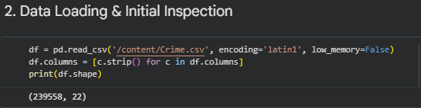
Figure 1: Data Loading & Initial Inspection
The target variable used in this research is the variable of arrest (Arrest), which is a binary variable (True/False). This variable is especially applicable in predictive policing because it directly assists in the decision-making activities in the operational aspect, such as resource allocation and prioritisation of law enforcement activities. Even though another variable in the dataset is the Domestic, the likelihood of arrest would give better, timely, and practical feedback on police tactics.
Relevant predictor variables were identified to include different crime behaviour aspects. They include coded categorical features (such as crime type and location description), spatial variables (district, community area, latitude, and longitude), as well as temporal ones (month, hour, day of the week, and weekend indicator). This combination will guarantee that contextual as well as behavioural patterns that may affect the outcome of arrests are well captured.

4.2 Data Preparation
Preparation of data was done to improve the quality of data and model reliability. There were initially some missing values in the dataset across some of its attributes, specifically location-related variables, including latitude, longitude, and ward. Missing values of these distinguishing characteristics were not filled in to maintain the spatial information integrity, since filling in such variables may hide the geographic occurrences.
Label encoding was used to convert categorical variables into numerical quantities, which allows their utilization in machine learning algorithms [4]. Although this method can impose implicit ordering, it has been chosen because of its efficiency in computation and its ability to handle large categorical features displayed by large cardinality in the dataset.
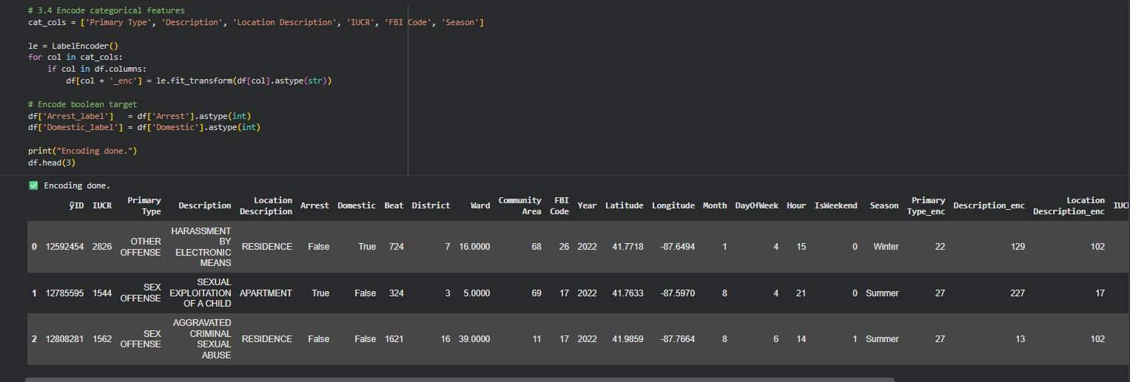
Figure 2: Encoding Categorical Variables
The application of feature engineering in order to derive meaningful temporal attributes in the date variable was used. Particularly, the derived items were the month, hour, the day of the week, season, and an indicator of a weekend. These characteristics are crucial because temporal dynamics play an important role in crime patterns, and their inclusion improves the modeling capability of the model to capture these cultural trends.
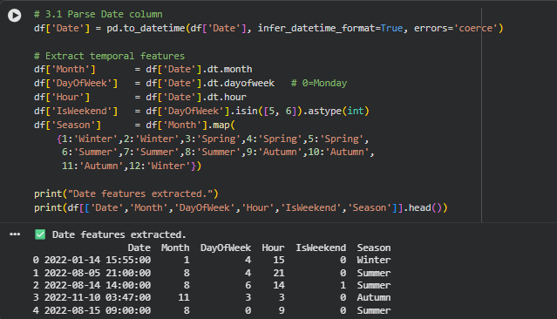
Figure 3: Parsing Date Column
The process of feature selection was carried out in order to avoid the inclusion of irrelevant or redundant variables because of the unique identifiers and prediction-irrelevant attributes. The selection of features had to be carried out in order to drop noise and overfitting, thereby reducing dimensionality and improving model generalisation [7]. There were also verification and deletion of duplicate records in order to guarantee data consistency.
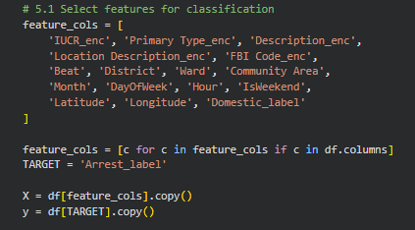
Figure 4: Feature Selection
One of the challenges was also found to be the imbalance of classes, with a minority of the data being based on arrest cases. To solve this, they used the Synthetic Minority Oversampling Technique (SMOTE) on the training data. Through this method, artificial samples of the superiority group are created, thus enhancing the capability of the model to be pattern sensitive to the arrest cases, and bias towards the superiority group is minimized. This also improves the model’s ability to generalise minority class patterns.

4.3 Model Selection
Three classification models were chosen, including Logistic Regression, Decision Tree, and Random Forest. It was selected based on the requirement of comparing models of different complexity and interpretability.
The reason why Logistic Regression has been selected as a base model is its ease and wide interpretability. It permits an understandable amount of influence of features on the likelihood of arrest, which can be useful in situations where transparency is important. The stride, however, on this model is that it assumes that relationships are linear and may not capture crime data adequately.
The Decision Tree model has been chosen because it would be able to model non-linear relationships and produce predictions from rules. It is interpretable, hence suitable for explaining the decision to those who are involved in the matter. In order to prevent overfitting and enhance generalisation on unobserved data, certain constraints were implemented.
The reason why Random Forest was selected was that it is an ensemble tool that can help solve the weakness of the Decision Trees on its own. It is able to aggregate several trees, therefore minimizing overfitting and enhancing predictor power. It is already efficient for processing high-dimensional data. The result of this, however, is a trade-off in interpretability.
In general, these models were chosen to compare interpretability and predictive performance, which allows overall assessing the appropriateness of these models to arrest prediction.

4.4 Evaluation Metrics
Various metrics were used to assess the model performance so as to have a comprehensive assessment. Overall classification performance was measured in terms of accuracy. Nonetheless, because of the imbalance between the classes, accuracy is not enough, and it might support the majority class.
Precision was added in order to determine the rate of the correctly predicted arrests out of all the predicted arrests, which is valuable in the minimization of false positives and even wasteful use of resources. Recall was one of the most important metrics (the crucial metric) because it is the measure of the model's capacity to recognize real arrest cases. When it comes to crime prediction, missing out on a possible arrest situation can be very relevant to the overall society, and thus, recall can play a crucial role.
F1-score was employed to balance precision and recall, which gives a more effective assessment in imbalanced contexts. As well, ROC-AUC was utilized in order to evaluate the capabilities of the model to classify between classes in question and across varying thresholds. In combination, the metrics guarantee both statistical and practical performance measurement in the evaluations of models, which benefits the making of choices in law enforcement practice [12].

5. Model Implementation
This section presents the process of implementation of the chosen classification models, such as data splitting, model training, and performance evaluation. The implementation was made in such a way as to make it robust, fair, and reliable when determining the result of arrests.
In the first step, the dataset was split into training and testing sets based on an 80:20 split. The stratified method of sampling was used so that the original class distribution of the target variable can be maintained in both subsets. This is especially relevant with an imbalance in the data set, and it makes sure that both categories are fairly represented in model testing and that no biased model performance estimates are made.
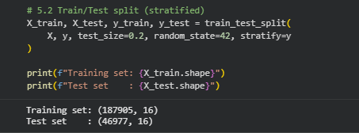
Figure 5: Splitting Dataset (Train & Test)
To deal with the problem of disproportion between the classes, the Synthetic Minority Oversampling Technique (SMOTE) has been implemented on the training data only [5]. This method produces artificial examples of the minority group (arrest cases), and this leads to a balanced training sample. The application of SMOTE on the training set alone prevents leakage of data, and the model testing on unseen data is not influenced.
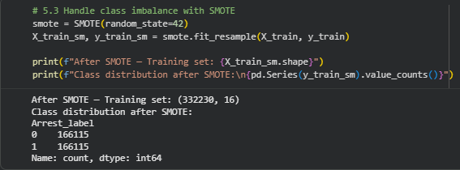
Figure 6: Handling Class Imbalance with SMOTE
The Logistic Regression model of feature scaling was done using the standardisation option since the analysis is sensitive to the scale of input variables. Conversely, the tree-based models like decision tree and random forest do not require scaling the features because the models are not sensitive to monotonic transformations of the data.
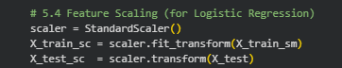
Figure 7: Feature Scaling for Logistic Regression
The original model that was applied was that of Logistic Regression, which was used as a comparative model. Balanced class weights were used to train the model to also take care of class imbalance. Although it is such a simple model, the Logistic Regression was used as a reference with which the effectiveness of more complicated models could be compared. On the test set, it produced predictions and evaluated its performance in terms of scores of probability, which were then translated into performance measures (ROC-AUC) and so on.
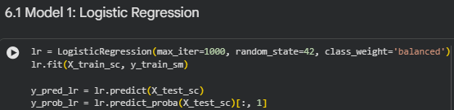
Figure 8: Logistic Regression Model Development
The second model, Decision Tree, was used, and the hyperparameters are controlled, such as a max depth of 8 and a minimum sample split threshold. It was these constraints that were introduced in order to curb overfitting and better generalisation. The trained model based on balanced data generated comprehensible decision rules, which provide an understanding of the impact of the features on arrest outcomes.
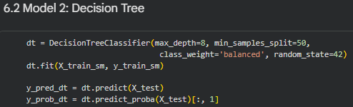
Figure 9: Decision Tree Model Development
The last model used was the Random Forest, which was applied as a combination of 200 decision trees, which had a maximum depth of 12. This structure was chosen in order to ensure a trade-off between the complexity of the model and computing power. Random Forest prevents excess variance by combining several trees and increases predictive results. The volume of the dataset necessitated parallel processing to make it more efficient in terms of training.
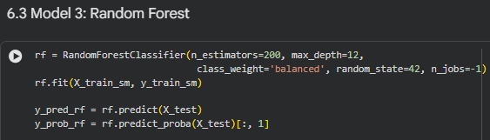
Figure 10: Random Forest Model Development
Confusion matrices, classification reports, and ROC curves were used to evaluate the model's performance. Confusion matrices were more informative on what is really good and what is not, what is really bad and what is not, thus allowing for a better understand the behaviour of models. The metrics included in the classification reports of the two categories (leader and follower) were precision, recall, and F1-score.
The difference noted in the process of implementation is that the random forest was capable of modeling complex non-linear interactions between variables like location, time, and type of crime, which logistic regression could not fit, as it is linear. This greatly enhanced effectiveness in classification, especially in cases of arrests. This demonstrates the relevance of ensemble models in crime datasets that have non-linear relationships amongst variables and are very interdependent.
Further, the cross-validation mechanism was carried out in 5-fold on the Random Forest model to determine its stability and generalisability. The model demonstrated a high ROC-AUC score in all the folds, which implies high performance and low variability.
On the whole, this implementation process allowed for a systematic comparison of models in terms of trade-offs in the context of simplicity, interpretability, and predictive accuracy in arrest prediction.

6. Results & Analysis
The three classification models, which include Logistic Regression, Decision Tree, and Random Forest, exhibit big disparities in their capacity to elicit patterns in the crime dataset. Such discrepancies bring into the limelight that there is a trade-off between interpretability and predictive performance, and the significance of the model selection in the complex and real-life data.
Logistic Regression had an accuracy of 61.70% and an ROC-AUC value of 0.639. Although this model showed mediocre recall of the arrest category (0.55), it had a low degree of precision (0.16), which implies that it had high false positives. This implies that though the model could determine a decent percentage of actual arrests, it was not effective in identifying them as compared to the non-arrest cases. One major weakness of the Logistic Regression is its inability to capture relationships that are non-linear, as is the case with crime data. The model was therefore unable to recognize complicated interactions between spatial-temporal and categorical variables, and thus, had poorer overall functionality.
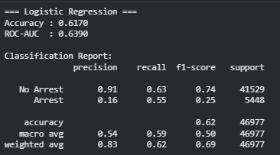
Figure 11: Evaluation Metrics of Logistic Regression
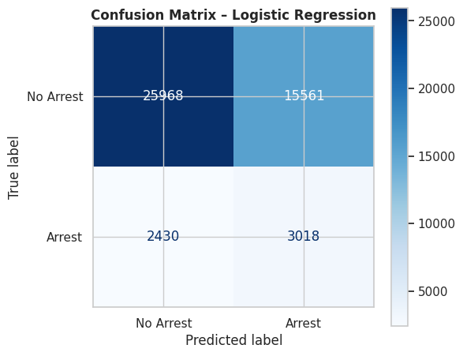
Figure 12: Confusion Matrix of Logistic Regression
The Decision Tree model, on the contrary, was a lot more accurate (80.00% and ROC-AUC=0.863). The model performed well in the arrest class (0.73), which shows that it can be applied in recognizing actual cases of arrest. This advantage implies that the Decision Tree has been able to adjust non-linear associations and interactions among variables compared to the Logistic Regression. But the precision (0.33) implies that the false positives are still a factor. The model still has some potential for overfitting tendencies even though the depth parameters are controlled, and restricts its generalisation of unseen data.
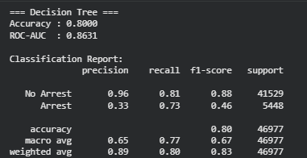
Figure 13: Evaluation Metrics of Decision Tree
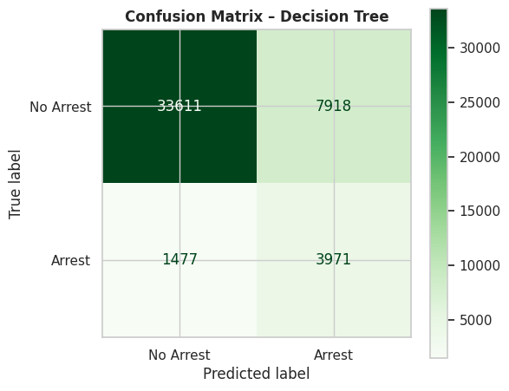
Figure 14: Confusion Matrix of Decision Tree
Random Forest has provided the overall most advanced results, as it gives an accuracy of 82.83 as well as a ROC-AUC of 0.877. The model was also highly recalled (0.71), as well as increasing the precision (0.37) over the Decision Tree. It means a more balanced performance, with better discrimination between arrest and non-arrest cases. It can be suggested that Level 1, depending on the idea of higher performance, is primarily explained by the ensemble nature of the Random Forest, which minimizes variance and improves non-linear and complex features of the data that may be captured by the model. In addition, the cross-validation showed that performance is consistent (ROC-AUC of 0.89), proving that the model can be robust and has generalisability.
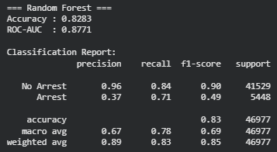
Figure 15: Evaluation of Random Forest
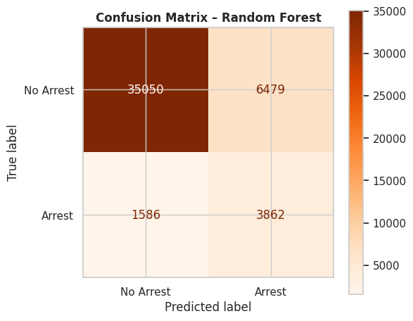
Figure 16: Confusion Matrix of Random Forest
Random Forest has no limitations, even though it has strengths. Though it increases the predictive power more, the levels of interpretability are lower as compared to simpler predictions. This is a challenge to policing where transparency and accountability are paramount. Thus, in spite of the fact that the most successful model under the predictive perspective is Random Forest, its implementation should take into consideration the requirement to be explained.
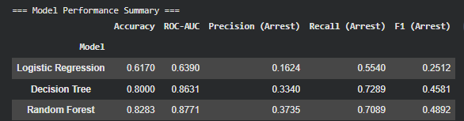
Figure 17: Model Performance Summary
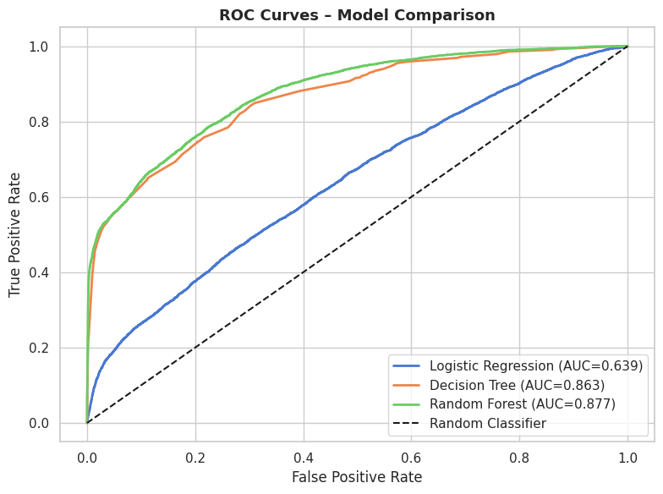
Figure 18: ROC Curves for Model Comparison
This difference in the accuracy of the models can be explained by the fact that these models are able to reproduce the underlying data complexity. Logistic Regression was less accurate because it assumed a linear relationship, and this confined its ability to model complex patterns of crime. Decision Tree, in contrast, had better accuracy as it was able to capture non-linear interactions, but also was overfit. Random Forest had the best accuracy because it uses a number of decision trees to minimise variance and enhance generalisation. This proves the fact that the models that are able to deal with non-linearity and feature interactions are much better in crime prediction.
The importance of features identified by the Random Forest model offers additional data on what causes individuals to be arrested or not. Location-based features (district, community area, latitude, longitude), crime-related (primary crime type and description), and temporal variables (hour and month) are considered the most influential. This implies that the timing and place of crime and the nature of the offence are strong sources of arrest probability. An example is that some districts and crime types are more likely to be arrested, meaning that there is some form of targeted policing or increased prosecution in certain places.
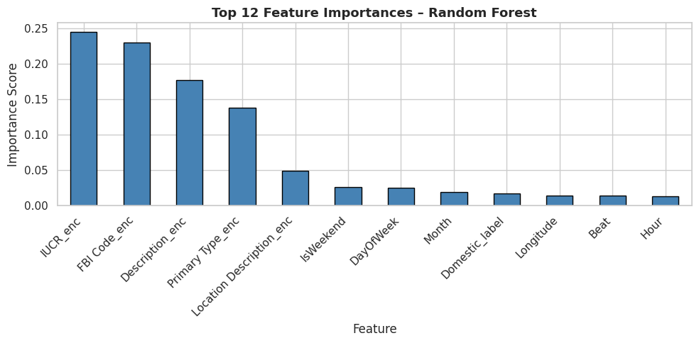
Figure 19: Feature Importance Analysis of Random Forest Model
Secondly, the fact that the positive predictor is a domestic variable means that there can be specific patterns of crimes that are domestic-related and affect arrest results.

7. Clustering Analysis
Unsupervised methods of learning were used on the subset of the data where an arrest had taken place in order to complement the classification models (Arrest = True). This method allows for further investigation of the trends in effectively solved cases, which can give more information than forecasting.
The K-Means clustering was applied to determine the natural clusters in the arrest positive data. Important attributes that were employed to cluster data comprised the spatial (latitude, longitude, district) and the temporal aspects (hour and month) in the data, which incorporated a location component and a behavioural component of crime. The elbow method was used to find the optimal number of clusters, and the most suitable clusters were four because they offer the best balance between simplicity in the model and model power.
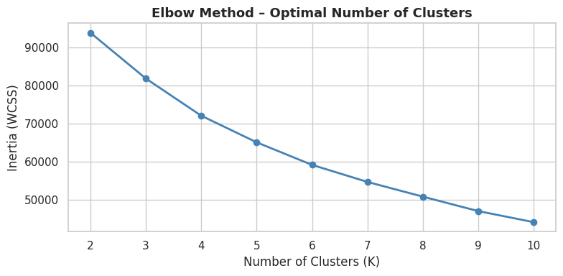
Figure 20: Elbow Method
The clustering findings showed that there were clear spatial and temporal patterns. As an example, some clusters had more crime activity in the evening days within particular districts, and other clusters had crime activities that happened late morning in other geographical locations. This indicates that arrest crimes do not have a homogeneous distribution but rather establish discernible patterns based on the place, as well as time.
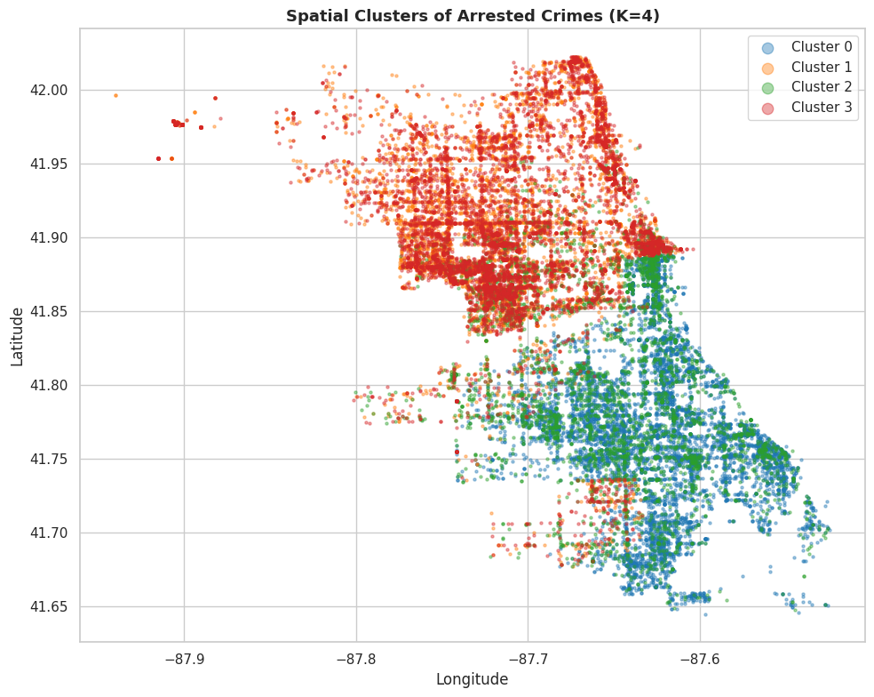
Figure 21: Spatial Cluster of Arrested Crimes
Nevertheless, one of the shortcomings of clustering is that it offers only descriptive formations, never outlining relationships among the variables; thus, interpretation becomes less actionable.
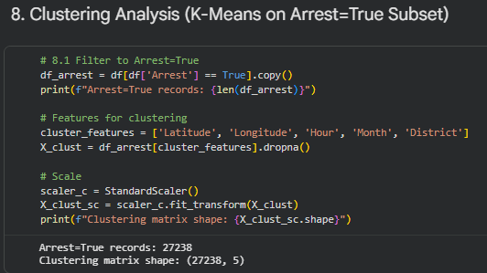
Figure 22: Clustering Analysis Metrics

8. Discussion
This research gives a conclusive analysis of the technique of classification and unsupervised learning methods within the context of the prediction of crime, bringing along both methodological and practical implications. The most striking finding is that there was an evident performance difference between the models, with random forest always performing well in all performance metrics compared to Logistic Regression and Decision Tree. This observation concurs with previous studies indicating that ensemble models would work better when dealing with non-linear, high-dimensional data that have complex relationships. Conversely, although interpretable, the predictive ability of the Logistic Regression was limited because of its linearity, which validates its use as an initial predictive model as opposed to a complete predictive model.
The Decision Tree model provided a medium balance as it was able to capture non-linear relationships better than Logistic Regression, but the model was also interpretable. Nevertheless, its tendency to overfit, despite controlled depth, indicates its weakness in the literature. This implies that the explanatory value of the Decision Trees is helpful, but its logical predictive validity might be limited in dynamic areas like crime analytics.
In practical considerations, the better results of the Random Forest imply that the method can be utilized in predictive systems of policing. It is especially important because of its high recall, making it less likely to miss the prospective cases of arrest, the consequences of which may be critical in society. But this should be counterbalanced by the desire to be transparent in law enforcement decision-making and to be accountable, as emphasized in the literature on ethical AI. This brings a trade-off between predictive accuracy and interpretability, and thus it may result in the need to use hybrid methodologies or explainable AI methods.
The results of clustering and association rule mining also add insights to the classification results. Even though clustering was useful in uncovering spatial and time association of arrest cases, association rules were useful in giving practically valuable information on crime type, location, and time periods. This proves the point that the integration of supervised and unsupervised methods provides a more comprehensive insight into crime patterns.
In general, the paper shows that properly applied and critically and responsibly, advanced machine learning methods can contribute greatly to decision-making in law enforcement.

9. Recommendations
According to the findings, the use of the Random Forest model in law enforcement agencies should be implemented to predict arrests because it is much more accurate and able to identify intricate crime patterns. The operation decision-making process must be enhanced to locate the crime hotspots and repetitive patterns to create a specific patrol strategy by using association rules. Furthermore, the insights can be clustered to assist in allocating resources because high-risk spots and periods would be marked. Data collection should be so as to improve the completeness and consistency of the spatial and contextual variables, as well as to boost the reliability of the models. Lastly, explainable AI methods should be incorporated to establish transparency and accountability in the existing predictive policing systems [8].

10. Conclusion
This research paper demonstrated that machine learning methodology is effective in predicting arrests based on crime data. Random Forest was superior to other models, and it is important to emphasize that the role of the ensemble technique in capturing complex patterns is significant and that the clustering and association rules contributed to the further understanding of the crime behaviour patterns. Nonetheless, there are drawbacks such as the imbalance of the classes, low interpretability of advanced models, and historical data bias. The future studies are to pursue explainable AI methods, use real-time data, and consider more advanced models like gradient boosting to achieve the furthest predictive efficiency and aid more intuitive reasoning in law enforcement.

References
[1] L. Hu, M. Jiang, J. Dong, X. Liu, and Z. He, “Interpretable clustering: A survey,” ACM Computing Surveys, vol. 58, no. 8, pp. 1–21, Feb. 2026.
[2] M. Bagaric, J. Svilar, M. Bull, D. Hunter, and N. Stobbs, “The solution to the pervasive bias and discrimination in the criminal justice system: transparent and fair artificial intelligence,” American Criminal Law Review, vol. 59, p. 95, 2022.
[3] M. Kaushik, R. Sharma, I. Fister Jr., and D. Draheim, “Numerical association rule mining: a systematic literature review,” arXiv preprint arXiv:2307.00662, Jul. 2023.
[4] F. Bolikulov, R. Nasimov, A. Rashidov, F. Akhmedov, and Y. I. Cho, “Effective methods of categorical data encoding for artificial intelligence algorithms,” Mathematics, vol. 12, no. 16, p. 2553, Aug. 2024.
[5] I. M. Alkhawaldeh, I. Albalkhi, and A. J. Naswhan, “Challenges and limitations of synthetic minority oversampling techniques in machine learning,” World Journal of Methodology, vol. 13, no. 5, p. 373, Dec. 2023.
[6] H. M. Castro and J. C. Ferreira, “Linear and logistic regression models: when to use and how to interpret them,” 2022.
[7] W. Jiang, Z. Li, X. Kang, L. Luo, Y. Zhou, Q. Liu, K. Liu, X. Ji, and G. He, “Hybrid modeling approach for natural gas desulfurization process: Coupling mechanism and data modeling via compact variable identification,” Gas Science and Engineering, vol. 123, p. 205243, Mar. 2024.
[8] O. Yapar, “Explainable AI in national security: Enhancing trust and accountability,” International Journal of Emerging Technologies and Innovative Research, Dec. 2023.
[9] Z. Jing, Y. Luo, X. Li, and X. Xu, “A multi-dimensional city data embedding model for improving predictive analytics and urban operations,” Industrial Management & Data Systems, vol. 122, no. 10, pp. 2199–2216, Nov. 2022.
[10] V. G. Costa and C. E. Pedreira, “Recent advances in decision trees: An updated survey,” Artificial Intelligence Review, vol. 56, no. 5, pp. 4765–4800, May 2023.
[11] S. M. Miraftabzadeh, C. G. Colombo, M. Longo, and F. Foiadelli, “K-means and alternative clustering methods in modern power systems,” IEEE Access, vol. 11, pp. 119596–119633, Oct. 2023.
[12] M. K. Tran, S. Panchal, V. Chauhan, N. Brahmbhatt, A. Mevawalla, R. Fraser, and M. Fowler, “Python-based scikit-learn machine learning models for thermal and electrical performance prediction of high-capacity lithium-ion battery,” International Journal of Energy Research, vol. 46, no. 2, pp. 786–794, Feb. 2022.
[13] P. Vogiatzoglou, P. Valcke, and S. Royer, “The era of pre-crime: How mass data surveillance and predictive policing intersect and interfere with privacy, data protection and due process rights in the EU,” 2023.
[14] Y. Zakur and L. Flaih, “Apriori algorithm and hybrid Apriori algorithm in data mining: a comprehensive review,” in E3S Web of Conferences, vol. 448, p. 02021, 2023.
[15] M. Mohammadagha, “Hyperparameter optimization strategies for tree-based machine learning models prediction: a comparative study of AdaBoost, decision trees, and random forest,” 2025.

Appendix: Python Code and its Analysis


