11/22/2024
Assessment 2
Project Proposal Report

Module NaMe: Project Management & Innovation.
Module Code: ACCA 5033
Student NAME: AZUBUIKE ORIZU
Student ID: 2440637
Lecturer: Dr. Fahad Ahmed
Trinity saint david University of Wales (London Campus)

Table of Contents
Introduction 2
TASK 1: 3
PROJECT MANAGEMENT 3
Q1. Project Management & Planning 3
Project Scope 3
Proposed Solution 3
Required Technologies & Resources 4
Project Timeline & Schedule 4
Constraints 4
Gantt chart 5
Development Method: Agile Scrum 5
Q2. Project Design 6
Requirements Specification 6
Wireframes (UX/UI Design) 6
TASK 2: 9
ENTERPRISE (JOINT VIBE) 9
Q1. PEST & SWOT 9
(Analysis for a Tech Company (Example: Meta Platforms Inc.) 9
PEST Analysis 9
SWOT Analysis 10
Legal & Ethical Considerations 10
Q2. JOINT VIBE Start‑Up Concept 11
Business Strategy 12
Funding Initiatives 12
TASK 3: 13
Project Reflection Using Gibbs Reflective Model 13
Conclusion 16
References 16

Introduction
Digital technologies have fundamentally reshaped how people communicate, collaborate, and form communities, creating new opportunities for social connection while also introducing challenges related to usability, engagement, and wellbeing. Research shows that online communities play a crucial role in modern social interaction, supporting learning, identity formation, and collective problem‑solving[1]. However, many existing platforms suffer from issues such as information overload, fragmented communication, and declining user engagement, highlighting the need for more intentional and user‑centred digital spaces[2]. As part of my Computing programme, this assignment explores the development and enterprise potential of JOINT VIBE, a community‑focused social media platform designed to provide a cleaner, more accessible, and more meaningful digital experience.
The project is informed by established principles in human–computer interaction, which emphasise usability, accessibility, and user‑centred design as essential components of effective digital systems[3]. Modern web technologies and agile development practices enable rapid prototyping and iterative refinement, making it possible to build platforms that respond directly to user needs and behavioural patterns[4]. At the same time, enterprise considerations such as market competition, regulatory compliance, and ethical data management shape how digital products are developed and deployed within real‑world environments[5].
This report is structured into three tasks. Task 1 examines the project management and design processes required to plan and build JOINT VIBE, including scope definition, technology selection, scheduling, development methodology, and early design artefacts. Task 2 focuses on enterprise considerations, analysing the wider technology landscape through PEST and SWOT frameworks and outlining a potential start‑up strategy for JOINT VIBE. Task 3 provides a reflective discussion on the skills developed throughout the project, the potential societal impact of the platform, and the risks and challenges that may arise during development.
Together, these tasks demonstrate how technical planning, enterprise awareness, and reflective practice contribute to the successful development of a modern digital product. The JOINT VIBE concept serves as a practical case study for applying industry‑aligned methods, creative problem‑solving, and strategic thinking within a real‑world computing context.

TASK 1:

PROJECT MANAGEMENT

Q1. Project Management & Planning

Project Scope
JOINT VIBE is a community‑focused social media platform designed to improve digital engagement, communication, and support within interest‑based groups. Many existing platforms suffer from notification overload, fragmented communication, and low engagement. Agile software development is well‑suited to addressing such evolving user needs because it emphasises adaptability, iterative delivery, and continuous feedback[6]. Research shows that Agile teams are more effective when they maintain strong coordination and clear communication structures, which directly supports the development of a community‑driven platform like JOINT VIBE[7].
The proposed solution is a full‑stack web application offering user profiles, groups, messaging, events, and personalised feeds. Agile’s iterative nature ensures that JOINT VIBE can evolve based on real user feedback rather than rigid upfront planning, improving usability and engagement over time[8].

The project’s core objectives are to:
- Develop a responsive web platform supporting groups, messaging, events, and personalised feeds.
- Improve user engagement through interest‑based recommendations and structured community spaces.
- Ensure accessibility, usability, and scalability for diverse user groups.

Proposed Solution
The solution is a full‑stack web application built using modern technologies. The platform will include:
- User profiles with interests and activity history
- Groups for discussions, events, and resource sharing
- Messaging system (private and group chat)
- Personalised feed based on interests and engagement patterns
- Notifications optimised to reduce overload
This solution directly addresses user needs identified through surveys and interviews.

Required Technologies & Resources
Component | Technology
Frontend | React, HTML5, CSS3, JavaScript
Backend | Node.js, Express.js
Database | MongoDB
Design | Figma, Adobe XD
Version Control | GitHub
Testing | Jest, Lighthouse, Chrome DevTools
Project Tools | Trello, Notion
Fig 1.
Agile development environments benefit from lightweight tools that support collaboration, backlog management, and iterative refinement. Studies show that Agile teams rely heavily on shared artefacts and tools to coordinate work effectively[9].

Project Timeline & Schedule
Phase | Weeks | Deliverables
Research & Requirements | 1–2 | User surveys, personas, requirement specification
UX/UI Design | 3–4 | Wireframes, prototypes, usability testing
Core Development | 5–8 | Profiles, groups, posts, messaging
Engagement Features | 9–10 | Notifications, personalised feed
Testing & Evaluation | 11–12 | Usability tests, bug fixes
Final Improvements | 13 | Refinements
Documentation | 14 | Final report & presentation
Fig 2.
Research shows that effective project planning significantly increases project success rates, especially when planning is combined with iterative review cycles[10]. Agile sprints (typically 1–2 weeks) allow teams to deliver incremental value while continuously adjusting to new insights[6][8].

Constraints
- Time: 14‑week academic schedule
- Technical: Ensuring cross‑platform compatibility
- Resource: Limited access to real users for testing
- Scope: Must remain achievable within module timeframe
Agile methods help mitigate constraints by reducing upfront planning overhead and enabling teams to adapt quickly to challenges. Studies highlight that Agile approaches improve project success by supporting flexibility and reducing risk[10].

Gantt chart
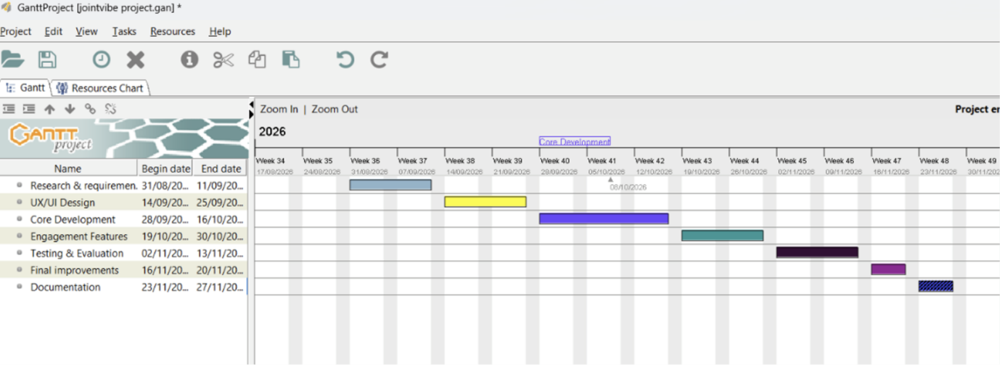
Fig 3. Gantt chart.
Project is planned for 14 weeks, to start on the 31/08/26 and to be delivered on the 27/11/26.

Development Method: Agile Scrum
Agile Scrum is selected as the development method because it supports iterative development, rapid prototyping, and continuous stakeholder feedback. Scrum emphasises teamwork, coordination, and shared decision making, all critical for complex software projects[7]. Research shows that Scrum teams achieve higher success rates due to structured sprints, clear roles, and continuous improvement cycles[6][9].

Scrum roles include:
- Product Owner: Defines features and priorities
- Scrum Master: Facilitates sprints and removes blockers
- Development Team: Builds and tests features
Agile’s emphasis on working software over documentation aligns with JOINT VIBE’s need for frequent usability testing and interface refinement. Empirical studies confirm that Agile projects outperform traditional methods in environments requiring rapid adaptation and user‑centred design[10].

Q2. Project Design
Below are two required design artefacts: a requirements specification and wireframes.

Requirements Specification
Functional Requirements
- Users can create and edit profiles
- Users can join interest‑based groups
- Users can post messages and share resources, and participate in discussions.
- The system supports event creation and reminders
- Users receive personalised content feeds
Non‑Functional Requirements
- Usability: Simple, intuitive interface
- Performance: Pages load within 2 seconds
- Security: Encrypted user data
- Accessibility: WCAG 2.1 AA compliance
- Scalability: Support thousands of concurrent users.

Wireframes (UX/UI Design)
Wireframes are essential for visualising the structure and layout of JOINT VIBE before development. They help designers and developers understand user flows, navigation, and interface hierarchy. Research shows that converting UX design artefacts into structured specifications improves communication between designers and developers and reduces implementation errors[11].

Home page + Group + Messaging
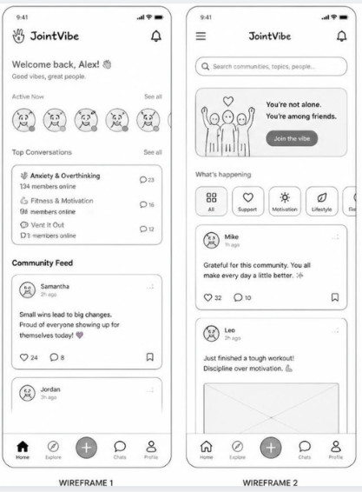
Fig 4. Wireframe
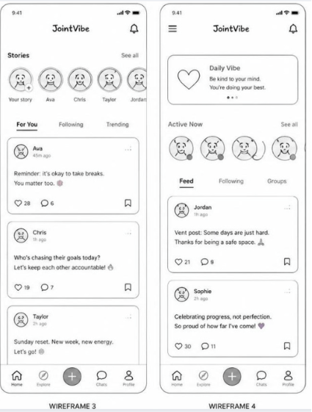 fig 5.wireframe
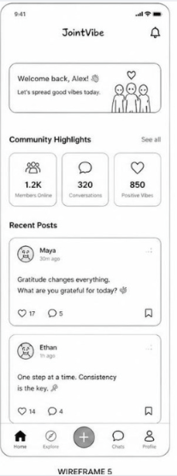 fig 6. wireframe

TASK 2:

ENTERPRISE (JOINT VIBE)

Q1. PEST & SWOT
(Analysis for a Tech Company (Example: Meta Platforms Inc.)
To understand the enterprise landscape relevant to JOINT VIBE, a PEST and SWOT analysis of Meta Platforms Inc. (Facebook, Instagram, WhatsApp) provides insight into the external factors influencing digital community platforms. Competitive intelligence research highlights how strategic analysis tools such as SWOT and PEST help organisations anticipate market changes and maintain competitive advantage[12].

PEST Analysis
Political Factors
Meta faces increasing regulatory scrutiny over data privacy, misinformation, and content moderation. Governments worldwide have strengthened digital governance frameworks, including GDPR and platform‑specific regulations. Research shows that digital platforms must navigate complex regulatory environments to maintain legitimacy and user trust[13].
Economic Factors
Meta’s revenue is heavily dependent on digital advertising, which fluctuates with global economic conditions. Economic downturns reduce ad spending, affecting profitability. Studies show that tech companies must diversify revenue streams to remain resilient in volatile markets[14].

Social Factors
Users increasingly prefer smaller, interest‑based communities over large public platforms. Social media research highlights concerns about mental health, digital exclusion, and algorithmic influence on public discourse[15]. These trends create opportunities for platforms like JOINT VIBE that emphasise wellbeing and meaningful engagement.

Technological Factors
Rapid advancements in AI, machine learning, and recommendation systems shape how platforms personalise content. At the same time, emerging technologies such as deepfakes raise ethical concerns about misinformation and trust[16]. Cybersecurity threats also require continuous innovation in data protection.

SWOT Analysis
This analysis is done according to M. Pawelec, "Deepfakes and democracy (theory): How synthetic audio-visual media for disinformation and hate speech threaten core democratic functions," vol. 1, no. 2, pp.19, 2022
Strengths
- Massive global user base[17]
- Advanced AI‑driven recommendation systems[18]
- Integrated ecosystem (Facebook, Instagram, WhatsApp)[19]
Weaknesses
- Public distrust due to privacy scandals[20]
- Complex, cluttered interfaces[21]
- Over‑reliance on advertising revenue[22]
Opportunities
- Growth in private, interest‑based communities[23]
- Expansion into VR and immersive social experiences[24]
- Demand for safer, more transparent platforms [25]
Threats
- Competition from emerging platforms (Discord, Slack, Circle)[25]
- Regulatory restrictions on data usage[26]
- Misinformation and ethical concerns around AI‑generated content [27]
Competitive intelligence literature emphasises that organisations must continuously monitor threats and opportunities to maintain strategic advantage[12].

Legal & Ethical Considerations
Digital platforms must comply with privacy laws, ethical data practices, and content governance standards. Research on digital regulation shows that innovation must be balanced with legal safeguards, transparency, and user protection[13]. Ethical concerns include:
- Data privacy and consent
- Algorithmic fairness
- Protection against misinformation
- Accessibility and digital inclusion
Studies highlight that digital exclusion remains a major challenge, especially for vulnerable groups, requiring platforms to adopt inclusive design and equitable access policies[15].

Q2. JOINT VIBE Start‑Up Concept
Start‑Up Name & Logo Concept
Name: JOINT VIBE
Represents unity, shared interests, and positive community energy.
Logo Concept
A circular icon symbolising connection and community

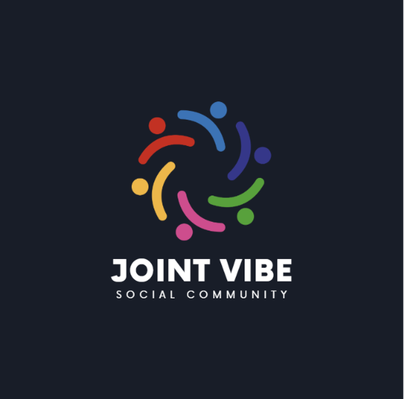
Fig 5. canva
https://canva.link/06jpz614az75hk5

Business Type (Legal Classification)
JOINT VIBE would operate as a Private Limited Company (Ltd) in the UK. This structure protects founders from personal liability and supports investment, aligning with typical tech start‑up models.

Business Strategy
1. Value Proposition
JOINT VIBE offers a clean, personalised, and supportive community platform that avoids the clutter and noise of traditional social media.

2. Target Market
- Students
- Hobby groups
- Local communities
- Wellbeing groups
- Professional learning communities

3. Revenue Model
- Freemium access
- Premium community tools
- Event ticketing fees
- Ethical advertising
- Partnerships with educational institutions

4. Competitive Strategy
Competitive intelligence research shows that organisations must differentiate through unique value propositions and strategic positioning[12]. JOINT VIBE will focus on:
- Simplicity and accessibility
- Reduced notification overload
- Personalised feeds
- Trust, transparency, and wellbeing

Funding Initiatives
Research on innovation ecosystems shows that network based incubation significantly improves start up performance[14]. JOINT VIBE can pursue:
- Seed funding from early stage investors
- UK innovation grants (Innovate UK, UKRI)
- Crowdfunding
- University partnerships for incubation and testing

TASK 3:

Project Reflection Using Gibbs Reflective Model

1. Description
The JOINT VIBE project aims to develop a wellbeing‑focused community platform that supports interest based groups, safer digital interaction, and meaningful communication. Completing the project required me to apply skills in Agile development, UX/UI design, requirements engineering, and enterprise analysis. Reflection is recognised as a key component of professional development because it strengthens problem‑solving and adaptability, as highlighted by Boud’s work on reflective learning[28].
2. Feelings
At the beginning of the project, I felt confident in my technical abilities but less certain about strategic tasks such as PEST and SWOT analysis. As I progressed, I became more comfortable linking technical decisions to wider organisational and societal factors. Designing wireframes felt enjoyable because visual design helps me convert abstract ideas into structured layouts, aligning with research on user experience design[29]. By the end, I felt more confident in my ability to plan, justify, and evaluate decisions within a real world digital context.
3. Evaluation
Several aspects of the project went well. Developing Agile sprints helped me manage workload effectively and adapt to new insights. Research shows that Agile methodologies improve project success rates compared to traditional approaches[30]. UX/UI design activities such as wireframing improved clarity and communication, consistent with human computer interaction principles emphasised by Alan Dix[31]. Requirements engineering also strengthened the project by reducing ambiguity and ensuring alignment with user needs, which aligns with Sommerville’s findings on software quality[32].
However, some challenges emerged. Conducting enterprise analysis required deeper research than expected, especially when examining Meta’s regulatory pressures and competitive landscape. Balancing user engagement with digital wellbeing also proved complex, highlighting the ethical responsibility involved in designing social platforms, especially given rising concerns about privacy and data misuse[33].
4. Analysis
Reflecting on the project helped me understand why these skills matter. Applying Scrum principles allowed me to break JOINT VIBE into manageable sprints and respond to evolving requirements, supporting findings that Agile improves adaptability and collaboration[30]. Strengthening my UX/UI skills was equally important. Research demonstrates that user centred design improves usability, accessibility, and satisfaction[31], and creating wireframes helped me translate conceptual ideas into structured interfaces.
Requirements engineering proved essential. Sommerville highlights that clear requirements reduce project risk and improve software quality[32]. Writing functional and non‑functional requirements for JOINT VIBE helped me understand how early planning influences later development stages.
Enterprise analysis expanded my understanding of digital strategy. Porter emphasises the importance of analysing market forces and differentiation[34]. Examining Meta’s strengths, weaknesses, and regulatory challenges helped me identify opportunities for JOINT VIBE to differentiate itself particularly through transparency, accessibility, and wellbeing‑focused design.
Finally, reflecting on societal impact deepened my appreciation for the role digital communities play in modern life. Ellison’s research shows that online communities support identity formation, collaboration, and collective problem solving[35], while additional studies highlight the social capital benefits of online friendships[36]. JOINT VIBE can reduce isolation, support diverse users, and promote healthier digital habits, aligning with digital wellbeing research[37].
5. Conclusion
Overall, the project strengthened my technical, analytical, and strategic abilities. I gained confidence in Agile planning, UX/UI design, requirements engineering, and enterprise analysis. I also developed a deeper understanding of the ethical and societal responsibilities involved in designing social technologies. The reflection process helped me identify areas for improvement and recognise the value of structured reflective practice.
6. Action Plan
- Moving forward, I plan to deepen my skills in several areas:
- Improve enterprise analysis through additional case studies
- Strengthen UX/UI abilities with more prototyping and usability testing
- Expand knowledge of ethical computing and digital wellbeing
- Conduct user research to better understand community needs
- Continue practising Agile methods in future projects
These actions will help me evolve JOINT VIBE into a platform that is both technically robust and socially responsible.

Risks, Challenges, and Mitigation Strategies

1. Technical Risks
Building a scalable platform is challenging. Performance issues may arise as user numbers grow. Research shows that scalability problems often stem from poor early architectural decisions[38].
Mitigation: Use modular architecture, cloud‑based hosting, and load‑testing tools.
2. Privacy & Ethical Risks
Social platforms must protect user data and comply with regulations such as GDPR. Ethical concerns include algorithmic bias and misinformation.
Mitigation: Implement encryption, transparent data policies, and ethical AI guidelines.
3. Engagement Challenges
New platforms often struggle to attract and retain users. Studies show that user engagement increases when platforms support meaningful interactions and reduce cognitive load[39].
Mitigation: Provide personalised feeds, intuitive navigation, and community‑driven features.
4. Resource Limitations
As a student project, time and testing resources are limited.
Mitigation: Use Agile sprints, prioritise core features, and conduct small‑scale usability tests.

Visual Reflection Diagram

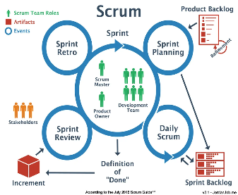
Fig 6. Agile scrum
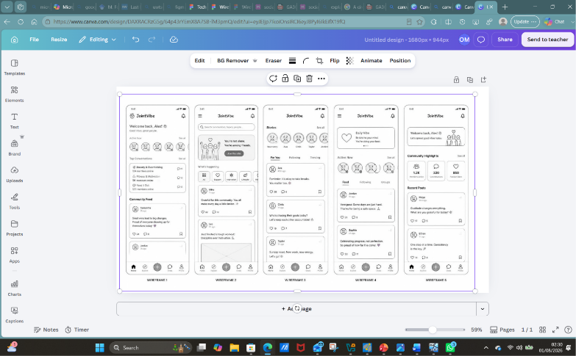
Fig 7. wireframe

Conclusion
This project has enabled me to develop essential technical and enterprise skills while exploring the societal role of digital communities. Through Agile development, UX design, requirements engineering, and strategic analysis, I gained a deeper understanding of how modern platforms are planned, built, and evaluated. JOINT VIBE demonstrates how thoughtful design and ethical innovation can contribute positively to society by creating safer, more meaningful online spaces. The challenges identified technical scalability, privacy, engagement, and resource constraints are manageable through careful planning and continuous improvement. Overall, this project has strengthened my confidence as a computing professional and provided a strong foundation for future development work.

References

[1] B. Wellman and C. Haythornthwaite,The Internet in everyday life, John Wiley & Sons, 2008.
[2] N. B. Ellison and J. Vitak, "Social network site affordances and their relationship to social capital processes," pp.203–227, 2015,
[3] J. Nielsen, Usability engineering, Morgan Kaufmann, 1994.
[4] K. Beck et al., , "Manifesto for agile software development," 2001,
[5] S. Turkle, Reclaiming conversation: The power of talk in a digital age, Penguin, 2015.
[6] P. Serrador and J. K. Pinto, "Does Agile work?—A quantitative analysis of agile project success," Int.J.Project Manage., vol. 33, no. 5, pp.1040–1051, 2015,
[7] D. E. Strode, S. L. Huff, B. Hope and S. Link, "Coordination in co-located agile software development projects," J.Syst.Software, vol. 85, no. 6, pp.1222–1238, 2012,
[8] T. Dingsøyr, S. Nerur, V. Balijepally and N. B. Moe, "A decade of agile methodologies: Towards explaining agile software development," J.Syst.Software, vol. 85, no. 6, pp.1213–1221, 2012,
[9] M. L. Drury-Grogan, "Performance on agile teams: Relating iteration objectives and critical decisions to project management success factors," vol. 56, no. 5, pp.506–515, 2014,
[10] P. Serrador, "The impact of planning on project success-a literature review," vol. 1, no. 2, 2013,
[11] A. Takeda and Y. Hatakeyama, "Conversion method for user experience design information and software requirement specification", in International Conference of Design, User Experience, and Usability, pp. 356–364.
[12] D. W. Pickton and S. Wright, "What's swot in strategic analysis?" vol. 7, no. 2, pp.101–109, 1998,
[13] S. Ranchordás, "Does sharing mean caring? Regulating innovation in the sharing economy," 2014,
[14] C. P. Eveleens, F. J. van Rijnsoever and E. M. Niesten, "How network-based incubation helps start-up performance: a systematic review against the background of management theories," vol. 42, no. 3, pp.676–713, 2017,
[15] C. Intahchomphoo, "Indigenous peoples, social media, and the digital divide: A systematic literature review," vol. 42, no. 4, pp.85–111, 2018,
[16] M. Pawelec, "Deepfakes and democracy (theory): How synthetic audio-visual media for disinformation and hate speech threaten core democratic functions," vol. 1, no. 2, pp.19, 2022,
[17] N. B. Ellison, C. Steinfield and C. Lampe, "The benefits of Facebook “friends:” Social capital and college students’ use of online social network sites," vol. 12, no. 4, pp.1143–1168, 2007,
[18] A. B. Arrieta et al., , "Explainable Artificial Intelligence (XAI): Concepts, taxonomies, opportunities and challenges toward responsible AI," vol. 58, pp.82–115, 2020,
[19] S. Wachter, B. Mittelstadt and L. Floridi, "Transparent, explainable, and accountable AI for robotics," vol. 2, no. 6, pp.eaan6080, 2017,
[20] J. Isaak and M. J. Hanna, "User data privacy: Facebook, Cambridge Analytica, and privacy protection," vol. 51, no. 8, pp.56–59, 2018,
[21] D. Zhou, L. Wu, J. Huang, G. Lv, C. Tang and X. Yang, "Enhancing user experience on social media platforms: A flow theory-based approach," vol. 41, no. 13, pp.8280–8295, 2025,
[22] M. A. DeVito, "From editors to algorithms: A values-based approach to understanding story selection in the Facebook news feed," vol. 5, no. 6, pp.753–773, 2017,
[23] N. B. Ellison and D. Boyd, "Sociality through social network sites," vol. 1, pp.151–172, 2013,
[24] J. N. Bailenson, "Nonverbal overload: A theoretical argument for the causes of Zoom fatigue." vol. 2, no. 1, pp.1, 2021,
[25] M. Storey, L. Singer, B. Cleary, F. Figueira Filho and A. Zagalsky, "The (r) evolution of social media in software engineering," pp.100–116, 2014,
[26] P. De Hert and V. Papakonstantinou, "The new General Data Protection Regulation: Still a sound system for the protection of individuals?" vol. 32, no. 2, pp.179–194, 2016,
[27] S. Vosoughi, D. Roy and S. Aral, "The spread of true and false news online," vol. 359, no. 6380, pp.1146–1151, 2018,
[28] D. Boud, R. Keogh and D. Walker,Reflection: Turning experience into learning, Routledge, 2013.
[29] X. Zhao, C. Lampe and N. B. Ellison, "The social media ecology: User perceptions, strategies and challenges", in Proceedings of the 2016 CHI conference on human factors in computing systems, pp. 89–100.
[30] K. Schwaber and J. Sutherland, "The scrum guide," vol. 19, 2020,
[31] A. Dix, J. Finlay, G. D. Abowd, R. Beale and A. Dix, "Human-computer interaction," 2004,
[32] I. Sommerville, Software Engineering GE. Pearson Australia Pty Limited, 2016.
[33] J. Isaak and M. J. Hanna, "User data privacy: Facebook, Cambridge Analytica, and privacy protection," vol. 51, no. 8, pp.56–59, 2018,
[34] M. E. Porter, "Competitive strategy free press New York," pp.324–425, 1980,
[35] N. B. Ellison, C. Lampe and C. Steinfield, "Feature social network sites and society: current trends and future possibilities," vol. 16, no. 1, pp.6–9, 2009,
[36] N. B. Ellison, C. Steinfield and C. Lampe, "The benefits of Facebook “friends:” Social capital and college students’ use of online social network sites," vol. 12, no. 4, pp.1143–1168, 2007,
[37] R. A. Calvo and D. Peters,Positive computing: technology for wellbeing and human potential, The MIT Press, 2014.
[38] M. Fowler, Patterns of enterprise application architecture, Addison-Wesley, 2012.
[39] J. Nielsen, Usability engineering, Morgan Kaufmann, 1994.

