Drill Press Design
Engineering Design
p101973
2018

Abstract
This is a report of the design process of a drill press. Research was carried out on what external factors have an effect of the design and production of a drill press. This will report indicates that the design of a drill press has been optimised and perfected thus meaning innovations in the operation design will have little effect on the customer satisfaction. It was found that to satisfy the customers’ needs it was far more productive to better the perception of value for the drill press. It will be shown what design features have a direct effect on value and how it would be incorporated in the product.
Table of Contents
Abstract 1
Introduction 3
Design Process Framework 4
Design Process 4
Problem identifications 4
Solution 4
Solution Validation 4
Design of a Drill Press 5
Design Process of Drill Press Stand 5
Problem/Need Identification 5
Quality requirements 5
The customer 5
Research 6
Solutions of needs 6
Main Slider Design 6
Final Design 7
Quality Function Deployment 9
Materials & Manufacturing Processes 10
Material Selection 10
Polymer Characteristics 10
Manufacturing Process 12
Prototyping 12
High Volume Manufacturing 12
Constraints of Injection Molding 13
Molding Design 13
Conclusion 14
Bibliography 15

Introduction
In this report a concept of a drill press will be designed. Identification of needs and requirements will be carried out, and then designed in a computer modelling software. The manufacturing processes of a prototype of a certain part will be explained in detail with relative justification for such choice. Also the manufacturing process of a determined volume will be discussed and possible costs.

Design Process Framework
To gain the best understanding of the functions and customer needs, a method/process of design should be used. This will help ensure that most aspects of the design are correctly fulfilled and or to satisfactorily level and all areas are thought of prior the design phase. By following a methodology not only gives a standardize format but also gives measurable determines.

Design Process
The design process can be broken into 3 main features.
- Problem/need identification
- Solution
- Solution validation
(Morgan, 2017)
Each of these features has sub sections:

Problem identifications
- Define problem: This is the primary stage of the whole process, it is where the Who?, What? , Why? Questions are asked. It is key to identify what is the problem?/need; Who does the problem/need effect?; and Why is it important to solve it?
- Research: This stage is where some background research is carried out. Elements such as: Customer research, Existing/similar solutions, customers need and feasibility.
- Specifications: A list of requirements and specifications that the product must meet in the design phase in order for it to be a success.

Solution
- Brainstorming solutions: if where possible solutions can be thought up. The more solutions generated the better chance of success.
- Deciding on solution: Use structured methods to decide on the final solutions, list specifications and the importance and score accordingly.
- Develop Product: The design, refinement and improvement are carried out on the product following the specifications. This can be done on Design and simulation software such as FEA.

Solution Validation
- Build prototype: Build a prototype to scale of the finial product to ensure everything works as it should. Also it should be checked against the specification, it is also possible to get customer feedback of the product.
- Test & redesign: The product should be tested in real world scenarios to ensure it works correctly. Stress analysis should be carried out if any redesigning is needed then it should be done then.
- Evaluation: The final product is critically evaluated, all process is documented and customer feedback should also be documented for future use.
(Science Buddies, 2017)

Design of a Drill Press
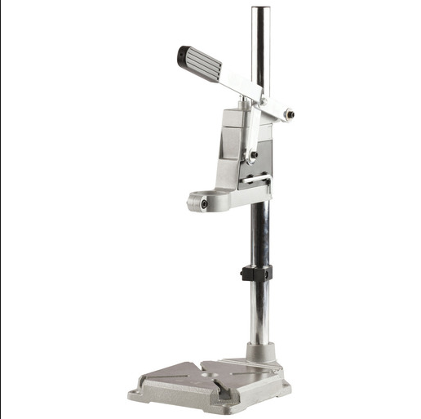
When looking to design a product such as a drill press stand the same design process framework should be used. Fig 1 below is a typical universal drill press. The fundamental movements will remain the same in the design. Some improvements in he design will be carried out to reduce cost and to gain better customer satisfaction.
Fig 1.
(Jaycar, 2017)
After some research of many drill presses it was found that is very little deviation from the design in fig 1. The main slider and handle are the only two parts which really have variation. The mechanism, table and sliding posts are common to several drill presses found.

Design Process of Drill Press Stand
The concept of the drill press stand will now follow the design process framework to gain a better understanding of what is needed and the best resolution.

Problem/Need Identification
As there is no problem as such the need of a dill press will be explained, to gain a better understanding of what criteria it must meet.

Quality requirements
- Drill press stand has to be competitive in market
- Has low manufacturing costs
- Pleasing on the eye
- Robust
- Customer has perception of value
- Has minimum effect on the environment
- Long life cycle

The customer
The customer would fall into the “DIY” market segmentation. Which is a market worth 40.7 billion USD in 2017 (Statista, 2017)thus making it a very competitive market. Within this market the drill press will be aimed at the lower cost, it could be said the “novice” DIY’er. This will be due to the cheaper lighter materials used to keep the cost down.

Research
Research was carried out to find critical information about the design. Dimensional information was gathered on dill collar size, drill depth and overall dimensions. It was found after researching into several drill presses that there was an average overall size of approximately 500mm (H) x 350mm (W) 300mm (D). It was also found that the collar of drills on the market had such a variation in diameter that the collar must be adjustable. The price of a similar drill press was from £9.89 (Ebay, 2017) to £24.99 (Westfalia, 2017). The price of each drill press reflects the quality of material and overall quality. With research into materials it was found that the main body parts such as table, main slider, slider collars and handle were made from casted aluminum and the post was made of stainless steel.

Solutions of needs
As discussed previously there is very little need to change several parts of the drill press due to them being similar on many drill presses. The main slider is where the variation will be compared to others on the market. When considering the requirements set out in the needs identification phase, it is apparent that there are some key requirements that must be considered. These specifications are:
- Robust
- Environmentally friendly
- Long life cycle
- Tooling costs
- Manufacturing costs
- Design costs
- Adjustable collar dimensions between 43mm - 35mm
- Have a minimum drill depth of 60mm
- Maximum height of 500mm
- Maximum width of 350mm
- Maximum depth 300mm

Main Slider Design
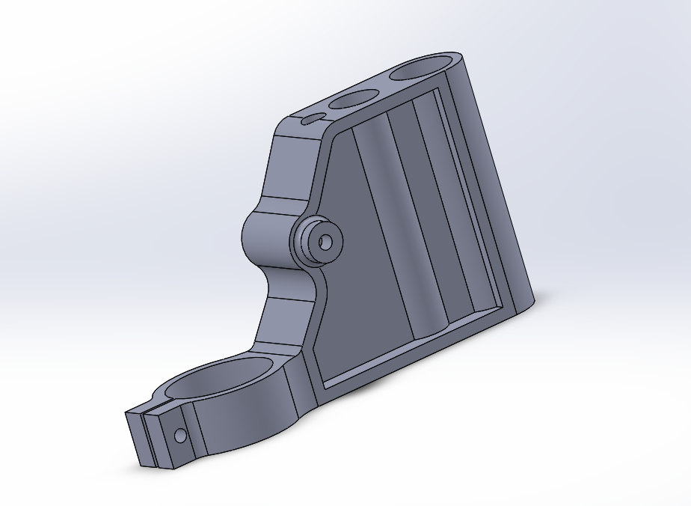
After considering all the specifications two designs were created in solidworks 3D modeling software. Which are in fig 3 & 4. Both of them tried to satisfy all the requirements as much as possible, but having said that there needed to be some variation in physical appearance.
Design 1
Fig 3.
Design 1 is very similar to other drill presses on the market. Except the design has been optimized; by taking unnecessary material away. By less material will reduce the cost of raw material.

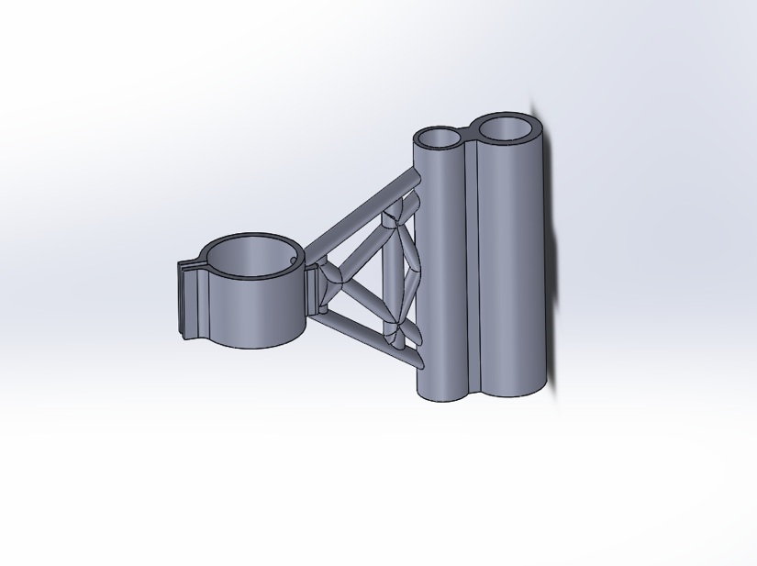
Design 2 has been optimized to reduce as much material as possible, but trying to keep as much structural strength as possible. This design is very eye catching and very unique which could be a big selling point.
Design 2
Fig 4.

Final Design
As both designs satisfy the specification another method of choosing which design is best is required; this is done by a design rating matrix. In fig 5 below is the design matrix, the first column is the specifications required; the second column is a rating of importance; then each design is given a score of how well it fulfilled the specification. Once each design has been scored each score is multiplied by the importance of the requirement, then all the points acquired by each design is totaled then a winner can be determined.
Quality Requirements | Importance | Design 1 | Design 2
Robust | 5 | 5 | 4
Environmentally friendly | 3 | 3 | 3
Long life cycle | 5 | 4 | 3
Tool cost | 4 | 4 | 1
Manufacturing cost | 4 | 4 | 3
Design cost | 4 | 5 | 2
Total |  | 106 | 68
Fig 5

After scoring the design matrix it was clear to see that design 1 was the overall winner, it outscored design 2 in every requirement. As design 1 has been chosen a quality function deployment diagram is carried out to gain a better understanding of customer satisfaction. This follows in Fig 2.

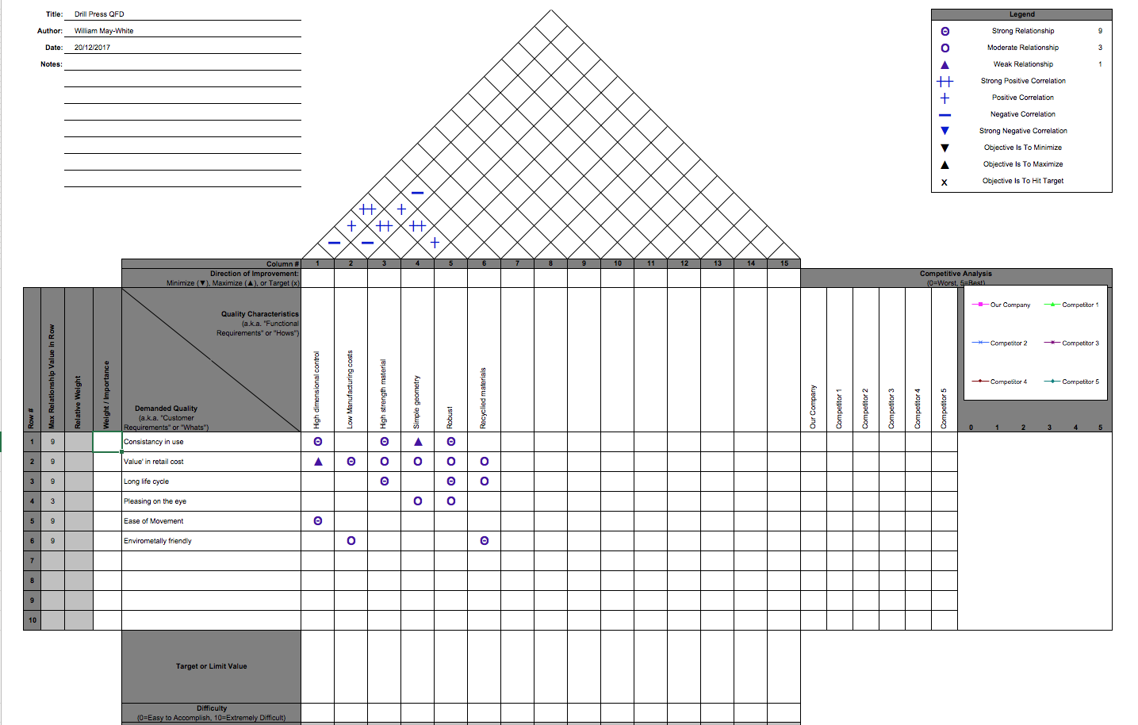
Fig 2.

Quality Function Deployment
After carrying out a QFD to gain a better understanding of the effect the quality characteristics will have on the customer needs. It was clear to see that some have a far greater effect than others. The first customer needs that had the biggest effect are the “Value” the customer sees in the product. This is mostly customer perception, if a customer sees the product being robust, made of good quality materials, from a house hold brand and at a reasonable price then they deem it as “good value”. The customer may be completely unaware of how much the product costs to produce, but they have a feeling that it is worth buying. This can be achieved by good market strategies, having said that all the quality characteristics have a direct link to the “value”. This is mainly due to them all having an effect on price and the quality of the product not just visually but in operations as well. The second biggest effect is the consistency of use this is how the drill press operates and how consistently it does it. It is critical that the drill always comes down square to the table and does so after years of use; this also ties in with the long life cycle. The others are customer needs are not that effected by the quality characteristics, therefore there will be bigger emphasis on the customer needs with 3 or more effected attributes.
In fig 2, the link between quality characteristics is also shown. The low manufacturing costs was found to have the most effect on all the other qualities. By understanding the target market, the product needs and the customer the manufacturing processes can be determined. The dimensional control of the product also has an effect on several other qualities; one of the main effects is the negative effect on the manufacturing costs. The higher the tolerance the high the production cost. So determining what is deemed satisfactory level of tolerance is very important and will be one of the main factors of the price of manufacturing. The robustness of the product will also have an effect on other factors; the main one will be on manufacturing costs. By making a robust product usually means a made of high strength material and a strong design.

Materials & Manufacturing Processes
The material selection will have a massive effect on the manufacturing process chosen. Due to the main slider only bearing the load of the drill it can be made of a polymer. This will allow for the manufacturing process to be injection molded, this gives the ability to gain high volume with the required dimensional accuracy.

Material Selection
The reason for choosing a polymer over an alloy is first the cost. A polymer is far cheaper to manufacture; this is due to first the tooling cost. The tooling needed to produce both an alloy and polymer is not that far apart with regards to price; but the volume achievable with one tool with polymer is far greater than alloy. Therefore, it will greatly be reducing the cost of producing a polymer. Second of all is its strength to weight ratio, knowing that the main slider does not bear that much load it is ideal in this situation. Furthermore, the cost of raw material, polymer is far cheaper than most alloys and thus can reduce the price of each unit.

Polymer Characteristics
Below is a short list of polymers that have the sufficient properties for the main slider for the drill press. They are polycarbonate, polyamide and polyoxymethylene. Below is a list of properties of each polymer and the properties they possess.

Polycarbonate (PC30)
- High impact strength
- Excellent strength retention at elevated temperatures
- High tensile, shear, and flexural strength
- High modulus of elasticity
- Low deformation under load
- Excellent creep and cold flow resistance
- Low coefficient of thermal expansion
- Good electrical insulation properties
- Easy to fabricate & machine
- Fair voids on thick sections
- Low flash
(International Polymer Solutions, 2017)

Polyamide (PA66) (nylon 6/6)
- High tensile strength
- Abrasion resistant
- Good surface finish
- Stiffness
- Chemical resistant to hydrocarbons
- Good dimensional stability
- Good voids on thick sections
- Medium flash
(Nicolet Plastics, 2018)

Polyoxymethylene
- High flexural
- High tensile strength
- Stiffness
- Hardness
- Excellent chemical resistance
- Low coefficient of friction
- Good fatigue resistance
- Medium flash
- Fair sinks in think sections
(Nicolet Plastics, 2018)
Material Selection Matrix
Material Requirements | Importance | Poloxymethylene | Polyamide | Polycarbonate
Flash | 3 | 3 | 3 | 4
Tensile Strength | 5 | 3 | 5 | 3
Friction | 4 | 4 | 2 | 2
Voids Section | 4 | 4 | 5 | 3.5
Surface Finish | 3 | 3 | 4 | 3
Chemical Resistance | 3 | 5 | 4 | 3
Abrasion Resistance | 3 | 2 | 4 | 3
Dimensional Stability | 4 | 5 | 3 | 5
Mould & Injection | 5 | 3 | 3 | 4
Cost | 5 | 3 | 3 | 1.5
Total |  | 136 | 140 | 123.5
Fig 6.
In the material selection matrix each of the 3 suitable polymers are scored against each determinate. Each determinate have been scored by the importance of the material requirements. The material score of the material requirements is then multiplied by the importance to give the material a score. As it can be seen polyamide is the most suitable polymer to use as the main slider unit.

Manufacturing Process
Having decided on the material that is going to be used; the manufacturing process can be decided with regards to a specific volume. Firstly we will consider the slider in prototype stage, where a small batch will be produced. Followed by the manufacturing process of a volume of 500 a day will be discussed.

Prototyping
Prototyping is an essential part of the design process, which commonly needs to be done relatively quickly. With advancements in 3D printing, a prototype is able to be made in the matter of hours. Due to polyamide having the ability to be 3D printed, this makes it ideal for prototyping. But due to the hours to produce a single part it is not feasible for any amount of volume. The prototypes produced will be used in testing with the remaining components to ensure that everything works as planned. A master part will be made to the exact dimensions of the design so when high volume manufacturing takes place each part can be gauged to this specification. The main slider will have a batch of 10 units made, so it can go through real life stress analysis, as well as going operational testing. The drill press will slide operated thousands of times autonomously then the parts will be gauged to see where the wear points are and how critical they are to the operation of the drill press. If any revisions to the design or material need to be made then it can be done before going into mass production.

High Volume Manufacturing
With regards to the manufacturing of the main slider with volumes of 500+ a day, there are several methods that could be used. The one which is the most feasible in this situation is injection molding. It is the only manufacturing process which is able to give the required volume, dimensional control and quality at the satisfactory price.
The fundamentals of injection molding do not really differ from product to product. Material is heated to a fluid form then pushed into a mold where it is left to solidify. Once the part is solid then the mold opens and the part is ejected out. The time from fluid entering the mold and the part being ejected can vary but is largely down to cooling time. If the part is designed well and the mold has a charged cooling system then the time can be greatly reduced.
The cost of manufacturing is heavy reliant on the design phase, when a product is designed not only does it have to meet the product requirements but also has to keep the manufacturing process in mind. The main slider due to its simple geometry and relatively small design will only need a mold tool of two parts. This will massively reduce the tooling cost. (Groover, 2010)
Another feature that the design team must consider is the shrinkages that will occur when the part is injection molded. Polyamide 6/6 has shrinkage of approximately 0.020 mm/mm (Groover, 2010) so the mold must be designed slightly larger than the finished product.
The cost of a tool is can range from 10,000-100,000 USD which will produce approximately 1 million parts (if correctly maintained). But can take up to 12 weeks to be made, this is why it is not feasible to prototype using the injection molding process. (Custom Part, 2017)

Constraints of Injection Molding
Below is a list that M.P. Groover deems as the main constraints that occur when injection molding.
- Short shots: As in casting, a short shot is a molding that has solidified before completely filling the cavity.
- Flash: Flashing occurs when the polymer melt is squeezed into the parting surface between mold plates; it can also occur around ejection pin.
- Sink marks and voids: These are defects usually related to thick molded sections. A sink mark occurs when the outer surface on the molding solidifies, but contraction of the internal material causes the skin to be depressed below its intended profile.
- Weld lines: Weld lines occur when polymer melt flows around a core or other convex detail in the mold cavity and meets from opposite directions; the boundary thus formed is called a weld line, and it may have mechanical properties that are inferior to those in the rest of the part.
(Groover, 2010)

Molding Design
With injection molding there are some constraints in the design of the mold. The plastics will come in the mold at different points, thus the material will have to mix and fuse to make a finish product. It does greatly decrease fill time but it could have some effect on the structural integrity of the part. When the mold is being designed it is important not have the weld points on any critical stress points. In fig 7 is the mains slider with the weld lines shown, the mold was chosen to meet at this point due to there being little stress on this point of the part.
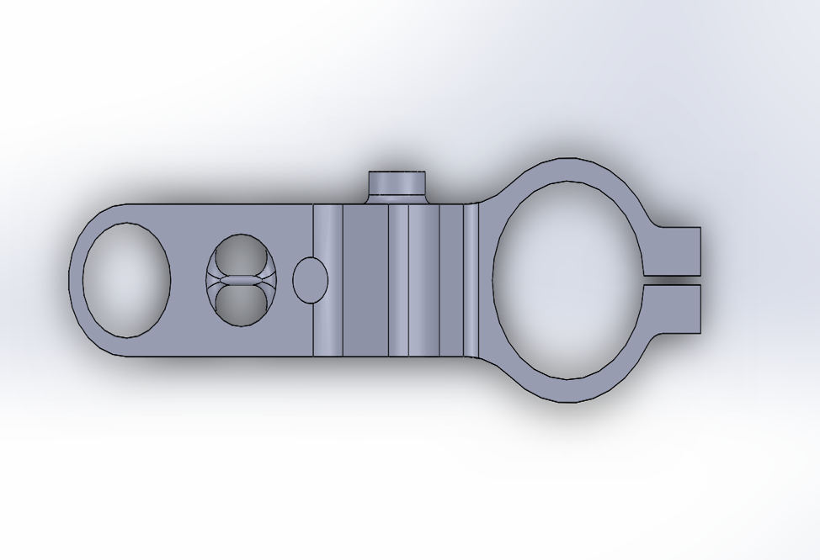
In fig 8 the yellow line which runs through the whole part is where the mold will meet. The black line indicates the direction that the mold pulls away from the fixed part of the mold and ejects the part. The holes in this part will be achieved by inserting cores when the mold is cold, the cores will be in the form of retractable bars with will slide into the mold then just before injection will be removed.
Fig 8.
Fig 9.
In fig 9 the orange arrow points to an area where the material optimization had the biggest effect. There is material left in this void not due it being needed but to ease the manufacturing process. If there was no material or just a reinforcing strut, then the mold faces would meet in the center of the part. This has some possible problems in the future. With the amount of volume that this part will have to produce it is likely that the tool will become worn. A worn tool is very susceptible to flash, where excess material is pushed into gaps which are not a part of the product. So by having this there will mean less mold face touch in around the part.

Conclusion
After completing the design process up to the prototyping stage it was made clear that customer needs and manufacturing needs have a large effect on the design of any product. The design of the main slider could have been optimized further to have even less material but still have the same structural strength but the customer could deem this as being “flimsy” and not as strong as a solid version. This would not satisfy the customers’ needs and would reduce sales even if the product was better. This report has shown that if there is equal research into customer needs and design/manufacturing then any product will be a success. With advancements in simulation software and materials such as polymers, it is possible to have a lightweight polymer with the same strength as an alloy.
To conclude the drill press may not be an innovative piece of engineering but it was designed with all aspect of the design process in mind. The manufacturing process is simple and scalable to higher volumes of 500 per day due to the simplicity of the part. The material chosen is more than satisfactory for the requirements of the part; it is easily accessible and relatively low cost.
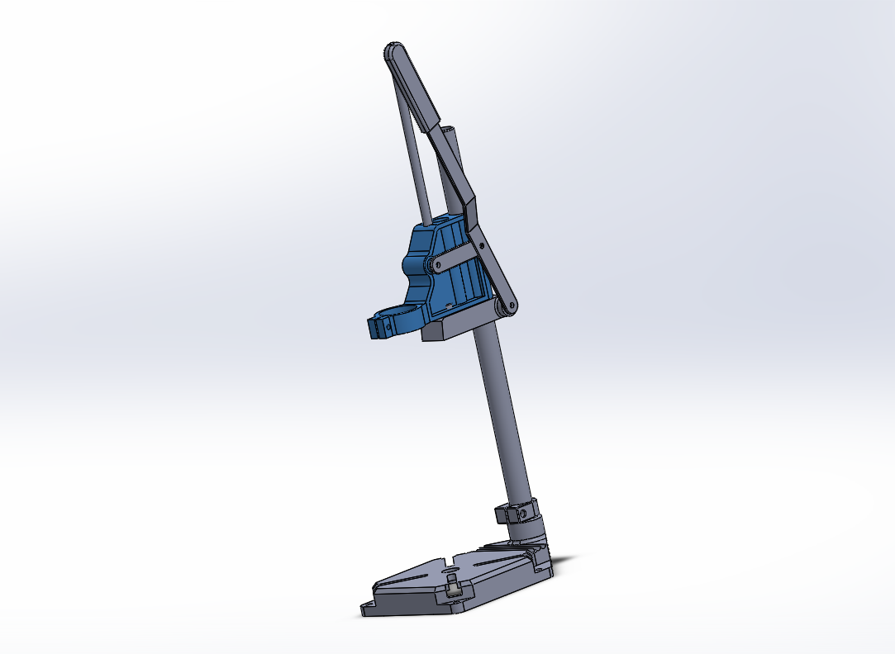
Here is the finished drill press stand assembled, as it can be seen it is very similar to most drill presses on the market except the main slider. As the main slider is made of a polymer and due to it needing less material the retail price of this should be less than competitors.
Fig 10.

Bibliography
Askeland, D. R., 1993. The Science & Engineering of Materials. Missouri: Chapman & Hall.
Custom Part, 2017. Injection Mold Calculator. [Online]
Available at: http://www.custompartnet.com/estimate/injection-tooling/
[Accessed 2nd January 2017].
Ebay, 2017. Drill Press Stand. [Online]
Available at: https://www.ebay.co.uk/i/253238899655?chn=ps&adgroupid=49962971442&rlsatarget=pla-378951013582&abcId=1129946&adtype=pla&merchantid=118980349&poi=&googleloc=9045398&device=c&campaignid=974960578&crdt=0
[Accessed 28th December 2017].
Groover, M. P., 2010. Fundamentals of Modern Manufacturing. 4th ed. Hoboken: John Wiley & Sons.
International Polymer Solutions, 2017. Polycarbonate data sheet. [Online]
Available at: http://www.ipolymer.com/pdf/Polycarbonate.pdf
[Accessed 30 December 2017].
Jaycar, 2017. Universal drill press stand. [Online]
Available at: https://www.jaycar.us/universal-drill-press-stand/p/TD2463
[Accessed 21 December 2017].
Morgan, R., 2017. Design Methodolgy. Swansea: UWTSD.
Nicolet Plastics, 2018. Materials Guide. [Online]
Available at: https://www.nicoletplastics.com/resources-plastic-injection-molding/plasticinjectionmoldingmaterials-guide
[Accessed 3rd January 2018].
Science Buddies, 2017. The Engineering Design Process. [Online]
Available at: https://www.sciencebuddies.org/science-fair-projects/engineering-design-process/engineering-design-process-steps#theengineeringdesignprocess
[Accessed 20th December 2017].
Statista, 2017. Global DIY market value. [Online]
Available at: https://www.statista.com/statistics/374093/global-diy-market-value/
[Accessed 23 December 2017].
Westfalia, 2017. Precision Drill Stand. [Online]
Available at: https://www.westfalia.net/shops/tools/hand_tools/vices_and_clamps/machine_vices/243987-precision_drill_rig_set.htm?art_nr=875161&gclid=Cj0KCQiAsqLSBRCmARIsAL4Pa9Q02jXRCTxkZ1GPpognFrkH1go2LlyUbkcyzdMRnGRTriOwz6vvy4caAp8EEALw_wcB&utm_medium=1.+SEA&utm_source=Google%C2%A0Adwords+WWC%C2%A0Produktdaten+UK&utm_campaign=Google%C2%A0Adwords+WWC%C2%A0Produktdaten+UK
[Accessed 29th December 2017].

