Problem solving and decision making
BMSW4004
daniel LAVRES (2008320)
Lecturer: suneth fernando

problem-solving tools

Problem solving generate from problems that we make during an process that can delay the project that we are creating but that is when the problem solving is use to analyze where the problem come from and what originate this problem doing this we will be able to go for the second process that is gathering some data that will help to review all the project from the beginning without delating any of the project but making the project better and next we should clarify the problem doing this we are exploring all the challenges that we my will find in the process of finding the best idea to resolve this problems because every time that we are trying to find one solution we will find some errors in the process because of that we should try many ideas possible for a perfect project so we need to thing out of the box for the best answer.

When we find the solution for the problem, we should put in practice the idea to see if nothing will fall in this process and see if it will be beneficial to resolve the problem and the threats of this decision will not cause more problems that already have and remember always to check if everything again just to make sure.

This are the steps:

Identify the problem

When you see that you got a problem in anything you need to identify were this problem originated and review all type of possibilities that may this affect you project, remember planning before anything to fix the project with most efficient way.

Develop multiple solution

When you have identify the problem you should start planning making multiple solution to the problem and see each one will be more useful to use but remember that you will need to put in mind that even if you find a solution you will need to see each solution come with a low risk of using and always expect not just for the success of resolving the problem but expect some threats to.

Execute every single solution possible

When your getter all the best solution that may fit in this type of situation you should put each one of the ideas in practice in your mind and see each will fit more to resolve the problem and will be more beneficial to the project and got a low risk.

Assess and put in action the project and review everything again to see if everything is fine

This final process is when you have choice the most suitable idea to resolve the problem and you are confident to present your solution to everyone but always remember that this solution came with profit to the project but will have some threats that will not affect to much the project.

There are some techniques that you can use to make everything more organize to solve the problem that you made; you could use:

Swot analysis

Swot analysis that will help to find all the strengths that are in the project to make this better all the weakness that you will find in the project knowing that will help you to find a better solution, opportunities to solve the problem that is creating multiples ideas that will generate the best one to use and the threats that you may get thru all of this process knowing all of this you will have more chance to s succeed and have a great work.

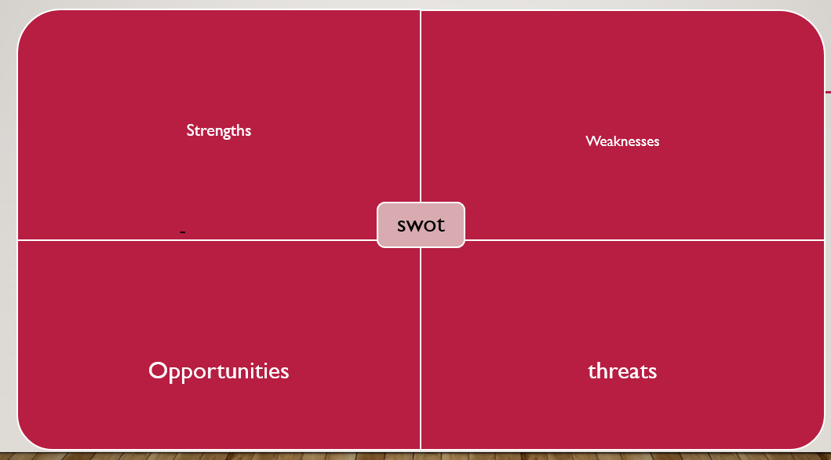

decision making

Decision making can be a process very difficult if you don’t follow the correct why of who to identifying all the decision that you my going to do, you will need to gather allot of information, and looking for a lot of alternative resolutions before doing any decision of anything.

You will need to use a process of step-by-step decision making to help you to make the most efficient and smart decision in any case for that you will need to organize all the information that my going to be relevant and defining diverse alternatives to make this will increase your change of getting the most efficient and satisfying alternative possible for a good decision.

We got seven steps and now I will tell you all the steps that are for:

Step 1: Identifying the decision

When you are going to decide, you need to first think why you are going to make this decision what generated you to make this decision and focus on all alternative decision that you can make to resolve the problem.

Step 2: Gather information

Gathering information is very essential before doing any radical decision you should first collet the most useful information in all type of whys on the internet, books, talking to people or even self-assessment all of this process is call internal and external research that you will need to do, doing this will help you reach your goals of making the most efficient decision possible.

Step 3: Identify the alternatives

In this step is when you did gather a lot of information and you think you are ready to make lots of alternatives decision and you be choosing a path that suits better in this type of situation and with all the important information that you had will help you a lot to find the best answer for your problem in this type of situation so list all the decision and see each on is the most correct to use.

Step 4: Weigh the evidence

On here we will use all the information and imagine all the action that you would use to put your decision in practice what am trying to say is that you will be imagining you doing all the alternatives that you made in step 3 to the end. This will help you not just see each decision is better but you will be able to identified all the consequences that each decision could affect you, while you are in this complex process you will see that you are getting some where with this technique and you will get the most favor answer for your problem and you are going to be able to give the best decision for your problem .

Step 5: Choose the best alternative

In step 5 is when you have made all the others steps and you have gain the bests alternative ways of resolving your problem in this step you will choice the best idea that you had and you see that fit more with the problem basically you will do the same was step 4 but you will have less ideas but all of them are good but you are looking for the most perfect one to use.

Step 6: Use your best idea

This is when you are confident with the alternative that your choice in the step 5 and you are sure that this is the solution more fit for this type of situation and you come with the smallest consequences.

Step 7: Review your decision and the consequences

In the final step is when you evaluate your choice and you see if was the result that you are looking for this type of situation, you should be able to know if this choice will not affect more the problem that is and you will see that the consequences of your choice will not affect the company more then with is and will be effectual to everyone in others aspects that this problem may have.

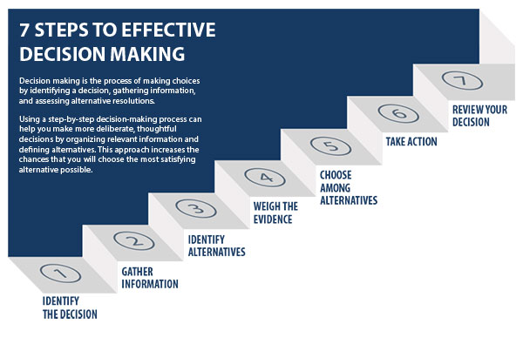

Current or past work experiences
In this part of the work, I will talk about some problem that my sister currently had on her work this will be one example of solutions to a work-based problem.
My sister work was a client supporter in a call center, in her job they had a serious problem in the organization of employee schedules.
A big part of the employees of her work didn’t like the schedules that the company was giving to them because this situation was making some of the workers work in the hours that the company was busier to work and that was making them very exhaustion and stressful and part of the time they are working, they had to be very calm and respectful to the clients who were very rude and that didn’t want to collaborate with the employer, and when I clients is like that is impossible to make the best assist that a worker can give to a client. All of this is just because the company don’t give flexible schedules to them, and this is making the company look bad and making profit with the clients and just having a lot of complains and bad review about their client support.
All of this made the company just lost 20% of the money that they were supposed to earn in July and 45% of the employers were not satisfies with the company because of the way the company was treating them and 13% of that people was asking for resignation because the schedules were not good and the hour the had to do was too much to just receive a bad payments, because of this the company was passing very bad moments in some months even knowing that 55% of the people that were in the company was very satisfied with the schedules they had because they didn’t had to many phone calls to answer because hours they are working wasn’t the busier time in the company and the could make the best use their work and give 100% of the assist that the clients need.
My sister told me that on the first of June the company had a big reunion about the schedules that was given to the employers and they made a plan to solve this problem by changing the schedules of everyone and making them more flexible and giving rotative schedules, doing this will help the employers to not being so tired for the next following day of work because they wouldn’t be doing the most busies days every single day, and the company decide to increase the salary and giving rewords for the employers that get good reviews from the clients, doing that would motivate the employers to work to receive their reword.

Conclusion

In my conclusion I think that problem solving and decision making is a basic guide that you should follow each step that is shows to you because if you want to get something done well you need to make a plan first before submitting anything that is asked for you to do, and analyze everything that you do can be very useful for you not just in work but also in your routine live because everything is a problem and daily you are everyday making decision to do something and that is when you star making plans for the best decision before doing what you are supposed to do.

Problem solving and decision making is very important in your lives, and we should use every time.

Reference
PROBLEM-SOLVING TOOLS: universaty moodle and https://www.reliableplant.com/Read/14690/high-performance-team
decision making:https://www.umassd.edu/fycm/decision-making/process/

