CYBERSECURITY PHISHING SIMULATOR REPORT
ACCA5033
Jake Whitehouse (2406098)
2026
Table of Contents
INTRODUCTION 2
TASK 1: PRACTICAL DEVELOPMENT 2
Q1: Initial Feedback 3
Summary of Feedback 3
Analysis of Feedback 3
Changes Made Based on Feedback 4
Q2: Implementation 4
TASK 2: ENTERPRISE & INNOVATION 7
Q1: Startup Idea 7
Q2: PEST Analysis 8
Political Factors 8
Economic Factors 8
Social Factors 9
Technological Factors 9
Legal and Ethical Considerations 9
TASK 3: REFLECTION 9
Q1: Practical Feedback 9
Q2: Project Management 10
Q3: Skills Developed 10
Q4: Positive Social Impact 10
CONCLUSION 11
REFERENCES 11
APPENDICES 11

INTRODUCTION
Phishing attacks are one of the most common cybersecurity threats, targeting users through deceptive emails and websites in order to gather personal information or to hijack accounts. These attacks often rely on social engineering techniques to manipulate individuals into committing an action such as clicking a malicious link or entering login details on fake platforms. [2]
This report focuses on the development of a Cybersecurity Phishing Simulator designed to introduce individuals to the risks associated with phishing. [7]
The aim of the project is to improve both user awareness and to reduce susceptibility to real world phishing attempts by providing a controlled yet realistic simulation. [3]
This report will also include details of the system’s development and implementation, along with an evaluation of feedback. In addition to this, it will also explore aspects of enterprise and innovation through a business perspective and will then conclude with an overall reflection on the project process and skills gained.
TASK 1: PRACTICAL DEVELOPMENT

Q1: Initial Feedback
To evaluate the concept of the Cybersecurity Phishing Simulator, informal interviews were conducted to gather feedback.

Participants were shown a basic prototype of the phishing simulation, including a sample phishing email and a mock log in page. They were then asked a set of questions.
These questions included:
• Does the phishing email appear realistic or suspicious?
• Would you be likely to interact with it if unaware it was a simulation?
• Is the purpose of the simulation clear?
• What would you change or improve to make it more effective?

Summary of Feedback
Users were able to recognise the educational purpose once explained.
• User 1: Noted that the phishing email looked realistic however suggested that a more clear branding inconsistency could improve detection during training.
• User 2: Found the login page convincing, and stated that they could see how some users may fall for it.
• User 3: Highlighted that the simulation itself was engaging however recommended that adding warning prompts after an interaction could reinforce learning.
• User 4: Suggested that improving visual design consistency would better match real world phishing examples.

Analysis of Feedback
The feedback provided indicates that realism is one of the stronger aspects of the simulation [1]. However, several participants suggested improvements related to user guidance and post interaction feedback.

Changes Made Based on Feedback
• Addition of subtle visual inconsistencies within the phishing emails
• Inclusion of a post interaction warning message
• Improved UI clarity
• Minor refinements within the layout

Q2: Implementation
The Cybersecurity Phishing Simulator was developed as an interactive prototype using Microsoft PowerPoint. The purpose of the simulation was to educate a wide range of users on how phishing attacks operate and improve their awareness of suspicious emails and websites, as such, PowerPoint is a strong candidate to be the vessel for this simulation as it is easy to use and accessible. Hyperlinks and action buttons are used throughout the presentation to create an interactive experience rather than a standard slideshow. [10]
The simulation begins with a start screen which introduces the user into the training environment and providing a “Start Simulation” button as seen in Figure 1. 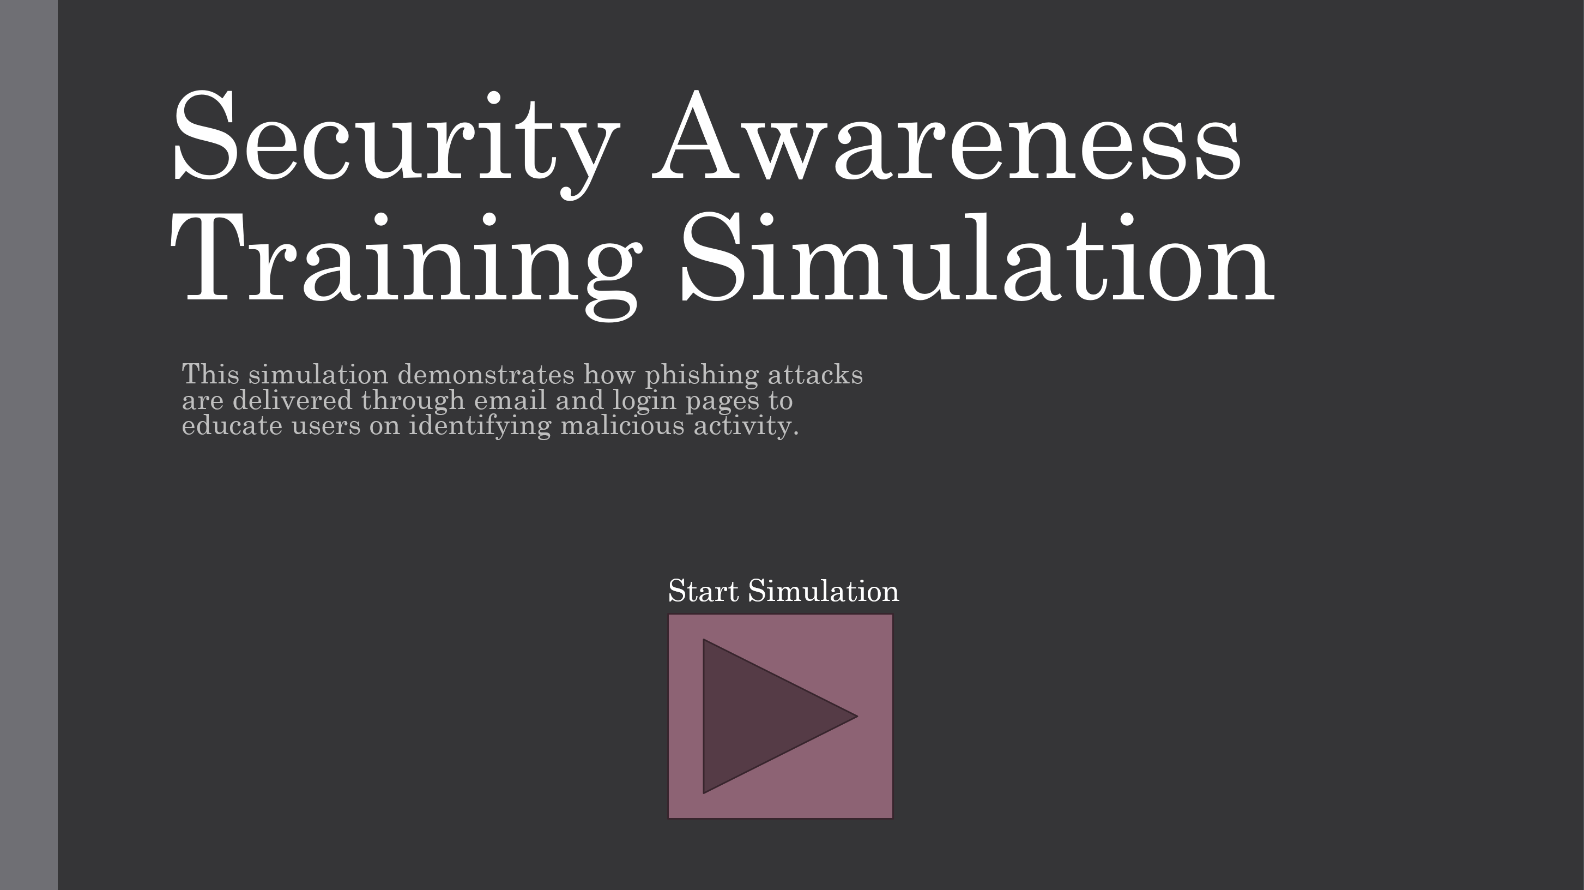
Figure 1
The phishing email was designed to imitate a legitimate banking security alert using urgent language and warning regarding account activity. The email includes two options: “Verify Account” or “Flag Email” as seen below in Figure 2. 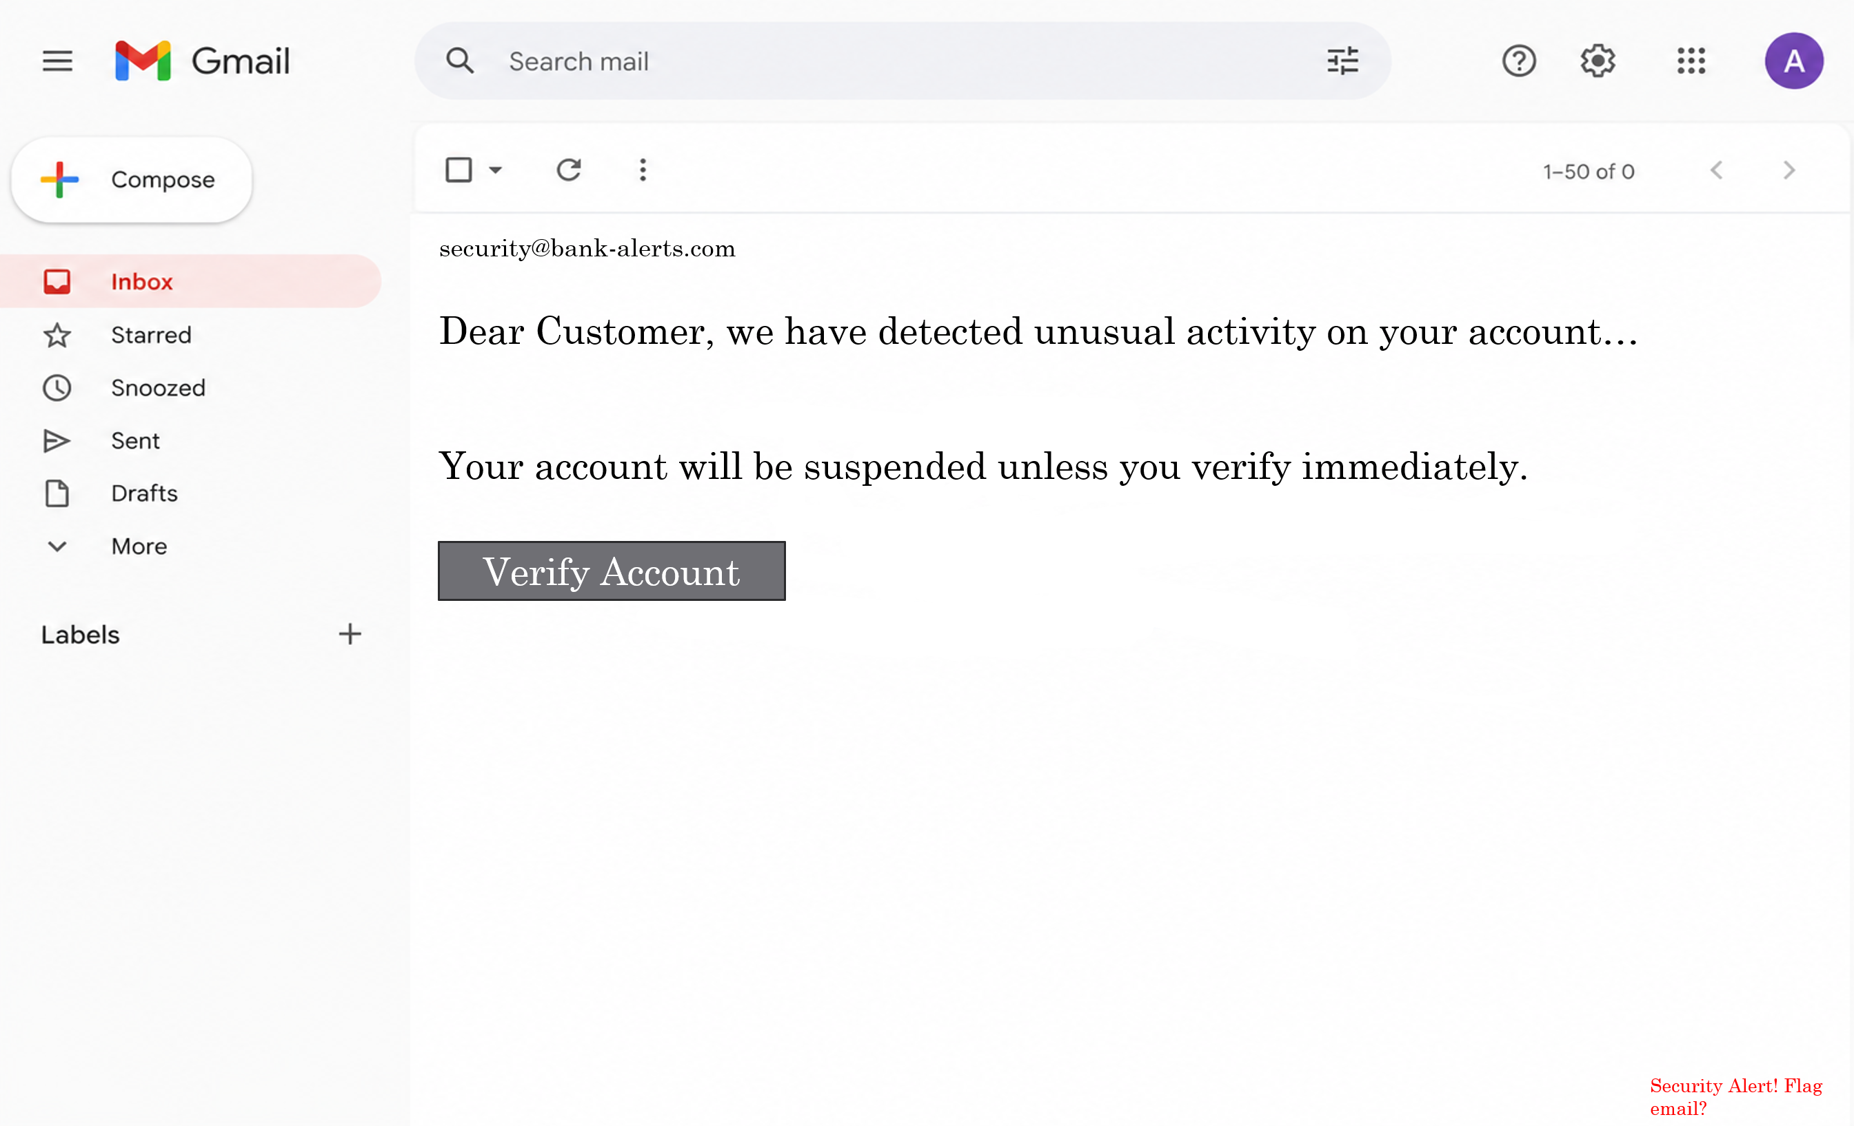
Figure 2
If the user correctly selected the button to flag the email, they were directed to a positive outcome screen shown in Figure 3. This screen informed the user that they had successfully identified a phishing attempt and provided a brief educational feedback which describes common phishing indicators. A replay button is included to allow the simulation to restart.
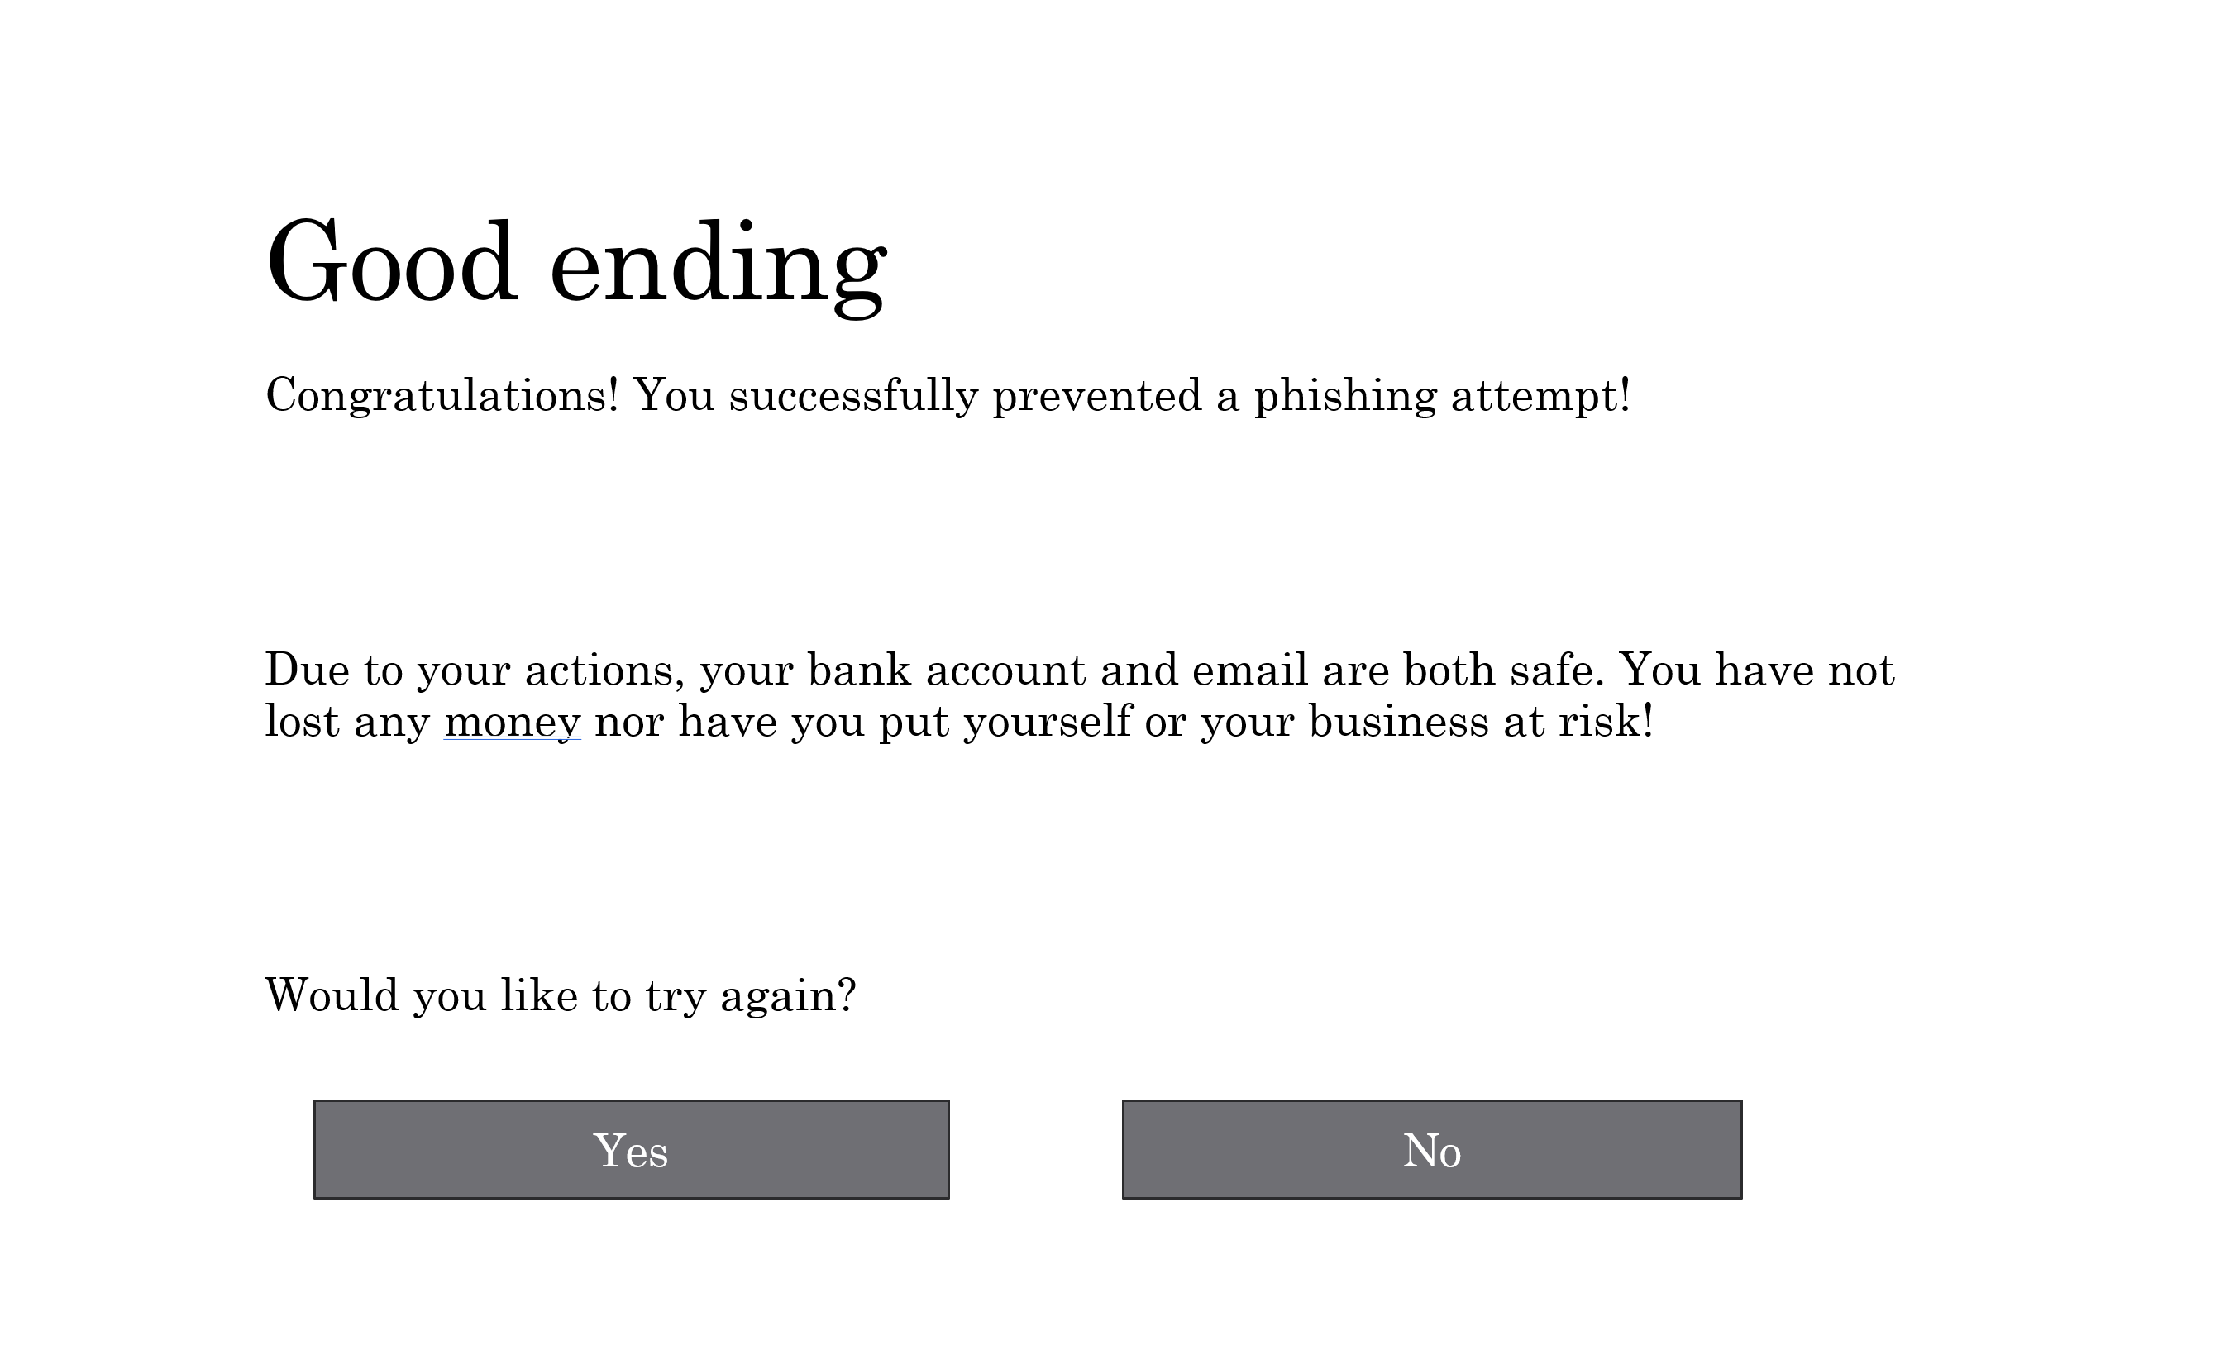
Figure 3
Selecting the button to verify the account as seen in Figure 2 takes the user to the simulated banking login page shown in Figure 4. This page included fields for an email address and passwords, alongside options to either log in or exit the page and flag the email. This login page was designed to replicate the appearance of a banking website in order to demonstrate how phishing websites attempt to collect sensitive information.
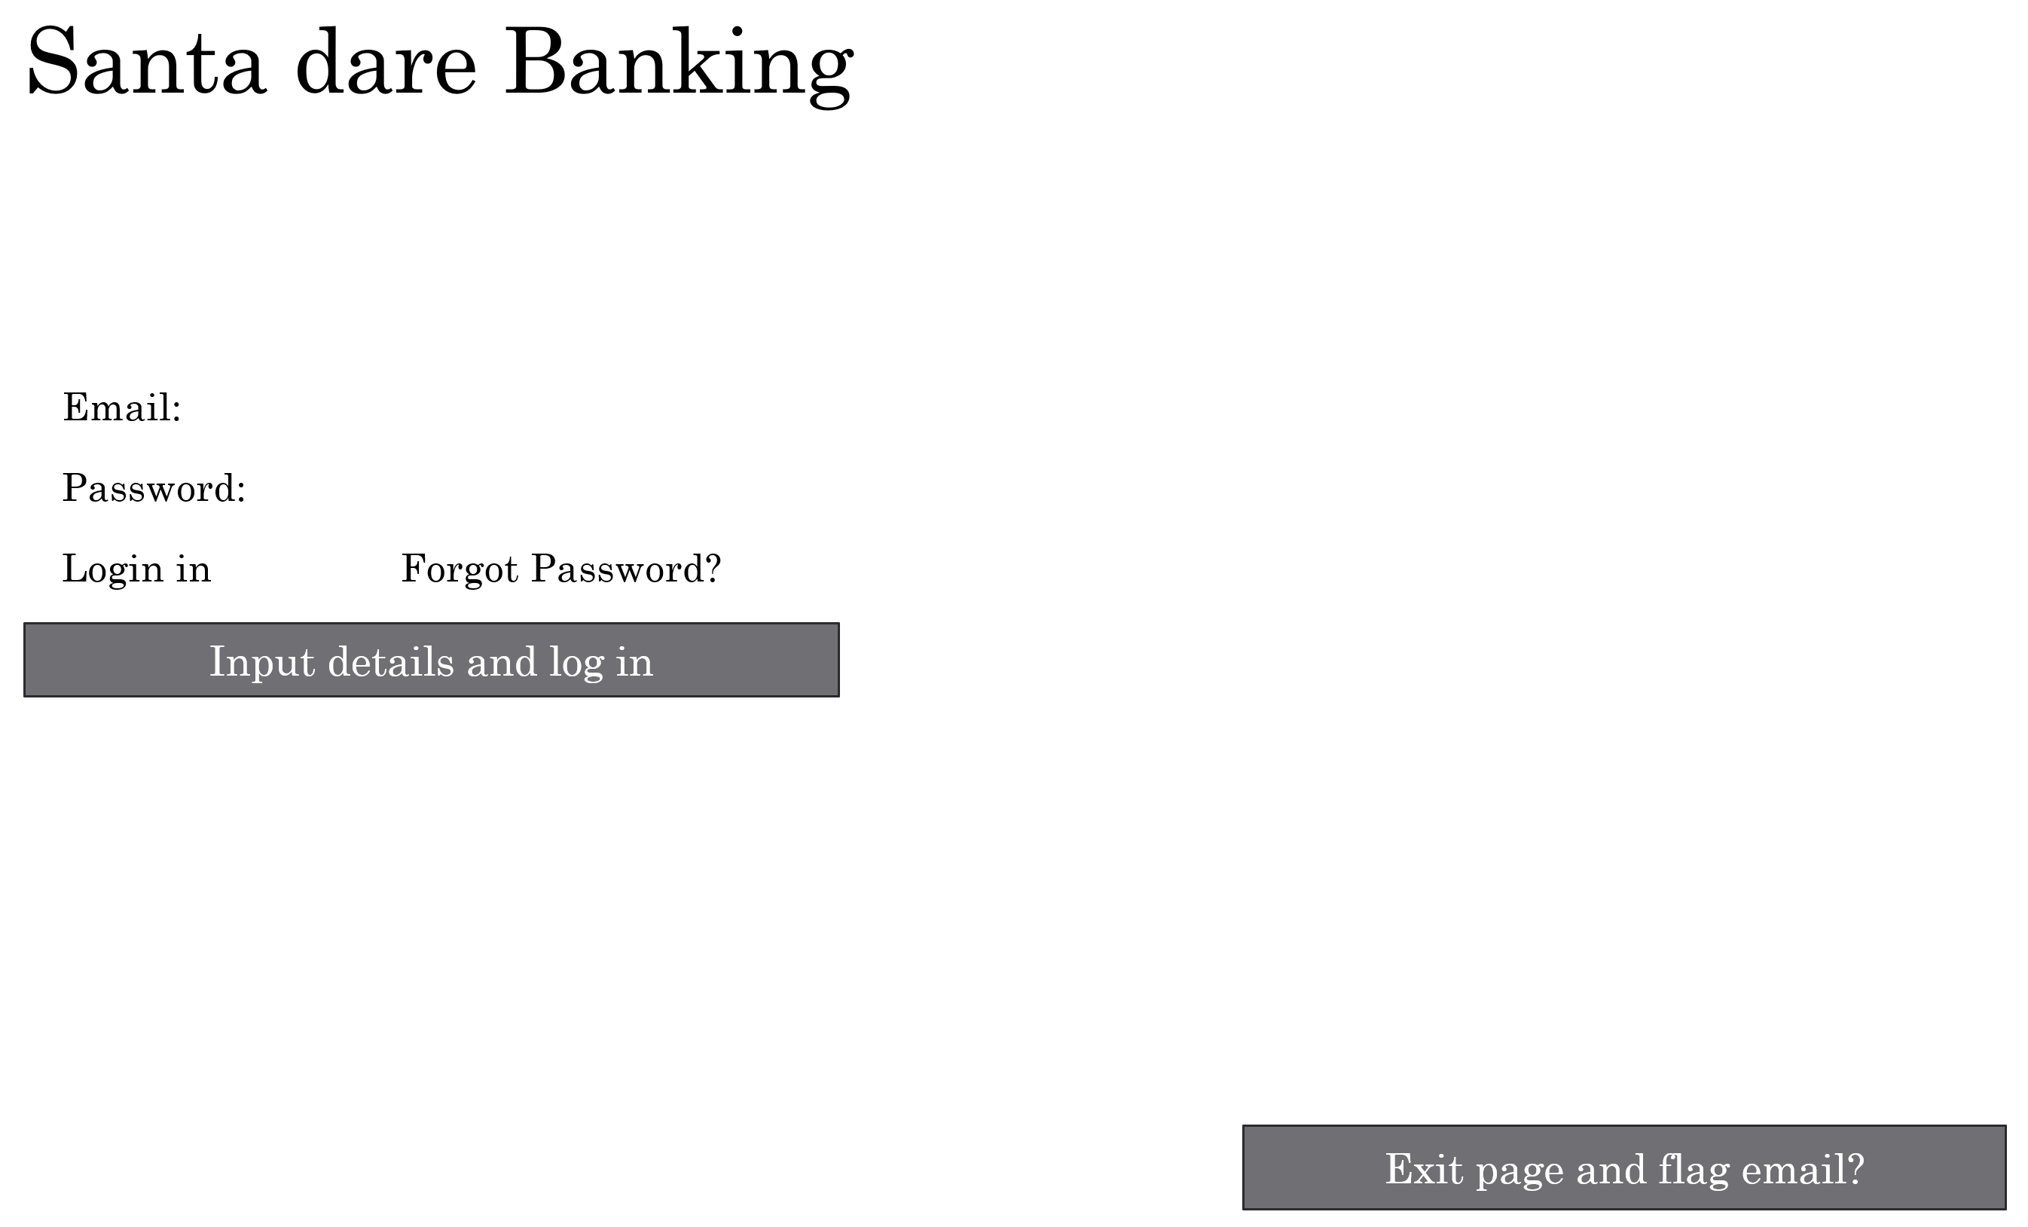
Figure 4
If the clicked the button to input details and log in, they were directed to the negative outcome screen shown in Figure 5. This screen explained to the user that they had fallen victim to a phishing attack and outlined the possible consequences such as account compromise or identity theft. The final slide, shown in Figure 6 demonstrates the restart functionality and overall system flow of the system.
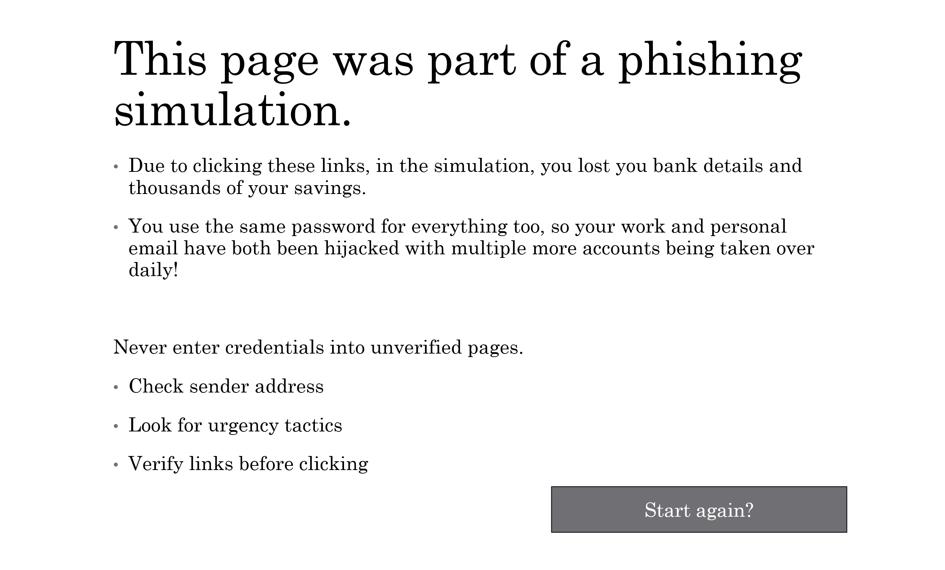
Figure 5
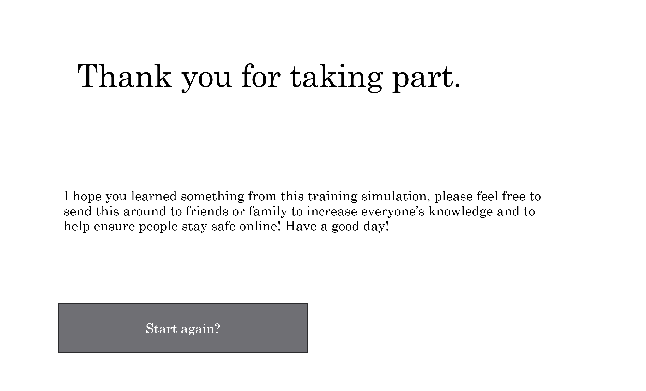
Figure 6

TASK 2: ENTERPRISE & INNOVATION

Q1: Startup Idea
The proposed start up for this project is named PhishGuard Solutions Ltd, a cybersecurity awareness company which is focused on phishing prevention and user security education. The company would specialise within developing interactive phishing simulation and training software designed to help organisations educate employees on identifying and responding successfully to phishing attacks. The primary aim overall is for the company to reduce the likelihood of successful phishing attacks by improving cyber awareness within workplaces and educational institutions.
The business would operate as a Private Limited Company (Ltd), which would provide limited liability protection for shareholders while also allowing the company to operate commercially within the cybersecurity sector. This business structure was chosen due to its flexibility, legal protection and overall suitability for small technology start-ups with growing potential.
The core business strategy overall would be to focus on providing subscription based cybersecurity training services to organisations. Companies would pay a monthly or annual fee to access phishing simulation tools, employee training modules and performance analytics. The phishing simulator developed within this project could form the foundation of a larger training platform capable of tracking a user’s responses and generating reports on employee awareness levels.
A secondary strategy would involve targeting educational institutions such as colleges or universities. As phishing attacks continue to grow globally, educational organisations are becoming more and more reliant on cybersecurity awareness training o protect both staff and students.
Several funding methods could be used in order to support the development of the start up in its early stages. Initially, funding could be acquired through government backed technology grants and cybersecurity innovation schemes. Additional funding opportunities may include small business loads or crowdfunding platforms. Subscription based revenue would then be the long-term source of income to support future expansion.
As cybersecurity threats continue to evolve, businesses all around the world are increasingly investing in employee awareness and preventative security measures. This creates a strong market opportunity for phishing awareness company capable of delivering an accessible and engaging cybersecurity training module.

Q2: PEST Analysis
A PEST analysis can be used to evaluate the external factors that may have an impact on the success and development of PhishGuard Solutions Ltd within the cybersecurity industry. These factors include political, economic, social and technological influences alongside legal and ethical considerations.

Political Factors
One major political factor affecting the company is cybersecurity legislation and data protection regulations. Businesses that operate within the United Kingdom must company with such laws as the UK GDPR and the Data Protection Act 2018 when handling user information. As the proposed company would provide phishing awareness training and collect user interaction date, it would be essential to ensure that all stored information is handled securely and ethically.

Economic Factors
Cybersecurity has become an increasingly important investment for many organisations due to the financial risks associated with cyberattacks. Phishing attacks can cause financial loss, operational disruption and reputational damage which encourages businesses to invest in preventative security measures. This creates a strong economic opportunity for PhishGuard Solutions Ltd. However, economic instability or reduced company budgets may negatively affect small organisation’s ability to invest in cybersecurity training, particularly in times of financial uncertainty.

Social Factors
Social factors strongly influence the demand for cyberawareness training. As technology usage increases, many users remain unaware of how sophisticated phishing attacks have become. Human error continues to be one of the largest causes of successful cyberattacks which highlights the importance of employee education and awareness.

Technological Factors
Rapid technological development prevents both opportunities and challenges for the company. Advancements in artificial intelligence have allowed cybercriminals to create increasingly convincing phishing emails and fraudulent websites which makes phishing attacks much more difficult to detect [6]. As a result, phishing awareness must continue to evolve alongside modern threats.

Legal and Ethical Considerations
The company would need to ensure that all phishing emails remain both ethical and educational rather than deceptive or harmful. Users participating in simulations should be informed that the system is designed for awareness training purposes. Additionally, all user data collected through the platform must be securely stored and processed in compliance with the relevant data protection legislation.

TASK 3: REFLECTION

Q1: Practical Feedback
The final version of the simulator was evaluated through informal user feedback from a small group of participants who interacted with the complete simulation. Overall, responses indicated that the simulation was more refined and effective when compared to the initial prototype. Users consistently highlighted that the phishing email and login page are close to what you would expect with some stating that the urgency of the email successfully replicated real world phishing tactics.
Several improvements were then made after the initial feedback. The addition of post-interaction feedback screens were effective, as users reported that it helped reinforce learning. The inclusion of clear educational messaging after both correct and incorrect responses also improved the overall training value.

Q2: Project Management
Throughout the project, formal weekly progress tracking sheets were not consistently used. Instead progress was managed and maintained in a more informal and iterative way, with tasks being completed and refined as the project developed. While this approach allowed for more flexibility in design and implementation, it also made structured time management more challenging.
One of the main issues encountered was balancing the different stages of development, particularly during the creation of the PowerPoint simulation. More time was spent refining design and user flow than initially expected, and as such how evenly time was distributed across other sections such as evaluation and documentation were impacted.
If the project were to be repeated, a more formal project management approach would be implemented from the start as this would ensure that development is more evenly paced and reduce the need for last minute adjustments.
Despite the lack of formal tracking, the project still followed a development process from research, to prototype creation, to testing and refinement.

Q3: Skills Developed
The project developed key skills within cybersecurity awareness, particularly understanding phishing techniques and social engineering tactics. Technical skills were also improved by creating an interactive simulation in PowerPoint using hyperlinks and action buttons to build a user navigation flow. Research skills were strengthened by analysing real phishing examples and applying them to improve realism. The project also improved problem solving evaluation. Overall, it enhanced both technical ability and understanding of cyber threats.

Q4: Positive Social Impact
The simulation has a positive social impact by improving awareness of phishing attacks, which are one of the most common forms of cybercrime. It provides a safe environment for users to practice identifying both suspicious emails and websites while reducing the risk of real-world security breaches. This benefits both individuals and organisations by improving decision making and reducing vulnerability to attacks.

CONCLUSION
The Cybersecurity Phishing Simulator project successfully demonstrated how phishing attacks can be replicated in a safe and educational environment to improve user awareness. The development process involved designing, implementing and evaluating an interactive simulation which highlighted key phishing indicators and user decision-making outcomes. Through the project, I developed a stronger understanding of cybersecurity threats, particularly in social engineering as well as improved technical and digital skills. User feedback also helped refine the effectiveness so the simulation and reinforced its educational value. Overall, the project achieved its aim of increasing awareness and reducing susceptibility to phishing attacks.
REFERENCES
[1] A. K. Jain and B. B. Gupta, “Phishing detection: analysis of visual similarity based approaches,” Security and Communication Networks, vol. 2017, Article ID 5421046, 2017.
[2] S. Sheng, M. Holbrook, P. Kumaraguru, L. Cranor, and J. Downs, “Who falls for phish? A demographic analysis of phishing susceptibility and effectiveness of interventions,” in Proceedings of the SIGCHI Conference on Human Factors in Computing Systems, 2010.
[3] Verizon, “Data Breach Investigations Report (DBIR) 2025,” Verizon Enterprise, 2025.
[4] National Cyber Security Centre, “Phishing attacks: guidance and prevention advice,” 2024.
[5] Microsoft, “Microsoft Digital Defense Report 2024,” Microsoft Security, 2024.
[6] European Union Agency for Cybersecurity, “ENISA Threat Landscape 2024,” ENISA, 2024.
[7] N. Jampen et al., “Systematic review of phishing detection and mitigation techniques,” Computers & Security, vol. 99, pp. 102050, 2020.
[8] P. Kumaraguru et al., “School of Phish: A real-world evaluation of anti-phishing training,” arXiv preprint, 2007.
[9] IBM Security, “Cost of a Data Breach Report 2024,” IBM Corporation, 2024.
[10] M. Khonji, Y. Iraqi, and A. Jones, “Phishing detection: a literature survey,” IEEE Communications Surveys & Tutorials, vol. 15, no. 4, pp. 2091–2121, 2013.

APPENDICES




