Assignment 2 report
Economics of sustainability (BMSP6007)
Rachel Pickersgill (2004655)

Contents

1. Introduction 2
2. Main findings 2
2.1 Global risks 2033 2
2.2 Impacts on sustainable development 2
2.3 17 Sustainable Development Goals 3
2.4 How to mitigate the effects of the risks on sustainable development. 4
2.5 Theories 5
3. Recommendations 6
4. Conclusion 7
5. References: 7

1. Introduction

The purpose of this report is to analyse the paper published by the World Economic Forum (WEF) 2023 and the risks proposed within this over the next ten years. Furthermore, this report will investigate how these risks could affect sustainable development, by exploring the sustainable development goals which the United Nations created and any theories which may be relevant; solutions to decrease the impact of the risk on sustainable development will also be investigated.

The World Economic Forum was established in 1971 as a not-for-profit foundation. The organisation is committed to improving the world and is for public and private cooperation. It is not run by the government but by political, business, and cultural leaders who aim to help shape global agendas (World Economic Forum, 2023). A global risks report is produced every year to describe the changes in occurring risks; it also gives a risk outlook for the next decade, ranking them by severity (World Economic Forum, 2023).

2. Main findings

2.1 Global risks 2033

The paper published by the world economic forum presents a number of long-term risks that could severely impact the world over the next ten years. Climate and nature-related risks are amongst the highest-ranked risks by severity. In addition, the paper outlines five new and accelerating risks, which include natural ecosystems, human health, human security, digital rights, and economic security. The report addresses a 2-year time frame and a 10-year time frame which allows an analysis of increasing and decreasing concerns enabling them to rank the risks based on severity (World Economic Forum, 2023). Global cooperation is vital for climate mitigation; if this is not achieved, then over the next ten years, global warming will continue to increase, and there will be an ecological breakdown. Currently, biodiversity loss is one of the most rapidly deteriorating long-term risks, along with climate change and natural disasters (McLennan, 2023), as seen in Figure 1. Figure 1 displays the predicted global risks ranked by severity over the next ten years.

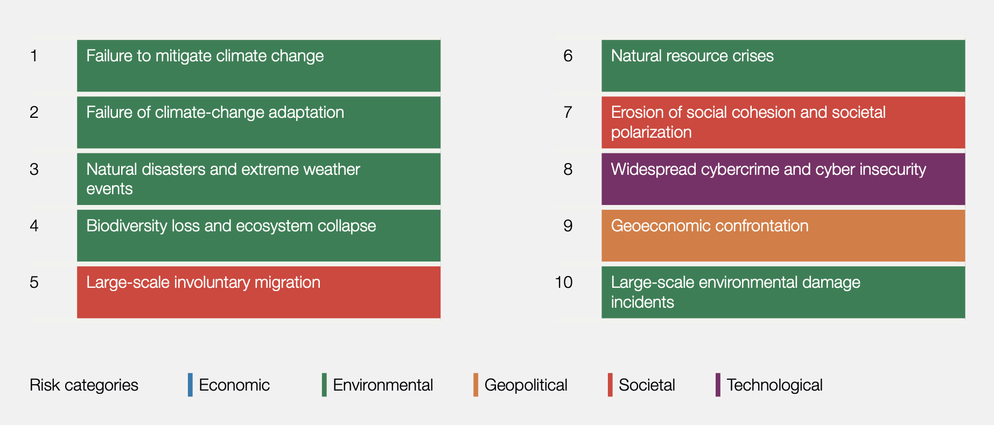
Figure 1:Global risks ranked by severity over the long term (10 years) (World Economic Forum, 2023-a).

2.2 Impacts on sustainable development

One of the risks which stand out the most, causing the most damage and impact on sustainable development, is “Natural ecosystems: beyond the point of return” (World economic forum, 2023b). This risk is ranked number four on the severity chart in Figure 1. Currently, humans “are using the equivalent of 1.6 Earths to maintain our current way of life” (UNEP, n.d-a); due to this, the natural ecosystems are struggling to meet the demands of humans, and natural capital is decreasing. Natural ecosystems and the biodiversity amongst ecosystems are rapidly declining. Human interventions have accelerated this risk due to pollution, which is produced by humans and the consumption of natural resources. Economic output is highly dependent on nature, and the decline in natural ecosystems could have a significant effect on society and the economy. The decline in natural ecosystems is significantly linked to climate change. It can lead to many other risks, such as the increased risk of natural disasters and a natural resource crisis (World economic forum, 2023c). The loss of natural ecosystems produces a chain reaction which causes further risks to society and the economy. The damage to ecosystems degrades the land, negatively impacts climate change, and decreases food security. Research has shown that land degradation can have negative adverse effects on 40% of the global population; climate change, caused by a decline in natural ecosystems, puts 100-300 million people at a higher risk of flooding and hurricanes due to the loss of coastal ecosystems. A decline in biodiversity and natural ecosystems will negatively impact the progress towards the 17 sustainable development goals put in place by the United Nations (UNEP, n.d-b).

2.3 17 Sustainable Development Goals

In 2015 the United Nations produced a set of 17 sustainable development goals as a call for action in all countries. These goals were put in place to be achieved by 2030. Every year a progress report is produced to ensure that countries are working towards meeting these goals (United Nations, 2015a).

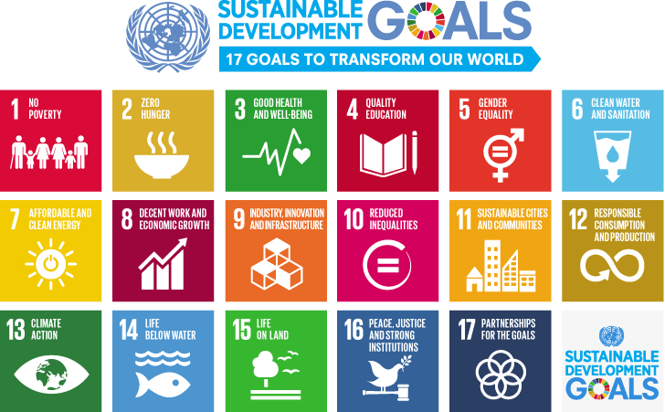
Figure 2: 17 Sustainable development goals. (United Nations, 2015-b)
The decline in natural ecosystems and biodiversity could have a knock-on effect on most of the goals but in particular, goals 2 and 13, possibly impacting the date by which these goals are set to be achieved. The loss of biodiversity and natural ecosystems will negatively impact goal number two, as our current food system is one of the primary drivers causing a decline in biodiversity agriculture alone is procuring a risk to 86% of species already at risk of becoming extinct. Currently, our system for producing food is to produce more food at a decreased cost. This means an increase in land clearance for agricultural use and the use of pesticides used on crops which are harmful to ecosystems. The pesticides used on crops to increase food production have an impact on the natural ecosystems, which erodes the diversity of important species that are vital to sustaining food production, therefore, threatening food security in the future. Due to food being produced at a lower cost, this causes an increase in demand as it is more affordable, accelerating the risks which follow. Not only is food production causing a decline in ecosystems, but it is also responsible for up to 30% of emissions produced by humans resulting in an impact on climate change (United Nations, 2021). The loss of biodiversity due to the current food production system in place puts the goal of zero hunger at risk, as ecosystems are crucial in sustaining food production.

Goal 13 aims to combat climate change and its effects on humans. The loss of natural ecosystems has a significant impact on climate change, therefore, could have a negative impact on this goal. Natural ecosystems play a considerable role in regulating climate change, and humans are destroying these ecosystems, which poses a risk to society and the economy. Marine ecosystems help to reduce carbon released into the atmosphere; currently, they help to absorb almost half of the carbon emissions produced by humans. By destroying these ecosystems, we increase climate change and the risks which accompany this (European Commission, 2009). It is not only the destruction of marine ecosystems which is impacting climate change, but it is also the degrading of peatland ecosystems and deforestation to create more land for agricultural use, contributing to this. Recent studies have shown that due to the deforestation and destruction of ecosystems in the Amazon rainforest, which is the world's largest carbon store, this ecosystem is now releasing more carbon than it can store, therefore, contributing to climate change (Taylor, 2021). Peatlands also play an integral role in reducing climate change, and these are also being destroyed for agricultural use. Peatlands are waterlogged conditions which slow the decomposition rate of plants storing the carbon the plants have absorbed. They also regulate water flows, reducing flooding, lowering ambient temperatures, and reducing the risk of spreading wildfires, helping to preserve the air quality. The remaining area of peatlands worldwide contains 44% of all soil carbon; loss of these ecosystems would result in this being released into the atmosphere, therefore, accelerating climate change (International Union for Conservation of Nature, n.d). The risk of natural ecosystems being destroyed past the point of return results in accelerated climate change affecting goal 13 of sustainable development. If nothing is done to change this, then this goal will not be achieved by 2030.

2.4 How to mitigate the effects of the risks on sustainable development.

To mitigate the risk of not achieving the goal of zero hunger is to produce food in a healthier way supporting biodiversity and therefore preserving natural capital. Limiting the use of pesticides and switching from monoculture to polyculture farming reduces the need for pesticides which damage the natural ecosystems. Polyculture farming mimics nature to help promote a balanced ecosystem; plants that naturally grow near each other are planted in this way, emphasising biodiversity (Bracken, 2019). Switching to polyculture farming helps to restore natural ecosystems meaning food production can be maintained, as species which are essential for sustaining human life are not harmed, increasing food security for future generations. This change could work towards the zero-hunger goal within the 17 sustainable development goals and help eliminate the risk of natural ecosystems collapsing. Another solution to the risk could be a global dietary change and reduction in food waste, which would decrease the demand for foods that have driven the intensification of agriculture resulting in the destruction of natural ecosystems crucial to human life. International decision-makers need to strengthen global agreements and guidelines to implement national-level action plans to transform the global food system making it more environmentally friendly, preserving the natural ecosystems, and ensuring food security for the future (Benton et al, 2021).

Action is being taken to mitigate the risk of not achieving the climate change goal due to the destruction of natural ecosystems. Governments are setting out their plans to help tackle the risks at COP15, a meeting held by the United Nations on the Convention on biological diversity. It is one of the most important meetings in which all the world’s nations meet to discuss the world’s biodiversity. As part of the declaration in 2021, the nations committed to helping biodiversity recover by 2030, with pledges to improve conservation, impose environmental laws and develop financial incentives for protecting biodiversity (Ashworth, 2022). Habitat restoration and conservation is one way in which the biodiversity crisis could benefit also helping to tackle the climate goal. Rewilding is one way an ecosystem could be restored, as it is a process which allows the landscape to regrow with no human interaction; this allows for ecosystems to restore and helps climate change by locking in more carbon. For example, if natural environments such as peatlands and woodlands were restored in the UK, they could lock away over a tenth of the greenhouse gases produced in a year (Chetan-Welsh & Hendry, 2022).

2.5 Theories

The loss of natural ecosystems and the effects this could have on food security due to the biophysical limits associated with the overconsumption of food goes hand in hand with the Malthusian perspective on economic growth. The Malthusian perspective suggests population will continue to grow; however, the land available for agriculture is limited. As shown in Figure 3 below, initially, the per capita output of food will increase simultaneously with population growth; however, if the population continues to increase, food becomes scarcer and drops to the subsistence level, we enter the Malthusian trap (Hussen, 2019a). If nothing is changed and we keep consuming at the current rate destroying natural ecosystems which sustain food production. In this case, the demand for food will inevitably become much greater than the supply available, positioning us in the Malthusian trap. Although Malthusian perspectives are relevant to this, the solution to the issue is not to control the population but to make changes to how we produce food which is mentioned in the previous section. The Malthusian perspectives overlook the fact that humans can adapt and that there are now technologies which can help with resource scarcity.
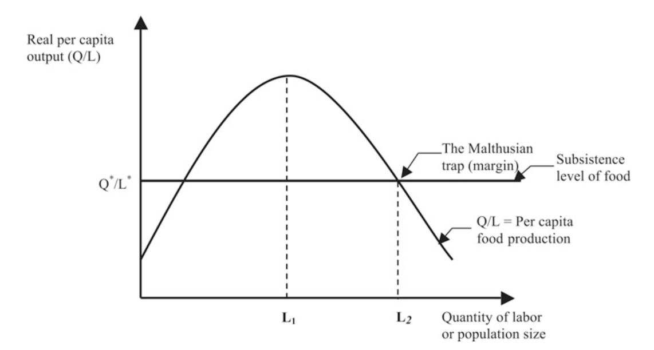
Figure 3: Malthusian Model. (Hussen, 2019-b)
The risk of natural ecosystems going beyond the point of return significantly impacts climate change. The neoclassic approach to economic growth suggests that if we continuously grow, we will eventually grow out of scarcity. However, to enable us to grow, we need more land, so natural ecosystems must be destroyed to free up land. Destroying the natural ecosystems increases climate change as ecosystems play an important role in reducing the effects of climate change. Kuznets curve suggests that economic growth will initially worsen environmental conditions up to a certain point; after this point, environmental quality improves (Hussen, 2019c). However, to enable growth, ecosystems must be destroyed; destroying the ecosystems contributes to climate change, whereas before the destruction, the ecosystems reduced the effects of climate change. This suggests that the Kuznets curve may not be accurate, and an ecological economic approach should be taken to achieve the sustainable development goals. This approach suggests that natural and human capital complement each other; the economy cannot function without natural capital. Without natural capital and natural ecosystems, human life would not be sustainable; the natural ecosystems also provide a vital service in helping to reduce climate change; therefore, these should be preserved (Hussen, 2019d).

3. Recommendations

Improving our global environmental quality has become a worldwide objective. In addition, there is now a growing concern that economic growth could result in reduced natural capital and resource stock, resulting in uncertainty for future generations and their productive capacity.

Recommendation 1: Pollution prevention (P2) could help to reduce the risk of our natural ecosystems collapsing, and the risks associated with this as a significant factor in the destruction of ecosystems is agriculture. The use of toxic chemicals on crops to increase yield and keep up with the demand is destroying ecosystems which are essential in sustaining human life. Substituting the toxic chemicals used in pesticides with ones which are not harmful would help to reduce the rate of destruction to natural ecosystems, preserving the natural capital for future generations (Callan & Thomas, 2013a).

Recommendation 2: There are already sustainable initiatives and programs in place to help restore natural ecosystems, such as the Green India mission, Mexico’s national forestry commission and the Belize barrier reef system. These act as a corrective measure rather than a preventative measure like pollution prevention (Wiggins, 2020). One program specific to preserving natural ecosystems is the PestWise Pesticide Environmental Stewardship Program (PESP); this program promotes the reduction of pesticides in agriculture above the regulatory system. However, for these programs to be successful, cooperation on a global scale is required as these programs are reliant on voluntary partnerships (Callan & Thomas, 2013b). These programs should be made mandatory on a global scale if the required changes are to be made to ensure the longevity of our natural ecosystems for future generations.

4. Conclusion

To conclude this report, it is evident that the long-term risk presented by the World Economic Forum report of natural ecosystems collapsing would be hugely detrimental to the world and could hinder the achievement of several sustainable development goals. Although there are already policies and programs in place, and the topic is being monitored in meetings such as COP15 to reduce the impact of the risk on the world and the sustainable development goals, more could be done to ensure that there is a change being made globally to help mitigate the risk of natural ecosystems collapsing. Pollution prevention could be a beneficial addition to the policies already in place to help the prevention of our natural ecosystems being destroyed beyond a point in which they are not able to be restored, putting the productive capacity and the welfare of future generations at risk. Mandating policies and producing more incentives for the preservation and restoration of natural ecosystems would also create a more globally cooperative approach to solving the risk portrayed in the World Economic Forum report, and the risks associated with this such as food security and climate change. The biophysical limits are evident, and without both the natural and human capital, life could not be sustained. Furthermore, if the restoration of natural ecosystems does not occur, then food security and climate change could be negatively affected, highlighting the urgency and significance of natural ecosystems.

5. References:

Figure 1: World Economic Forum. (2023-a). The Global Risks Report 2023 18th Edition. Retrieved May 5, 2023, from: https://www3.weforum.org/docs/WEF_Global_Risks_Report_2023.pdf.

Figure 2: United Nations. (2015-b). Sustainable Development. The 17 goals. Retrieved May 5, 2023, from: https://sdgs.un.org/goals.

Figure 3: Hussen, A. M. (2019-b). Principles of environmental economics and sustainability an integrated economic and ecological approach (4th ed.). London: Routledge.

Ashworth. J. (2022). COP15 explained: What is the biodiversity conference and why is it important? Retrieved May 6, 2023, from: https://www.nhm.ac.uk/discover/news/2022/june/cop15-explained.html.

Benton. T., Bieg. C., Harwatt. H., Pudasaini. R., & Wellesley. L. (2021). Food system impacts on biodiversity loss. Retrieved May 6, 2023, from: https://www.chathamhouse.org/2021/02/food-system-impacts-biodiversity-loss.

Bracken, M. E. S. (2019). Monocultures Versus Polycultures. In Elsevier eBooks (pp. 483–486). Retrieved May 6, 2023, from: https://doi.org/10.1016/b978-0-12-409548-9.11169-8.

Callan, S. J., & Thomas, J. M. (2013a). Environmental Economics and Management: Theory, Policy, and Applications. Cengage Learning. Retrieved May 9, 2023, from: https://moodle.uwtsd.ac.uk/pluginfile.php/484816/mod_resource/content/1/The%20core%20book%20down%20pdf.pdf.

Callan, S. J., & Thomas, J. M. (2013b). Environmental Economics and Management: Theory, Policy, and Applications. Cengage Learning. Retrieved May 9, 2023, from: https://moodle.uwtsd.ac.uk/pluginfile.php/484816/mod_resource/content/1/The%20core%20book%20down%20pdf.pdf.

Chetan-Welsh. H., & Hendry. L (2022). How are climate change and biodiversity loss linked? Retrieved May 6, 2023, from: https://www.nhm.ac.uk/discover/how-are-climate-change-and-biodiversity-loss-linked.html.

European Commission. (2009). Nature’s role in climate change. Retrieved May 5, 2023, from: https://climate.ec.europa.eu/system/files/2016-11/nature_and_climate_change_en.pdf.

Hussen, A. M. (2019a). Principles of environmental economics and sustainability an integrated economic and ecological approach (4th ed.). London: Routledge.

Hussen, A. M. (2019c). Principles of environmental economics and sustainability an integrated economic and ecological approach (4th ed.). London: Routledge.

Hussen, A. M. (2019d). Principles of environmental economics and sustainability an integrated economic and ecological approach (4th ed.). London: Routledge.

International Union for Conservation of Nature. (n.d). Peatlands and climate change – IUCN. Retrieved May 5, 2023, from: https://www.iucn.org/resources/issues-brief/peatlands-and-climate- change#:~:text=In%20peatlands%2C%20year%2Dround%20water,to%20mitigate%20the%20climate%20crisis.

McLennan. M. (2023). Global Risks 2023: Tensions Peak between Urgent Cost of Living Crisis and Sustainable Climate Action. Retrieved May 6, 2023, from: https://www.marshmclennan.com/content/dam/mmc-web/insights/publications/2023/global-risks-report-2023/global-risks-report-2023-press-release.pdf.

Taylor. C. (2021). The Amazon rainforest is now releasing more carbon than it can absorb, study finds. Retrieved May 5, 2023, from: https://www.cnbc.com/2021/07/15/amazon-rainforest-now-releasing-more-carbon-than-it-absorbs-study.html#.

UNEP. (n.d-a). Facts about the nature crisis - UN Environment Programme. Retrieved May 5, 2023, from: https://www.unep.org/facts-about-nature-crisis#:~:text=What%20are%20the%20impacts%20of,adversely%20affected%20by%20land%20degradation.

UNEP. (n.d-b). Facts about the nature crisis - UN Environment Programme. Retrieved May 5, 2023, from: https://www.unep.org/facts-about-nature-crisis#:~:text=What%20are%20the%20impacts%20of,adversely%20affected%20by%20land%20degradation.

United Nations. (2015a). Sustainable Development. The 17 goals. Retrieved May 5, 2023, from: https://sdgs.un.org/goals.

United Nations. (2021). Our global food system is the primary driver of biodiversity loss. Retrieved May 5, 2023, from: https://www.unep.org/news-and-stories/press-release/our-global-food-system-primary-driver-biodiversity-loss.

Wiggins. B. (2020). These 8 Ambitious Ecological Projects Are Helping to Heal the World. Retrieved May 9, 2023, from: https://www.globalcitizen.org/en/content/ecological-restoration-projects/.

World Economic Forum. (2023). 2. Global Risks 2033: Tomorrow’s Catastrophes. Retrieved May 5, 2023, from: https://www.weforum.org/reports/global-risks-report-2023/in-full/2-global-risks-2033-tomorrow-s-catastrophes/.

World Economic Forum. (2023). Global Risks Report 2023. Retrieved May 6, 2023, from: https://www.weforum.org/reports/global-risks-report-2023/.

World Economic Forum. (2023). Our mission. Retrieved May 6, 2023, from: https://www.weforum.org/about/world-economic-forum.

World Economic Forum. (2023b). The Global Risks Report 2023 18th Edition. Retrieved May 5, 2023, from: https://www3.weforum.org/docs/WEF_Global_Risks_Report_2023.pdf.

World Economic Forum. (2023c). The Global Risks Report 2023 18th Edition. Retrieved May 5, 2023, from: https://www3.weforum.org/docs/WEF_Global_Risks_Report_2023.pdf.

