Modern Manufacturing Technology
Technical Report

Valentina Mascov – 1909334
Tutor: Ryan Cording
Jordan Jenkins
Module: Robotics & Automation / Industry 4.0
ACMA4010
University of Wales Trinity Saint David

Executive Summary

Technology is making an impact on every step of manufacturing process and the purpose of this report is to analyse a technology will have the biggest impact within manufacturing in the coming 20 years. First part of the report is mainly based on the development of manufacturing following the second part which describe – Industry 4.0 nine technology and the economic benefits of manufacturing. The third part will compile changes when adjusting new manufacturing technologies.

Table of contents:

- Introduction……………………………………………………………………………………….. 4
- Findings………………………………………………………………………………………..….5-7
- The Nine Pillars of Industry……………………………………………………………..8-13
- Conclusion………………………………………………………………………………………….14
- Reference list……………………………………………………………………………………..15

- Introduction

Since 1970’s manufacturing industry has been an improvement for factories around the world and this report will briefly look at the next generation of robots where – Robots making Robots – in first part. The second part will cover the Nine Technologies of Industry 4.0 and the transformations of Industrial Production following the third part of a conclusion.

- Findings

73% of global robotics sales come from five of the largest manufacturing economies. China sold 36% of robots in 2017. China was recognized as lead of industry of manufacturing. China’s delivery company JD is taking nearly all of the humans out of the process.
Robotics used by manufacturing industries
- Robotics for transferring materials
- Robotics for processing parts
- Robotics for product assembly
As robotics systems continue to improve faster productivity, investment in robots contributed to 10% of GDP growth from 1993 to 2016.
As robots and other autonomous system continue to improve in functionality and decline in costs going forward, their likely impact on productivity will be even more significant. At least six technologies look like candidates to comprise the next innovation wave: the Internet of Things, advanced robotics, blockchain, new materials, autonomous devices, and artificial intelligence. Perhaps artificial intelligence and robotics are the most important. Artificial intelligence has many functions, including but not limited to learning, understanding, reasoning and interactions.
While these technologies are already in the marketplace, all are generally too expensive and ineffective to be widely adopted enough to drive higher rates of economy-wide productivity growth. This is why, for example, despite the excitement over “Industry 4.0” technologies, they do not appear to have been adopted on a large scale, as evidenced in part by most manufacturers in developed nations appearing to be in the very early stages of adoption.11 Likewise, while there is considerable excitement about machine learning software systems, their current capabilities remain relatively limited—notwithstanding some promising early applications. Fully autonomous cars that are safe and sold at a price point most consumers can afford are likely at least 15 years away.12 And fully dexterous robotic hands are not likely to be in the market before 2030, or even 2040.13 As MIT roboticist Rodney Brooks wrote, “Having ideas is easy. Turning them into reality is hard. Turning them into being deployed at scale is even harder.”14 If these technologies really were “ready for prime time,” one would expect to see higher rates of productivity growth. But, to paraphrase Robert Solow, we see the next production system everywhere except in the productivity statistics. (Robotics and the Future of Production, 2019)
Korea has the most robots per employee -710 robots per 10,000 employees- in manufacturing; Singapore, Germany, Japan and Sweden followed. United States has 200 industrial robots per 10,000 workers and Russia also India just 4 and 3 robots per 10,000 workers.

Figure 1.a

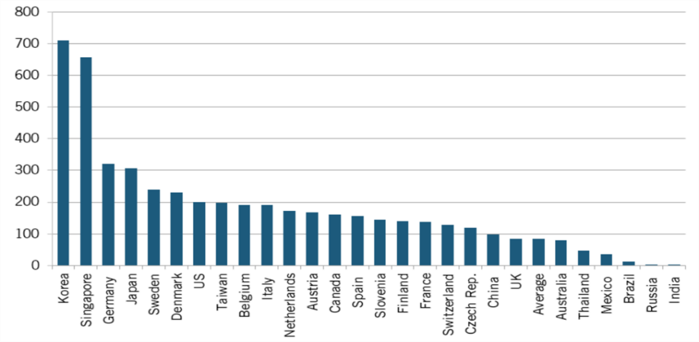

Figure 1.b

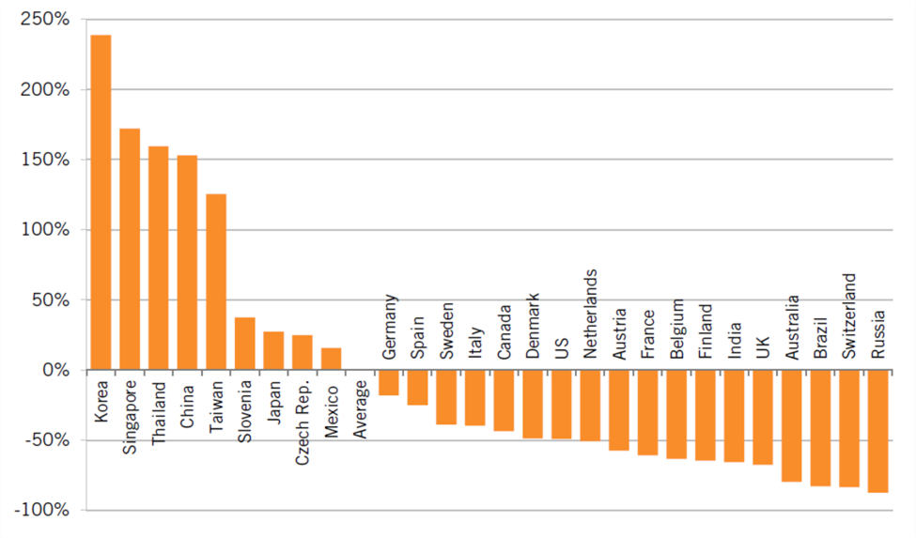

In Japan, Erik Brynjolfsson Director, Massachusetts Institute of Technology Initiative on the Digital Economy explain how the machines are made to figure out on their own and solve the problem. Putting together the date and the computer chips can get up to 1 million folder improvement, machines being able to recognize objects and that is something only humans could do well. In Kitakyushu, Japan the robots are made to work with people having a controlled and light moving.
A safer prosses and the collaboration between the human and robotics can reduce the Adelaide time by 85%.

- The Nine Pillars of Industry 4.0 – Transforming Industrial Production

Figure 2.

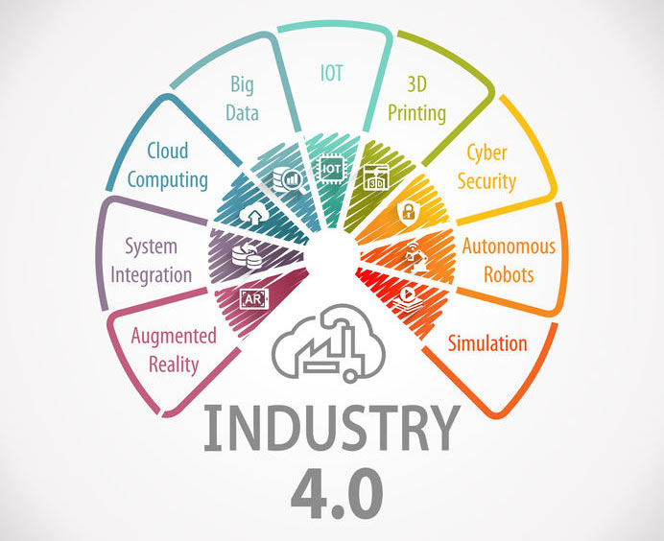

Industrial Revolution
- First Industrial Revolution
First Industrial revolution is the transition from manual labor to steam engine where the mechanical advantage of steam engines was leveraged to lessen the human labor.
- Second Industrial Revolution
Advent of electricity into industries marks the second Industrial revolution. Electrical motors and analog systems replaced the steam engine. There was little to no manual labor involved. Mass production assembly lines were introduced during this period.
- Third Industrial Revolution
Computers, PLC and electronics in factories and industries made it possible for humans to program the electrified machines and third industrial revolution was born. It eventually paved way for automation. (2019)

Pillars of Technological Advancements
Industry 4.0 is built on 9 technology pillars. These advancements bridge the digital and physical worlds and make autonomous and smart systems possible. Supply chains and businesses are already using some of these innovative technologies, but the full completion of Industry 4.0 comes at the front when used together. (See figure 2)

Industry 4.0 in a nutshell
Industry 4.0 is signalling a change in the traditional manufacturing landscape. Also known as the Fourth Industrial Revolution, Industry 4.0 encompasses three technological trends driving this transformation: connectivity, intelligence and flexible automation.
Industry 4.0 converges IT (Information Technology) and OT (Operational Technology), to create a cyber-physical environment.
This convergence has been made possible thanks to the emergence of digital solutions and advanced technologies, which are often associated with Industry 4.0. These include:
- Industrial Internet of Things
- Big Data
- Cloud computing
- Additive manufacturing (AM)
- Advanced robotics
- Augmented and virtual reality (AR/VR)
These technologies are helping to drive manufacturing’s digital transformation through the integration of previously disparate systems and processes through interconnected computer systems across the value and supply chain.
Embracing Industry 4.0, digital manufacturing and the interconnectivity that comes with it opens a myriad of benefits for companies, including greater agility, flexibility and operational performance. (Real-World Examples of Digital Manufacturing in Action, 2019)

Big Data and Analytics
Analytics based on large data sets has come out recently in the world of manufacturing, where it optimizes quality of production, improves equipment service, and saves energy. Big data analytics in Industry 4.0 is in the context that the comprehensive evaluation and collection of data from many different sources—production equipment and systems and organization- and CMS—will become standard to support decision making in real-time.
For example, Infineon Technologies, a semiconductor manufacturer has reduced product failures by correlating single-chip data encapsulated in the testing phase at the end of the production process with process data collated in the wafer status phase in the early process. In this way, industry 4.0 analytics helped Infineon to quickly identify patterns that assist them in discharging faulty chips early in the production process and improved production quality.

Autonomous Robots
Manufacturers in numerous industries have used robots to tackle complex assignments, but now they are progressing towards greater utility. They are becoming more flexible, autonomous, and cooperative. And hence, they will interact and work safely with humans and learn from them. These robots and Analytics chatbot will be economical and have a more excellent range of capabilities than those used in manufacturing today.
For example, Kuka, a European robotic equipment manufacturer, offers autonomous robots that interact. These robots are interconnected to work together and automatically adjust their actions to fit the next unfinished product in the line. Control units and High-end sensors enable close collaboration with humans.

Simulation/ Digital Twin
A digital twin is a virtual simulation of a real-world product, machine, system, or process based on IoT sensor data. It allows businesses to better analyse, understand, and improve the maintenance and performance of products and industrial systems. For instance, an asset operator can use a digital twin to identify a specific malfunctioning part, predict potential issues, and improve uptime.
The German machine-tool vendor Siemens developed a virtual machine that can simulate the machining of parts utilizing the data from the physical machine. This shredded the setup time for the actual machining process by as much as 80 percent.

Industrial Internet of Things ( IIoT )
In the current scenario, only some of a manufacturer's machines and sensors are networked and make use of embedded computing. The Industrial Internet of Things is so central to Industry 4.0 that the two terms are used interchangeably. Most of the physical things in Industry 4.0 – devices, machinery, robots, products, equipment, - use sensors to provide real-time data about their performance, condition, or location.
This technology lets organizations run smoother supply chains, rapidly modify, and design products, stay on top of consumer preferences, prevent equipment downtime, track products and inventory, and much more.
A drive-and-control-system vendor, Bosch Rexroth, outfitted a production facility for valves with a decentralized production and semi-automated process. Products are identified by identification codes, radiofrequency and workstations to know which manufacturing steps must be performed for each product and can adapt to perform the specific operation.

Augmented Reality
Augmented-reality-based systems support various services, like sending repair instructions over mobile devices and selecting parts in a warehouse. These systems are currently in their infancy, but in the coming time, organizations will make much broader use of AR to provide workers with real-time information to improve decision-making and work procedures.

Additive Manufacturing
Organizations have begun to adopt additive manufacturing, such as 3-D printing, mostly to produce individual components and prototypes. Having Industry 4.0 in place, these additive manufacturing methods will be widely used to make small batches of customized products that offer construction advantages, like high performance, lightweight designs, and more.
For example, aerospace organizations are using additive manufacturing to apply new designs that reduce aircraft weight and lower expenses for raw materials such as titanium.

Cybersecurity
Numerous organizations still rely on production systems and management, and that is disconnected or closed. With the use of standard communications protocols and increased connectivity with Industry 4.0, the need to protect manufacturing lines and critical industrial systems from cybersecurity threats increases drastically. As a result, reliable and secure communications and access management of machines and users are a must.
During the past year, various industrial equipment vendors have joined forces with cybersecurity companies through partnerships or acquisitions.

Cloud Computing
Cloud computing is the "great enabler" of digital transformation. In the present scenario, cloud technology goes way beyond scalability, speed, cost efficiencies, and storage. It gives the foundation for most advanced technologies – from AI and ML to the IoT – and provides organizations with a way to organize.
The data that power Industry 4.0 cloud computing technologies reside in the cyber-physical systems and cloud at the core of Industry 4.0 use the cloud to coordinate and communicate. (Polestar, 2021)

- Conclusion

Based on the information found is responsible to say that manufacturing processes will increase in flexibility and allow for the economic production of small lot sizes. Robots, smart machines, and smart products that communicate with one another and make certain autonomous decisions will provide this flexibility.
Industry 4.0 presents tremendous opportunities for innovative producers, system suppliers, and entire regions. But, as with previous transformational developments, Industry 4.0 also poses a severe threat to laggards. As business models, economics, and skill requirements shift, we could well see major changes in top positions, at both the company and regional levels in the next years.

- Reference list:

Future of Manufacturing Technology (online) Available at: 2020: Future of Manufacturing Technology | IndustryWeek
Future of global manufacturing (online) Available at: The future of global manufacturing (brookings.edu)
Industry 4.0 Future of Productivity (online) Available at: Industry 4.0: The Future of Productivity and Growth in Manufacturing Industries (bcg.com)
Manufacturing the future (online) Available at: Manufacturing the future: The next era of global growth and innovation | McKinsey
Manufacturing process development (online) Available at: Manufacturing Process Development - TechSolve
Real World Examples of Digital Manufacturing in Action (online) Available at: Industry 4.0: 7 Real-World Examples of Digital Manufacturing in Action - AMFG
The Importance of manufacturing (online) Available at: The Importance of Manufacturing in Economic Development: Has This Changed? - ScienceDirect
The evolution of manufacturing (online) Available at: The evolution of manufacturing (alphr.com)
The nine technologies behind the Industry 4.0 (online) Available at: The 9 technologies behind Industry 4.0 | Knowledge Centre | Essentra Components UK
The History of Industrial Robots (online) Available at: The History of Industrial Robots, From Single Taskmaster to Self-Teacher - YouTube
The Robot Revolution (online) Available at: The Robot Revolution: The New Age of Manufacturing | Moving Upstream - YouTube

