Changemakers: Creativity and Value Creation
Assignment 2: Project Management and Innovation
ACCA5033
Student name: Ilia Fedorovich
Student ID: 2410118
Group: 1
Lecture name: Dr Fahad Ahmed
University of Wales Trinity Saint David
London Campus
Contents
Introduction 2
Task 1. Project Management & Design 3
Project management and planning 3
Project Design 6
Task 2. Enterprise 11
Analysis of a Tech Company 11
Enterprise Planning for the Medicine Reminder 13
Task 3. Project Reflection 15
Conclusion 17
References 18

Introduction
This assignment presents the development of a project idea based on a medicine reminder mobile app. The goal of this work is to explore how a digital health idea can be planned, designed and evaluated using creativity, innovation and enterprise principles.
The assignment includes project management and design with gantt chart and UI sketches, PEST and SWAT analysis for a tech company of my choice (Samsung Electronics (Samsung Health)), potential start-up name, logo business type and strategy, funding options and reflection.

Task 1. Project Management & Design

Project management and planning
The main goal of my project is to design and plan a mobile application called Medicine Reminder, which helps users manage daily medication schedules. Many people forget to take medicine on time, especially elderly or people who take several pills per day. This app will send reminders, show dosage information, and track when the next refill is needed. It will be designed to be simple and easy to use for all ages.
The project scope focuses on the following areas:
- Designing the key app screens
- Planning key features (notifications, dosage tracking, refill alerts)
- Understanding user needs
- Creating a timeline and milestones for development
- Planning resources such as development tools and testing devices
The project is limited by time, budget, and knowledge. I am completing this project alone and do not have advanced programming skills yet. Because of this, the work focuses mainly on design and planning rather than a full working application. Also, the project must follow data safety rules because medication information is personal and sensitive.
The selected development method is Agile, because it allows changes to be made during the project. If feedback shows that something is not clear or useful, it can be improved quickly [1], [2].
Tools that can be used for development in the future:
- Android Studio for app development
- Firebase for notifications and databases
These tools are free for small projects and widely used by developers.
The chart below shows the estimated timeline for the project:
- Background research
- Similar app analysis
- Requirements collection
- Target user analysis
- First UI sketches and design ideas
- Complete development courses for Android Studio
- Complete courses for Firebase
- Create wireframe for main screens
- Feedback from users and improvements
- Final development and design
- Report

Figure 1. Gantt Chart
Resources Needed:
- Desktop PC or laptop (App design and testing)
- Android Studio and Firebase software (development, wireframe and UI)
- Internet connection (courses, research and communication)
- User feedback (improve usability)
The project success depends on having enough time and collecting useful user opinions.

User Requirements:
- Clear reminders at the right time
- Easy input of medication name and dose
- A clean and readable interface
- Notifications for refills and doctors' appointments
- Security of personal health data

Project Design
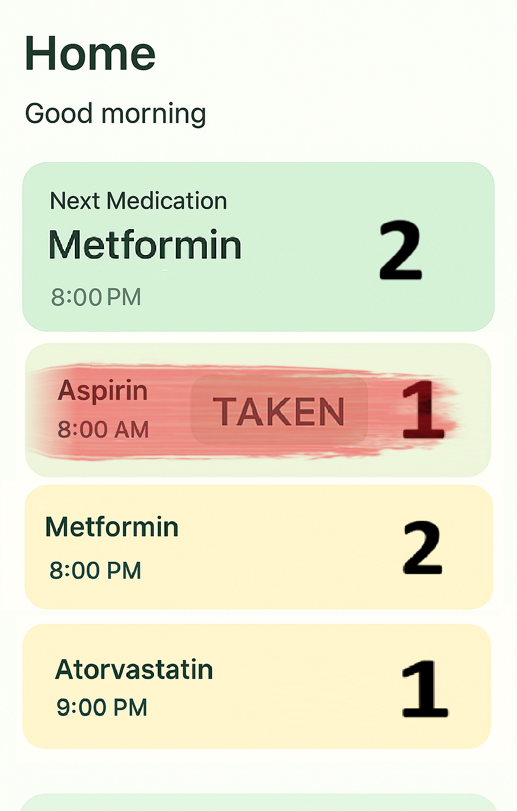
Figure 2. Home Screen with daily doses information
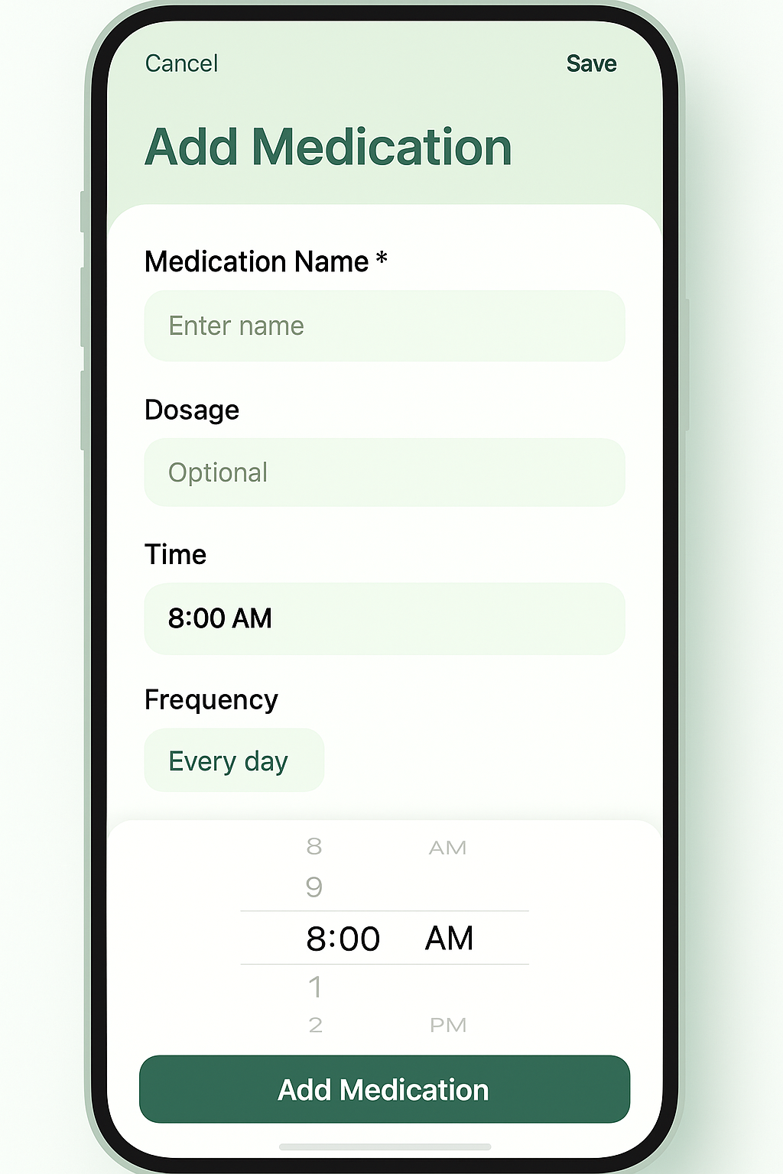
Figure 3. Add medication screen
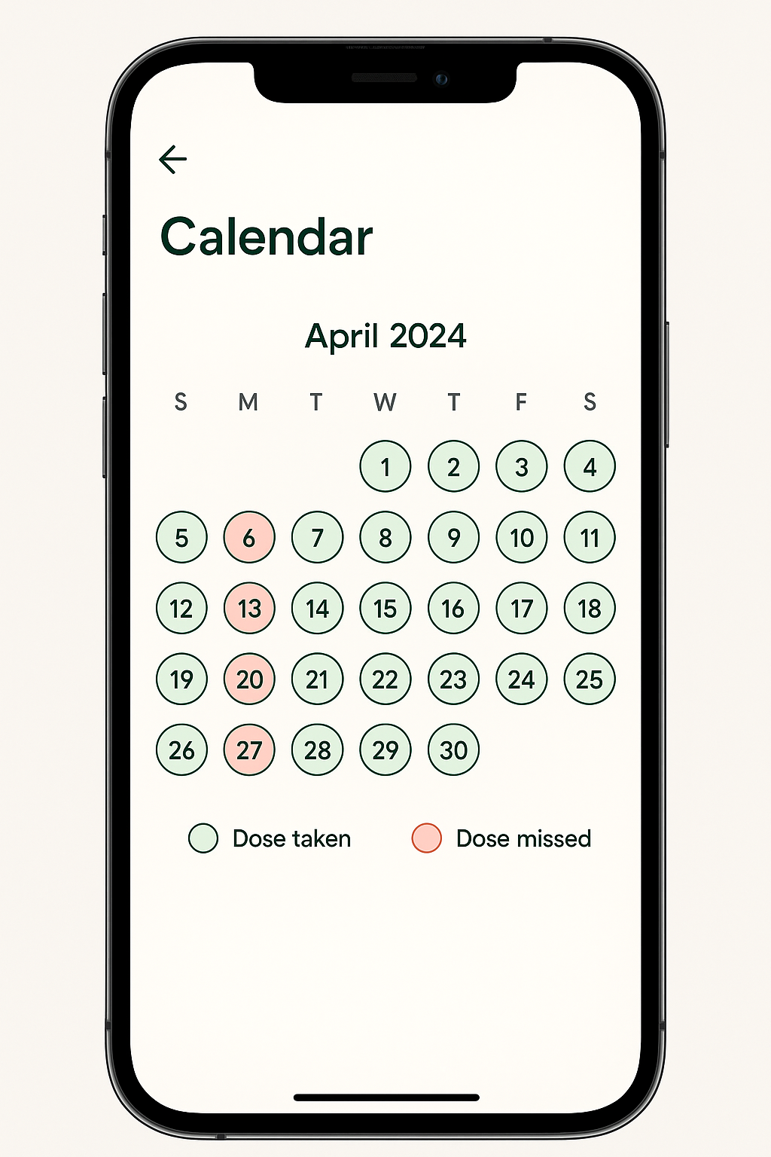
Figure 4. Calendar with colourful marks
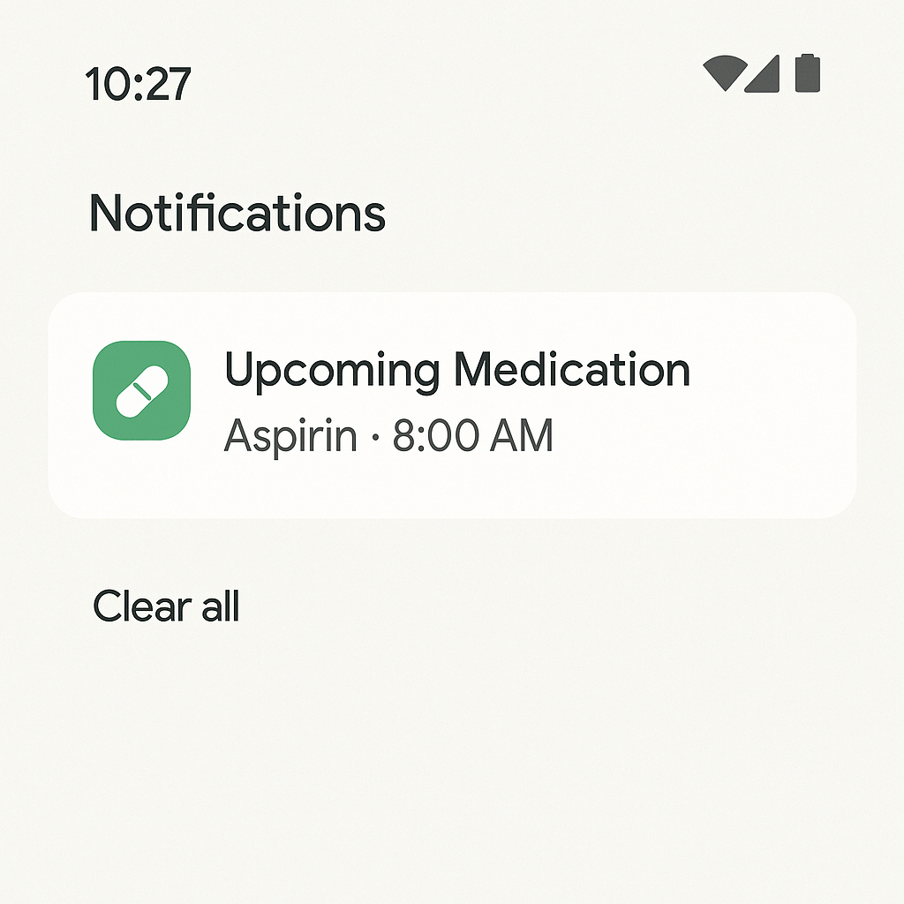
Figure 5. Notification screen
Design style:
- Large buttons for older users
- High-contrast colours for readability
- Minimal text on screen
Wireframes will be created in a simple style to show ideas clearly [4].
Flow Chart:
Home page → Add/edit medication → Check information → Set Reminder → Save → Scheduled calendar → Close the app
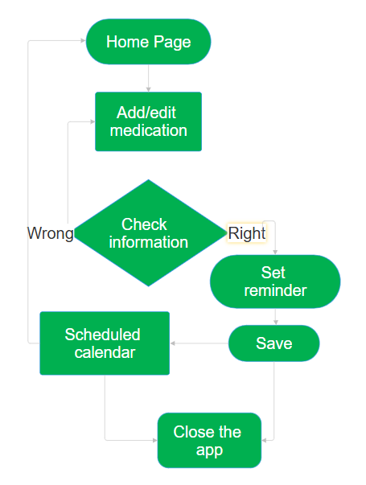
Figure 6. Flow Chart

Task 2. Enterprise

Analysis of a Tech Company
Samsung Health (Samsung Electronics)
Samsung Health is a digital health platform developed by Samsung Electronics, a global technology company. The application is designed to help users monitor and manage their health using mobile devices and wearable technology. Samsung Health supports features such as activity tracking, sleep monitoring, heart rate measurement, and health data analysis. It is widely used on Android smartphones and Samsung wearable devices, which makes it an important example of a modern health technology company [5].
Samsung Health operates in the mobile health sector, which is growing rapidly due to increased smartphone usage and greater awareness of personal health. The platform combines hardware (smartphones and wearables) with software to collect and analyse health data. This makes Samsung Health a strong example of how technology companies create value through innovation and user-focused design.
SWOT Analysis of Samsung Health:
Strengths
One of the main strengths of Samsung Health is its integration with Samsung devices. The application works seamlessly with Samsung smartphones and wearables such as Galaxy Watch, allowing accurate and automatic data collection. Another strength is its large user base, as Samsung devices are used globally. The platform also offers a wide range of health features, which increases its usefulness for different users.
Weaknesses
A key weakness of Samsung Health is that it works best within the Samsung ecosystem. Users with non-Samsung devices may experience limited functionality. Another weakness is that the application can feel complex for older users, as it offers many features that may not be necessary for basic health tracking. This can reduce accessibility for some user groups.
Opportunities
There are many opportunities for Samsung Health to expand. The growing demand for digital health solutions creates space for new features such as medication reminders, caregiver access, and integration with healthcare providers. Partnerships with hospitals, pharmacies or insurance companies could also increase the value of the platform [6].
Threats
Samsung Health faces strong competition from other health platforms such as Apple Health and Google Fit. Another threat relates to data privacy and regulations, as health data is sensitive and must be protected carefully. Any data security issue could negatively affect user trust [8].
PEST Analysis of Samsung Health:
Political
Samsung Health must comply with health data regulations such as GDPR. These regulations protect users but also increase development and compliance costs. Government support for digital health innovation is a positive factor.
Economic
From an economic perspective, Samsung Health benefits from Samsung’s strong financial position. However, economic downturns may reduce consumer spending on wearable devices, which can affect usage.
Social
Social factors strongly support Samsung Health. People are interested in tracking their health and fitness.
Technological
Technological factors are highly favourable. Advances in sensors, mobile applications and cloud computing support the development of health platforms. However, Samsung Health must continuously update the system to stay compatible with new devices and security standards [7], [9].

Enterprise Planning for the Medicine Reminder
The name for the project is Medicine Reminder.
The name is easy to remember and clearly related to healthcare and medication management.
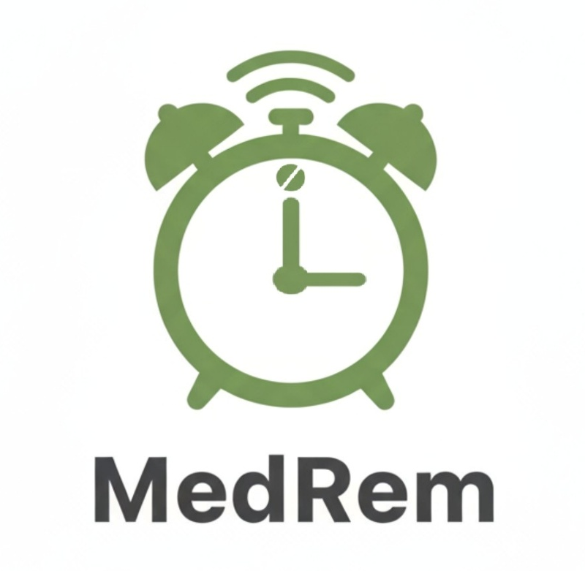
Medicine Reminder would operate as a technology-based startup in the mobile health sector. The main product is a mobile application designed for smartphones as a software-based business, Medical Reminder can be developed and distributed online, which keeps costs relatively low.
Figure 7. App Logo
The most suitable legal classification for Medicine Reminder would be a Private Limited Company (Ltd). This structure is commonly used by startups in the UK. A private limited company offers limited liability, which means the personal finances of the owner are protected if the business faces financial difficulties. It also helps build trust with users, partners, and potential investors. In the early stages, the company could be owned by a single founder, with the option to add shareholders later if the business grows [12].
The main business strategy for Medicines to focus on simplicity, accessibility, and reliability. Many existing medication reminder apps are complex and difficult for older users. Medicine Reminder is offering a clean interface, large text and clear reminders. The target users include older adults, people with long-term health conditions and busy individuals who want a simple reminder tool [13].

Medicine Reminder would use a freemium model. The basic version of the app would be free and include essential features such as medication reminders, a daily schedule and a calendar view. A premium version could offer additional features such as refill reminders, caregiver access, or advanced reporting [14].
At the early stage, Medicine Reminder could be developed using self-funding, especially as a student project. Development tools for mobile applications are often free or low-cost, which makes this possible.
In the future, several funding options could support growth:
- University enterprise grants or startup competitions
- Small business grants for digital health innovation
- Partnerships with pharmacies or healthcare organisations
- Subscription income from premium app features

Task 3. Project Reflection
This project provides a strong opportunity to develop both technical and transferable skills [10]. One of the main skills I intend to develop further is mobile application development. While this assignment focuses on planning and design, the next stage would involve learning tools such as Android Studio and Firebase.
Another important skill is user-centred design. Designing Medicine Reminder for both elderly users and younger users helped me understand accessibility, readability and usability principles. In future development, I would like to improve my skills in usability testing and interface evaluation by collecting real user feedback and applying changes based on that feedback [3].
The project also supports the development of enterprise and project management skills. Creating a business plan, selecting a legal structure and considering funding options helped me understand how technology ideas can be transformed into viable startups. This knowledge will be useful for future projects and potential self-employment opportunities.
The Medicine Reminder project has the potential to create a positive social impact by addressing a real and common problem. Many people forget to take medication on time, which can lead to health complications and increased pressure on healthcare systems. By providing clear reminders and an easy-to-use interface, Medicine could help users follow their treatment plans more accurately [11].
The project is especially valuable for older adults and people with long-term conditions, who often manage multiple medications. The use of simple colour interface and large text makes the app accessible to users who may struggle with complex technology. Supporting medication adherence can improve quality of life and reduce preventable health risks.
In general, Medicine Reminder aligns with the growth of digital health solutions, where technology is used to support prevention rather than treatment. This can reduce hospital visits and support independent living, which benefits both individuals and society.
One of the main risks facing the Medicine Reminder project is data privacy and security. Health-related data is sensitive and users must trust that their information is protected [15]. To reduce this risk, the app would collect only essential data and follow data protection regulations such as GDPR. Clear privacy policies and transparent communication would help build user trust.
Another challenge is user engagement. Some users may ignore notifications or stop using the app over time. To reduce this risk, the app design focuses on simplicity and minimal interaction. Future improvements could include gentle motivational feedback, optional reminders that users can customise or some achievement system [13].
Competition is also a potential risk. There are many medication reminder apps available. Medicine Reminder reduces this risk by focusing on a specific user need and prioritising accessibility over feature overload. Keeping the app simple and user-friendly helps differentiate it from more complex competitors.

Conclusion
This assignment explored the development of a digital health project through creativity, innovation and enterprise planning. Using the Medicine Reminder app as a project idea, the work demonstrated how a real problem can be transformed into a structured and realistic project concept. The assignment combined research, design, business planning and reflection, which helps create a well understanding of how technology projects are developed.
Overall, this assignment helped me to improve both technical and analytical skills and provided useful experience in planning and evaluating a technology-based project. The Medicine Reminder concept represents a strong foundation that could be developed further in future academic or professional work.

References
[1] H. Kerzner, Project Management: A Systems Approach to Planning, Scheduling, and Controlling, 14th ed. Hoboken, NJ, USA: John Wiley & Sons, 2025, ISBN 978-1394290031.
[2] E. K. Zadeh, A. B. Khoulenjani, and M. Safaei, “Integrating AI for Agile Project Management: Innovations, Challenges, and Benefits,” Int. J. Ind. Eng. Constr. Manag., vol. 1, no. 2, pp. 1–10, Jul. 2024.
[3] P. Chow et al., “Effectiveness of mobile health applications for medication adherence,” PLOS ONE, vol. 15, no. 2, 2020.
[4] K. Schnall et al., “User-centered design approaches in mobile health,” JMIR mHealth and uHealth, vol. 4, no. 2, 2016.
[5] Samsung, “Samsung Health | Apps & Services | Samsung UK,” accessed on Dec. 14, 2025. [Online]. Available: https://www.samsung.com/uk/apps/samsung-health/
[6] S. Ranjit et al., “User acceptance of mobile health reminder applications,” International Journal of Medical Informatics, vol. 146, 2021.
[7] M. Patel et al., “Digital health interventions: A systematic review,” Frontiers in Digital Health, vol. 3, 2021.
[8] K. Schwaber and J. Sutherland, The Scrum Guide: The Definitive Guide to Scrum: The Rules of the Game, Scrum.org, Nov. 2020.
[9] Visual Paradigm, “What Is PEST Analysis?” Visual Paradigm, [Online]. Available: https://www.visual-paradigm.com/guide/strategic-analysis/what-is-pest-analysis/
[10] J. W. Drisko, “Transferability and Generalization in Qualitative Research,” Research on Social Work Practice, vol. 35, no. 1, May 2025, doi: 10.1177/10497315241256560.
[11] K. Kvarnström, A. Westerholm, M. Airaksinen, and H. Liira, “Factors Contributing to Medication Adherence in Patients with a Chronic Condition: A Scoping Review of Qualitative Research,” Pharmaceutics, vol. 13, no. 7, Art. no. 1100, Jul. 2021, doi: 10.3390/pharmaceutics13071100.
[12] T. Dalwai and M. Salehi, “Business strategy, intellectual capital, firm performance, and bankruptcy risk: evidence from Oman’s non-financial sector companies,” Asian Review of Accounting, vol. 29, no. 3, pp. 474–504, Aug. 2021, doi: 10.1108/ARA-01-2021-0008.
[13] M. Fang, W. Yang, H. Li, and Y. Pan, “Enhancing User Experience through Optimization Design Method for Elderly Medication Reminder Mobile Applications: A QFD-Based Research Approach,” Electronics, vol. 12, no. 13, Art. no. 2860, Jun. 2023, doi: 10.3390/electronics12132860.
[14] R. S. Kaplan and D. P. Norton, “Using the Balanced Scorecard as a Strategic Management System,” Harvard Business School Working Paper, no. 10-074, 2010.
[15] J. Song, Z. Han, W. Wang, J. Chen, and Y. Liu, “A new secure arrangement for privacy-preserving data collection,” Comput. Stand. Interfaces, vol. 80, Art. no. 103582, 2022, ISSN: 0920-5489.

