

Student Name: Md Ismail Hossan

Student ID: 2521543

Module Name: Marketing Management

Module Code: LCMB7024

Lecturer’s Name: Dr Muhammed Tariq

Work Count: 2658

Table of Contents
1. Introduction 3
2. Task 1: Critical Analysis of the Macro Marketing Environment 4
2.1 Macro Marketing Environment 4
2.2 Analysis of Macro Factor 1 5
2.2.1 Impact on Amazon (Pioneer Organisation) 5
2.2.2 Impact on Alibaba (Follower Organisation) 5
2.3 Analysis of Macro Factor 2 6
2.3.1 Impact on Amazon (Pioneer Organisation) 6
2.3.2 Impact on Alibaba (Follower Organisation) 7
3. Task 2: Strategic Responses of Pioneering and Follower Organisations 7
3.1 Amazon’s (Pioneering Organisation) Strategic Responses 7
3.2 Alibaba’s (Follower Organisation) Strategic Responses 10
4. Conclusion 11
5. References 13

1. Introduction
The fast growth of online technology has drastically transformed the retailing industry around the world and e commerce is now a formidable business force in the contemporary trade. Online retail has reached humongous fraction of the overall sales in the United Kingdom, and it is steadily growing, in keeping with shifting consumer behaviour and building digital connexions. In this dynamic environment, companies in the e commerce industry need to adjust their strategies in line with the changing macro environmental forces that both present opportunities and competitive forces. In this report, the macro marketing environment of two key players in the UK e commerce market with Amazon leading the market and Alibaba Group operating under AliExpress as a follower are analysed. Although both organisations have a presence in the UK marketplace, their size, positioning and market influence vary greatly creating a valuable point of comparative analysis. The macro marketing analysis is considered one of the elements of strategic decision-making. Companies that cannot detect and act on the external forces stand the risk of losing their competitive edge whereas companies that scan the environment in advance may transform threats into opportunities. In this report, the PESTLE framework has been used to analyse two macro factors, which are technological factors and legal factors. The strategic responses of each firm are also analysed in the report based on the Growth Matrix by Ansoff. The report is designed with the goal of initially examining the macro environment and then strategic response of the chosen organisations.

2. Task 1: Critical Analysis of the Macro Marketing Environment

2.1 Macro Marketing Environment
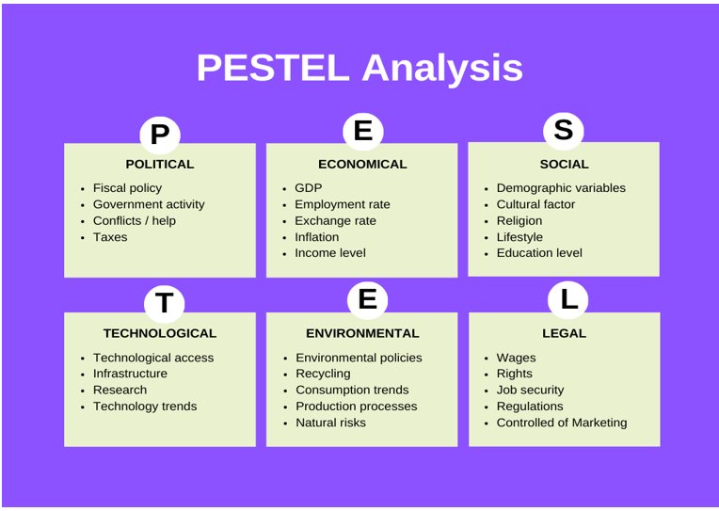
Figure: PESTLE Framework (Priporas et al., 2020)
The PESTL model including Political, Economic, Social, Technological, Legal, and Environmental factors are popular tools for analysing macro environmental forces influencing organisational strategy (CIPD, 2023). It is critically important to environmental scanning and has become basic to strategic marketing both at an academic and practical level.
In the UK ecommerce industry, there are two macro factors that are of particular importance. First, technological advancement including artificial intelligence, machine learning, and mobile commerce is reshaping consumer behaviour and improving supply chain efficiency and competition. Second, legal and regulatory changes such as the Digital Services Tax, Online Safety Act 2023, UK GDPR requirements impose compliance costs, while also imposing barriers to entry to new firms.

These factors are chosen because they have transformative impact on the industry. Technological developments are responsible for competitive differentiation based on innovation and efficient e function, while regulatory frameworks set the constraints within which firms operate in the market, affecting both the strategy adopted and the overall functioning of the market (Market Research Future, 2025; US Department of Commerce, 2025).

2.2 Analysis of Macro Factor 1

2.2.1 Impact on Amazon (Pioneer Organisation)
Amazon's long-term dominance in the UK e Commerce space is firmly grounded in their early and ongoing investment in advanced technologies. Its deployment of AI driven recommendation systems, predictive logistics and cloud infrastructure through AWS has helped provide a highly integrated and efficient ecosystem to strengthen customer loyalty and operational efficiency. The extent of adoption of Amazon Prime in the UK is indicative of the transformation of technological capability into a better customer experience and market dominance (Frisbi, 2024). Moreover, rapid growth of AI adoption provides great opportunities for Amazon to advance personalisation, optimise pricing strategies and automate fulfilment processes, furthering the differentiation advantage (US Department of Commerce, 2025).
However, this technological supremacy is not without problems. The rising accessibility/democratisation of AI tools lowers the barriers to entry as competitors can imitate some of Amazon's capabilities, which could erode its first mover advantage over time. Additionally, ongoing investment in state-of-the-art technologies, like its 2024 AI logistics purchase, entails great financial commitment and introduces the company to risks of implementation (Market Data Forecast, 2025). While technological advancement can lead to cost reduction and service enhancement, it simultaneously increases the pressure of competition and expectations within the UK e commerce industry (Carreño, 2024).

2.2.2 Impact on Alibaba (Follower Organisation)
Alibaba's AliExpress is a follower in the UK market, based more on winning by cost and in making incremental improvements in logistics than relying on advanced technological integration. Initiatives like the Global 5 Day Delivery programme have led to an improvement in fulfilment performance, bridging a key shortcoming of Amazon's quick delivery, while adding appeal to customers (BCP Publication, 2022). Furthermore, the usage of AI driven marketing by the platform during big events like the Double 11 Shopping Festival demonstrates its ability to use technology as a tool for acquiring and engaging customers (Sensor Tower, 2024).
Nevertheless, AliExpress is constrained in the technological advancement into sustained competitive advantage due to its structure. Its ecosystem is less developed and integrated than Amazon's infrastructure with limitations on consistent service quality at scale. While Alibaba's strategic shift towards AI driven innovation is a recognition of this gap's existence, its implementation within the UK context is complicated by individual consumer expectations, regulatory pressures and trust concerns (TechNode, 2024). Consequently, while technological advancement creates opportunities for efficiency gain, it also leaves AliExpress vulnerable to growing capability gaps and competitive ambiguity.

2.3 Analysis of Macro Factor 2

2.3.1 Impact on Amazon (Pioneer Organisation)
The regulatory landscape of the UK has expanded significantly to become more complex to digital market players (Kotler et al., 2020). Digital Markets, Competition and Consumers Act (2024) coined the term Strategic Market Status (SMS), which allows the Competition and Markets Authority (CMA) to utilise increased attention to companies with high impact in the digital economy a classification where Amazon is a candidate (US Department of Commerce, 2025). Also, a UK Digital Services Tax (DST) at a rate of 2 percent levied on qualifying revenues in April 2020, on the amount of revenues earned in the country, added about 860 million in 2024, and Amazon is among the biggest contributors (US Department of Commerce, 2025).
In the case of Amazon, regulatory complexity poses a threat because it raises compliance costs, constrained some competitive behaviours and exposes the company to the risk of litigation (Carreño, 2024). On the other hand, the legal and compliance infrastructure of Amazon that had been built throughout decades of operating in the UK market poses a competitive disadvantage. Its implemented compliance-related frameworks, GDPR-compliant data management, and compliance with the Consumer Rights Act is expensive to copy and is an unspoken benefit compared to more recent market participants (Market Research Future, 2025).

2.3.2 Impact on Alibaba (Follower Organisation)
As a follower organisation, Alibaba is particularly vulnerable to the disproportionately large threat of regulatory change. Being a cross-border platform, whose base is in a non-EU/UK, Alibaba is subjected to increased scrutiny by a set of online safety regulation (UK Online Safety Act) and data protection laws, which are like those in the GDPR, and consumer rights laws. Such non-compliance fines provided by the European Data Protection Board are up to 4% of annual global turnover which can be a substantial liability to a platform as massive as Alibaba (Market Data Forecast, 2025).
Moreover, the regulatory setting is growing sensitive to Chinese cross-border e-commerce platforms and their practises, especially their regard to product quality (eMarketer, 2024). Whereas Amazon has been able to spend decades incorporating compliance infrastructure in its UK business operations, AliExpress will need to invest massively to satisfy the demands of UK regulators and consumers, as well as compete on a price level (BCP Publication, 2022). Regulatory change therefore is a more immediate and structurally suppressive issue to Alibaba than Amazon. The combination of low institutional trust, high compliance investment requirements, and high sensitivity to geopolitically influenced regulatory tightening is its comparative weakness.

3. Task 2: Strategic Responses of Pioneering and Follower Organisations

3.1 Amazon’s (Pioneering Organisation) Strategic Responses
Response to External Challenges and Opportunities
Amazon pursues a reactionary strategy in response to the pressure of external environments, using the technology change and regulation to support a competitive edge. In the UK, its 15 million Prime subscribers (approximately 39 percent of online purchasers) prove how AI based personalisation and predictive logistics increases retention and efficiency in operations (Frisbi, 2024). Instead of viewing AI as a support mechanism, Amazon adopts it as part of the company strategy, which allows it to reduce costs and differentiate services, which aligns with its long-term technological transformation (Carreño, 2024).
Nevertheless, this strategy poses a strategic conflict. The proliferation of AI lowers barriers to entry, which means that competitors can copy some of the elements of the Amazon model. At the same time, UK regulations like digital taxation and competition review add to the costs of compliance. Nonetheless, Amazon is larger and has existing systems of compliance that enable it to manage regulatory pressure better than competitors, making regulation a structural obstacle (Market Research Future, 2025). Importantly, its reaction is adaptive and defensive in a balanced innovation and dominance preservation.
Application of Ansoff Matrix
The strategic growth of Amazon is pertinent to the Matrix of Ansoff, which is penetration, development, expansion, and diversification to maintain the competitive advantage in the UK and international markets (Ansoff, 1957).
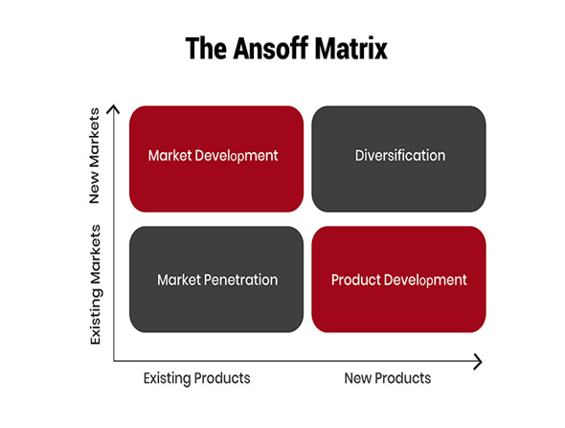
Figure: Ansoff Matrix (Ansoff, 1957)
Market Penetration: The market penetration of Amazon in the UK is also manifested in its 15 million Prime subscribers showing the UK online buyer count at about 39 percent of Amazon purchasers, thus, enhancing retention and loyalty to make a purchase (Frisbi, 2024). This scale enhances high switching costs but simplifies regulatory pressure of market power.
Product Development: The growing use of AWS and AI powered logistics systems, including the latest use of AI in fulfilment optimisation, points to a consistently developing product outside of the retail sector (Market Research Future, 2025). This enhances differentiation, but one must capitalize heavily.
Market Development: Amazon spreads its logistics and fulfilment networks worldwide, which allows the company to deliver with accelerated standards. Nonetheless, this growth introduces the company to various regulations and operational risks (Carreño, 2024).
Diversification: The expansion of Amazon into AWS, Prime Video, and smart products creates major nonretail sources of revenue, and dependence on e commerce becomes less essential (Hassel and Sieker, 2022). More importantly, this wide coverage adds complexity and regulation strain to an organisation.
Industry Examples Supporting Strategic Response
The strategy of Amazon can be demonstrated by tangible results in the industry. In the UK, 15 million users of Prime underline successful penetration on the market by growing loyalty, frequency of purchase, and switching costs (Frisbi, 2024). This model of subscription introduces customers into Amazon system, making it more stable in long run revenue.
The example of product development and diversification is quite clear with AWS that brings a great portion of the Amazon operating profit and makes the company a global technology powerhouse (Charles and Uford, 2023). This minimises the use of retail and fosters innovation throughout the business.
Furthermore, Amazon combines millions of third-party sellers, fulfilment and data system, and this offers effective network effects, hardly replicable (Ritala et al, 2014). Nonetheless, this leadership has enhanced the questioning of the labour conditions and market power within the UK. The examples show that strategy and operations are closely connected.

3.2 Alibaba’s (Follower Organisation) Strategic Responses
Adapted Strategy to Sustain Competitiveness
Relying on AliExpress, Alibaba takes an adaptive approach to be competitive in the UK, and it is mostly influenced by the follower position and lack of resources. Competition is based on cost efficiency, cross border scalability, and promotional intensity instead of technological leadership. The Global 5 Day Delivery option is a direct reaction to the fulfilment expectations that minimises one of the main drawbacks against faster delivery competitors (Yallabena, 2025).
Nonetheless, such adaptation is mostly reactive. Despite AliExpress leveraging AI powered marketing, during the Double 11 campaign, the company struggled to attain high app ranking in the UK, but its technological ecosystem is less integrated to facilitate uniform service provision and differentiation (Sensor Tower, 2024). The action of Alibaba to reorganise into AI driven and user focused operation is indicative of strategic intent, though implementation remains problematic (TechNode, 2024).
More importantly, depending on the price sensitive consumer puts strain on the margin and poor loyalty. Although this is advantageous in the short term in terms of growth, it can provide little sustainable benefit, limiting its competitiveness with other market leaders (Rahman, 2024).
Application of Ansoff Matrix
Ansoff Matrix can explain the strategic growth of Alibaba by looking into penetration, development, expansion and diversification to maintain competitiveness in the international markets such as the UK (Ansoff, 1957).
Market Penetration: AliExpress enhances penetration in the UK market by using aggressive pricing and promotional activities like the Double 11, which has increased the download of apps and activity on the app to a very high level (Sensor Tower, 2024). It is an effective strategy in increasing short term purchase but restricting long term devotion.
Product Development: Alibaba incorporates the use of AI driven recommendation systems and seller tools to enhance the functionality of the platform. Nevertheless, these advances are in the form of incremental development and inferior to the competitors (Rahman, 2024).
Market Development: AliExpress actively expands in Europe with the enhancements of cross border logistics including accelerated delivery programmes, which makes the company stronger within the UK market (Market Data Forecast, 2025).
Diversification: Alibaba uses wider ecosystem, such as logistics and digital service, assisted by organisational restructuring, to support global scalability (TechNode, 2024). Nonetheless, its influence of diversification in the UK is rather short.
Industry Examples Supporting Strategic Response
The competitive strategy of Alibaba in the UK is observed in the market behaviours and performance measures. Its differentiation with other fast rising models like Temu and Shein is how cross border low price retail models are redefining consumer segments especially to the buyers who are cost conscious (Yallabena, 2025). This suggests that AliExpress can scale its demand despite structural disadvantages.
One such example is its performance at the Double 11 Shopping Festival where the high download rankings in the UK serve to illustrate the effectiveness of targeted and data driven campaigns in generating high traffic and short-term engagement (Agus Putra et al., 2024). This strengthens its dependency on the intensity of the promotions as opposed to the enduring differentiation.
Also, the shift to a decentralised organisational structure of Alibaba reflects an endeavour to enhance responsiveness and innovation within global markets (TechNode, 2024). Nevertheless, functional results are still disproportionate especially the aspect of reliability of logistics and building of trust in the UK environment.
All these illustrate the idea that amidst scale and visibility, Alibaba shows limited competitive impact due to execution gaps.

4. Conclusion
This report has critically evaluated the macro marketing environment of UK e commerce industry with respect to the technological and legal aspects and assessed the strategic responses of Amazon and Alibaba. The results reveal that the technological development is one of the driving forces of competitive difference with technology, and the operational limits are formed by regulatory evolution of the frames where the firms can compete. As the first mover, Amazon makes use of superior technology capacities and already developed compliance frameworks to transform the external forces to strategic benefits. Alibaba, in its turn, is a follower and hence operates with a more reactive strategy, using cost efficiency and incremental gains, which restricts its capacity to succeed to differentiation over time. The strategic orientation being different is further noted with the application of the Growth Matrix of Ansoff. Amazon has a multidimensional growth strategy where it involves penetration, development, and diversification compared to Alibaba that has a more oriented approach of penetrating and expanding the market. All in all, the discussion reveals that macro environmental scanning is a key factor in the maintenance of competitiveness in the dynamic markets. Companies that seek to anticipate and address pressure posed by external factors is at a better position to continue benefiting, but those that use the response strategy have structural limits. Marketing responses that are adaptive therefore cannot be optional but are a necessity towards long term strategic success in a changing e commerce world.

5. References
Agus Putra, A., et al. (2024) 'Analyzing Alibaba: Unveiling the strategies, business ethics, and global market expansion', International Journal of Research and Review, 11(1), pp. 575–587. Available at: https://www.ijrrjournal.com/IJRR_Vol.11_Issue.1_Jan2024/IJRR64.pdf (Accessed: 22 March 2026).
Ansoff, H.I. (1957) 'Strategies for Diversification', Harvard Business Review, 35(5), pp. 113–124.
BCP Publication (2022) 'Competitive strategy analysis of cross-border e-commerce: AliExpress in the UK market', BM Journal. Available at: https://bcpublication.org/index.php/BM/article/download/3100/3053/3025 (Accessed: 23 March 2026).
Carreño, A.M. (2024) 'Analysis of Amazon's evolution from an online bookstore to a global tech giant', Institute for Change Leadership and Business Transformation. Available at: https://adolfocarreno.com/2024/12/02/analyzing-amazons-evolution-from-an-online-bookstore-to-a-global-tech-giant / (Accessed: 23 March 2026).
Charles, I.I. and Uford, I.C., 2023. Comparative analysis and evaluation of business and financial performance of Amazon. Com: A three-year period critical review of exceptional success. European Journal of Business, Economics and Accountancy, 11(2), pp.69-92.
CIPD (2023) PESTLE analysis. Available at: https://www.cipd.org/en/knowledge/factsheets/pestle-analysis-factsheet / (Accessed: 22 March 2026).
eMarketer (2024) AliExpress: Reports, statistics and marketing trends. Available at: https://www.emarketer.com/topics/category/aliexpress (Accessed: 23 March 2026).
Frisbi (2024) Comprehensive guide to Amazon UK in 2024. Available at: https://www.frisbi.com/blog/comprehensive-guide-to-amazon-uk-in-2024 (Accessed: 22 March 2026).
Hassel, A. and Sieker, F., (2022). The platform effect: How Amazon changed work in logistics in Germany, the United States and the United Kingdom. European Journal of Industrial Relations, 28(3), pp.363-382.
Kotler, P., Armstrong, G., Harris, L. and Piercy, N. (2020) Principles of marketing. 8th European edn. Harlow: Pearson.
Market Data Forecast (2025) Europe e-commerce market size, share, 2033. Available at: https://www.marketdataforecast.com/market-reports/europe-e-commerce-market (Accessed: 23 March 2026).
Market Research Future (2025) UK e-commerce market industry impact insights 2035. Available at: https://www.marketresearchfuture.com/reports/uk-e-commerce-market-46301 (Accessed: 23 March 2026).
Priporas, C.V., Kamenidou, I., Nguyen, N. and Shams, R., 2020. The impact of the macro-environment on consumer scepticism towards cause-related marketing: Insights from an economic crisis setting. International Marketing Review, 37(5), pp.841-861.
Rahman, M.S. (2024) E-commerce evolution: a strategic analysis of Alibaba's business ecosystem, SSRN. Available at: https://ssrn.com/abstract=5109165 (Accessed: 22 March 2026).
Ritala, P., Golnam, A. and Wegmann, A. (2014) 'Coopetition-based business models: the case of Amazon.com', Industrial Marketing Management, 43(2), pp. 236–249.
Sensor Tower (2024) AliExpress case study: driving organic growth and store ratings improvement. Available at: https://sensortower.com/blog/aliexpress-case-study (Accessed: 23 March 2026).
TechNode (2024) Alibaba group restructures e-commerce operations, 22 November. Available at: https://technode.com/2024/11/22/alibaba-group-restructures-e-commerce-operations-to-boost-global-expansion/ (Accessed: 23 March 2026).
US Department of Commerce (2025) United Kingdom: Digital economy. Available at: https://www.trade.gov/country-commercial-guides/united-kingdom-digital-economy (Accessed: 22 March 2026).
Yallabena (2025) AliExpress leads UK eCommerce market with Temu, Shein, and TikTok Shop, 13 January. Available at: https://yallabena.com/aliexpress-leads-uk-ecommerce-dominating-cross-border-retail-with-temu-shein-tiktok-shop/ (Accessed: 22 March 2026).

