BMSK5006
KNOWLEDGE AND INFORMATION MANAGEMENT SKILLS FOR THE WORKPLACE
LECTURER: DOMNAN MIRI
Shafia Bibi
1711966

TABLE OF CONTENTS
INTRODUCTION 2
TASK 1 3
Use of Data 3
Data, Information and Knowledge 3
Tacit and Explicit Knowledge 4
Five Decisions Made Today 7
Lack of Pre-existing Data, Information and Knowledge. 8
Invention of a New Product 9
TASK 2 10
Part 1 10
Basic Competitive Strategies of Cost Leadership and Product Differentiation 10
SABRE’s Way of Providing American Airlines with A Competitive Advantage 11
The Erosion of American Airlines Lead Over its Competitors 12
Part 2 13
What is Information System 13
Categories of Computer-based Information Systems 13
Supporting Managers at Each Level of an Organisation 14
CONCLUSION 15
REFERENCES 16

INTRODUCTION

In this assignment, the theory and importance of knowledge management in regard to an organisations knowledge and their management will be assessed. The crucial knowledge management practices necessary for organisational advancement will also be highlighted in this assignment. A framework will be developed to establish knowledge management.
There are two tasks that will be discussed in this report. Task 1 is based on data, information and knowledge. A definition of data, information and knowledge will be given, alongside the importance of each of them. This report also highlights the link between all three and how they can be acquired, retained and transferred. Also, there are different types of knowledge and this will be critically analysed. Furthermore, the effects of the lack of data, information and knowledge will be highlighted. Task 2, which will be in two parts, is based on the travel industry, revealing some information on airlines and their competitive advantage. Moreover, information systems are a great part of competitive advantage, hence this will be included.

TASK 1

Use of Data
Data are raw facts that have little or no value, until they are processed. Some set of data can be considered as useful to some and useless to others. The main difference here would be their interpretation of the data. According to Computer Hope (2019), data consists of images, signs, symbols, numbers and even sounds or videos. If the data relates to any persons then this would become useful data to them, becoming what is called information. Information is data that has been processed for a purpose. Information can improve decision making. Information can be considered as knowledge as the information obtained can bring power, when used correctly. The knowledge acquired from the data may be different from each individual. This depends on a person’s understanding and the use of information. For example, “14111988” is just a set of numbers. This is called data. When separated by dots and given a name e.g. Simone Brown 14.11.1988, this can be interpreted as a date of birth which is information, but someone with little understanding may still think it as useless. They will not consider this as information or gain any knowledge from this.

Data, Information and Knowledge
Knowledge, data and information all differ from each other. The diagram below shows the relation between each component.
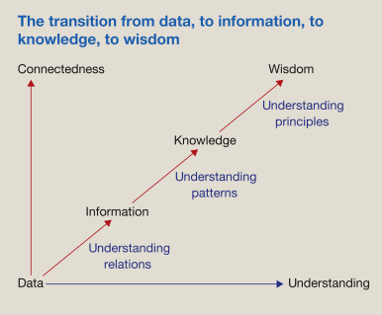

Fig. 1. (Cooper, 2017).
This diagram shows how data, information and knowledge all play significant roles, which lead to wisdom. When used correctly, data can change to information. This requires understanding of the raw facts in order to interpret them into information. There are different types of information processes. This includes categorizing, organising, summarising, calculating and selecting. There are two types of value of information: tangible and intangible value. Tangible are physical elements, e.g. cash and intangible are nonphysical elements, e.g. customer loyalty (Murphy, 2019). As the understanding of data and information increases, knowledge and power are developed further. The better the interpretations, the more knowledge and wisdom can be acquired. Knowledge differs from data and information, as knowledge leads to power and wisdom. Data and information are simply facts and figures; however, the knowledge is much greater as this can be used to carry out further actions and expand one’s intelligence. Structured and organised information leads to knowledge, which is mainly gained through formal communications (Cooper, 2017). The quality of the information is very important for getting the knowledge correct. Examples of quality can be the exact time, currency, frequency and even the accuracy and relevance of the information. Wisdom is the understanding of right from wrong, which involves knowledge.

Tacit and Explicit Knowledge
From a philosopher’s point of view, knowledge starts off from somewhere. Aristotle (384-322 BC), an Ancient Greek philosopher and scientist suggests knowledge is built on ones existing knowledge. He quotes, “All instruction given or received by way of argument proceeds from pre-existent knowledge”, cited in Dempster (2008). To be able to prove one’s knowledge, they should be able to explain their knowledge using previous examples. He classes this as demonstration. With much practice, a lot of experience is gained, which in turn becomes a principle or a foundation for new knowledge. This principle does not need to be proven in any forms. Aristotle believes perception plays an important role, but it is just a starting point in understating principles. On the other hand, philosopher Epicurus (341-270 BC) another Greek philosopher, believes perception is the “foundation and starting point of all knowledge” (Dempster, 2008). Perceptual experience is what leads to more knowledge. The content and belief may not be accurate, but its result is knowledge development.
Knowledge can be split into three parts: explicit knowledge, implicit knowledge and tacit knowledge. Explicit knowledge is the most basic, easy to communicate and it is stored. Implicit knowledge is the practical application of the explicit knowledge, and tacit knowledge is gained through one’s intuition or experiences but harder to communicate (Alexander, 2019). According to Park, Vertinsky and Becerra (2015), the processes for tacit knowledge and explicit knowledge transfer differ significantly. The transfer of tacit knowledge has a considerable amount of impact on the performance of young and older organisations, however explicit knowledge is easily transferred and has more impact on the performance of older organisations. This shows older organisations are not changing their style of knowledge transfer to adapt to this modern world. Also, younger organisations are approaching the needs of its employees by using different techniques. Below is a comparison of tacit knowledge and explicit knowledge, and different ways of transferring knowledge:
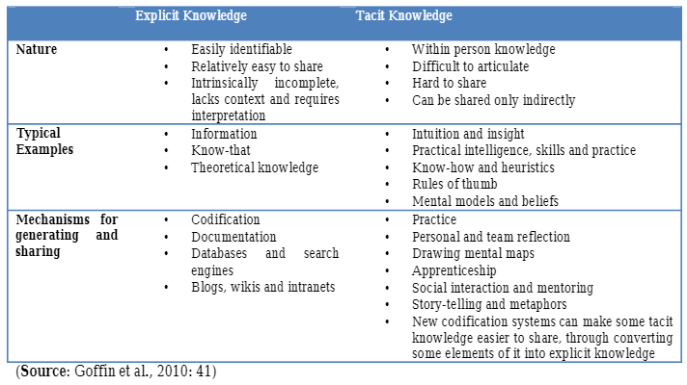

Table 1. (Goffin et al. 2010, p. 41).
It is evident in this table that explicit knowledge is far easier to identify and transfer, as it is can be communicated through documents, reports and other platforms. However, the downside of explicit knowledge is that it may be incomplete and lack accurate content. For those with language barriers, it may be harder to translate. Tacit knowledge is one’s own intuition and experience. It is harder to transfer, as it can be difficult to explain. Explicit knowledge is more about the knowing factor, and tacit is more to do with practical factors. Tacit knowledge requires skills and practice, within oneself and between team members. According to Nonaka and Konno (2000), cited by Magd (2014), “tacit knowledge is deeply rooted in an individual’s actions and experience, as well as in the ideals, values or emotions he/she embraces.” With the appropriate level of communication and interaction, tacit knowledge may be transferred using some elements of explicit knowledge. This can be considered as knowledge management. Jennex (2007), cited in Magd (2014), suggests that what may be tacit knowledge to some, may be considered as explicit knowledge to others. This has led people to realize the value of transferring tacit knowledge into explicit knowledge and encourage researches on how to implement knowledge management in any organizations.

The model of knowledge conversion was founded by Nonaka and Takeuchi in 1993, to illustrate the process of relations between explicit and tacit knowledge (Easa, 2012, p. 27). To obtain the information they have, they undertook research in several Japanese manufacturing companies, to discover how knowledge is created and can be transferred. This can be seen in the table below:
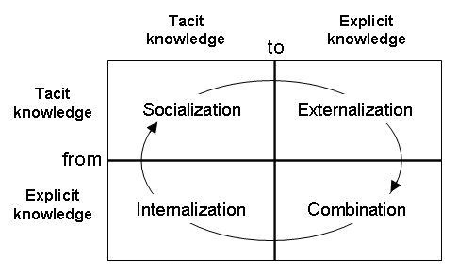

Table 2. (Kumar, 2019).

Socialization is the interaction and knowledge transfer between individuals in an organization. They can do this in meetings and apprenticeships where they can share ideas and experiences. They are also able to observe behavior of others. The knowledge can be passed by word of mouth, written documents or imitations. Externalization is writing down the thoughts and ideas that have been shared. This helps retain the knowledge transferred. This can be done through asking questions and recording answers. Combination is the storage of knowledge and creating a link between old and new knowledge. This can be achieved through a variety of sources e.g. emails, letters and meetings. It also helps to categorize the knowledge learnt. Internalization is the organizations knowledge. Individuals can learn through guidance and documents.

An example of tacit and explicit knowledge can be seen in a card game: Poker. There are a lot of basic rules in the game. However, to win the game one is required to master their skills, using different strategies. There are different numbers and images on the cards and every individual is aware of the meaning. This is explicit knowledge as it is in written format. However, the strategies that are used are not written. They are one’s intuition and experience. This is called tacit knowledge. It is one’s feelings and thought, and until shared, it remains with oneself. Once it is shared, this can be regarded as explicit knowledge. It depends on how it is perceived or received. Knowledge can be acquired, retained and transferred. This is known as knowledge management life cycle. The transfer of knowledge would depend on every individual, whether they want to share their knowledge or keep it for their self-satisfactory needs. This is part of their personality trait.

Five Decisions Made Today
Below are examples of data, information and knowledge that are involved in 5 actions taken:
 | DATA | INFORMATION | KNOWLEDGE
DRIVING TO THE GP SURGERY | Key, buttons, steering wheel, brakes, mirrors, sat nav. | The key starts the engine, the brake helps start and stop the car, buttons for the radio, mirrors for rear view. | Without inserting the key, the engine will not start. The steering wheel will help take correct turns, whilst the sat nav will direct to the correct destination. The mirrors will ensure safety of driver and other road users.
MEASURING ROOM TEMPERATURE | Number 18. | When added with a degrees symbol, it is a temperature. | With the knowledge of signs ad symbols, the temperature will be identified. It can then be changed to preferred temperature. Without symbol, it could be a birthday, date or amount.
MILK FOR BREAKFAST | White fluid. Plastic bottle.  Cold. | Label on bottle. | The label identifies the fluid as milk. It has nutritional information on the label. It is cold as it was stored in the fridge.
USING THE LAPTOP | Black device with numbers, symbols, letters. | It is a laptop. Can easily be switched on using power button. Can open and fold shut. Comes with a unique charger and has its own storage bag. | Can be used for typing and viewing content. Personal or official use. Can connect to Wi-Fi and Bluetooth. Can be used to communicate with people via webcam, emails or social platforms. Has a variety of pre-installed applications.
TURNING OFF THE LIGHT SWITCH | White box with switches and screws. | It is used for switching on and off. | The light helps brighten the room. In daytime it is not required, therefore can be switched off. It does not make much difference to the brightness in the room.

Lack of Pre-existing Data, Information and Knowledge.
Driving to the GP surgery - Without the knowledge of inserting the key to start the engine, the car simply would not move. Driving to the surgery would seem almost impossible. Not every car is the same but, in this case, the key when inserted, starts the heating, radio, satnav and every other function. Also, without passing the theory and practical tests, it is not hard to imagine the endless damages that could be done when driving. Without the information and knowledge, the correct use of functions, how to navigate safely, road signs and symbols would not be followed appropriately, not to forget the laws that could be broken.
Measuring room temperature – Without the knowledge and information on how to use a thermometer properly, it would be pointless trying to find the temperature. Also, if the thermometer was faulty the correct temperature would not be given. The thermometer will need to show accurate data for information to be gained.
Milk for breakfast – If the label was not on the bottle of milk, it will be hard to distinguish what type of milk it is. Details on the label gives accurate information on what type of milk it is and what nutrition it contains. It also has the best before date and manufacturer information. A person with who cannot understand the date may drink it after its expiry date. Without the label, a person with dairy allergy may drink cow milk regarding it as soya milk. Therefore, it is essential to have the correct data and information.
Using the laptop – If a person does not understand the basic functions of a laptop, it will be difficult for them to run a laptop. If the data on the keyboard was all jumbled up then the buttons would not process the correct letters, numbers or symbols. Without the knowledge of Wi-Fi, one could not enjoy the benefits it has.
Turning off the light switch – Without the knowledge of a light switch, a light cannot be turned on or off. Light switches can vary in function. Some can turn on and off, whereas others can be turned on, off and even be dimmed. Some lights can even be switched on and off remotely using a Wi-Fi connected device. This device will need to have accurate data in order to be able to connect to the Wi-Fi and the light.
Without information and knowledge, data would be useless. There has to be a connection between a person and the data, for example, a person taking their theory test. They will be required to learn the meaning of each symbol in the test book, in order to acknowledge the meaning and understand the impacts they can have. This would become their knowledge. If they cannot understand the symbols (data), then they will not gain any knowledge.

Invention of a New Product
Shaf Cosmetics Ltd was recently launched online. Its base is in Birmingham, UK. The manufacturing company is a German company. Shaf Cosmetics sell various makeup, from a cheap range to a more luxury range. It does not have a specific age range that they cater for, however it is unsuitable for under threes due to small parts. Shaf Cosmetics does not specify gender as any gender can purchase from them. Also, the products are cruelty free, which may attract potential vegan customers. The geographic area can extend to further locations as it is an online business. The products can be advertised through a wide range of social platforms, tv advertises and even bill-board advertisement.
As it is not age or gender specific and bearing in mind young children are not likely to buy, the age range it is focused on is 13-year olds and above. Males too can wear makeup so there is not a specific gender to aim for. The price range is as low as £5.50 for lip glosses, to £17.50 for more luxury. This is to make products more affordable and provide quality too. The prices of the products (information) can be set, taking into consideration the demographic data, e.g. age and gender. As there is a wide geographical area, there will be a mixed level of income in households, as well as size of families. For that reason, there will be a cheaper range to a more expensive range of products. With this knowledge, Shaf Cosmetics can be advertised through different methods, without any restrictions.

TASK 2

Part 1
In 1953, the president of American Airlines and a senior sales representative for IBM met on a flight from Los Angeles to New York. They had built a conversation on the travel industry and data processing systems. With five years of discussions, they had come to an arrangement for Semi-Automatic Business Research Environment (SABRE). This was to make life easier, taking bookings and recording them. Through SABRE, they were able to manage bookings better and reserve seats. Flights were not over or under booked. This resulted with happier customers. By 1964, everything was fully installed and running well.

Basic Competitive Strategies of Cost Leadership and Product Differentiation
Consumers were able to save money through SABRE and agencies. SABRE had expanded to be used by travel agents, which meant SABRE was growing rapidly. SABRE was able to offer very low fares to the consumers. It adapted needs of travel agents and consumers by adding more services e.g. online reservations. This is how American Airlines gained cost leadership. They took control of the income and expenditure through SABRE. By going online, they were able to reduce operating costs as they had fewer staff to pay for.
By replacing the hand-written tickets of the 1950s, they were able to save 30% of investments. According to IBM (2018), “Customer experience is a key competitive differentiator for airlines.” Working alongside IBM, American Airlines understood what it meant to meet customer needs. This is why they created SABRE. They are much more reliable and productive with SABRE in force. They also gained more power over their customers. To be more efficient, American Airlines needed to change the way they operated. They needed to incorporate digital opportunities. American Airlines had to know where they are and what could be done to improve their services. To get where they are, American Airlines may have used a Strategic K Gap Analysis tool to analyse their current situation and requirements for the future.

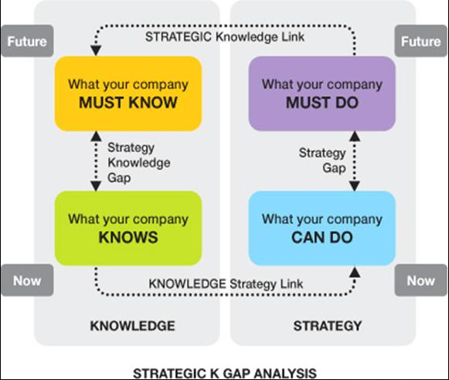

Fig. 2 (Sharma and Chowdhury, 2007).

SABRE’s Way of Providing American Airlines with A Competitive Advantage

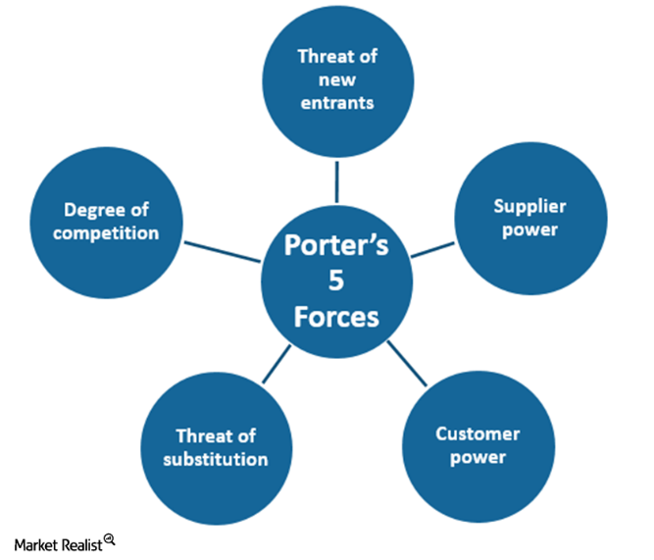

Fig. 3 (Prince, 2019).
Porter’s Five Forces is a framework for analysing competition in the industry. The elements of the force are: threat of new entrants, power of supplier, bargaining power of buyers, threat of substitute products and the degree of competitive rivalry. SABRE protects American Airline from threat of new entrants by having a high barrier for entry. Not every organisation will be able to afford to join SABRE. To reach the level of SABRE, other competitors will need to invest into a large amount of money and have sufficient resources. They will need to have skilful employees, meeting every demand of customers. Other organisations will need to ensure their information system is consistent with modern technology. American Airlines have supplier and buyer power as they are a top leading airlines company.

The Erosion of American Airlines Lead Over its Competitors
American Airline lost their power over customers as they did not maintain customer needs or keep up with the trends of the travel industry. They were comfortable in their zone, hence lost out in the late 1980s. They did not bring innovation to the market, where younger organisations were implementing new ideas. SABRE delivers their services to thousands of shops, take thousands of passengers and manage hundreds of bookings through their technology (SABRE, 2019). However, American Airlines were not able to maintain this. They were stuck in the middle.
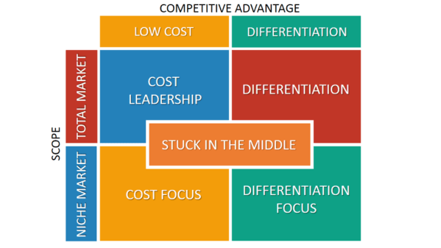

Fig. 4 (B2U - Business-to-you, n.d.).
Porters competitive strategy describes how a company positions itself within the competitive industry. A company usually prefers to place themselves in cost leadership and differentiation, rather than focus or niche. Cost leadership and differentiation would both engage more with customers, building customer value and loyalty. American Airline, in this case, have failed to meet some of these competitive advantages, therefore have lost out to their rivalry competitors. They are stuck in the middle.

Part 2

What is Information System
Information systems is the compilation of information, gained through people and resources. The purpose of an information system is that it can improve an organisations strategy and processes, storage, and even sharing of information in a more efficient manner. The information system can include, but is not limited to, hardware, software and digital applications (Techopedia, 2019). Another benefit for having an information system is that it can help translate data into information, which would lead to knowledge gain.

Categories of Computer-based Information Systems
Information systems can be split into two groups: manual information systems, and computer-based information systems. Below are four examples of computer-based information systems:

Category | Description | Example
Operations support systems, including transaction processing systems. | Translates business data into useful information. | Products.
Management information systems. | Using database information to produce reports. | Sales reports.
Decision support systems. | Data is gained from a variety of sources and examined by managers for future referencing. | Pricing.
Executive information systems. | Analyzes business trends. | Staff turnover.

The responsibility of operational support system is to effectively manage business transactions, monitor business processes, promote communication and renew company database. - The information system usually handles business operations (operation support system) and creates a lot of information for external and internal use, though some may require further handling for effective use by the manager. Management information systems provides managers with information that can help with their daily tasks. It usually contains information regarding what the manager has asked beforehand. Information can be transferred when asked or in a regular timeframe. Decision support systems are usually for specific reasons. This can be done in an interactive way, e.g. online meetings or face-to-face meetings. This can be accessed by other business professionals. Executive information systems are also tailored to managerial preferences and other professionals. It gives quick and easy access to certain information that is required by them, in which would support the business strategy.

Supporting Managers at Each Level of an Organisation
Computer-based information systems can be related to Porters Five Forces. Heavy information systems can build a high barrier for entry to the organisation, due to high start-up costs. This will have positive effect on the manager as they will have one less issue to think about. Managers can focus their attention on how to retain their customers, promote the business and improve operational efficiency. This will make it harder for rival companies to match their standards. Computer-based information systems are far better than manual systems, as computers are faster to transfer with, organise and process information. It can also bring accuracy and reliability.

CONCLUSION

Knowledge is a simple word but with many factors. Only with much research one can learn the importance of knowledge. Knowledge has different foundations and start-up lines. Different factors can impact the effectiveness. All businesses require knowledge on knowledge. It is important to learn how to acquire, retain and transfer knowledge in the correct manner. It is crucial to have the correct understanding of data, information and knowledge, in order to successfully transfer knowledge. New ideas and further actions can be taken, as a result of the new knowledge. There are different views on knowledge and even with philosopher material, knowledge takes a lot of time to understand. Only then can it be passed on appropriately.
Information systems too play an important role in an organisation. As there are different information systems, it is important to find out which system works best for the organisation. As there are many different systems, a wide range can be used. This would help not only the manager to plan and maintain the company goals, this would help the overall business’s success. Knowledge on information systems can increase competitive advantage of a business, reducing the chances of threats to entry. Managers can plan far better for the future and provide support to others. Knowledge management and information systems mainly rely on the processes and control.

REFERENCES

Alexander, R. (2019). Tacit, Explicit, and Implicit Knowledge: Definitions and Examples. [online] Bloomfire. Available at: https://bloomfire.com/blog/implicit-tacit-explicit-knowledge/ (Accessed 27 Nov. 2019).

B2U - Business-to-you (n.d.). Top Business, Strategy and Management Frameworks EXPLAINED | B2U. [figure] Available at: https://www.business-to-you.com/frameworks/ (Accessed 27 Nov. 2019).

Cooper, P. (2017). Data, Information, Knowledge and Wisdom. Anaesthesia & Intensive Care Medicine, [online] 18(1), pp.55-56. Available at: https://www.sciencedirect.com/science/article/pii/S1472029916301813 (Accessed 15 Nov. 2019).

Computer Hope (2019). What is Data? [online] Computerhope.com. Available at: https://www.computerhope.com/jargon/d/data.htm (Accessed 19 Nov. 2019).

Dempster, W. (2008). The Foundations of Knowledge in Aristotle and Epicurus. Stance: An International Undergraduate Philosophy Journal, 1, pp. 20-25.

Easa, N. F. H. (2012). KNOWLEDGE MANAGEMENT AND THE SECI MODEL: A STUDY OF INNOVATION IN THE EGYPTIAN BANKING SECTOR. Scotland: University of Stirling.

Goffin, K. et al. (2010). Managing Lessons Learned and Tacit Knowledge in New Product Development. Research-Technology Management, pp. 39-51, table.

IBM (2018). American Airlines. [online] Available at: https://www.ibm.com/case-studies/american-airlines (Accessed 27 Nov. 2019).

Jonsson, A. (2015). Beyond Knowledge Management – Understanding How to Share Knowledge Through Logic andPpractice. Knowledge Management Research & Practice, 13(1), pp.45-58.

Kumar, P. (2019). Knowledge Management Basics for Emerging Economies. [table] ResearchGate. Available at: https://www.researchgate.net/figure/Nonaka-Takeuchi-KM-model-SOURCE-Nonaka-I-Takeuchi-H-The-knowledge-creating_fig1_256298137 (Accessed 27 Nov. 2019).

Magd, H. (2014). Innovative Engineering Organizational Excellence Best Practices Through Capturing Tacit Knowledge: Evidence from Saudi Arabia. Nang Yan Business Journal, 2(1), pp.112-122.

Murphy, C. (2019). How do Tangible and Intangible Assets Differ? [online] Investopedia. Available at: https://www.investopedia.com/ask/answers/012815/what-difference-between-tangible-and-intangible-assets.asp (Accessed 19 Nov. 2019).

Park, C., Vertinsky, I. and Becerra, M. (2015). Transfers of tacit vs. explicit knowledge and performance in international joint ventures: The role of age. International Business Review, [online] 24(1), pp.89-101. Available at: https://www.sciencedirect.com/science/article/pii/S0969593114000808 (Accessed 27 Nov. 2019).

Prince, S. (2019). Porter’s 5 Forces: KSU’s Position in the US Freight Rail Industry. [figure] Available at: https://marketrealist.com/2016/02/porters-5-forces-ksu-position-in-the-us-freight-rail-industry/ (Accessed 27 Nov. 2019).

SABRE (2019). Sabre – An Innovative Technology Company. [online] Available at: https://www.sabre.com/ (Accessed 27 Nov. 2019).

Sharma, R. and Chowdhury, N. (2007). On the Use of a Diagnostic Tool for Knowledge Audits. Journal of Knowledge Management Practice, 8(4), p.10, figure.

Techopedia (2019). What Does Information System (IS) Mean? [online] Techopedia.com. Available at: https://www.techopedia.com/definition/24142/information-system-is (Accessed 27 Nov. 2019).

