Qualification: CIPD Diploma in Applied Human Resources

Module Name:

Contributing to Resourcing and Talent Planning in the Organisation.

Word Count:

3192 (Total)

Student Name: Sarah Mason
Student Number: 2005783
CIPD Membership Number:

By signing below, I confirm that the work/evidence presented is my own, unaided work. I understand the regulations pertaining to candidate malpractice and the action that may be taken as a result.

Signed: Sarah Mason
Date: 13th September 2020

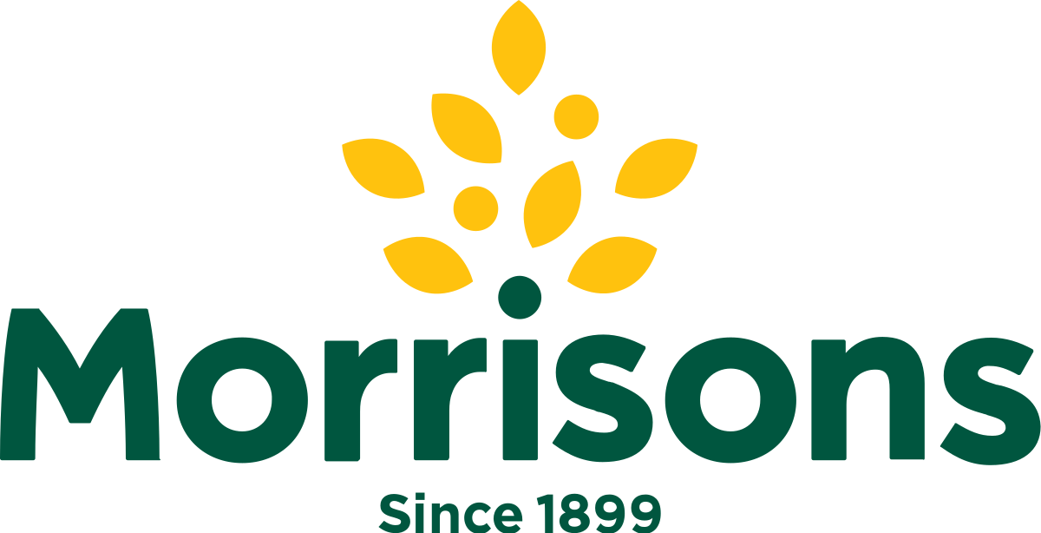

Table of content.

- Title page
- Morrisons
- Table of contents
- Evidence Matrix.
- Evidence Matrix
- Summary
- LO1 & LO2
- LO1 & LO2
- LO1 & LO2
- Conclusion
- LO3
- LO3
- LO3
- References
- to 42 Evidence

Evidence Matrix
Candidate name: Sarah Mason |  |  |  |  | CIPD Membership/registration No.:
Qualification title: Contributing to Resourcing and Talent Planning in the Organisation. |  |  |  |  | Unique Learner No. (ULN):2005783
Unit code | Unit title |  | Assessment criteria no. | Evidence description | Evidence reference number |  | Assessor  initials | I/V initials if sampled
5ARTP | Contributing to Resourcing and Talent Planning |  | 1.1 | Morrisons strategy | EV!
5ARTP | Contributing to Resourcing and Talent Planning |  | 1.1 | Morrisons Values | EV2
5ARTP | Contributing to Resourcing and Talent Planning |  | 1.1,1.2 | Payroll | EV3
5ARTP | Contributing to Resourcing and Talent Planning |  | 1.1,1.2 | RHRP | EV4
5ARTP | Contributing to Resourcing and Talent Planning |  | 1.2 | Performance review | EV5
5ARTP | Contributing to Resourcing and Talent Planning |  | 1.2 | Graduates and apprentices | EV6
5ARTP | Contributing to Resourcing and Talent Planning |  | 1.2 | Pathways | EV7
5ARTP | Contributing to Resourcing and Talent Planning |  | 3.1,3.2,3.3,3.4,3.5,3.6 | Restructure | EV8
5ARTP | Contributing to Resourcing and Talent Planning |  | 3.1,3.2,3.3,3.4,3.5,3.6 | Interview process | EV9
5ARTP | Contributing to Resourcing and Talent Planning |  | 2.1,3.1,3.2,3.3,3.4,3.5,3.6 | Home shopping | EV10
5ARTP | Contributing to Resourcing and Talent Planning |  | 1.1,1.2,1.3,2.2-1,3.1,3.2,3.3,3.4,3.5,3.6 | Testimonial Chloe Phillips | EV11
Candidate declaration:
- I confirm that the work/evidence presented for assessment is my own unaided work.
- I have read the assessment regulations and understand that if I am found to have ‘copied’ from published work without acknowledgement, or from other candidate’s work, this may be regarded as plagiarism which is an offence against the assessment regulations and leads to failure in the relevant unit and formal disciplinary action.
- I agree to this work being subjected to scrutiny by textual analysis software if required.
- I understand that my work may be used for future academic/quality assurance purposes in accordance with the provisions of the Data Protection Act 1998.
- I understand that the work/evidence submitted for assessment may not be returned to me and that I have retained a copy for my records.
- I understand that until such time as the assessment grade has been ratified through internal and external quality assurance processes it is not final.
Signature: |  | Sarah Mason |  |  |  | Date: | 13/06/2020

Summary

This report outlines my views on Morrisons resourcing and talent planning. I will be discussing my findings with Chloe Phillips, People Manager, Haverfordwest store.

I looked at different aspects of resourcing and talent planning and I also considered the impact that COVID-19 pandemic has changed the process.

My evidence gained was based on a literature review sourced online, from my own experience as a previous People Manager at Haverfordwest and Carmarthen stores and from meetings with Chloe Phillips.

LO 1&2 – Evaluate Morrisons approach to talent planning and recommended ways to improve.

Morrisons PLC is a Yorkshire based food retailer. It has grown from a market stall in Bradford to one of the UK’s leading supermarket with now having over 110,000 colleagues in over 500 stores, serving over 11 million customers every week.

Part of the Morrisons corporate responsibilities 2019/2020 is looking after our colleagues and the success of our colleagues is dependent on recruiting, developing and retaining the right people.

Morrisons approach to talent planning is predominantly set around the companies six priorities.

Six Priorities

- Be more competitive
- Serve our customers better
- Find local solutions
- Develop popular and useful services
- Simplify and speed up
- Make the core supermarket strong again

(EV1+2)

Morrisons approach to talent planning sways more to promoting talent from within the Morrisons business and then a smaller amount of externally recruiting. By following this strategy Morrisons are reducing the time hiring and the potential colleagues track record is at hand and they can source a cultural fit easily. It costs less and strengthens employee’s engagement and retention (Bika 2020).

When recruiting for Morrisons it is clearly determined from the payroll budget. The budget is not set at store level, it is set at head office; they calculate the store sales history, size and layout of the store, where the store is geographically and regionally and any seasonal factors. Seasonal factors can be as with all stores Christmas time, some stores depending on Geographic’s will require extra payroll due to an increase in customer footfall, therefore seasonal staff would be required to ensure the business runs correctly and to give the customers the best experience.

Morrisons work on what they call a contract base, this is shown in a weekly finance report. This report can indicate when the business requires recruitment. The contract base is set to allow flexibility to increase colleagues’ hours when the business requires it or to stay inline with the payroll budget and run the business with no extra hours. However, for this to work correctly you need to have the right hours in the right place. This will need to be monitored by the store manager and the people manager and they need to move staff depending on the hours they work and their skills across the business, this could be within the same store or another store within traveling distance.(EV3+4)

Workforce management (right hours right place) is placing the right people in the right place at the right time. This can separate the excellent companies from the competition, it is about teamwork for it to work efficiently (Burley 2020).

CIPD – States that ‘workforce planning describes the continued alignment of needs and priorities of the organisation to ensure it can meet legislation, regulatory, service and production requirements as well as organizational objectives (CIPD 2020).
Succession planning is essential within Morrisons so that skilled areas are fully covered. A talent pipeline supports this, a colleague can show an interest, or a manager can identify a potential talent. Every colleague has an annual career discussion and a performance review, from these discussions a clear development plan can be created for the colleague. This can also give the manager developing the colleague an outlook into what areas the colleague needs to work on and it can also determine if the colleague is capable or actually wants to achieve the progression (will or skill).(EV4+5).

78.9% of males and 73.5% of females are in employment of which 16,3% are in wholesale and retail trade. 16.3% are in accommodation and food services and 18.6% are in the human, heath and social work activities (nomis).

The employment rate in Pembrokeshire is very much on par with Wales as a whole. More people in Pembrokeshire are self employed compared to employed. There is a higher amount of retired people in Pembrokeshire in comparison to across Wales. Pembrokeshire has a lower rate of people with no qualifications, and a higher rate of people with degree equivalent qualifications in comparison with the Welsh average. Even with these statistics Pembrokeshire has a skill shortage, this suggests that it is the quantity and access to labour rather than the quality of labour (Pembrokeshire Economic Profile).

Haverfordwest is renowned for being a retirement destination. Younger generations leave Pembrokeshire to pursue their education and career prospects leaving a shortfall of potential graduates joining the Morrisons graduate scheme.

The Open University states that the majority of organisations in surveys across Wales, 92% struggled to find workers with the right skill set. This means that Welsh employers are having to pay a higher financial price to ensure the business have the right skill set to remain productive. The shortfalls in skills is costing companies recruitment costs, extra salaries, temporary staffing, and the cost of the staff hired with less skills than are required for the positions. This led to Welsh employers having to leave roles vacant due to lack of skills. It is crucial that Welsh companies have a more sustainable approach. Investing in work-based training will allow better training and development and will result in a more motivational loyal and productive workforce (Thomas 2020).

Morrisons Talent Pipeline

Pathways

Morrisons pathway programme is designed to help people move through the business. It is structured to provide development and experience to progress to the next level. A colleague would develop to a team manager and a team manger would develop to a deputy manager and a deputy manger to a store manager. All candidates must display the correct behavioral qualities and have gained endorsements from the store manager and the people manager to go on to pathways. When the business feels that the candidate has successfully completed the programme they will attend an assessment Centre, where they will complete various assessments of their learnings and demonstrate this by presenting and answering key questions. A successful candidate would be placed in a role for a 12-week period, this is called ‘safe hands’ this allows the candidate to gain experience and demonstrate the skills they have learnt. The ‘safe hands’ is monitored with reviews and feedback, once successfully completed they would attend a ‘sign off’ assessment. The successful candidate is placed in stores with available positions this could be within a 25-mile radius (EV7).

Graduate Scheme.

Morrisons graduate scheme is available to 25-year-old and under, who have gained a 2.1 or above degree. The scheme is available to internal or external candidates yearly. Morrisons runs 10 graduate schemes these are in manufacturing, logistics, supply chain, technology and digital, finance, buying, engineering, corporate, people and retail. The graduate scheme is managed via head office and the application process is based on interviews, tests and assessment centers. The graduate will be part of the leadership team with the potential to be a store manager within 2 years (EV6).

Apprenticeships

Morrisons offers apprentice schemes this is an opportunity to work in a retail environment, whilst earning cash and gaining a qualification. The scheme develops skills both behavioral and operationally, it can be the starting block to building a future career within the business.

Morrisons also offers skilled apprenticeship schemes for existing colleagues in Butchery, bakery and for fish mongers. The scheme is for 2 years, the colleague is mentored by existing experienced skilled colleagues and are reviewed monthly by a training officer. On successful completion they will receive a certificate from Cambrian training, and they will also receive a pay increase (EV6).

Conclusion.

My conclusion when reviewing Morrisons current talent planning in Haverfordwest store is that being in a labour market of fewer jobs, managers decide to stay in positions until retirement which can have a negative impact on progression within the store. The nearest store geographically is 30 miles away, this impacts the opportunity for development in Haverfordwest and can lead colleagues with great experience and potential to leave to progress their careers elsewhere. It would benefit the succession of candidates if they had a relocation package or have travel costs provided, as they can not be out of pocket. This would benefit the business but could be very costly to the company.

The graduate scheme is restricting as it is only open to 25-year-old and under. This stops mature graduates applying, mature graduates tend to have more experience. Younger graduates are hungry and are already in a learning mindset. However, it can be overwhelming being placed in a management position with little or no experience, in a busy day to day environment. This could have a negative impact on them, and they could be unable to continue with the scheme. I feel that by opening this to mature graduates also could support the business.

Morrisons pathway scheme has been adapted to become an excellent tool for the business it means that every candidate has the same opportunity and it is consistent with its outcome. Speaking to Chloe Phillips and from my own previous experience I believe it becomes hard for the individual stores as there is no training and development plan factored into the payroll budget. This can impact the store and requires careful planning, as areas will maybe have to run on fewer hours to accommodate costs. The training could be funded centrally by head office to support this or a training budget could be part of the payroll budget.

LO3 – Contributing to people resourcing.

On 23rd January 2020 Morrisons announced a re-structure for all management positions this could potentially affect 3000 jobs. When I was people manager for Morrisons I was involved in a previous management restructure and I ensured that the whole process ran smoothy and professionally.

The restructure was a 45-day consultation period for all senior and team managers. Brexit was viewed as the main reason that for the change, as sales were down 1.7% like for like. Morrisons structure was very top heavy in comparison to their competitors.

The new structure was due to commence on 30th March 2020(EV8). The new structure meant that the new manager roles had a large departments to manage, therefore recruitment of general assistants was necessary to fill any shortfalls in areas that were understaffed and for the manager to be able to fulfill their role fully. COVID-19 pandemic effected this process and the restructure was postponed until 1st June 2020.

The COVID-19 pandemic had a huge effect on the business and the decision to postpone the restructure, resulted in further consultation meetings with all that were affected. The delay protected the business during the difficult time and kept experienced managers in the business.

When ‘lockdown’ was announced on 23rd March 2020, this enforced the temporary closure of the Bakery, Deli, Oven fresh, Fish counter, Butchery counter, and the Customer Café as these were fresh food prep areas. This resulted in an immediate plan to deploy the colleagues to other departments according to the need of the business.

The business looked at the need of the customer by introducing a home shopping department to a large number if its stores, head office decided that Haverfordwest store would be one of these. The information was received by the store on 26th March 2020 and it was expected that the live date for opening would be 6th April 2020, just ten days later (EV10)

The store received a recruitment guide which outlined a clear guidance on the recruitment required (EV9). The guide stated that the process would take 14 weeks, however due to the demand for home delivery for the business and the customer the onboard process was drastically changed (EV9). Morrisons head office created blanket vacancies, this was a ten-minute conversation instead of the normal process of a 45 minutes procedure consisting of a shop floor activity, situational role plays and an interview (EV9). Communication was key between the store and head office to ensure that the correct procedures were adhered to and the deadlines were met.

The required roles were advertised through Morrisons official careers site for external candidates and through social media and word of mouth for internal candidates, this generated the interest from friends and family. The process allowed for interview slots of 10 minutes intervals. The interviews were held by the people team and the home shopping manager. The interviews were held over 2 days, once complete decisions were made of who to recruit (EV10).

All successful candidates were informed with an offer of employment. Right to work in the UK checks were required (Morrisons.jobs). Right to works are to prevent illegal working in the UK (Gov.uk). Morrisons protects itself by ensuring all stages comply with legislative procedure. All procedures comply with the equality act and ACAS. The home shopping drivers also required DVLA license checks and DBS checks to show if there are any unspent convictions.

All the new colleagues required an induction to cover health and safety, fire safety and food safety, along side general information about Morisons. Due to my previous people manager experience, I supported with the induction process. The COVID-19 pandemic meant we had to consider social distancing when planning. The job induction was planned over 3 days and due to the small size of the training room we decided to use the staff canteen, where we could space the chairs out. We required everyone to complete a track and trace form and hand sanitizer was provided. (EV10).

I supported the onboarding and the home shopping team and on reflection I feel that although it was vastly different to the normal procedures, it was completed fully and within the guidelines and timescale. All policies and legal requirements were in place to protect the business as well as the employee. In my opinion from my previous experience as a people manager at Morisons the 10-minute interview process would not be suitable to use long term. The short interview process does not allow you to gain enough information to be able to make informed decisions, although it did allow for more interviews to happen in just a few days. The Morrisons interview process allows to focus on behaviors and excellent customer service skills within the Morrisons values (EV9) this allows you to gain knowledge about the candidate as you have more time to assess the caliber of the interviewee (EV9).

Morrisons changed its core purpose in response to COVID-19. This was to provide reassurance to the customer and reflect the extent of the role it sees itself playing in ‘feeding the nation’ (Hammett).

“The company has paid a lot of attention to its core purpose. It isn’t what they do or how they do it, it’s why a company exists and we are currently believe the biggest contribution we can make in the country is playing our full part in ‘feeding the nation” (Potts)

Morrisons immediately made payments to its smaller suppliers to help with the cashflow. They also launched a new range of simple to order food parcels and set up dedicated call customer call center’s for orders from customers who do not online shop (Hammett).

Morrisons also looked after their people by setting up a colleague hardship fund to support colleagues who are in financial difficulty and also paid any colleagues full sick pay if they were off with the virus or shielding, even if they were not normally eligible.

Morrisons amid COVID-19 were reporting a 3% increase in profit for the year, and for a six-week period during COVID-19 like for like sales increased by 5%. Morrisons put itself in a better place to with stand COVID-19, this predominantly due to it being more of cash-generated business. This allowed it to compassionate in its response to the pandemic (Breteton).

References

Chloe Phillips Morrisons Haverfordwest store 2020, 8th August 2020.

CIPD 2020. https://www.cipd.co.uk/. 10th September 2020

David Potts 2020
https://www.marketingweek.com/morrisons-changes-core-purposnse-to-coronavirus/ 11th September 2020.

Ellen Hammett 2020
https://www.marketingweek.com/morrisons-changes-core-purposnse-to-coronavirus/ 12 September 2020.

Lynne Thomas 2020
http://www.open.ac.uk/wales/en/news/skills-shortage-costing-welsh-organisations-over-%C2%A3350-million 11th September 2020.

Morrisons PLC 2020
https://www.morrisons.jobs/life-at-morrisons 8th August 2020,

Morrisons PLC 2020
https://www.morrisons-corporate.com/cr/policy/ 10th September 2020.

Nikoletta Bika 2020
https://resources.workable.com/stories-and-insights/advantages-disadvantages-of-internal-recruitment 10th September 2020.

Nomis 2020
https://www.nomisweb.co.uk/reports/lmp/la/1946157391/report.aspx#tabempunemp 10th September 2020.

Open University 2020
http://www.open.ac.uk/wales/en/news/skills-shortage-costing-welsh-organisations-over-%C2%A3350-million 11th September 2020.

Pembrokeshire Economic profile 2020
file:///C:/Users/Sarah/Downloads/Pembrokeshire%20Economic%20Profile%20(FINAL)%20(002)%20(1).pdf 10th September 2020.

EV1
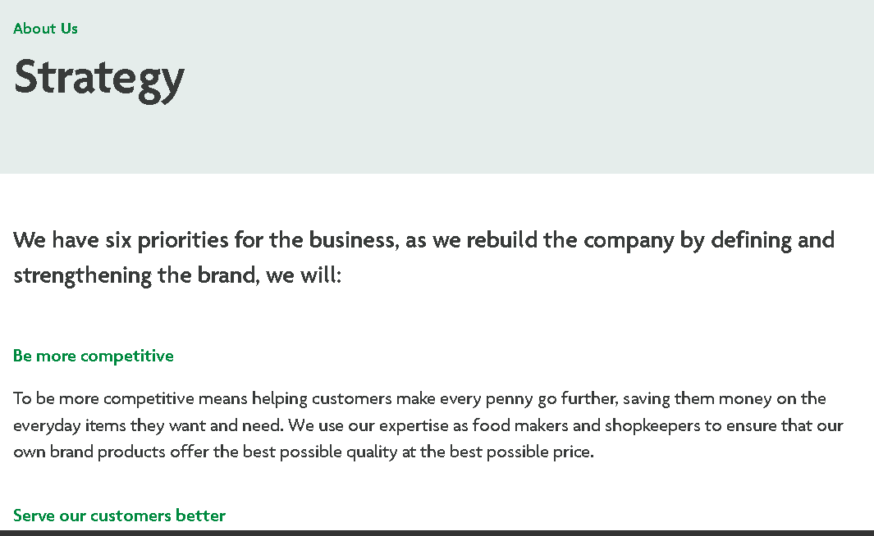
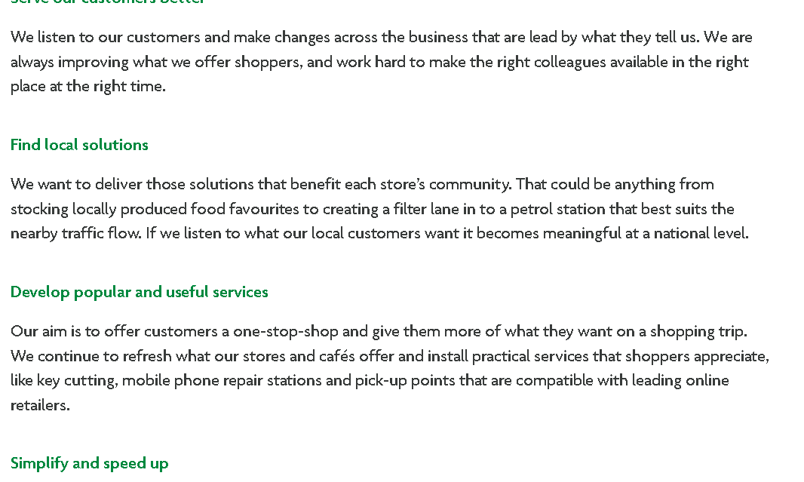
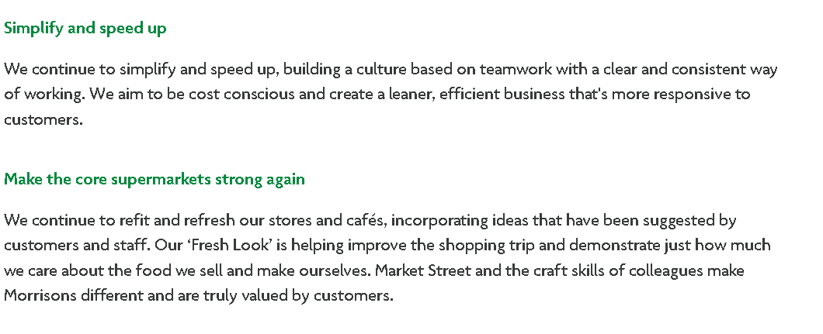
EV2
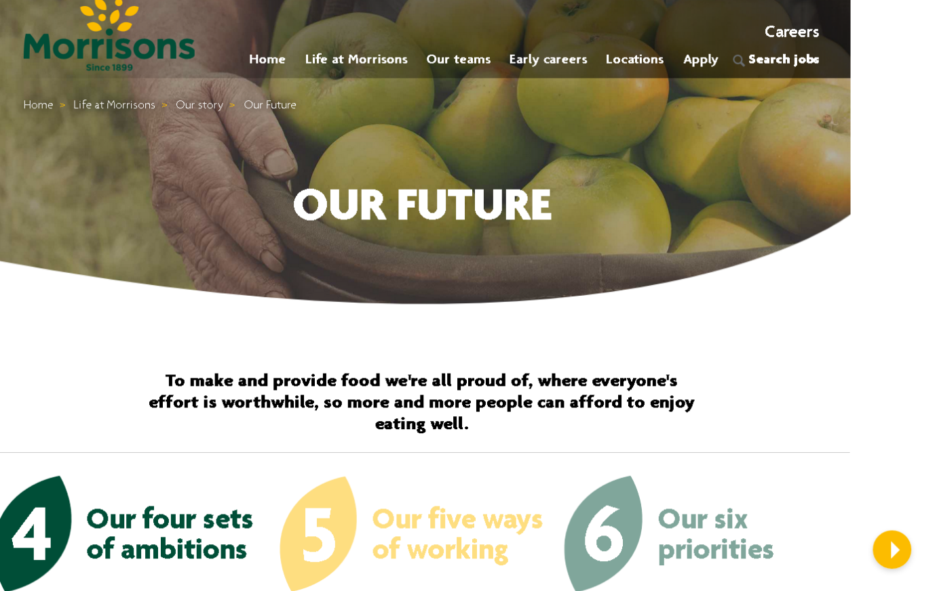
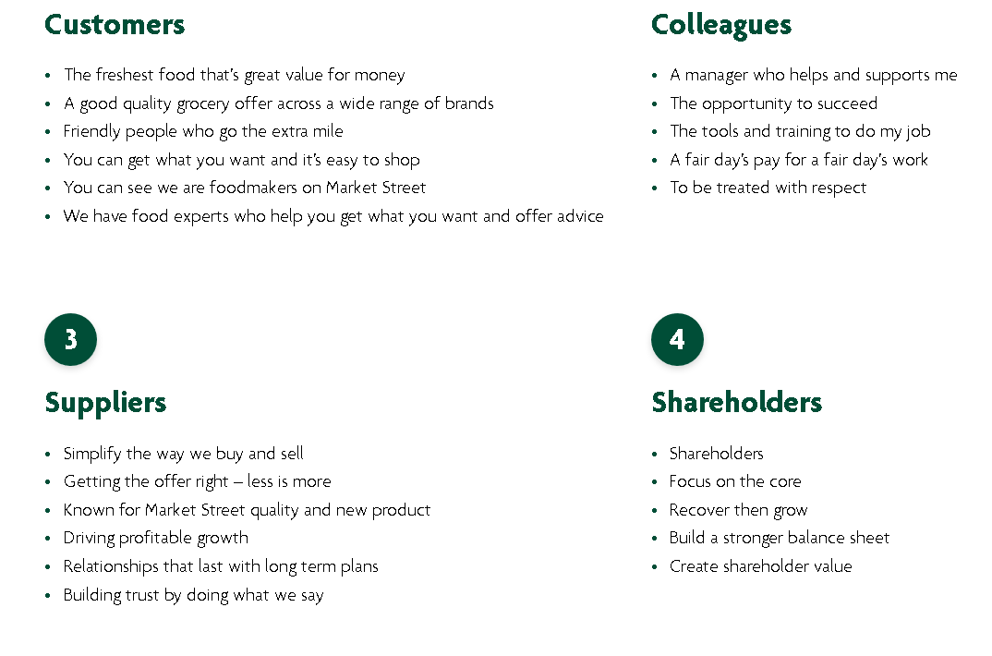
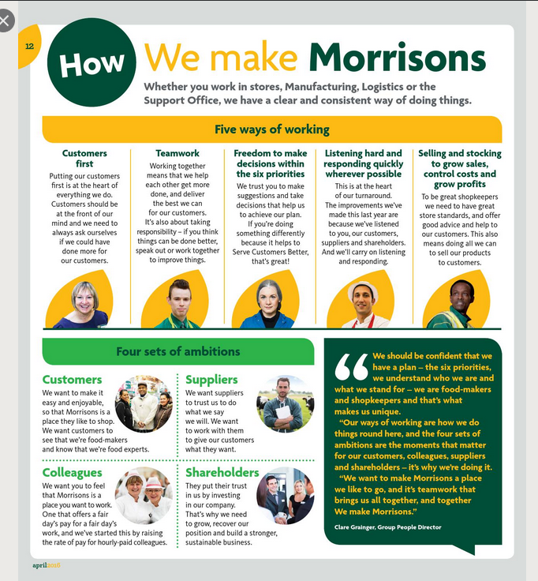

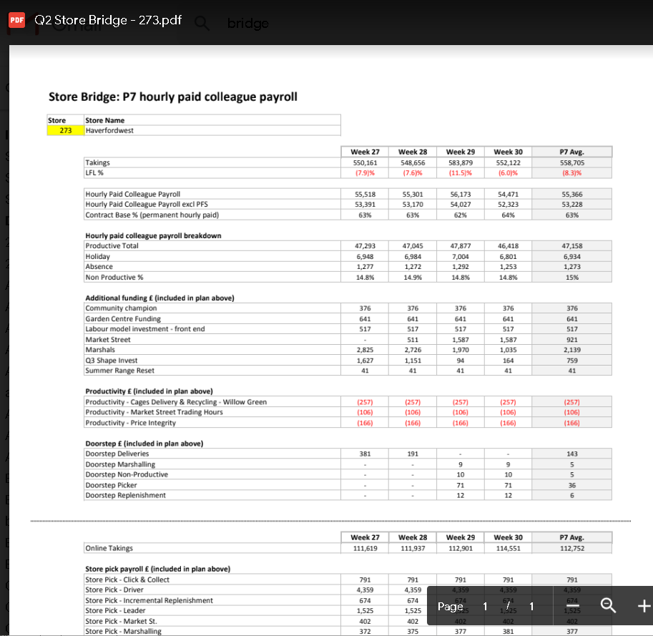

EV3
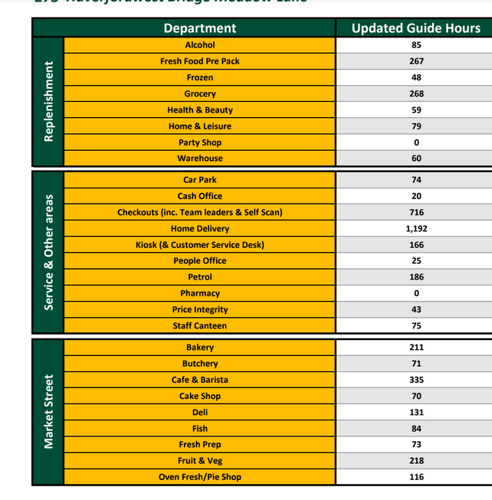

EV4

EV5

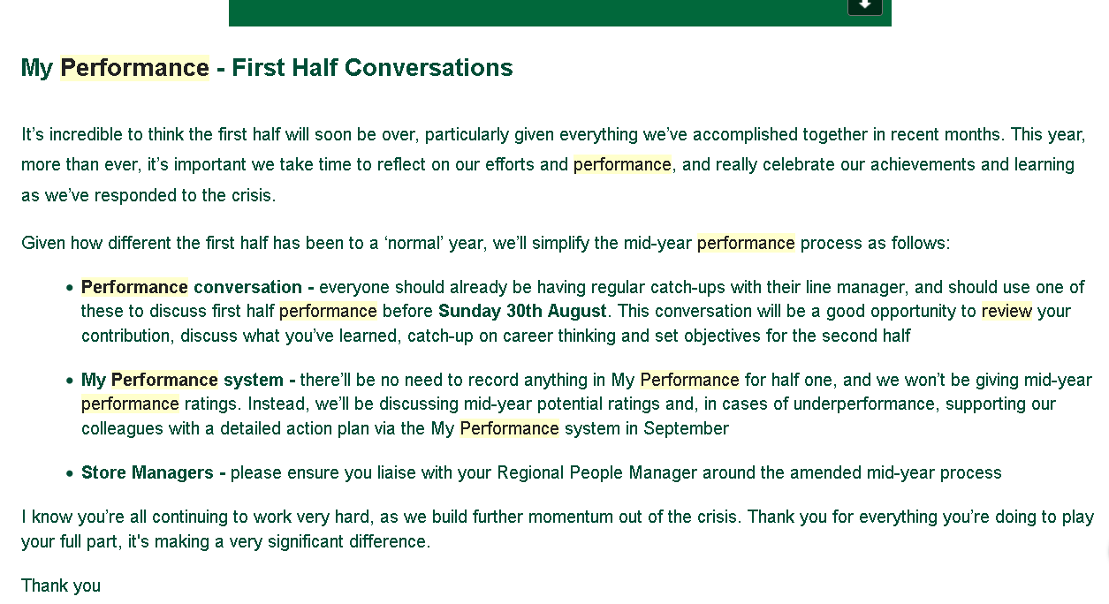
EV6
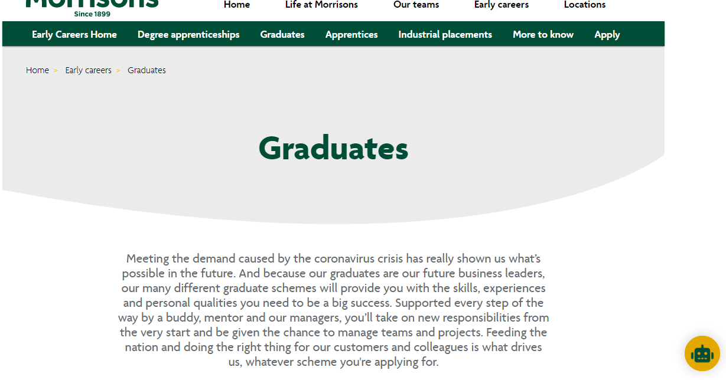



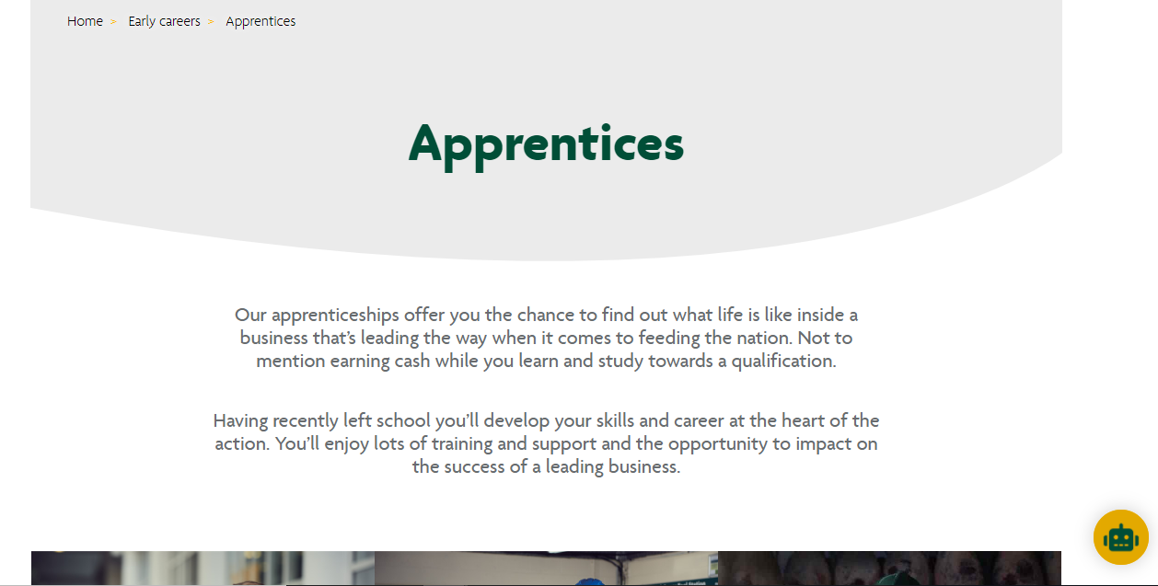

EV7
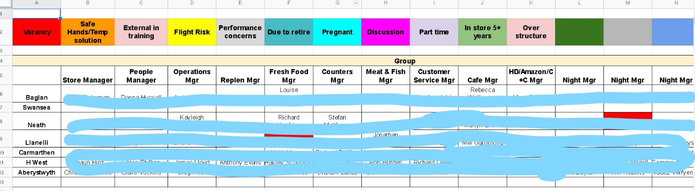

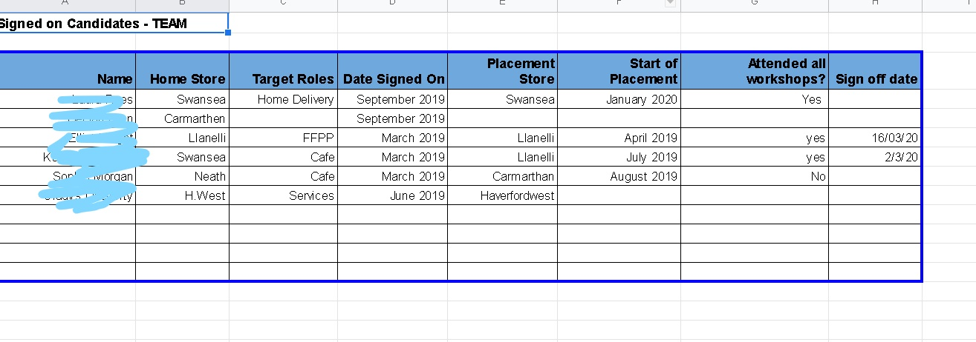

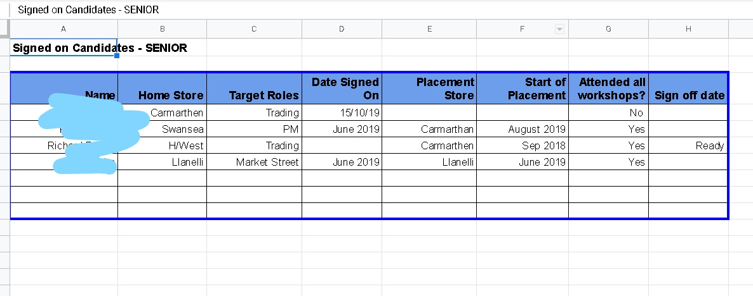

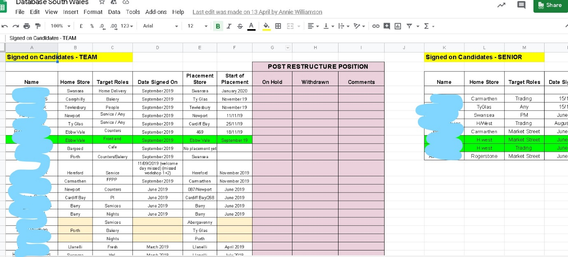

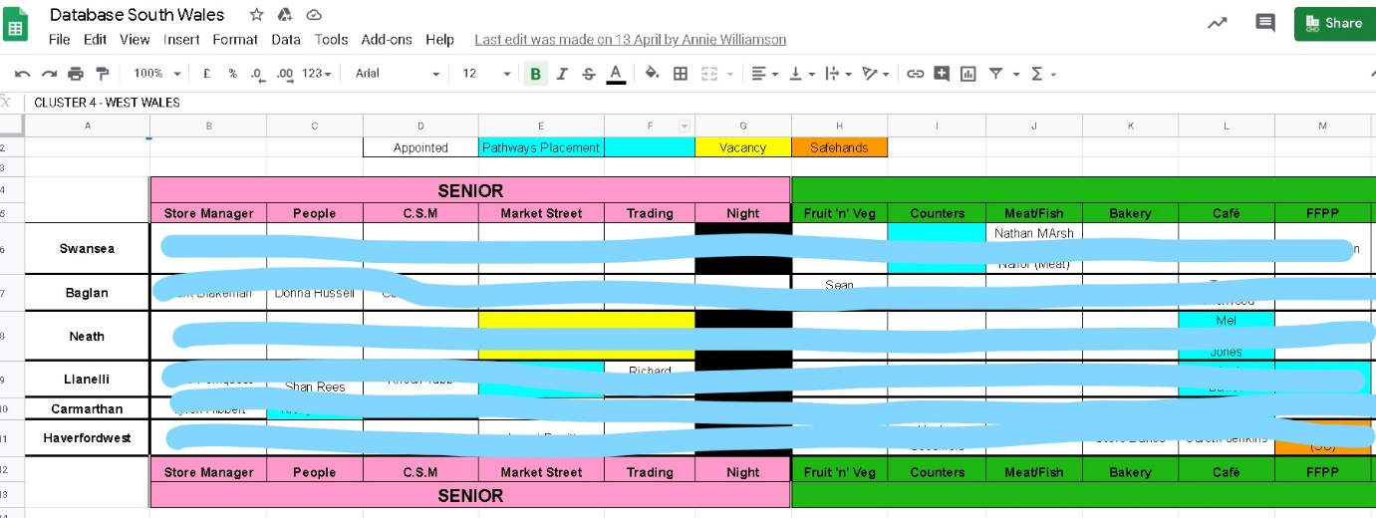

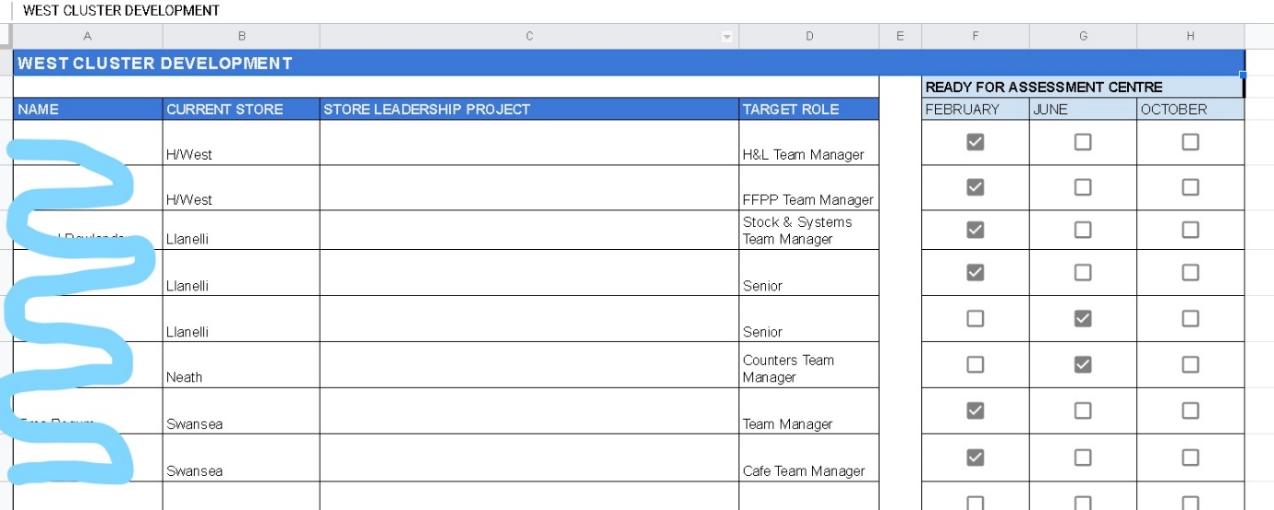

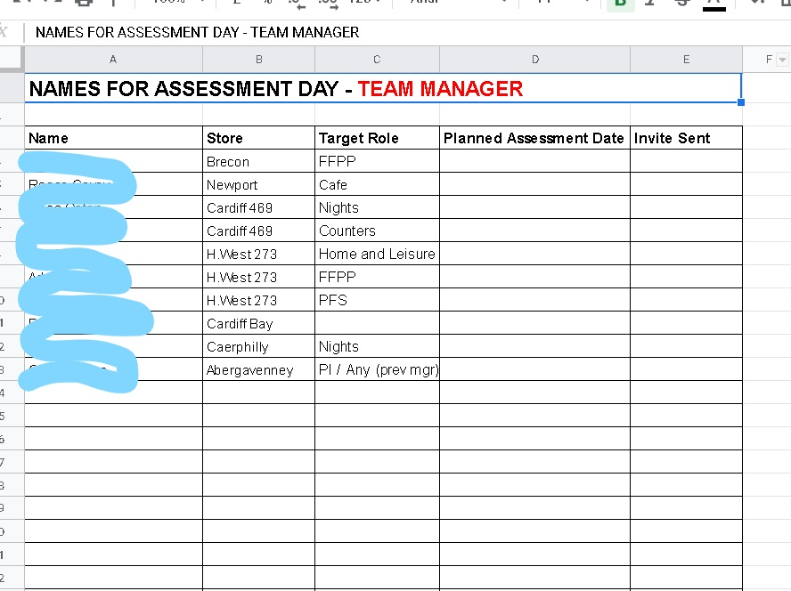

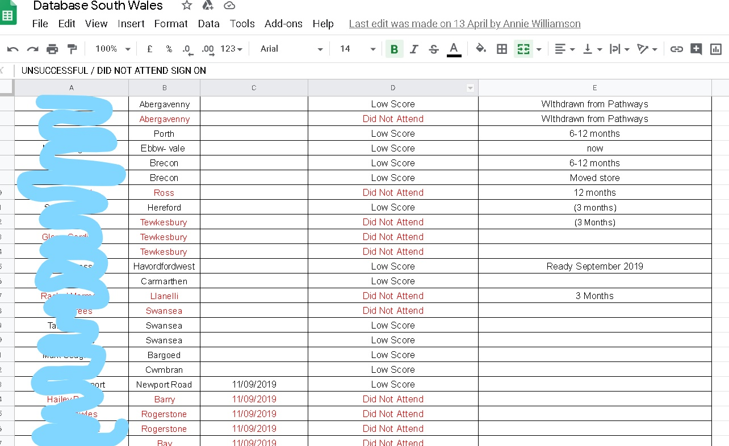

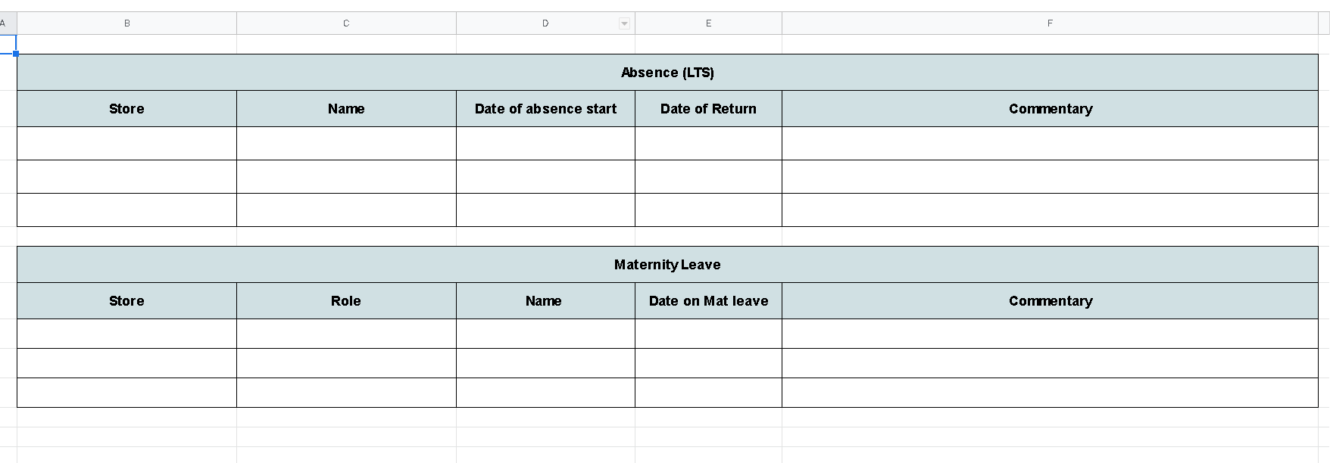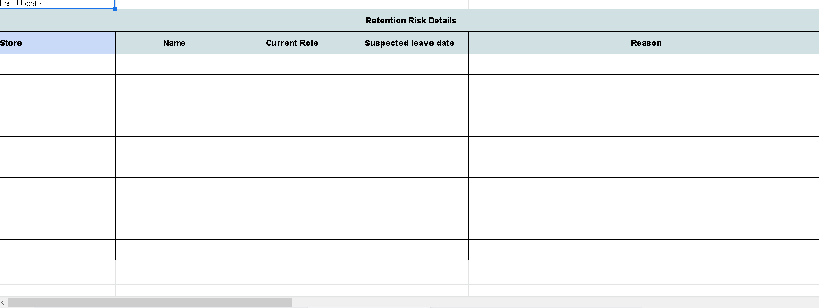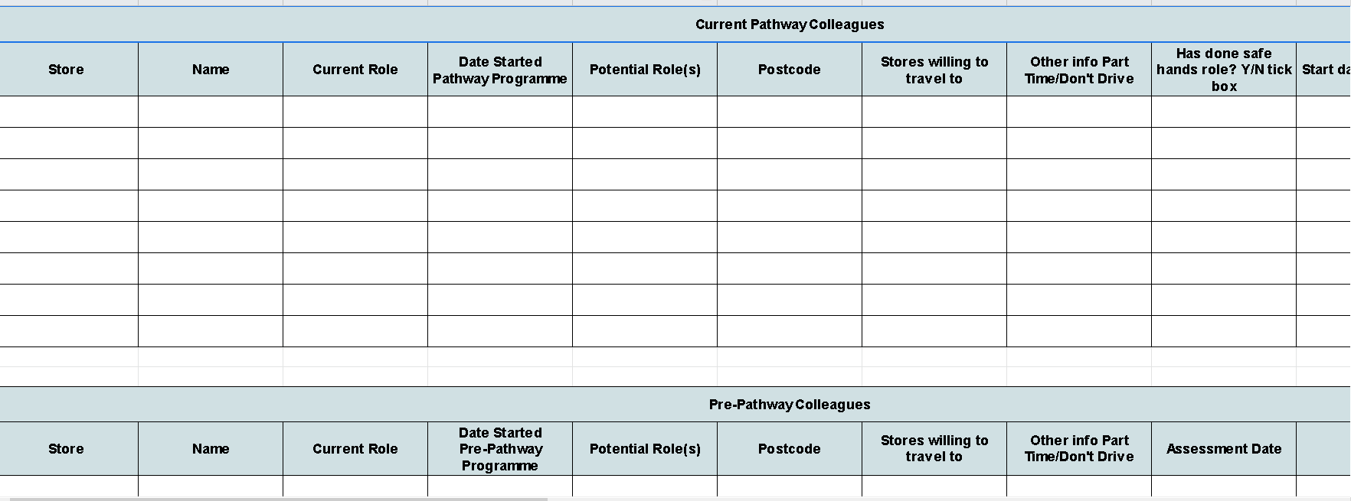
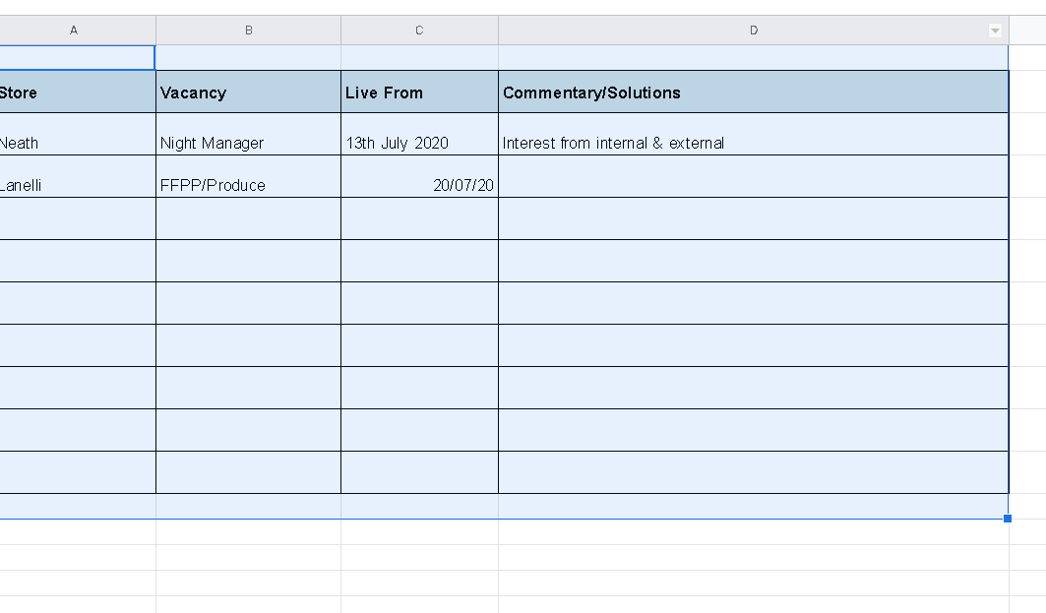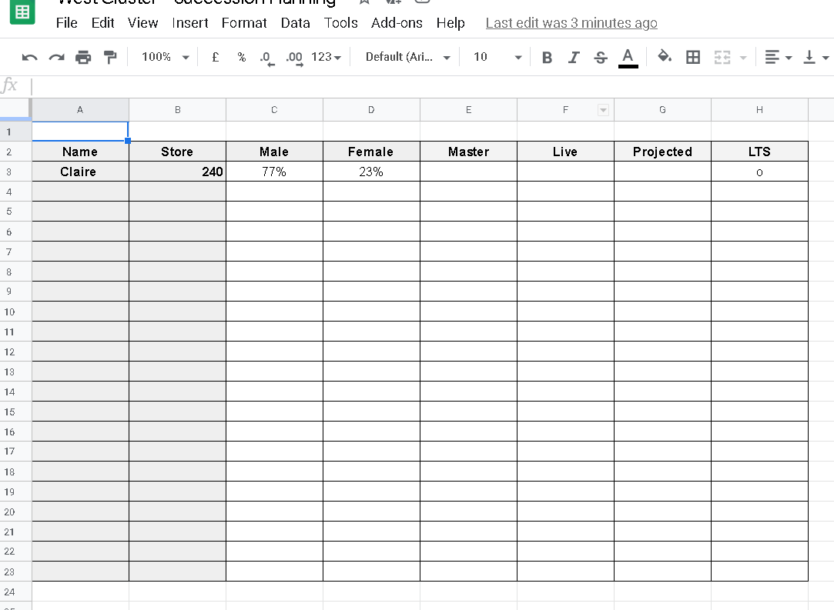
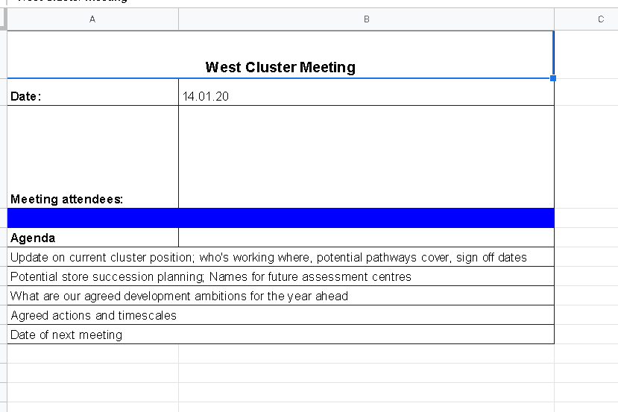

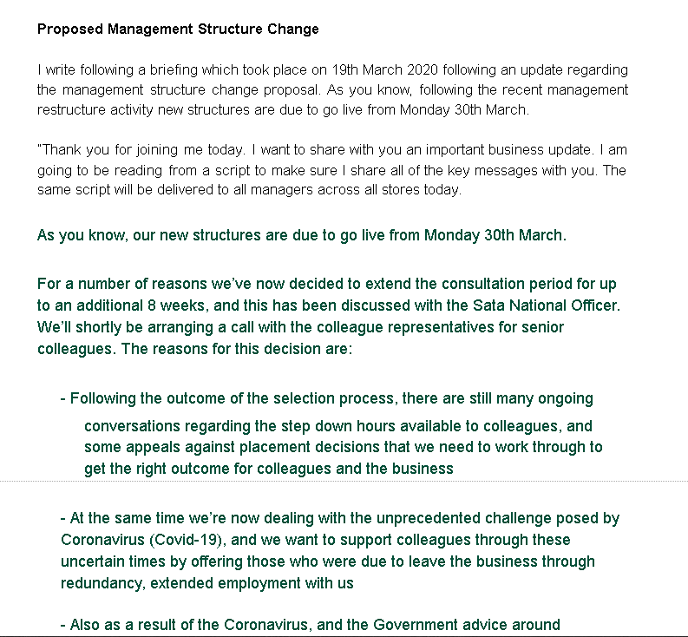

EV8
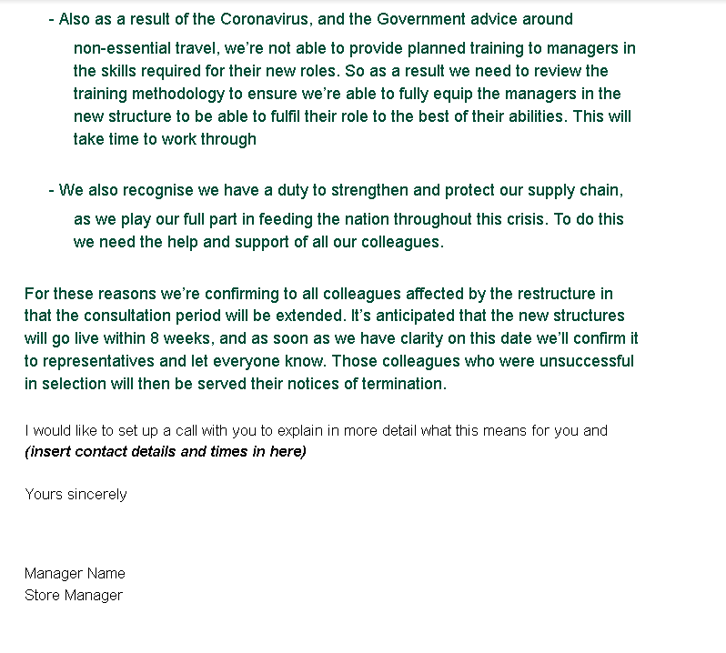

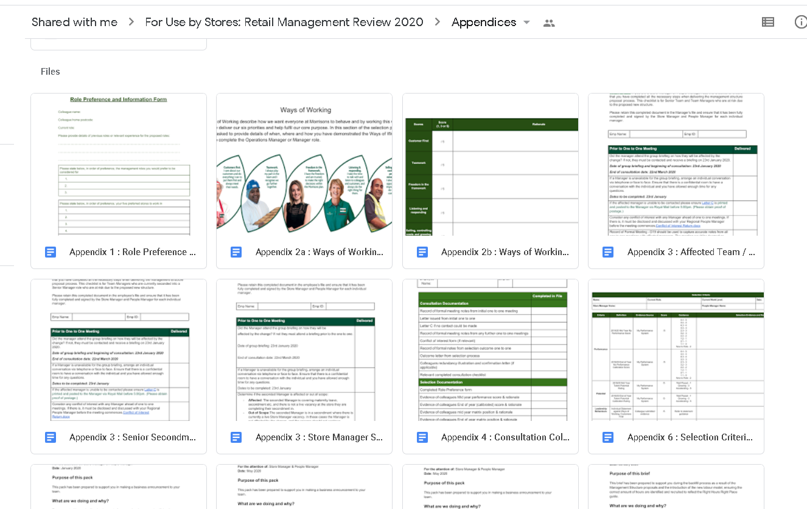

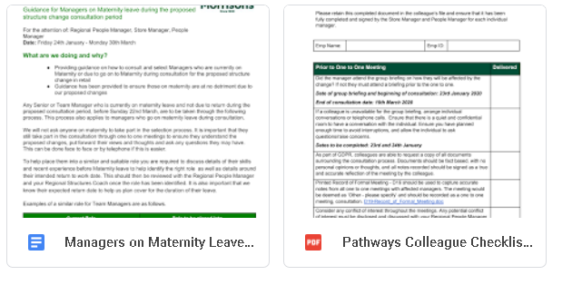

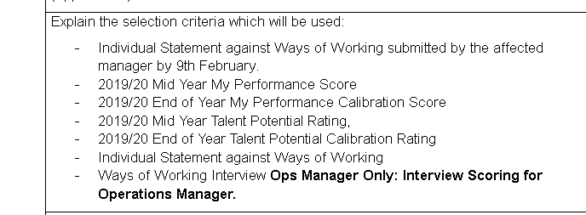
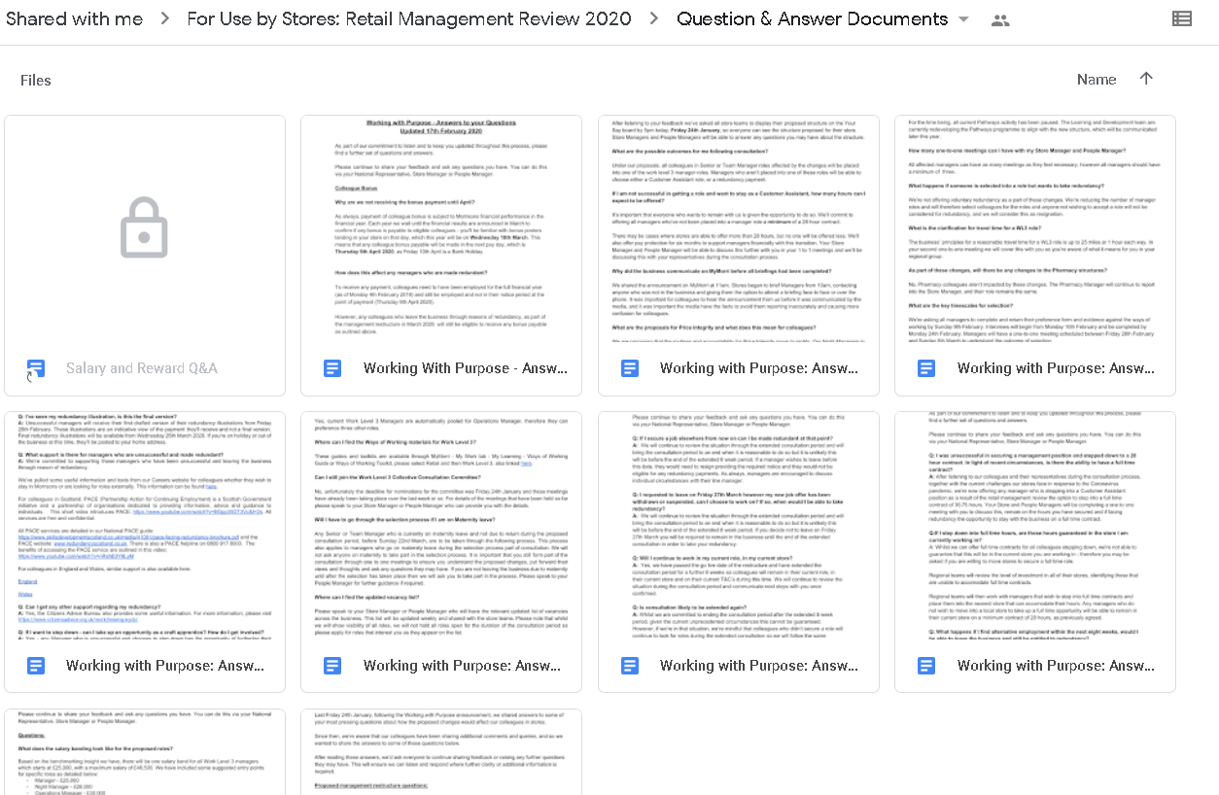

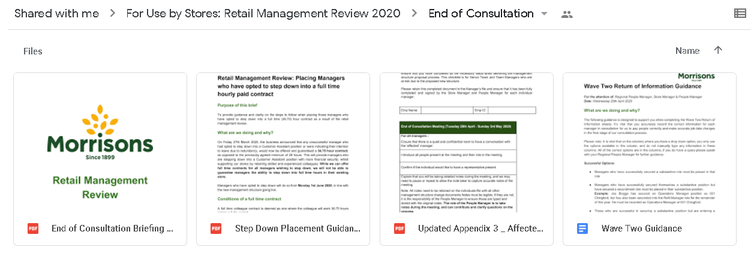

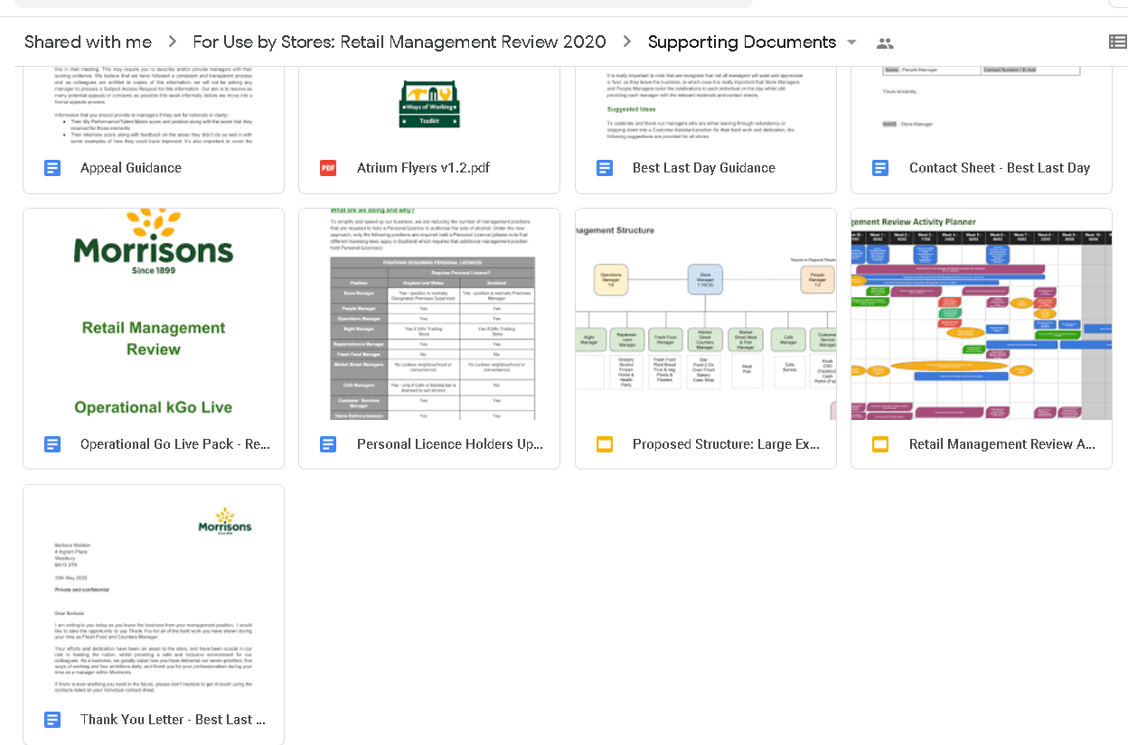
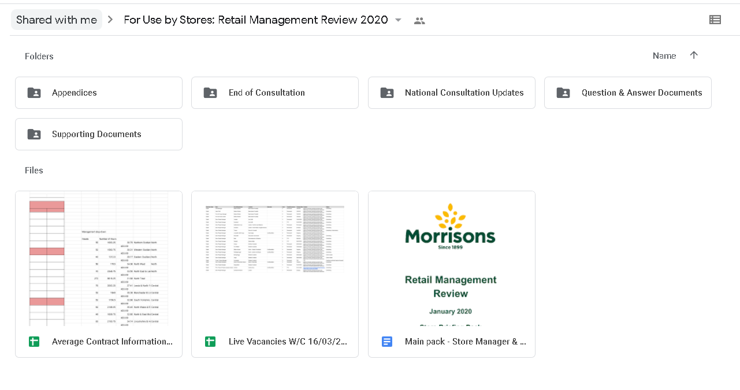
EV9
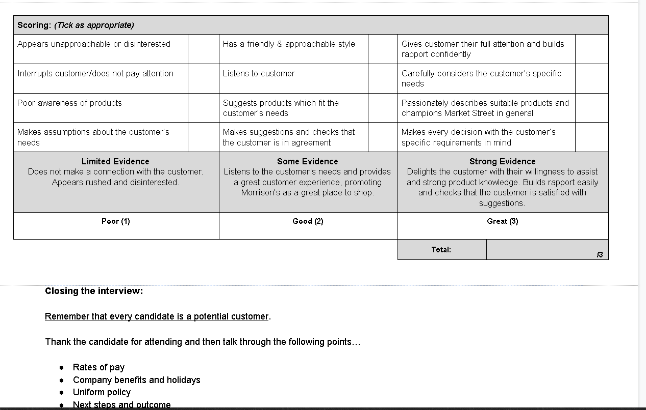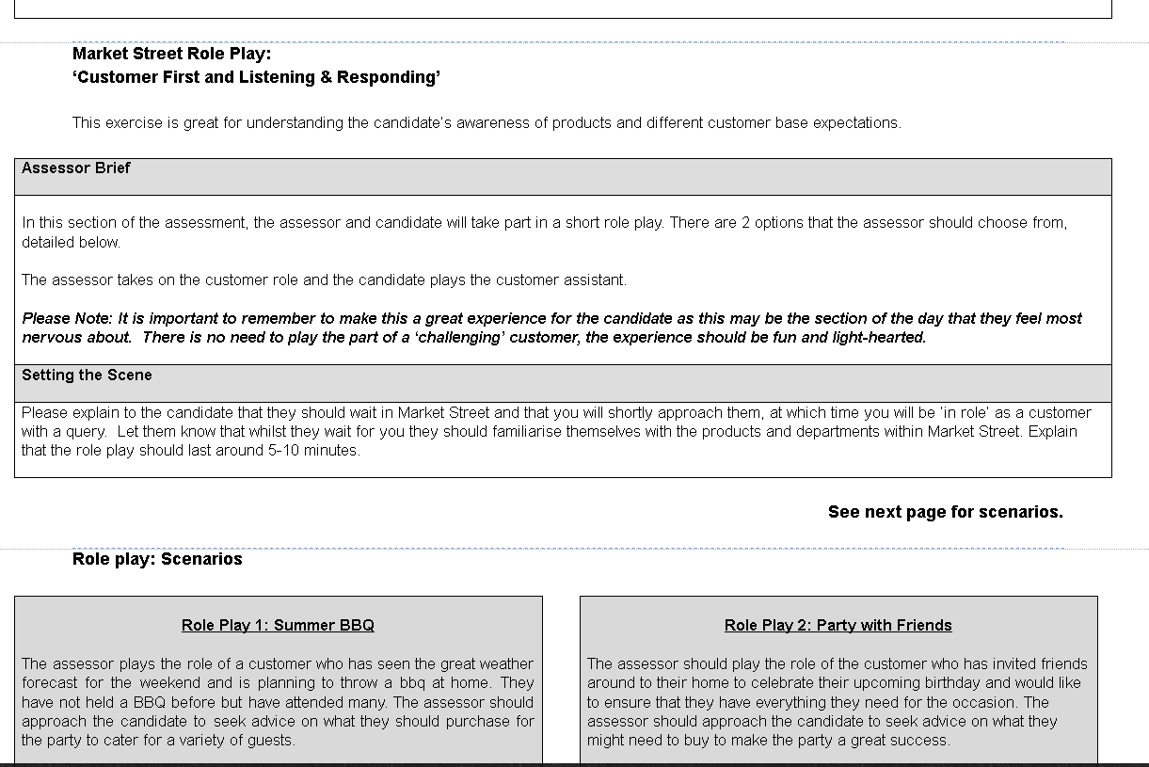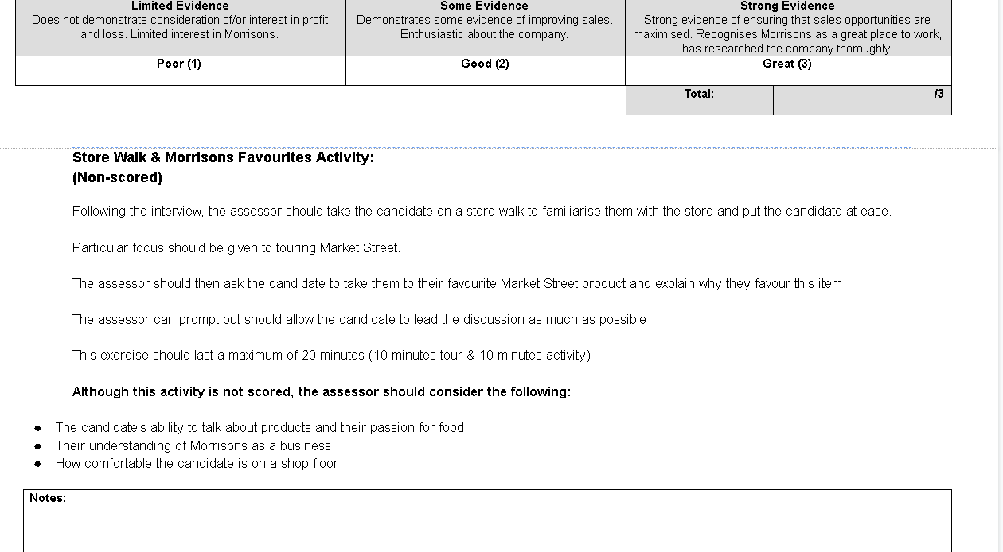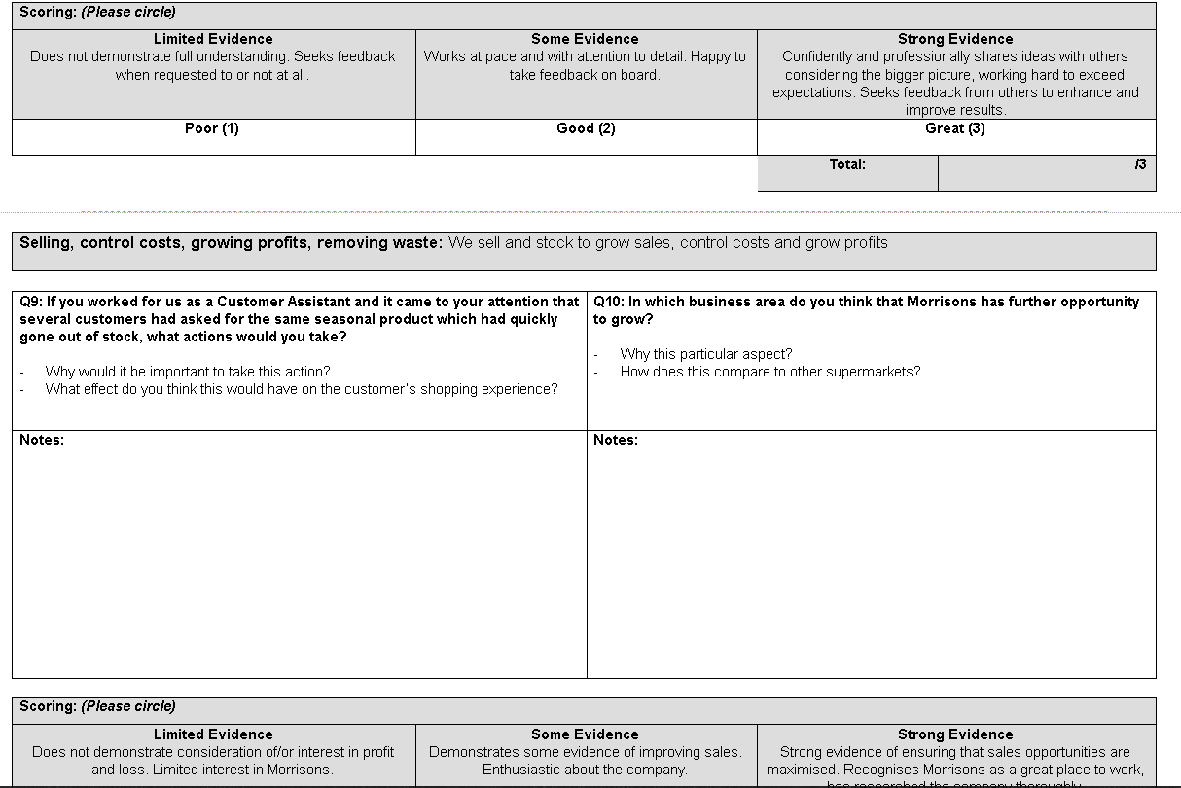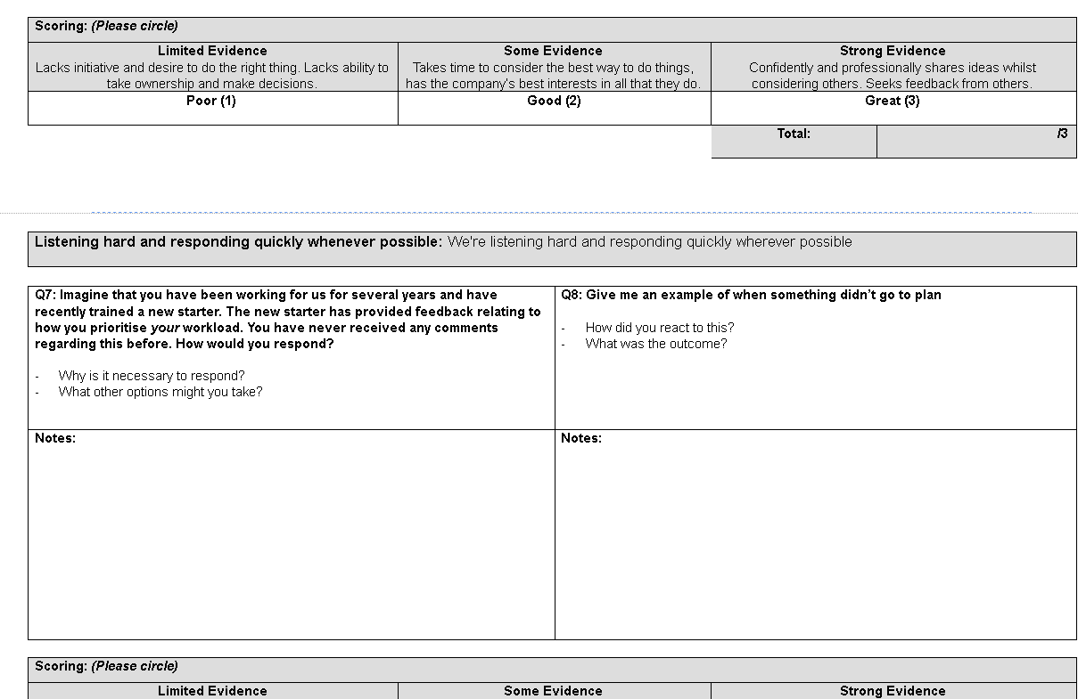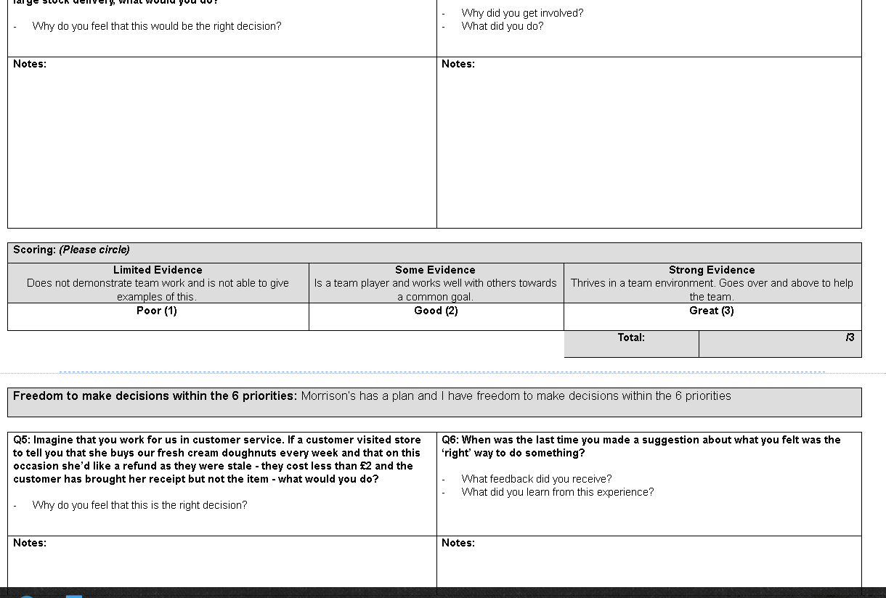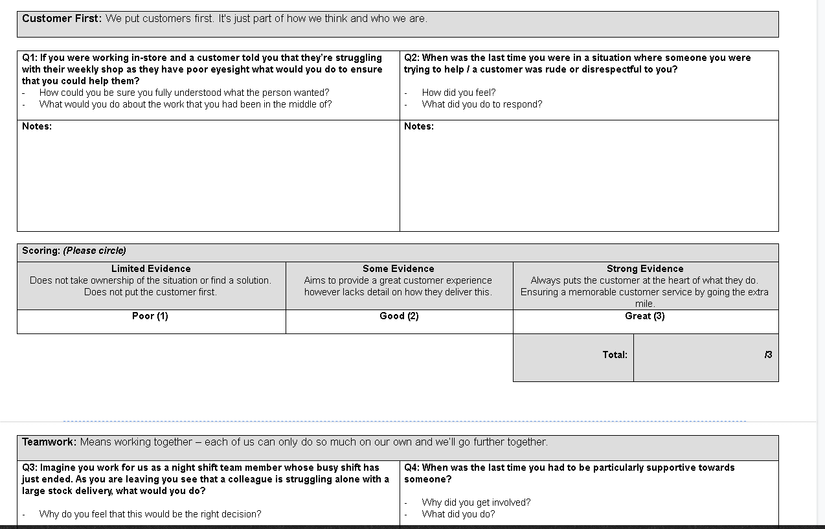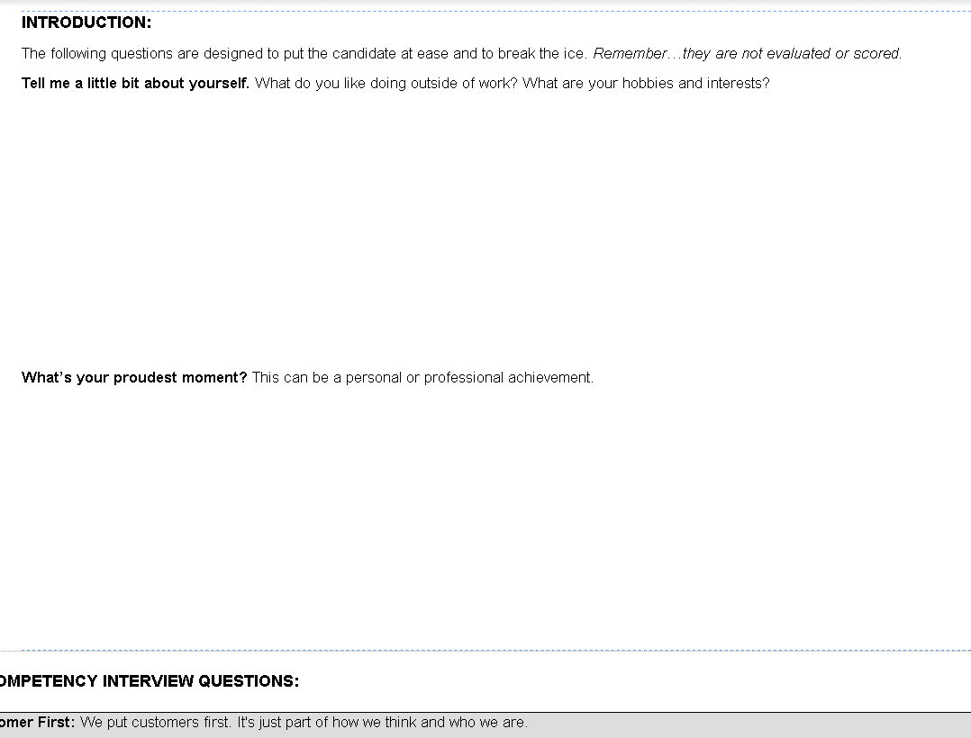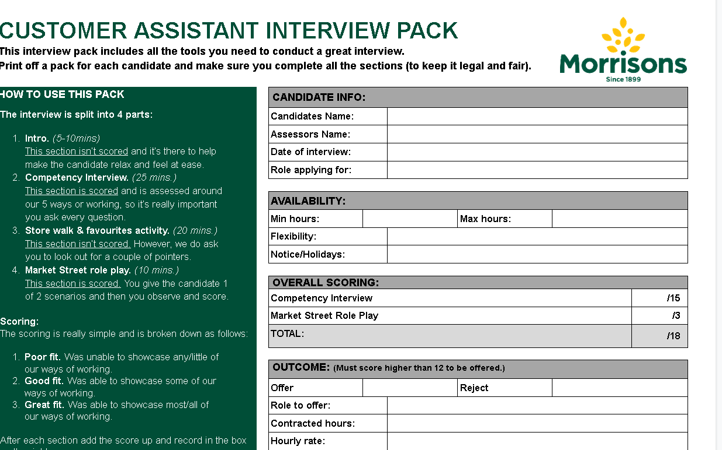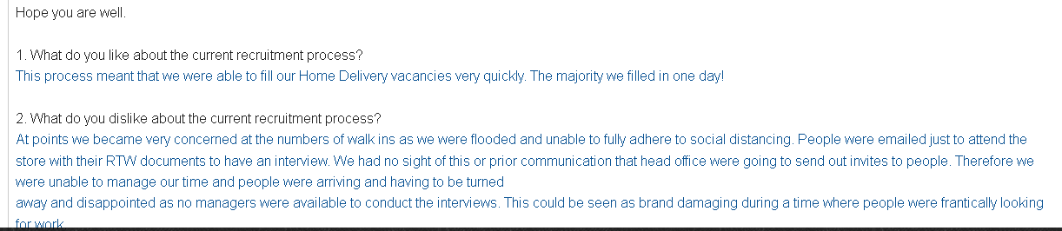
EV9

EV9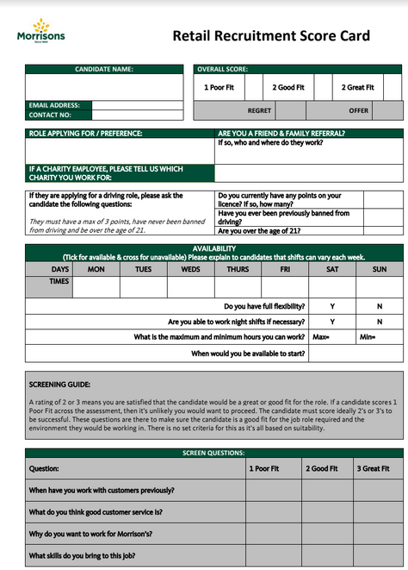

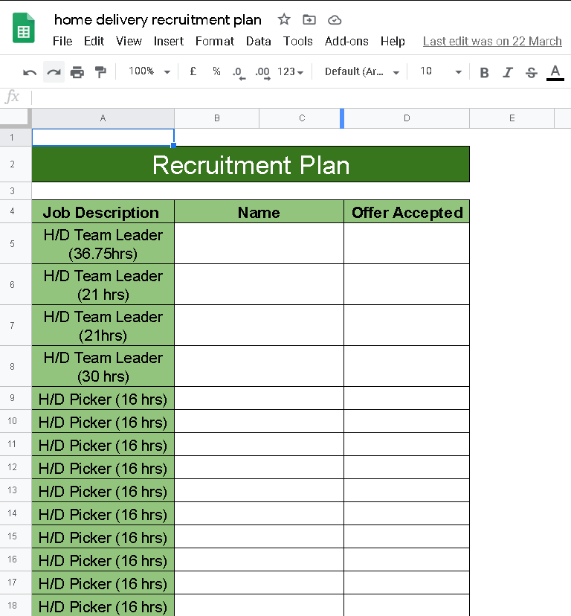

EV10
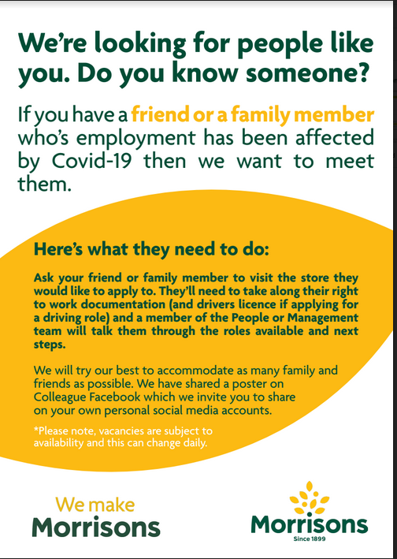

EV10
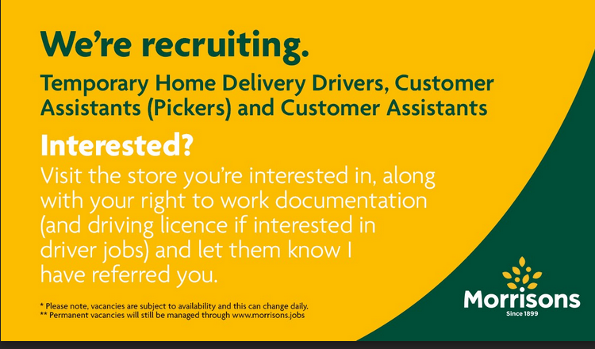
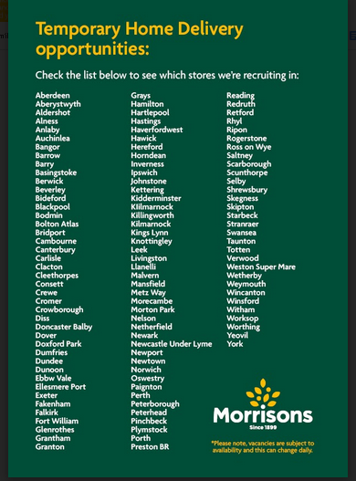

EV10
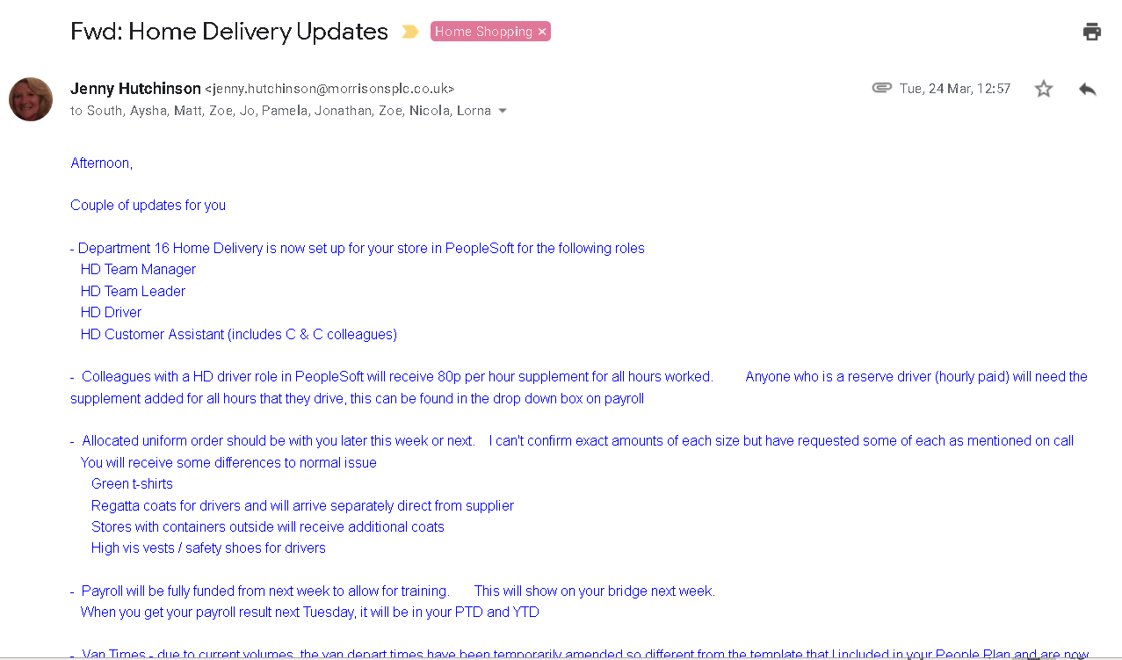

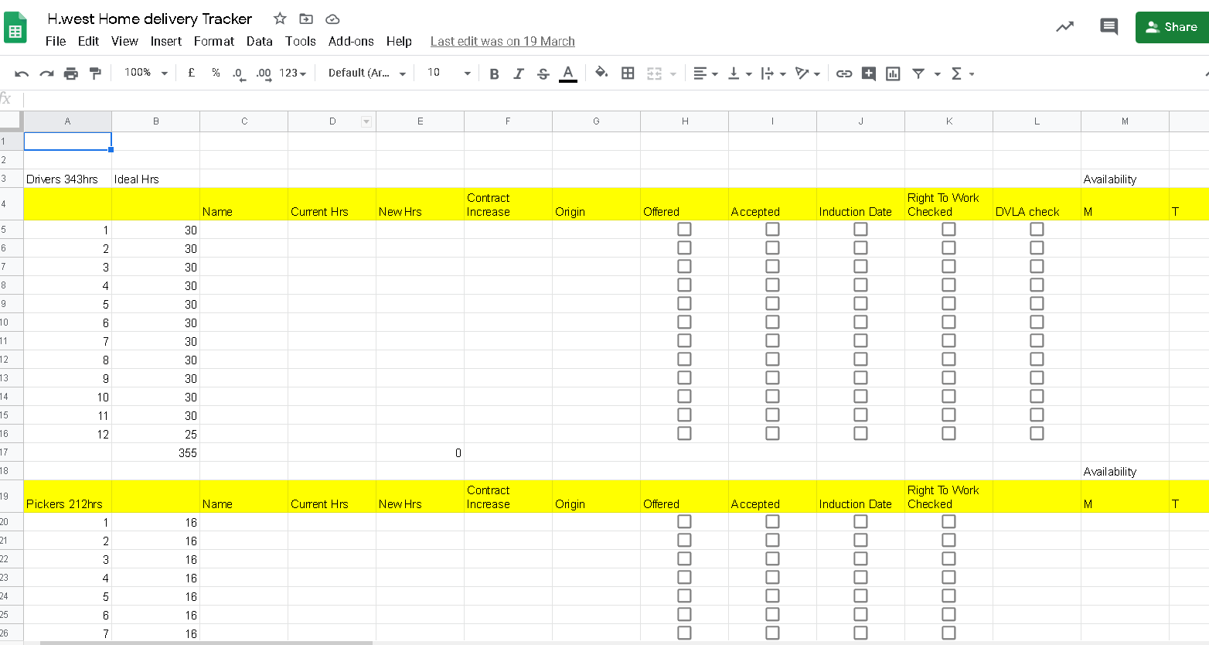
EV10
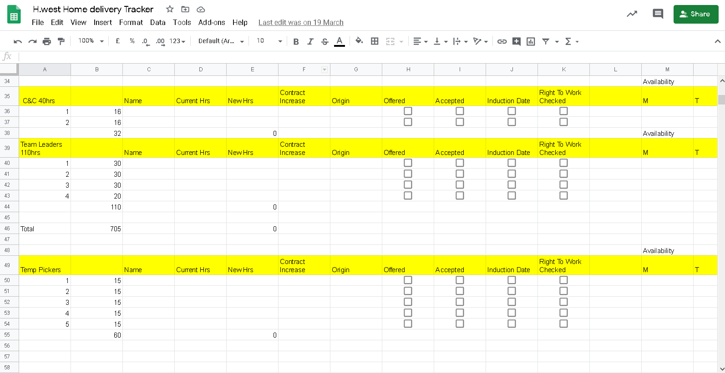

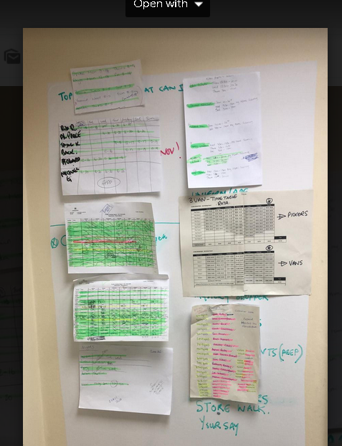
EV10
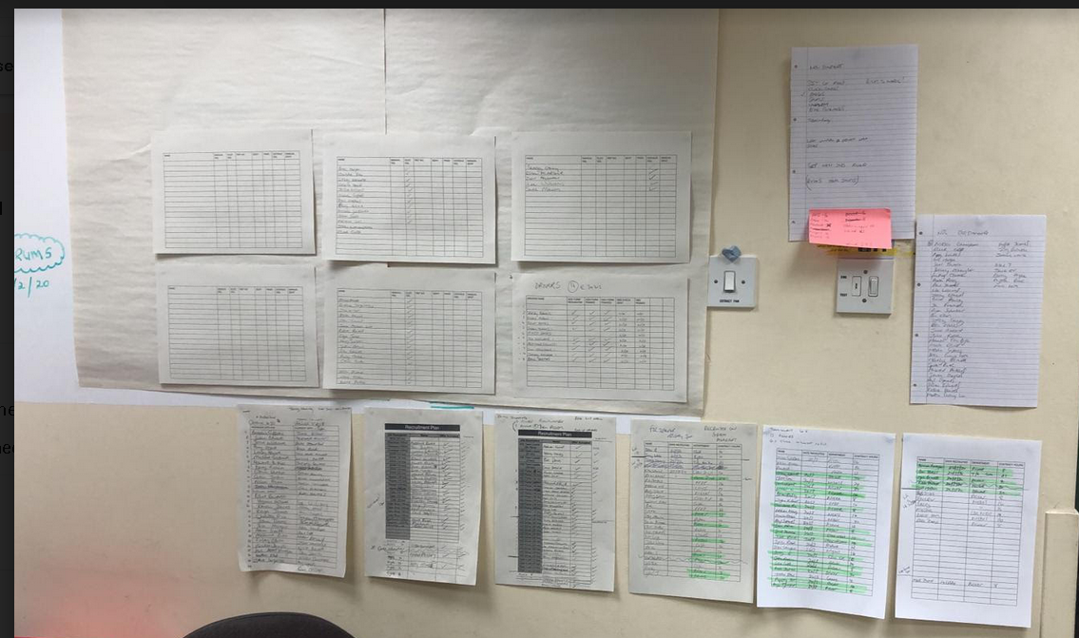

EV10

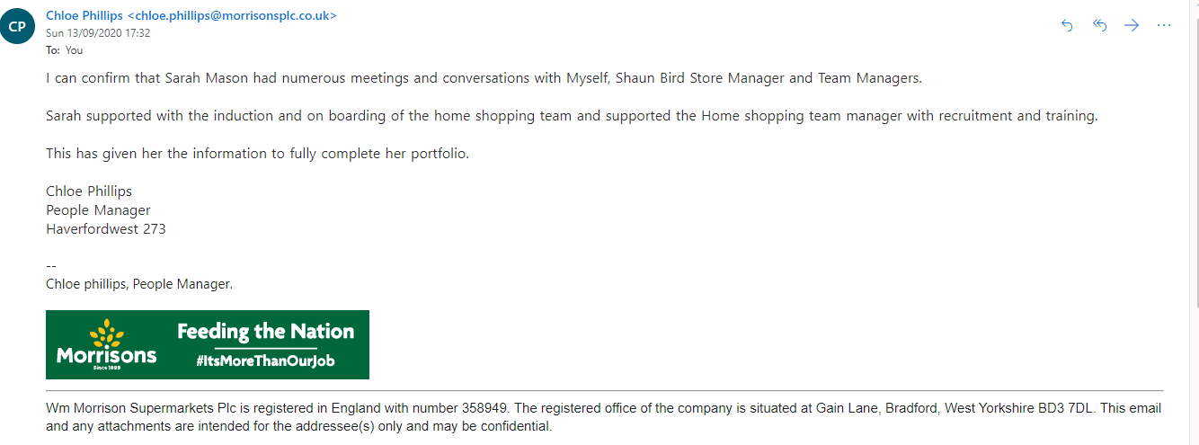

EV11

