Student Name: Amir Majeed
Student ID: 2315812
Course Code: ACCA6026
Component 2 Data Mining
Lecturer Name: Dr Nouh Elmitwally

Table of Contents
Introduction 2
1.1 Purpose and Practice of Data Mining 3
1.2 Dataset Description and Exploration 3
• Dataset Attributes 3
• Explanation of the Tableau Visualisation 6
1.3 Data Pre-processing and Post-processing 7
• Handling missing values 7
• Encoding categorical variables: 11
• Balancing the dataset 12
• Feature selection or engineering 12
1.4 Sampe Runs and Analysis Methods 13
1.5 Business Recommendations 17
1.6 Reflective Commentary 18
1.7 References 18

Introduction
Stroke continues to be one of the world's leading causes of mortality and permanent disability, putting a heavy burden on communities and healthcare systems. Therefore, early detection of high-risk individuals is crucial for efficient prevention, focused intervention, and better patient outcomes. Advances in data mining and machine learning provide powerful tools for evaluating massive healthcare datasets to find hidden patterns and enhance evidence-based decision-making.
This project explores the Stroke Prediction Dataset, which comprises demographic, lifestyle, and medical data including age, gender, hypertension, heart disease, marital status, work type, home type, average glucose level, body mass index (BMI), smoking status, and stroke occurrence. The key objectives are to forecast stroke risk using classification approaches and to uncover meaningful patterns or clusters among individuals based on their health and lifestyle variables.
A combination of exploratory data analysis and predictive modelling is applied to attain these goals. Tableau is used for data preparation, visualisation, and early investigation, giving a better understanding of variable distributions and relationships. Weka is used for the primary data mining activities, where a number of clustering techniques and classification algorithms are used and assessed.
A structured examination of the dataset, including model selection, performance evaluation, and preparation procedures, is included in the report. The findings are interpreted to highlight key risk factors and population segments associated with stroke. Lastly, useful suggestions are given for public health organisations and healthcare practitioners, illustrating how data-driven insights can assist clinical decision-making and preventive measures.

1.1 Purpose and Practice of Data Mining
Data mining refers to the systematic process of applying statistical techniques, machine learning algorithms, and database management systems to uncover meaningful patterns, correlations, and trends within large and complex datasets. Its primary goal is to transform raw, unstructured data into actionable knowledge that supports informed decision-making. Core data mining tasks include classification, clustering, association rule mining, and prediction—each providing different insights depending on the nature of the data and the problem being addressed [1].
In the healthcare sector, data mining plays a crucial role in enhancing clinical decision support and advancing predictive analytics. By analysing electronic health records, laboratory test results, imaging data, and other medical information, predictive models can identify patients who are at heightened risk of developing specific conditions, forecast hospital readmissions, or estimate likely treatment outcomes. For example, early signs of chronic illnesses such as heart disease or diabetes can be detected through hidden patterns in patient data, enabling timely interventions and preventive care. Data mining also contributes to personalised medicine by recommending tailored treatment plans based on historical patient profiles and similar clinical cases.
Beyond clinical applications, hospitals rely on data mining to streamline operational processes. It helps optimise staff allocation, improve resource utilisation, reduce operational costs, and strengthen overall service quality.
In this project, data mining techniques are applied to a Stroke Prediction Dataset to develop classification models that estimate stroke risk and clustering methods that reveal underlying patient trends. The insights gained highlight the potential of data-driven approaches to support early detection, enhance healthcare decision-making, and guide effective public health strategies.

1.2 Dataset Description and Exploration

Dataset Attributes
An attribute is a column in a dataset that provides information on the subject under study [2].
The information is divided into several columns that describe the health and lifestyle of the patients.
A binary class variable (stroke) is one of 12 attributes and 4,909 instances in the Stroke Prediction Dataset. The dataset contains a variety of data types: A kind of categorical data called nominal data is used to categorise or categorise observations into discrete groups that lack a natural ranking or order. Nominal qualities include gender, ever married, work type, home type, and smoking status.
Numerical attributes, also known as quantitative or numeric attributes, are variables in a dataset that are represented by numbers and indicate quantifiable quantities. Numerical attributes include age, average glucose level, and BMI.
Binary attributes, which typically indicate a yes/no, true/false, or present/absent state, are a unique kind of categorical or numerical attribute that can only have two possible values. Heart disease, stroke, and hypertension are represented by binary markers.
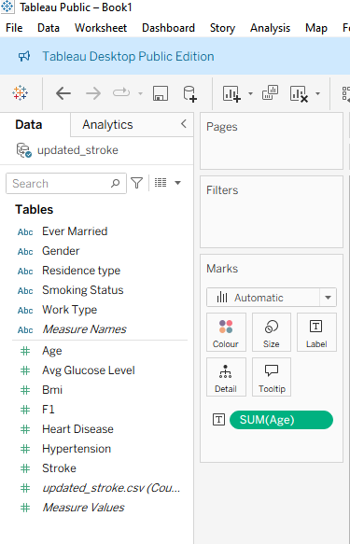
Figure 1 Dataset structure and attribute

Tableau investigation verified that there were no missing values. Participants range in age from infancy to 82 years, with an average age of roughly 42.9 years. The population is generally overweight, as indicated by the mean BMI of 28.9. The distribution of the average glucose level is right-skewed, indicating many extreme values, with a mean of 105.3.
Class distribution analysis revealed significant imbalance, with stroke cases accounting for only about 4.3% of records. This imbalance required correction during modelling to avoid biased predictions.
Important insights were obtained by visualisations. The prevalence of stroke increased dramatically with age, according to histograms. Outliers in glucose and BMI readings were found using box plots. Age, hypertension, heart disease, and the incidence of stroke were all positively correlated, according to scatter plots. Tableau dashboards showed that stroke rates are much greater in people with cardiovascular diseases. Weaker correlations were seen between dwelling type and smoking status.
Attribute ranking using information gain consistently highlighted age, average glucose level, hypertension, and heart disease as the most influential predictors. Gender and residence type contributed minimally.
Overall, investigation showed patterns that are medically intuitive and emphasised the necessity of preprocessing techniques such feature scaling and class balancing. These results guided feature engineering and model selection, guaranteeing accurate predictive analytics and significant clustering.

Explanation of the Tableau Visualisation

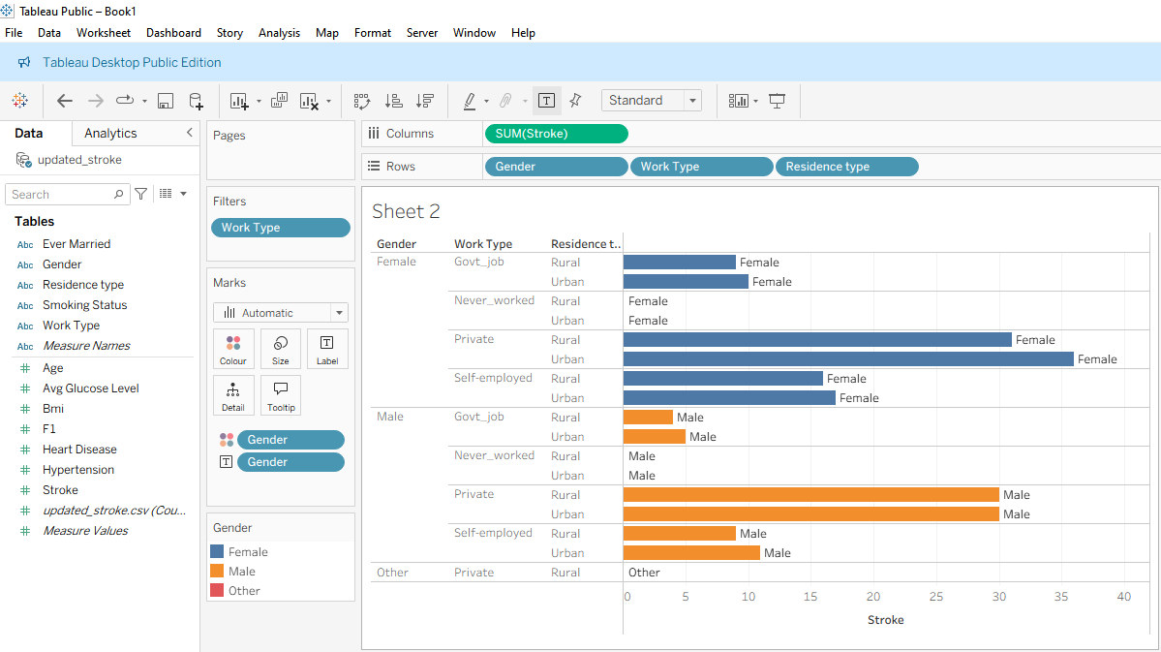
Figure 2 Explanation of the Tableau Visualisation

Tableau is a business intelligence and data visualisation platform that helps businesses and industries make well-informed decisions by analysing, interpreting, and presenting data through interactive dashboards, charts, and reports [3].
This Tableau worksheet displays the sum of stroke cases broken down by Gender, Work Type, and Residence Type (Urban/Rural). The horizontal bar chart shows how stroke occurrences vary across different demographic and employment categories.
Work Type (Govt_job, Never_worked, Private, Self-employed) and Residence Type are grouped after Gender (Female, Male, Other) on the Rows shelf. SUM(Stroke) shows the total number of stroke cases for each subgroup on the Columns shelf. Bars are colour-coded by gender, making comparisons visually evident.
Key observations from the chart include.
Private-sector workers (both male and female) show the highest number of stroke cases, particularly in urban areas.
Self-employed individuals also demonstrate noticeable stroke counts, again higher in urban than rural settings.
Females in private urban employment appear to have slightly higher stroke totals than males in the same category.
Government job and “never worked” categories show relatively low stroke counts.
Very few cases appear under the “Other” gender category, indicating limited representation.
Overall, the visualisation suggests that stroke occurrence is more prevalent among urban residents, especially those working in the private sector, and that both gender and employment type influence observed stroke patterns.
Figure 2 illustrates stroke counts by gender, work type, and residence. The highest stroke prevalence is observed among private-sector workers in urban areas, with females showing slightly higher counts than males, highlighting the interaction between occupation, location, and gender in stroke risk.

1.3 Data Pre-processing and Post-processing

Handling missing values
I have uploaded the dataset in google drive.
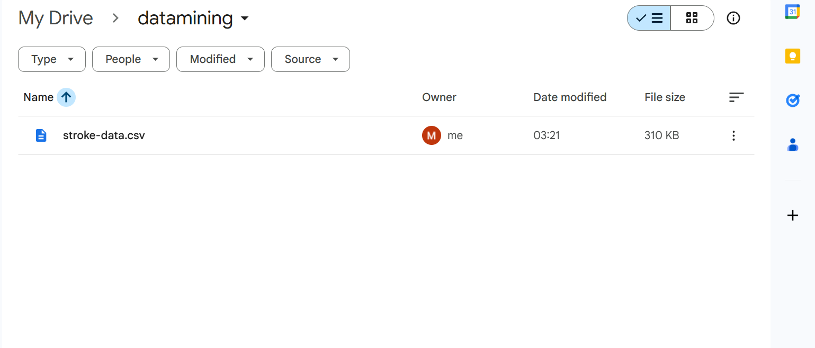
Figure 3 Upload dataset in google drive

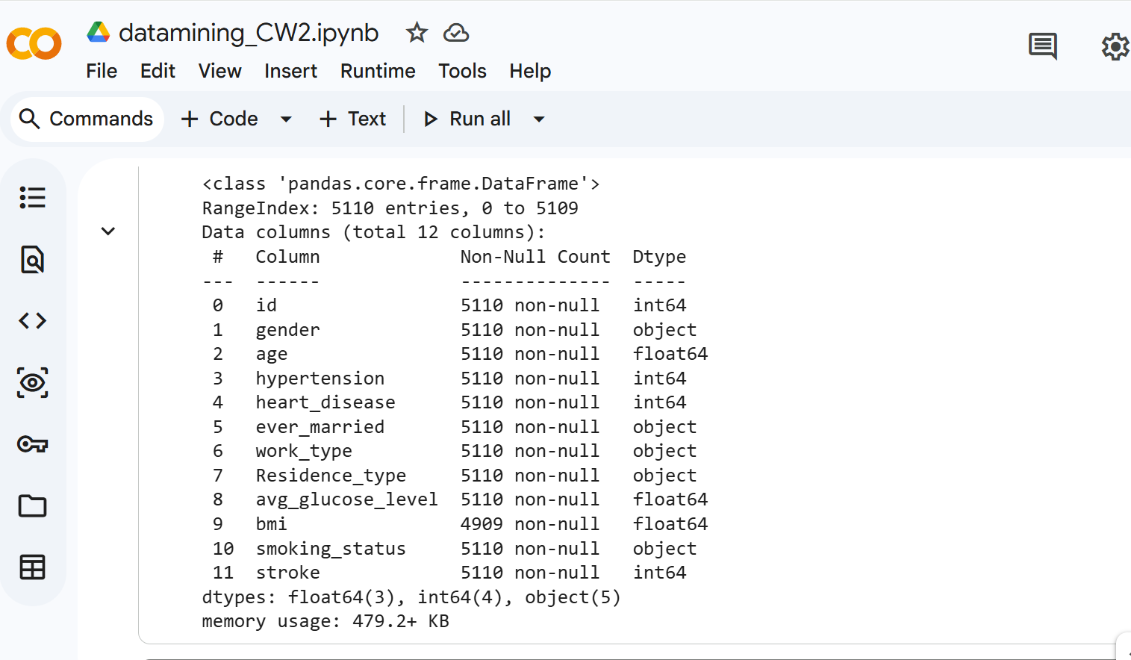
Figure 4 loaded dataset into google drive

Figure 4, presents the structure of the dataset, including the number of entries, feature names, data types, and if the data has missing values. This forms a good basis for the scope of the dataset and the amount of pre-processing it needs.

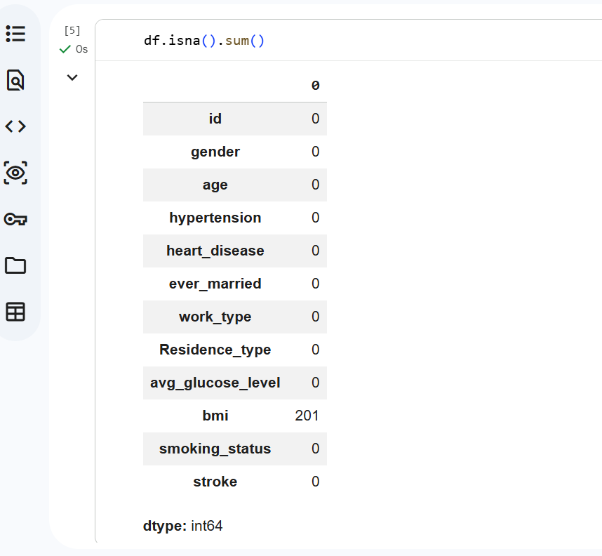
Figure 5 Missing value, bmi column has missing value – 201

Figure 5, presents the missing value count of the dataset. The graph indicates that there are 201 missing values in the 'bmi' column, whereas all other columns contain complete information. In light of this, preprocessing should consider handling missing values.

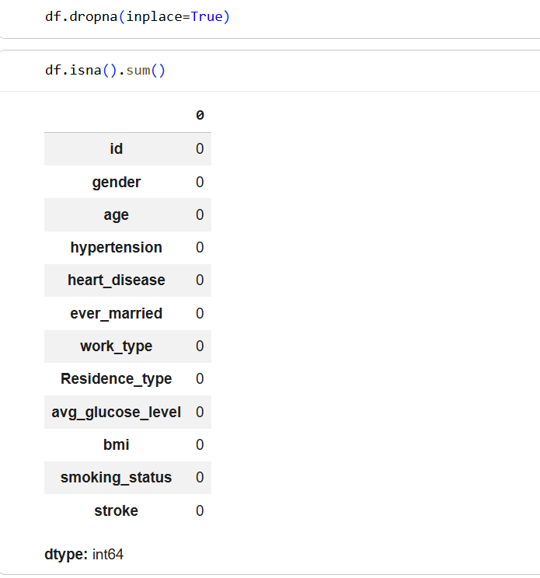
Figure 6 handling missing values by dropping the columns containing those missing values

Encoding categorical variables:
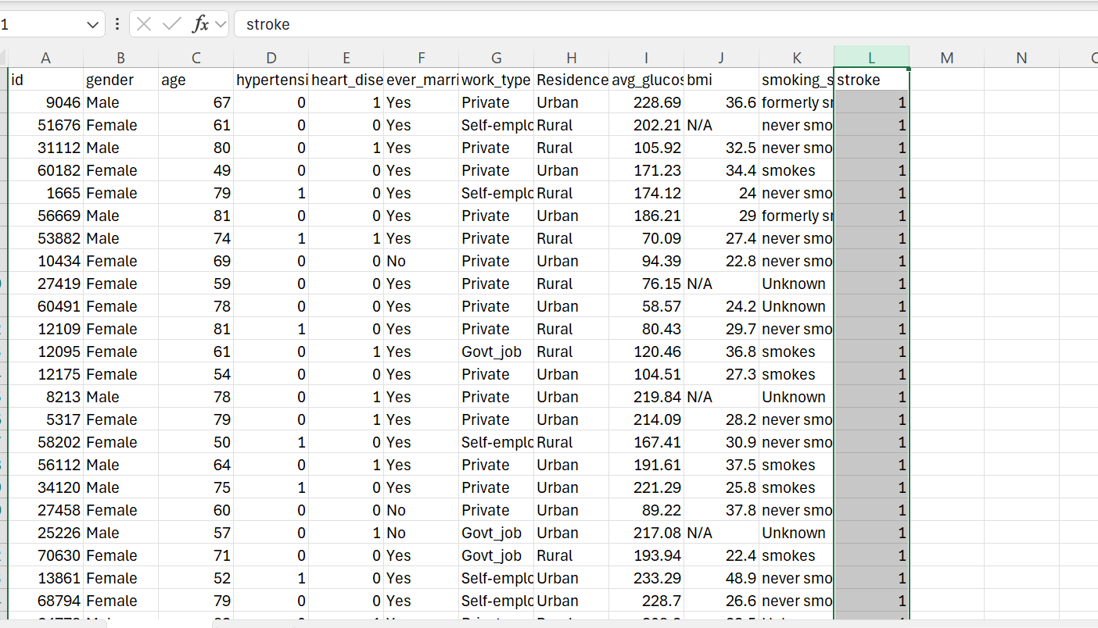
Figure 7 The original dataset before encoding
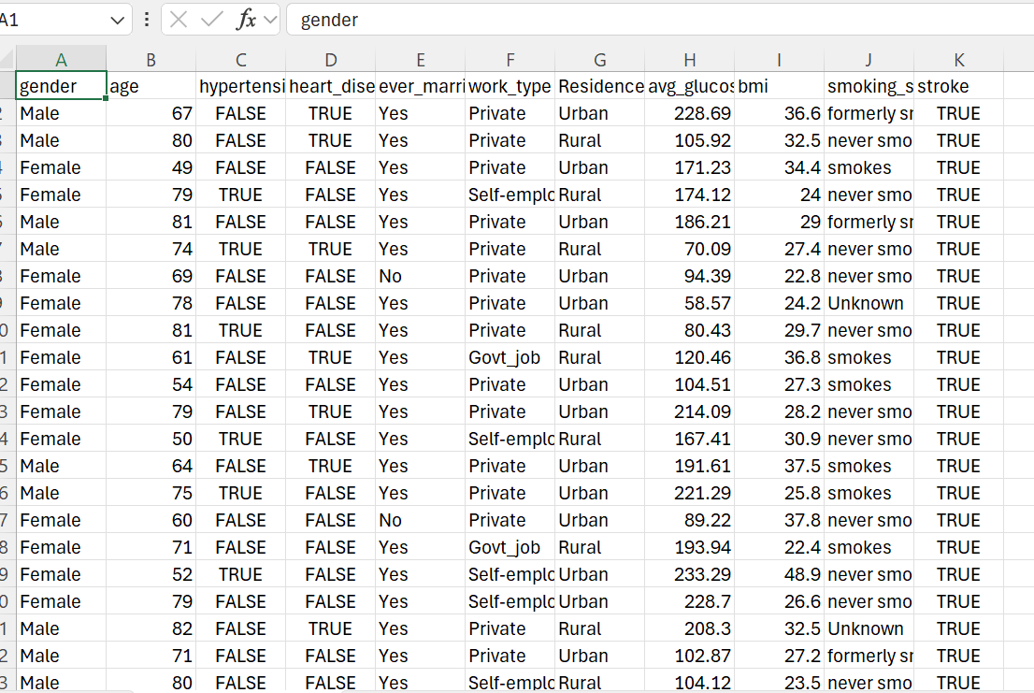
Figure 8 The encoded dataset by converting 1- True, 0-False

Balancing the dataset
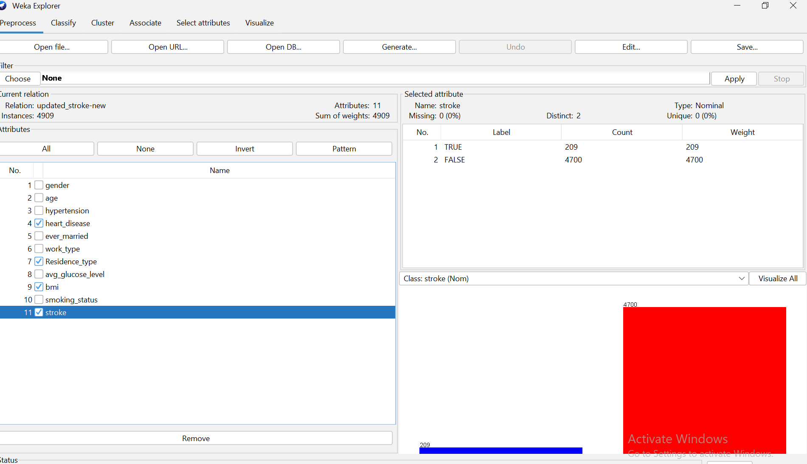
Figure 9 balancing the dataset.

Feature selection or engineering
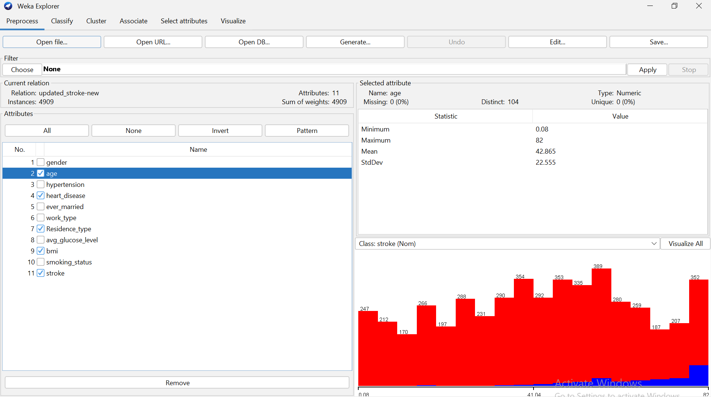
Figure 10 Selecting sort of features as part of Feature Engineering

1.4 Sampe Runs and Analysis Methods
Tableau was selected as the primary visual analytics tool for this project due to its ability to support fast, interactive exploration of complex dataset [4]. Healthcare datasets often contain multiple dimensions, including demographic attributes, behavioural factors, and medical variables. Tableau’s interface is designed to handle such multidimensional data efficiently, enabling users to quickly create and manipulate visual representations without advanced programming knowledge. Unlike predictive modelling tools that focus on statistical classification or probability estimation, Tableau emphasises descriptive analytics. This makes it particularly suitable for pattern discovery, trend analysis, and the identification of population-wide insights. In this project, Tableau was utilised to visualise stroke-related trends, offering an intuitive way to interpret the distribution of stroke cases across different demographic and lifestyle categories.
A horizontal bar chart was chosen as the primary visualisation because of its effectiveness in comparing categorical variables with several subgroup levels. Horizontal bar charts are particularly advantageous when category labels are long or when many categories are included, as they maintain readability while clearly separating each subgroup. In this case, the chart was used to represent the total number of stroke cases across three key categorical variables: Gender, Work Type, and Residence Type. These variables play a significant role in understanding disparities in stroke prevalence, and the visualisation allows users to immediately see variations in stroke occurrence between groups. For example, differences in stroke rates between private-sector employees, government workers, and self-employed individuals become visible at a glance.
Arranging the variables hierarchically—starting with Gender, followed by Work Type, and then Residence Type—adds structure to the analysis. This hierarchical arrangement enables drill-down exploration, where users can begin by assessing broad trends and then narrow their focus to more specific demographic combinations. For instance, one can initially identify whether males or females exhibit higher stroke counts and then explore how work categories contribute to these differences. Further drilling down into Residence Type reveals whether urban or rural environments influence stroke distribution within those employment groups. Such structured exploration is essential for identifying specific high-risk clusters, such as urban male private-sector workers or rural female self-employed individuals. These insights support targeted intervention strategies, making the visualisation particularly valuable for healthcare planners and policymakers.
Colour encoding by gender enhances the interpretability of the visualisation. By assigning distinct colours to male and female categories, Tableau makes it easier to compare gender-related patterns without relying on numerical data alone. Colour acts as a visual cue that draws attention to differences and similarities across groups, allowing subtle trends to emerge. For example, small gender disparities that might not be readily identifiable through numerical summaries become more obvious when encoded visually. This supports intuitive pattern recognition and ensures gender dynamics in stroke patterns are not overlooked. Additionally, colour encoding reduces cognitive load, making the chart easier to interpret for non-technical stakeholders, such as clinicians or public health administrators.
The decision to aggregate stroke outcomes using SUM(Stroke) provides a straightforward method for identifying which demographic segments exhibit the highest concentration of stroke cases. Aggregation in this manner does not attempt to measure individual-level risk but instead focuses on identifying areas where strokes occur most frequently across the population. This distinction is important because concentration analysis is often more relevant for public health planning than individual probability estimation. For example, if a large number of stroke cases are clustered within a particular work category or residential environment, health authorities may prioritise resource allocation, preventive campaigns, or screening programmes for that group. Aggregated visualisations offer a clear overview of case distribution, guiding strategic decision-making.
Together, the visualisation options used in Tableau enhance the interpretability of broader analytical processes. While Tableau itself is not used for predictive modelling in this project, the visual insights it provides serve as a contextual foundation for the predictive models developed using Weka. Tableau highlights population-wide patterns—such as which groups have the highest stroke counts or how demographic characteristics interact—while Weka identifies risk factors and generates predictive classifications at the individual level. This complementary relationship ensures that both descriptive and predictive elements of the analysis are addressed.
By combining Tableau and Weka, the project benefits from a well-rounded analytical framework. Tableau supports exploratory research by helping analysts form hypotheses based on visible trends. For example, if visual patterns suggest that urban populations have higher stroke counts, predictive modelling can then be used to determine whether environmental or lifestyle variables contribute significantly to stroke risk. Tableau also strengthens evidence-based decision-making by providing accessible visual outputs that can be easily communicated to stakeholders. These visuals help bridge the gap between technical analysis and practical policy implementation.
In summary, Tableau plays a vital role in this project by enabling clear, intuitive visual analysis of stroke data across multiple demographic categories. Its interactive features, combined with structured hierarchies, colour encoding, and aggregation, offer powerful support for identifying high-risk groups and understanding population-level trends. When used alongside Weka’s predictive models, Tableau contributes to a comprehensive analytical approach that integrates both descriptive and predictive perspectives to improve healthcare insights and support informed public health decision-making.

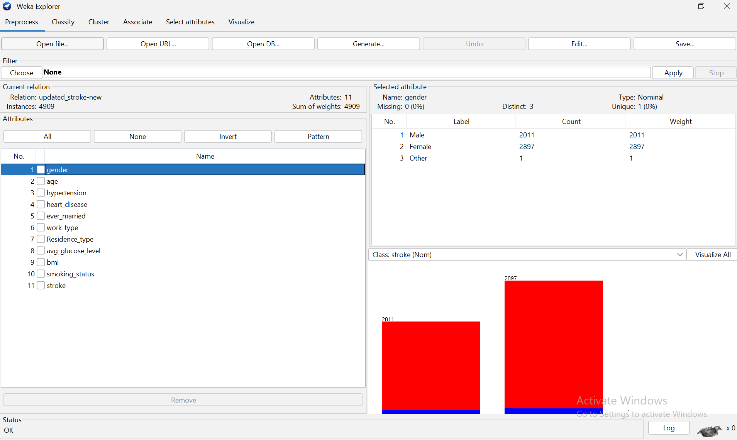
Figure 11 Weka Explorer used for Analyses

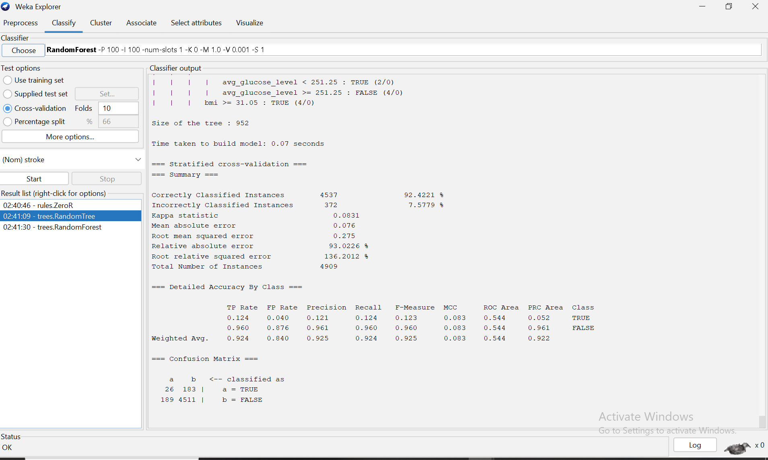
Figure 12 Decision Tree

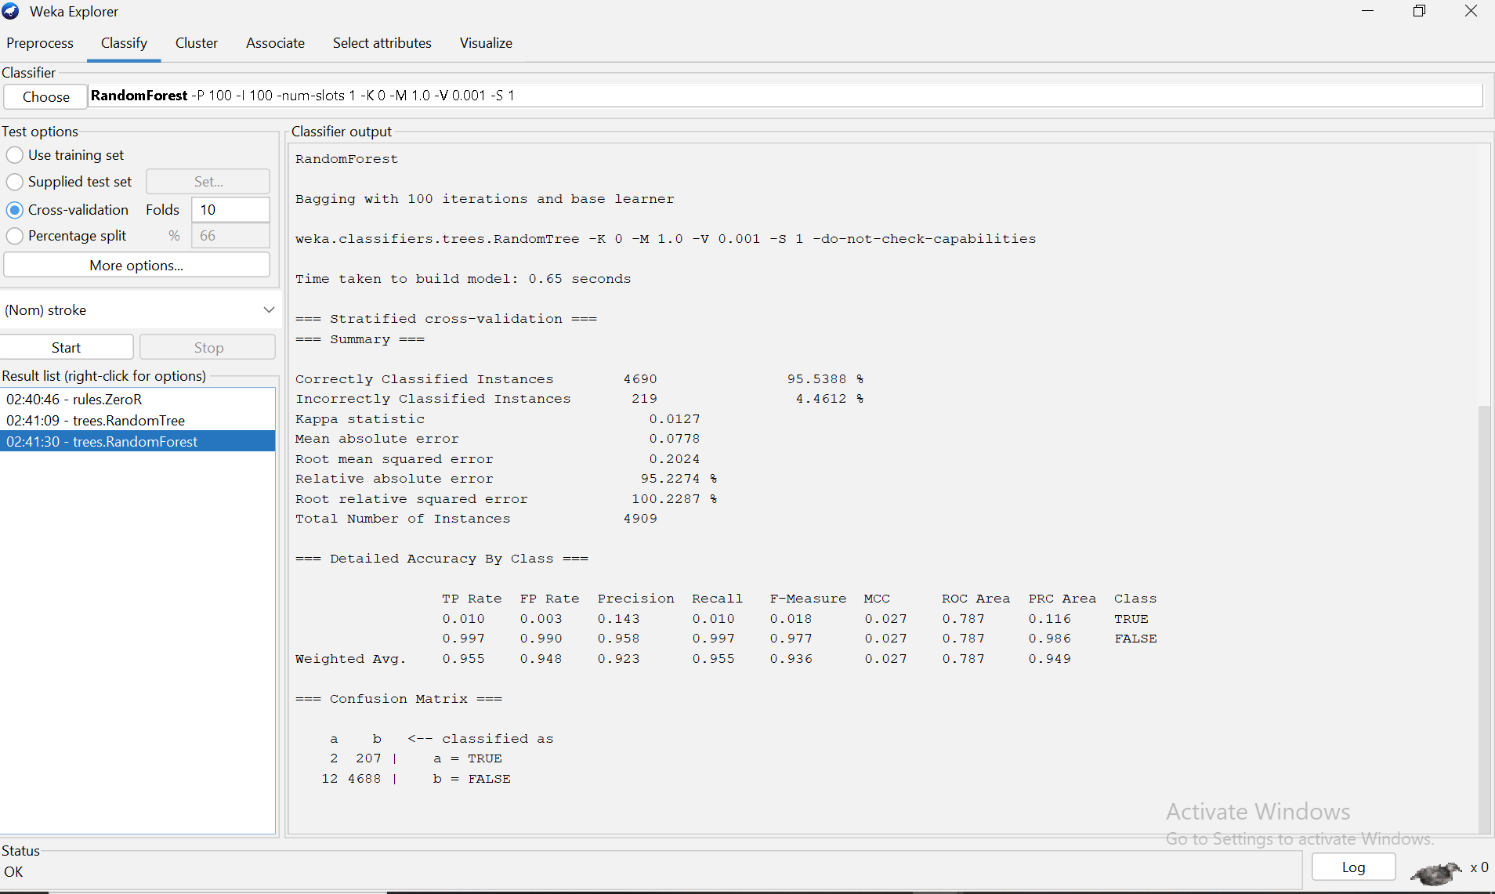
Figure 13 : Random Forest

1.5 Business Recommendations
The analytical findings and Tableau visualisations provide several practical recommendations for healthcare providers and public health organisations. The data indicates that individuals employed in the private sector—particularly those living in urban environments—exhibit a notably higher prevalence of stroke. This underscores the need for targeted workplace health initiatives within private companies, including routine cardiovascular screening, stress-management workshops, and wellness programmes that focus on controlling blood pressure, cholesterol, and blood glucose levels.
Given the higher concentration of stroke cases in urban populations, prevention strategies should prioritise these communities. Local health authorities could implement outreach programmes offering free risk assessments and educational sessions on lifestyle modification, such as smoking cessation, increased physical activity, and the adoption of healthier dietary habits.
The findings also show a slightly elevated stroke prevalence among women working in private urban roles, highlighting the importance of gender-sensitive healthcare interventions. Employers and clinicians should promote accessible screening services and support work-life balance policies that mitigate stress-related health risks for women in demanding occupations.
From a clinical perspective, the Weka predictive models identified age, average blood glucose, hypertension, and heart disease as major contributors to stroke risk. Integrating predictive analytics into electronic health record systems can help clinicians identify high-risk individuals earlier, enabling more personalised monitoring and intervention strategies.
The clustering results further suggest the presence of distinct risk groups within the population. Public health agencies can use these insights to design targeted prevention programmes rather than relying solely on broad messaging. By combining predictive modelling with demographic analysis, healthcare systems can allocate resources more effectively, reduce stroke incidence, and improve overall population health outcomes.

1.6 Reflective Commentary
Weka and Tableau's examination of the Stroke Prediction Dataset yielded insightful information about the usage of data mining methods in the medical field. According to accepted medical knowledge, the classification models did a respectable job of detecting important risk factors like age, average blood sugar, hypertension, and heart disease. But because of the dataset's significant class imbalance, accuracy was insufficient to assess performance; instead, metrics like recall and AUC provided more useful information.
The integration of predictive modelling and visualisation was a major project strength, as Tableau facilitated the interpretation of patterns and the efficient communication of results. Enhancing model dependability also involved data preprocessing, which included balancing the dataset and addressing missing BMI values.
Among the limitations were the comparatively limited number of stroke cases and the absence of comprehensive clinical characteristics. I would use more sophisticated balancing techniques, investigate other algorithms, and use more comprehensive health data in my future work to increase forecast accuracy and insights.

1.7 References
[1] A. Khatri and Agasti, Data Mining for Beginners: A Programmer’s Guide. India: Educohack Press, 2025.
[2] M. L. Gillenson, Fundamentals of Database Management Systems. United States: Wiley, 2023.
[3] F. Green, Winning with Data in the Business of Sports: CRM and Analytics. United Kingdom: Taylor & Francis, 2021.
[4] M. Mittal and N. G. Raheja, Data Visualization and Storytelling with Tableau. United States: CRC Press, 2024.

