UWTSD
Name - Judith Churcher
Course – Business and Management (BA)
Module – Distinctiveness and Regeneration (BMSP4005)
Assignment 2 – Report 3,000 Words (Newcastle Emlyn)

Executive Summary.
This report is to investigate Newcastle Emlyn and why plans have been made to start a regeneration programme. The purpose is to help Newcastle Emlyn’s economic recovery and to build strong, sustainable and durable communities. I went out to do a field report and asked the local community what they thought could help the town to improve and thrive. With this information I have structured out two plans that could potentially make a difference. If successful, it could help the growth of grounded businesses and strengthen foundational economy. If the plans were in place, they could open up more opportunities for people in and around the town which will help develop skills and business growth. Although there is no timeline in when the plans would make that difference I am confident that with the support of all stakeholders it will make substantial difference to Newcastle Emlyn.

Contents

- Introduction
- Historical Development
2.a Changing Fortunes
2.b Existing Assets, Structures and Economic Character
2.c Key Stakeholders and Interest Groups
2.d Local/Regional Development Strategies
3. Regeneration Ideas
3.a Plan 1 : Grants for New Businesses
3.b Plan 2 : Quarterly Welsh Fairs
4. Conclusion

- Introduction.
In this report I will be talking about the historical development of Newcastle Emlyn. I will be looking at what has been successful and what has failed over time whilst looking at their existing assets, structures and economic character. I will be exploring Newcastle Emlyn’s stakeholders and interest groups and look at its local development strategies. For the second part of my report, I will be exploring two future opportunities for the regeneration of Newcastle Emlyn based on findings and relevant theory. We are told by ‘Davies, (2002) that since the 1990’s the term regeneration was known as an economic and infrastructural development and now it is more commonly known as an advancement of the social, economic and environmental well-being of an area.’ This being said ‘Hughes, (1998) says that if these regeneration programmes do not have a culture component they will not work. For these to work, communities need to have hope and need to see the creativeness in the decisions made.’ To heighten Newcastle Emlyn’s current sense of pride, belonging and engagement we need to learn more about the local area. By applying what information found, we can address their disadvantages, social isolation, low aspirations and poor community unity. A community with the same goals and engagement come together and create a stronger culture. Newcastle Emlyn could have a lot to offer, but they need to grow their visitor economy. It lacks in online presence which then fails to showcase any local businesses events or experiences that the community has to offer.

- Historical Development.
Newcastle Emlyn, located in the county of Dyfed, is a town that sits in the Teifi Valley.
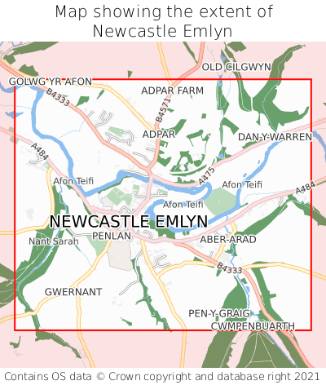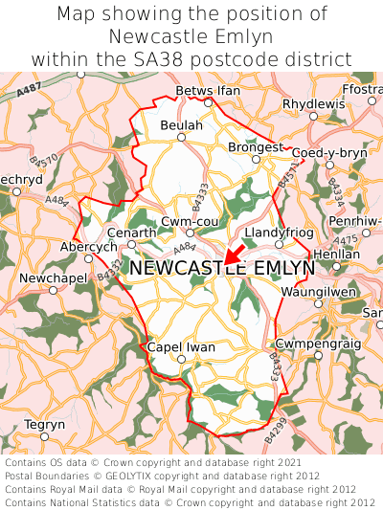
The Newcastle Emlyn castle originated in 1240 by the Welsh prince, Maredudd ap Rhys and was attacked numerous times following many refurbishments but in 1645 it was blown up with gunpowder during the English Civil war. The castle was known for its uniqueness as it was the one of very few that was built with Welsh stone. For many years Newcastle Emlyn was a valuable town as it was a collection point for hogs and Welsh cattle and moved them from West Wales to England. The name Newcastle Emlyn came from the Cantref of Emlyn which was an administrative district in medieval Dyfed. (Newcastle Emlyn Traders, 2022) During the Industrial times, the town played a part in the agricultural sector with neighbouring towns opening coal and iron works there was a higher demand for aquacultural produce. As well as this they used the fast-flowing streams and rivers to power what machinery they had this then helped build on the cloth and woollen mills. By the end of the 19th century there were over 52 working mills in this area. In Wales, wool was then, an important industry. Today, the town has over 80 businesses that range from retail to hospitality, most which are independent retailers. Coivd-19 has made an impact on businesses which have had to close, relocate or become online only. This has hit the town economy and ‘Carmarthenshire County Council (2022) tells us that it has left 10% of properties vacant.’

2.a Changing Fortunes.
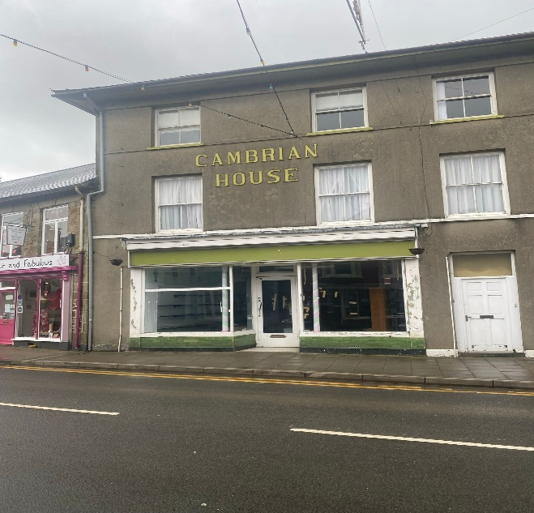
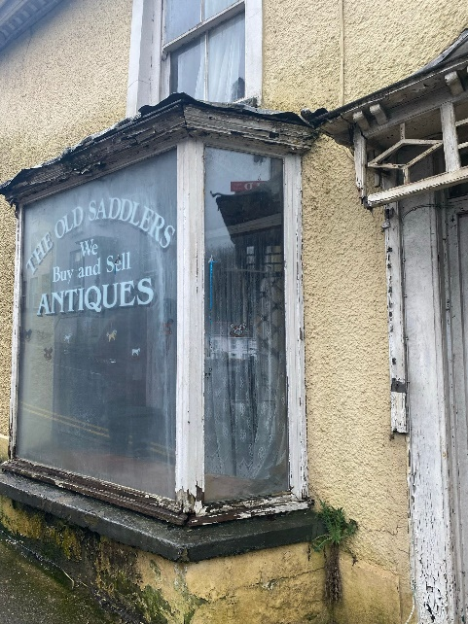
Over the years Newcastle Emlyn’s populations age range has risen to 11.1% of those between 65 and 74 (ilivehere, 2021). Whilst carrying out the field report at Newcastle Emlyn, I found during my observations that the average passer-by were elderly which highlights how much of an older persons location it actually is. Most of the residents of this age will be retired and most of the individuals that I spoke to had lived there since a young age. (Personal communication, 2022) Newcastle Emlyn’s property ownership and rental statistics show that there is a high percentage of residents own their homes and only 11.2% are socially rented. According to the ‘Office for national statistics, (2021) Due to the rapid increase in housing prices from 2020 by Covid-19 and the shortage of employment opportunities within the town there is not much hope for the new residents of the area who want to get on the property market. House prices in Newcastle Emlyn are on average £20,000-£50,000 more than rural country but to be able to move into one of these homes you would need to have a successful business that can support your outgoings which you probably wouldn’t get from setting up in Newcastle Emlyn as it currently stands.

2.b Existing Assets, Structures and Economic Character.
Newcastle Emlyn relies on visitors to contribute to the town economy. For visitors there is not much to keep them occupied for long. On our visit to the town, we could see that there was a variety of independent stores and plenty of coffee shops. There are only a few hotels/b&b’s in the town and surrounding area. Away from the town they do have natural and industrial heritage attractions like the Cenarth Falls, Coracle Museum, the National Wool Museum and the Teifi Valley Railway. (Carmarthenshire County Council, 2022) These all serve great purpose to Newcastle Emlyn and is a great part of not only their heritage, but the Welsh heritage. Newcastle Emlyn is a passing point for those travelling through to Cardigan. This could cause challenges here, as on the field trip I had found that the traffic flow through the town was very heavy and there is not an awful lot of room for the larger lorries to manoeuvre around. Despite it being central, it is quite rural. ‘Holton (2022) tells us that developing a rural community is difficult. Change for some communities is not comfortable, if new business were to come in it could have a positive effect for some but a negative for others. People of the community would see it as new breath of fresh air, but to existing businesses they could see them as a threat to an already struggling town.’

2.c Key Stakeholders and Interest Groups.
“Stakeholder theory has been developed over the last thirty years to counter this dominant mindset. In particular, it has been developed to solve or at least reconceptualize several specific problems.” (R. Edward Freeman, 2010) Stakeholders are important for the businesses of Newcastle Emlyn. They give practical and financial support, these people that are interested can range. We are told by ‘Gartenstein, D (2018) that people need to work together and aim for the same goals for a prosperous relationship between business and stakeholders. As you can see from the image below, they extend from primary stakeholders, the supplies and employees out to the secondary stakeholders that could be the media or government.’ To be able to gain financial benefits from this they need to engage their stakeholder communities. To be able to be a part of something and feel like it is more than a job and customers that believe in your product of service will be more likely to do their best.
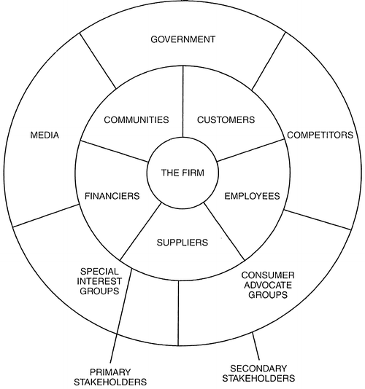

2.d Local/Regional Development Strategies.
Newcastle Emlyn already has Economic Recovery & Growth Plan in place prepared by Carmarthenshire County Council from June 2021. They tell us that the plan, over the next 5 years, is to focus on the longer-term prosperity and growth of the town. Since the Covid-19 pandemic, communities have come together and are focused on what matters to them. Now more than ever the Council want to address immediate economic recovery for long term growth. (Carmarthen County Council, 2021)
The priority actions that have been outlined due to their weaknesses – despite being diverse and vibrant, have been prioritised. As previously stated, many properties that are suitable for employment floorspace are empty. The Council want to support new start-ups and encourage current companies to stay in the town.
Marketing is a key issue that needs to be addressed. Social media and a strong online presence are what makes companies stand out in the current times. The town needs a strong locally lead marketing and branding to promote the town. This will be ideal for informing people of attractions and events that many take place to get the visitor in.
For the success of the above plans, Newcastle Emlyn needs to change to a SMART town. To be able to run the marketing, banding and visitor strategies reliable connectivity is key. Currently to be able to run your business online as well as in the physical premises is proving difficult and the best solution would be to move your business to online only and save money on renting.

- Regeneration Ideas.
3.a Plan 1 : Grants for New Businesses.
To be able to rent out a property to start your own business in Newcastle Emlyn would prove difficult for anyone without much behind them. To be able to get small businesses grants, it can be quite competitive. Start up business grants would be hard to get in the town as you have no guarantee of the kind of results you would see in the current town economic state that it is in. Offering grants to new businesses in the town will help fill up the current empty and unused shop spaces. Grants could be offered to independent business if the business type is not already in the town. Newcastle Emlyn’s range of current shops vary from bath bomb cosmetics to fabric shops. As they are such a small town, having more than one type would not be appealing for the visitor sectors and would only be competition for the ones that are already there. Keeping the community in the loop of what best businesses to join the town should be key as they will know what will work better for the community.
In 2005, the first Welsh Social Enterprise Strategy was launched, which supports negotiators to support local firms. “The Community Investment Fund administered by the Welsh Council for Voluntary Action has provided £2.65m in loans and £353,000 in development grants to help social enterprises become investment ready and compete for public procurement contracts.” (Murtagh, B & McFerran, 2015) With this being said, the grants were a success to helping new markets and businesses which shows that this could work in a smaller town and create potential growth not only for the local community but for visitors also. People will want to feel secure knowing that starting a business there could be a success. For this to happen they will need support from the whole community and will have to work together to show people what they have to offer.

To be able to get the grant for a new business start-up, they should have an criteria to meet. The business must not be one that is already set out in the town, we don’t want to have competition between businesses that are already running. To bring this idea together, the stakeholders are an important part of the plan. The Carmarthenshire County Council would be the primary stakeholders as they would need to see the benefits for giving the grants to new start-ups. We would need to get the community together to make sure everyone’s input has been listened to. The current community may not see welcome to some businesses. When speaking to the local residence on the filed trip, many said that they would like to see the shops full with new opportunities for people as seeing them bare seems such a shame for a once thriving town. As a secondary stake holder, competitors would be other independent business. Shops that open should not be the same and should be independent stores that customers can walk into, they should not be used as storges stores for businesses with an online presence only.
Location for the new business is not worrying. There are more than 3 empty premises on the main road through Newcastle Emlyn and can be filled with little work needing to be done, making it an easy and quick solution. Social media will also play a big part in their success. After being given the grant, they would have to show that they are doing what they can to make their business work. Social media can help show the local community and any tourism visitors what they have to offer and why they should come and visit.
Grants need to be reviewed for the people and outsiders of Newcastle Emlyn. To be able to help the community and get the tourism back up after the hit of Covid-19 it needs to be feasible to be able to start up a business in a quiet town. With the opening of new and different markets this will draw back in the tourism and help the economy recovery.

3.b Plan 2 : Quarterly Welsh Fairs.
To be able to get the tourism back, there needs to be something to bring them in. I would suggest a quarterly Welsh fair. The Welsh language and culture is slowly dying, and for a town that prides itself for people coming from a small tight-knit community that doesn’t want to see the Welsh language and traditions die out. This would be a great opportunity for people in and around the area to show what they have and what they are proud of. Doing this will give the people of Newcastle Emlyn a sense of community and pride.
Like the Royal Welsh show that takes place in Builth Wells once a year, it is an agricultural event with attractions, entertainment and competitions. ‘Carradice, P (2011) tells us that the Royal Welsh Show has done nothing but continued to grow each year and is an event that is enjoyed by everyone wherever they from.’ The fair will not only be for those who are Welsh but for anyone who would like to learn about the Welsh background and traditions and be able to keep them going. This is good evidence to show that it could be a success as people will come from all over. As the Royal Welsh Show is a very large event that only happens once a year, they have plenty of room for all the attractions. For this to happen at Newcastle Emlyn it would need to be in a suitable area. Where the cattle market happens, the event could take place here. As we are limited to room it could be stalls of Welsh made ornaments or homemade traditional Welsh foods. The event would be put on for the whole day and due to the size, it could be done quarterly during school holidays, which would give people enough time to come and visit and not have to wait a year if missed.
The issues that would arise for this plan would be the traffic flow. Newcastle Emlyn struggles for car parking spaces without the need for events. To accommodate the extra foot flow, for the event days, land could be opened and used as temporary car parking spaces. Small charges could be applied to use the car park which could then contribute to the efforts from staff that help set up the Welsh Fair.
Stakeholders that will be a part of this would be the council as they will need to approve the use of the car parks and area of use. Community should be listened to as this should be something that they can all work together to make a success to feel like they are part of a community again. The media will play a massive role in this as it will be key to ensuring that it is known that the event is happening.
Welsh fairs could bring in all kinds of people to visit Newcastle Emlyn. The aim of this future opportunity is to bring people together. It is important to the community to feel like they are a part of something. A Welsh fair will help them feel at home and it gives them the opportunity to educate the younger generation so that they Welsh culture will not be lost.

- Conclusion.
Taking everything into account, it is clear Newcastle Emlyn needs a regeneration programme to help its overall economy. The town is unique, and changes can’t be made that will change the community feeling. Big brand chains, if they were to enter the town, would then make it lose the effect of a small rural tourism town. Help is clearly needed for those who would and could start up their own independent business there. The change could make a difference to the town and the community in many ways. With both future opportunity ideas, there is no time scale to show when or if the plans would be successful. Saying this, we would need to make sure that we gave the plans enough time to be able to make a change and build on the experience and feedback. It is important to discuss with all members to help bring focus to the desired outcome. As part of the planning process, we need to learn how to follow through on monitoring and evaluation. Both plans show evidence that the economy decline in Newcastle Emlyn could be tackled, but with the understanding that the area, money required and the means of redevelopment all effect its rate of success.
After seeing how deprived it was of life from the field trip and the locals agreeing, they still had nothing bad to say about where they came from. They are proud of where they come from and what they have to show, it is important for people to know how far Newcastle Emlyn has come from many many years ago. Although it may have a poor external perception, there is much life and love form the people.

- References.
Carmarthenshire County Council. (2022) About Newcastle Emlyn. Town Economy. About Newcastle Emlyn (carmarthenshire-towns.info)
Carradice, P. (2011) BBC WALES. The history of the Royal Welsh Show. BBC Blogs - Wales - The history of the Royal Welsh Show
Catford, N. (2017) Disused Stations Site Record. Disused Stations: Newcastle Emlyn Station (disused-stations.org.uk)
Davies, J.S. (2002), The governance of urban regeneration: a critique of the ‘governing without government’. Public Administration, P.7
Gartenstein, D. (2018) Business operations. The importance of stakeholders. The Importance of Stakeholders (bizfluent.com)
Holton, M. (2022) Beef Magazine. 10 reasons rural community development is hard to do. 10 reasons rural community development is hard to do (beefmagazine.com)
Hughes, R. (1998). Culture makes communities conference. Leeds: Joseph Rowntree Foundation, 13.
Ilivehere. (2022) Socio-economic statistics for Newcastle Emlyn, Carmarthenshire. Socio-economic statistics for Newcastle Emlyn, Carmarthenshire (ilivehere.co.uk)
Jones, S.E.M. (2022) Newcastle Emlyn Town Council. History of Newcastle Emlyn. Cyngor Tref Castell Newydd Emlyn | Newcastle Emlyn Town Council - Town History
Murtagh, B & McFerran. (2015) Environment and Planning C: Government and Policy. Volume 33, page 5. Adaptive utilitarianism, social enterprises and urban regeneration (sagepub.com)
Newcastle Emlyn Traders. (2022) History. History - Visit Newcastle Emlyn
Office of National Statistics. (2021) Recent trends in the housing market: January 2021. Recent trends in the housing market - Office for National Statistics (ons.gov.uk)
R. Edward Freeman. (2010) Stakeholder Theory: The State of the Art. Cambridge University Press, 2010. P.3 Stakeholder Theory: The State of the Art - R. Edward Freeman, Jeffrey S. Harrison, Andrew C. Wicks, Bidhan L. Parmar, Simone de Colle - Google Books Accessed: 02.03.22

Photos.
Get the data. (2022) Newcastle Emlyn on a map. Map showing the extent of Newcastle Emlyn. [Photograph] Accessed: 01.03.22 Available at: Where is Newcastle Emlyn? Newcastle Emlyn on a map (getthedata.com)
Get the data. (2022) Newcastle Emlyn on a map. Map showing the position of Newcastle Emlyn within the United Kingdom. [Photograph] Accessed: 01.03.22 Available at: Where is Newcastle Emlyn? Newcastle Emlyn on a map (getthedata.com)
Bonnafous-Boucher M., Rendtorff J.D. (2016) Springer Link. Stakeholder Theory in Strategic Management. [Photograph] Accessed 02.03.22 Available at: Stakeholder Theory in Strategic Management | SpringerLink

