BMSW 4014
The Decline of the Retailer Wilko
Kudeja Begum

January 25, 2024

Table of Contents
Introduction 3
Nature, Scope, and Impact of the Problem Faced by Wilko 3
The Core Problem: Inability to Secure Emergency Funding 3
The Extent of the Problem: Affecting Stores and Workforce 3
Impact on the Organization 3
Macroeconomic Factors and Mini Budget Fallout 4
SWOT Analysis of Wilko 4
Strengths 4
Weaknesses 4
Opportunities 5
Threats 5
Strategic Recommendations 5
PESTLE Analysis of Wilko's Decline 6
Political Factors Impacting Wilko 6
Economic Analysis 6
Social Factors Impacting Wilko 7
Technological Analysis 7
Environmental factors affecting Wilko 8
Strategic Recommendations 8
Evaluation of Options and Decision-Making 8
Conclusion 9
References 10
Appendix 13

Introduction
Wilko, a UK home goods retailer, has been struggling financially, causing its stock price to plummet. Wilko, founded in 1930, has over 400 stores nationwide. However, the company's inability to get emergency cash has affected thousands of workers and other key individuals. This research examines the causes of Wilko's death and their implications (Embling et al., 2020). The store borrowed £40 million to remain open, replace leadership, and sell assets due to the weak economy. About 12,000 individuals lost their jobs when it ended in August. The short budget of last year and other foreign economic variables have also had a major impact. This report will employ SWOT and PESTLE studies to highlight Wilko's predicament and what may have been done to prevent this terrible outcome.

Nature, Scope, and Impact of the Problem Faced by Wilko

The Core Problem: Inability to Secure Emergency Funding
Wilko, a famous British shop, was in trouble after failing to acquire emergency cash. Not being capable of increasing money wasn't a one-time problem; it was the result of long-term money problems (Ekaterina Salnikova and Stanton, 2021). The store's attempts to get £40 million the previous year were a clear sign that a problem was about to happen.

The Extent of the Problem: Affecting Stores and Workforce
A lot of people were affected by this financial mess, and it had a direct effect on Wilko's 400 shops globally. What's worse is that it put the jobs of about 12,000 workers in serious danger. The danger of being laid off hung over this large workforce, showing the terrible human cost of the company's financial problems (Kickert et al., 2020).

Impact on the Organization
This lack of funds had many effects, making it very hard for Wilko to operate its corporate and make smart choices. The corporation had to contract with rough waves caused by major changes in leadership, which was a smart move meant to get the store back on track. Also, Wilko sold a key delivery centre, showing how desperately it was trying to get its finances back on track. Sadly, these steps were not enough to keep the company from going out of business in August (Xu, Loi and Chow, 2019).

Macroeconomic Factors and Mini Budget Fallout
Wilko's failure cannot be looked at in isolation from the state of the economy as a whole. The small budget had a lot of special effects on the economy, which made things even worse in the years before the crash. The economic turmoil was a major factor in making the credit market tighter, which made it harder for Wilko to get the money he needed. The store's closing was a stark warning of how even well-established companies can be hurt by changes in the economy as a whole. It also showed how important it is to have strong financial planning and flexible corporate strategy.

SWOT Analysis of Wilko
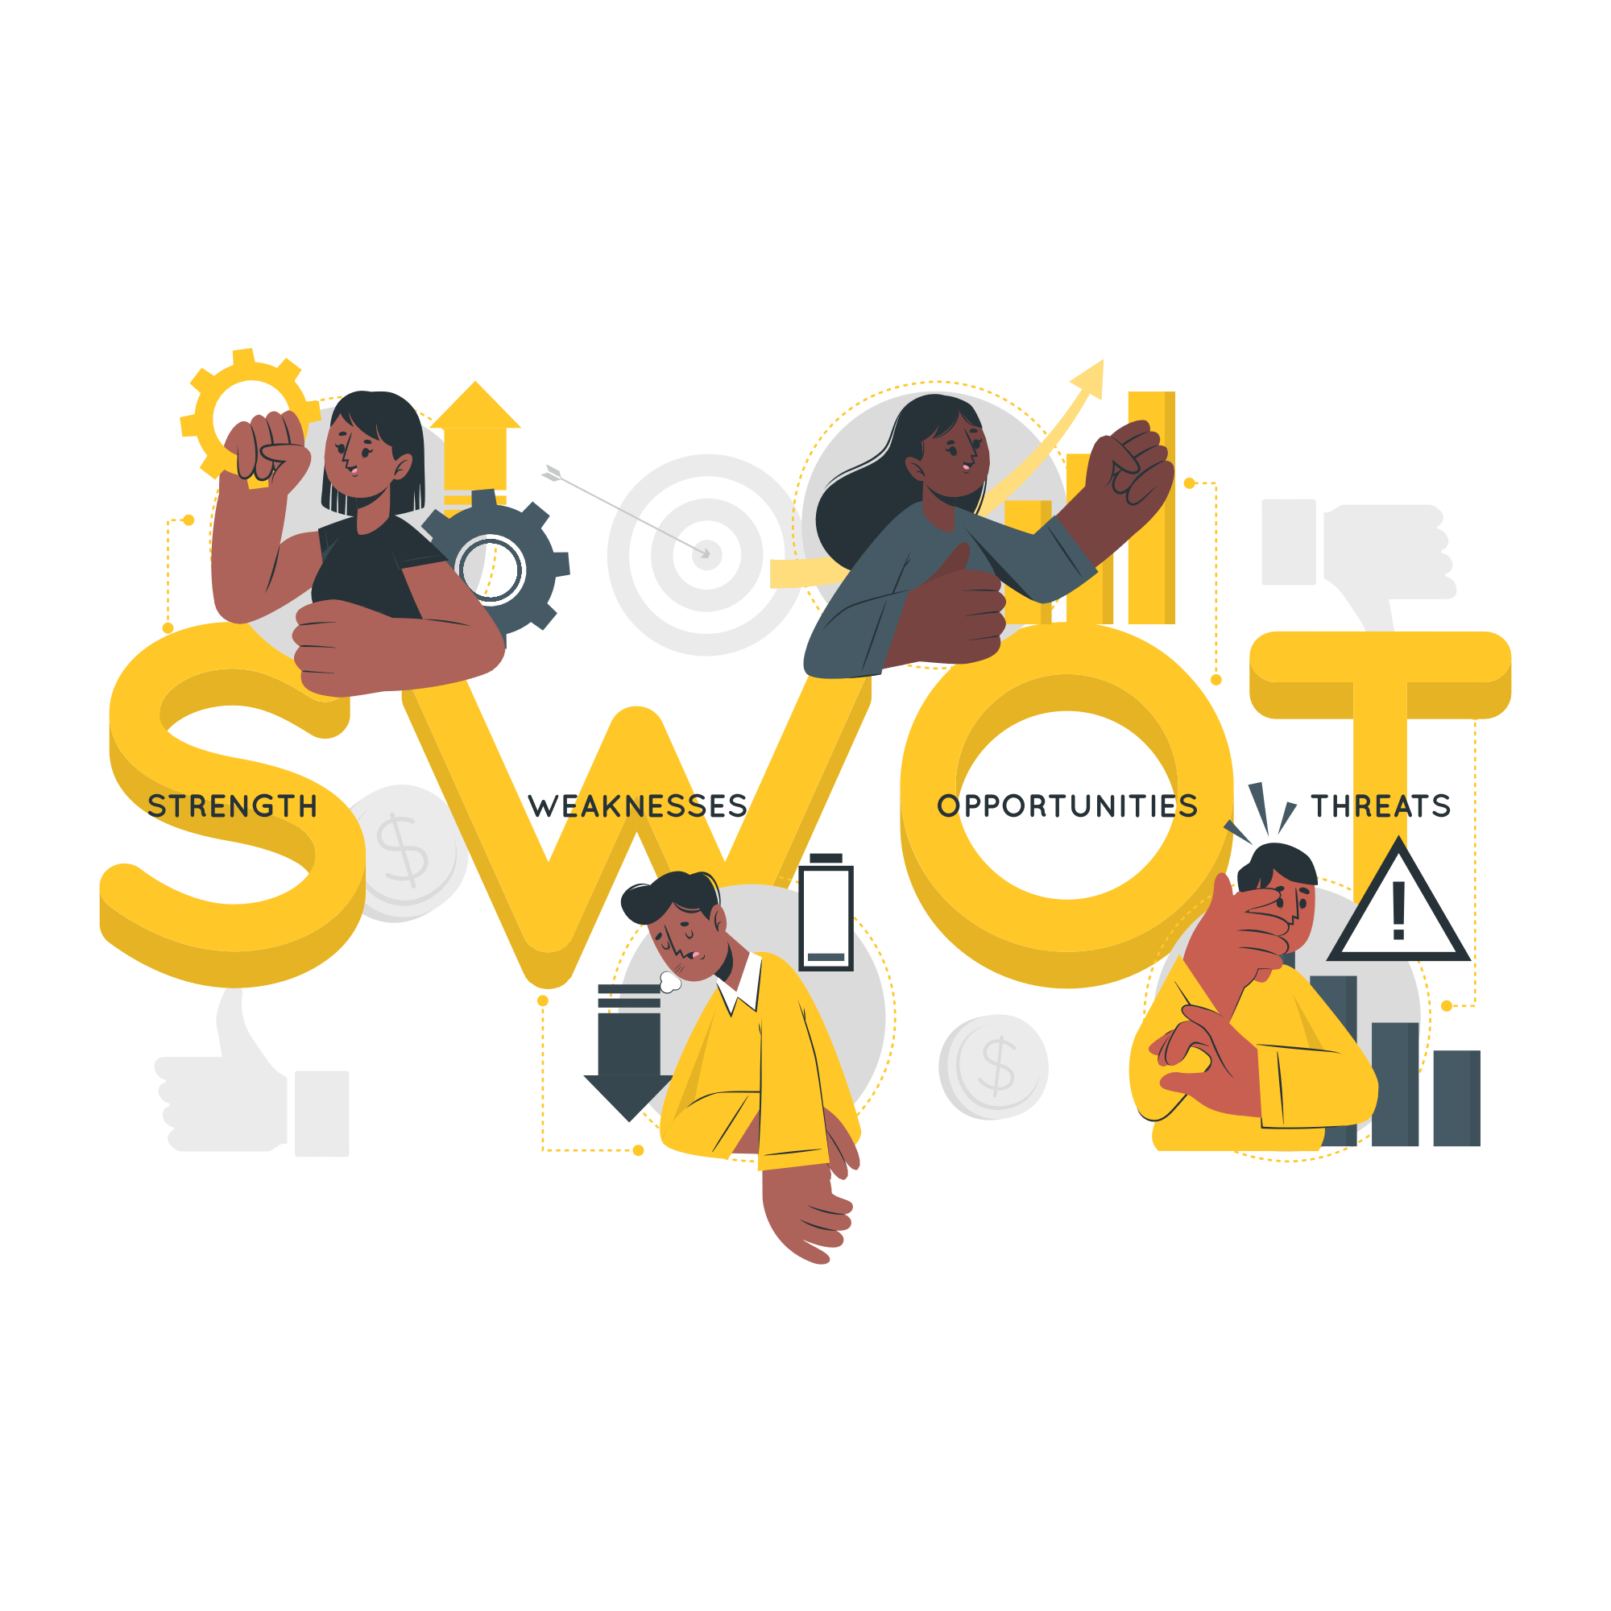
Figure1: SWOT Analysis

Strengths
Wilko, founded in 1930, has a strong brand and nearly a century of history. This durability has earned consumers' confidence and recognition. The retailer sells cleaning goods, gardening tools, and more to a broader audience (McEachern and Warnaby, 2019). Wilko's 400 UK locations provide convenient and accessible services to its large client base, boosting foot traffic and loyalty. Wilko's operations depend on its broad reach and diverse product.

Weaknesses
A £38 million pre-tax loss and a drop in cash savings to £57.8 million show how bad Wilko's recent money problems have been (Dearbail Jorda, 2023). This slowdown shows how dependent the company is on the unstable UK market, which makes it even more vulnerable during economic downturns. Its financial security has also been harmed by questionable management choices, like the £3 million dividend payment while the company was losing money.

Opportunities
Acquisitions: Wilko has received early interest from purchasers, suggesting recapitalization. Financial support from this investment may help the business survive and grow.
E-commerce expansion: Wilko might minimise its dependence on brick-and-mortar stores by expanding online (Pournader et al., 2021). Wilko can capitalise on the 46% increase in UK internet purchasing last year by focusing on e-commerce.
Strategic Alliances: Wilko could strengthen its market position by merging or partnering with complementary retailers. Such collaborations would improve operating efficiency, extend consumer bases, and diversify product offers, improving market reach and stability (Bürgy, Michon-Lacaze and Desaulniers, 2019).

Threats
Economic Instability and Consumer Spending: The economic slump and rising inflation have cut consumer spending, threatening Wilko. Inflation rates have risen beyond 7% this fiscal year, forcing customers to prioritise essential over discretionary spending, hurting companies like Wilko that rely on in-store visitation.
Resilient Retailers: B&M, Poundland, and Lidl's strong supply chains and aggressive pricing make competition tough (Reuters, 2023). By targeting budget-conscious shoppers, these competitors have taken market share from Wilko.
Risk to Reputation and Workforce Stability: Potential redundancies and shop closures could damage Wilko's reputation and customer trust (De Giovanni, 2020). Employee morale may decline, impacting service quality and operational efficiency, essential for retail success in tough times.

Strategic Recommendations
Strategic Advice Secure Investment: Prioritise buying or investing in Wilko to stabilise its finances. Engaging with preliminary investors could avert financial deterioration and sustain operations during strategic reforms.
Restructure Operations: Prioritise profitable sectors and geographies. Analyse sales data to find profitable regions and cut unprofitable ones. This method would reduce expenditures and boost revenue (Dolega, Rowe and Branagan, 2021).
Enhance Online Presence: Improve the online shopping interface to suit post-pandemic consumer expectations (Queiroz, Telles and Bonilla, 2019). A speedier, more intuitive website and innovative digital tools like AI-driven suggestions can increase online sales and client base.

PESTLE Analysis of Wilko's Decline
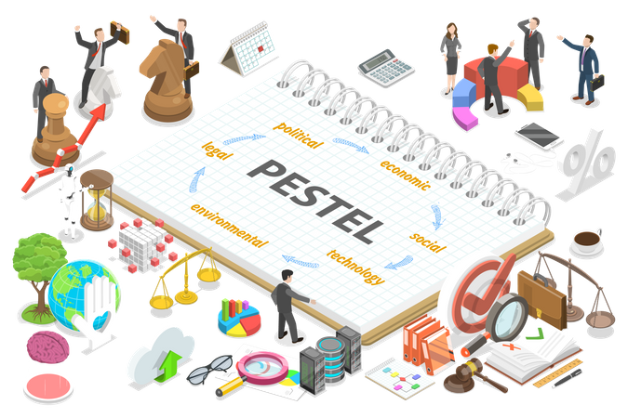
Figure 2: PESTLE Analysis

Political Factors Impacting Wilko
Brexit and Trade: Trade obstacles and higher tariffs have affected Wilko's supply chain since the UK left the EU (Amsl et al., 2023). These adjustments have raised operational costs, hurting profits. Tariffs on imported items, which make up a substantial component of Wilko's inventory, have raised prices and squeezed margins.
Government Interventions: The temporary VAT decrease for some industries and company rates relief have cushioned economic downturns in the UK. However, retail sector support has been erratic and sometimes insufficient to counterbalance the negative consequences of extended economic struggles on companies like Wilko, who depend on stable market conditions to sustain their low prices (Fritz et al., 2019).

Economic Analysis
In 2021, UK inflation reached a 40-year high of 9.1%, and interest rates were raised to 1.75% by mid-2023 to reduce inflation. This economy has shaped consumer behaviour, especially in bargain shopping. Discount stores are seeing increasing business as people seek cheaper shopping options due to growing living costs (Kopetz and Steiner, 2022). Despite rising client traffic, inflationary factors that lower disposable incomes have limited revenue growth, creating a contradictory problem for Wilko.

Social Factors Impacting Wilko
Altering Consumer Behaviour: Recent trends show a shift towards sustainable internet shopping. A 2023 Retail Industry Report found that 65% of UK consumers chose eco-friendly brands. Wilko may enter into this burgeoning market area by offering eco-friendly products.
Demographic Shifts: The UK's demographic landscape is changing, with millennials and Gen Z becoming the primary consumers. Tech-savvy, cost-conscious consumers choose convenience and value, which Wilko can capitalise on by improving online services and personalising products (Galera‐Zarco et al., 2020).

Technological Analysis
Digital Transformation in Retail: Wilko must adapt to digital commerce to survive. Large internet retailers dominate with powerful e-commerce platforms. To attract more customers, Wilko needs add AI-driven recommendations and mobile-first shopping experiences to its website.
Streamlining Operations: Wilko can cut costs by using automated inventory systems and data analytics. These technologies boost efficiency and reveal customer behaviour, enabling more targeted marketing and stock management, essential for financial recovery and competitiveness.
Legal Considerations for Wilko
Compliance with UK Retail and Employment Laws: Wilko must follow UK employment rules, including staff management, while it enters administration. This includes Insolvency Act and Employment Rights Act requirements to consult employees about redundancy, fair treatment, and sufficient notice periods. Failure to comply might result in serious legal and financial fines.
Securing Deals and Partnerships: Wilko must examine the Companies Act and contractual duties when restructuring (Purcărea et al., 2022). Financial and operational regulations must be checked before any deals or partnerships are made to avoid liabilities and guarantee the restructuring process is lawful and advantageous to all stakeholders.

Environmental factors affecting Wilko
Consumer demand for eco-friendly products: Environmentally friendly items are becoming more popular, especially in the UK. Current surveys show that over 60% of UK buyers favour eco-friendly products, giving Wilko an opportunity to adapt its product line.
Sustainability Regulations: The UK government is tightening regulation of product packaging and waste minimization (Fergnani, 2020). Companies should limit plastic use and enhance recycling. To avoid penalties and meet consumer expectations, Wilko may need to change how it packages and markets items under the new law.

Strategic Recommendations
Take advantage of government support: Wilko should actively seek government economic help to reduce its financial problems. This comprises emergency funding, tax relief, and business support loans for failing enterprises to keep jobs and operations going.
Accept Technology: Wilko needs a strong online retail platform to compete. This includes modernising their e-commerce platforms, using data analytics for customer insights, and integrating advanced logistical solutions to improve shopping and market reach(Caboni and Hagberg, 2019).
Adapt to Social and Environmental Trends: Wilko must reposition its products to suit consumer demand for sustainable and ethical items (Sholihah et al., 2020). This involves procuring eco-friendly items, optimising packaging to decrease waste, and promoting products that meet consumers' ethical standards.

Evaluation of Options and Decision-Making
There are several possible ways to handle Wilko's cash problems. To begin, the company could have gotten instant help by reorganising its debt. Talking to creditors about getting longer payment terms or lower interest rates could have eased short-term money problems (Dekimpe, 2019). However, this method depends on creditors working together and doesn't fix the problems that cause operations to be less efficient. Second, adding more types of products and spending money on e-commerce systems could have brought in extra money.
Wilko could have gotten a bigger piece of the growing online shopping market by making its web footprint bigger. How well this approach works depends on how much money the company has to invest at the start and how quickly it can adapt to changes in digital shopping. Streamlining processes to cut costs is a third choice. This could have meant closing shops that weren't doing well, improving the way the supply chain is managed, or renegotiating contracts with suppliers (Verhoef and Bijmolt, 2019). Cost-cutting steps like these might help, but they could also hurt employee happiness and the brand's image.

Conclusion
Using SWOT and PESTLE models, the study showed important reasons that led to Wilko's fall. Mismanagement of finances and unstable leadership were two of the company's biggest weaknesses. Tough market competition and an unstable economy made things even worse. Opportunities that were missed, like going digital and adapting to changing market trends, were very important ones. Wilko's business was greatly affected by the mini-budget and the subsequent economic slump, as well as by changes in customer habits and new shopping technology. To stop these kinds of drops, stores like Wilko should make it a high priority to be financially stable and keep their leadership and operating strategies flexible. The goal of these suggestions is to help stores find their way around the complicated retail world so they can stay in business and grow in a market that is changing quickly.

References
Amsl, S., Watson, I., Teller, C. and Wood, S. (2023). Presenting products on websites – the importance of information quality criteria for online shoppers. International Journal of Retail & Distribution Management. doi:https://doi.org/10.1108/ijrdm-04-2023-0266.
Bürgy, R., Michon-Lacaze, H. and Desaulniers, G. (2019). Employee scheduling with short demand perturbations and extensible shifts. Omega, [online] 89, pp.177–192. doi:https://doi.org/10.1016/j.omega.2018.10.009.
Caboni, F. and Hagberg, J. (2019). Augmented reality in retailing: a review of features, applications and value. International Journal of Retail & Distribution Management, 47(11), pp.1125–1140. doi:https://doi.org/10.1108/ijrdm-12-2018-0263.
De Giovanni, P. (2020). Blockchain and smart contracts in supply chain management: A game theoretic model. International Journal of Production Economics, 228(1), p.107855. doi:https://doi.org/10.1016/j.ijpe.2020.107855.
Dearbail Jorda (2023). Wilko: Lisa Wilkinson ‘devastated’ over the firm’s failure. www.bbc.com. [online] 28 Nov. Available at: https://www.bbc.com/news/business-67552360 [Accessed 3 Jun. 2024].
Dekimpe, M.G. (2019). Retailing and retailing research in the age of big data analytics. International Journal of Research in Marketing, [online] 37(1). doi:https://doi.org/10.1016/j.ijresmar.2019.09.001.
Dolega, L., Rowe, F. and Branagan, E. (2021). Going digital? The impact of social media marketing on retail website traffic, orders and sales. Journal of Retailing and Consumer Services, [online] 60(102501), p.102501. doi:https://doi.org/10.1016/j.jretconser.2021.102501.
Ekaterina Salnikova and Stanton, J.L. (2021). Remove the negatives or highlight the positives? The effect of negativity bias in food preferences. British Food Journal, 123(7), pp.2601–2616. doi:https://doi.org/10.1108/bfj-11-2020-1035.
Embling, R., Pink, A.E., Lee, M.D., Price, M. and Wilkinson, L.L. (2020). Consumer perception of food variety in the UK: an exploratory mixed-methods analysis. BMC Public Health, 20(1). doi:https://doi.org/10.1186/s12889-020-09548-x.
Fergnani, A. (2020). Corporate foresight: A new frontier for strategy and management. Academy of Management Perspectives, 36(2). doi:https://doi.org/10.5465/amp.2018.0178.
Fritz, J., Stochl, J., Fried, E.I., Goodyer, I.M., Borkulo, C.D. van, Wilkinson, P.O. and Harmelen, A.-L. . van (2019). Unravelling the complex nature of resilience factors and their changes between early and later adolescence. BMC Medicine, [online] 17(1), pp.1–16. doi:https://doi.org/10.1186/s12916-019-1430-6.
Galera‐Zarco, C., Opazo‐Basáez, M., Marić, J. and García‐Feijoo, M. (2020). Digitalization and the inception of concentric strategic alliances: A case study in the retailing sector. Strategic Change, 29(2), pp.165–177. doi:https://doi.org/10.1002/jsc.2319.
Kickert, C., vom Hofe, R., Haas, T., Zhang, W. and Mahato, B. (2020). Spatial dynamics of long-term urban retail decline in three transatlantic cities. Cities (London, England), [online] 107, p.102918. doi:https://doi.org/10.1016/j.cities.2020.102918.
Kopetz, H. and Steiner, W. (2022). Internet of things. Real-Time Systems, pp.325–341. doi:https://doi.org/10.1007/978-3-031-11992-7_13.
McEachern, M.G. and Warnaby, G. (2019). 1 - Community building strategies of independent cooperative food retailers. [online] ScienceDirect.
Pournader, M., Ghaderi, H., Hassanzadegan, A. and Fahimnia, B. (2021). Artificial intelligence applications in supply chain management. International Journal of Production Economics, 241(108250), p.108250. doi:https://doi.org/10.1016/j.ijpe.2021.108250.
Purcărea, T., Ioan-Franc, V., Ionescu, Ş.-A., Purcărea, I.M., Purcărea, V.L., Purcărea, I., Mateescu-Soare, M.C., Platon, O.-E. and Orzan, A.-O. (2022). Major shifts in sustainable consumer behavior in romania and retailers’ priorities in agilely adapting to it. Sustainability, 14(3), p.1627.
Queiroz, M.M., Telles, R. and Bonilla, S.H. (2019). Blockchain and supply chain management integration: a systematic review of the literature. Supply Chain Management: an International Journal, 25(2), pp.241–254. doi:https://doi.org/10.1108/scm-03-2018-0143.
Reuters (2023). UK retailer Wilko collapses, putting 12,000 jobs at risk | CNN Business. [online] CNN. Available at: https://edition.cnn.com/2023/08/10/economy/wilko-store-files-bankruptcy/index.html.
Sholihah, M., Maezono, T., Mitake, Y. and Shimomura, Y. (2020). Formulating service-oriented strategies for servitization of manufacturing companies. Sustainability, 12(22), p.9657. doi:https://doi.org/10.3390/su12229657.
Verhoef, P.C. and Bijmolt, T.H.A. (2019). Marketing perspectives on digital business models: A framework and overview of the special issue. International Journal of Research in Marketing, [online] 36(3), pp.341–349. doi:https://doi.org/10.1016/j.ijresmar.2019.08.001.
Xu, A.J., Loi, R. and Chow, C.W.C. (2019). What threatens retail employees’ thriving at work under leader‐member exchange? The role of store spatial crowding and team negative affective tone. Human Resource Management, 58(4), pp.371–382. doi:https://doi.org/10.1002/hrm.21959.

Appendix


