Digital Skills and Research Methods

Module Code: BMSW4003

Name: Loredana Andreea Zsofi
Student ID: 2111130

Lecturer: Amitave Banik
Abstract
The outbreak of the pandemic has given rise to the use of several new techniques in different fields. This has also ensured that the organization is able to undertake new measures so that they are able to solve modern problems. This outbreak of the pandemic has also made an impact upon the overall education system. This has also given rise to the virtual learning environment. Further, this has been one of the prime focus of the research and the different aspects which are associated with this process has also been included in the particular research.

Table of Contents
1. Introduction 5
1.1 Research Title 5
1.2 Rationale 5
1.2 Objectives 5
2. Literature Review 6
2.1 Introduction 6
2.1.1 Different techniques that has been included in the Virtual Learning Environment 6
2.1.2 Use of critical thinking skills in enhancing the learning process of the students 6
2.1.3 Impact of VLE on enhancing the critical thinking skills of students 7
2.2 Summary 7
3. Methodology 8
3.1 Data collection tools and techniques 8
3.2 Sample size 8
3.3 Data analysis 8
3.4 Ethical consideration 9
4. Data Analysis 12
4. 1 Primary Data Analysis 12
4.2 Secondary Data Analysis 15
Uses of critical thinking skills to enhance innovation among the students 15
Techniques of the Virtual Learning Approach 15
5. Conclusion and Recommendations 18
5.1 Conclusion 18
5.2 Recommendations 18
References 19
Books and journals 19
Website References 19
Appendix: Figures 21
List of figures
Figure 1 12
Figure 2 12
Figure 3 13
Figure 4 14
Figure 5 14

1. Introduction

1.1 Research Title
The impact of VLE on the on the skill development of the students- A research on University of Wales Trinity Saint David London Campus

1.2 Rationale
Virtual learning environment is a dynamic mode implemented in the academic field as this is a modern approach to the learning through internet or the use of mega devices that enhance the way of providing modern education. Due to the pandemic situations, many educational institutions started providing education through online methods which thus changed the whole process of modern learning. This is one of the important aspects which can help me in understanding the different aspects of the learning environment. Further, this will also ensure that I am able to undertake the research properly so that I am able to achieve better grades in my exams. Moreover, this will also ensure that I am able to enhance my learning process.

1.2 Objectives
Aim: To understand the role of the VLE on enhancing the critical thinking skills of the students of University of Wales Trinity Saint David London Campus.
Objectives:
1. To examine the different techniques that has been included in the Virtual Learning Environment.
2. To determine the use of critical thinking skills in enhancing the learning process of the students.
3. To analyse the impact of VLE on enhancing the critical thinking skills of students.

2. Literature Review

2.1 Introduction
This is one of the significant aspects of the overall research which helps in gathering more information regarding the overall research. Further, this also allows the individuals to gather more information about the Virtual Learning Environment. The different aspects of this particular method are discussed below:

2.1.1 Different techniques that has been included in the Virtual Learning Environment
The Virtual Learning Environment is one of the recent technological advancements which has helped the students of the modern time to gain more information regarding the subject matter. This process includes the role play among the classmates so that they are able to get interested in learning the syllabus which is included in the overall research. This also allows the students to gain the importance within the competitive environment (skillsyouneed, 2021). They are able to gain the proper knowledge regarding the different subjects which has helped them in enhancing the quality of the services. Further, this ensures that the students are able to minimise the mistakes which they make in their learning courses. Interaction is also one of the key approaches which is used by the organisation so that they are able to clear the confusion which they are having regarding the overall process.

2.1.2 Use of critical thinking skills in enhancing the learning process of the students
The critical thinking skills is one of the most significant skills which allows the individuals to think critically regarding the subject and they are able to share innovative ideas as well. This is one of the significant aspects which allows the students to think critically about a subject and ensure that they are able to gain the necessary advantages out of this particular issue (campbellsville, 2021). This also increases their chances of getting placed to one of the renowned organisation. Hence, it can be said that the students are able to make the modifications within their learning process so that they can increase the overall chances of getting better placement. Moreover, this particular learning approach can ensure that the organization is able to get in-depth knowledge regarding the subjects and they are able to gain the relevant advantages within the competitive market.

2.1.3 Impact of VLE on enhancing the critical thinking skills of students
The Virtual Learning Environment is one of the technological advancements which has taken place in the recent times. This is one of the significant aspects which has helped the student to get the in-depth knowledge regarding the different subjects and they are also able to enhance the critical thinking skills (Piedra, 2021). With the help of different audiovisuals which are present in the virtual learning environment, the student are able to get the proper details regarding the subject matter and they are also able to gain the relevant advantages from the application of the overall critical thinking skills. This help the student as well to think about more new ideas regarding this particular subject.

2.2 Summary
This section of the research has helped in discussing the different aspects which is related to the Virtual Learning Environment. It has also explained the impact of this aspect in enhancing the overall knowledge of the students.

3. Methodology

3.1 Data collection tools and techniques
There are several tools and techniques that make the research more effective. In this research both primary and secondary data has been used (Jansen & Warren, 2020). With the help of primary data, a survey link has been provided to the students that help them to gather information. Not only that, secondary data also been implemented that allow the students to gather information from various sources like different books, journals, articles, magazines and so on.

3.2 Sample size
An online survey will be conducted for this specific research due to the pandemic situations. Ten students have participated in this survey that helps the researcher to get or collect real and genuine information. With the help of this relevant information, the researcher can make the project more authentic. Moreover, this process saves the time of the researcher and allows them to gather effective answers.

3.3 Data analysis
It is referred to as the effective method that allows the researcher to collect information through using various kinds of techniques. It is one of the essential aspects of the overall research as it allows the researcher to get relevant information. This information helps the researcher to solve any kind of problems regarding the topic (Kothari, 2016). There are several data collection methods, qualitative and quantitative method is used in this research. Qualitative method allows the researcher to collect authentic information based on the real time. Quantitative method helps the researcher to conduct the overall research in a systematic way. In this research both these methods has been used so that the research can be supported with more authentic and real time information.

3.4 Ethical consideration
Ethical consideration is the most important part of this research. It allows the researcher to understand the limitations of the research and also allows them to identify the areas where they can make the required improvements. To make the research more effective the researcher takes some measures like security so that the data can be kept in a safe and secured way. Along with that, they also use strong password and ID that helps to protect all the information in a safe way. Apart from that, the researcher also follows all the rules and regulations that make the research more authentic. The researcher also takes permissions before conducting the survey with the students.

Questionnaire:
1. Does virtual learning supports the education system in this pandemic situation?
a. Yes
b. No
c. May be
2. Does Virtual learning is effective in developing efficient skills of the students?
a. Yes
b. No
C. May be
3. Does virtual learning promotes stress to the students?
a. Yes
b. No
c. May be
4. Is virtual learning better than offline mode of learning?
a. Yes
b. No
c. May be
5. Does University of Wales Trinity Saint David London Campus offers proper resources to the students for virtual learning?
a. Yes
b. No
c. May be

4. Data Analysis

4. 1 Primary Data Analysis
1
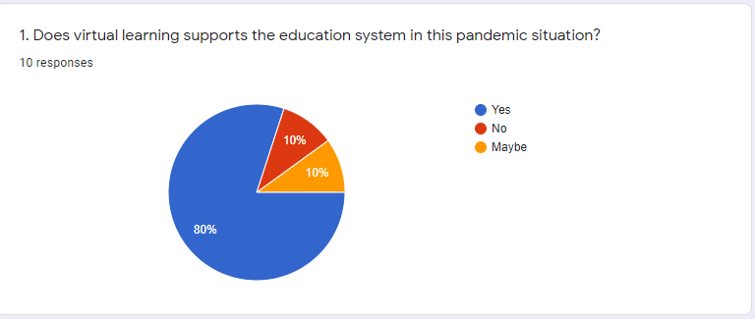
Figure 1
Source: (docs, 2021)
Analysis: In support of the above figure, it can be easily determined that the responses which came into support of the virtual learning was about 80%, whereas the response against the support of the virtual learning is 10% and for maybe it is 10 respectively.
2
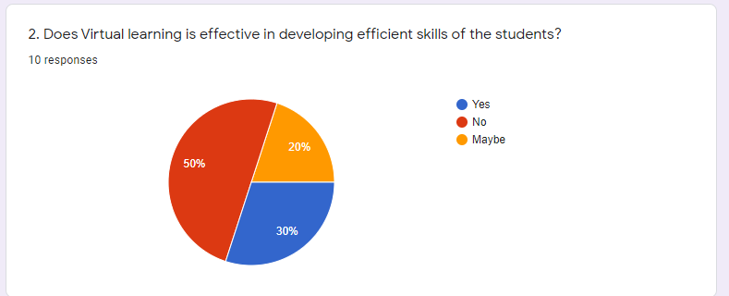
Figure 2
Source: (docs, 2021)

Analysis: The virtual learning is treated as a source to provide education in the pandemic situation with an aim of developing efficient skills of the students. Around 30% has responded for yes, 50% has responded for no and the remaining 20% responded for may be in the particular questionnaire.
3
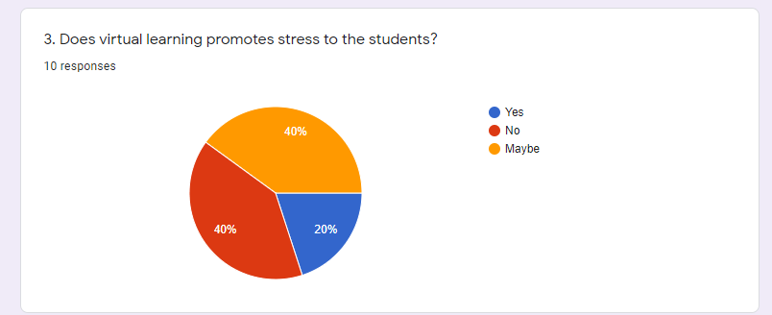
Figure 3
Source: (docs, 2021)
Analysis: In the above figure, different responses were collected whether the virtual learning promotes stress to the students, around 20% of the students responded for yes, 40% has responded against the question and 40% has responded for maybe respectively.
4

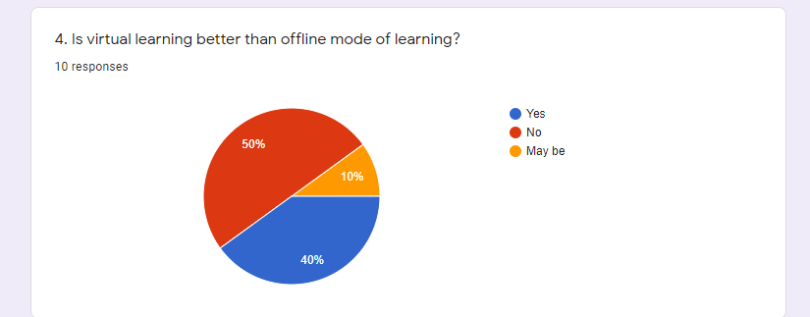
Figure 4
Source: (docs, 2021)

Analysis: Responses were collected to determine the opinion regarding the better mode of learning by choosing from the two alternatives, the virtual learning and the offline mode. 40% has responded for yes while on the other side, 50% has responded for no and the rest 10% responded for maybe respectively.
5

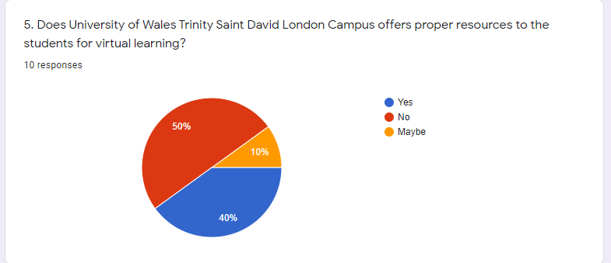
Figure 5
Source: (docs, 2021)

Analysis: The above figure explains to analyse on the University of Wales Trinity Saint David London Campus whether they provide proper resources for executing virtual learning. Around 40% has responded yes whereas 50% for no and the rest 10% has opted for maybe.

4.2 Secondary Data Analysis

Uses of critical thinking skills to enhance innovation among the students
Critical thinking is one of the most effective skills that helps the students to analyse any kind of complications in depth (Ennis, 2016). With the help of these skills, the students are able to make the right decisions as it allows them to research the topic in detail (Paul and Elder, 2017). Therefore, they are able to collect more and reliable information that helps to move the assignment effectively. Effective critical thinking skills allow the students to enhance their creativity level and also encourages them in a positive way. Along with that, it also helps in the successful growth of their career (Park, et.al, 2016, pp.41-51).
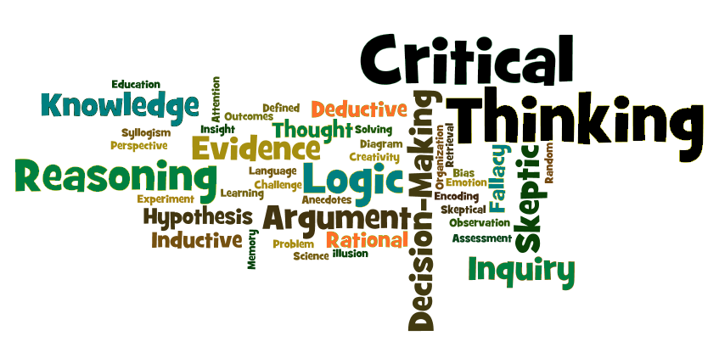
Source: (Piedra, 2021)

Techniques of the Virtual Learning Approach
There are several techniques that are used in Virtual Learning Approach. Those techniques are described in the following section.
Interaction:
It is one of the most significant techniques of the virtual learning approach. With the help of these techniques, the students are able to communicate with their teachers effectively. It allows the students to clear out their misunderstandings if any (Team, 2020). Effective interaction helps the students to solve their queries so that they can easily understand the topic. Along with that, it allows the student to show their interests in the subject. It helps the students to stay active in the classroom and share their points of view with each other, which allows them to enhance their already existing skills.
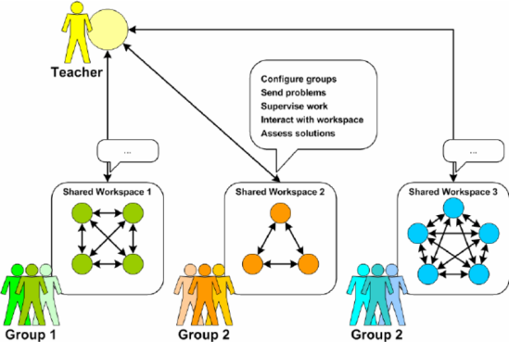
Source: (Piedra, 2021)
Feedback:
Feedback is essential for the students as it boosts their confidence level. Along with that, it also helps the students to enhance their overall performances. Apart from that, it allows the student to understand their strength and weakness so that they are able to know which areas need to be improved (HOLL, 2020). In this way, they are able to avoid repeating mistakes and enhance their pre-existing skills. Effective feedback allows the students to stay satisfied so that they can communicate with their team members effectively. Further, it also helps the students to stay focused in their study which helps in the successful growth of their career.
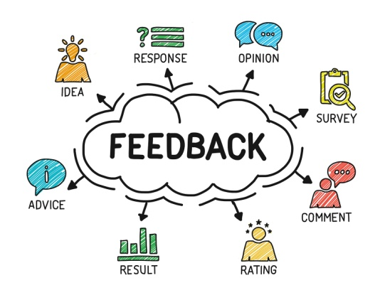
Source: (HOLL, 2020)
Audiovisuals:
Audiovisuals is the one of the most important tools that allows the students to interact with their teachers effectively (Morais, and de Laforcade, 2018, pp.116-122). With the help of audiovisuals, the teachers are able to show slides to the students that are more acceptable for them. It provides good experiences to the students that allow them to stay motivated. Along with that, it allows the students to stay encouraged (Baumiller, 2018).

Source: (HOLL, 2020)

5. Conclusion and Recommendations

5.1 Conclusion
The above research has mainly focused on the Virtual learning environment. Due to the pandemic situations, most of the institute used VLE platform. It is basically referred as the online platform that allows the students to get digital solutions. Along with that, it also enhances the learning experiences of the students. Effective VLE helps the teachers to track the overall performances of the students. Not only that, it also helps the teachers to plan their lessons effectively. Several techniques have also been described in this report that helps to increase the efficiency of the workplace. It has also discussed several methods that help the students to improve their already existing skills and knowledge.

5.2 Recommendations
There are different ways through which the educational institution will be able to enhance the use of Virtual Learning Environment. These strategies are described below which can allow the organisation to enhance the use of Virtua Learning Process:
Incorporating effective role play: The technique of role play is one of the effective ways through which the individuals are able to enhance the use of the virtual learning environment. This method will allow the students to get an in-depth knowledge regarding the overall process. It is recommended that the organisations can incorporate the technique of effective role play (Erstad, 2021).
Enhancing the use of audio visuals: The use of audio visuals can ensure that the individuals are able to get the proper information regarding all the process. This also ensures that the organisation is able to increase their knowledge regarding different subject as well. Hence, it is recommended that the individuals are able to enhance the use of the audio visuals.

References

Books and journals
Baumiller, R.C., (2018). Audiovisuals. American journal of human genetics, 42(4), p.637.
Ennis, R.H., (2016). A concept of critical thinking. Harvard educational review.
Kothari, C.R., (2016). Research methodology: Methods and techniques. New Age International.
Morais, F. and de Laforcade, S., (2018). Audio-Visuals. Grey Room, (73), pp.116-122.
Park, M.Y., McMillan, M.A., Conway, J.F., Cleary, S.R., Murphy, L. and Griffiths, S.K., (2016). Practice-based simulation model: A curriculum innovation to enhance the critical thinking skills of nursing students. Australian Journal of Advanced Nursing, The, 30(3), pp.41-51.
Paul, R. and Elder, L., (2017). Critical thinking. Rohnert Park, CA: Sonoma State University.

Website References
campbellsville, (2021). How Virtual Learning Is Transforming K-12 Education. [Online]
Available at: https://online.campbellsville.edu/education/virtual-learning-transforms-education/
docs, (2021). Google Forms. [Online]
Available at: https://docs.google.com/forms/d/1G3_DUA3e6aNFJILB36ncCzkBX6ZMZgzkFZ41R_L8yII/edit#responses
Erstad, W., (2021). 6 Critical Thinking Skills You Need to Master Now. [Online]
Available at: https://www.rasmussen.edu/student-experience/college-life/critical-thinking-skills-to-master-now/
HOLL, R., (2020). The Importance of Feedback. [Online]
Available at: https://www.learninga-z.com/site/breakroom/importance-of-feedback
Jansen, D. & Warren, K., (2020). What (Exactly) Is Research Methodology?. [Online]
Available at: https://gradcoach.com/what-is-research-methodology/
Piedra, D., (2021). Teaching in the Virtual Classroom: Strategies for Success. [Online]
Available at: https://evolllution.com/programming/teaching-and-learning/teaching-in-the-virtual-classroom-strategies-for-success/
skillsyouneed, (2021). Critical Thinking Skills. [Online]
Available at: https://www.skillsyouneed.com/learn/critical-thinking.html
Team, A. L., (2020). Training Methods for the Virtual Classroom (12 Popular Strategies and Tools). [Online]
Available at: https://www.avantixlearning.ca/training/training-methods-for-the-virtual-classroom-12-popular-methods/

Appendix: Figures
Figure 1:
Figure 2:
Figure 3:
Figure 4:
Figure 5:
Figure: 6
Figure: 7
Figure: 8
Figure: 9

