Name: Aidan Griffiths
Student ID: 2501271
Module: Database Concepts
Course Work 2

Contents
- Title Page
- Contents
- Introduction
- Task 1 content
- Report
- Testing
- References

Introduction
The scenario covers a leasing company called Eco Ride which is a green transport company used to promote a more sustainable and healthy commuting system using electric bikes for rent. The system allows riders to rent electric bikes from public areas such as parks, train stations and universities and can return them to any of these locations.
The idea of this system is to help replace paper-base processes using a well-documented and structured database to improve the efficiency, accuracy and visibility of the system. The system records the details of the riders, bikes, current rentals, maintenance and staff. Using this system should allow the reduction of bike loss, unreturned bikes, double bookings etc.

Task 1 content

Screenshot 1 – Navigation Pane
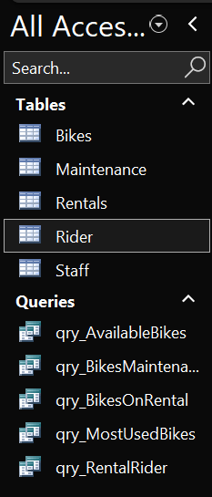
This shows the navigation panel with all the created tables and queries in the database.

Screenshot 2 – Bike Table Design View
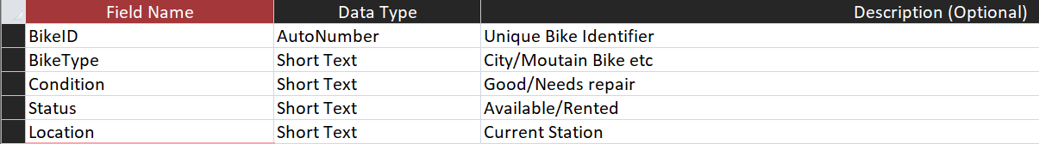
This shows fields, data types and descriptions used in the bike table

Screenshot 3 – Maintenance Table Design View
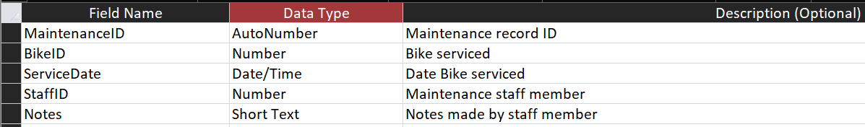
This shows fields, data types and descriptions used in the maintenance table

Screenshot 4 – Rental Table Design View
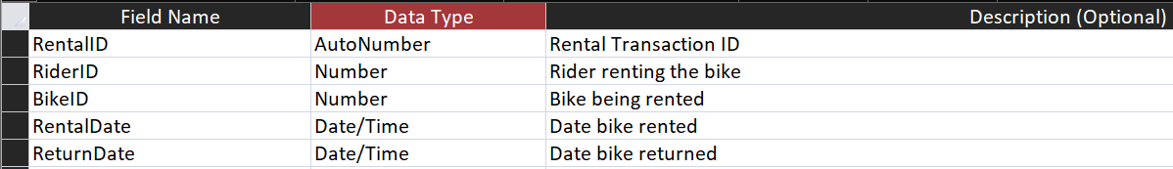
This shows fields, data types and descriptions used in the rental table

Screenshot 5 – Rider Table Design View
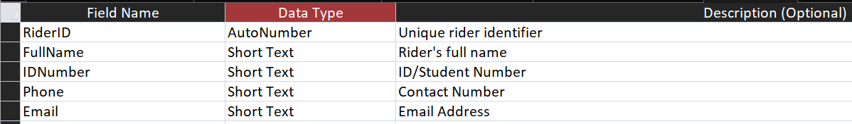
This shows fields, data types and descriptions used in the rider table

Screenshot 6 – Staff Table Design View
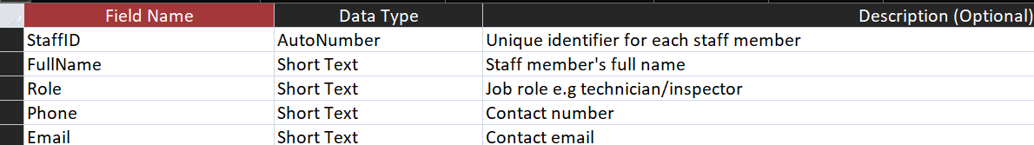
This shows fields, data types and descriptions used in the staff table

Screenshot 7 – Example query
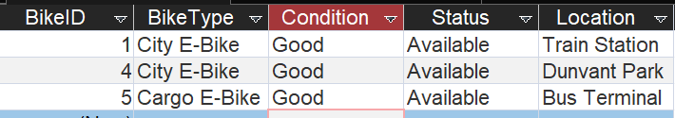
Query shows a search for available bikes only. The query also shows the condition, location and bike type of all the available bikes.

Screenshot 8 – Relationship diagram
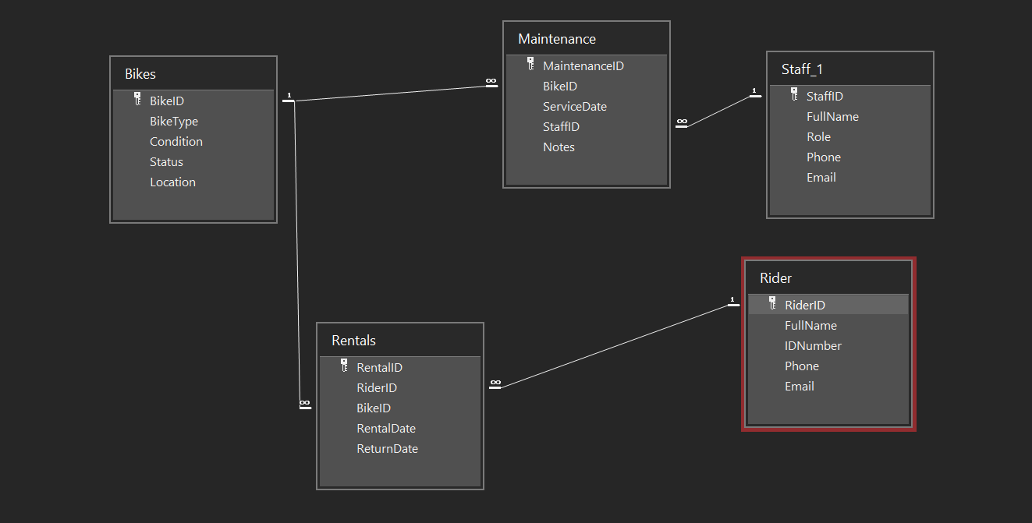
This shows the full entity relationship diagram containing all primary and foreign keys from each table including the 1-∞ symbols. An example of a primary and foreign relationship is the Rider ID being the primary key in the Rider table, and the foreign key in the Rental table.

Screenshot 9 – Example Datasheet View
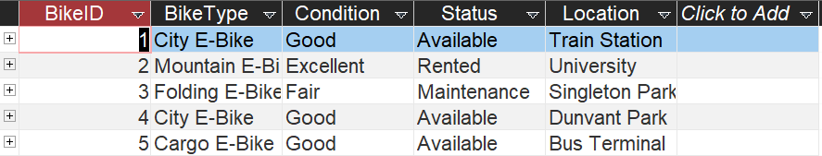
This is an example of a datasheet view of the Bike table showing all entered sample data including the bike ID, bike type, condition, status and location.

Report

Design Decisions
The system was designed based on relationships to ensure the data is accurate and consistent. The key entities of Riders, Bikes, Maintenance, staff and rentals were identified based off the requirements of the system. Each one was implemented by creating separate tables and were given primary keys to identify records uniquely. Furthermore, foreign keys were used to establish relationships between the entity tables and the enforce referential integrity tool was used to prevent invalid records.
In addition, the system was normalised to 3NF (Third Normal Form). This minimised redundancy and dependency issues which shows how this design supports maintenance tracking and will improve the overall data integrity.

System Implementation
The system allows riders, management of bike inventory, recording of rentals and tracking of maintenance and staff to be registered to the database. A collection of sample data was used to populate each table and reflects the scenario requirements of active rentals, available bikes and bikes in maintenance. Queries were also used to show the functionality of the system including the viewing available bikes, showing bikes currently on rental, tracking the current maintenance, rider activity and identifying the most used bikes.

Challenges and Future improvements
One of the main challenges that occurred was making sure all the relationships were defined correctly and the referential integrity was enforced without causing issues when entering sample data.
In the future, the system could be improved by using automated validation such as preventing the rental of a bike that is already unavailable.

Validation and Functional Testing

Functional Testing
Functional Requirements | Test | Expected Result | Actual Outcome | Result
Register Riders | Added multiple rider records to the rider table | Rider details stored with unique RiderID | Riders added successfully | Pass
Manage bike records | Added bikes with different types, conditions and statuses | Bikes stored and retrievable | Bike records displayed correctly | Pass
Record bike rentals | Created rental records linked to existing riders and bikes | Rentals linked only to valid RiderID and BikeID | Invalid entries blocked by referential integrity | Pass
Track maintenance activities | Added maintenance records linked to bikes and staff | Maintenance linked to valid BikeID and StaffID | Maintenance records stored correctly | Pass
Track staff involvement | Linked maintenance records to staff members | Staff member identified for each maintenance task | Staff involvement correctly recorded | Pass
Enforce data integrity | Attempted to delete a bike with related records | Deletion prevented | Referential integrity enforced | Pass
Track bike returns | Updated ReturnDate for completed rentals | Rental marked as completed | Return dates updated correctly | Pass

Query Testing
Query Name | Purpose | Test Ran | Expected result | Actual Result | Result
qry_BikesOnRental | Identify bikes currently rented | Ran query with active rentals present | Bikes with no return date displayed | Correct records returned | Pass
qry_AvailableBikes | View bikes available for rental | Ran query filtering status = available | Only available bikes shown | Correct bikes listed | Pass
Qry_BikesMaintenance | Identify bikes needing service | Ran query filtering status = maintenance | Bikes under maintenance shown with staff full name | Correct records returned | Pass
Qry_MostUsedBikes | Identify most used rented bikes | Rand totals query count | Bikes ranked by number of rentals | Correct ranking displayed | Pass
Qry_RentalRider | View rental history of a rider | Entered rider name parameter | Rental history displayed | Correct rental history shown | Pass

References
All references used from the Moodle tutorial word documents for Microsoft Access work

Microsoft Access
[1] Home&Learn, “Microsoft Access - Free Course: Queries,” Homeandlearn.co.uk, Apr. 2023. Available: https://www.homeandlearn.co.uk/access/access-queries.html. [Accessed: Jan. 19, 2026]

