
RESEARCH PROPOSAL
A critical analysis of responsibility within the sports supplements market with particular reference to eBay.


Vivian Presgrave (p151998)
P151998

Table of Contents
List of figures 2
1. Introduction 3
1.1 Rational 3
1.2 Aims and Objectives 3
1.3 Background and literature review 4
2. Research Design 6
2.1 Methodology 6
2.2 Research Philosophies 7
2.3 Research Approaches 8
2.4 Research Strategy 9
2.5 Time Horizon 10
2.6 Sample 10
2.7 Data Collection Methods 10
2.8 Limitations and Ethical Considerations 11
2.8.1 Resource Limitations 11
2.8.2 Ethical Considerations 11
3. Reliability and validity 12
4. Resources and planning 13
4.1 Resources 13
4.2 Gantt Chart 13
15
5.0 References 16
6.0 Appendices 19

List of figures

Figure 1-CSR Pyramid by Carroll (1991) 4
Figure 2: Research Onion by Saunders (2009) 7
Figure 3:The Process of Deduction by Bryman and Bell (2007) 8
Figure 4:Gantt Chart showing the tasks carried out during the dissertation process 15
Figure 5:Step Model of deductive category application by Mayring (2000) 19

Introduction
This aim of this research is to critically analyse responsibility within the sports supplement market with particular reference to eBay.

1.1 Rational
Low-self-esteem, poor body image and insecurities of not meeting the modern ideal of masculinity are causing more men to spend and consume sports supplements, which is causing several health and phycological issues (Reaney, 2015). Bigorexia is an example of a phycological issue that could arise, due to the obsession with the use of sports supplements. eBay exploits the issue, by offering and promoting cheaper or discounted sports supplements in order to attract more customers, without regarding the dangers associated with unregulated sports supplements.
For a competitive market to coordinate adequately, buyers must have appropriate information to evaluate competing products or services (Friedrich Hayek, 1945). However, sports supplements on eBay may fail to produce adequate information and regulations for a number of reasons:
- Cost to produce information may be high
- Low incentives to provide the necessary information
- There may be incentives to falsify information
Often customers seeking a health-and-energy boost may be reluctant to purchase expensive vitamins and supplements from upscale stores and distribution outlets. Instead, turning to sites such as eBay to purchase vitamins for cheaper prices. According Collins (2013), counterfeit products with unsafe chemicals are often a quick and dishonest technique used in the supplement world is to create a pill that mirrors a name-brand health supplement.
According to NHS (2013), traces of dangerous chemicals such as, Dinitrophenol (DNP) can also be present in some supplements, such as fat burners and are very dangerous health to human health, inevitably leading to a coma or death.

1.2 Aims and Objectives
The aim of this research will examine the responsibility within the sports supplement market, specifically at eBay.
There are three objectives of this study:
- Critically analyse responsibility in the sports supplements market

- Investigate regulation within the sports supplements market

- Make recommendations into how the challenges can be solved for the needs of future consumers

1.3 Background and literature review
Corporate Social Responsibility (CSR) intends to ensure that corporations, such as eBay operate their business in an ethical manner. This suggests that businesses, such as eBay have economic, legal, ethical and philanthropic responsibilities, which is represented by Carroll’s pyramid (1991).
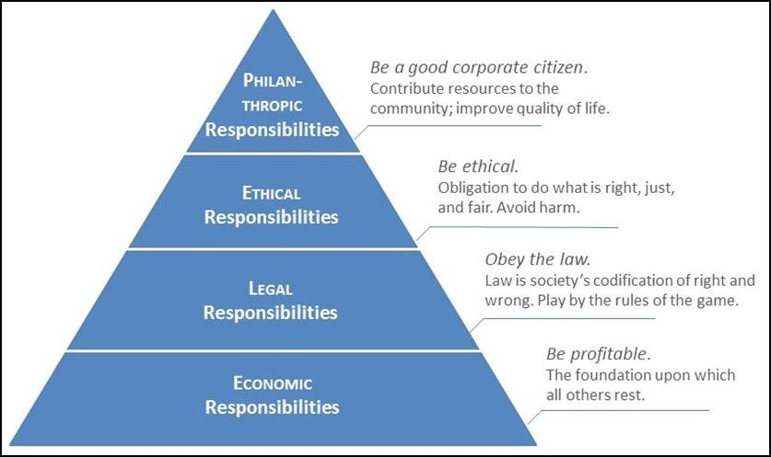

Figure 1-CSR Pyramid by Carroll (1991)

However, Milton Friedman opposes this stating the only responsibility of a corporation is to maximise its profits, as long as it stays within the laws (Friedman,1970). Freeman’s stakeholder theory disputes this, by advocating the consideration of several constituencies’ interest when making decisions for a business (Freeman, 2010).
This isn’t the case with eBay as they respond inadequately to the responsibilities of internal strategies, such as self-regulation against the sales of some untested or unlicensed sports supplements.
There is currently no major influence that insists on the self-regulation of sports supplements on eBay, which adversely doesn’t create social responsibility in eBays corporate culture.
Due to the nature of the sports supplement industry, eBay is often criticised for unethical and unregulated sales of sports supplements.
The public theory of interest supports this, by asserting intervention is necessary when markets deviate from perfect market conditions. (Pigou, 2013). Often, “market failure” occurs when a system of price-market institutions fails to stop “undesirable” activities, such as the sales of counterfeit or expired supplements that contain dangerous chemicals. Three key market failures include, monopolies, uncompensated negative externalities, and asymmetrical information. These theories will be explored in detail in the main body of the dissertation.

Research Design

2.1 Methodology
According to Wall (2007) research consists of a course of actions that are undertaken with the objective of understanding and identifying something new about a specific topic, field, subject or discipline. This study intends to do that by investigating the responsibility of sports supplements being supplied to customers purchasing from eBay.
Bauman, et al., (2013) believes research has three purposes, this includes attaining knowledge on a specific subject, translating the findings, so they can be applied in practice, and informing policy.
According to Saunders, et al., (2007) the research process can be represented as an onion. Several layers and approaches are accessible and therefore should be utilised when conducting research.
Issues such as, research strategies and approaches are some issues that must be addressed before the central point and core of the onion (data collection and analysis).
Figure 2 illustrates the contents of the onion layers. The following subsections explain the contents of the onion: philosophies, approaches, strategies, choice, time horizons, and techniques and procedures. To successfully obtain the objectives presented in the research question, a systematic route will be applied using the layers illustrated in figure 2.
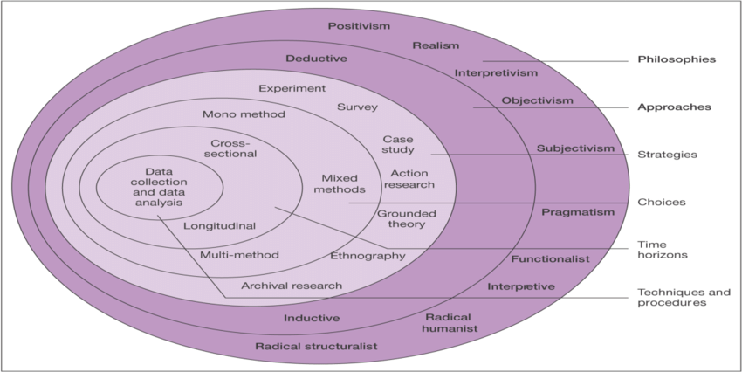Figure 2: Research Onion by Saunders (2009, p.108)

2.2 Research Philosophies
Saunders, et al., (2007) proposes the two key philosophies involved in the research are interpretivism and positivism. As a philosophy, positivism is only concerned with “factual” knowledge, which is obtained through observation. Positivism studies the role of the researcher and is limited to data collection and interpretation in an objective way.
The Philosophy applicable for the purpose of research is mainly positivism, and in order to attain the research objectives presented in the research question, research findings will be observable and quantifiable, through the use of surveys. Interpretivism comprises of the researcher’s interpretation on elements of the study (Myers, 2008). Therefore, interpretivism incorporates human interest into a study.
There will also be components of interpretivism implemented which will provide recommendations, in to how the challenge’s facing sports supplement regulations on eBay can be resolved
Extensive qualitative data will be attained through a content analysis. Due to the fact, positivism and components of interpretivism are integrated in the research philosophy, it is more suitable to define the philosophy as pragmatism.

2.3 Research Approaches
The two research approaches, are deductive and inductive (Saunders, et al. 2009 and Collins and Hussey 2009). The deductive theory involves planning a theory and research strategy to test a set hypothesis, which can be utilised to examine and explain associations between cause and effect variables (Saunders et al. 2000).
The concepts in a deductive approach have to be operationalised in a manner, that allows facts to be measured quantitatively.
However, an inductive approach consists of a theory being developed on the basis of analysis of collected data (Saunders, et al 2000).
The purpose of this study is deductive, as it follows set objectives, in order to attain a conclusion from the statistical analysis of the data collected (Lee and Lings, 2008).
Moreover, the application of the deductive approach will help to explain the problems associated with sports supplement sales on eBay. The process of deduction is presented below.
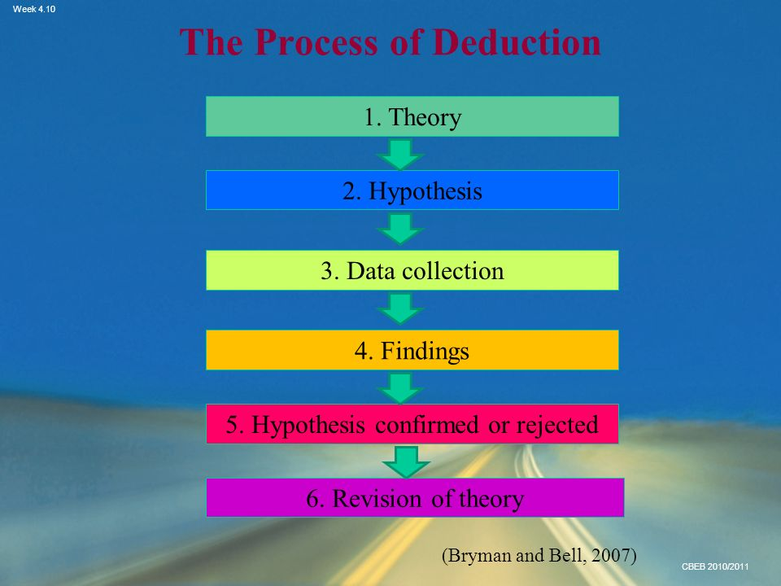

Figure 3:The Process of Deduction by Bryman and Bell (2007)

2.4 Research Strategy
Saunders, et al. (2007) believes research strategy is concerned with how the researcher plans on conducting the research using a variety of tools and techniques during the process. The research onion, by Saunders, et al., (2007) clearly shows there are five methods that can be utilised for collecting primary data.
This study will look to employ surveys in the form of online questionnaires and a content analysis of sports supplements on eBay. According to Blankenship (2009), questionnaires are important as it allows the researcher to attain data that will describe the research group being analysed and allow the researcher to attain a better insight into their attitudes, beliefs or preferences on the subject of sports supplements. This form of survey will be applied to obtain statistical, tangible data (in accordance with the positivism philosophy) on the use of sports supplements amongst users of sports supplements. The data collected will be analysed quantitatively. The second part will involve an online questionnaire which follows a positivism approach with closed questions using a Likert scale with a section of close-ended questions which will be deductively analysed quantitively, using statistics on Microsoft Excel. The same questionnaire will have open ended questions, which is an interpretive approach, inductively analysed with thematic analysis.
The qualitative research method of a content analysis will be used to collect and data systematically and reliably, so that patterns and generalisations can be established from the relation to the categories of interest to the researcher (Haggarty, 2009). The research conducted will used to obtain a better understanding on the sports supplement market on eBay. Whilst conducting a content analysis, ‘coding units’ will be utilised. These units vary vastly according to the data obtained, but an example would be the number of positive and negative responses by customers reviewing a specific supplement. The procedure for a content analysis is presented below, in the Appendices. It will also insure a statistical analysis will be produced quantitively. The comparison of quantitative and qualitative data will allow for a more in-depth analysis.

2.5 Time Horizon
The research will be associated with cross sectional time horizon approach and will be used as a research tool used to capture information based on data gathered for a specific point in time. The data gathered is from a pool of participants with varied characteristics and demographics known as variables.
However, Page., et al., (1995) argues it does not help determine cause and effect and cannot be used in determining the cause and effect of the subject being studied.

2.6 Sample
According to Thomson (2012), sampling consists of selecting some part of a population to observe, so that one may estimate something about the whole population. Purposive sampling, or judgemental sampling involves the researcher’s knowledge about the population, and is utilised to hand-pick sample members for the research study (Denise F, et al., 2008). This is advantageous and crucial for this study, as a homogenous sampling technique will be applied to select participants that already have a knowledge and understanding about the sports supplement industry, due to purchasing or using sports supplements (Macnee & McCabe, 2008).

2.7 Data Collection Methods
This study will utilise a mixed-methods triangulation design where questionnaires and a content analysis will provide a diverse range of data for interpretation. According to Denzin (1978), triangulation is a combination of qualitative and quantitative methodologies, to support a research design as a single method cannot sufficiently resolve issues of rival causal factors.
Qualitative data received from the content analysis and quantitative data from the questionnaires will be beneficial, as it will show patterns or contrasts between the outcomes, and therefore provide a greater understanding and analysis of the data and how it relates to the set objectives of the research question.
There will be approximately 200 respondents for the questionnaire. Questionnaires also, reduce the set-up and administration costs and it is easier to collect sensitive information via online questionnaires than face to face (Explorance. 2018).
In my studies, people who use sports supplements will be targeted as respondents for the questionnaires and content analysis.

2.8 Limitations and Ethical Considerations

2.8.1 Resource Limitations
The main issue to consider during this research study is not being able to capture emotional responses or feelings of the respondents in question. As, the questionnaire is not face-face, the researcher cannot observe changes in body language or facial expressions when respondents answer questions.
To combat this a Likert scale will be utilised, too see how strongly the respondents agrees or disagrees with the questions provided. Allowing the researcher, to obtain a greater assertion in response.

2.8.2 Ethical Considerations
Cooper and Schindler (2008, p.34) believes ethics are the norms or standards of behaviour that direct moral choices about an individual’s behaviour and how they relate or interact with others. For this research, an ethics document with stringent ethical regulations will be followed. Participants engaging in the research are informed about the specificities of the research, it’s purpose and guidelines needed to achieve its aims and objectives.
All participants involved will be 18 years or above and will therefore legally qualify to provide their own consent to partake in the research study.
The research is accompanied by an ethics form which will comply with confidentially regulations, and ensure confidentially of participants information attained in the research.

Reliability and validity
Cooper and Schindler (2003) asserted reliability involves supplying consistent findings. Whereas, validity is involved with the extent of accuracy represented by research findings in a particular situation (Hussey and Collins, 2013).
According to Hussey and Hussey (1997) validity is concerned with the extent to which the research findings accurately represent what is really happening in the situation. According to Easterby-Smith et al (2008), the reliability of a research project can access by implementing the following three questions:
- Do the measures duplicate the same findings on different occasions?
- Did other academics researching the subject achieve the same findings?
- Is a transparency, as to how the raw data was analysed?
It is vital for this study to take into account the challenges that could face the reliability and validity of the findings through minimising error and biased results, whilst ensuring the appropriate research design and methodology is implemented to attain the objectives of the research question.

Resources and planning

4.1 Resources
This report will look to employ any relevant resources that will contribute to the gathering, examination and presentation of the proposed research. Several forms of secondary resources, such as books, academic reports, videos, academic journals and specific websites, such as the NHS (National Health Service) website will be utilised to support the study. Secondary Research is crucial for the research project, as it’s relatively quick to access and it provides a suitable idea of the validity of the data (McQuarrie, 2015).

4.2 Gantt Chart
A Gantt chart is a tool that displays detailed tasks that need to be completed, over a specific time period (Kumar,2015). The Gantt chart provides the researcher with a blueprint to remain on the right track and accomplish the set tasks during the timeline. Presented below in Figure 4, is the Gantt chart that will be utilised to compete tasks during the dissertation.

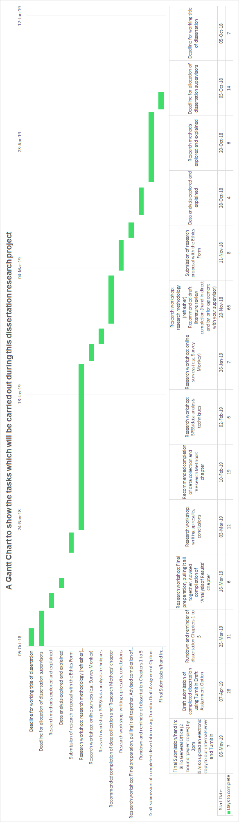
Figure 4:Gantt Chart showing the tasks carried out during the dissertation process

5.0 References
Aljazeera's Male body image - Bigorexia / Muscle Dysmorphia, 2015 (video file), Available from:< https://www.youtube.com/watch?v=5PFh7Filn7k> {18 November 2018}
Ainsworth, R. (2018). Warnings issued over deadly DNP 'diet drug'. [online] nhs.uk. Available at: https://www.nhs.uk/news/medication/warnings-issued-over-deadly-dnp-diet-drug/ [Accessed 18 Nov. 2018].

BBC News 'Bigorexia': Muscle dysmorphia 'now affects one in 10 gym-going men', 2015 (video file), Available from:< https://www.youtube.com/watch?v=VqJpDS8F6hk> {18 November 2018}

C.Blankenship, D. (2009). Applied Research and Evaluation Methods in Recreation. 1st ed. Champaign, IL: Human Kinetics, pp.55-56. Carol Leslie Macnee, S. M. (2008). Understanding Nursing Research: Using Research in Evidence-based Practice. Lippincott Williams & Wilkins: Philadelphia.
Collis, J. and Hussey, R. (2009) Business Research: A Practical Guide for Undergraduate and Postgraduate Students. Houndsmill: Palgrave Macmillan.
Gary Collins, M. (2018). Why You Should Never buy Supplements on Amazon or eBay! A Must-Read by Former FDA Special Agent Gary Collins - The Simple Life. [online] The Simple Life. Available at: https://www.thesimplelifenow.com/why-you-should-never-buy-supplements-on-amazon-or-ebay-a-must-read-by-former-fda-special-agent-gary-collins/ [Accessed 18 Nov. 2018].
Cooper, D. R. (2003). Business Research Methods . New York: McGraw-Hill.
GOV.UK. (2018). Classifying pharmaceutical products for import and export. [online] Available at: https://www.gov.uk/guidance/classifying-pharmaceutical-products [Accessed 18 Nov. 2018].
Dalgliesh, J. and Nutt, K. (2013). Treating men with eating disorders in the NHS. Nursing Standard, 27(35), pp.42-46.
Denise F. Polit, C. T. (2008). Nursing Research: Generating and Assessing Evidence for Nursing Practice. Philadelphia: Lippincott williams & wilkins.
Denzin, N. (1978). The Research Act: A theoretical introduction to sociological methods. New York: McGraw-Hill.
Easterby-Smith, M., Golden-Biddle, K., & Locke, K. (2008). Working with Pluralism: Determining Quality in Qualitative Research. Organizational Research Methods, 11(3), 419–429. Elizabeth D. Kantor, C. D. (2016). Trends in dietary supplement use among US adults from 1999–2012. JAMA Intern. Med. , 316:1464–1474.
Freeman, R. E. (2010). Strategic Management. Cambridge: Cambridge University Press.
Friedman, M. (1970). The Social Responsibility of Business is to Increase its Profits. New York: The New York Times Magazine.
Friedman, M. (2018). The Social Responsibility of Business is to Increase its Profits. [online] Umich.edu. Available at: http://umich.edu/~thecore/doc/Friedman.pdf [Accessed 18 Nov. 2018].
Hayek, F. (1945). The Use of Knowledge in Society. The American Economic Review, 4(35), pp.519-530.
Haggarty, L. (2009). What is content analysis? Medical Teacher, 18(2), pp.99-101.
Headline, B. t. (2011). Supplements, who needs them? London,UK: NHS.
Hussey, J. and Hussey, R. (1997). Business Research: A Practical Guide for Undergraduate and Postgraduate Students. 1st ed. London: Macmillan Business.
Ilker Etikan, S. A. ( 2016). Comparison of Convenience Sampling and Purposive Sampling. American Journal of Theoretical and Applied Statistics, 1-4.
Jill Collis, R. H. (2013). Business Research: A Practical Guide for Undergraduate and Postgraduate Students. London: Macmillan International Higher Education.
K, R. C. (2015). Real World Research . London: John Wiley & Sons Ltd.
M, C. (2013). WHO traditional medicine strategy: 2014-2023. Hong Kong, China: World Health Organization (WHO).
Marik, P. and Flemmer, M. (2012). Do Dietary Supplements Have Beneficial Health Effects in Industrialized Nations? What Is the Evidence? Response to Letter from Mister and Hathcock. Journal of Parenteral and Enteral Nutrition, 36(3), pp.266-266.
McQuarrie, E. F. ( 2015). The Market Research Toolbox: A Concise Guide for Beginners. California: SAGE Publications.
M.K. Trochim, W. (2018). Social Research Methods - Knowledge Base - Deduction & Induction. [online] Socialresearchmethods.net. Available at: http://www.socialresearchmethods.net/kb/dedind.htm [Accessed 18 Nov. 2018].
MHRA. (2011). Public Assessment Reports for herbal medicines. [online] Retrieved from MHRA (Regulated Medicines and Medical Devices). Available at: (http://www.mhra.gov.uk/Publications/ [Accessed 18 Nov. 2018].
Myers, M. (2008). Qualitative Research in Business & Management. Thousand Oaks, California: SAGE Publications.

News 5 Cleveland's Dietary Supplement Dangers, 2014 (video file), Available from: < https://www.youtube.com/watch?v=0gNa7ZKnM7> {18 November 2018)

Owens, S. (2018). The growing demand for dietary supplements in the UK. [online] Wales Online. Available at: https://www.walesonline.co.uk/special-features/growing-demand-dietary-supplements-uk-14843771 [Accessed 18 Nov. 2018].
Pigou, A. (2013). The Economics of Welfare. London: Palgrave Macmillan .
Randy M. Page, G. E. (1995). Basic Epidemiological Methods and Biostatistics: A Practical Guidebook. Burlington, Massachusetts: Jones & Bartlett Learning.
Reaney, P. (2018). Body-building supplement overuse signals new male eating disorder. [online] U.S. Available at: https://www.reuters.com/article/us-health-supplements-men/body-building-supplement-overuse-signals-new-male-eating-disorder-idUSKCN0QB2B320150806 [Accessed 18 Nov. 2018].
Saunders, M. L. (2007). Research Methods for Business Students. London: Pearson.
Sheri Bauman, D. C. (2013). Principles of Cyberbullying Research: Definitions, Measures, and Methodology. London: Routledge.
Thompson, S. K. (2012). Sampling. London: John Wiley & Sons.
Wall, P. S. (2017). Research Methods. Chester: Palgrave.
White, A. (1941). Growth-inhibition produced in rats by the oral administration of sodium benzoate: Effects of various dietary supplements. . Yale J. Biol. Med., 13:759–768.

6.0 Appendices

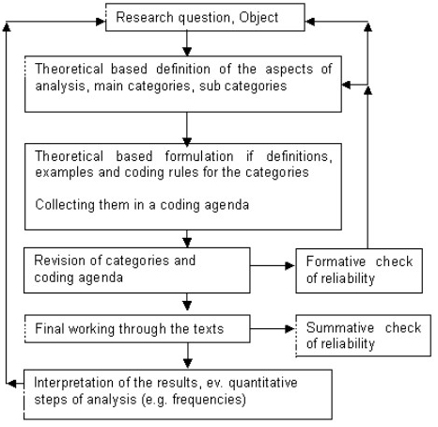

[Figure 5:Step Model of deductive category application by Mayring (2000)

