Questionnaire analysis

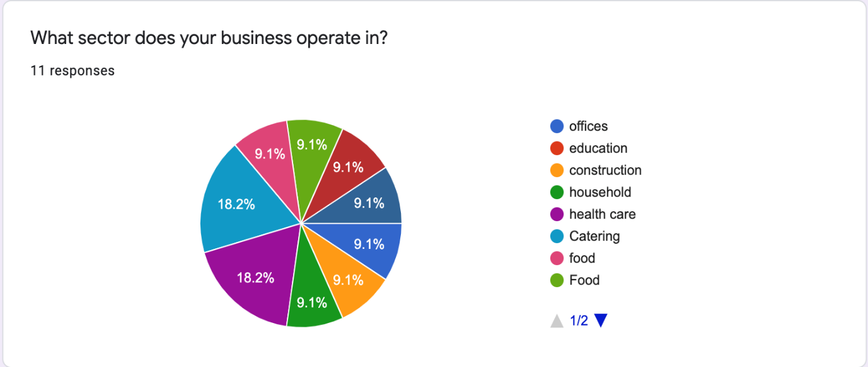

By analysing the pie chart we can see that people from all backgrounds are tempted to make use of the cleaning services that Fantastic for cleaning are offering. Because of this finding we should prepare our self to offer outstanding specialised services in most of the sectors. With two of the highest sectors being Health Care and Catering with double the percentages than the rest we highly believe that our company should prepare to offer more tailored services for those two sectors, without underestimating the other sectors. In order to target the Health Care market we can advertise our business to them by pointing out that our staff have got a good understanding of the level of cleaning required for this sector and that we can supply perfectly suited cleaning products and procedures that adhere to the requirements of this market sector. The same strategy we can use in the case of the catering businesses with few amendments which will consist of the fact that we can provide food grade cleaning products and procedures.

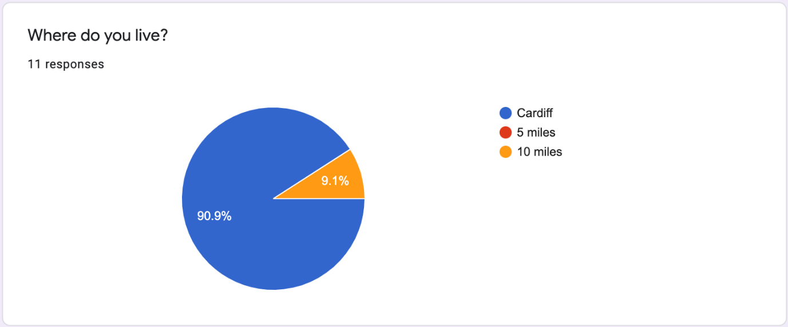

With an overwhelming percentage of our potential clients that filled up our questionnaire living in Cardiff, to be more concise over 90%, we reached the unanimous decision that Fantastic for cleaning should be Cardiff based as well in order to manage the business and the sites of the clients in a more time efficient way. Another conclusion was that in order to be able to facilitate and lessen the traveling time to work for our employees we should encourage Cardiff based people to apply for our vacancies. Furthermore would be beneficial that our suppliers would be local as well, and in case of stock shortage at any of our clients locations we would be able to restock in an effective manner at short notice with minimal delays. In other words it is much better to be based around the vast majority of the clients and to travel just fewer journeys to the sites that are not in Cardiff, because this will impact on our costs as well by minimising them.

Website analisys

In our group we created a website to promote a cleaning company in the Cardiff area. In the following text I will take you through what I did and more important why I did it.

I did the first two pages out of five of the website which are the Home page and the Cleaning Services page.
For the home page I decided to keep the things simple and to make a pleasant and easy to navigate website for our possible clients.
I used neutral colours in order to make all the information clearly visible and easy to watch and read. On the Home page I used a slideshow at the top to make it more attractive, eye catching and interactive, followed by a map that includes our location so people can clearly see where we are and also to be ranked higher in the search engines, because this is an important SEO feature. A short introduction of who we are and what we do it is also present in the middle of the page.
At the bottom of the Home page is a brief message to our clients detailing why they should chose us and on the bottom left it is a Get a quick quote form where visitors can drop us their details in order to get a quote from us.

On the second page, called the Cleaning services page I included a brief piece of information stating that we are offering tailor made cleaning services to suit all and every need that our clients might have. In the rest of the page are tiles interactive images that shows the name of the specific service when the cursor of the mouse is hovering on top of them. This was my contribution to our group site.
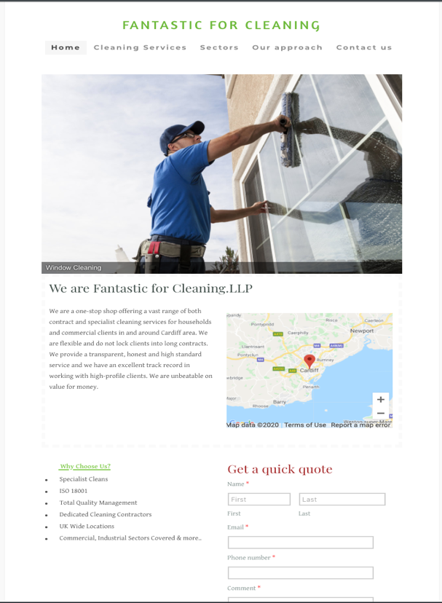
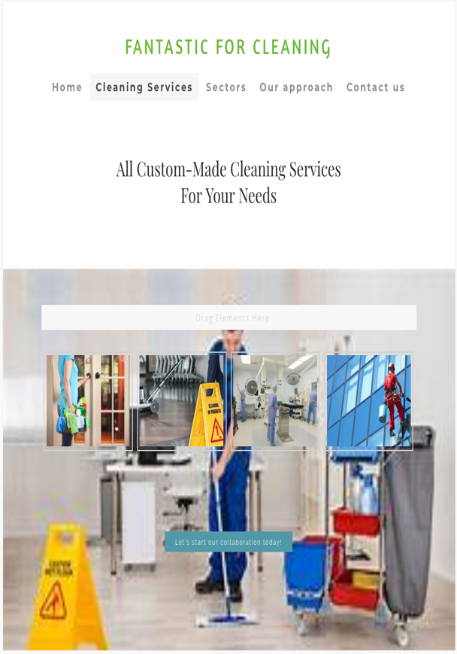
Email: 1817290lac@gmail.com
Password: 20181729020

