BMIH4006 Operating Hotel Facilities AS3

**Slide 1: Title Slide**
[Grab your reader’s attention with a great quote from the document or use this space to emphasise a key point. To place this text box anywhere on the page, just drag it.]
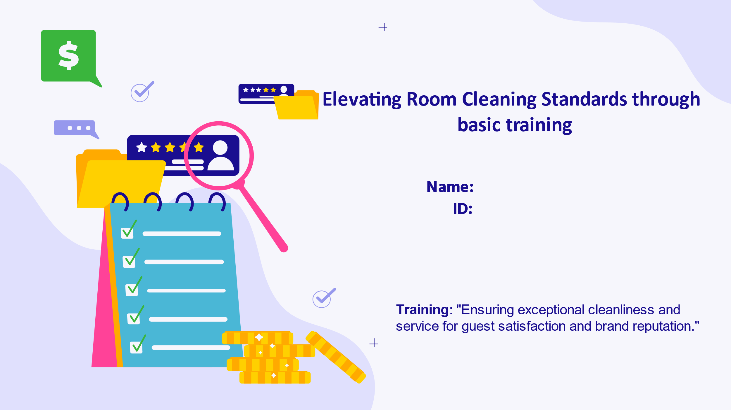
Valentina Matei
2221642

**Slide 2: Agenda**
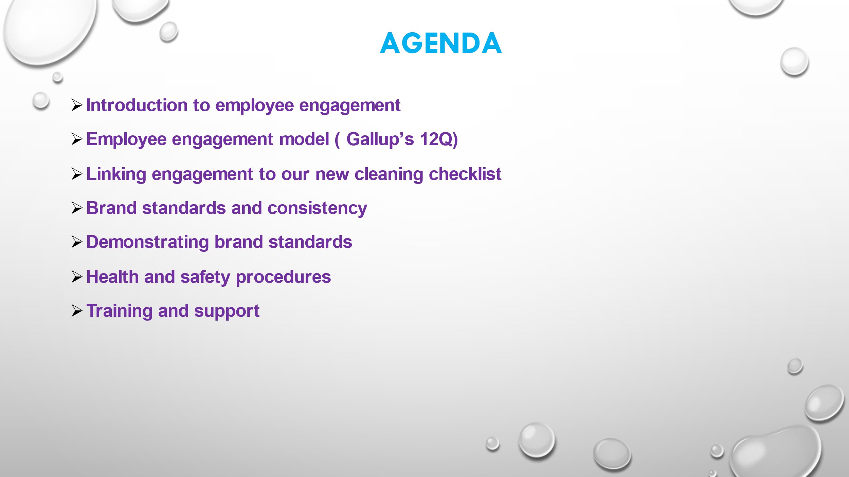
In today’s presentation, I will present:
Introduction to employee engagement
Employee engagement model (Gallup’s 12Q)
Linking engagement to our new cleaning checklist
Brand standards and consistency
Demonstrating brand standards
Health and safety procedures
Training and support
Finally, I will conclude the presentation with a short overview and a QNA session.

**Slide 3: Introduction to Employee Engagement**
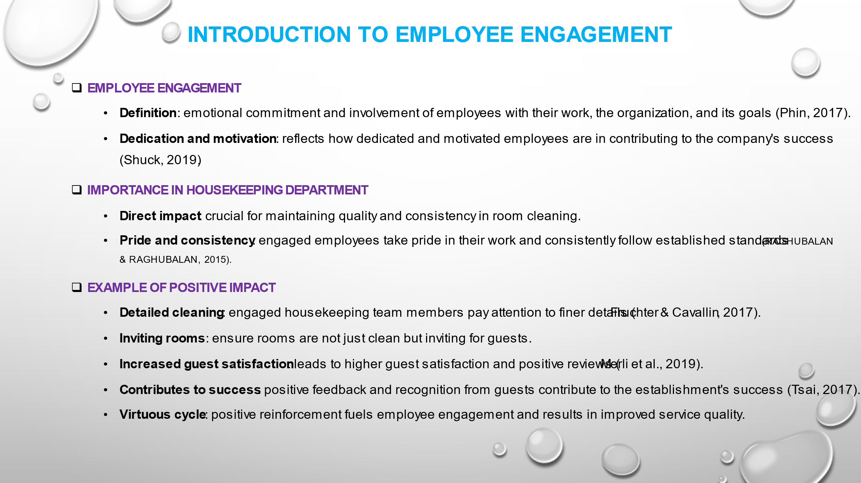
Employee engagement is their emotional investment in their work, the company, and its goals. It depends on how committed and motivated employees are to company success. Employee engagement affects room cleaning quality and consistency. Engaged workers are more likely to take pride in their work, go above and above, and follow procedures.
Now consider a positive impact example. An engaged housekeeping team member cleans a room according to the checklist and notices the little details. They keep rooms clean and appealing. This increases guest happiness and positive ratings, which boosts business. Engaged staff receive more visitor praise. These positive reinforcements boost their engagement, establishing a circle of better service.

**Slide 4: Employee Engagement Model**
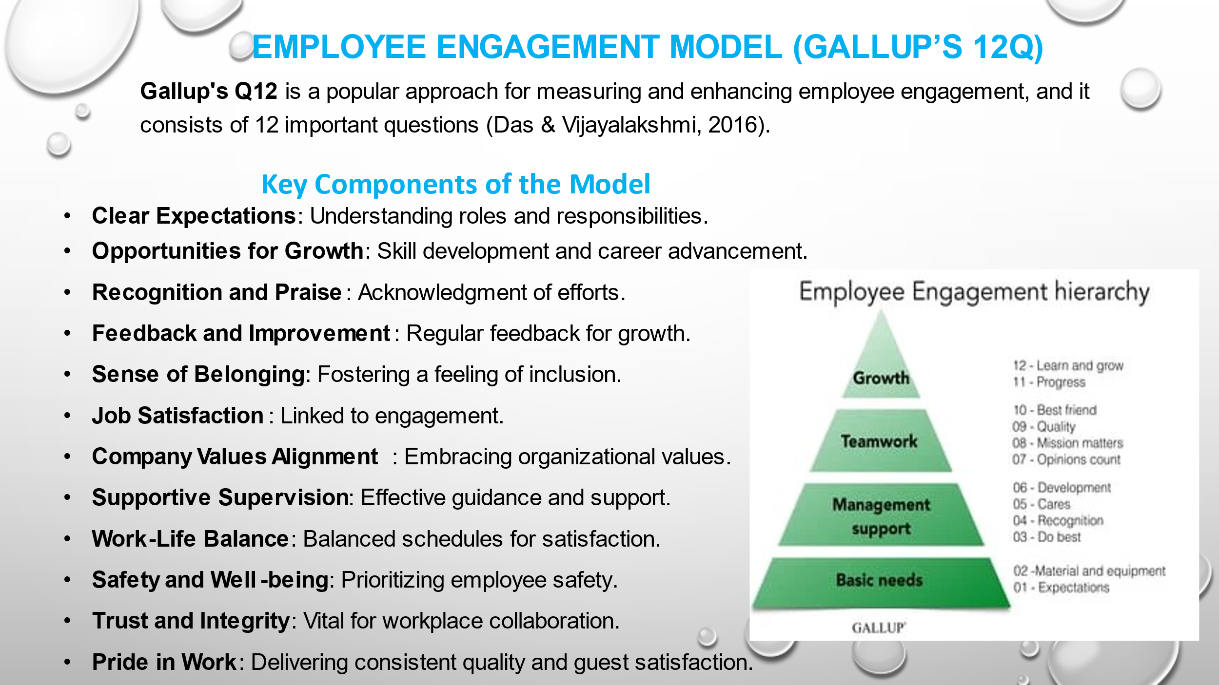
Employee Engagement Model
We use Gallup's Q12, a proven employee engagement model. Gallup's Q12 is a popular approach for measuring and enhancing employee engagement, and it consists of 12 important questions.
Let’s discuss the key components of Gallup’s model relating to our housekeeping checklist. Employees require clear expectations of their jobs and duties. In housekeeping, this includes knowing the room cleaning checklist tasks. Skill development and career promotion boost housekeeping employee engagement. This could involve certifications, promotions, or cross-training. Housekeepers who are recognized for their work are more engaged. This recognition may come from managers, supervisors, or satisfied guests. Feedback sessions enable growth. Housekeepers use constructive criticism to improve their abilities and satisfy standards. Fostering a sense of belonging is crucial. Team meetings, open communication, and participation in housekeeping foster this sense of belonging. Moreover, engagement and job satisfaction are linked. Contented housekeepers are more engaged, which leads to consistent room cleaning. Housekeepers who practice cleanliness, order, and visitor happiness align with the company's values. Good housekeeping managers and supervisors guide, support, and provide resources to help employees succeed. A balanced work-life schedule can boost housekeeping employee engagement and job satisfaction. Housekeeping prioritizes employee safety and well-being. Engaged workers prioritize their own and others' safety. Besides, integrity and trust are essential at work. Trust between housekeeping supervisors and staff improves teamwork and performance. Finally, housekeeping requires pride. Engaged staff take delight in providing clean, inviting rooms that satisfy guests.
**Slide 5: Linking Engagement to Our New Cleaning Checklist**
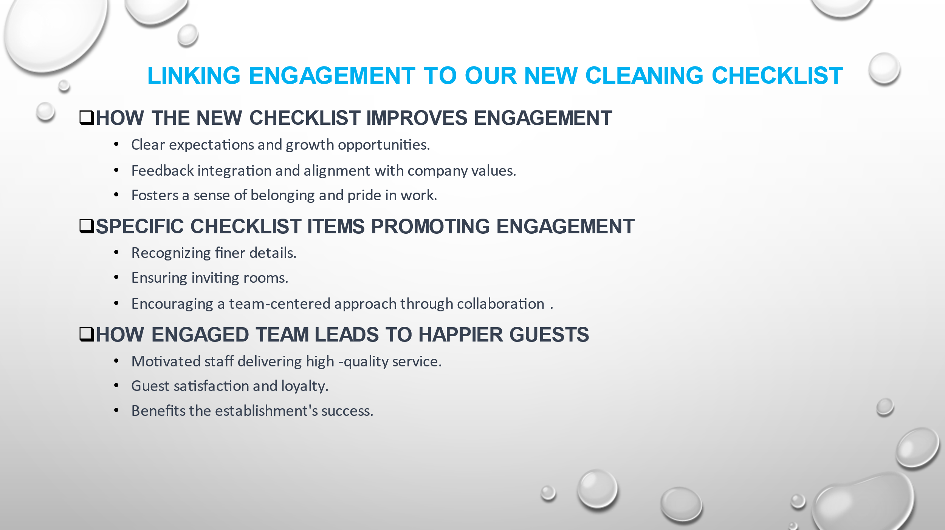
There are some ways the new checklist increases engagement. Our new cleaning checklist boosts staff engagement. There are clear expectations and growth potential. Utilizing feedback and matching it with our corporate principles helps our team feel connected and proud of their job. Besides, there are some checklist items that promote engagement. Recognizing the value of finer details, inviting rooms, and promoting teamwork are checklist items that increase engagement. You must realize that an engaged housekeeping team directly affects our clients' happiness. Guests notice and appreciate our dedicated, proud, and constantly high-quality workforce. Increasing guest pleasure and loyalty boosts our business.
**Slide 6: Brand Standards and Consistency**
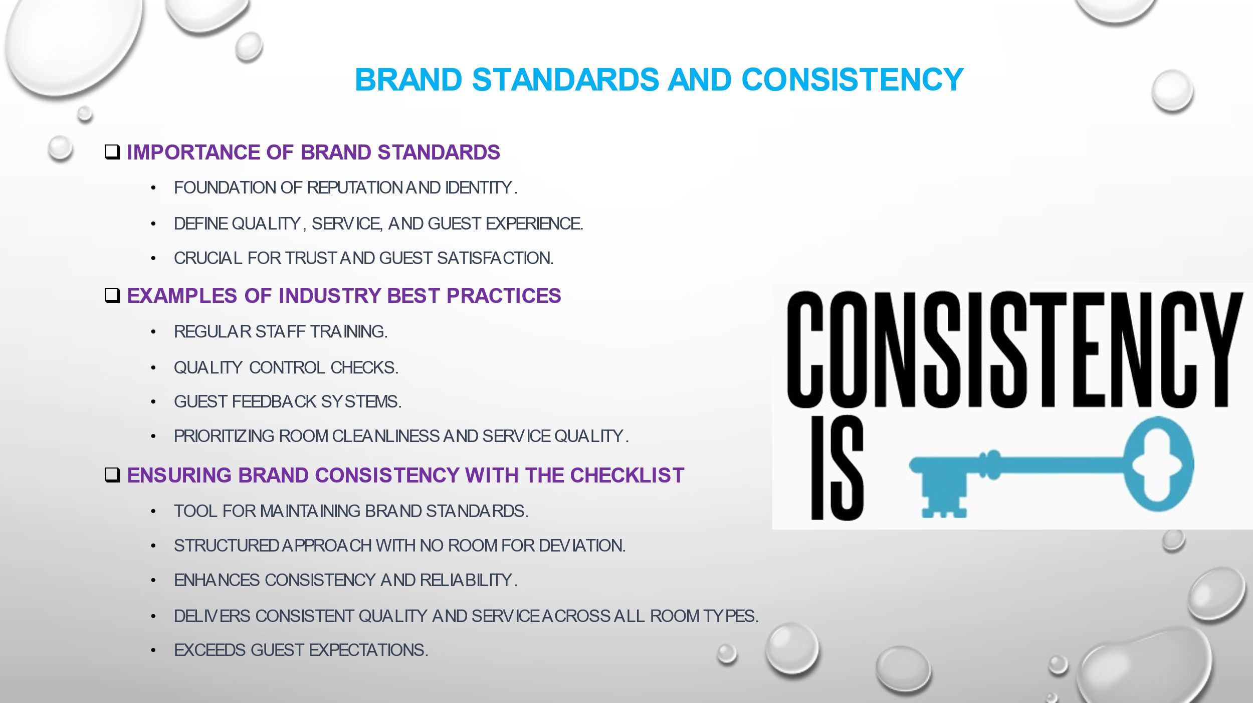
Let’s talk about the importance of brand standards. A hospitality establishment's reputation and identity are built on its brand standards. They define our guest experience, quality, and service. Building trust and guest pleasure requires maintaining these standards. Now let’s see examples of industry best practices in maintaining brand standards. Hospitality leaders use staff training, quality control checks, and guest feedback systems to maintain brand standards. They also prioritize room cleanliness and service consistency. Let’s know how our checklist ensures brand consistency The room cleaning checklist guarantees every room is cleaned to brand standards. Its organized method eliminates deviation, improving consistency and reliability. Our checklist ensures quality and service in regular and suite rooms, exceeding visitor expectations. By following our checklist, we maintain brand standards and improve guest experience, setting us apart in the competitive hospitality sector.

**Slide 7: Demonstrating Brand Standards**
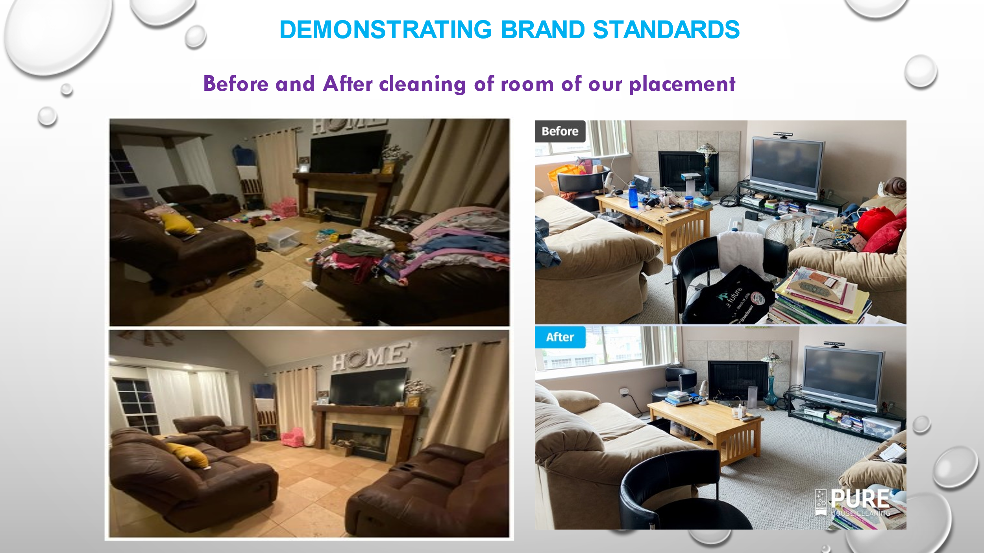
Let’s watch how our room cleaning checklist makes room brand standards today. A 'before' and 'after' image shows how our checklist improved the room's cleanliness and presentation. The 'before' photograph may show a messy room with dusty beds and amassed items. The 'after' photograph will show a spotless room with neatly made beds, shiny surfaces, and every detail in place, consistent with our property's branding and guarantee of excellence. These images show how our checklist ensures each accommodation meets our brand standards, giving guests the quality and experience they expect.
**Slide 8: Health and Safety Procedures**
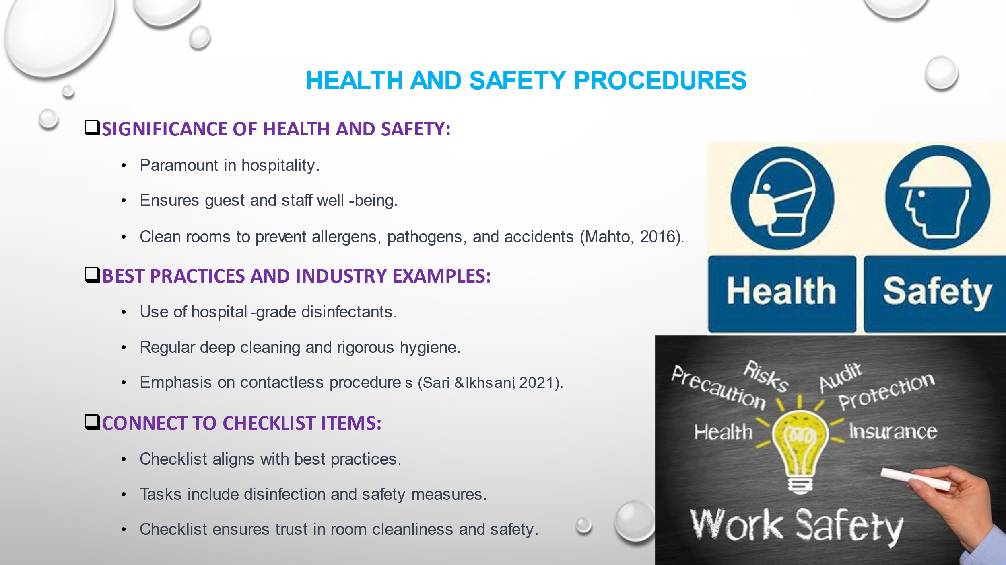
In hospitality, health and safety are crucial. The safety of guests and staff is paramount. Clean rooms help with this. Clean rooms prevent allergens, germs, and accidents.
Top hotels and resorts have strict cleaning standards. They utilize hospital-grade disinfectants, deep clean, and follow strict hygiene requirements. Many increasingly prioritize contactless check-ins.
Our room cleaning checklist follows these guidelines. It comprises cleaning, disinfecting, and safety activities. Disinfecting high-touch surfaces, using recommended cleaners, and reporting maintenance issues contribute to health and safety. By carefully following the checklist, we ensure our visitors' room cleanliness and safety.

**Slide 9: Training and Support**
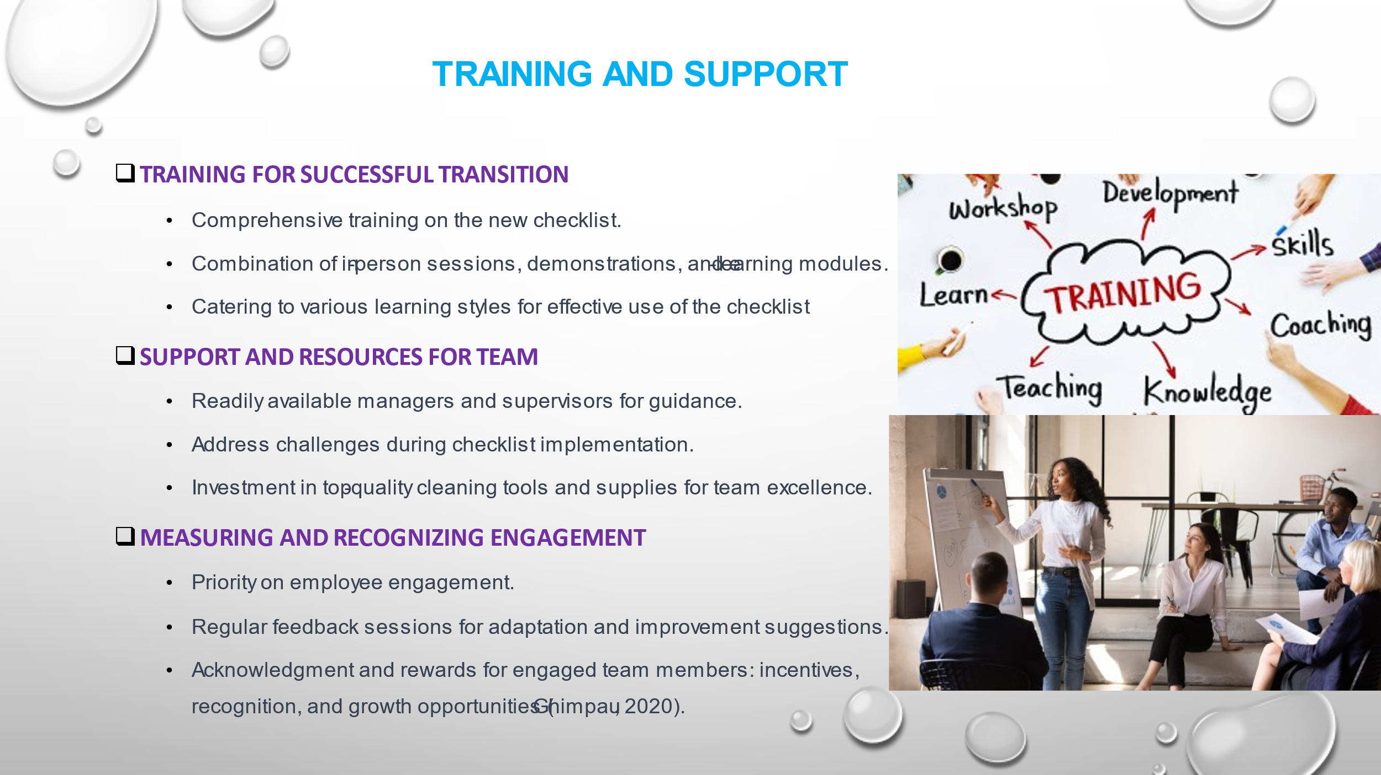
Our team will receive extensive training to successfully implement the new checklist. This training will include in-person sessions, hands-on demonstrations, and interactive e-learning courses. This method fits different learning styles and ensures that all team members can use the checklist.
We know our team needs support and resources. Our managers and supervisors will be accessible to answer questions, provide direction, and resolve any issues during the new checklist implementation. We also bought high-quality cleaning tools, equipment, and supplies to help our staff succeed.
Employee engagement is our top goal, and we monitor and acknowledge it. We will hold regular feedback sessions to assess the team's checklist compliance and solicit improvements. Team members who work hard will receive incentives, recognition, and advancement possibilities.
Through rigorous training, regular support, and engagement recognition, we are assuring the effective implementation of the new checklist and creating a motivated and engaged staff that is devoted to excellent service and brand standards.
**Slide 10: Conclusion**
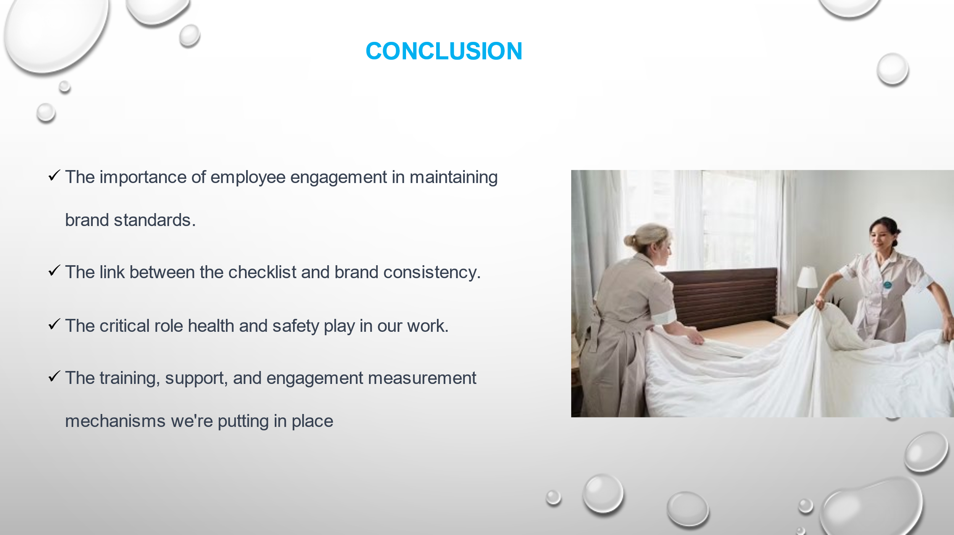
Let's conclude with today's presentation's main points:
Maintaining brand standards through staff engagement.
Checklist-brand consistency relationship.
Health and safety are vital to our job.
Our training, support, and engagement measurement systems.

Slide 11: References
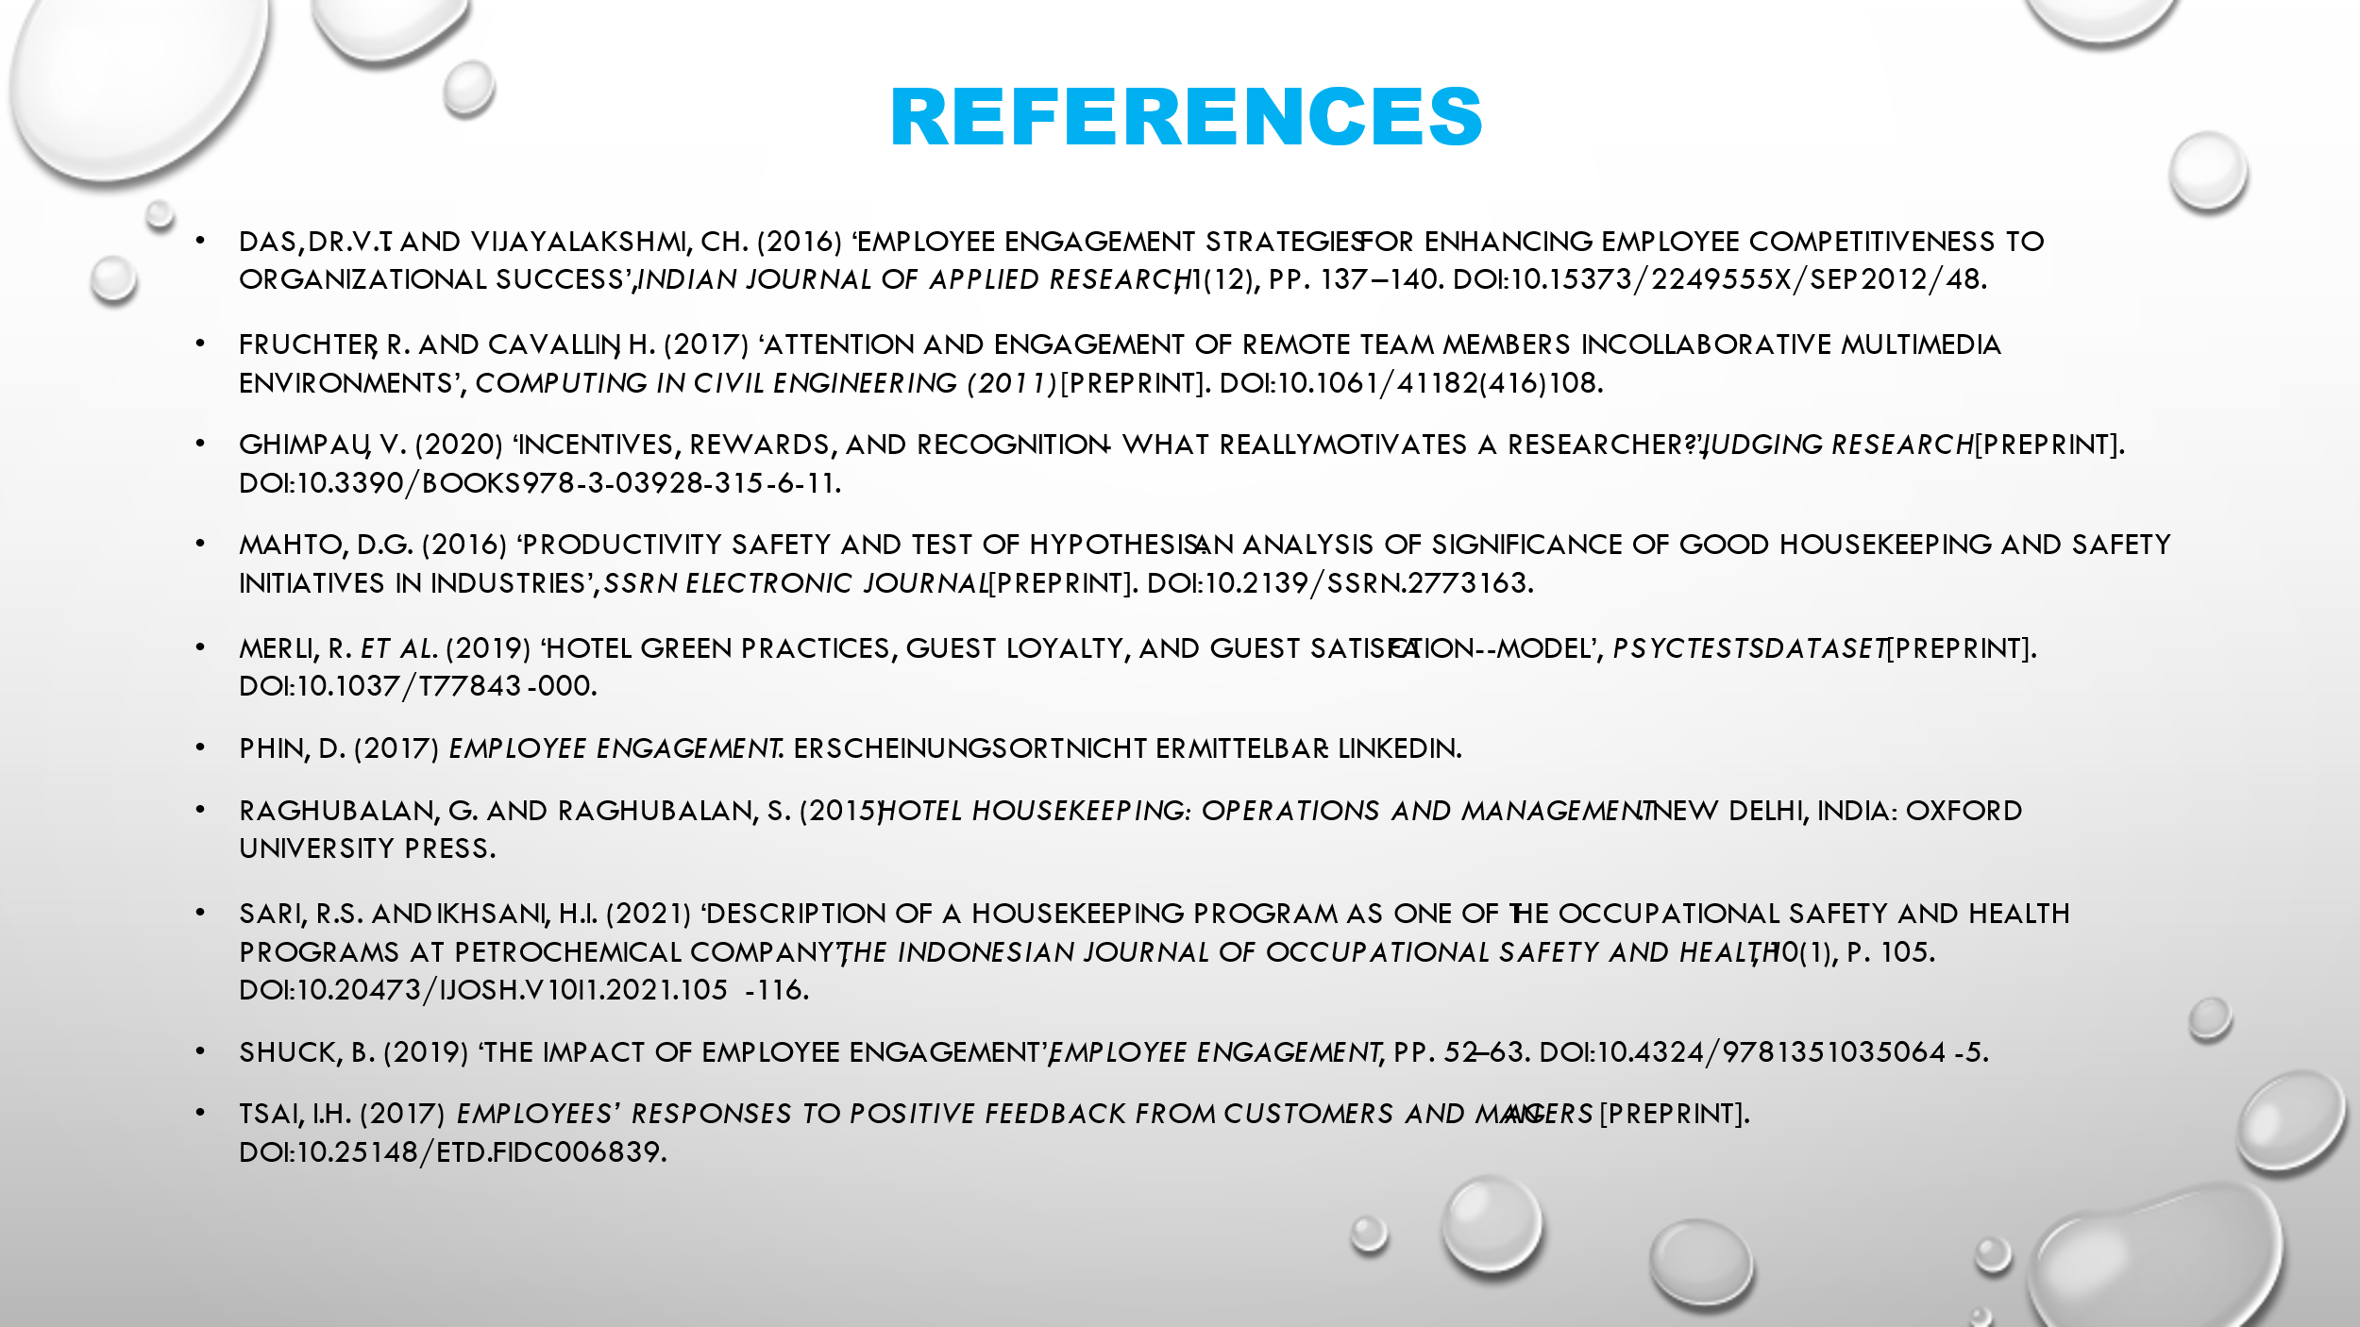
Das, Dr.V.T. and Vijayalakshmi, Ch. (2016) ‘Employee engagement strategies for enhancing employee competitiveness to organizational success’, Indian Journal of Applied Research, 1(12), pp. 137–140. doi:10.15373/2249555x/sep2012/48.
Fruchter, R. and Cavallin, H. (2017) ‘Attention and engagement of remote team members in Collaborative Multimedia Environments’, Computing in Civil Engineering (2011) [Preprint]. doi:10.1061/41182(416)108.
Ghimpau, V. (2020) ‘Incentives, rewards, and recognition - what really motivates a researcher?’, Judging Research [Preprint]. doi:10.3390/books978-3-03928-315-6-11.
Mahto, D.G. (2016) ‘Productivity Safety and test of hypothesis: An analysis of significance of good housekeeping and safety initiatives in industries’, SSRN Electronic Journal [Preprint]. doi:10.2139/ssrn.2773163.
Merli, R. et al. (2019) ‘Hotel Green Practices, guest loyalty, and guest satisfaction--model’, PsycTESTS Dataset [Preprint]. doi:10.1037/t77843-000.
Phin, D. (2017) Employee engagement. Erscheinungsort nicht ermittelbar: LinkedIn.
Raghubalan, G. and Raghubalan, S. (2015) Hotel Housekeeping: Operations and Management. New Delhi, India: Oxford University Press.
Sari, R.S. and Ikhsani, H.I. (2021) ‘Description of a housekeeping program as one of the Occupational Safety and Health Programs at Petrochemical Company’, The Indonesian Journal Of Occupational Safety and Health, 10(1), p. 105. doi:10.20473/ijosh.v10i1.2021.105-116.
Shuck, B. (2019) ‘The impact of employee engagement’, Employee Engagement, pp. 52–63. doi:10.4324/9781351035064-5.
Tsai, I.H. (2017) Employees’ responses to positive feedback from customers and managers [Preprint]. doi:10.25148/etd.fidc006839.

Slide 12

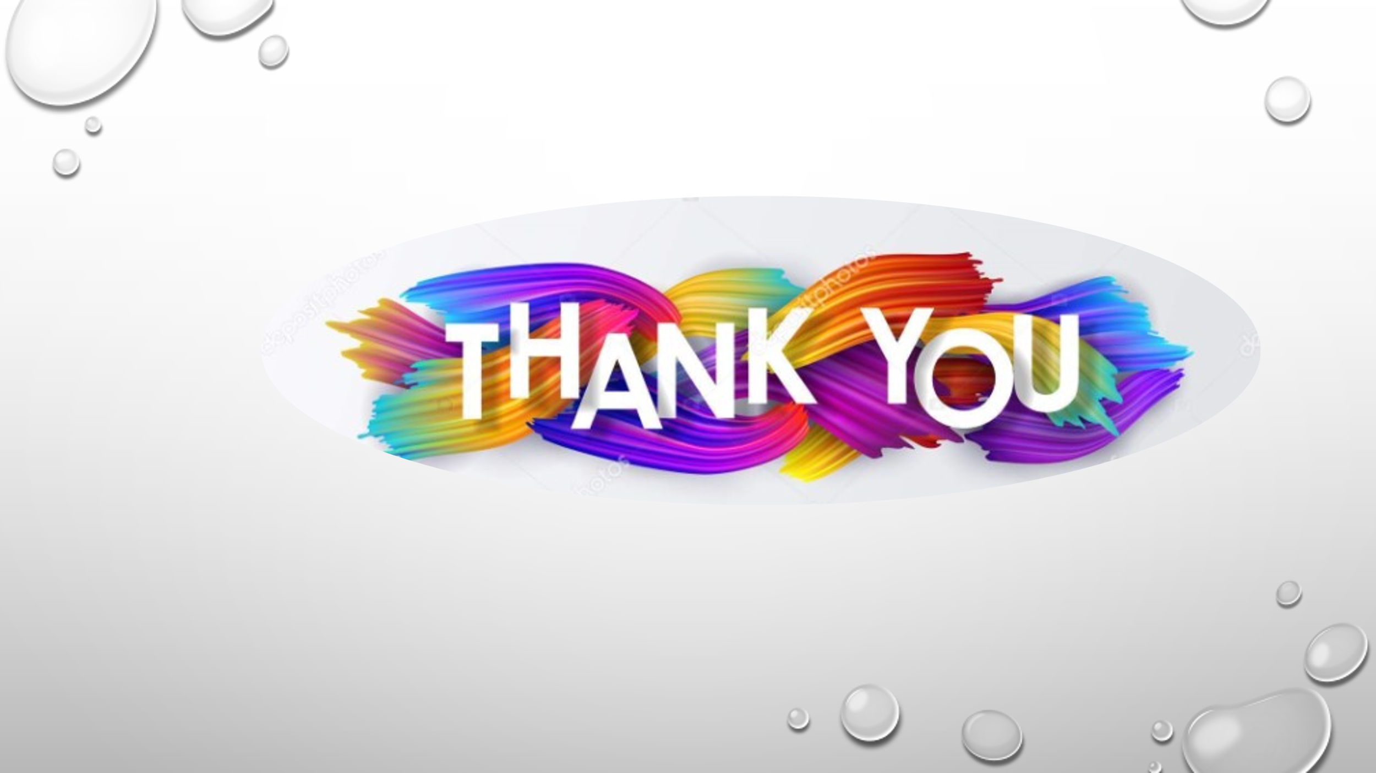

Thank you for attending and participating in today's presentation. We hope you found our new cleaning checklist and its effects on employee engagement and visitor satisfaction helpful. We're open to any questions, conversations, or clarifications about the checklist, training, or related topics. Feel free to voice concerns.
Your queries are crucial as we go forward. Maintaining and improving brand standards and guest experience is our priority. Again, thanks for your time and effort. We look forward to working together to continue offering excellent service and cleanliness to our customers.

