Information Engineering– ACCB4013

Title: Database Design (The Book Store)

By Rhys Davies 1803152

Web development

Submission date: 6th May 2019

Module Tutor: B Holland

Contents
Documentation – Task 1 4
Relationships 4
User Requirements 6
Documentation – Task 2 8
Tbl_Author 8
Tbl_Books 9
Tbl_Customer 10
Tbl_Staff 11
Tbl_Stock 12
Tbl_Supplier 13
Tbl_Order 14
Frm_Menu 15
Frm_Reports 16
Frm_Customer 17
Frm_Staff 18
Frm_Authors 19
Frm_Books 20
Frm_Stock 21
Frm_Supplier 22
Frm_Orders 23
Relationships 24
Macros 24
Queries and Reports 25
Query 1 - qry_37yearOldsWhoLikeScienceFictionandFantasy 26
Report 2 – 37yearOldsWhoLikeScienceFictionandFantasy 26
Report 2 – Books Under £7 27
Query 3 – Delivered After a Certain Date 28
Report 3 - Delivered After a Certain Date 29
Query 4 – Most Popular Author 30
Report 4 – Most popular Author 31
Query 5 – Most sold genre 32
Report 5 – Most Popular Genre 33
SQL 34
User Guide 36

Documentation – Task 1
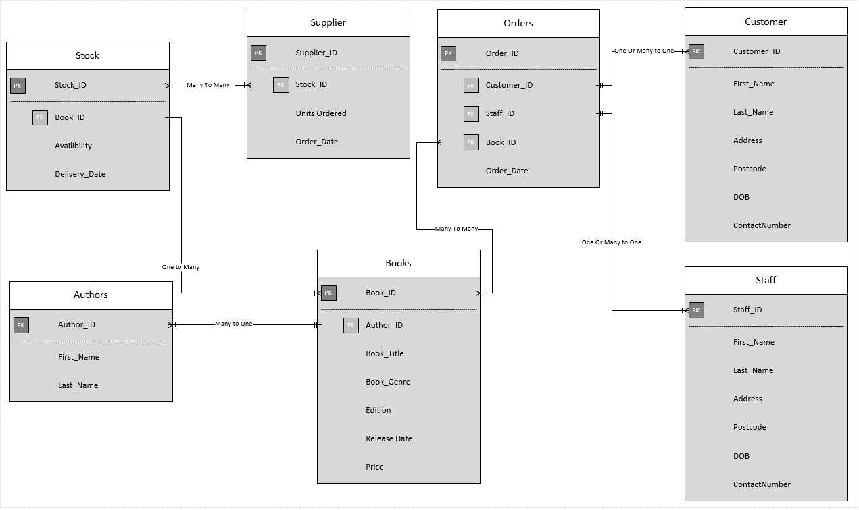
ERD
The ERD above is what my database is going to based off. It will consist of 7 tables all of which will relate together and use primary and foreign keys.

Relationships
Author_ID shares a many to one relationship tbl_Books. Many authors can have a book, but one book can have one author.
Supplier_ID shares a one or many to one or many relationship with tbl_Stock. This is as many of the stock can have many suppliers or it can have one supplier, and vice versa.
Book_ ID shares a one to many relationship with tbl_Stock. Tbl_Books can have many books however that book can only have 1 stock value.
Book_ID also shares a relationship, many to many, with tbl_Orders. Tbl_Books like above can have many books however there can also be many books in one order.
Customer_ID shares a one to many relationship with tbl_Orders. Customers can have many orders, but one order can only have 1 customer at a time.
Staff_ID shares a one to many relationship with tbl_Orders. Staff can deal with many orders, but one order can only have 1 staff member deal with it.
Normalisation
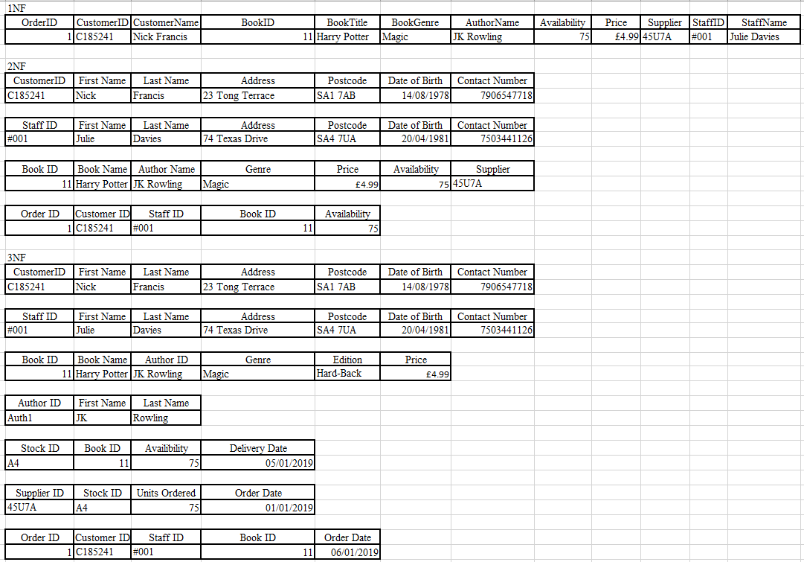
“Database Normalization is a technique of organizing the data in the database. Normalization is a systematic approach of decomposing tables to eliminate data redundancy(repetition) and undesirable characteristics like Insertion, Update and Deletion Anomalies. It is a multi-step process that puts data into tabular form, removing duplicated data from the relation tables.” [1]
The above tables are tables I have converted from First normal form to Third Normal Form.

User Requirements
Below is the list of the user’s requirements;
- User has the ability to add or delete information from any table.
- User should be able to view on screen: Book, stock, order and customer details.
- User should be able to view ongoing customer orders.
- User should be able to query the system and print out relevant reports.

My database allows the user to add (Blue) and delete (Red) information from any table at the click of a button as shown in the screenshot below.
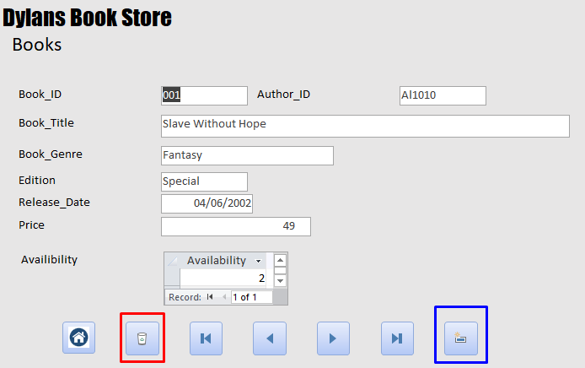
The user can also view the Book, Stock, Orders and Customer details and more from the menu page as shown below.
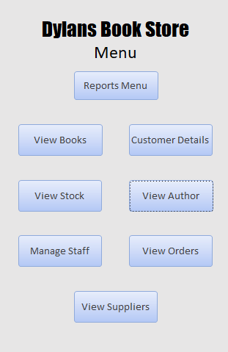

The user can also view customer orders as shown below.
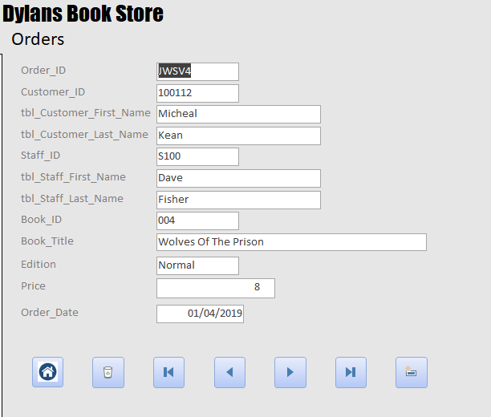

The user can view queries (Red) and print out relevant reports (Blue) as shown below.
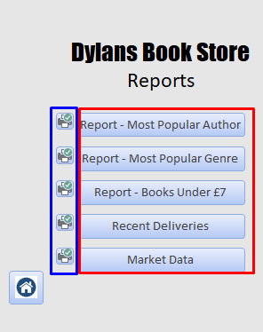

Documentation – Task 2

Tbl_Author
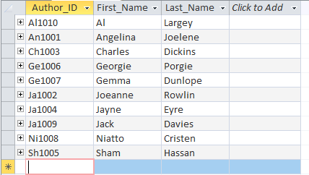
Tbl_Author is to contain the authors first and last name and apply them an ID to be used in other fields.
Data Types:
Author ID (short text (10)) Primary Key
First Name (short text (25)) Foreign Key
Last Name (short text (25))

Tbl_Books
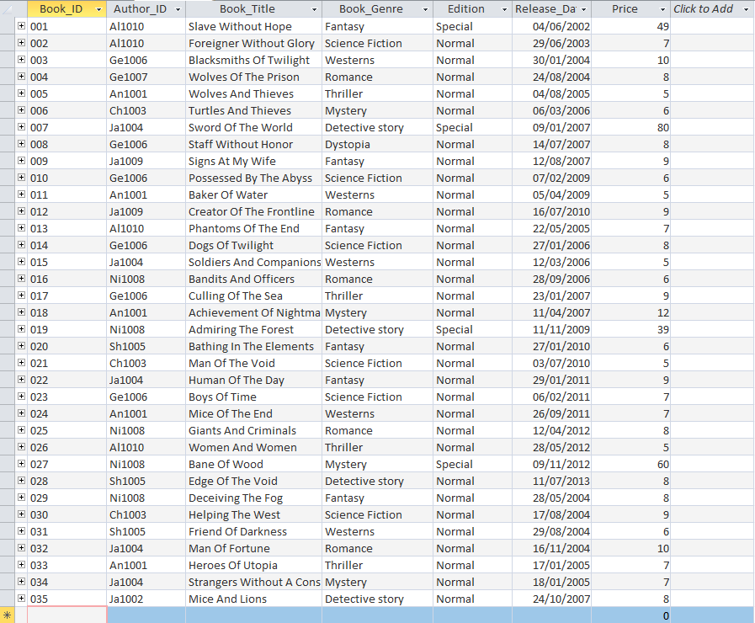
Tbl_Books contains all the information for the books Dylan’s Book store has. This contains an ID for the book to be called, an Author ID to link who wrote the book, a Title for the book, genre, edition for the book so the customers can find out if its special edition or not, when it was released and finally the price of the book.
Data Types Used:
Book ID (short text (10)) Primary Key
Author ID (short text (10)) Foreign Key
Book Title (long text (255))
Book Genre (short text (25))
Edition (short text (25))
Release Date (short text (25))
Price (number)

Tbl_Customer
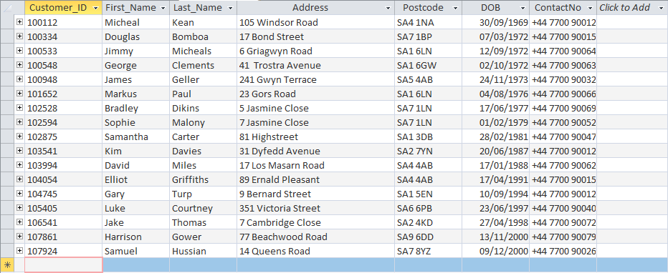

Tbl_Customer is for keeping track of all the customers of Dylan’s Book Store. It contains all the important information a customer table would need such as; Customer ID to uniquely identify the table, first name, last name, address, postcode, date of birth and contact number.
Data Types Used:
Customer ID (short text (10)) Primary Key
First Name (short text (10))
Last Name (short text (10))
Address (short text (50))
Postcode (short text (7))
DOB (date/time)
ContactNo (long text)

Tbl_Staff

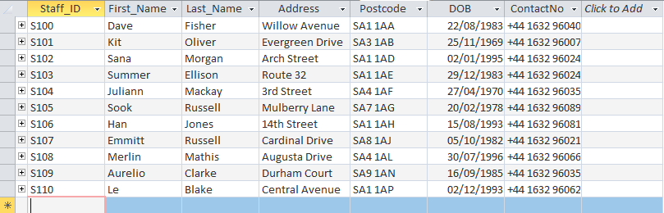
Tbl_Staff is for keeping track of all the Staff that work at Dylan’s Book Store. It contains all the important information a staff table would need such as; Staff ID to uniquely identify the table, first name, last name, address, postcode, date of birth and contact number.
Data Types Used:
Staff ID (short text (10)) Primary Key
First Name (short text (10))
Last Name (short text (10))
Address (short text (50))
Postcode (short text (7))
DOB (date/time)
ContactNo (long text)

Tbl_Stock
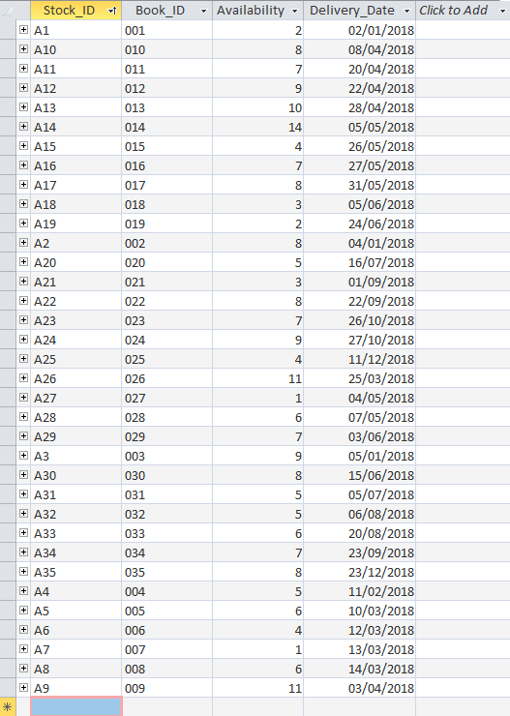

Tbl_Stock is for keeping track of all the stock of the books at Dylan’s Book Store. The table had a Stock ID to be referred to in other tables, a Book ID so the table the stock applies to, the availability of that stock and when it was delivered to the store.
Data Types Used:
Stock ID (short text (10)) Primary Key
Book ID (short text (10)) Foreign Key
Availability (short text (10))
Delivery Date (date/time)

Tbl_Supplier
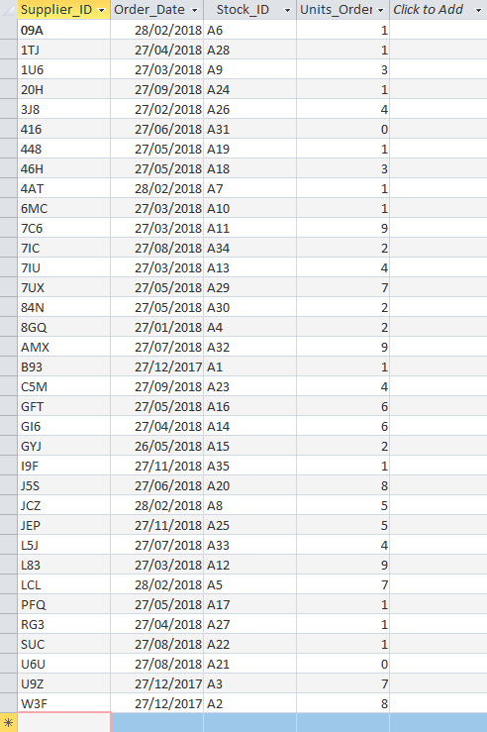
Tbl_Supplier is for storing all the suppliers that supply the books to Dylan’s Book Store. The table has a Supplier ID to be referred to in other tables, a Stock ID so it can gather how many units are held at the store aswell as the book in question. There is a field for units ordered and the order date.
Supplier ID (short text (10)) Primary Key
Stock ID (short text (10)) Foreign Key
Order Date (date/time)
Units Ordered (number)

Tbl_Order

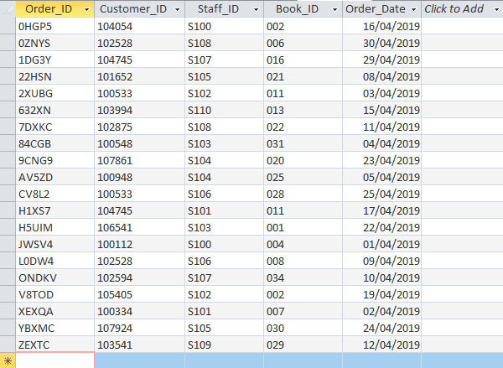
Tbl_Order is for tracking all customer orders from Dylan’s book store. There needs to be an Order ID, this is the primary key of the table. The customer ID is there to know who the order belongs to. Staff ID is in the table to see what staff member dealt the order. The Book ID is there to know what book was purchased, and finally what day the order happened.
Order ID (short text (10)) Primary Key
Customer ID (short text (10)) Foreign Key
Staff ID (short text (10)) Foreign Key
Book ID (short text (10)) Foreign Key
Order Date (date/time)

Frm_Menu
This is the menu screen for the database. From here you can access many features of the database. It is possible to view books the store has, view customer details, view customer orders and manage stock as described in the user requirements. From this menu you can also view the suppliers to place an order and manage staff, you can also view the reports screen which allows you to print reports. There is an AutoExec macro that when the database is opened the menu is instantly opened for the user to use.

Frm_Reports
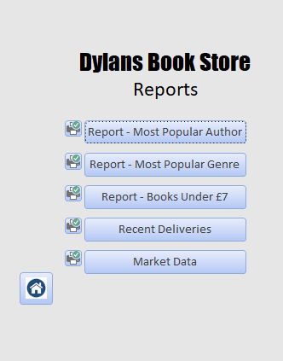
This is the reports menu from this menu you can view all the premade reports and print them out. You can also return back to the main menu by clicking the home button.

Frm_Customer
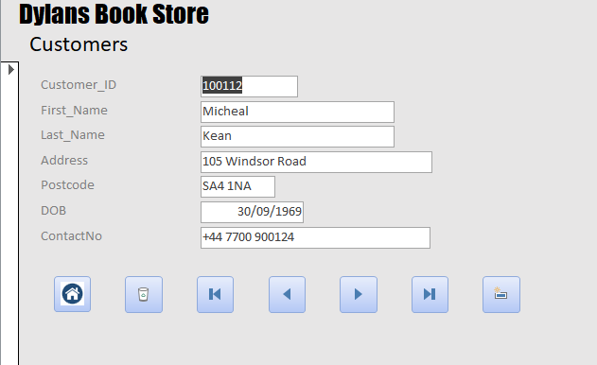
This is the customers form. The fields display the data from the customer table. The bottom row of buttons is as follows. Home button, delete record, first record, previous record, next record, last record and new record. All these buttons are to simplify tasks for the user.

Frm_Staff

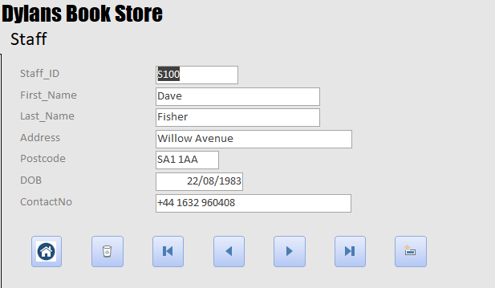
This is the Staff form. The fields display the data from the staff table. The bottom row of buttons follows the same style as the previous forms.

Frm_Authors
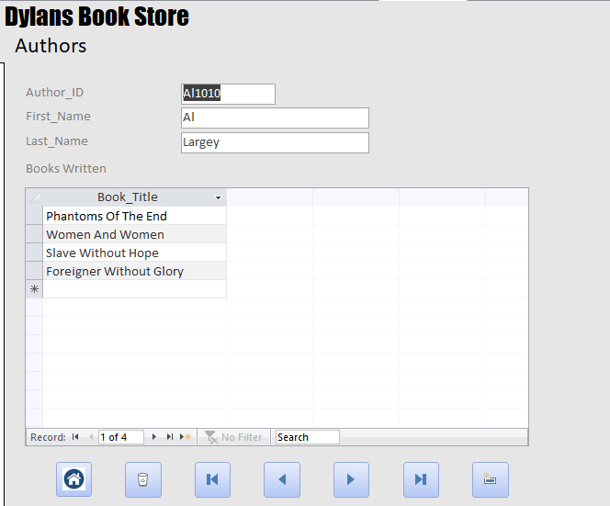
The authors menu displays the data from the others table however it also displays a list of the books they have written, therefor if a customer was to come in and ask for books from an author the staff member has to find the author and the list of books will be there to be seen. The bottom row of buttons follows the same style as the previous forms.

Frm_Books
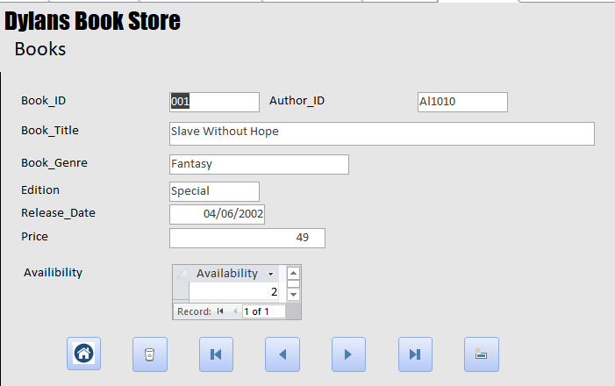
The Books menu very similar to the authors form above uses a sub form to call, in this instance, the availability of the book from another form. This makes It more user friendly as the user doesn’t have to back out to the menu and then go into the stock from, find the correct book and look at the stock, or look at the stock report, it is all in one menu.

Frm_Stock
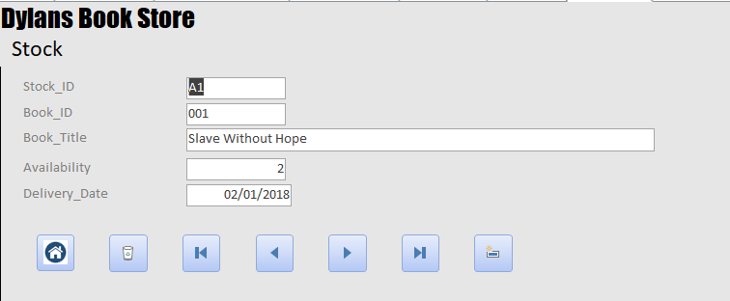
The Stock menu shows all the data from the stock table in a nice easy to read format. It also displays the books title which is taken from the book table using the book ID from the stock table. The buttons are the same as on the other menus.

Frm_Supplier
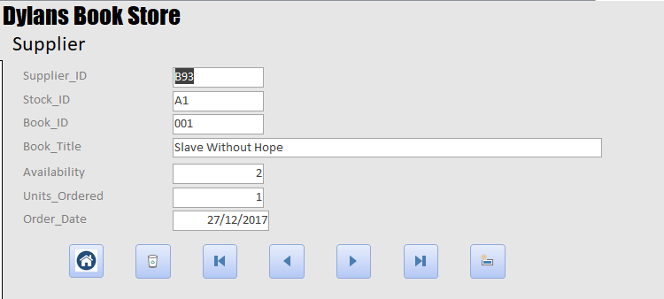
The supplier menu shows the suppliers code, stock ID and book ID. This is to correspondently get the correct stock for the correct book which will in turn get the correct supplier ID that supplies the stock for that book. Buttons at the bottom are the same as on other menus.

Frm_Orders

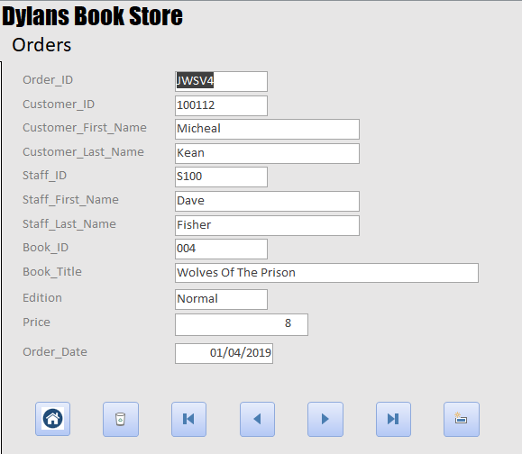
This is the orders menu, where the user can find out all the current orders. The menu contains the order ID, Customer ID, Customer Name, Staff ID, Staff Name, Book ID, Book Title, Book Edition, Price, when it was ordered. All this combined use the relevant fields for a good Buttons at the bottom are the same as on other menus.

Relationships

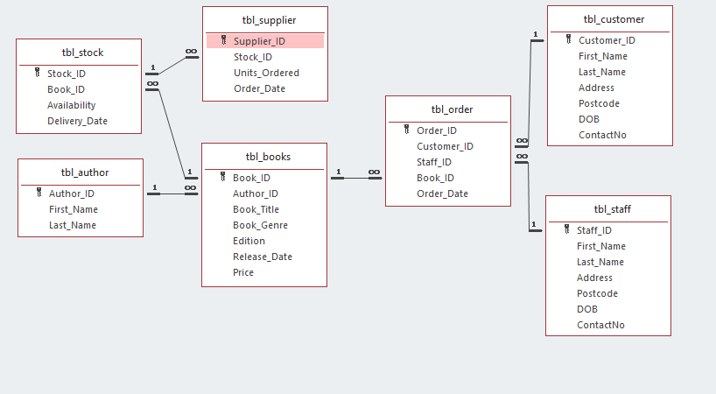
This is relationships diagram from access.

Macros

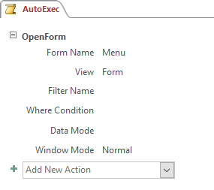
This is the macro used to automatically have the menu form come up when the document is opened.

Queries and Reports
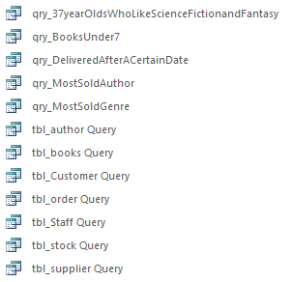
These are the queries used. Some were to create the reports and some were used to create the tables using SQL.

Query 1 - qry_37yearOldsWhoLikeScienceFictionandFantasy
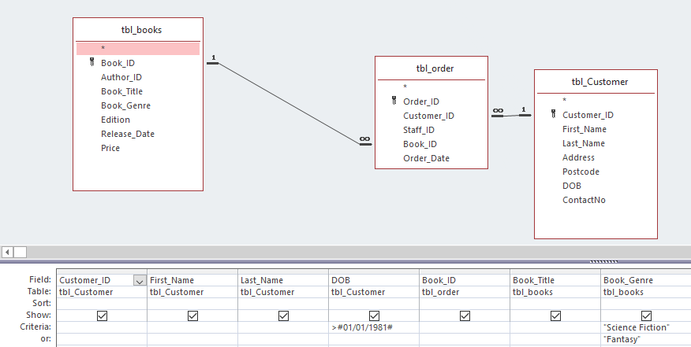
This was the query I ran for research into the market of Dylan’s Book store.
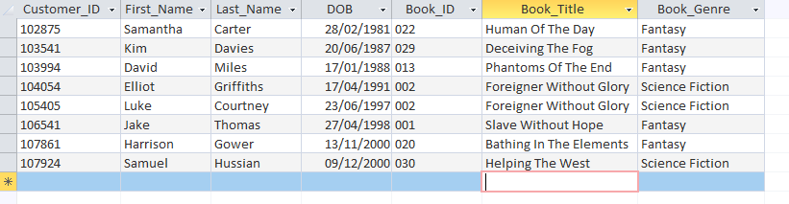
Here is the data I got back from the query.

Report 2 – 37yearOldsWhoLikeScienceFictionandFantasy
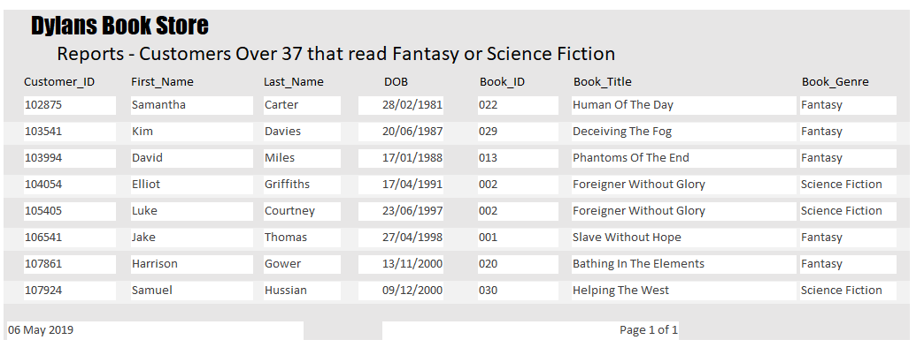

Query 2 – Books under £7
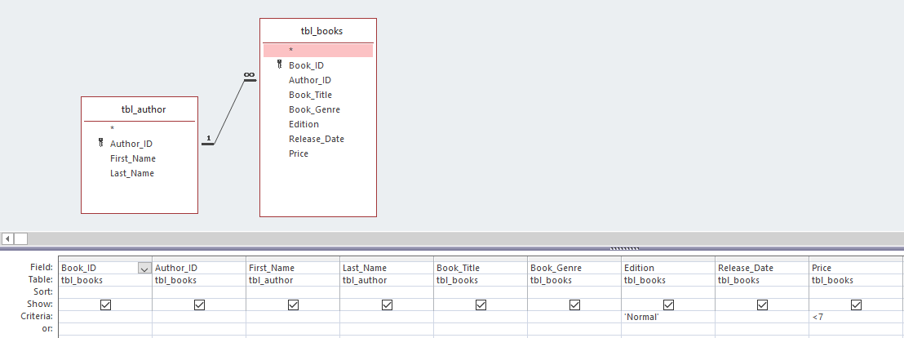
This was the query I ran to find books under £7.
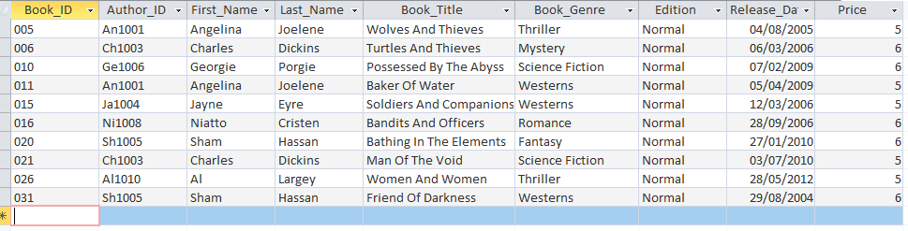
The data I received back from the query.

Report 2 – Books Under £7
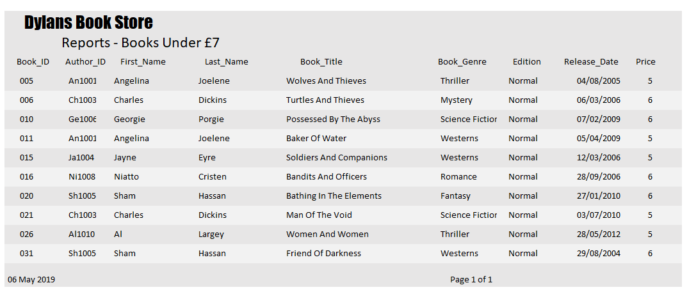

Query 3 – Delivered After a Certain Date
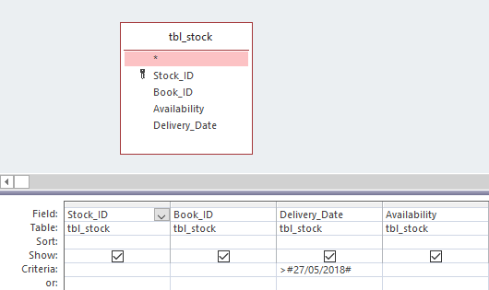
The query I ran to find out what books were delivered after a certain date.
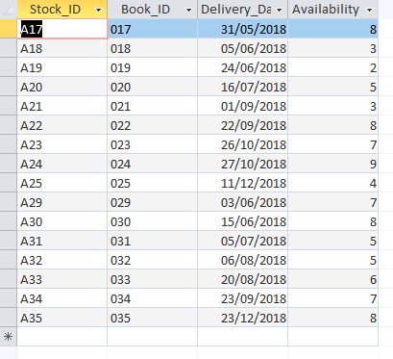
Shows only dates after the date specified in the criteria

Report 3 - Delivered After a Certain Date
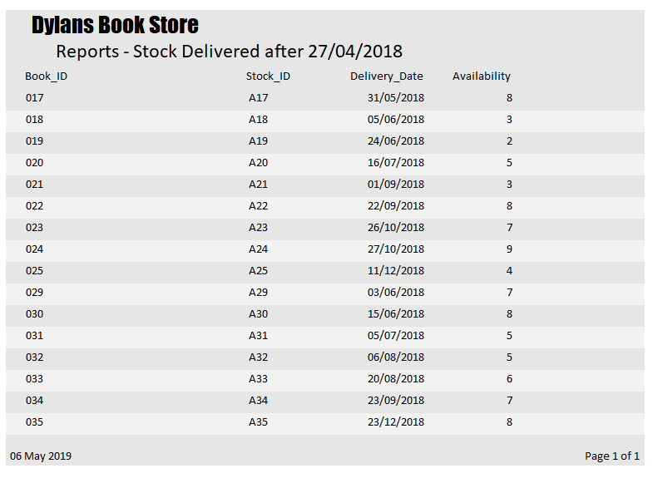

Query 4 – Most Popular Author
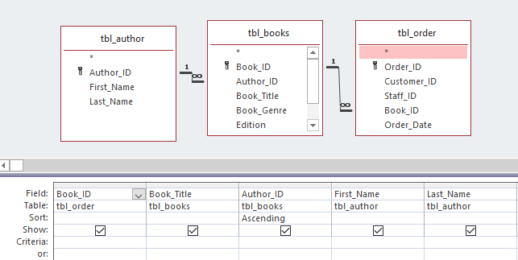
Query ran to find out the most sold author.
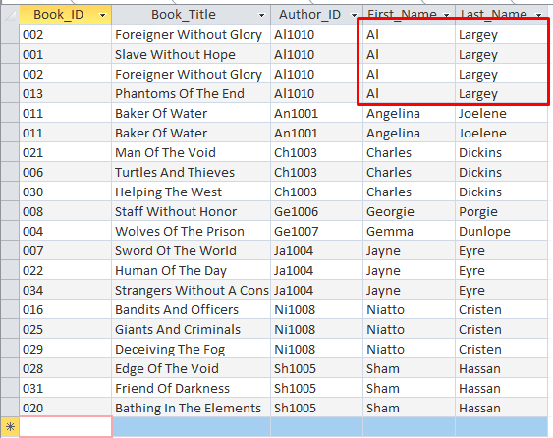
Shows the authors and how many books they sold.

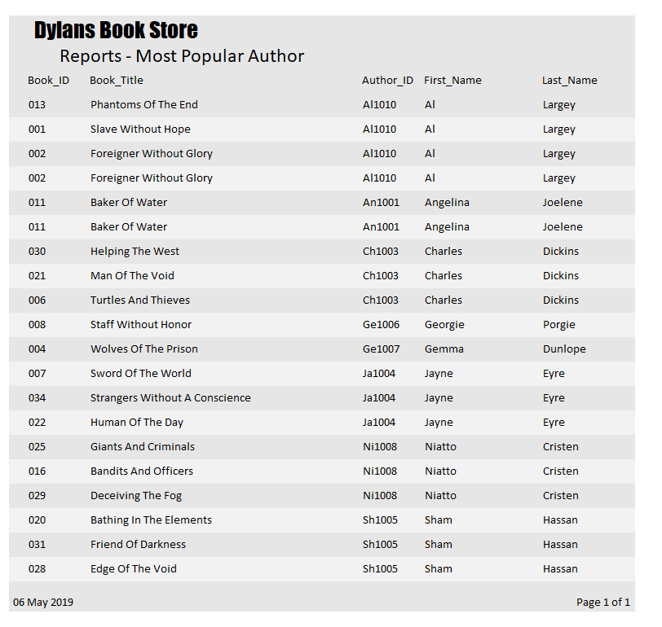
Report 4 – Most popular Author

Query 5 – Most sold genre
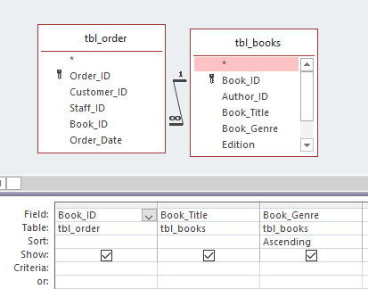
Query ran to find out the most sold genre.
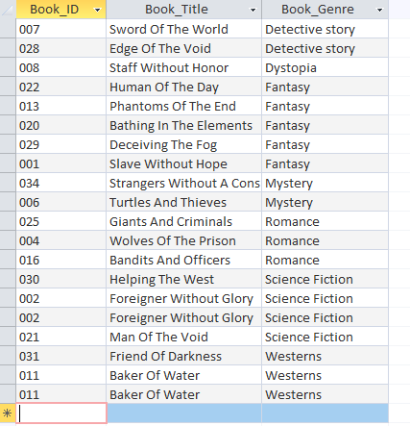
Shows the authors and how many books they genre.

Report 5 – Most Popular Genre
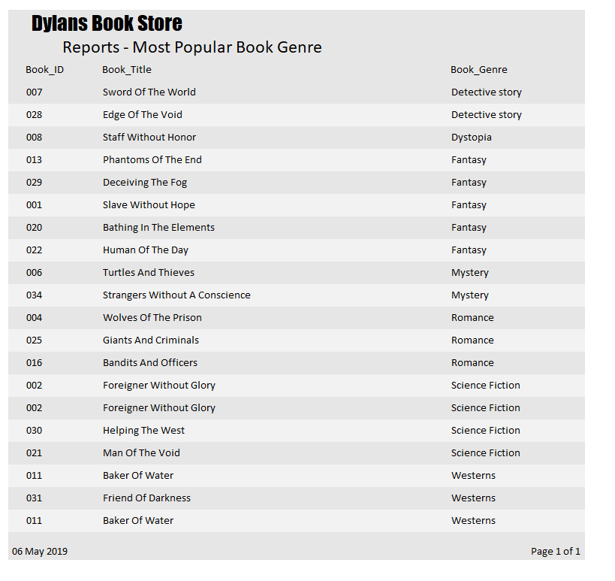

SQL
Tbl_Author
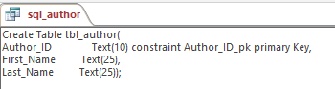
Tbl_Books
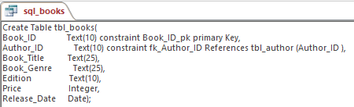
Tbl_Customer
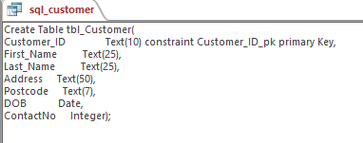
Tbl_Staff
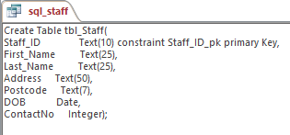
Tbl_Order
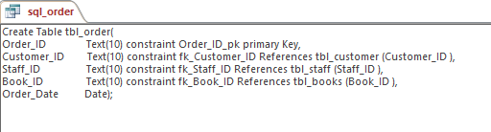
Tbl_Stock
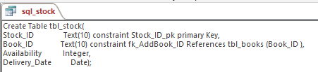
Tbl_Supplier
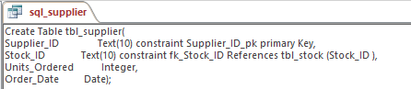

User Guide
Understanding the Menus
To navigate the menus, click the button of the menu you would like to visit.

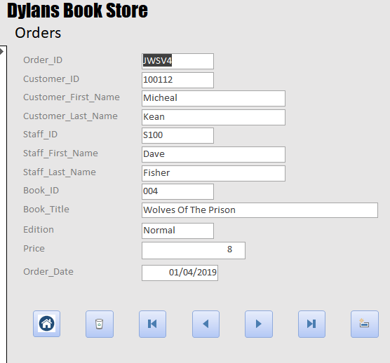
This is what a normal menu looks. As you can see this is the Orders menu. It shows the Order ID, Customer ID, Customer Name, Staff ID, Staff Name, Book ID, Book Title, Book Edition, Price, date of order.
Understanding the Buttons

First Record
Delete Record
Previous Record
Next record
Last Record
Add Record
Home
At the bottom of all menus are these buttons. They all follow the same format and positioning for usability. The order they use is as followed
Home button, delete record, first record, previous record, next record, last record and new record. This is also shown in the labelled diagram above.

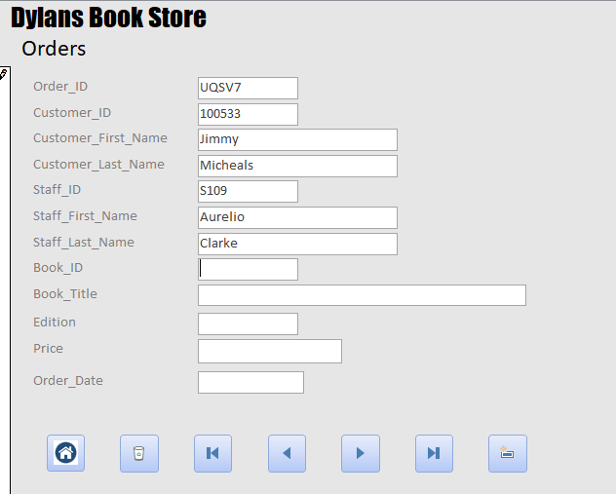
Adding data

For data entry, click the icon like shown above in the red box. It will show a blank field.
- Enter an Order ID to get started (example. UQ67S)
- Enter the customers ID who is buying the book.
*The name of the customer will then autofill if the correct ID is given *
- Enter your staff ID.
*The name of the Staff member will then autofill if the correct ID is given*
- Enter the Book ID of the book they are buying
*The name of the Book will then autofill if the correct ID is given*
- To complete the order, enter the current date.
That is how to enter an order to the system

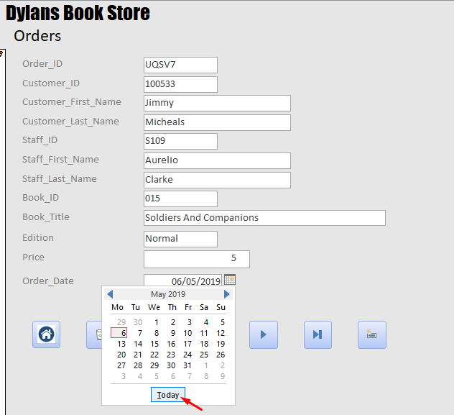

Deleting Data
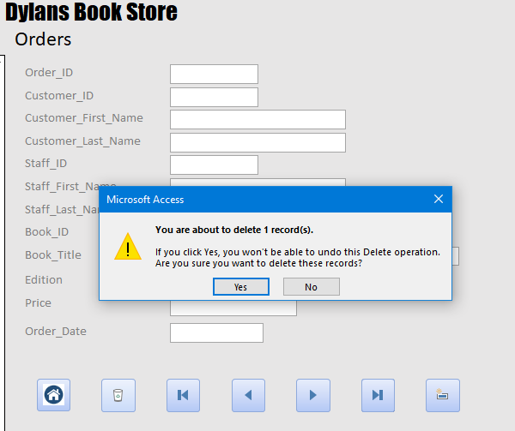



To delete data simply click on the little bin icon and click yes to deleting the data and the data will disappear.

Viewing and Printing Reports
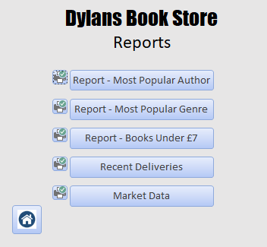

To view reports simply click on the report’s menu, all the reports are there to be viewed just click on a button to see it.
To Print simply click the printer button by the side of the report and select the printer.

Bibliography

[1] | “Study Tonight,” [Online]. Available: https://www.studytonight.com/dbms/database-normalization.php. [Accessed 05 05 2019].

