

University Wales Trinity Saint David
School of Engineering

Combined Advanced Vehicle Dynamics
ACHA6003
AWD Torque Vectoring

Steffan Robinson
1801468

Abstract
This report aims to analyse the Ferrari FF’s new four wheel drive system to understand its effect on vehicle dynamics and potential control strategies from the torque vectoring front wheel drive system.

Table of Contents
Abstract 2
1. Introduction 4
2. Torque Vectoring Systems 5
2.1 Generic Torque Vectoring System 5
2.2 Ferrari FF Torque Vectoring System and Mechanical Torque Path 6
3. Ferrari FF Lumped Mass Model 7
4. Calculations 8
4.1 Base Vehicle Calculation 8
4.1.1 Moment of Inertia 8
4.1.2 Dynamic Index 8
4.1.3 Inertial Conjugate 9
4.1.4 Base Vehicle Specifications 10
4.2 Clutch Pack Calculation 10
4.2.1 Clutch Pack Torque Capacity and Approximate Sizing 10
4.2.2 Axial Force 11
4.2.3 Power Loss Characteristics 11
4.3 Longitudinal Acceleration Calculations 11
4.4 Yaw Rate Calculations 12
5. Potential Improvements 14
6. Conclusions 15
7. References 16
8. Appendix 18
8.1 Vehicle Base Data 18

Introduction
This report aims to investigate and analyse the 2011 Ferrari FF All Wheel Drive systems, as if it were being analysed from a direct rival manufacturer in order to understand the effects on the vehicle dynamics and potential control strategies from the torque vectoring front wheel drive system. In order to do so, there are a few stages that need to be undertaken. There will be a need for some standard information such as base vehicle data, an explanation on how a generic torque vectoring system works and a lumped mass model of the vehicle. There will also need to be calculations of the centre of gravity, moment of inertia, clutch packs torque capacity, approximate sizing’s, axial force, power loss characteristics and longitudinal acceleration, dynamic index.

Torque Vectoring Systems

Generic Torque Vectoring System
It is normally down to the differentials to transfer engine torque to the wheels this allows the ability to vary torque to each driven wheel. Torque vectoring works differently, it requires an electronic monitoring system to control the clutch pack on either side of the differential. A rear wheel drive differential will just monitor wheel speed, whereas a front wheel drive differential will have to monitor both rotational speed and steering angles of the wheels. During a drive cycle different forces are applied, and a torque vectoring system would analyse these forces and adjust the torque accordingly. By either decreasing or increasing to each wheel. However, most torque vectoring systems are found in all wheel drive vehicles where the differential oscillates the amount of torque between the front and rear wheels. Under normal driving conditions the front wheels will then receive a predetermined amount of torque, normally a set percentage, and the rest of it will be sent to the rear wheels. (Radu, 2020)
Torque vectoring in hybrid or electric vehicles is slightly different where instead of a wet clutch pack the electric motor is used to send the torque and power to the wheels but can be increased or decreased independently to improve performance and with the decreasing or braking of an individual wheel energy can be recuperated through a regenerative braking process. Torque vectoring offers the capability of individual torque distributions and has a direct impact on the yaw rate of the vehicle (Knauder, et al., 2014) Where yaw rate is rate of change of heading angle.
Another example of torque vectoring is used across numerous manufacturers such as Mercedes, Range Rover, Subaru, and Ford. With all of them working in slightly different ways. The Mercedes system works when the Electronic Stability Program (ESP) detects understeer, braking pressure is applied to the inside rear wheel and torque distribution is shifted to favour the outside wheel (Mercedes-Benz of St.Louis, 2018). The Range Rover system has an electronic differential which constantly balances the distribution of engine torque between the four wheels while cornering (Land Rover, 2021). Subaru has a system that works in 3 ways, to increase, hold or release brake pressure at an individual wheel to increase braking force and providing more traction, similarly to the Mercedes system (Szigethy & Ruth, 2019) Finally the Ford system works by imitating the use of a limited-slip differential (LSD), constantly trying to balance the engine torque output between the driven wheels to suit its environment (T.C Harrison Ford, 2021). These toque vectoring systems are cheaper and simpler than other systems because these systems try to replicate mechanical systems. By reducing the speed on the inside wheel creates a similar speed differential along both outside and inside wheels like a mechanical system, this then increases yaw rate and helps to rotate the car. However, despite being a cheaper and simpler option brake based torque vectoring systems do have their disadvantages such as in a performance sense they give slower times in racing due to braking with the possibility of overheating and with the increase in brake usage the need to replace pads is greater (Shah, 2021).
Having the ability to send torque to each of the four driven wheels not only improves performance but allows for more control over the vehicle, which gives better stability especially in poor conditions. This ability improves a vehicles handling when cornering, if one uses understeer as an example where there is weight transfer to the outer wheels more torque can be sent to these wheels to provide it with more grip to quell understeer. With the use from the wet clutch packs, it means that the torque being provided to each wheel can be decreased or increased to suit the needs of the vehicle.

Ferrari FF Torque Vectoring System and Mechanical Torque Path
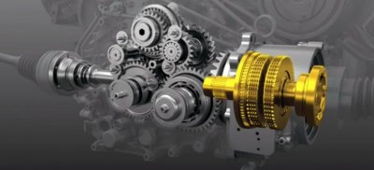

Figure 1- Ferrari FF PTU (Autozine, 2016)
The Ferrari FF’s all-wheel drive system is half the weight of a conventional system, this is down to there being two gearboxes driving the wheels separately. This systems weight reduction is down to there being no front, rear, and centre differential as well as a transfer case, there is however, an E-diff at the rear axle. All in all, this 4RM system weighs 45kg which is, as mentioned, around half the weight of the conventional four wheel drive system (Cackett, 2012). The front gearbox sits in line with the front axle and can handle up to 20% of the engines total torque output. This gearbox sits inline along with the engine which is slightly behind the front axle to provide better and more central mass distribution. With the 4RM system being lightweight in comparison to other 4WD or AWD systems it means that there is less mass being transferred from side to side aiding its performance while cornering (Ferrari, 2021). This gearbox is a helical gearset with two forward drives and a reverse drive which is driven by a conical gear off the crankshaft. With the front gearbox having two gears it’s difficult to see how that’s been paired with a seven speed gearbox at the rear however, the front first gear is geared 6% longer than the rear second and the front second gear is also geared 6% geared longer than fourth at the gear. That means that the front first gear covers the rears first and second and the fronts second covers the rears third and fourth gear. The torque is then sent along the half shafts towards each wheel from the oil-bathed, wet multi plate clutches (Ferrari, 2021). However, this system does not work above fourth gear because the torque at that speed can be handled by the rear wheels alone. The front and rear transmissions both have two electronically controlled hydraulic wet multiplate clutches, one for each wheel (Austin, 2011). The front transmission can match the speed of the rear wheel; however, this depends on the amount of slip in the clutches, this allows for higher top speed but slower acceleration. This system also allows power to be directed from side to side for maximum performance. However, there is no connection between the rear and front wheels they are just electronically controlled (Tag-Electronics , 2014).

Ferrari FF Lumped Mass Model
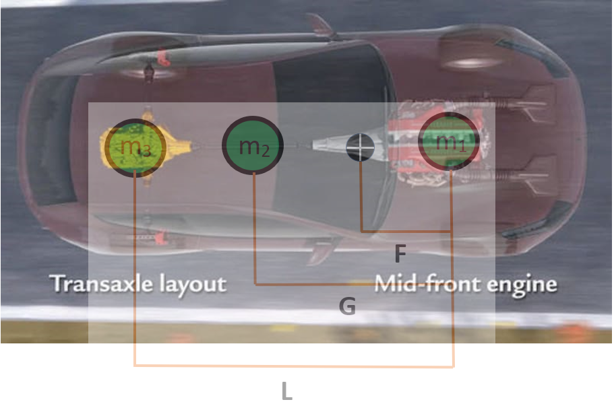
Figure 2- Ferrari FF Lumped Mass Model (Glucker, 2011) **NOT TO SCALE**
The figure above shows a lumped mass model of the Ferrari FF. The two masses, m₁ and m₃ were calculated through using the kerb weight and the weight distribution. The FF has a weight distribution of 47:53, front to back, respectively, despite it being front engine. And a kerb weight of 1880kg. Therefore, m₁ was 883.6kg and m₃ 996.4kg, obviously with m₁ at the front vehicle mass and m₃ being the rear weight. The third mass, m₂ was based upon the number of passengers in the vehicle, from 1-4. By using data from (WorldData, 2021) the average weight across Europe for a male is 85kg and 70kg for women. Therefore, by using the average, it was calculated that each passenger weighs 77.5kg. After calculating the masses, it was required to work out the distances of those masses relative to the engine, m₁. Therefore, as the engine was on the front axle and the rear transmission on the transaxle, one can estimate that the length L was equivalent to the wheelbase of 2.99m. M₂ was a little bit more of an estimate and needed to take a visual estimation. As seen in the figure above it would be fair to estimate that the driving position is around 2/3 from the data point of m₁ and since the wheelbase was 2.99, it was estimated that the distance of m₂, G, was around 1.99m. The distance F would be considered the centre of gravity, it was calculated by taking moments around that point using the equation below:
$$Centre of Gravity (F)=\frac{m_{2}G+m_{3}L}{m_{1}+m_{2}+m_{3}}$$
Equation 1- Centre of Gravity (Sandford, 2021)
By using the data calculated above in the equation it was calculated that the centre of gravity was 1.62m from the engine, m₁, when there were two 75kg passengers. However, with the addition of 3 or 4 the centre of gravity gets pulled closer towards the engine at 1.63 and 1.64, respectively. And with just a single passenger on board the centre of gravity is 1.60m. With an increased m₂ being multiplied by G, it generates a higher numerator to give a bigger F (centre of gravity) value.

Calculations
All calculations are presumed to be for a Ferrari FF with 2, 75kg passengers in the front seats, unless stated otherwise.

Base Vehicle Calculation
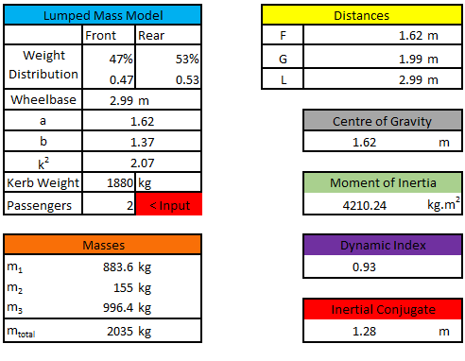
Figure 3- Base Vehicle Calculation Spreadsheet
This spreadsheet allowed the user to enter his desired number of passengers in the Ferrari FF and see how the weight of said passengers would impact all of the calculated values.

Moment of Inertia
The moment of inertia is the rotational inertia with respect to a specific rotational axis. A vehicle with a low moment of inertia will respond better and quicker to steering commands and a vehicle with high moment of inertia will be worse at responding to steering movement (Ritzel, 2009). It is the resistance to angular rotation.
$I_{zz}=(m_{1}$ $× F^{2})+\left(m_{2} × {(G-F)}^{2}\right)+(m_{3} ×{(L-F)}^{2})$ $Izz=mr^{2}$
Equation 2- Moment of Inertia (Sandford, 2021)
In the case of having 2 passengers in the vehicle the moment of inertia is 4210.24kg.m².

Dynamic Index
The dynamic index of a vehicle can give a description on the vehicles handling characteristics. A vehicle with a high DI can give a slow and lumbering feel whereas a vehicle with a low DI usually suggests a livelier, more agile, and nimble vehicle. However, having a DI which is very low can results in an uncontrollable vehicle (Sandford, 2021).
$$DI=\frac{I_{zz}}{m_{total}×a×b}$$
Equation 3- Dynamic Index (Sandford, 2021)
The dynamic index of the FF was calculated at 0.93. A value between 0.9-0.92 usually suggests a vehicle that has found a compromise between agility and control. (Sandford, 2021) The equation above uses the moment of inertia as the numerator and the m_{total}, a, and b (a being the distance of the centre of gravity from the front and b being the distance of the centre of gravity from the rear).

Inertial Conjugate
The centre of percussion (its preferred term) is the point at which there is no translation with a free body with a finite mass and inertia properties is loaded in a direction that does not pass through the centre of gravity of said body (Blundell & Harty, 2004). The inertial conjugate point at which the vehicle will rotate relative to the rear axle. The force and moment are resolved at the centre of gravity. Mass, distance from centre of gravity to front and rear axles, and moment of inertia determine the lateral force and accelerations direction and magnitude at the rear tyres (Sandford, 2021).
$$c=\frac{k^{2}}{a}$$
Equation 4- Inertial Conjugate (Sandford, 2021)
In this case the inertial conjugate for the FF was calculated at 1.28m. This value would increase with less passengers, with one passenger the inertial conjugate would be 1.34m.
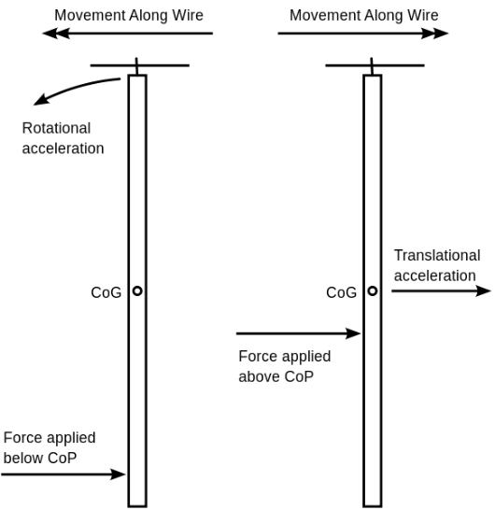
Figure 4- Inertial Conjugate (Centre of Percussion) (Wikipedia, 2011)
The figure above demonstrates the effect on the position of the centre of percussion (CoP). When a force is applied above it one gets translational acceleration and movement along the wire. However, when a force is applied below the CoP there is still movement along the wire but now there is rotational acceleration applied.

Base Vehicle Specifications
With a dynamic index of 0.93 it means that the Ferrari FF has been set up to try and find the sweet spot between agility and control, while still trying to maintain high performance despite the vehicle weighing almost 1.9 tonnes. These dynamic figures overall suggest this and irrelevant of the number of passengers the FF still maintains a dynamic index below 1 which still gives the vehicle a good balance of agility and control regardless of cargo.

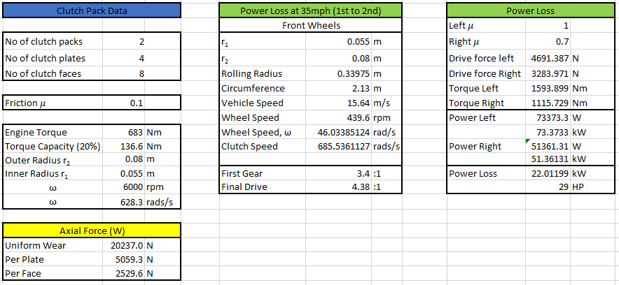
Clutch Pack Calculation
Figure 5- Clutch Pack Calculations
This spreadsheet, similarly, to the others have been created in order to update whenever values change on other sheets. With the blue title being clutch pack data, yellow being axial force calculations and green being power loss calculations.

Clutch Pack Torque Capacity and Approximate Sizing
Since the Ferrari FF can only deliver 20% of the total output torque to the front wheels, that the clutch pack would only be dealing with that 20%. Meaning the front clutch pack was operating a maximum 136.6Nm when the engine was at 6000rpm. To approximate the size of clutch, one used images of the drivetrain in comparison to the brake discs since the size of those were known.
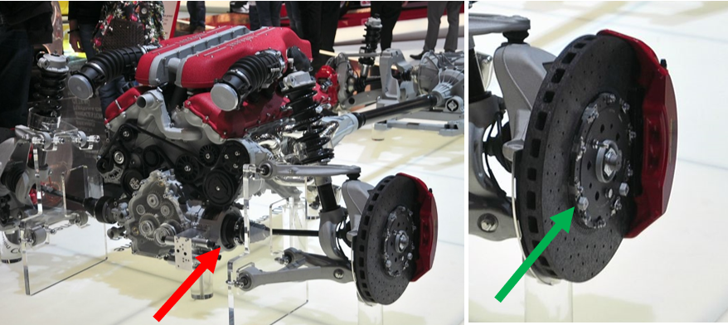
Figure 6- Ferrari FF Drivetrain (Pistonheads, 2012)
Since the front brake discs were 398mm (Ferrari, 2021), we estimated that the clutches had to be smaller than the outer circle on the brake discs (green arrow) which had a diameter of around 200mm, therefore a 100mm radius. Since it wasn’t half that again it was somewhere in the middle and that’s when the estimation came in at 80mm for the outer radius and then from there subtracted 25mm to account for material on the surface on the clutch. In the spreadsheet there was the availability to vary the outer and inner radius with a list of sizes.

Axial Force
Axial Force is the force applied to the clutch packs to control the amount of slip allocated to each one. The axial force was calculated through the equation below:
$$T=\frac{μW(r_{2}+r_{1})}{2} W=\frac{2T}{μ(r_{2}+r_{1})}$$
Equation 5- Axial Force (Sandford, 2021)
By using a friction coefficient of 0.1 for carbon fibre soaked in oil, the torque the 20% of max output and the radiuses were estimated to give an axial force of 20237N which works out at 5059.3N per plate and 2529.6N per face.

Power Loss Characteristics
The calculation for power loss was conducted with the vehicle speed being set at 35mph while changing gear from 1st to 2nd at 6000rpm. In order to obtain a power loss, the left and right side of the vehicle were set on different surfaces to obtain different 𝜇 values. With the left side being on dry asphalt and the right side on wet asphalt the FF lost 29HP (22kW). As the difference in 𝜇 increases the power loss increases.

Longitudinal Acceleration Calculations

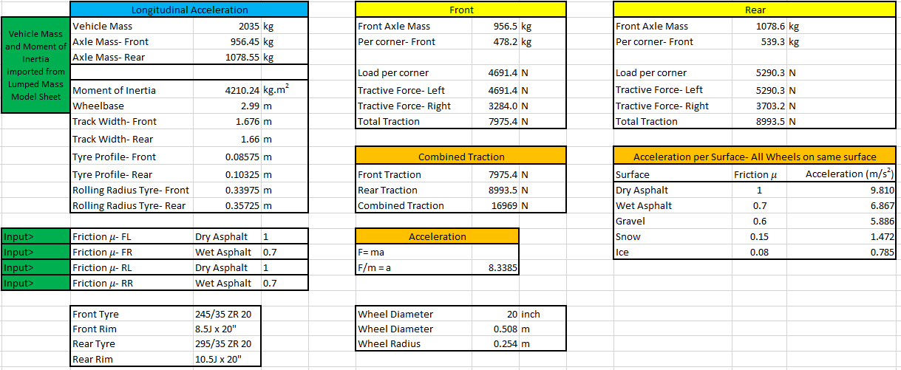
Figure 7- Longitudinal Acceleration Spreadsheet
This spreadsheet was created so that the mass and subsequently the moment of inertia would update from the Base Vehicle calculations sheet depending on the number of passengers in the vehicle. This spreadsheet would also allow one to manipulate the surface the FF was driving on, these were dry asphalt, wet asphalt, gravel, snow, and ice and their given 𝜇 value (HP wizard, 2021). It would also update all of the traction data for the set condition when an individual wheel would enter a different surface. This would therefore give up to date data on the combined traction force and the subsequent longitudinal acceleration of the vehicle regardless of what wheel was on which surface. As one can see the improvements when all wheels are on the same surface are quite clear, with a directly proportional link between friction and acceleration.
To calculate the longitudinal acceleration, one used the loadings on both axles, and the load per corner (per wheel) these values were based upon the weight distribution 47:53 meaning there was a higher loading on the rear axle. From there the load per corner would be multiplied by its respective 𝜇 value to get the tractive force from that individual wheel which would subsequently be added together to get the total traction at the wheel (front or rear). With a simple F=ma it is then possible to get the acceleration per traction variant.

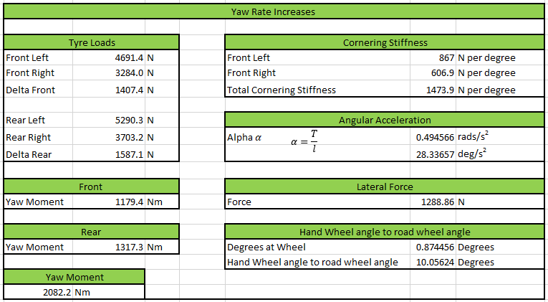
Yaw Rate Calculations
Figure 8- Yaw Rate Calculation Spreadsheet
This yaw rate spreadsheet went hand in hand with the longitudinal acceleration. When changing the surface and the frictions the tyre loads for all of the tyres update according to which surface, they are on. In order to calculate the yaw moment there were a few stages to consider beforehand. The yaw moment for the front and rear was calculated by multiplying the difference between right and left tyre loads by half of the track width.
$$Yaw front and rear=∆ Force ×\left({Avergae Track Width \atop 2}\right)$$
Equation 6- Yaw moment for the front and rear wheels
The yaw moment was calculated by adding both front and rear yaw moments together and multiplying by both track widths by 2 to get the average then 2 again for the yaw moment for the front and rear. From there we could use the cornering stiffness values for each side (if one wanted to be on two surfaces) (Sandford, 2021) and the lateral force which was calculated from the yaw moment and centre of gravity to generate degrees of wheel turn and use the 15.1:1 steering ratio to get a handwheel to wheel angle.

Potential Vehicle Dynamic Improvements

On/Off Power
Since the E-diff is controlled electronically it is able to control the torque sent to each individual wheel, through this the vehicle can maintain a reluctance to turn or yaw damping. The ability to increase and decrease the amount of torque in each wheel can reduce the effect of either understeer or oversteer while under heavy acceleration. There are numerous sensors that are able to monitor these actions such as engine speed sensor, clutch speed sensor, wheel speed sensor and throttle position sensor.

Straight Line and Cornering
The biggest feeling when either accelerating hard or cornering hard is the weight transfer either longitudinally or laterally, some sort of position sensor on the suspension might be able to read the amount of roll and reduce it beforehand. Therefore, a handwheel sensor might be of use which could read the handwheels position and movement to decide along with other sensor what amount of wheel needs which amount of torque.

On-limit lane change manoeuvres
The E-diff could control the torque at the rear wheels at the high speed, as Ferrari say themselves, paired with the other sensors such as handwheel, brake sensor, throttle sensor and wheel speed sensor.

How AWD system inter-reacts with other control systems
The AWD system with react with other systems such as the ABS, wheels speed sensors, electronic stability control, will interact with each other to provide the best torque vectoring system at any given moment. By braking inside wheels under cornering to increase the angular rotation of the vehicle.

Conclusions
To conclude the Ferrari FF has all the characteristics of a sports car but the vehicle is able to control itself. It is able to do this with help from the 4RM AWD and torque vectoring system, however, unlike most AWD systems it’s half the weight. This gives the FF dynamic index of 0.93 which suggests its agile and responsive but has a good balance between agility and control.

References
Austin, M., 2011. Explaining the Ferrari FF's tow gearbox four wheel drive system. [Online]
Available at: https://www.caranddriver.com/news/a18736603/funky-four-explaining-the-ferrari-ffs-two-gearbox-four-wheel-drive-system/
[Accessed 6 May 2021].
Autozine, 2016. 4 wheel drive. [Online]
Available at: https://www.autozine.org/technical_school/traction/4WD_3.html
[Accessed 5 May 2021].
Blundell, M. & Harty, D., 2004. Multibody Systems Approach to Vehicle Dynamics. In: Multibody Systems Approach to Vehicle Dynamics. Oxford: Elsevier Butterworth Heinemann, p. 517.
Cackett, N., 2012. Ferrari FF. [Online]
Available at: https://www.autocar.co.uk/car-review/ferrari/ff/first-drives/ferrari-ff
[Accessed 6 May 2021].
Ferrari, 2021. Ferrari FF. [Online]
Available at: https://www.ferrari.com/en-EN/auto/ff
[Accessed 6th May 2021].
Glucker, J., 2011. Video: Ferrari FF 4RM drivetrain explained. [Online]
Available at: https://www.autoblog.com/2011/03/08/video-ferrari-ff-4rm-drivetrain-explained/#slide-1734850
[Accessed 7 May 2021].
Green Car Congress, 2017. Mitsubishi e-Evolution concept features three-motor powertrain with new Dual Motor active yaw control. [Online]
Available at: https://www.greencarcongress.com/2017/10/mitsubishi-e-evolution-concept-features-three-motor-powertrain-with-new-dual-motor-active-yaw-contro.html#:~:text=Mitsubishi%20first%20deployed%20an%20active,vehicle%20was%20accelerating%20or%20decelerating.
[Accessed 5 May 2021].
HP wizard, 2021. Tire friction and rolling resistance coefficients. [Online]
Available at: http://hpwizard.com/tire-friction-coefficient.html
[Accessed 9 May 2021].
Knauder, B., Theunissen, J., Savitski, D. & De Novellis, L., 2014. Electric Torque Vectoring for Electric Vehicles, Surrey: ATZelektronik.
Land Rover, 2021. Explore Range Rover Sport. [Online]
Available at: https://www.landrover.com/vehicles/range-rover-sport/technologies.html#:~:text=The%20Torque%20Vectoring%20by%20Braking,the%20four%20wheels%20when%20cornering.
[Accessed 7 May 2021].
Mercedes-Benz of St.Louis, 2018. 2018 Mercedes-Benz C-class Performance. [Online]
Available at: https://www.mbstl.com/2018-mercedes-benz-c-class-performance/#:~:text=Torque%20Vectoring%20Brake%3A%20When%20the,to%20favor%20the%20outside%20wheel
[Accessed 7 May 2021].
Pistonheads, 2012. Ferrari FF. [Online]
Available at: https://www.pistonheads.com/gassing/topic.asp?h=0&f=47&t=1896258&i=40
[Accessed 9 May 2021].
Radu, V., 2020. What is torque vectoring and how does it work. [Online]
Available at: https://www.autoevolution.com/news/what-is-torque-vectoring-and-how-it-works-152235.html#
[Accessed 5 May 2021].
Ritzel, 2009. VEHICLE DYNAMICS. [Online]
Available at: https://ritzel.siu.edu/courses/302s/vehicle/vehicledynamics.htm
[Accessed 8 May 2021].
Sandford, M., 2021. Vehicle Mass DI, Swansea: UWTSD.
Shah, V., 2021. Torque Vectoring Explained. [Online]
Available at: https://www.carexpert.com.au/car-news/torque-vectoring-explained
[Accessed 7 May 2021].
Szigethy, N. & Ruth, P., 2019. Dynamic Duo. Drive Performance Magazine, 16 January.
T.C Harrison Ford, 2021. What is Ford Torque Vectoring Control. [Online]
Available at: https://www.tch.co.uk/about/why-choose-ford/torque-vectoring-control/
[Accessed 7 May 2021].
Tag-Electronics , 2014. Ferrari FF. [Online]
Available at: http://www.tag-electronic.com/-FERRARI-FF,49-.html
[Accessed 6 May 2021].
Wikipedia, 2011. Centre of Percussion. [Online]
Available at: http://ckw.phys.ncku.edu.tw/public/pub/Notes/GeneralPhysics/Powerpoint/Solutions/Center%20of%20percussion.htm
[Accessed 8 May 2021].
WorldData, 2021. Average sizes of men and women. [Online]
Available at: https://www.worlddata.info/average-bodyheight.php
[Accessed 7 May 2021].

Appendix

Vehicle Base Data



