Programme: BA Leadership and Management Skills for the Workplace
Module Code: BMSK5006
Student Name: Rabia Miah
Student ID: 1605763
Module’s Lecture Name: Mr Anupam Mazumdar
Knowledge and Information Management Skills for the Workplace

Table of Contents
1 Introduction 3
2 Knowledge Management in the Context of Knowledge Assets 4
2.1 Organization’s overview – Rush Hair Salon 4
2.2 Relationship Between Data, Information & Knowledge 4
2.3 Individual Knowledge VS Organizational Knowledge 5
2.4 Identify Knowledge Assets: Analysing & Techniques 6
2.5 Evaluation of Actual & Potential Knowledge 7
3 Knowledge Management Process in the Context of Organizational Development 9
3.1 Requirements for Creating, Storing, Applying & Integrating Knowledge 9
3.2 Intellectual Property Rights (IPR) & Knowledge Management Process 11
4 Framework for Establishing knowledge Management culture 14
4.1 Knowledge Management’s Contribution to the Organization 14
4.2 Knowledge Requirements for the Organization 15
4.3 KMS Framework to Enable Knowledge Sharing in Organization 16
4.4 Recommendations 18
5 Conclusion 19
References 20

1 Introduction
The modern business world is all about information. business or organization with the highest information or knowledge have a competitive advantage over every organization in the market. and managing knowledge is the best way of using the information or knowledge for the purpose of business (Al-Hawamdeh, 2013). The term, Knowledge management can refer to the process which helps the people related to an organization to share, access and use or continuously update business knowledge and information. Collecting or gathering information or knowledge about the market or business is not enough nowadays. It needs proper management because the management of knowledge within a business organization is very significant. It helps the organization to make informed decisions, making fewer mistakes or reducing the cost of gathering information. the purpose of this paper is to provide is to give an insight on knowledge management in the context of a business organization, Rush hair Saloon.

2 Knowledge Management in the Context of Knowledge Assets
Understanding the difference as well as relations between different elements or terms in the knowledge management process helps to identify the knowledge assets of the organization (Hislop, Bosua and Helms, 2018). to better understand the knowledge management process in the context of a business organization like Rush Hair, the management should have the ability to distinguish between different terms of knowledge management.

2.1 Organization’s overview – Rush Hair Salon
Rush Hair is a UK based hair saloon business organization which was founded by Andy Phouli and Stell Andrews in 1994 at Wimbledon (Hair, 2019). They start the business with a vision of creating a brand for unique and creative hairstyles. But the most significant milestone for the rush Hair was opening the advanced academy for the benefit of the people in the organization. the management of this information or knowledge led to becoming one of the most successful hairstyle company of UK. With about more than 62 saloons across the UK, the business is running effectively because of the information management strategy followed by the Rush hair. But the knowledge management of the organization is not working effectively with newer branches of the organization. Employees lack the willingness to sharing information or knowledge spontaneously and the management is facing many complications regarding the knowledge management of the organization.

2.2 Relationship Between Data, Information & Knowledge
In the context of knowledge management program of a business organization like Rush Hair, the basic understanding of data, information or knowledge helps the management in understanding the knowledge management process within the organization. a framework can be used to understand the relationship between these individual elements.
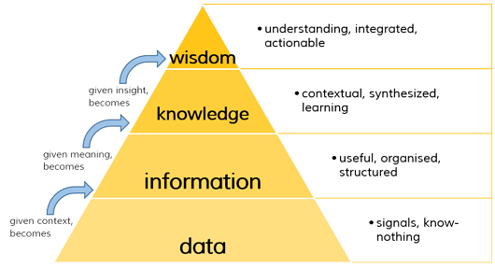
Figure 1: Relationship between data, information, knowledge & wisdom
(Source: Leonard, Swap and Barton, 2014)
Data: Data is the collection of discrete or raw facts or materials that are usually collected by extensive market research (Hunter, 2015). The Rush Hair Saloon continuously come up with different hairstyle ideas regularly. To do so, they need extensive market research for understanding the trends or facts that influencing the needs of the customers. these collected raw facts or trends are the data for the Rush Hair Saloon.
Information: When the data processes to a meaningful conclusion, these are called information. information is the processed form of raw data (Huseman and Goodman, 2017). The information usually provides answers or results. If it doesn’t, it’s not information. the management of Rush Hair, analyse and interpret the collected data to meaningful information to understand the trends and needs of the customers precisely and on to the point.
Knowledge: The next step in interpreting meaningful information from raw data is knowledge (Knowledge Management Systems, 2010). The information comes knowledge if we apply our experiences or jurisdiction unto processed information. The management of Rush Hair takes different decisions to meet the customers demands according to the processed information. taking different decisions and expertise on information makes the information knowledge for the organization.
Wisdom: Information is the last element of the framework which refers to understanding & integration of knowledge (Leonard, Swap and Barton, 2014). The actionable plans or the action took by the management of Rush Hair based on the knowledge of the organization is the wisdom.

2.3 Individual Knowledge VS Organizational Knowledge
An understanding of the different form of knowledge within the organization is a significant step forward in understanding knowledge management (Koskiala and Launo, 2012). There are two basic types of knowledge in the context of a business organization, explicit knowledge and tacit knowledge. The explicit knowledge is the knowledge within the organization or organizational knowledge, and tacit knowledge is more private and based on the expertise of a person.
Individual Knowledge: Individual knowledge can be referred to the tacit or more personalised knowledge that a person process (Lehaney, 2010). The knowledge is more likely to be based on the expertise of the individual within the organization. The employee’s workings in the different branch of the Rush hair have direct contacts with the customers and they know the needs or the demands of the customer. They also know the trends regarding hairstyles in the market. The employees of Rush Hair are also expertise in different area which is the individual knowledge of them.
Organizational Knowledge: The term organizational knowledge can be defined as the combination of individual knowledge or resources that can reside in different groups within an organization or in different levels of the organization (Leonard, Swap and Barton, 2014). The organizational knowledge of the Rush Hair can be the Artistic Team of the organization who have individual expertise but works together to develop or innovate unique and creative hairstyles for the customers.

2.4 Identify Knowledge Assets: Analysing & Techniques
To effectively use the knowledge assets of an organization, first, they need to identify the knowledge of the organization (Hislop, Bosua and Helms, 2018). the different organization uses different techniques or models to identify the knowledge assets of their organization. According to the Rush Hair Saloon, they use an integrative knowledge auditing system to identify what are the assets they have regarding knowledge.
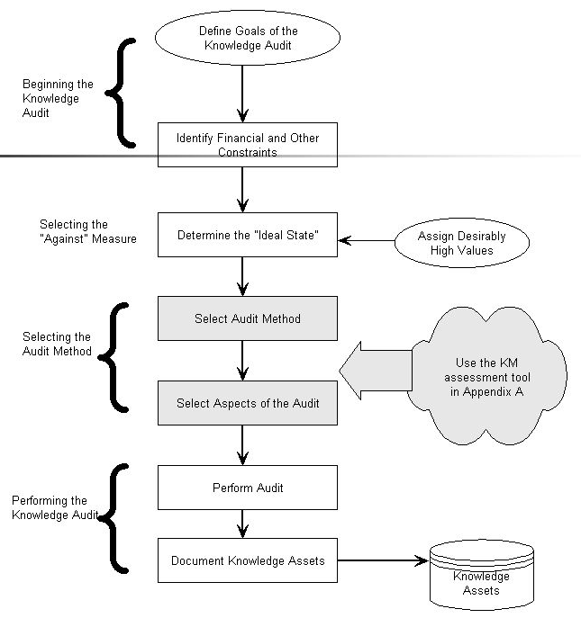
Figure 2: Identifying the knowledge assets of an organization
(Sources: Hislop, Bosua and Helms, 2018)
The knowledge auditing framework of Rush Hair includes defining the goals and objectives of auditing knowledge and identifying the financial constraints of the auditing process. the next step of the management is to develop or define a standard for the knowledge assets or determining the ideal state of the knowledge. Then the management needs to adopt or select the most effective auditing method from different tools which consider the three components of knowledge management, people, process and technology (McDowall, 2012). Selecting the aspects of the audit is another important factor in this step. The final step of the auditing process is the implementation of auditing tools or strategies and documenting knowledge assets of the organization. The Rush Hair Salon document the knowledge assets in the comprehensive KMS system which facilitate the further use of the knowledge assets.

2.5 Evaluation of Actual & Potential Knowledge
The management of an organization needs to understand the difference between actual knowledge and the potential knowledge of an organization to effectively prioritize the importance of the knowledge within the organization. there is a certain difference between actual and effective knowledge.
Actual vs Potential Knowledge: Actual knowledge in the individual or organizational level refer to the clear and precise facts that come from analysing data or information. actual knowledge of an organization can be referred to the current strength that an organization possess or the current situation of the business organization (Senge and Senge, 2015). On the other hand, potential knowledge of an organization can refer to the ability the organization have in growing the knowledge within the organization.
The opportunity or gap to develop or increase the business further is the potential knowledge the organization have an individual level or organizational level. The actual knowledge is implemented or obtained knowledge from potential knowledge. In Rush Hair, the employees may have a plan for innovating a new hairstyle, but the final hairstyle may differ from the planned one, which can describe as the actual knowledge of the organization.

3 Knowledge Management Process in the Context of Organizational Development
The different organization uses different knowledge management process according to their business process or strategy (Symes, McIntyre and Barnett, 2016). But every knowledge management process must need to analyse the impact of the intellectual property in the knowledge management process. The goal of every knowledge management process is to create new knowledge for the organization and managing the old or existing knowledge effectively.

3.1 Requirements for Creating, Storing, Applying & Integrating Knowledge
Effective knowledge management is an integrative process for gathering or creating knowledge, storing them for further use, applying the stored knowledge when necessary and sharing the knowledge with different parties of the organization (Tokoro and Steels, 2010). The Rush Hair uses an integrative knowledge management process in order to manage knowledge in the organization.

Figure 3: Knowledge Management Process
(Source: Tokoro and Steels, 2010)
Creating or Acquisition of Knowledge: The first step in the knowledge management process in the context of a business organization is to create or generate knowledge from a different source (Von Krogh, Ichijō and Nonaka, 2013). The different business organization uses different tools to generate knowledge such as writing, market research etc. Rush Hair Saloon uses two main tools for creating or generating knowledge. Extensive market research about different trends and the community of practices.
Capturing & Collecting Knowledge: The second step in the knowledge management process is to capture or collect knowledge or information by using different mediums such as interview, questionnaire, survey etc (Al-Hawamdeh, 2013). The management of the Rush hair Saloon uses the survey methods and questionnaire about customers satisfaction and needs after every transaction or interaction with the customers.
Knowledge Organization: The collected knowledge or information need to be organized effectively in order to have the best output when needed (Hislop, Bosua and Helms, 2018). If the knowledge is not organized in an effective manner, it will be hard to use when necessary. The Rush Hair Saloon take different steps to organize the knowledge after collecting such as cataloguing, classifying and abstracting the information or knowledge.
Storage of Knowledge: The collected or organized knowledge need to be well documented and stored for further uses. Different forms of storing can be used in the organization. in this era of technological development, most of the business uses computer technology in order to store knowledge. But the most effective way of storing knowledge is to store them in different formats such as cases, documents, causes, diagrams, processes etc (Hunter, 2015). The Rush Hair Saloon uses different formats, most cases, causes and process to store knowledge. The cases of interaction or customer dissatisfaction, or the process of operation are stored for further references or uses of the knowledge.
Sharing Knowledge: Sharing knowledge is known as the most important step in the knowledge management process. the collected and stored knowledge should be shared with different parties of the organization in a different format. The knowledge may be shared in the form of storytelling, case study analysis, extensive training discussion forums etc. the management of the Rush hair Saloon uses different training programs as well as meetings and discussion forum to share the collective knowledge among the employees and its branches across the UK.
Integrating with Knowledge Applications: Business organization are now driven by technological advancement, mostly the advancement in information technology. There are different applications used to form the implication of knowledge in an organization. integration of knowledge with knowledge application facilitates the accessibility of knowledge among the employees which makes the decision-making process quicker (Huseman and Goodman, 2017). The Rush hair Saloon uses an integrative knowledge management system (KMS) to integrate the collected information for further uses. It helps them to take effective decisions quickly and increase the managerial flexibility of the organization.

3.2 Intellectual Property Rights (IPR) & Knowledge Management Process
Intellectual property rights have critical importance in the knowledge management process of an organization. The term Knowledge is itself an intellectual property for a business organization (Koskiala and Launo, 2012). Every organization have their own unique knowledge which is a result of the extensive business research and knowledge management within the organization. These intellectual properties have a great impact on the knowledge management process of an organization.
Figure 4: Common Intellectual Properties of an organization.
(Source: McDowall, 2012)
The term intellectual property can be referring to the intellectual capital which are the knowledge assets of an organization. The common intellectual property of an organization is the patents, trademarks, copyrights etc which are knowledge assets of an organization (Tokoro and Steels, 2010). Trademarks are the symbols, signs, or names of an entity that distinguish it from others. The name of different products and brand by Rush Hair Salon is trademarked under the trademark law of the UK which distinguish the organization and its service or products from others. The patent is the right of property for a limited duration which can be an invention. The patented invention gives the rights of using, selling or transferring right of the invention. The patented elements by the Rush Hair are few, they have patented products or services provided to the customers. The most important intellectual property of an organization as well as for Rush Hair is the copyrighted documents of different market analysis by the Rush Hair (McDowall, 2012). The result of different market research for the business purpose, different publications etc are copyrighted by the management of Rush Hair.
These are the common intellectual property that has significant importance in the knowledge management of Rush Hair. The intellectual property of a business who maintain KMS in the organization, are stored in knowledge or the KMS which helps to effectively use these properties and protecting them from infringement
Stored Knowledge | Example of Rush Hair
Patent | Document of new product or service innovation.
Copyright | Rights of different documents: research results, publications etc.
Trademark | Rush Hair, Company logo, product logo or sometimes product name.
IP - Related information or knowledge | The flow of information or knowledge within the organization.
Innovation concept or ideas | The trend in the market, product or service trends etc.
Figure 6: Intellectual Property stored in the Knowledge of an organization.
These intellectual properties are complicated to collect, acquire, store or share without proper permission or the authority of the management (Lehaney, 2010). Management of IP is one of the most significant things the management need to do for effective and efficient results. But to manage the IP of an organization the management, the IP assets needs to incorporate with different business strategies where the strategy regarding knowledge management is the most important.
Knowledge-based intellectual property management system: The Rush Hair Saloon integrate their intellectual property by integrating it with the knowledge management system or the knowledge-based intellectual property system (Leonard, Swap and Barton, 2014). The knowledge-based intellectual property management system helps the organization to manage the IP of the organization by integrating it with a knowledge management system within the organization. The knowledge-based property management system of Rush Hair consists of two main components, intellectual portfolio management and intellectual property searching.
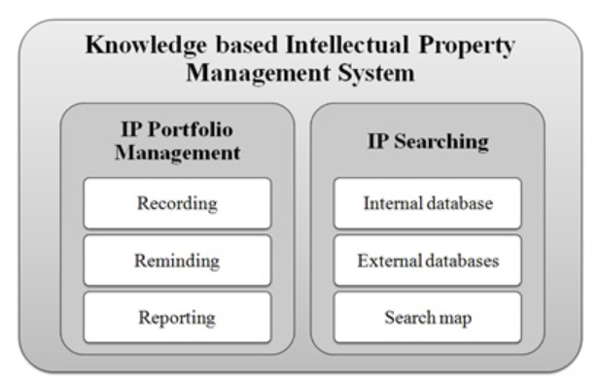
Figure 5: Knowledge-Based Intellectual Property Management System
(Source: Leonard, Swap and Barton, 2014)
The intellectual property portfolio management based on the knowledge management process consists of recording, reminding and reporting which facilitates the intellectual property or managing the rights of the knowledge. The portfolio management of IP includes the knowledge system in data capturing, reviewing and the reminding for the renewal of the intellectual property of Rush Hair Saloon. On the other, the knowledge management systems also need to incorporate with IPS for searching intellectual property when needed. The IP searching options in knowledge-based intellectual property system include searching data from both internal and external source and mapping search options (McDowall, 2012). The IP assets of an organization are the stored knowledge within the knowledge management system. The different intellectual property of Rush Hair Saloon which is integrated into the knowledge stored in the KMS is providing below.
The Intellectual property of an organization like Rush Hair has great importance in the knowledge management process. because organizational knowledge and the intellectual property of an organization are interrelated with each other. If they are not incorporated or integrated properly, the management of the intellectual property of the organization won’t be effective.

4 Framework for Establishing knowledge Management culture
Effective management of the knowledge within the organization is very crucial in order to have the best output from the knowledge an organization have different levels of operations. The management of knowledge has many contributions to the organization (Senge and Senge, 2015). but to manage knowledge effectively, a proper framework for establishing knowledge sharing or enabling knowledge sharing culture knowledge should be implemented in the organization.

4.1 Knowledge Management’s Contribution to the Organization
There is common saying that “information is power” which is a common expression that comes in mind when someone talks about the contribution of knowledge in an organization. management of the flow of information or knowledge between the employees or business in an organization has tremendous benefits starting from making quick decisions to promoting the importance of knowledge sharing.
Enabling effective & faster decision making: The employees of the organization can make a quick decision as they have relevant access to the knowledge when they needed (Symes, McIntyre and Barnett, 2016). The collaboration of the expertise of every individual in a commonplace brings the power of making effective and quick decisions. The employees of the Rush Hair can access every o formation regarding their business through a central KMS from anywhere they are working.
Reusing ideas or documents effectively: The knowledge management culture of an organization also gives the management the opportunity of reusing the same documents or intellectual property effectively (Tokoro and Steels, 2010). Everything starting from customers cases and intellectual property are well documented which helps the management to reuse it and lower the operational cost.
Avoiding doing the same mistakes: Documented knowledge and making knowledge management culture of the employees helps them to avoid doing the same mistakes over and over as everything is documented in the knowledge management process (Von Krogh, Ichijō and Nonaka, 2013). Rush Hair employees were able to increase customer satisfaction by studying and solving customer cases effectively.

4.2 Knowledge Requirements for the Organization
The knowledge management processor evaluation needs different knowledge requirements in an organization to implement the process more effectively (Al-Hawamdeh, 2013). The knowledge requirements of Rush Hair typically consist of three components, people, process and technology.

Figure 7: Knowledge requirements of an organization
(Source: Al-Hawamdeh, 2013)
People: A knowledge management process of an organization is mostly relying on the individual expertise of its employees (McDowall, 2012). according to the management of Rush Hair, the knowledge management of the organization needs about 70% effort from the people within the organization. people with different expertise help the management to build the organizational knowledge management system effectively.
Process: The process is another important part of the knowledge required of an organization. effective knowledge management needs different methods or tools to manage the knowledge effectively such as creating knowledge management maps, integration with the business strategy, developing business standards etc (Symes, McIntyre and Barnett, 2016). about 20% effort of knowledge management of Rush Hair comes from their process. the Rush Hair Saloon uses a comprehensive knowledge management system and integrates it with another business strategy to have the best outcomes.
Technology: The modern business era is all about technology, more specifically technology that manages the information flows (Hunter, 2015). The organization uses different tools to capture, store, analyse and interpret from raw data. The purpose of using the technology is diverse, such as data storing and formatting, data mining or analysis or adopting automation in the knowledge management process. The Rush Hair adopted different technology mostly to facilitate the automation of knowledge management within the organization. the comprehensive computer-based KMS system also helps to store and analyse data or knowledge quickly.

4.3 KMS Framework to Enable Knowledge Sharing in Organization
The different organization uses a different framework for knowledge management within the organization. but the most important fact is to align it with the business strategy and developing the culture of sharing knowledge within the organization in different level of the management (Hunter, 2015). The knowledge management framework of Rush Hair is integrated with the business strategy and operational planning which enable the organization to make the knowledge sharing a culture of the employees.
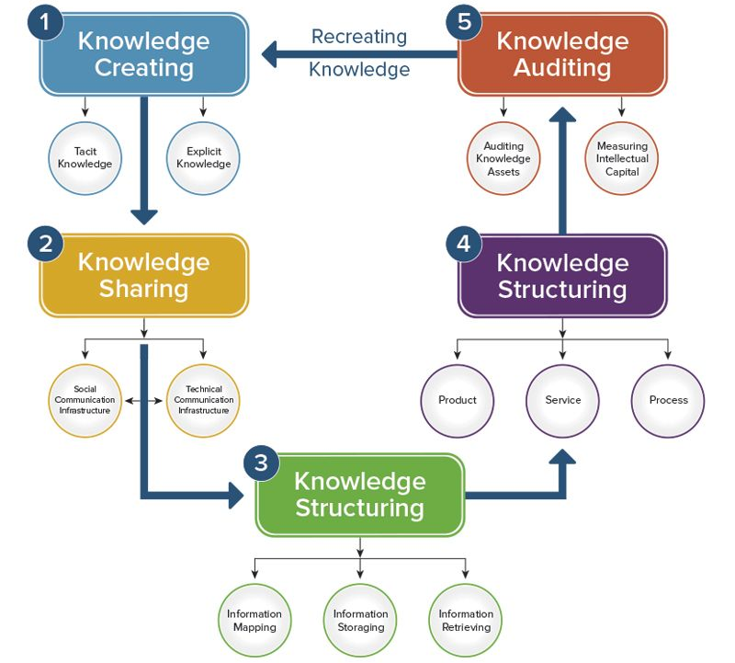
Figure 8: Knowledge management framework of Rush Hair
(Source: Lehaney, 2010)
Creating Knowledge: The first step of the knowledge management framework of Rush Hair is creating knowledge (Tokoro and Steels, 2010). The management of Rush capture or create explicit or tacit knowledge from the individual or organizational level. Explicit knowledge is the knowledge typically adopted by the organization. and tacit knowledge is the expertise of the individual employees. the Artistic Team of Rush Hair is combinedly the example of organizational knowledge and member of the Artistic team possess individual or tacit knowledge.
Sharing Knowledge: The next step in the knowledge management framework is to share knowledge between the parties. This is the most important part of the knowledge management which needs to be implemented with the organizational structure (Hunter, 2015). The knowledge management framework should integrate with the organizational frameworks for enabling a knowledge sharing culture. collected knowledge or captured knowledge usually shared via social communication structure or technical communication structures which includes meetings, training or discussion sessions with employees from a different level of the management.
Structuring Knowledge: the step, structuring knowledge involves the proper categorising or storing Knowledge in the organization. structuring knowledge helps a business organization to get the necessary information as quickly as possible (Huseman and Goodman, 2017). The management of Rush Hair structure the knowledge developing processes of information or knowledge mapping, storing and retrieving from the stored devices. The structuring of knowledge also involves the consideration of product, service or process of the business organization. considering these components while developing a knowledge management framework helps the organization to enable knowledge sharing within the organization.
Auditing Knowledge: To enable knowledge sharing within the business organization, the management need to audit the knowledge on a regular basis to measure the intellectual capital of the business organization (Al-Hawamdeh, 2013). The Rush Hair usually audit the knowledge of the organization for two main reasons, to identify the knowledge assets of the organization and auditing or to know to knowledge capital of the organization.
Recreating Knowledge: Auditing the knowledge assets and intellectual property may result in the need for recreating knowledge (Lehaney, 2010). After auditing the knowledge assets, the management of the Rush Hair may find different knowledge gaps. The management then recreates the necessary knowledge by adopting extensive market research and again go through every process of the knowledge management framework.
The knowledge management framework adopted by the Rush Hair is integrated with the organizational framework in every stage which enables the knowledge sharing within the organization and make a culture of knowledge sharing within the organization.

4.4 Recommendations
Rush Hair Salon is a UK based hairstyle industry operating their business over 20 years across the different market of UK. The idea of the business and their effective management bring them many awards and success. But the most important factor behind their success is the effective management of knowledge within the organization. Though they were successful in managing the knowledge effectively, sometimes they face different obstacles regarding the knowledge management strategy or framework which need to be developed or resolved.
The management of the Rush Hair was able to enable a knowledge sharing culture, but the employees sometimes were finding it hard in sharing knowledge or sharing their own individual expertise with the broader management. The management of Rush Hair should start the knowledge sharing culture early in the career of the employees. and providing proper training to the employees to understand the importance of effective knowledge sharing within the organization. The knowledge workers of the organization should work with the training process of the employees.
The management of Rush Hair faces most of the difficulties regarding knowledge management when they open a branch in another market. the new workforce lack of different expertise and are not aware of the importance and process of knowledge sharing. The management of the Rush Hair should conduct different training programs for the new employees to adopt them with the process and culture of the knowledge sharing process. the new employees always have different tacit knowledge or expertise while they are recruited. The management should develop the method of transferring the individual tacit knowledge to explicit or organizational knowledge.

5 Conclusion
The primary goal of an organization regarding the implementation of knowledge management is to increase the efficiency of the company and helps the employees from different management level to make quick decisions. The idea of knowledge management is to develop expertise within the organization and dispersing the expertise in operating the business effectively and profitably. The implementation of KMS helps an organization in collaborating and facilitates idea generations, develop a culture of knowledge sharing, protect the right of the intellectual properties, capture, store knowledge for the future generation or the future workforce. But implementing the KMS is not the only this the organization should do for effective results, Proper alignment and integration with business purpose or strategies is needed. This paper gives an insight into the importance of knowledge management and the way the proper way of managing knowledge effectively.

References
Al-Hawamdeh, S. (2013). Knowledge Management. [S.I.]: Elsevier Science.
Hair, R. (2019). 20 Years of Rush Hair and Beauty | Rush Hair & Beauty. [online] Rush Hair & Beauty. Available at: https://www.rush.co.uk/blog/rush/20-years-rush/4986 [Accessed 3 May 2019].
Hislop, D., Bosua, R. and Helms, R. (2018). Knowledge management in organizations. Oxford: Oxford University Press.
Hunter, B. (2015). The power of KM. 2nd ed.
Huseman, R. and Goodman, J. (2017). Leading with knowledge. Thousand Oaks, Calif.: Sage Publications.
Knowledge Management Systems. (2010). Gardners Books.
Koskiala, S. and Launo, R. (2012). Information, knowledge, evolution. New York: North-Holland.
Lehaney, B. (2010). Beyond knowledge management. Hershey, Pa.: Idea Group.
Leonard, D., Swap, W. and Barton, G. (2014). CRITICAL KNOWLEDGE TRANSFER. 5th ed.
McDowall, S. (2012). Evolution, knowledge and revelation. Cambridge: Cambridge University Press.
Senge, P. and Senge, P. (2015). The fifth discipline. 4th ed.
Symes, C., McIntyre, J. and Barnett, R. (2016). Working Knowledge. 5th ed. Milton Keynes: Open University Press.
Tokoro, M. and Steels, L. (2010). The future of learning. 2nd ed. Amsterdam: IOS Press.
Von Krogh, G., Ichijō, K. and Nonaka, I. (2013). Enabling knowledge creation. 1st ed. Oxford: Oxford University Press.

