Student number: 2234498
Module: Principles of Professional Legal Practice
Module Code: BMLW4001

The lawyer is an individual in the prospect of the legal system of a society in which he provides advice to the client regarding the level of appropriateness and possibility of finding a solution and overall matters of law and he also helps in the selection of the alternative method of dispute resolution if one is not working and help the client in form of representation in all legal proceedings. There are different kinds of misconduct in response to which various criminal penalties and expulsion from practice have been introduced.

Element 1
Subject: Ethical and Professional Considerations in Prospect of Legal Implications of Investing in a New Startup Company
Dear Mr Moneymaker,
This email is intended to address any legal issues that may emerge from your desire to invest in a startup business. A lawyer's top responsibility should be to guarantee that any legal advice given is impartial, according to the law, and in line with professional ethics.
One of the most significant pieces of law about investments and financial activities in the UK is the Financial Services and Markets Act 2000, or FSMA. This Act aims to foster fair competition in the financial industry, uphold market integrity, and protect consumers' interests. If investors choose to invest in this start-up company as described by FSMA, several ethical and legal difficulties may arise (Du and Xie, 2021).
One of the first crucial questions is whether the new startup’s operations fall under the FSMA's definition of regulated activities. If a startup is interested or required of obtaining authorization from FCA, should shares and other financial products be offered by the start-up before offering or promoting such investments lawfully? Some severe legal repercussions could be led by getting engaged in such unregulated investment activities for both investors such as the startup company and yourself in this case (Biancone et al., 2020).
Financial promotion, an advertising strategy used to persuade investors to engage in investment activities is encouraged by the financial promotion that govern by FSMA. Inspiring other investors to accept the offer of an investment from that new firm requires caution because it would have been illegal to do so without first applying for authorization from the FCA. As a result, the FSMA cannot be satisfied with investments made because of unlawful financial promotions (Breidbach, Keating and Lim, 2020).
The obligation of assessing potential risks and conducting due diligence is one critical mind that should be kept in mind. It is a fact that a considerable number of risks may be associated with the decision of investing in a new startup along with the possibility of generating substantial returns. So, the potential conflict of interest should need to be addressed in ensuring adherence to professional ethical standards. In the provision of advice on starting a specific startup company, some level of conflict of interest may arise. The client's best interests always are prioritized by lawyers by remaining impartial. A perception of conflict of interest could also result because of offering advice on investment in a particular business or venture due to which the level of independence and objectivity of the legal advisor could be compromised (Bătae, Dragomir and Feleagă, 2021).
One important thing that is recommended for ensuring compliance with FSMA and addressing professional and ethical concerns is of seeking proper guidance from a qualified and skilled financial advisor based on your unique financial objectives and circumstances. Some level of necessary expertise is possessed by such experts based on which personalized advice could be offered (Raza et al., 2020).
My primary focus as a lawyer is to provide relevant and accurate legal advice for all investment-related matters. Please feel free to reach out at any time if you have further questions or concerns (Martin, Shilton and Smith, 2022).
Yours sincerely,

Element 2
The set of rules and principles set by the Solicitors Regulation Authority is referred to as the SRA Code of Conduct based on which the behaviour and conduct of lawyers are governed in England and Wales. One regulatory body is termed SRA which has the responsibility of overseeing law firms and solicitors in the prospect of these jurisdictions. The ethical and professional standards are outlined by the SRA code of conduct that must have to be followed by solicitors. The promotion of a high level of competence and integrity is considered the focus (Collins, 2020). A comprehensive understanding of the rules will be presented in the following paragraph. The core principles are focused on the structure of the SRA code of conduct based on which the obligations and duties of solicitors are mentioned. Daily practice of people is focused under, Rules 1 to 4 and Rules 6.1 to 6.5 as NQ Solicitors (Bowyer, 2019). Honesty and integrity must have to be ensured by Solicitors and they must ensure that confidence and trust are maintained in the legal profession, the public and customers. The importance of being accountable and truthful is focused on this principle (Habel, 2021).
It is very important that any level of influence from others must have to be avoided by Solicitors and this means they must have to act independently. Legal advice according to this principle should be impartial (Unger, 2020). Diligence to effectively represent their clients, required skills and competent legal services must have to be provided by Solicitors. To maintain competence throughout your career it is noted that Continual professional development is one important aspect. Client confidentiality is another important aspect that must have to be upheld by Solicitors which means they must have to ensure the protection of information (Boon and Whyte, 2019).
The importance of Rules 6.1 to 6.5 is highlighted under one practical example of a situation when two clients are represented by a solicitor, but their interests are in conflict. Take an example you are representing a company, but you are also involved in the provision of legal advice to the director of the targeted company in a personal capacity (Hatchard, 2019).

Element 3
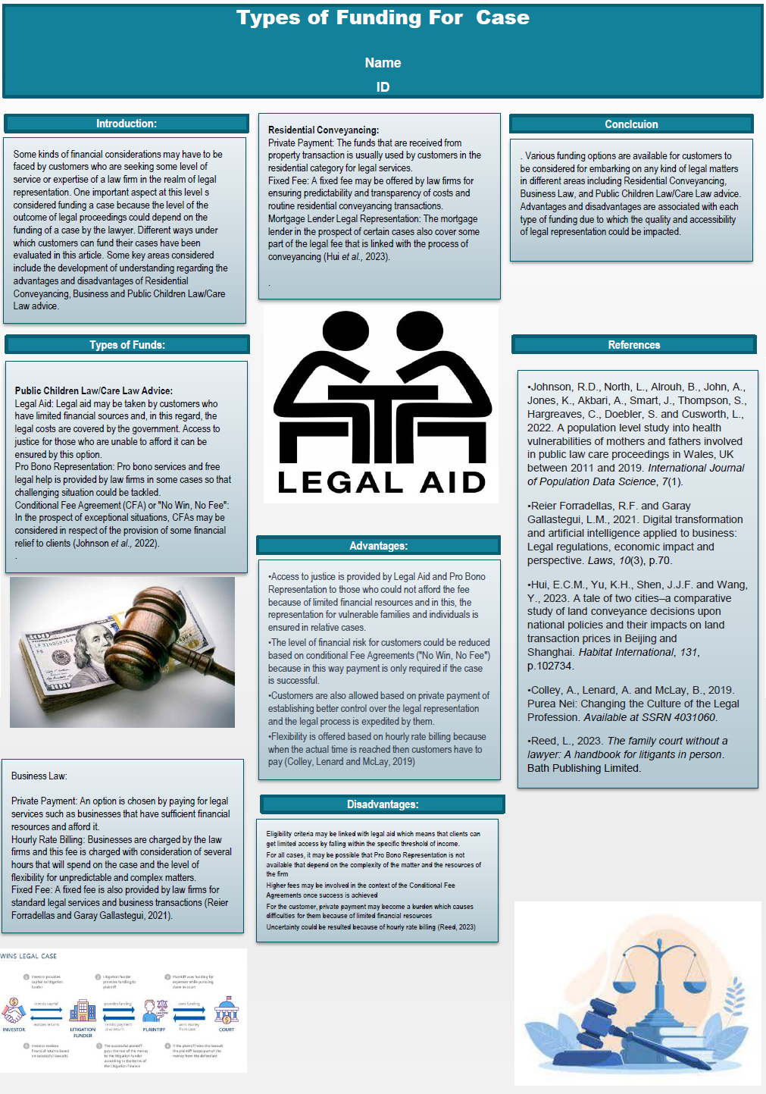

Reference list:

Bătae, O.M., Dragomir, V.D. and Feleagă, L., 2021. The relationship between environmental, social, and financial performance in the banking sector: A European study. Journal of Cleaner Production, 290, p.125791.
Biancone, P.P., Saiti, B., Petricean, D. and Chmet, F., 2020. The bibliometric analysis of Islamic banking and finance. Journal of Islamic Accounting and Business Research, 11(9), pp.2069-2086.
Boon, A. and Whyte, A., 2019. Lawyer disciplinary processes: an empirical study of solicitors’ misconduct cases in England and Wales in 2015. Legal Studies, 39(3), pp.455-478.
Bowyer, R., 2019. Regulatory threats to the law degree: The Solicitors Qualifying Examination and the purpose of law schools. Law and Critique, 30(2), pp.117-121.
Breidbach, C.F., Keating, B.W. and Lim, C., 2020. Fintech: research directions to explore the digital transformation of financial service systems. Journal of Service Theory and Practice, 30(1), pp.79-102.
Collins, G., 2020. Cyber security: Cyber security awareness month-making people the first line of defence. LSJ: Law Society of NSW Journal, (71), p.87.
Du, S. and Xie, C., 2021. Paradoxes of artificial intelligence in consumer markets: Ethical challenges and opportunities. Journal of Business Research, 129, pp.961-974.
Habel, G., 2021. Achieving Regulatory Fairness: A Disproportionately Slow Process?. Solic. J., 164, p.64.
Hatchard, J., 2019. Legal Practitioners as Potential Money Launderers: Beneficial Ownership Transparency and PEPs: Solicitors Regulation Authority v Sharif (2019). Denning LJ, 31, p.189.
Martin, K., Shilton, K. and Smith, J.E., 2022. Business and the ethical implications of technology: Introduction to the symposium. In Business and the Ethical Implications of Technology (pp. 1-11). Cham: Springer Nature Switzerland.
Raza, S.A., Umer, A., Qureshi, M.A. and Dahri, A.S., 2020. Internet banking service quality, e-customer satisfaction and loyalty: the modified e-SERVQUAL model. The TQM Journal, 32(6), pp.1443-1466.
Unger, A., 2020. Legal education future (s)–the changing relationship between law schools and the legal profession. In Key Directions in Legal Education (pp. 3-16). Routledge.

