

Student Name: Asaduzzaman Tutul
Student ID: 2435434

Programme: Master of Business Administration
Module & Code: International Marketing: Principles and Practices (LCMB7026)

Word Count: 5492
Assignment Title: Assessment component 1: Individual report
Lecturer: Tushara Balendran
Submission Deadline: 24/04/2026

Table of Contents
1. Introduction 1
2. Comparison of the market analysis via PESTEL Framework 2
2.1 Political Factors 2
2.2 Economic Factors 3
2.3 Social Factors 5
2.3.1 Cultural Factors 5
2.3.2 Hofstede Model 6
2.3.3 Hofstede Cultural Dimensions Comparison 6
2.4 Technological Factors 8
2.5 Environmental Factors 8
2.6 Legal Factors 9
3. Strategic Analysis of STP Strategy 10
3.1 VALS Model 10
3.1.1 United Kingdom VALS Profile 10
3.1.2 India VALS Profile 11
4. Comparative Analysis of the Marketing Mix (7Ps) 13
5. Directional Strategy of Development 19
6. Ethical Issues 21
7. Recommendations 21
8. Conclusion 23
Section 2 24
Reflective Account (Gibbs Reflective Cycle) 24
1. Description 24
2. Feelings 25
3. Evaluation 25
4. Analysis 26
5. Conclusion 26
6. Action Plan 27
11. Reference 28

List of Table
Table 4: Market Segmentation Variables (UK vs India) 11
Table 5: 7Ps Marketing Mix Comparison 14

List of Figure
Figure 1: PESTEL Framework 2
Figure 2: GDP Comparison (UK vs India) 3
Figure 3: Inflation Rate Comparison (UK vs India) 4
Figure 5.Hofstede Cultural Dimensions Comparison 6
Figure 6.Perception Map 12
Figure 7.. Comparative product width and depth of Zara in the United Kingdom and India 15
Figure 8.. Comparative flagship store concepts of Zara in the United Kingdom 16
Figure 9. Zara India flagship store concept located in upscale shopping malls 17
Figure 10. Comparative website layouts of Zara in the United Kingdom and India 19
Figure 11. Gibbs’ Reflective Cycle illustrating the six stages of structured reflection 24

1. Introduction
International marketing can be defined as the process through which organisations design, execute and integrate marketing strategies in various national markets with a view of attaining a competitive advantage and sustained growth (Kotler and Keller, 2016). With a growing global business environment, companies are going global in search of new markets and opportunities. But cross-border operation necessitates the adjustment to various cultural, economic, and regulatory environments (Hollensen, 2020). Balancing between global standardisation and local adaptation to the needs of the different consumers is one of the major challenges facing multinational companies (Douglas and Wind, 2017). Zara, a major fashion retailer in the world with the Inditex Group, is known to have a fast-fashion format, effective supply chain and the capacity to react swiftly to evolving customer trends (Ferdows et al., 2004). This report is a critical assessment of Zara international marketing in the United Kingdom and India, which are two markets with a different economic and cultural environment. The Hofstede cultural dimensions’ theory is used to analyse cultural differences and reflective insights are reinforced by Gibbs Reflective Cycle. The report adopts the major frameworks such as PESTEL, STP and the 7ps marketing mix to evaluate the performance of Zara, and give strategic recommendations on how it can improve its competitiveness globally.

2. Comparison of the market analysis via PESTEL Framework
Macro-environmental factors that affect the business strategies in the international markets are usually analysed with the help of PESTEL framework. It assesses political, economic, social, technological, environmental and legal forces on organisational performance (Johnson, Whittington and Scholes, 2020).

Figure 1: PESTEL Framework

2.1 Political Factors

Stability in politics is a very important factor that defines the business environment of multinational corporations. The political environment of the United Kingdom is very stable and has well established regulatory institutions. This stability facilitates foreign investment and provides an international retailer with a predictable market environment.
Contrarily, India has an even more complicated regulatory environment because it has national and state-level policies. Taxation, import duties and foreign direct investment regulations are also some of the regulatory issues that foreign retailers encounter when entering the Indian market (Deloitte, 2023).
Favourable and Unfavourable
“The United Kingdom provides a favourable stable political environment for business operations, whereas India presents unfavourable regulatory complexity due to varying state-level policies.”

2.2 Economic Factors
Economic influences are of critical importance in the international marketing strategies especially in the aspect of consumer buying power and pricing. The United Kingdom is a developed market with a large GDP and good consumer purchasing power, a fact that allows companies like Zara to occupy the mid-premium market. India, in its turn, is a developing economy with a high rate of growth and strong income inequality of the regions (World Bank, 2024).
“Compared to the United Kingdom, India demonstrates significantly higher long-term growth potential due to rapid urbanisation, rising disposable incomes, and an expanding middle-class population, although current consumer spending levels remain lower than in developed markets (World Bank, 2024; McKinsey, 2023).”
GDP Comparison

Figure 2: GDP Comparison (UK vs India)
(Source: World Bank, 2024)
“The variation in inflation rates highlights differences in economic stability and consumer spending behaviour between the two markets. Higher and more volatile inflation in India increases price sensitivity among consumers, whereas relatively stable inflation in the UK supports consistent purchasing patterns.
Inflation Rate
Inflation rates also play a critical role in shaping consumer behaviour and pricing strategies. Higher inflation reduces consumers’ purchasing power and may limit discretionary spending on fashion products.
Inflation Rate Comparison (UK vs India)

Figure 3: Inflation Rate Comparison (UK vs India)
(Source: World Bank, 2024)
“The variation in inflation rates highlights differences in economic stability and consumer spending behaviour between the two markets.
Favourable and Unfavourable
“The UK offers favourable high purchasing power, while India presents favourable growth opportunities but also unfavourable price sensitivity among consumers.”

2.3 Social Factors

Social and cultural factors play a big role in the consumer behaviour of international markets. The United Kingdom is highly individualistic, where consumers prefer to express themselves in fashion, whereas India is more collectivistic and higher power distance, so the choice is made under the impact of social norms and cultural traditions (Hofstede, 2011).
The UK has dynamic fashion trends, which are guided by seasonal collections whereas in India, people wear clothes based on cultural events like festivals and weddings. Also, the evolving social trends in both nations due to urbanisation and younger generations are demanding the modern and international fashion.
Favourable
“Increasing fashion awareness and growing youth population in both markets create favourable conditions for Zara’s fast-fashion strategy.”

2.3.1 Cultural Factors
The cultural aspect is an important attribute that influences the consumer behaviour in foreign markets. Hofstede (2011) suggested that the United Kingdom is a high individualism country, with consumers attaching importance to personal choice and self-expression with fashion. Conversely, India is more collectivistic and power distance, i.e. buying choices depend on social norms, family expectations and cultural traditions.

2.3.2 Hofstede Model
Definition of Hofstede Model.
The model of Hofstede cultural dimensions is an approach introduced by Geert Hofstede which clarifies that cultural values in various nations affect individual behaviour and decision making in business and marketing situations. Some of the main dimensions identified by it include individualism versus collectivism, power distance, uncertainty avoidance, masculinity versus femininity and long-term orientation which are used to ensure that organisations understand cultural differences among various countries and compare them (Hofstede, 2011).

2.3.3 Hofstede Cultural Dimensions Comparison
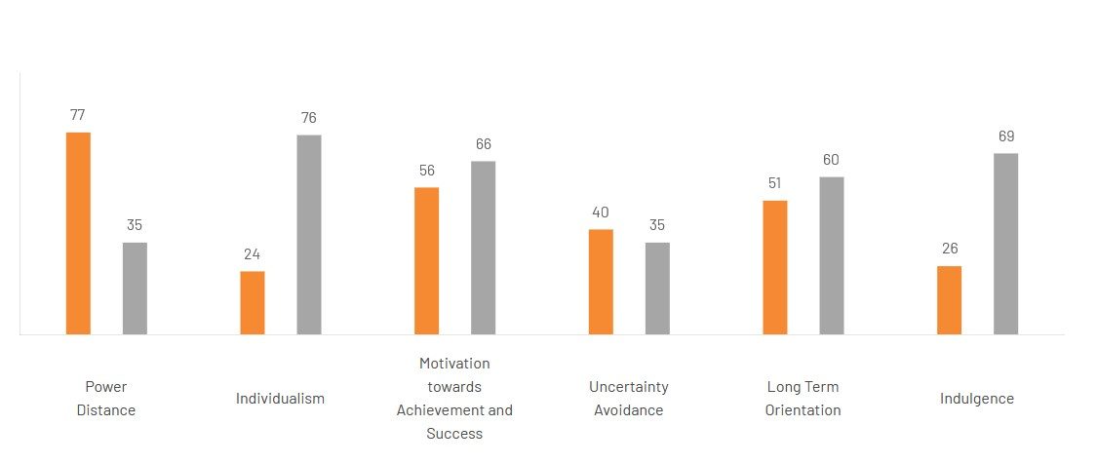
Figure 5.Hofstede Cultural Dimensions Comparison (Hofstede Insights, 2024)
The model of Hofstede cultural dimensions describes the impact of national culture on consumer behaviour and decision-making across the nations. It offers six major dimensions, which assist in making comparisons of cultural differences between the United Kingdom and India.
- Power Distance (UK: 35 | India: 77): The United Kingdom has a low power distance, which implies that individuals believe in equality and freedom of choice. Conversely, India is characterised by high power distance where hierarchy and power significantly affect consumer and organisational behaviour. (Hofstede Insights, 2024)
- Individualism vs Collectivism (UK: 76 | India: 24): UK is very individualistic and consumers care about the choice and self-expression. In India, purchasing decisions are affected by family and social groups, making it more collectivist. (Hofstede Insights, 2024)
- Masculinity (Achievement vs Cooperation) (UK: 66 | India: 56): Both nations have comparatively competitive culture, although the UK is a bit achievement-focused, and consumers represent the importance of success, status, and performance. (Hofstede Insights, 2024)
- Uncertainty Avoidance (UK: 35 | India: 40): The two countries are not very cautious about uncertainty avoidance and are therefore receptive to new ideas and fashion trends, although India is a bit more cautious with risk-taking.
- Long-Term Orientation (UK: 51 | India: 60): India is more long-term oriented, with the country being more concerned with future rewards, savings and tradition, whereas the UK is more oriented between short- and long-term planning. (Hofstede Insights, 2024)
- Indulgence (UK: 69 vs. India: 26): UK is very indulgent, i.e. consumers enjoy spending and consumption on lifestyles whereas India is more austerity, i.e. social norms that regulate consumption behaviour are stronger.
Advantages & Disadvantages of Hofstede Model (Hofstede Insights, 2024)
Advantages
- Helps learn and make comparisons of the cultural differences across nations.
- Helps to enhance segmentation and targeting in overseas markets.
- Offers an organized and common method of analysis.
- Helps in modifying marketing to local cultures.
- Enhances decision making in international marketing strategies.
Disadvantages
- Makes generalisations on culture and assumes that all people in a given country are similar.
- On the basis of outdated research evidence that might not be a true representation of culture today.
- Incidents of disregard to individual differences and subcultures within countries.
- Does not consider organisational or situational influences
- May simplifies the behaviour of the culture within the international markets.

2.4 Technological Factors

The evolution of technology is extremely important in the formulation of retail strategies in contemporary times. United Kingdom is experiencing a well-developed digital infrastructure and firms have the opportunity of adopting superior e-commerce services and online marketing strategies. (Statista, 2024)
In recent years, there has been a high internet penetration and mobile commerce in India. The rising use of online shopping sites has presented new possibilities to fashion retailers. (World Bank, 2023)
Favourable
“Advancements in e-commerce and digital adoption in both the UK and India provide favourable opportunities for expanding Zara’s online retail presence.”

2.5 Environmental Factors

Environmental sustainability has become a major concern in the global fashion industry. Consumers in the United Kingdom are increasingly concerned about sustainable fashion, recycling and environmentally friendly production methods. In India, awareness of sustainable fashion is also increasing, particularly among younger consumers. As a result, Zara has introduced initiatives such as the use of recycled materials and environmentally friendly packaging in order to reduce environmental impact (Inditex, 2023
Unfavourable
“Rising environmental concerns and stricter sustainability regulations may create unfavourable challenges in terms of increased operational costs.”

2.6 Legal Factors

Legal regulations play an important role in shaping international retail operations. In the United Kingdom, strict labour laws, consumer protection regulations and environmental policies influence the operations of fashion retailers. In India, regulatory policies may vary across different states, creating additional complexity for international companies. Therefore, Zara must ensure compliance with local labour regulations, import policies and consumer protection laws in order to maintain its market presence. (UK Government, 2024)
Favourable and Unfavourable
“The UK’s structured legal framework is favourable for business stability, whereas India’s complex and diverse regulations may be unfavourable for foreign companies.”
Similarities
Consumer behaviour in the United Kingdom and India has a number of similarities. The consumers in both markets are developing growing interest towards fast fashion and international brands like Zara. Also, the increase in the digital platforms has affected the purchasing behaviour and online shopping is getting more popular in the two countries. The images of brands and fashion styles are also important in shaping the purchase decisions in both markets (Chaffey and Ellis-Chadwick, 2019).
Differences
Although such similarities exist, the two markets have some major differences. The United Kingdom has a higher disposable income therefore consumers are trend-driven and less price-sensitive. Conversely, the Indian consumers are price conscious and culturally oriented in terms of values and social regulations. Also, the UK consumers are more often online shoppers, whilst the Indian consumers are more often and more inclined to use the physical retail outlets, but the usage of e-commerce is currently expanding very quickly. (Hofstede, 2011).
“The insights from the PESTEL analysis provide a foundation for understanding the external environment of the UK and Indian markets, which directly informs Zara’s segmentation, targeting, and positioning strategies discussed in the following section.”

3. Strategic Analysis of STP Strategy
Developed and emerging markets vary with regard to segmentation strategies. Zara is aimed at the same consumers in the UK, who buy fashion items regularly and keep up with the trends worldwide.
Urban middle-class consumers who seek international brands are more emphasised in the segmentation in India.
There is also a big difference in positioning in the two markets. The competitors of Zara in the UK high street fashion market include H&M, Topshop and others. In India, the brand is, however positioned as global prestigious fashion retailer.

3.1 VALS Model

Definition
The VALS (Values, Attitudes and Lifestyles) model is a psychographic segmentation framework that categorises consumers based on their psychological traits, motivations, resources, and lifestyle patterns. Developed by SRI International, it divides consumers into different groups to help marketers understand why people buy products, not just who they are. The model is widely used in international marketing to identify consumer behaviour differences across markets and to design more targeted marketing strategies. (SRI International, 2023)

3.1.1 United Kingdom VALS Profile

- Experiencers: Trend-driven, young consumers seeking fashion, variety, and excitement; highly responsive to Zara’s fast fashion.
- Achievers: Career-focused consumers who value status, success, and quality; prefer stylish brands that reflect their lifestyle.
- Thinkers: Practical, educated consumers who prefer quality, value, and rational purchase decisions.
- Believers: Traditional consumers influenced by culture, family values, and established brands.

3.1.2 India VALS Profile

- Strivers: Status-oriented consumers who aspire to own international brands but are highly price-sensitive.
- Makers: Practical consumers focused on functionality, durability, and value for money.
- Innovators: High-income, trend-conscious consumers who adopt global fashion early.
- Survivors: Low-income consumers focused on basic needs and affordability, with limited brand engagement.
Table 4: Market Segmentation Variables (UK vs India) (Kotler and Keller, 2016; McKinsey & Company, 2023)
Segmentation Variable | United Kingdom | India
Demographic | Young professionals, middle-to-high income earners | Urban middle-class population, young consumers
Geographic | Major urban cities such as London, Manchester, Birmingham | Metropolitan cities such as Delhi, Mumbai, Bangalore
Psychographic | Fashion-conscious, trend-driven, individualistic lifestyle | Aspirational, status-conscious, socially influenced lifestyle
Behavioural | Frequent fashion buyers, online shopping oriented, brand-aware | Occasion-based buyers, price-sensitive, increasing digital adoption

“Zara adopts a differentiated targeting strategy by focusing on distinct consumer groups in different markets. In the United Kingdom, the company targets fashion-conscious young professionals and trend-driven consumers who prioritise style, convenience, and frequent product updates.
“Zara’s positioning strategy differs across markets in line with consumer expectations and competitive conditions. In the United Kingdom, Zara is positioned as an affordable fast-fashion brand that offers trendy, high-quality clothing at competitive prices, appealing to fashion-conscious consumers seeking value and style.
Perception Map:
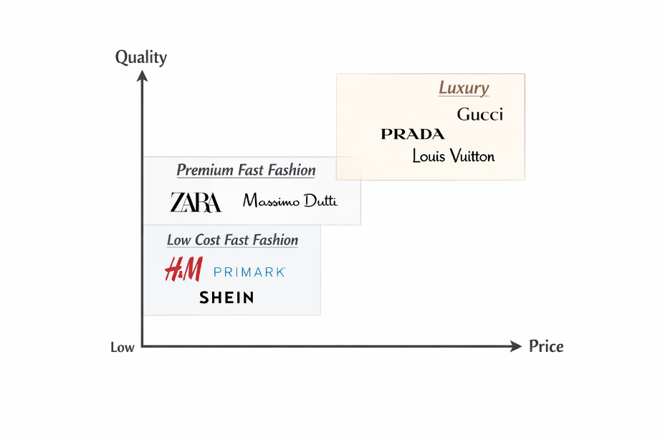
Figure 6.Perception Map (Kotler and Keller, 2016)
The perception map illustrates the positioning of Zara in relation to its competitors based on price and quality. Zara is positioned between high-end luxury brands and low-cost fast-fashion retailers, offering a balance between affordability and quality. This positioning enables the brand to attract fashion-conscious consumers who seek trendy clothing at reasonable prices. In comparison, brands such as H&M are positioned at a lower price level, while luxury brands occupy the high-price, high-quality segment (Kotler and Keller, 2016).

Similarities and Differences in STP Strategy (UK vs India)
Similarities
- Zara targets urban, fashion-conscious consumers in both the UK and India
- In both markets, the brand focuses on young consumers and trend followers
- Zara uses a global fast-fashion positioning strategy in both countries
- Both markets are supported by Omni channel retailing (online + offline stores)
- Strong emphasis on brand image and fashion trends in customer targeting
Differences
- In the UK, Zara targets mid-premium mass consumers, while in India it targets aspirational middle-class consumers
- UK positioning focuses on affordable fast fashion, while India positioning is more aspirational and premium brand-oriented
- UK consumers are more trend-driven and individualistic, whereas Indian consumers are more price-sensitive and culturally influenced
- Digital shopping is more dominant in the UK, while India still has a strong reliance on physical retail stores
- Marketing in the UK is mainly social media and influencer-led, while in India it also includes celebrity endorsements and cultural marketing
“The segmentation, targeting, and positioning analysis provides a strategic foundation for understanding how Zara addresses different consumer groups in the United Kingdom and India, which directly informs the design and implementation of its marketing mix strategies discussed in the following section.”

4. Comparative Analysis of the Marketing Mix (7Ps)
The 7Ps marketing mix framework extends the traditional marketing mix by incorporating service-related elements such as people, process and physical evidence (Booms and Bitner, 1981).

International Marketing Thesis (7Ps) Analysis
Marketing mix is a basic framework in the marketing strategy that helps organisations to incorporate value design and delivery to customers. A conventional marketing mix comprises 4 components which include product, price, place and promotion. The 7Ps model of marketing mix is one of the most common marketing mixes that are used to examine how firms respond to marketing in new markets (Kotler and Keller, 2016).
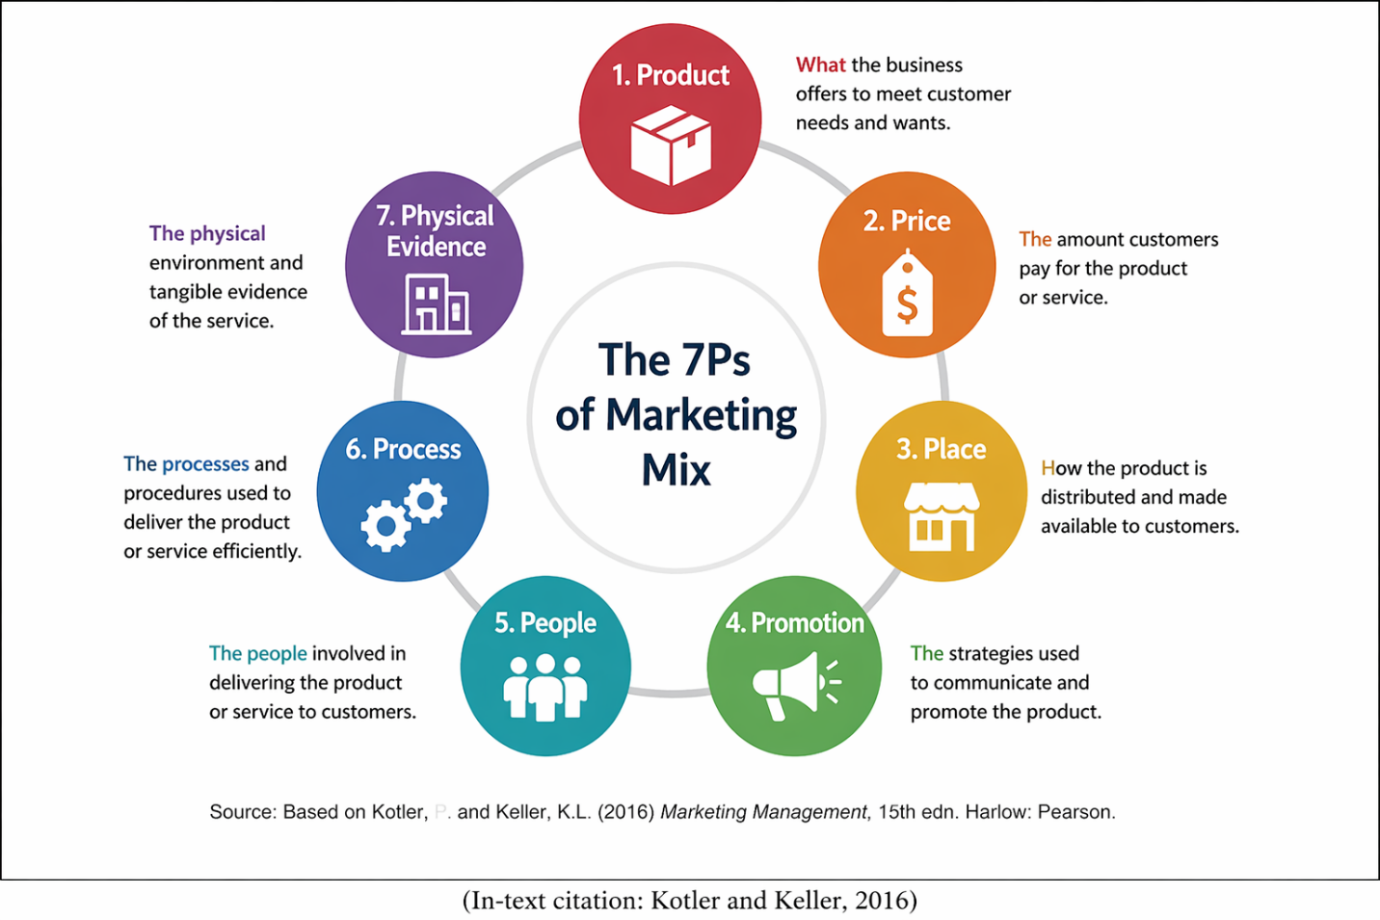
Table 5: 7Ps Marketing Mix Comparison (Kotler and Keller, 2016; Inditex, 2023)
Marketing Mix | United Kingdom | India
Product | Seasonal fashion collections | Adapted designs for climate
Price | Mid-premium pricing | Slightly higher due to import duties
Place | High-street stores and online retail | Shopping malls and flagship stores
Promotion | Social media and influencer marketing | Digital campaigns and celebrity endorsements
People | Fashion-trained staff | Customer service-oriented staff
Process | Efficient global supply chain | Centralised inventory systems
Physical Evidence | Modern minimalist store design | Premium retail environment

Product Strategy
Product strategy describes how products or services are designed, of what quality and variety to be provided by an organisation in response to the needs of customers. The strategy of the product of Zara is largely founded on a business model of fast fashion that the company employs to respond to the shifting trends of consumers by launching new collections of clothing as quickly as possible. (Hollensen, 2020).
Nevertheless, product adaptation may be required in case of working in foreign markets. Product design is based on the consumer preferences and the weather conditions as well as cultural considerations. As an example, in India Zara often launches more light clothes and fabrics which are breathable and more appropriate to use in warmer climate of the country. Moreover, some of the product styles can be reinterpreted to meet the cultural inclinations and trends. (Kotler and Keller, 2016; Inditex, 2023).
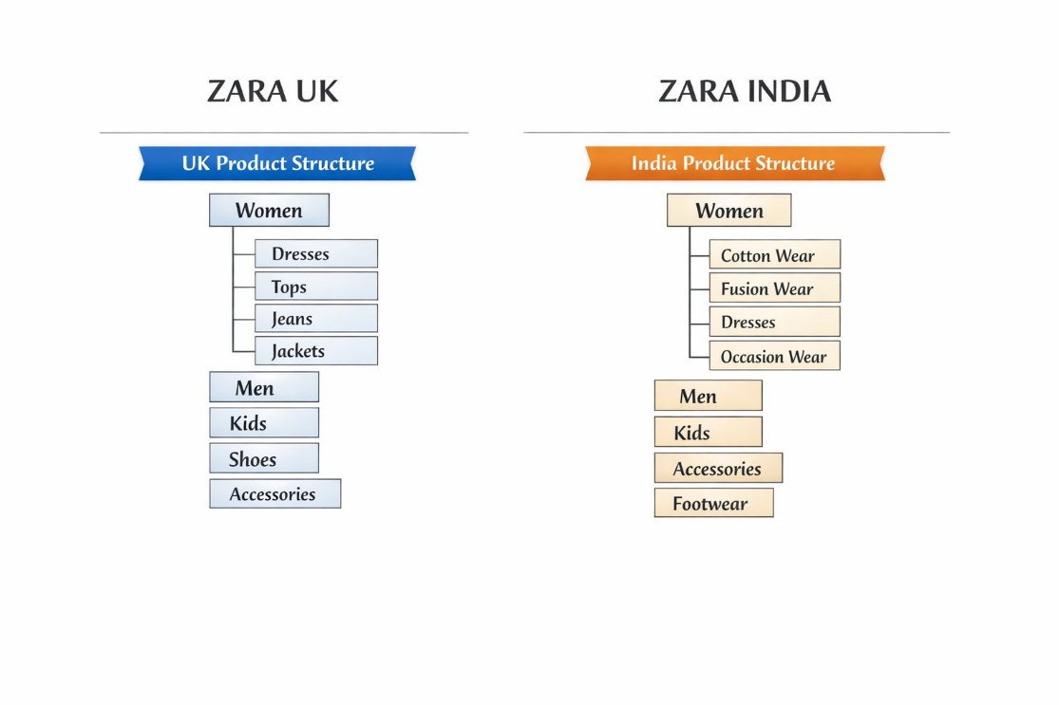
Figure 7. Comparative product width and depth of Zara in the United Kingdom and India (Zara, 2024)
Kotler and Armstrong (2018) state that when working on the international level, companies should consider balancing between standardisation of products worldwide and adjustment to the local market to be efficient and relevant in the market.
Price Strategy
Pricing strategy plays a crucial role in determining Zara’s competitiveness in international markets. In the United Kingdom, Zara follows a mid-premium pricing strategy, offering fashionable products at relatively affordable prices compared to luxury brands, targeting middle-income and trend-conscious consumers.
In India, Zara adopts a premium pricing strategy relative to local purchasing power, mainly due to import duties, logistics costs, and taxation. This results in slightly higher prices, positioning Zara as an aspirational international brand for urban middle-class consumers.
Overall, Zara uses a market-based pricing approach, adjusting prices according to economic conditions, competition, and consumer purchasing behaviour in each country (Kotler and Keller, 2016).

Place Strategy
Place strategy refers to the distribution channels used by a company to deliver products to customers efficiently. Zara uses a strong Omni channel distribution strategy in both the United Kingdom and India, integrating physical stores with online platforms to enhance customer convenience and accessibility.
In the United Kingdom, Zara operates through direct channel distribution, including high-street retail stores and its official e-commerce website. This allows the brand to maintain full control over customer experience, pricing consistency, and brand image.
In India, Zara also follows a direct channel strategy, mainly through flagship stores located in major shopping malls in cities such as Mumbai, Delhi, and Bangalore, supported by a growing online retail platform.
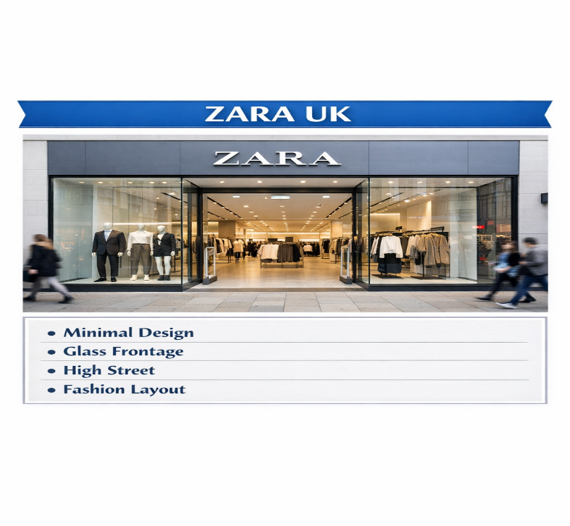
Figure 8. Comparative flagship store concepts of Zara in the United Kingdom (Zara, 2024)
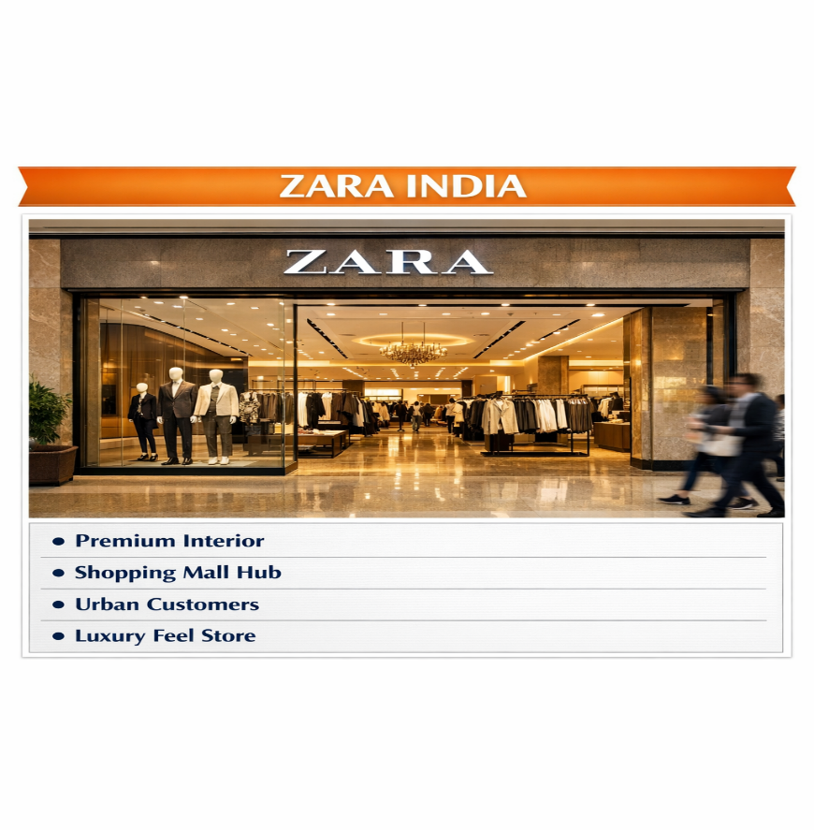
Figure 9. Zara India flagship store concept located in upscale shopping malls (Zara, 2024)
Promotion Strategy
Promotion can be defined as the communication activities that companies employ in order to create awareness and convince consumers on their products. Zara applies various forms of promotion in various markets based on the consumer behaviour and media consumption pattern.
Zara has been riding on digital marketing in the United Kingdom through social media sites and web marketing. These mediums will enable the organisation to tap into the younger generation that uses digital media a lot.
It is believed that influencer marketing has emerged as a potent promotional tool in the new markets, where the use of social media grows exponentially (Statista, 2023).

People
The people element of the marketing mix refers to employees who directly or indirectly influence customer experience and service quality. Zara places strong emphasis on employee training and customer service to maintain consistent brand standards across international markets.
In terms of workforce size, Zara (Inditex Group) employs approximately over 165,000 employees globally. In the United Kingdom, Zara operates with around 3,000–4,000 staff across stores and corporate functions, while in India, it employs approximately 2,000+ staff across major cities including Mumbai, Delhi, and Bangalore.
These employees play a key role in enhancing customer satisfaction through product assistance, store management, and brand representation. Well-trained staff ensure a consistent shopping experience across both markets, supporting Zara’s global brand identity.
Process
Process refers to the systems and procedures used by a company to deliver products and manage customer experience efficiently. Zara is well known for its highly efficient supply chain and fast-fashion production system, which ensures quick design, production, and distribution of products across global markets.
Customer complaint handling is an important part of Zara’s process strategy. In both the United Kingdom and India, customers can raise complaints through in-store service desks, official websites, and customer care support channels.
The company follows a structured feedback system where customer issues are recorded and analysed to improve product quality, service delivery, and overall shopping experience.
Physical Evidence
Physical evidence refers to the tangible elements that shape customer perception of a brand, including store design, packaging, and digital presence. Zara maintains a consistent modern and minimalist store design across international markets to reinforce its premium fast-fashion brand image.
In the United Kingdom, Zara stores are located in high-street shopping areas and feature a clean, minimalist layout with premium visual merchandising. The official website (UK) is also designed with a simple, user-friendly interface, allowing customers to browse and shop efficiently online.
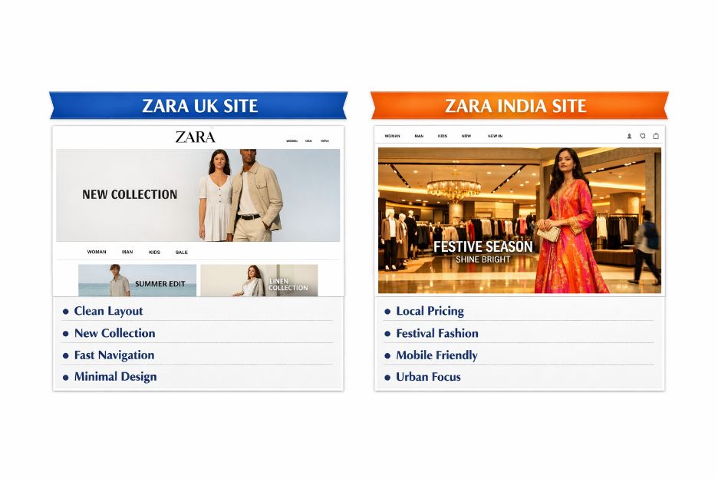
Figure 10. Comparative website layouts of Zara in the United Kingdom and India (Zara, 2024)
In India, Zara stores are mainly located in premium shopping malls in major cities, featuring a high-end retail environment that supports its aspirational brand positioning. The official website (India) provides localized content, pricing, and product availability, improving accessibility for Indian consumers.

5. Directional Strategy of Development
The directional development strategy of Zara is mainly aimed at developing the market and digital growth in the emerging markets like India. The business will enhance its physical retail provisions in large urban areas and at the same time invest in the e-commerce store.
Expansion of the fashion industry across the world is a huge opportunity to the expansion strategy of Zara. McKinsey (2023) states that in the international fashion market, there has been a steady rise in the growth because of the increase in disposable income, urbanisation and multi-fold increase in online shopping.
Ansoff Matrix Analysis (Zara) -
Ansoff Matrix refers to the strategic planning tool that is employed to determine the growth opportunities in terms of products and markets. It is a combination of four strategies which include market penetration, product development, market development, and diversification. This is the main model that Zara uses to enhance its international expansion plan especially in the United Kingdom and India.
The most prevailing strategy adopted by Zara is market penetration. The company aims at maximizing sales of current products in current markets by updating products regularly, offering competitive prices and good online and offline retail store. In the United Kingdom, Zara gains a larger market share by engaging customers more, better digital shopping experience, and launching new seasonal collections in order to capture loyal customers.
Zara is also planning to develop its products. The company is constantly launching new fashion designs, styles and seasonal collections that cater to the evolving consumer preferences. This is a significant strategy especially in the fast changing fashion markets such as UK where customers require new trends on a regular basis.
Market development entails the expansion of geographical markets using the already developed products. Zara has been able to implement this strategy by venturing into emerging markets like India. In India, Zara focuses on the urban middle-income customers in large cities such as Mumbai, Delhi and Bangalore, and localizes the retail presence and marketing strategies to the consumer behaviour and culture of the locals.
Zara has a relatively low level of diversification. Even though the company has since grown to include related product lines like accessories and beauty lines, the company does not invest a lot in non-related business lines. This conservative strategy enables Zara to stay focused on its core business (fast fashion) and minimize the risk in business.
In sum, Zara primarily relies on market penetration and product development as its strategic growth as facilitated by selective market expansion, but with limited diversification as a way of maintaining brand consistency and operational efficiency.

6. Ethical Issues
Ethical concerns in the fashion industry include environmental sustainability and labour practices. Fast fashion contributes to textile waste and environmental damage (Joy et al., 2012).
Ethical Practices
- Sustainable fashion initiatives: Zara has introduced eco-friendly materials, recycling programs, and reduced packaging waste to support environmental sustainability in global markets.
- Improved labour standards monitoring: The company works with suppliers to ensure compliance with basic labour standards and ethical sourcing practices within its supply chain.
Unethical Practices
- Fast fashion environmental impact: Zara’s rapid production model contributes to high textile waste and environmental pollution due to overproduction and short product life cycles.
- Labour exploitation concerns: Like many fast-fashion brands, Zara has faced criticism regarding working conditions in parts of its global supply chain, including low wages and factory ethics issues in outsourced production locations.
Zara has introduced sustainability initiatives such as recycled materials and reduced water usage (Inditex, 2023). However, critics argue that fast fashion remains environmentally unsustainable.

7. Recommendations
According to the examination carried out in this report, various strategic suggestions can be made to enhance the international marketing strategy used by Zara in United Kingdom and India.
United Kingdom
- Strengthen sustainability positioning by increasing use of recycled fabrics and promoting eco-friendly fashion campaigns, as UK consumers are highly environmentally conscious.
- Enhance digital personalisation on Zara’s website and app to improve customer experience and increase repeat purchases.
- Continue focusing on fast product turnover to maintain competitiveness in the highly saturated UK fashion market.
- Expand influencer and social media marketing to strengthen engagement with younger, trend-driven consumers.
India
- Improve product localisation by introducing more climate-friendly and culturally adaptable clothing, such as lightweight and festival-inspired collections.
- Adopt more competitive pricing strategies to address high price sensitivity among middle-class consumers.
- Expand omnichannel retailing, especially improving online shopping platforms to reach non-metro cities.
- Increase brand awareness campaigns using celebrities and influencers, as these have strong influence on Indian consumer behaviour.
- Strengthen supply chain efficiency to reduce import-related costs and improve affordability.
Overall, the recommendations focus on strengthening sustainability and digital engagement in the United Kingdom while improving affordability, localisation, and market accessibility in India.

8. Conclusion
In conclusion, this report has critically analysed Zara’s international marketing strategies in the United Kingdom and India using key frameworks such as PESTEL, STP, and the 7Ps marketing mix. The findings highlight that both markets differ significantly in terms of economic conditions, cultural values, and consumer behaviour, requiring a balance between global standardisation and local adaptation. The UK represents a mature and highly competitive market with strong digital infrastructure and high consumer purchasing power, while India offers strong growth potential driven by urbanisation and an expanding middle class. Zara’s fast-fashion model, supported by an efficient supply chain, enables the company to respond quickly to changing trends in both markets. However, challenges such as cultural differences, price sensitivity, and sustainability concerns require continuous strategic improvement.

Section 2

Reflective Account (Gibbs Reflective Cycle)
This reflection paper applies the Reflective Cycle (1988) proposed by Gibbs to critically reflect on the research, analysis and preparation of the international marketing report on Zara in the United Kingdom and India. In academic reflection, Gibbs model is well known as it offers a systematic way of making sense of experiences with reference to six steps: description, feelings, evaluation, analysis, conclusion and action plan (Gibbs, 1988).
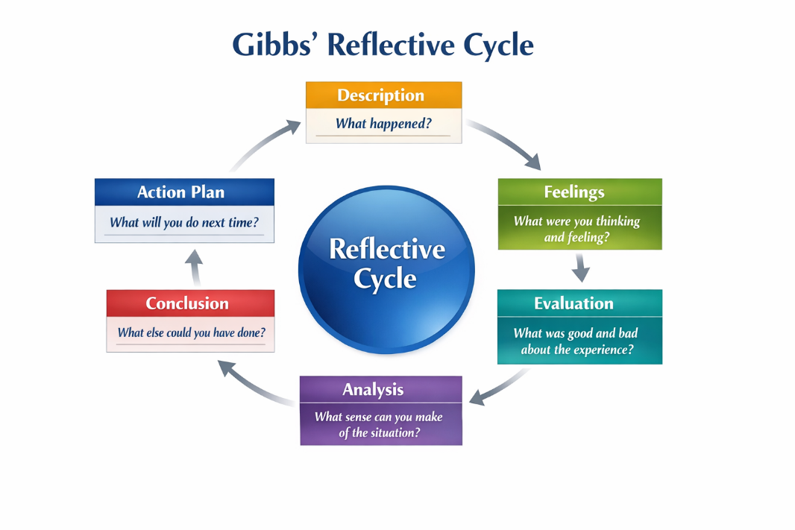
Figure 11. Gibbs’ Reflective Cycle illustrating the six stages of structured reflection (Gibbs, 1988)

1. Description
This assignment was aimed at analysing two opposite markets in which Zara operates, the United Kingdom and India, and evaluating their international marketing strategies. Some of the most important marketing frameworks that had to be used in the report include PESTEL, STP, 7Ps marketing mix, Hofstede cultural dimensions, VALS model as well as Ansoff Matrix. The research methodology included gathering secondary data through the credible academic sources (textbooks) (Kotler and Keller, 2016; Hollensen, 2020), peer-reviewed journals, and industry reports (Statista, McKinsey, Euromonitor, and World Bank).
The assignment was to compare macro-environmental (political, economic, social, technological, environmental, and legal) and micro-environmental factors (segmentation, targeting, positioning and marketing mix decisions). The last goal was to assess the ways Zara changes its global strategy to suit the needs of various international markets and give strategic advice.

2. Feelings
I was confident at the start of the assignment since I was already aware of some fundamental marketing concepts like the 4Ps and PESTEL analysis. Nonetheless, I was even a little bit overwhelmed by the difficulty in integrating several theoretical frameworks into a single report. The fact that two countries such as the UK and India are very different also posed a challenge particularly when it comes to cultural and economic differences.
As I went on with it, I got more familiar with the format of the report. I began to be more assertive as I understood that every framework could be implemented in stages. Nevertheless, I felt the pressure in making sure that my writing was analytical and not descriptive as this is one of the major demands at MBA level.

3. Evaluation
There were a number of strengths of the research process. The credibility of academic and industry sources like Kotler and Keller (2016), Johnson et al. (2020), and Hofstede (2011) were one of the key strengths, as using such sources enhanced the credibility of the analysis. The other strength was the systematic application of structures that enabled me to divide complex international marketing problems into manageable parts.
But there were some flaws as well. A weakness was that this was hard to be consistent across the various analytical models. As an example, it demanded higher critical thinking to correlate the PESTEL results with STP strategy. The other problem was to reconcile theory with practice. There are places where I first paid too much attention to description and not a critical assessment, which lowered the level of analysis. Time management was also an issue because incorporating various frameworks took more time than anticipated.

4. Analysis
The application of the PESTEL framework made me realize the impact of the external environmental factors on the international strategy of Zara. Indicatively, the UK is a politically stable and economically mature market, and India has high growth potential, but is complex in terms of regulation and price sensitive (Johnson et al., 2020). This made me see how the macro-environmental conditions have a direct impact on the pricing, distribution, and product strategies.
The cultural dimensions developed by Hofstede proved especially helpful in the analysis of the differences in consumer behaviour. The individualism culture and the collectivism culture in the UK and India have made people express themselves in terms of fashion and create a stronger impact of family and traditions in the purchasing choices, respectively (Hofstede, 2011).
The STP framework enabled me to understand how Zara has focused on various consumer segments in each market and the 7Ps marketing mix enabled me to analyse the operational choices, which include pricing, promotion and distribution. Kotler and Keller (2016) affirm that effective international marketing must ensure that these strategies are aligned with the local market conditions, which was reflected in the analysis.

5. Conclusion
The assignment was very helpful in enhancing my knowledge on international marketing and the way international firms like Zara perform in various markets. I got to know that effective international marketing should be based on a compromise between world standardisation and localisation. The process has also enabled me to become more analytical and research skills, especially in the use of theoretical frameworks to business scenarios. The reflective cycle of Gibbs enabled me to critically assess my learning experience in a systematic way and to uncover my strengths and weaknesses in my approach (Gibbs, 1988).

6. Action Plan
Improvement of Critical Analysis
Next time I will undertake an assignment, I will work on enhancing critical thinking by minimizing descriptive data and more thoroughly evaluating it. This will assist in making sure that all frameworks are used analytically and not merely described like PESTEL, STP and 7Ps.
Use of Academic Sources.
I will also use more peer-reviewed journal articles and academic books to enhance the reliability and credibility of my points. This will enhance the quality of my work as a whole and will cut down on excessive dependency on general industry reports.
Integration of Theoretical Models
I will strive to improve the connections among various frameworks (e.g., relating the results of the PESTEL analysis to STP decisions) to make sure that everything is consistent and that there is more coherence between sections of the report.
Time Management and Planning
I will also manage my time better by scheduling out every step of research, analysis and writing. This will assist in alleviating the stress at the time of final submission and enhancing the general structure and quality.
In addition, I will work on the academic writing style to make them more logical and critical in their argumentation and their critical approach to theories. Such gains, in general, will enable me to attain a greater academic performance in subsequent assignments.

11. Reference
Booms, B.H. and Bitner, M.J. (1981) Marketing strategies and service marketing. Available at: https://www.researchgate.net/publication/280615376 (Accessed: 17 April 2026, 01:10 AM)
Bitner, M.J., Zeithaml, V.A. and Gremler, D.D. (2018) Services Marketing. Available at: https://www.mheducation.com (Accessed: 17 April 2026, 01:10 AM)
Chaffey, D. and Ellis-Chadwick, F. (2019) Digital Marketing. Available at: https://www.pearson.com (Accessed: 17 April 2026, 01:10 AM)
Deloitte (2023) Retail Industry Outlook India. Available at: https://www.deloitte.com/in/en/pages/consumer-business/articles/retail-industry.html (Accessed: 17 April 2026, 01:10 AM)
Douglas, S.P. and Wind, Y. (2017) Globalization and marketing strategy. Available at: https://www.sciencedirect.com (Accessed: 17 April 2026, 01:10 AM)
Euromonitor (2023) Apparel and Footwear Report. Available at: https://www.euromonitor.com (Accessed: 17 April 2026, 01:10 AM)
Ferdows, K., Lewis, M.A. and Machuca, J.A.D. (2004) Rapid-fire fulfillment. HBR. https://hbr.org/2004/11/rapid-fire-fulfillment (Accessed: 17 April 2026, 01:10 AM)
Gibbs, G. (1988) Reflective Cycle. Available at: https://www.ucd.ie (Accessed: 17 April 2026, 01:10 AM)
Hofstede, G. (2011) Cultural dimensions theory. https://doi.org/10.9707/2307-0919.1014 (Accessed: 17 April 2026, 01:10 AM)
Hollensen, S. (2020) Global Marketing. Pearson. https://www.pearson.com (Accessed: 17 April 2026, 01:10 AM)
Inditex (2023) Sustainability Report. https://www.inditex.com (Accessed: 17 April 2026, 01:10 AM)
Johnson, G., Whittington, R. and Scholes, K. (2020) Exploring Strategy. https://www.pearson.com (Accessed: 17 April 2026, 01:10 AM)
Joy, A. et al. (2012) Fast fashion sustainability issues. https://doi.org/10.2752/175174112X13340749707123 (Accessed: 17 April 2026, 01:10 AM)
Kotler, P. and Armstrong, G. (2018) Principles of Marketing. https://www.pearson.com (Accessed: 17 April 2026, 01:10 AM)
Kotler, P. and Keller, K.L. (2016) Marketing Management. https://www.pearson.com (Accessed: 17 April 2026, 01:10 AM)
McKinsey & Company (2023) State of Fashion Report. https://www.mckinsey.com (Accessed: 17 April 2026, 01:10 AM)
Statista (2023) Influencer marketing statistics. https://www.statista.com (Accessed: 17 April 2026, 01:10 AM)
Statista (2024) Fashion market data. https://www.statista.com (Accessed: 17 April 2026, 01:10 AM)
World Bank (2024) World Development Indicators. https://data.worldbank.org (Accessed: 17 April 2026, 01:10 AM)
OECD (2024) Economic outlook. https://www.oecd.org (Accessed: 17 April 2026, 01:10 AM)
Reuters (2024) Zara expansion strategy. https://www.reuters.com (Accessed: 17 April 2026, 01:10 AM)
Financial Times (2025) Retail analysis. https://www.ft.com (Accessed: 17 April 2026, 01:10 AM)
El País (2025) Inditex performance. https://elpais.com (Accessed: 17 April 2026, 01:10 AM)
Zhang, E. (2024) Zara supply chain analysis. https://www.researchgate.net (Accessed: 17 April 2026, 01:10 AM)
Jangid, M. (2022) Zara case study. https://www.researchgate.net (Accessed: 17 April 2026, 01:10 AM)
Basak, S. (2018) Fashion retail analysis. https://www.researchgate.net (Accessed: 17 April 2026, 01:10 AM)
McKinsey (2023) Global retail transformation. https://www.mckinsey.com (Accessed: 17 April 2026, 01:10 AM)
Inditex (2022) Corporate overview. https://www.inditex.com (Accessed: 17 April 2026, 01:10 AM)
ResearchGate (2024) Fast fashion studies. https://www.researchgate.net (Accessed: 17 April 2026, 01:10 AM)
WTO (2024) Global trade trends. https://www.wto.org (Accessed: 17 April 2026, 01:10 AM)

