  EXPLORATORY DATA ANALYSIS – REPORT AND DEMONSTRATION |   Module: L7 - Data Mining & Visualisation  Module code: ACCA7015  Lecturer: Dr Nouh Elmitwally  Student name: Nadejda Toma  Student ID number: 2232920  Submission deadline: 28th July 2026

Table of Contents

Abstract 2
1. Introduction 2
2. Literature Review 3
3. Methodology 5
3.1 Analytical design 5
3.2 Dataset and target 5
3.3 Data audit and feature selection 6
3.4 Data split and preprocessing 8
3.5 Classification models 8
3.6 Evaluation and tuning 9
3.7 K-Means clustering 9
4. Classification Results and Critical Evaluation 10
4.1 Baseline and initial model comparison 10
4.2 Hyperparameter tuning 11
4.3 Final test performance 12
4.4 Error analysis and operational trade-off 12
4.5 Feature importance and business interpretation 13
4.6 Evaluation 14
5. Clustering evaluation 15
5.1 Selecting the number of clusters 15
5.2 Customer profiles and business interpretation 17
5.3 PCA visualisation and validity 17
6. Business Recommendations and Implementation 18
7. Conclusion 20
References 22

Abstract

This report examined how data mining can support customer retention using a large telecommunications churn dataset. Two classification models were compared, followed by customer segmentation among those who had already churned. Random Forest produced the stronger predictive result, reaching a test ROC-AUC of 0.683 and recall of 0.676. This indicates useful but moderate discrimination rather than reliable certainty. The clustering analysis retained two customer profiles after the Elbow and Silhouette methods produced different evidence. One group contained lower-value, lighter-usage customers, while the smaller group included higher-value customers with heavier usage and greater service contact. Together, the findings show that prediction and segmentation answer different business questions: one supports risk prioritisation, while the other helps shape the response. The proposed approach is suitable for decision support, not automatic retention action. Cost-based thresholds, human review and a controlled campaign are recommended before wider use, because predictive accuracy alone cannot show whether an intervention will prevent churn.

1.Introduction

Customer churn remains a major concern for telecommunications providers because customers can move to competing services, reducing recurring revenue and increasing the cost of retention. The difficulty is not simply recognising that customers have left but identifying patterns that may indicate elevated churn risk early enough for the company to respond. Data mining and machine learning are useful in this context because they can examine large customer datasets and detect relationships that are difficult to identify through manual analysis alone. Recent telecom churn studies show that customer usage, revenue, service activity, device information and demographic attributes can all contribute to predictive modelling [1], [2].
This study analyses a telecom customer churn dataset containing 100,000 customer records and 100 variables. The target variable is binary: churned or non-churned. Although the dataset contains a wide range of attributes, using every variable without judgement may introduce noise, redundancy or possible leakage. Therefore, 25 features were selected based on their relevance to revenue, call and service usage, account history, handset information, geographical area and demographic characteristics. Previous churn research also highlights the value of combining exploratory analysis, feature selection and predictive modelling instead of treating classification as an isolated task [3], [4].
Two supervised classification models are evaluated: Logistic Regression and Random Forest. Logistic Regression provides a transparent baseline, while Random Forest can capture more complex and non-linear relationships between customer characteristics and churn. The study also applies K-Means clustering to the customers who have already churned. This complementary analysis does not predict churn; instead, it identifies whether different profiles exist among churned customers and whether they may require different retention strategies.
This study aims to apply data mining techniques to identify telecom customers with elevated churn risk and to generate practical insights for customer-retention decision-making. The objectives are to prepare the selected data, build and compare classification models, tune the stronger model, evaluate the results critically, and use clustering to investigate patterns among churned customers. The study does not claim to predict exactly when an individual customer will leave, because the available dataset does not contain a sufficient time-based history for time-to-churn modelling. Instead, it focuses on providing a realistic risk-prioritisation tool and identifying the data improvements needed for stronger future prediction.

2. Literature Review

Telecom churn is usually treated as a binary classification problem: the model estimates whether a customer is likely to leave or remain. Recent research shows that this is a mature but still difficult area of data mining because account, usage, service and demographic variables capture only part of customer behaviour [1], [5], [6]. Data mining can reveal patterns that support retention decisions [2], but a churn score is not a certain forecast. It estimates risk from past observations, and its value depends on how well the available data represents the real decision.
Many classifiers have been tested in telecom research. Logistic Regression remains useful because it is relatively transparent and provides a strong baseline. Its main weakness is its linear representation of the relationship between predictors and log-odds, unless interactions are added manually. Tree-based models, including Random Forest and gradient boosting methods, can capture non-linear relationships more easily. Chang et al. [1] and Sikri et al. [7] report benefits from ensemble models, while Aldalan and Almaleh [8] support comparing several algorithms instead of assuming that one will always dominate. Reviews by Manzoor et al. [5] and Barsotti et al. [6] reach a similar conclusion: model rankings change with the dataset, preprocessing and validation design. High scores from one study cannot therefore be transferred directly to another telecom dataset. A complex model is justified only when its improvement is reliable and sufficient to offset lower transparency and higher implementation cost.
Feature selection is also important because telecom datasets often contain correlated measures, identifiers and weak predictors. Kusnawi et al. [3] found that the selection method can affect classifier performance, while Dudáš and Szoliková [9] stress the need to consider relationships among variables rather than assessing each feature alone. Still, removing more variables does not automatically create a better model. Useful interactions may be lost, and selection performed before splitting the data can leak information into validation or testing. Class imbalance requires the same dataset-specific judgement. Balancing methods improved results in the imbalanced settings examined by Sikri et al. [7] and Suguna et al. [10]. In the present dataset, however, churn and non-churn are almost equally represented. Applying SMOTE simply because it is common in the literature could distort the observed distribution without solving an existing problem.
Evaluation should match the business use. Accuracy alone can hide uneven performance between churners and non-churners. Precision indicates how many customers flagged as risky churn, while recall shows how many true churners are found. F1-score balances them, and ROC-AUC assesses ranking ability across thresholds [5], [6]. No single metric answers the whole business question. A provider may accept lower precision when missing a valuable churner is costly, but broad interventions can waste retention resources. Poudel et al. [11] argue that global and customer-level explanations make predictions more actionable. Even so, feature importance shows association, not causation. A model can indicate who appears at risk and which variables influenced the score, but it cannot prove that changing one variable will prevent churn.
Unsupervised learning provides a different type of insight. K-means does not predict churn; it groups similar customers using distances between standardised feature values. It is widely used in segmentation because it is simple and scalable [12]. This simplicity brings limitations. K-means favours compact clusters, is sensitive to scaling and extreme values, and requires the number of clusters to be selected. Patel et al. [13] compare the elbow and silhouette approaches, supporting the testing of k rather than choosing it for convenience.

3. Methodology

3.1 Analytical design

The study combined supervised and unsupervised data mining. Classification estimated whether a customer would churn, while clustering explored patterns among customers who had already left. The work was completed in Jupyter Notebook with Python, pandas, NumPy, Matplotlib, Seaborn and scikit-learn. The workflow covered data understanding, preparation, model comparison, tuning, final testing and business interpretation. All randomised operations used random_state = 42.

3.2 Dataset and target

The dataset (Figure 1) contained 100,000 customer records and 100 columns. The binary target, churn, identified retained customers as 0 and churners as 1. Initial inspection found no exact duplicates and no missing target values. The data contained 50,438 non-churners (50.44%) and 49,562 churners (49.56%), making the target almost balanced (Figure 2).
SMOTE was not applied because there was no meaningful minority-class problem. Although resampling can support imbalanced churn datasets, using it here could alter the observed distribution without solving an existing issue [10], [11].
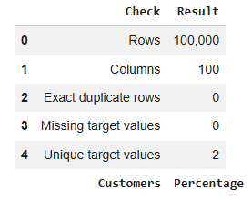

Figure 1. Dataset overview.

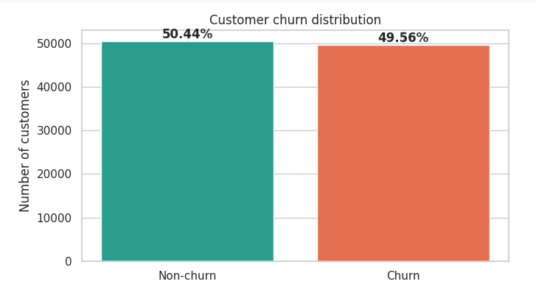

Figure 2. Customer churn distribution.

3.3 Data audit and feature selection
The audit examined data types, missingness and unique values. Nine columns had at least 20% missing data, while Customer_ID was unique for every row. The identifier was excluded because it represented identity rather than customer behaviour.
Twenty-five features were selected using business relevance, missingness, coverage and redundancy (Figure 3). The final set covered revenue (4 features), usage and service quality (9), account characteristics (5), device information (4), and geography or demographics (3). It contained 19 numerical and six categorical variables. Missingness among these variables was low, with a maximum of 1.732%.
The selection was domain-led and did not use test performance or target-based rankings. Negative values in change_mou and change_rev were retained because they represented real decreases. Large revenue and usage values were also retained because they may describe high-value customers.

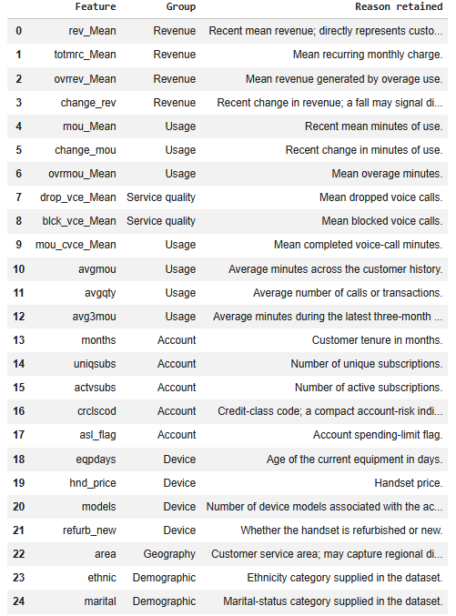

Figure 3. Five feature groups and their variables.

3.4 Data split and preprocessing

Stratified random sampling produced 80,000 training, 10,000 validation and 10,000 test records. Each subset preserved a churn rate of approximately 49.56%. Training data fitted the initial models, validation data supported comparison and tuning, and testing was reserved for one final evaluation. After tuning, training and validation were reunited so the final model learned from 90,000 records (Figure 4).
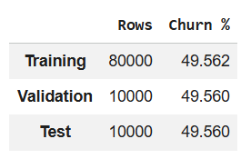
Preprocessing was contained within scikit-learn pipelines. Numerical missing values were replaced with training medians. Categorical values were mode-imputed and one-hot encoded, while unseen categories were ignored safely. Robust scaling was used for Logistic Regression because its optimisation is affected by numerical scale. Random Forest did not require scaling. Learning these transformations after splitting prevented validation and test information from entering training. Such leakage can inflate performance and reduce reproducibility [14].

Figure 4. Training, validation and test split.

3.5 Classification models

Logistic Regression was selected as an efficient and relatively interpretable baseline. It used the liblinear solver and a maximum of 2,000 iterations. Its linear structure is useful for comparison but may miss threshold effects and feature interactions.
Random Forest was selected as a flexible non-linear alternative [1], [6]. The initial model used 80 trees, maximum depth 24, square-root feature sampling and at least two records per leaf. It can capture interactions among tenure, usage, revenue and device features, but it is less transparent and can overfit if tree growth is not controlled [9], [10]. The comparison therefore tested whether the extra complexity produced a meaningful gain.

3.6 Evaluation and tuning

Accuracy, precision, recall, F1-score and ROC-AUC were reported. ROC-AUC was the main selection metric because it assessed the ranking of customer risk across possible thresholds. Several measures were retained because no single metric represents the complete business problem [15].
Three controlled Random Forest configurations varied depth, minimum split size, minimum leaf size and class weighting. Because the target was almost balanced, weighting was tested as a minor tuning choice rather than a correction for severe imbalance. Forty trees kept the validation search practical for demonstration. Validation ROC-AUC selected the configuration. It was then refitted on the 90% development data with 120 trees and evaluated once on the untouched test set.
This compact search supported reproducibility but could not guarantee the global optimum. A wider cross-validated search was therefore treated as future work, not a reason to check the test set repeatedly.

3.7 K-Means clustering

K-Means was applied only to the 49,562 churners. Nine numerical features represented customer value, usage, service experience, tenure and device age: rev_Mean, totmrc_Mean, mou_Mean, change_mou, drop_vce_Mean, custcare_Mean, months, eqpdays and hnd_price. Values were median-imputed and standardised because Euclidean distance is affected by scale.
The Elbow Method examined WCSS for values from k = 1 to k = 10 using the full standardised churn dataset. Silhouette scores compared solutions from k = 2 to k = 6 using a reproducible sample of 5,000 churners to keep processing time practical. The two methods were used because they evaluate different aspects of cluster quality [8], [12]. The final model was fitted to all churners using 20 initialisations. Cluster sizes and original-scale profiles supported interpretation. PCA provided a two-dimensional visualisation only, it did not create or select the clusters.

4. Classification Results and Critical Evaluation

4.1 Baseline and initial model comparison

The dummy classifier provides an essential reference point. It achieved 0.504 accuracy and a ROC-AUC of 0.500, while recall and F1-score for churn were both zero. In practical terms, it predicted only the majority class and failed to identify any customer who left. A useful model must therefore show that it has learned more than the class distribution.
Logistic Regression improved accuracy to 0.586 and ROC-AUC to 0.623. Its precision, recall and F1-score were all close to 0.582, indicating an even, but modest, separation of the classes. Random Forest performed better on every validation measure. It reached 0.626 accuracy, 0.652 recall, 0.633 F1-score and 0.675 ROC-AUC. Compared with Logistic Regression, the gains were 4.0 percentage points in accuracy, 7.0 points in recall and 5.2 points in ROC-AUC. This agrees with recent churn studies where ensemble models captured patterns missed by simpler linear models [1], [6], [9]. However, the present evidence only shows that Random Forest generalised better on this validation set. It does not prove which non-linear relationship caused the improvement, and Logistic Regression remains a useful transparent benchmark. Table 1 reports the exact results, while Figure 5 provides a clearer visual comparison.

Table 1. Validation performance of the baseline and classification models
Model | Accuracy | Precision | Recall | F1-score | ROC-AUC
Dummy Classifier | 0.504 | 0.000 | 0.000 | 0.000 | 0.500
Logistic Regression | 0.586 | 0.582 | 0.582 | 0.582 | 0.623
Random Forest | 0.626 | 0.616 | 0.652 | 0.633 | 0.675

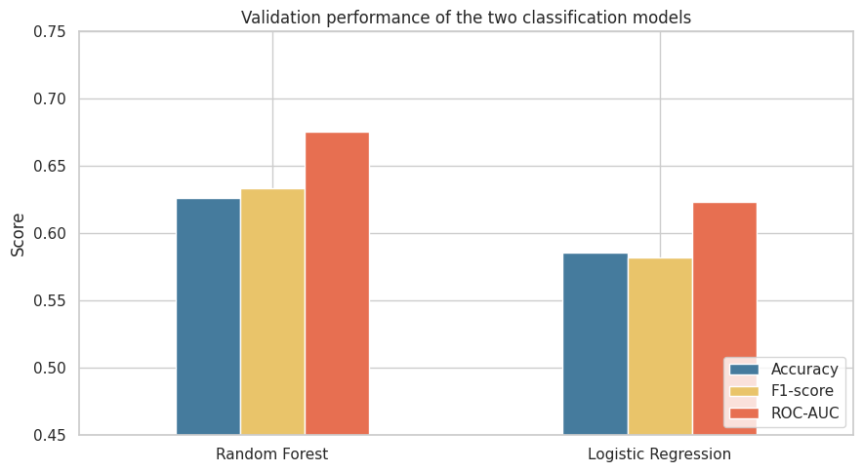
Figure 5. Validation comparison of Logistic Regression and Random Forest.

4.2 Hyperparameter tuning

Only Random Forest was taken forward. Three deliberately limited configurations were compared rather than conducting a large search. Configuration C, with a maximum depth of 18, larger minimum split and leaf sizes, square-root feature sampling and balanced class weights, produced the highest candidate recall (0.662), F1-score (0.634) and accuracy (0.622). Its ROC-AUC was 0.670. The complete comparison is presented in Table 2.
This result needs careful reading. Configuration C did not exceed the initial forest’s validation ROC-AUC of 0.675, so tuning did not demonstrate better ranking. Instead, it selected a more regularised structure that slightly favoured churn detection and avoided overly specific branches. The candidates used 40 trees for an efficient comparison; the final forest used 120 for greater stability. Reusing one validation set across three candidates leaves some selection sensitivity. Repeated cross-validation would test stability more strongly, although the untouched test set still provides a credible final check.

Table 2. Random Forest tuning results
Configuration | Accuracy | Precision | Recall | F1-score | ROC-AUC
A – Flexible | 0.617 | 0.610 | 0.631 | 0.620 | 0.663
B – Lightly regularised | 0.621 | 0.612 | 0.646 | 0.628 | 0.667
C – More regularised | 0.622 | 0.609 | 0.662 | 0.634 | 0.670

4.3 Final test performance

Configuration C was refitted on the combined training and validation data, then evaluated once on the 10,000-row test set. It achieved 0.628 accuracy, 0.613 precision, 0.676 recall, 0.643 F1-score and 0.683 ROC-AUC. The figures are close to the validation results, suggesting that performance did not collapse on unseen data. The small ROC-AUC increase should not be claimed as a tuning gain because the final model used more training data and a different evaluation sample. Table 3 summarises the final performance.
A ROC-AUC of 0.683 means that, for a randomly selected churner and non-churner, the model ranks the churner higher about 68.3% of the time. This is clearly above random ranking, but moderate rather than strong. Accuracy is about 12.4 percentage points above the majority-class baseline, yet more than one-third of customers remain incorrectly classified. Several measures are therefore needed because no single score captures discrimination and the consequences of errors [15].

Table 3. Final test performance of the tuned Random Forest.
Model | Accuracy | Precision | Recall | F1-score | ROC-AUC
Tuned Random Forest | 0.628 | 0.613 | 0.676 | 0.643 | 0.683

4.4 Error analysis and operational trade-off

The confusion matrix makes the result more concrete. Of 4,956 customers who churned, 3,350 were identified, and 1,606 were missed. Another 2,113 non-churners were incorrectly labelled at risk, while 2,931 were correctly retained in the non-churn class. The model would therefore send 5,463 customers into a retention workflow, but only 61.3% would churn. Whether that is acceptable depends on the intervention.
For a low-cost message or service call, 67.6% recall may be useful because finding more potential churners matters more than some unnecessary contacts. An expensive discount changes that judgement. False positives consume budget, while false negatives may represent lost future revenue. The default 0.50 threshold should not become a business rule. It should be chosen on validation data using campaign cost, expected customer value and the relative cost of both errors. Retention is not profitable merely because a customer is correctly identified [6].
Figure 6 therefore combines two views: the ROC curve shows discrimination, whereas the confusion matrix shows operational workload at the current threshold.
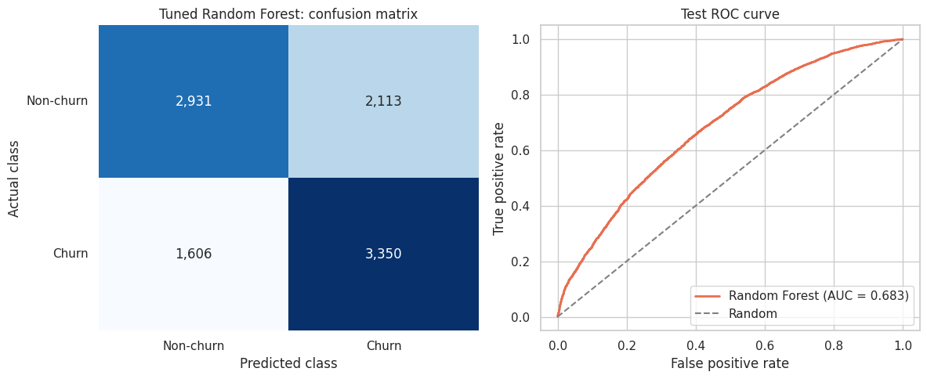
Figure 6. Final confusion matrix and ROC curve.

4.5 Feature importance and business interpretation

Equipment age (eqpdays, 0.104) and customer tenure (months, 0.082) were the strongest features. Changes in minutes (change_mou, 0.062), average usage, change in revenue and average monthly revenue also contributed. The pattern is plausible: device lifecycle, relationship length and changes in engagement may distinguish customers approaching churn. These variables give managers starting points for monitoring. For example, an older device combined with falling use may justify a device-upgrade message or service review.
Importance must not be confused with causation. Figure 7 shows how variables helped this forest reduce impurity; it does not show that changing them would prevent churn. No feature exceeded 0.104, suggesting that the model relies on several weak signals rather than one decisive predictor. This fits the moderate ROC-AUC and the overlap between customer profiles. Impurity importance can also favour variables with many split points, while correlated usage measures can divide or redistribute importance [16]. Aggregating one-hot categories improves readability but does not remove these limitations.

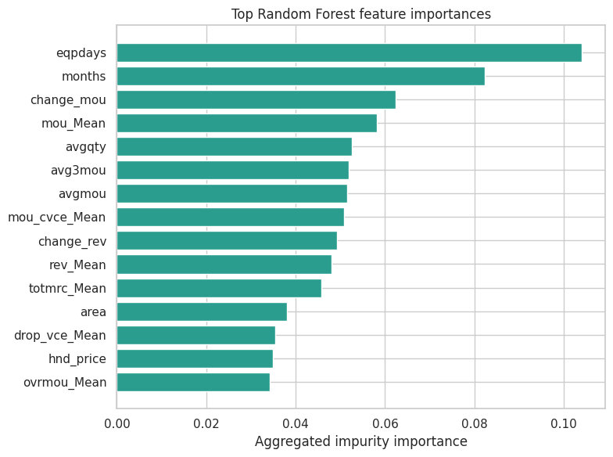
Figure 7. Aggregated Random Forest feature importance

4.6 Evaluation

The model is suitable for prioritisation, not automatic decisions. The data are largely a static snapshot and do not fully capture complaint outcomes, failed payments, contract dates, competitor offers, changing network quality or the sequence of behaviour. Tuning cannot recreate information that was never recorded. This binary model estimates who may churn, not when. Timing would require dated observations and time-to-event analysis.
The defensible use is to rank customers for a controlled retention campaign, select a cost-based threshold and measure incremental retention against a control group. Performance should be monitored because behaviour and offers change. Under these conditions, the model remains useful despite its moderate score. It narrows a large customer base into a more relevant contact pool while keeping uncertainty visible.

5. Clustering evaluation

5.1 Selecting the number of clusters

The results did not indicate one completely unquestionable cluster solution. Figure 8(1) shows that WCSS decreased from approximately 445,000 for one cluster to 358,000 for two clusters and 305,000 for three clusters. After k = 3, the reduction became more gradual. Based only on the visual bend, the Elbow Method therefore suggests that three clusters could be considered. This method is useful for identifying when additional clusters produce progressively smaller gains in compactness. Its limitation is that WCSS will always decrease when more centroids are added, while the location of the elbow is judged visually and may be subjective [13].
The silhouette results offered a different perspective (see Figure 6 (2)). This measure considers both cohesion within each cluster and separation from neighbouring clusters [17]. The highest score was obtained for k = 2 at 0.304. This was followed by 0.220 for k = 3, 0.198 for k = 4, 0.154 for k = 5 and 0.161 for k = 6.
Both methods were used because they evaluate different properties of the solution. Relying only on the Elbow graph could give too much weight to a visually selected turning point, while using only silhouette could also favour a simpler partition without considering its business usefulness. In this case, k = 2 was retained because it achieved the strongest measured separation and produced two understandable customer profiles. The disagreement between the methods is still important. It shows that two clusters are the most defensible option among those tested, rather than proof that two perfectly distinct customer groups exist. The silhouette score of 0.304 remains modest, so the segmentation should be treated as exploratory.

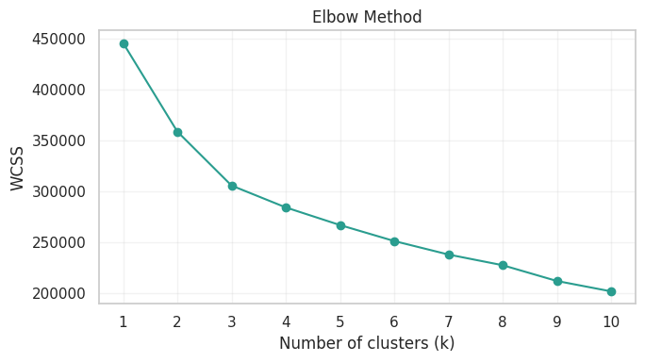
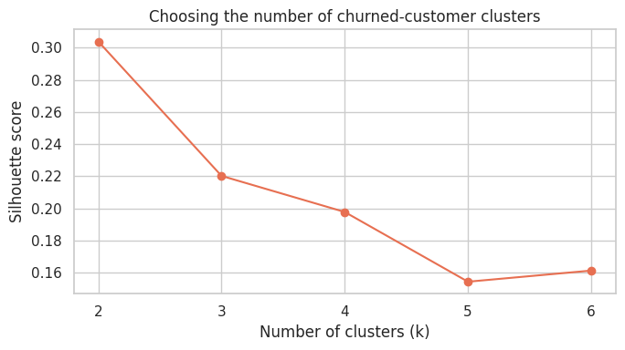
Figure 8. Selection of the number of clusters: (1) Elbow Method and (2) Silhouette scores.

5.2 Customer profiles and business interpretation

The final solution divided the 49,562 churned customers into two unequal groups. Cluster 0 contained 36,240 customers, representing 73.12% of churners. These customers had lower average revenue, fewer monthly minutes and limited contact with customer care. They also had older equipment, with a mean equipment age of 480.65 days. This profile may suit lower-cost retention activity, such as automated plan reviews, device reminders or carefully limited incentives.
Cluster 1 contained 13,322 customers, or 26.88% of churners. Average revenue reached 101.51, compared with 42.20 in Cluster 0, while average monthly usage was 1,067.93 minutes rather than 267.04. These customers also recorded more dropped calls and considerably more customer-care activity. Their average change in usage was -49.50 minutes, showing a sharper decline than the -12.83 recorded in Cluster 0. This combination suggests a higher-value group experiencing stronger service friction or falling engagement. Faster service recovery and targeted retention contact may therefore be more suitable than generic discounts.
The smaller cluster should not be described as a group of outliers. K-Means assigns every customer to the nearest centroid and does not independently identify abnormal observations. Cluster 1 is better interpreted as a coherent high-value segment within the churned population. The results also show association rather than causation (Figure 9). More dropped calls and customer-care contacts do not prove that these factors caused customers to leave.
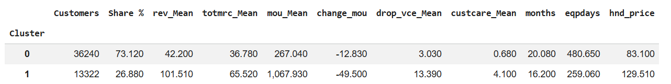
Figure 9. Size and mean characteristics of the two churned-customer clusters.

5.3 PCA visualisation and validity

Figure 10 presents the two clusters using PCA. The first two components represented 51.41% of the total variance. Some separation is visible, although overlap remains between the groups. This supports the modest silhouette score. The remaining 48.59% of variation is not visible in the two-dimensional graph, so PCA should not be treated as proof that the clusters are either fully separated or invalid. It was used only for visualisation; K-Means was fitted using all nine standardised features.
Finally, these clusters describe differences among customers who had already churned. They do not predict when a current customer will leave. Their practical value comes from combining them with predicted churn risk and testing different retention actions for each profile. Cluster stability and campaign response should also be checked on newer customer data before the segments are used operationally.
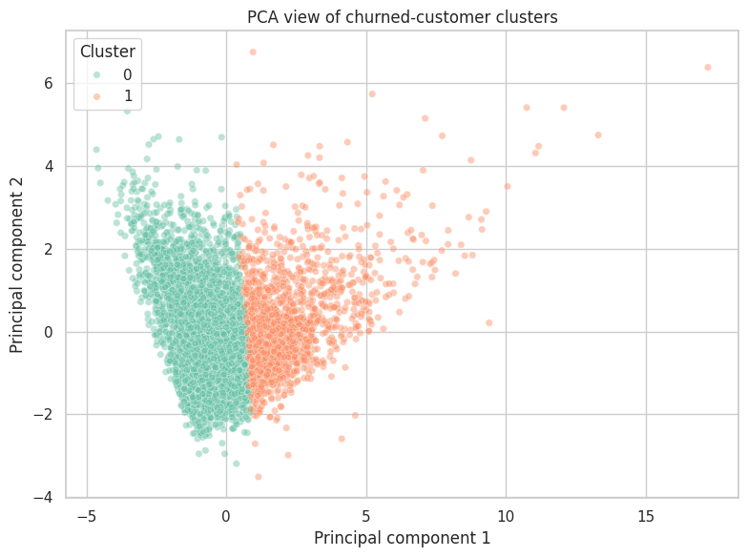
Figure 10. Profiles of the two churned-customer clusters.

6. Business Recommendations and Implementation

A churn score has limited value if it does not lead to a sensible business action. Automatically offering a discount to every customer classified as high risk would be expensive and could reward customers who had no intention of leaving.
The decision threshold should reflect the cost of the intervention. A service message or automated plan review is inexpensive, so a lower threshold may be acceptable even if it includes more false positives. A device subsidy or large discount requires stronger evidence because an unnecessary offer may cost more than the revenue it protects. Recent churn literature also argues that predictive performance should be considered together with customer value, campaign cost and the practical purpose of the model [4], [6]. For this reason, the same prediction should not always produce the same response.

Table 4. Proposed risk-based customer retention framework.
Customer priority | Evidence considered | Suggested action | Cost approach
High risk and high-value profile | High revenue, heavy usage, service contacts, falling engagement | Personal contact, technical review and service recovery | Higher cost may be justified
High risk and lower-value profile | Lower revenue, older equipment, lighter usage | Automated plan review, device reminder or limited incentive | Keep intervention cost low
Medium predicted risk | Some warning signals, but greater uncertainty | Monitoring message or account review | Avoid expensive incentives
Low predicted risk | Limited evidence of immediate churn | No direct retention offer | Continue normal service

The clustering results provide a starting point for differentiated action. Customers matching the smaller, higher-value profile showed greater usage, more dropped calls, more contact with customer care and a sharper reduction in monthly minutes. The first response should be a technical or service review rather than an immediate discount. A personal call, investigation of network problems or faster complaint resolution may address the customer’s actual experience while protecting a more valuable relationship. Still, these patterns are associations. The data do not prove that dropped calls caused churn, so the company should verify the issue before choosing an intervention.
The larger cluster had lower revenue and usage, fewer customer-care contacts and considerably older equipment. Automated plan reviews, device reminders and modest upgrade offers may be more proportionate for this group. A heavily subsidised device could improve retention, but it may not be profitable for a low-value account. This creates an important business trade-off: the customer may be at risk, yet the cost of retaining that customer can still exceed the expected benefit.
Cluster membership also requires caution. K-Means was trained only on customers who had already churned. It cannot simply be assumed that every active high-risk customer fits one of the historical profiles. Before operational use, active customers should be mapped to the nearest profile, and the stability of that assignment should be checked. Research on algorithmic customer segmentation similarly stresses that statistical separation does not replace business and domain validation [17].
A small, controlled campaign is recommended before full deployment. Eligible customers could be randomly divided into intervention and control groups. Results should be measured through incremental retention, cost per retained customer, protected revenue, complaints and customer response, rather than through model accuracy alone. A standard churn model predicts who is likely to leave, but it does not identify who will remain specifically because an offer was made. Some high-risk customers may leave regardless, while others may remain without receiving anything. Uplift modelling addresses this difference by estimating the effect of an intervention on each customer [18]. Until such experimental evidence is available, the model’s recommendations should be treated as informed hypotheses rather than proven retention solutions.
Performance should finally be monitored over time. Customer behaviour, prices, competitors and network conditions can change. A model that is useful today may become less reliable later. Regular evaluation, human review for expensive offers and clear limits on the use of personal characteristics would keep the retention process both financially responsible and fair.

7. Conclusion

This report examined customer churn from two connected perspectives: identifying patterns linked to customers leaving and understanding whether those customers shared similar characteristics. The analysis considered customer value, usage, account history, equipment and service experience.
The findings showed that churn cannot be explained by one clear factor. Instead, it appears to develop through a combination of changes in behaviour and differences in the customer relationship. Declining usage, older equipment and service contact were meaningful signals, but none of them provided a complete explanation on its own.
The analysis also showed that customers who left were not all alike. One group had lower value and lighter usage, while another included more active and valuable customers with greater service interaction. This difference matters because churn should not be treated as one simple problem affecting every customer in the same way.
The main conclusion is that customer data can make churn easier to understand, even when it cannot explain every individual decision. The study turned a large and complex dataset into clear business intelligence while keeping the uncertainty and limitations of the findings visible.

References

[1] V. Chang, K. Hall, Q. A. Xu, F. O. Amao, M. A. Ganatra and V. Benson, "Prediction of customer churn behavior in the telecommunication industry using machine learning models," vol. 17, no. 6, pp.231, 2024,
[2] A. H. Al-Shakarchi, S. A. Mostafa, M. Z. Saringat, D. A. Mohammed, S. H. Khaleefah and M. M. Jaber, "A data mining approach for analysis of telco customer churn", in 2023 Al-Sadiq International Conference on Communication and Information Technology (AICCIT), pp. 23–27.
[3] K. Kusnawi, J. Ipmawati, B. P. Asadulloh, A. Aminuddin, F. F. Abdulloh and M. Rahardi, "Leveraging various feature selection methods for churn prediction using various machine learning algorithms," vol. 8, no. 2, pp.897–905, 2024,
[4] K. D. Singh, P. D. Singh, A. Bansal, G. Kaur, V. Khullar and V. Tripathi, "Exploratory data analysis and customer churn prediction for the telecommunication industry", in 2023 3rd International Conference on Advances in Computing, Communication, Embedded and Secure Systems (ACCESS), pp. 197–201.
[5] A. Manzoor, M. A. Qureshi, E. Kidney and L. Longo, "A review on machine learning methods for customer churn prediction and recommendations for business practitioners," vol. 12, pp.70434–70463, 2024,
[6] A. Barsotti et al., , "A decade of churn prediction techniques in the telco domain: a survey," vol. 5, no. 4, pp.404, 2024,
[7] A. Sikri, R. Jameel, S. M. Idrees and H. Kaur, "Enhancing customer retention in telecom industry with machine learning driven churn prediction," vol. 14, no. 1, pp.13097, 2024,
[8] A. M. Aldalan and A. Almaleh, "Customer Churn Prediction Using Four Machine Learning Algorithms Integrating Feature Selection and Normalization in the Telecom Sector," vol. 17, no. 3, pp.76–83, 2023,
[9] A. Dudáš and A. Szoliková, "Feature Selection Based on Three-Dimensional Correlation Graphs," vol. 5, no. 3, pp.91, 2025,
[10] R. Suguna, J. Suriya Prakash, H. Aditya Pai, T. R. Mahesh, V. Vinoth Kumar and T. E. Yimer, "Mitigating class imbalance in churn prediction with ensemble methods and SMOTE," vol. 15, no. 1, pp.16256, 2025,
[11] S. S. Poudel, S. Pokharel and M. Timilsina, "Explaining customer churn prediction in telecom industry using tabular machine learning models," vol. 17, pp.100567, 2024,
[12] M. Alves Gomes and T. Meisen, "A review on customer segmentation methods for personalized customer targeting in e-commerce use cases," vol. 21, no. 3, pp.527–570, 2023,
[13] P. Patel, B. Sivaiah and R. Patel, "Approaches for finding optimal number of clusters using k-means and agglomerative hierarchical clustering techniques", in 2022 international conference on intelligent controller and computing for smart power (ICICCSP), pp. 1–6.
[14] M. Rosenblatt, L. Tejavibulya, R. Jiang, S. Noble and D. Scheinost, "Data leakage inflates prediction performance in connectome-based machine learning models," vol. 15, no. 1, pp.1829, 2024,
[15] O. Rainio, J. Teuho and R. Klén, "Evaluation metrics and statistical tests for machine learning," vol. 14, no. 1, pp.6086, 2024,
[16] L. F. Voges, L. C. Jarren and S. Seifert, "Exploitation of surrogate variables in random forests for unbiased analysis of mutual impact and importance of features," vol. 39, no. 8, pp.btad471, 2023,
[17] J. Salminen, M. Mustak, M. Sufyan and B. J. Jansen, "How can algorithms help in segmenting users and customers? A systematic review and research agenda for algorithmic customer segmentation," vol. 11, no. 4, pp.677–692, 2023,
[18] T. Verhelst, D. Mercier, J. Shrestha and G. Bontempi, "Partial counterfactual identification and uplift modelling: theoretical results and real-world assessment," Mach Learn, vol. 113, no. 3, pp.1043–1067, Mar 2024, doi: 10.1007/s10994-023-06317-w.

