DATA SECURITY, GOVERNANCE AND COMPLIANCE

Table of Contents
Part 1: Research into Security Frameworks/Models 3
Part 2: Custom Design Approach 8
Part 3: Critique, Analysis 12
References 16

Part 1: Research into Security Frameworks/Models
In order to respond to the security, governance and compliance issues that NatureGreen (NG) encounters, it is necessary to firstly be familiar with various laid-down frameworks which organizations apply to govern and secure their information systems. The two frameworks, which will be discussed here, are ITIL (Information Technology Infrastructure Library) and ISO 27000 series (namely, ISO 27001 and ISO 27002) which offer organized methods of managing IT services and information security, respectively. These models are very applicable in the context of NG where the company would be depending on cloud services, wireless networks and personal devices.
1. ITIL (Information Technology Infrastructure Library)
Overview of ITIL
ITIL is a world-known framework of IT service management (ITSM), which is intended to assist firms in aligning their IT services with the business requirements. The framework is composed of a collection of best practices that make sure that IT services are provided efficiently and securely in all stages of their life-cycle- service strategy, service operation through to service improvement (Lopes et al. 2024).
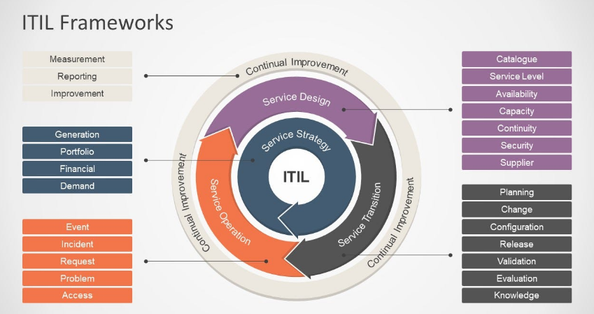
Figure 1: ITIL Framework
The major emphasis points of ITIL are:
Service Strategy: A match point between IT services and business goals and objectives.
Service Design: The IT services are designed to suit the business requirements in a way that is secure and scalable.
Service Transition: The transition of new services into the live environment should be managed to cause as little disruption as possible and to have sufficient security controls.
Service Operation: It is the responsibility to oversee the operation of IT services in order to achieve the requirements of security and performance.
Continuous Service Improvement: Reflectively reviewing and enhancing IT services and security of these services to keep pace with business requirements and threats.
Relevance to NatureGreen
Since NG is international, and requires cloud services, mobile devices as well as wireless networks, ITIL provides a universal service management model that would be of immense value. The model aids in the oversight of the various IT activities of the NG, and therefore in making sure that security is incorporated during the various stages of service life cycles. Some of the important features of ITIL that would value NG would include:
Service Design: Having security issues (i.e. encryption of data, access control and secure communication mechanisms) built into the design stage of services.
Service Transition and Operation: The operations of service transition and management of service deployments and operation (including cloud infrastructure and wireless networks) and continued adherence to security policies.
Continual Service Improvement: Conducting periodic reviews of the security procedures and effecting amendments to align to the emerging threats and business developments is very important to a company like NG that is growing at a very high rate (Sholeh and Pramudya, 2025).
ITIL will provide a strong basis in relation to the security of the IT services of NG by ensuring that IT services are handled according to the requirements of the business.
2. ISO 27000 Family (ISO 27001 & ISO 27002)
Overview of ISO 27000 Series
ISO 27000, namely, ISO 27001 and ISO 27002, is an international standard offering a system of defining, implementing, administering, and enhancing an Information Security Management System (ISMS). These standards provide information security guidelines and best practices of securing information and managing information security risks.
The ISO 27001 stipulates the stipulations of creating, operating, sustaining and enhancing an ISMS. It offers an orderly way of dealing with sensitive company information which keeps it confidential, intact and accessible. The ISO 27002 offers the implementation of strategies of the ISMS security control, including aspects like access control, incident management, physical security, and supplier management.
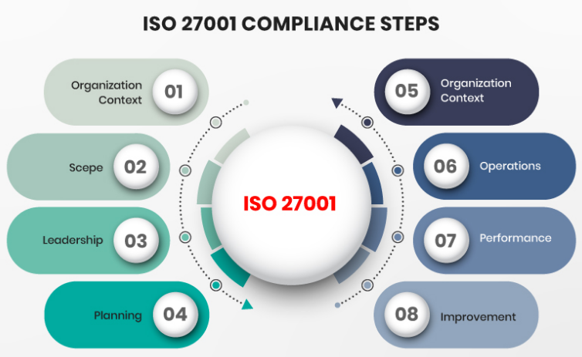
Figure 2: ISO 27001 Compliance Steps

Key Elements of ISO 27001/27002
Risk Management: ISMS style best focuses on risk identification and assessment, which is important to companies such as NG with a broad scope of risks (e.g., unauthorized access, data breach, and cyberattacks).
Controls Implementation: ISO 27002 provides specifications on how the security controls should be implemented in order to reduce the risks identified. These measures include technical, physical as well as administrative controls aimed at securing information assets (Salihu and Dervishi, 2024).
Continuous Improvement: As there is with ITIL, ISO 27001 promotes the culture of constant improvement so that the information security policies and practices of NG are updated accordingly to the emerging threats and vulnerabilities.
Compliance: ISO 27001 is aimed at assisting the organization to meet the requirements of the legal, regulatory and contractual requirements of information security.
Relevance to NatureGreen
The ISO 27001 and ISO 27002 are specifically applicable to NG, which must consider taking care of sensitive information including customer data, intellectual property, and staff data in its operations across all its locations worldwide. The following are some specific ways as to how these frameworks can prove beneficial to NG:
Risk Management: The risk management system provided in ISO 27001 can be used to help NG to identify and deal with the threats to its wireless networks, cloud services and mobile access. As an example, a proper secure use of personal devices that have access to company information by ensuring that such devices are properly secured and cloud services are properly set to ensure security (Yuliana and Hasibuan, 2022).
Security Controls: With the adoption of the control guidelines in ISO 27002, NG can ensure that it has strong security policies to ensure that data in transit and at rest are safeguarded, users are controlled and controlled, and external service providers are also secure.
Compliance and Audits: The ISO 27001 assists NG in proving its adherence to the international data protection policies (e.g., GDPR) and this is particularly significant due to the international nature of the company customers.
Key takeaway
The ISO 27001 and 27002 will give NG a systematic and holistic way of protecting its information resources, risks, and global regulation requirements. The NG has a chance to use the combination of the ISMS framework provided by ISO 27001 and the security controls provided by the ISO 27002 as a strong tool to resolve the issues of information security and governance.
3. Supplementary Frameworks
Besides ITIL and ISO 27000, one can also mention a number of other frameworks and models that can be used as the supplements to the security and governance strategy offered by NG:
COBIT: This framework includes the practice of IT governance and management to align the IT objectives with the business objectives. It is a control and risk management one, which is most useful to NG since it deals with a distributed and large IT infrastructure (Merchan-Lima et al. 2021).
NIST Cybersecurity Framework (CSF): It is a flexible framework in identifying, protecting, detecting, responding, and recovering of cybersecurity risks. It is particularly applicable in case of the organization such as NG where the threat landscape is shifting in many ways (Gujuman, Toacă and Ursachi, 2025).
CIS Controls: The Center of Internet Security (CIS) provides a list of the best practices in cybersecurity that may assist NG in securing its IT infrastructure through the prioritization of security best practices.
These frameworks combined with ITIL and ISO 27000 can give NG a balanced solution of security, governance, and compliance management.

Part 2: Custom Design Approach
2a. Proposed Approach – Model & Tables
Referring to the earlier investigation of such frameworks as ITIL and ISO 27000, we are going to design a security model based on the requirements of NatureGreen now. This model must deal with the organizational as well as technological components of security, governance and compliance bearing in mind the global operations of the company, its cloud-based infrastructure as well as its dependence on the mobile and wireless technologies (Jøsang, 2024).
Security Framework Design:
Step 1: Determine the Important Security Elements to NatureGreen
Considering the situation, NatureGreen must have a framework that guarantees confidentiality, integrity, and availability (CIA) of its data and systems and in this case, because it is handling sensitive customer data, intellectual property and staff information. The key security elements would be:
Data Protection: Secure customer and employee data with encryption, access control, and data storage.
Network Security: Secure the wireless networks and cloud services using firewall settings, intrusion detection systems (ID), and secure access control.
Control: Establish a clear set of access policies and authentication procedures, to make sure that unauthorized users cannot access important systems and data (Miloslavskaya and Tolstaya, 2022).
Incident Management: Have a solid incident management plan with detection, response, and recovery plan.
Risk Management: Investigate the risks to the system on a regular basis and adjust security structure accordingly.

Step 2: Map ITIL and ISO 27000 to the Security Model of NatureGreen
ITIL and the ISO 27000 will be incorporated in the tailored security solution.
Service Design (from ITIL):
Use secure design principles in developing the IT services such that security is designed into the service lifecycle.
State security requirements of individual services such as encryption, access control, and adherence to international data protection standards (e.g., GDPR).
Operation and Service Transition (of ITIL):
Secure the transition of security into production systems without interruptions, which guarantees on-going data and systems security.
Offer services safely, and constantly check the vulnerabilities and breaches.
Constant Service Enhancement (of ITIL):
Periodically revisit and advance security practices depending on new risks and business evolutions, so that the security environment can be constantly adjusted to the new conditions (Zaydi and Nassereddine, 2021).
ISO 27001 & ISO 27002 Integration:
Risk Management: With the help of risk assessment procedures introduced in ISO 27001, the possible threats to the network, cloud, and personal devices are identified.
Security Controls: ISO 27002 security controls, e.g. access control, data encryption and incident management.
Compliance: Make sure that all the security practices are consistent with international data protection guidelines.

Security Measure | Framework/Model | Description/Action
Data Protection | ISO 27001, ITIL | Ensure data confidentiality using encryption, access control, and secure data storage techniques as part of service design and operation.
Network Security | ISO 27001, ITIL | Apply secure network configurations (e.g., firewalls, IDS) and ensure compliance with security standards for wireless and cloud services.
Access Control | ISO 27002 | Implement role-based access control, strong authentication methods (MFA), and ensure secure access to company resources, especially for staff and customers using personal devices.
Incident Management | ITIL, ISO 27001 | Develop an incident response strategy, which includes detection, logging, response, and recovery procedures aligned with best practices for minimizing damage from security breaches.
Risk Management | ISO 27001, NIST CSF | Regularly identify, assess, and mitigate risks related to cyber threats, data breaches, and compliance violations.
Compliance & Auditing | ISO 27001 | Regular internal audits and external assessments to ensure adherence to data protection laws like GDPR and industry regulations.
Table 1: Security Measures and Their Corresponding Frameworks
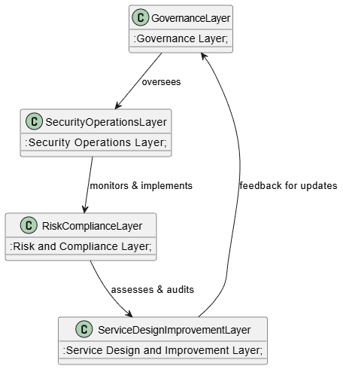
Figure 3: High-Level Security Framework
The above diagram shows the High-Level Security Framework of NatureGreen, which shows how four critical layers of security governance interrelate and flow. Governance Layer is in charge of the overall security architecture that has to make sure that there are policies, regulations and compliance requirements that are complied with. The Security Operations Layer has the responsibility to actively implement and monitor security measures, which are security access and incident management (Calder and Watkins, 2024). The Risk and Compliance Layer revolves around risk identification, evaluation and auditing whereby the company is made sure that it adheres to the legal and regulatory requirements. Finally, Service Design and Improvement Layer incorporates security in the design and development of the IT services and improving on security on the basis of operational layer suggestions. The arrows in the diagram indicate how these layers are connected to each other, and the continuous feedback loop makes all the layers enhance and know about each other, evolve to new threats and improve the business needs (Fonseca-Herrera, Rojas and Florez, 2021).

Part 3: Critique, Analysis
The suggested security frameworks, ITIL and ISO 27000, will be criticized in the section regarding the security requirements of NatureGreen. Further, we will examine the importance of implementing their security structures and policies to reflect the current security environment and compliance expectations on a regular basis by a business, particularly by international organizations such as NatureGreen. The paper will also discuss how NatureGreen can use these structures to address risks and enhance the governance and compliance of the organization in its global business activities (Ayat and Shafiee, 2025).
1. ITIL and ISO 27000 Critique in addressing the naturegreen needs
ITIL (Information Technology Infrastructure Library)
ITIL Strengths of NatureGreen
ITIL offers a systematic method of the management of IT services in different phases of their life cycle. Since NatureGreen has widespread cloud services utilization, wireless network, and mobile devices, the ITIL method of aligning IT services to the business objectives presents a strong benefit. The services are secured at the beginning with the assistance of ITIL which mitigates such critical areas as service design, transition, and operation (Magnusson et al. 2025). In the case of NatureGreen, such stages will guarantee the safety of a company by reducing the number of disruptions and safeguarding valuable information, including customer data and intellectual property. One more prominent characteristic of ITIL is its focus on the continuous service improvement. In the case of a developing company, such as NatureGreen, it is necessary that IT services be reviewed and updated regularly so as to conform to emerging security threats, business requirements and technological changes (Alrehili and Alhazmi, 2023). This type of constant improvement process would make sure that NatureGreen can remain ahead of any security vulnerabilities by testing its security systems on a regular basis and revising them where needed.
Furthermore, incident management, which is one of the fundamental elements of the ITIL, enables NatureGreen to design systematic procedures of identifying, responding, and recovering security incidents. As the company is performing on the international level, and various teams and systems are involved in the incident, the clearly established incident management process would guarantee the quick and coordinated reaction to the breach or attack.
ITIL weaknesses to NatureGreen
ITIL has some weaknesses such as implementation can be cumbersome especially in large organizations with complicated infrastructure. With the global presence and various IT services, NatureGreen might have difficulties in implementing ITIL to all the activities of the company. The framework needs a thorough process of adapting to the needs of the company, and it is resource-consuming and may be quite disruptive in the transition phase (Makhija, 2021).
Furthermore, ITIL is more of a service management tool in the IT industry and though it covers security issues in the IT environment systematically, it does not go in depth of detail of specific cybersecurity measures like data protection, network security, etc. In the case of NatureGreen that is increasingly threatened by cyberattacks, it could be required to have more frameworks such as ISO 27000 that could offer a more knowledgeable and thorough focus on information safety.
ISO 27000 Series (ISO 27001 & ISO 27002)
NatureGreen strengths of the ISO 27000
The ISO 27000 series provides a universal framework of information security management standards. The ISO 27001 offers a methodical way of putting in place, exercising, sustaining and enhancing an Information Security Management System (ISMS). This will be especially helpful to NatureGreen that handles sensitive data in various jurisdictions. With the alignment of its practices to ISO 27001, NatureGreen can be able to secure its information systems and comply to the standards of the regulations in all the regions of its operations (Muñoz, Ladino and Castillo, 2024). The risk management that is central to ISO 27001 is another important strength of this system. In the case of NatureGreen, the risk management is a top priority because of the type of business it has, as it operates on wireless networks, cloud services and mobile access. The ISO 27001 offers a proper structure of recognizing, evaluating and reducing risks associated with cybersecurity threats, including unauthorized access, information breaches and possible attacks on cloud infrastructure (Reuben-Owoh and Haig, 2025). This risk management strategy will keep the security structure of the company abreast with the new threats. Moreover, ISO 27002 gives specifications when applying certain security controls, such as, access control, encryption, incident management and physical security. The controls play a vital role in the security of the data and systems of the NatureGreen, as both internal and external threats are sufficiently mitigated. Since the company is growing, a solid base of ISO 27002 will assist NatureGreen in protecting its property and intellectual property (Alwahaibi et al. 2022).
ISO 27000 weaknesses to NatureGreen.
Nevertheless, the application of ISO 27000 may also prove challenging to NatureGreen especially at its international size and the quick expansion. Creating an ISMS in several locations with varying regulations may be both a time and resource-consuming activity. In addition, the ongoing renovations of the system to meet the changing threats need a major dedication of the leadership and IT departments of the company (Baisholan et al. 2021). Whereas, ISO 27001 has a detailed risk management framework, it does not offer service management specifications as offered by ITIL. To achieve effective implementation of ISO 27001, NatureGreen can be required to complement the framework with more frameworks to ensure service design, transition, and operation are managed effectively with a high emphasis on security.
2. Significance of the Ongoing Revisit of Security Frameworks and Rules
The Changing Cybersecurity Environment
Among the major factors that make businesses constantly revise their security models, the blistering development of cybersecurity threats should be mentioned. The new forms of cyberattacks are constantly being developed, and they use the gaps in the old security systems and technologies. To illustrate, as firms such as NatureGreen continue to use cloud services, mobile devices, and wireless networks, the attack surface is growing, and it is now more difficult to provide protection to sensitive data (Boyes and Higgins, 2024). Cyberattacks like ransomware, phishing, and data breach are continuously becoming more and more complex and sophisticated. In the case of NatureGreen, which has operations in different global markets, even with some of these markets being in different countries that have divergent cybersecurity laws and regulations, the capability of keeping up with any emerging threat is a critical issue. It is also particularly so since cybercriminals gain more sophisticated and specific methods of going around the conventional security strategies. Modifying security structures will enable NatureGreen to implement the newest protection technologies and measures, so its data will not be vulnerable in the world of a constantly evolving threat environment.
Regulatory Compliance Necessity
Regulatory compliance is another major essential aspect that requires constant changes. With the changing international data protection legislation including GDPR and CCPA, companies will need to make sure that their security systems are compliant with all these rules. The consequence of not following laws regarding data protection may entail huge financial fines, as well as damaged reputation and loss of client confidence (Kenyon, 2024). In the case of NatureGreen where there is high customer data in various jurisdictions, the most important thing to do is to remain in compliance with these changing regulations. The frequent revision of security frameworks can be used to ensure that the company is in line with the new legal requirements, and it is able to pay the penalty at an expensive cost and retain the confidence of its customers.

References
Alrehili, A.A. and Alhazmi, O.H., 2023, September. ISO/IEC 27001 standard: analytical and comparative overview. In International Conference on Advances in Data-driven Computing and Intelligent Systems (pp. 143-156). Singapore: Springer Nature Singapore.
Alrehili, A.A. and Alhazmi, O.H., 2024. ISO/IEC 27001 Standard: Analytical and Comparative Overview Check for updates. Advances in Data-Driven Computing and Intelligent Systems: Selected Papers from ADCIS 2023, Volume 1, 891, p.143.
Alwahaibi, A., Bin, W., Hassa, W., Basri, W., Wan Ismail, W.B. and Almamari, M., 2022. A systematic literature review on it security standards for higher education institution. Tianjin Daxue Xuebao (Ziran Kexue yu Gongcheng Jishu Ban)/J Tianjin Univ Sci Technol, 55, pp.194-213.
Ayat, M. and Shafiee, S., 2025. Developing a comprehensive IT governance framework for Iranian hospitals: a fuzzy Delphi approach. International Journal of Health Governance, 30(4), pp.410-421.
Baisholan, N., Kubayev, K.E. and Baisholanov, T.S., 2021. Modern tools for information security systems. Известия НАН РК. Серия физико-математическая, (1), pp.14-18.
Boyes, H. and Higgins, M.D., 2024. An Overview of Information and Cyber Security Standards. Journal of ICT Standardization, 12(1), pp.95-134.
Calder, A. and Watkins, S., 2024. IT governance: an international guide to data security and ISO 27001/ISO 27002.
Fonseca-Herrera, O.A., Rojas, A.E. and Florez, H., 2021. A model of an information security management system based on NTC-ISO/IEC 27001 standard. IAENG Int. J. Comput. Sci, 48(2), pp.213-222.
Gujuman, L., Toacă, Z. and Ursachi, V., 2025. Implementing ISO/IEC 27001 in Software Development: The Role of Human Resources in Ensuring Information Security.
Jøsang, A., 2024. Governance and Information Security Management. In Cybersecurity: Technology and Governance (pp. 377-403). Cham: Springer Nature Switzerland.
Kenyon, B., 2024. Nine steps to success: an ISO 27001: 2022 implementation overview.
Lopes, S., Leite, P., Carvalho, S. and Teixeira, P., 2024, April. Using ITIL as part of the NIST Cybersecurity Framework. In 2024 12th International Symposium on Digital Forensics and Security (ISDFS) (pp. 1-6). IEEE.
Magnusson, L., Iqbal, S., Elm, P. and Dalipi, F., 2025. Information security governance in the public sector: investigations, approaches, measures, and trends. International Journal of Information Security, 24(4), p.177.
Makhija, A.K., 2021. Information security management systems-evolving landscape and ISO 27001: An empirical study. Journal of Accounting, Finance, Economics, and Social Sciences, 6(1), pp.9-17.
Merchan-Lima, J., Astudillo-Salinas, F., Tello-Oquendo, L., Sanchez, F., Lopez-Fonseca, G. and Quiroz, D., 2021. Information security management frameworks and strategies in higher education institutions: a systematic review. Annals of Telecommunications, 76(3), pp.255-270.
Miloslavskaya, N. and Tolstaya, S., 2022. Information security management maturity models. Procedia Computer Science, 213, pp.49-57.
Muñoz, C.M.B., Ladino, D.A.C. and Castillo, J.D.N., 2024, October. Security model with a holistic approach for mobile applications of financial entities in Colombia. In 2024 Congreso Internacional de Innovación y Tendencias en Ingeniería (CONIITI) (pp. 1-6). IEEE.
Reuben-Owoh, B. and Haig, E., 2025. A Systematic Review of Voluntary Cybersecurity Standards and Frameworks: B. Reuben-Owoh, E. Haig. International Journal of Information Security, 24(5), p.206.
Salihu, A. and Dervishi, R., 2024, October. Evaluating the Impact of Risk Management Frameworks on IT Audits: A Comparative Analysis of COSO, COBIT, ISO/IEC 27001, and NIST CSF. In 2024 International Conference on Electrical, Communication and Computer Engineering (ICECCE) (pp. 1-8). IEEE.
Sholeh, M.B. and Pramudya, N.D., 2025. Comparative Study of Information System Governance Frameworks: Foundations for IT Risk Management Using COBIT 2019 and ITIL. Jurnal Transformatika, 22(2), pp.73-80.
Yuliana, R. and Hasibuan, Z.A., 2022. Best practice framework for information technology security governance in Indonesian government. International Journal of Electrical and Computer Engineering, 12(6), p.6522.
Zaydi, M. and Nassereddine, B., 2021. A conceptual hybrid approach for information security governance. International Journal of Mathematics and Computer Science, 16(1), pp.47-66.

